IJITCE Paper format for A4 size page
First Author ^{#1}, Second Author ^{*2}, Third Author ^{#3}
# First-Third Department, First-Third University
Address Including Country Name
¹ first.author@oxford.edu
³ third.author@harvard.edu
* Second Company
Address Including Country Name
² second.author@example.com

Abstract—For your paper to be published in the conference proceedings, you must use this document as both an instruction set and as a template into which you can type your own text. If your paper does not conform to the required format, you will be asked to fix it.

Keywords: Paper format, publish, template, sample
- Introduction
This document is a template. An electronic copy can be downloaded from the IJITCE journal website. For questions on paper guidelines, please contact the editorial board as indicated on the journal website. Information about final paper submission and its process is available from the website.
Before submitting your final paper, check that the format conforms to this template. Specifically, check the appearance of the title and author block, the appearance of section headings, document margins, column width, column spacing and other features.

- Page Layout
An easy way to comply with the conference paper formatting requirements is to use this document as a template and simply type your text into it.
- Page Layout
Your paper must use a page size corresponding to A4 which is 210mm (8.27") wide and 297mm (11.69") long. The margins must be set as follows:
- Top = 19mm (0.75")
- Bottom = 43mm (1.69")
- Left = Right = 14.32mm (0.56")
Your paper must be in two column format with a space of 4.22mm (0.17") between columns.
- Page Style
All paragraphs must be indented. All paragraphs must be justified, i.e. both left-justified and right-justified.
- Text Font of Entire Document
The entire document should be in Arial font. Any other type of fonts must not be used. Other font types may be used if needed for special purposes.
Recommended font sizes are shown in Table I.
- Title and Author Details
Title must be in 24 pt Regular font. Author name must be in 11 pt Regular font. Author affiliation must be in 10 pt Italic. Email address must be in 9 pt Courier Regular font.
TABLE I
Font Sizes for Papers
Font Size | Appearance (Arial)
Font Size | Regular | Bold | Italic
8 | table caption (in Small Caps),  figure caption,  reference item |  | reference item (partial)
9 | Author email address | abstract body | abstract heading (also in Bold)
10 | level-1 heading (in Small Caps),  paragraph |  | level-2 heading,  level-3 heading,  author affiliation
11 | Author name
24 | Title

All title and author details must be in single-column format and must be center aligned.
Every word in a title must be capitalized except for short minor words such as “a”, “an”, “and”, “as”, “at”, “by”, “for”, “from”, “if”, “in”, “into”, “on”, “or”, “of”, “the”, “to”, “with”.
Author details must not show any professional title (e.g. Director, Manager, Lead), any academic title (e.g. Dr.) or any membership of any professional organization

To avoid confusion, the full name must be written as the last part of each author name (e.g. Mike Smith).
Each affiliation must include, at the very least, the name of the company or university and the name of the country where the author is based (e.g. Travel Research Limited, UK / Massachusetts Institute of Technology, Cambridge, Massachusetts, USA).
Email address is compulsory for the corresponding author.

- Section Headings
No more than 3 levels of headings should be used. All headings must be in 10pt font. Every word in a heading must be capitalized except for short minor words as listed in Section III-B.
- Level-1 Heading: A level-1 heading must be in Small Caps, center aligned and numbered using uppercase Roman numerals. For example, see heading “III. Page Style” of this document. The two level-1 headings which must not be numbered are “Acknowledgment” and “References”.
- Level-2 Heading: A level-2 heading must be in Italic, left-justified and numbered using an uppercase alphabetic letter followed by a period. For example, see heading “C. Section Headings” above.
- Level-3 Heading: A level-3 heading must be indented, in Italic and numbered with a numbers followed by a right parenthesis. The level-3 heading must end with a colon. The body of the level-3 section immediately follows the level-3 heading in the same paragraph. For example, this paragraph begins with a level-3 heading.
- Figures and Tables
Figures and tables must be center aligned in the column. Large figures and tables may span across both columns. Any table or figure that takes up more than 1 column width must be positioned either at the top or at the bottom of the page.

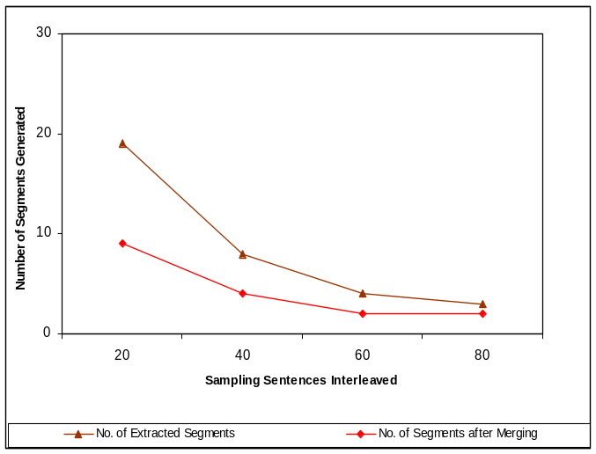

Fig. 1. A sample graph image

Fig. 2 shows an example of a low-resolution image which would not be acceptable, whereas Fig. 3 shows an example of an image with adequate resolution. Check that the resolution is adequate to reveal the important detail in the figure.
Please check all figures in your paper both on screen and on a black-and-white hardcopy. When you check your paper on a black-and-white hardcopy, please ensure that:
- the colours used in each figure contrast well,
- the image used in each figure is clear,
- all text labels in each figure are legible.

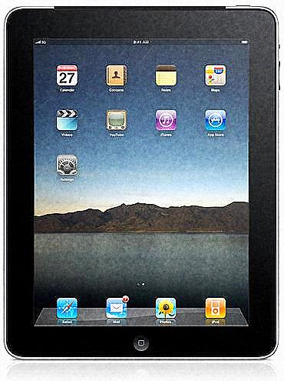
Fig. 2. Example of an unacceptable low-resolution image

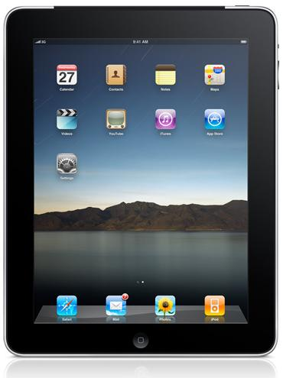
Fig. 3. Example of an image with acceptable resolution

- Figure Captions
Figures must be numbered using numbers. Figure captions must be in 8 pt Regular font. Captions of a single line (e.g. Fig. 2) must be centered whereas multi-line captions must be justified (e.g. Fig. 1). Captions with figure numbers must be placed after their associated figures, as shown in Fig. 1.
- Table Captions
Tables must be numbered using uppercase Roman numerals. Table captions must be centred and in 8 pt Regular font with Small Caps. Every word in a table caption must be capitalized.

- Page Numbers, Headers and Footers
Page numbers, headers and footers must not be used.
- Links and Bookmarks
All hypertext links and section bookmarks will be removed from papers during the processing of papers for publication. If you need to refer to an Internet email address or URL in your paper, you must type out the address or URL fully in Regular font.
- References
The heading of the References section must not be numbered. All reference items must be in 8 pt font. Please use Regular and Italic styles to distinguish different fields as shown in the References section. Number the reference items consecutively in square brackets (e.g. [1]).
When referring to a reference item, please simply use the reference number, as in [2]. Do not use “Ref. [3]” or “Reference [3]” except at the beginning of a sentence, e.g. “Reference [3] shows …”. Multiple references are each numbered with separate brackets (e.g. [2], [3], [4]–[6]).
Examples of reference items of different categories shown in the References section include:
- example of a paper in [1]
- example of a book in a series in [2]
- example of a journal article in [3]
- example of a conference paper in [4]
- example of a patent in [5]
- example of a website in [6]
- example of a web page in [7]
- example of a databook as a manual in [8]
- example of a datasheet in [9]
- example of a master’s thesis in [10]
- Conclusion
The version of this template is initial. Most of the formatting instructions in this document have been compiled by Editorial members. This template can be used for developing papers to submit to IJITCE Journal.
Acknowledgment

The heading of the Acknowledgment section and the References section must not be numbered.
Authors wish to thank James Pictures for allowing experiment their findings and acknowledge Peter Jones and others contributors for developing and maintaining this template. To see the list of contributors, please refer to the journal website.
References
- Stefen Schroedl, Kiri Wagstaff, Seth Rogers, Pat Langley and Christopher Wilson., “Mining GPS traces for Map Refinement,” Data Mining and Knowledge Discovery, vol. 9, pp. 59-87, 2004.
- D. Lee, “The Map-Building and Exploration Strategies of Simple Sonar-Equipped Mobile Robot,” Cambridge Univ. Press., Cambridge, 1996.
- P. Weckesser, and R. Dillmann, “Modeling unknown environment with a mobile robot,”, Robotics Autonomous Systems, vol. 23, pp. 293–300, 1998.
- Y. L. Ip, A.B. Rad, K.M. Chow and Y.K. Wong, “Segment-based map building using enhanced adaptive fuzzy clustering algorithm for mobile robot applications,” Journal of intelligent and robotic systems, vol. 35, pp. 221-245, 2002.
- LÜ WeiFen, “A heuristic path-estimating algorithm for large-scale real-time traffic information calculating,” Patent, Apr. 2008.
- www.example.com
- Interface control document. Navstar GPS Space Segment (Navigation User Interfaces), 2000.
- Asoke K Talukder and Roopa R Yavagal. “Mobile Computing-Technology, Applications and Service Creation,” Tata McGraw Hill Publishing Company, 2005.
- J. Padhye, V. Firoiu, and D. Towsley, “A stochastic model of TCP Reno congestion avoidance and control,” Univ. of Massachusetts, Amherst, MA, CMPSCI Tech. Rep. 99-02, 1999.
- Wireless LAN Medium Access Control (MAC) and Physical Layer (PHY) Specification,PhD thesis submitted to university of Malaya..

