ASPNet Identity MVC App

Contents

[Objective 1](#_Toc22356728)

[Specification of platform used 1](#_Toc22356729)

[About the Solution Stack 1](#_Toc22356730)

[Please let me know what you think 4](#_Toc22356731)

# Objective

An MVC project implementation for authentication using ASP.NET Identity

# Specification of platform used

API - ASP.NET MVC 5

Tools used - Visual studio 2017

Methodologies for Authentication - OAuth and ASP.NET Identity

# About the Solution Stack

Application includes the required dependencies as below to implement MVC Code first Entity framework solution for storing user details.



Authentication via Google + and Facebook using OAuth industry standard

Machine generated alternative text:
Google APIs 
aspNetldentity 
RPI 
o. 
APIs & Services 
Dashboard 
Library 
Credentials 
OAuth consent screen 
Domain verification 
Page usage agreements 
OAuth consent screen 
Before your users authenticate, this consent screen will allow them to choose 
whether they want to grant access to their private data, as well as give them a link 
to your terms of service and privacy policy. This page configures the consent 
screen for all applications in this project. 
Verification status 
Not published 
Application name 
The name of the app asking for consent 
ASPNetldentity 
Application logo 
An image on the consent screen that will help users recognize your app 
Local file for upload 
Support email 
Shown on the consent screen for user support 
rohitendofgoodtmes@gmail.com 
Browse 
About the consent screen 
The consent screen tells your users who is 
requesting access to their data and what kind of data 
you're asking to access 
OAuth verification 
To protect you and your users, your consent screen 
and application may need to be verified by Google 
Verification is required t your app is marked as 
Public and at least one of the following is true: 
• Your app uses a sensitive and/or restricted 
scope 
• Your app displays an icon on its OAuth consent 
screen 
• Your app has a large number of authorized 
domains 
• You have made changes to a previously-verified 
OAuth consent screen 
The verification process may take up to several 
weeks, and you will receive email updates as it 
progresses. Learn more about verificatiom 
Before your consent screen and application are 

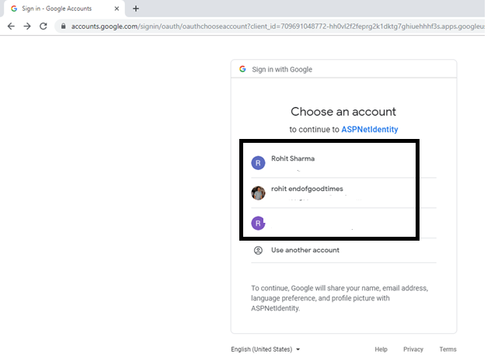

Machine generated alternative text:
Register 
My ASP.NET Applicatic X 
O localhost:56357/Account/ExternaILoginCalIback# 
Application name 
Home 
Register. 
About 
Conta ct 
Associate your Google account. 
Association Form 
YouVe successfully authenticated with Google. Please enter a user name for this site below and click the Register button to finish logging in 
Email 
S 2019 - My ASPNET Application 
rohitendofgoodtimes@gmaiLcom 
Register 

Verification of working authentication. User logged in after redirection from google and details stored in database.

Machine generated alternative text:
Home Page - 
My ASP.NET Applic X 
O localhost:56357 
Application name 
Home 
About 
Conta ct 
Hello 
Log off 
ASP.NET 
ASP_NET is a free web framework for building great Web sites and Web applications using HTML, CSS and 
JavaScript 
Leam more » 

Details of user entry via Google Plus

Machine generated alternative text:
m Server Explorer 
23 
Azure (Not connected) 
Data Connections 
DefaultConnection (Identity) 
Tables 
_MigrationHistory 
AspNetRoIes 
AspNetUserCIaims 
AspNetUserLogins 
AspNetUserRoIes 
Views 
AspNetUsers [Data] 
Startup.Auth.cs 
Max Rows: IDDD 
Identity 
AccountControIIer 
EmailConfirmed PasswordHash 
934b512f-857c-4aS6-80cD-4Sd15ecO... 
NULL 
Email 
rohitendofgoo... 
NULL 
False 
NULL 
NULL 
NULL 
I dentin,' 
I SecurityStamp 
b2f44a29-34ba-... 
NULL 
PhoneNumber 
NULL 
NULL 
PhoneNumbI 
False 
NULL 

# Please let me know what you think

Thanks!