User Management App

Contents

Objective 1

Specification of platform used 2

About the Solution Stack 2

Assumptions 2

Flow implemented 3

Unit test Project 6

What currently does not work 7

Please let me know what you think 8

# Objective

As shared in folder, an API and angular app consuming the same needs to be created

## Delivery requirements

### API

A Web API built with .NET Core 2.x that exposes the `User` resource:

- Required HTTP methods are `GET`, `POST`, `PATCH` and `DELETE`

- Integration tests that test the endpoints

- Assert the responses (e.g. models and status codes)

- Users should be vertices with an optional edge to managers in the database

### Client

A simple user management application built with Angular:

- It should be possible to list, add, edit and remove users

- The API from the first requirement should be consumed for user storage and retrieval

- Angular Material should be used as the UI library of choice

- Redux (NgRx) should be used for state management

# Specification of platform used

Angular CLI: 8.3.6

Node: 12.1.0

API - ASP.NET Core 2.2

Tools used - Visual studio 2015, Visual studio Code

# About the Solution Stack

**Console application** - .NET Core

**Libraries** – System, System.Configuration, System.Collection.Generic

**Error Logging** – As in API response.

**Dependencies for core API-** xunit, swashbuckle, FluentAssertions, Entity Framework

**Platform & tools used:**

Angular CLI: 8.3.6

Node: 12.1.0

API - ASP.NET Core 2.2

Visual studio 2015, Visual studio Code

# Assumptions

1. Id of users should be something unique. Hence GUID is used to represent a user resource (or key)

# Flow implemented

State management using Redux(NgRx) is not implemented, as I have not worked with it and I need some time to gain this knowledge and practice in order to implement. Also displaying of user’s manager has not been implemented uptil now.

Angular application calls api and allow for all CRUD operations

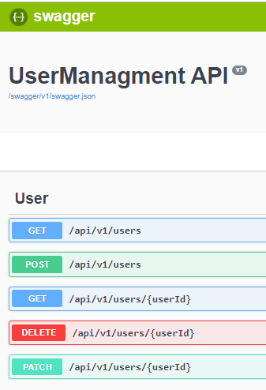

View Users screen

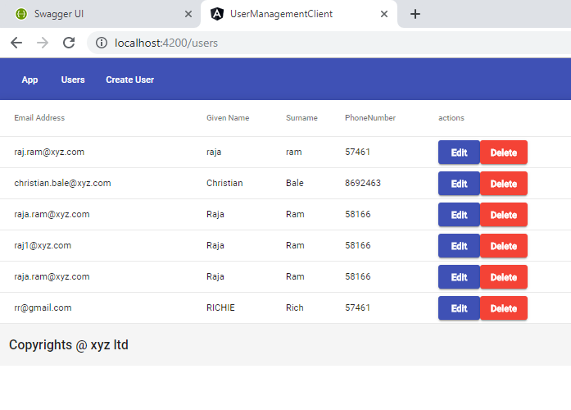

Editing user screen

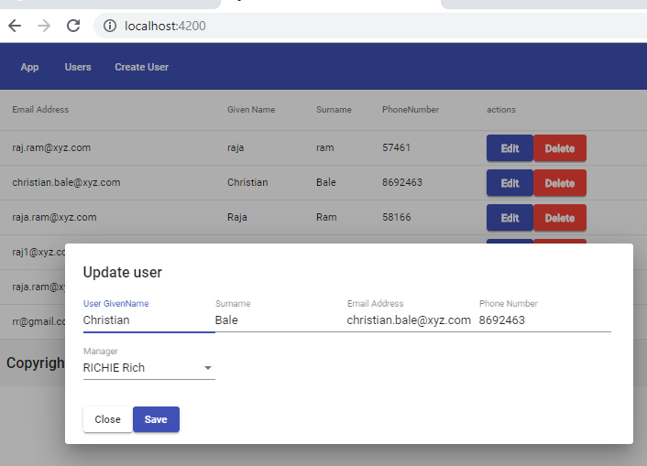

Creating user screen

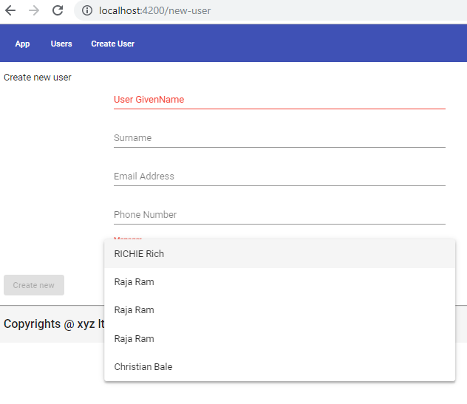

# Unit test Project

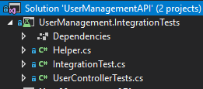

Test class contains details of all unit tests created for the project. UserControllerTests class file tests for all integrationscenarios and can be extended for new tests.

**Present state of unit tests-**

Currently not all unit tests pass . There is an issue of id values not passing on to the in memory database used for testing.

**Test_CreateUser** and **Test_GetAllUsers** pass without issues.

**Note – All dependencies for the project is already added in the solution**

# What currently does not work

Deleting user from app is not working. Although delete functionality is working from swagger. The id for deleting user is not getting passed somehow to api. However, get, post and patch works absolutely fine both from swagger and from APP

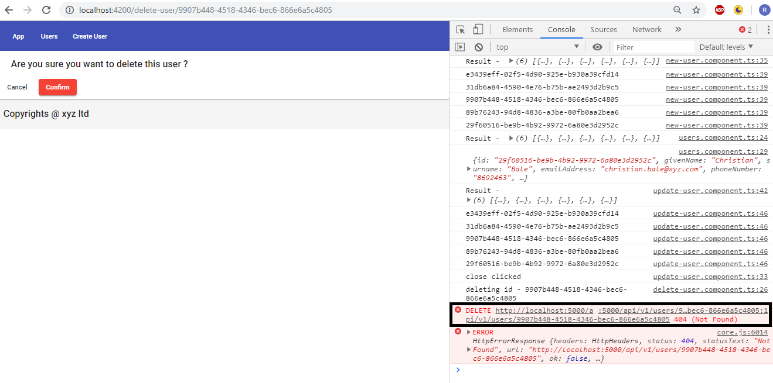

# Please let me know what you think

Thanks!