Week 8

Part 1
- What is an exception in Python?
An exception is a runtime error that occurs while a program is executing and interrupts normal program flow.

- What is the purpose of using exception handling in Python?
Exception handling prevents the program from crashing and allows it to handle errors gracefully and continue execution.

- What is the difference between a syntax error and an exception in Python?

Syntax Error | Exception
Happens before execution | Happens during execution
Code won’t run at all | Program starts, then fails
Example: missing colon | Example: division by zero

- How do you raise an exception in Python?
We can raise an exception in python using the keyword raise for
e.g.: - raise ValueError ("Invalid value")

- What is the try-except block in Python?
The block of code try-except allows use to test the code for any errors and handle them accordingly.

- What is the syntax of the try-except block in Python?
The syntax of try-except block is: -
try:
# risky code
except ExceptionType:
# error handling

Part 2
- Write a Python program that prompts the user to enter two integers and then divides the first integer by the second integer. Handle any exceptions that may occur during the division operation.

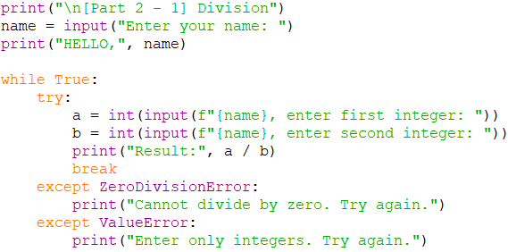

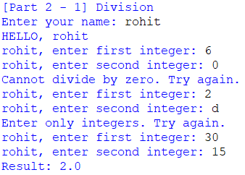

- Write a Python program that reads a file name from the user and attempts to open the file. Handle any exceptions that may occur if the file does not exist or if there is an error reading the file.

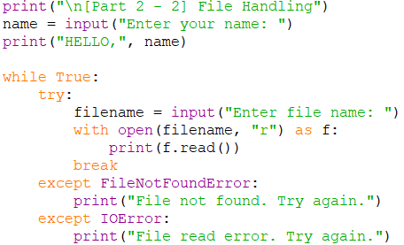

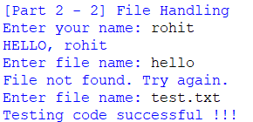

- Write a Python program that prompts the user to enter a list of numbers and calculates the average of those numbers. Handle any exceptions that may occur if the user enters non-numeric values.

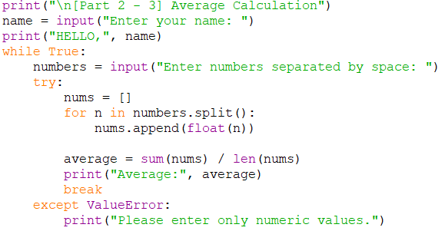

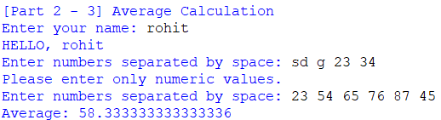

- Write a Python program that generates a random number between 1 and 10 and prompts the user to guess the number. Handle any exceptions that may occur if the user enters non-numeric values or if the guess is out of range.

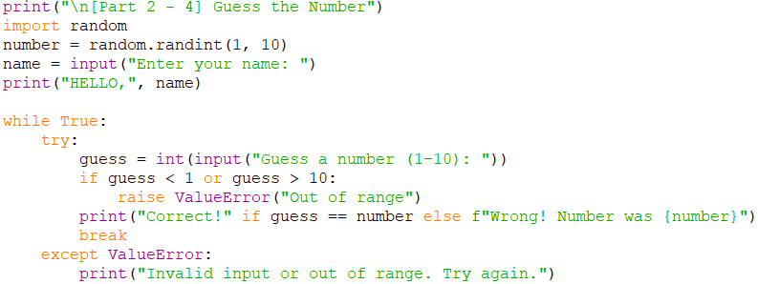

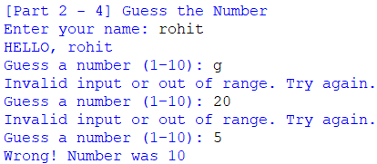

- Write a Python program that prompts the user to enter a list of integers and then calculates the sum of those integers. Handle any exceptions that may occur if the user enters non-numeric values.

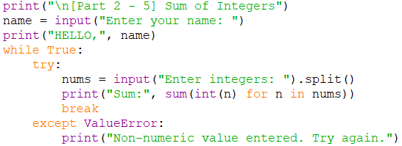

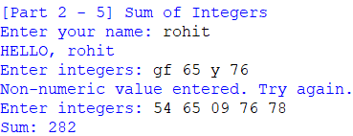

- Using try…except, showcase the ZeroDivisionError.

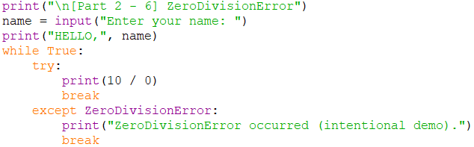

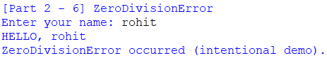

- Create a simple list containing five elements and try to print the sixth element of the list. [use IndexError exception]

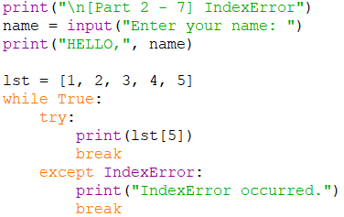

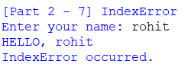

- Try printing a variable without declaring it. [use NameError exception]

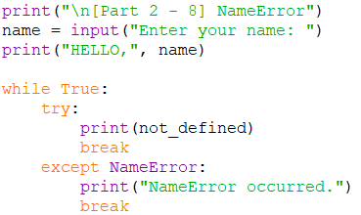

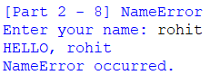

- The ‘else’ in try…except…else statements are used to run the code on the else block if there are no exceptions in the ‘except’ block. Show an example.

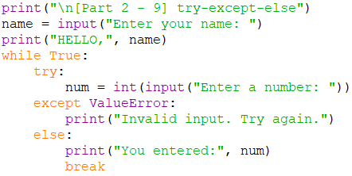

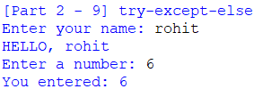

- In Python, we can choose to throw an exception if a condition occurs. To throw an exception, we use the ‘raise’ keyword. Show an example.

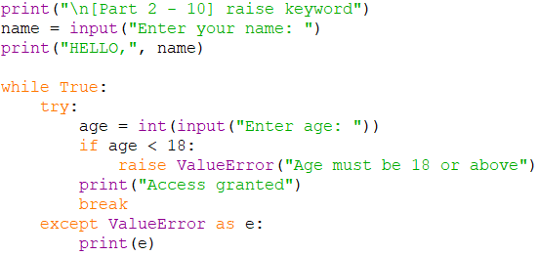

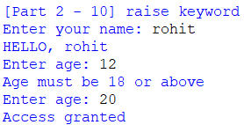

Part 3

- Write a Python program that prompts the user to enter a string and then converts it to an integer. Handle the ValueError exception that may occur if the string cannot be converted to an integer.

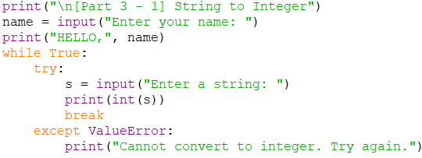

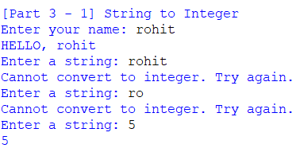

- Ask the user for the numerator and denominator value; and perform division. If the user enters a number, the program will evaluate and produce the result.
If the user enters a non-numeric value, then, the try block will throw a ValueError exception, and we can catch that using a first catch block ‘except ValueError’ by printing the message ‘Entered value is wrong’.
And suppose the user enters the denominator as zero. In that case, the try block will throw a ZeroDivisionError, and we can catch that using a second catch block by printing the message ‘Can’t divide by zero’.

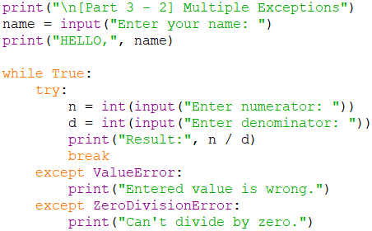
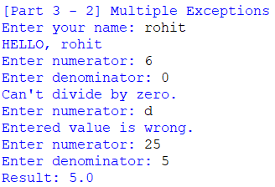
- Ask the user to enter an amount of money. In the try block, run a condition to check if the input value is less than 10 thousand; in which case raise a ValueError and print your message inside it. In the except block, catch the ValueError we previously raised and print the message inside it.
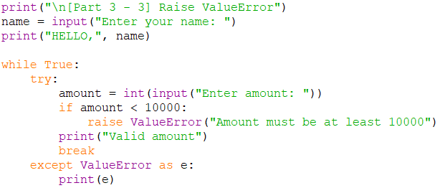

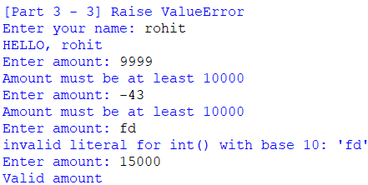

- Write a Python function that takes a list of integers as an argument and returns the largest integer in the list. Handle the ValueError that may occur if the argument is an empty list.

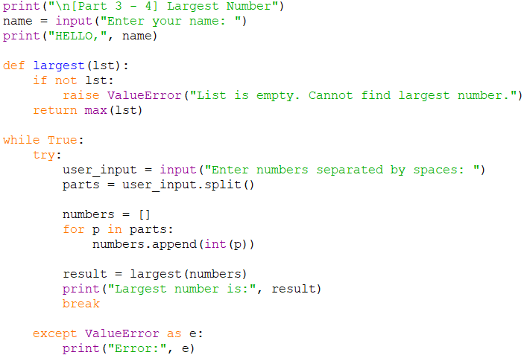

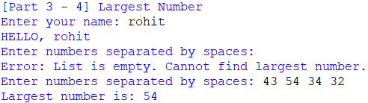

- Write a Python function that takes a dictionary as an argument and returns the value associated with a given key. Handle the KeyError that may occur if the key does not exist in the dictionary.

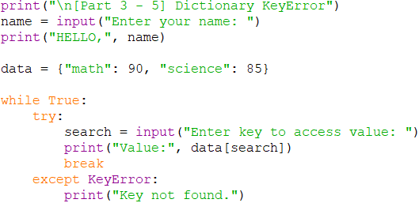

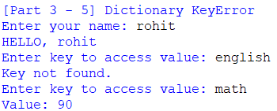

- Write a Python function that takes two strings as arguments and concatenates them. Handle the TypeError that may occur if either argument is not a string.

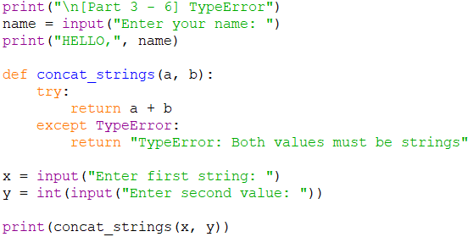

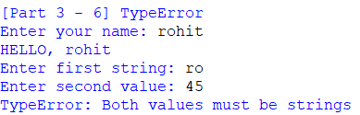

Part 4
You are working on a program that keeps track of the grades for a class of students. The program should allow the user to input the name and grades of each student, and then calculate and display the average grade for the class.
Write a Python program that:
- Uses a list to store the names of the students.
- Uses a dictionary to store the grades of each student, with the student names as keys and the grades as values.
- Uses exception handling to handle errors that may occur when the user inputs the grades, such as non-numeric values or values outside the range of 0-100.
Here are some additional details and requirements:
- The program should prompt the user to enter the number of students in the class.
- For each student, the program should prompt the user to enter the student's name and their grades (separated by commas).
- The program should display an error message if the user enters an invalid grade for a student, and allow the user to re-enter the grade.
- The program should use a try-except block to handle exceptions when converting the grade to a float.
- The program should use a while loop to allow the user to re-enter an invalid grade.
- The program should use the format () function to display the grade with two decimal places.
