4MM013
Computational Mathematics
PYTHON_WORKSHOP-9

Name: - Rohit Sahani
Student Id: -NP02CS4A250027

Problem 1: Consider varying the value of step size h to a bigger value
and smaller value and check for the error. Consider varying the value of
‘a’ and again check the error.

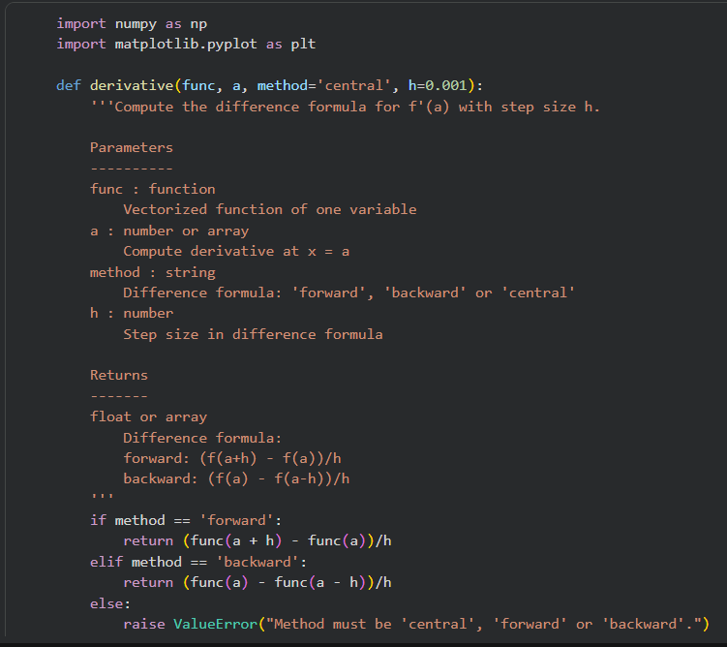

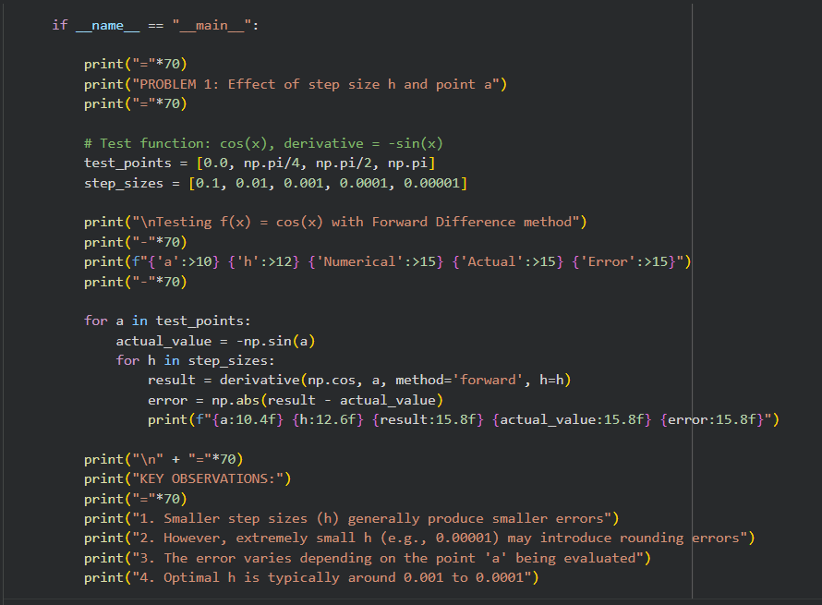

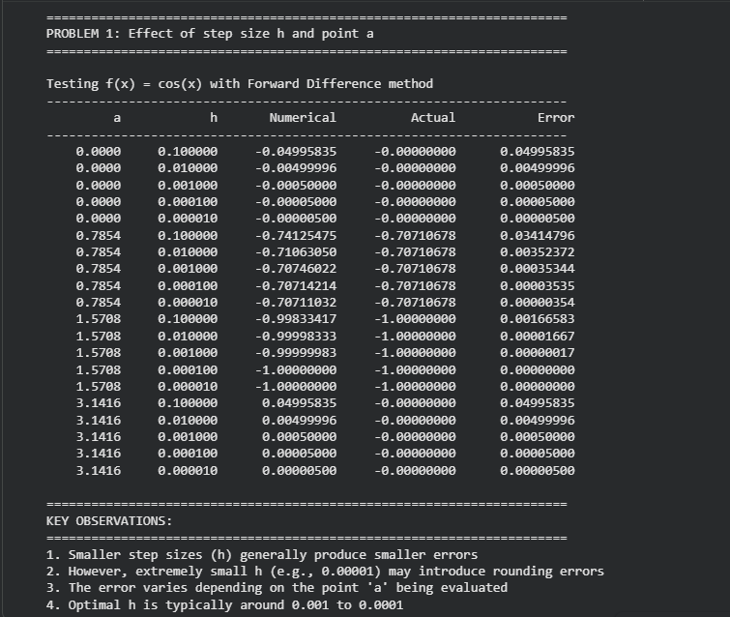
Output:-

Problem 2: In the above code, only the Forward and Backward
Difference formulae have been implemented. Please add the a few lines
of code to derivative() function to implement the Central Difference
formula and then compare its result with the Forward and Backward
Difference methods.

Problem 2: In the above code, only the Forward and Backward
Difference formulae have been implemented. Please add the a few lines
of code to derivative() function to implement the Central Difference
formula and then compare its result with the Forward and Backward
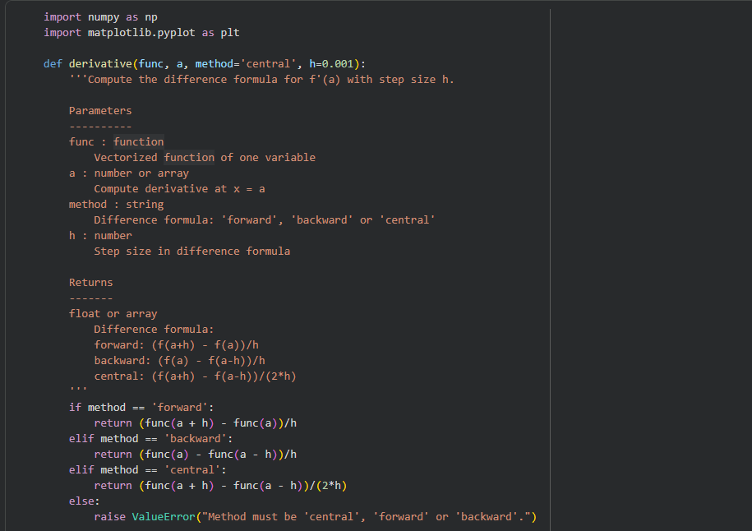
Difference methods.

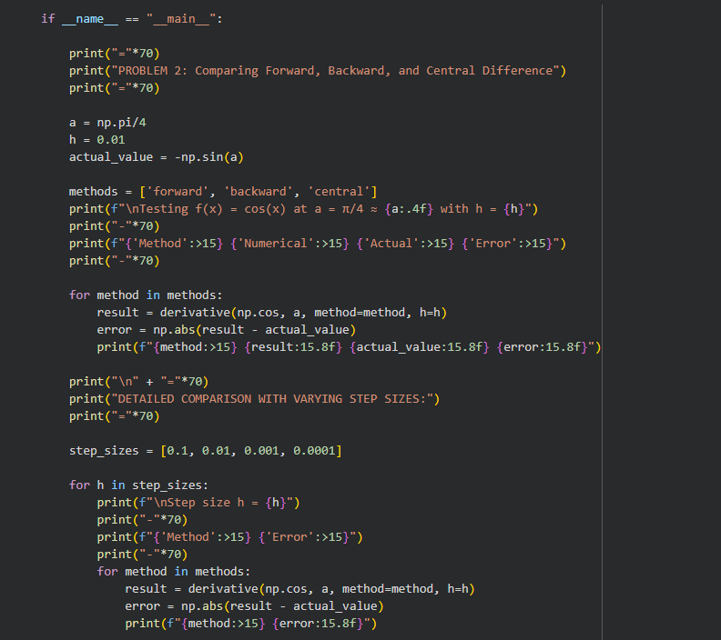

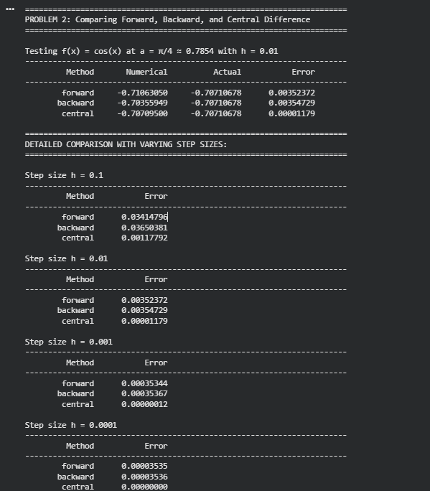
Output:-

Problem 3: The derivative() function can take an array of inputs for aa
and return the derivatives for each aa value. So, calculate the derivative
of y = sin(x) for multiple equidistant values and plot it along the true
values. You can use line:
x = np.linspace(0,5*np.pi,100) to generate multiple equidistant values as the input array.
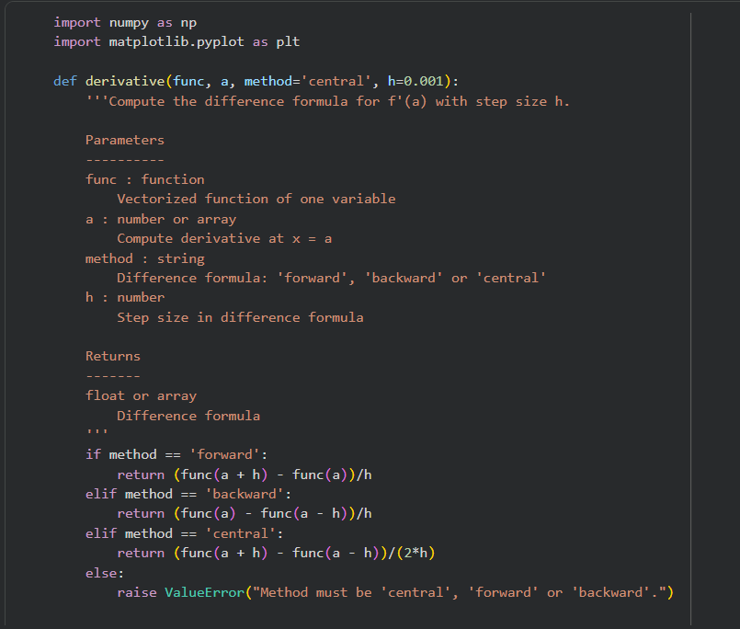

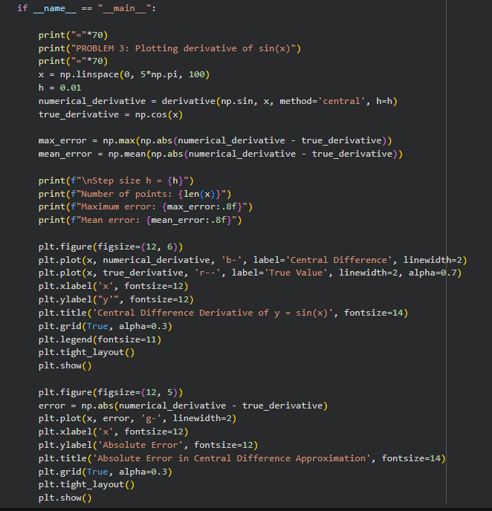

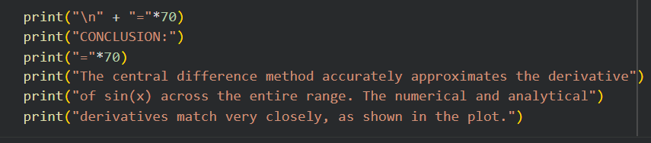

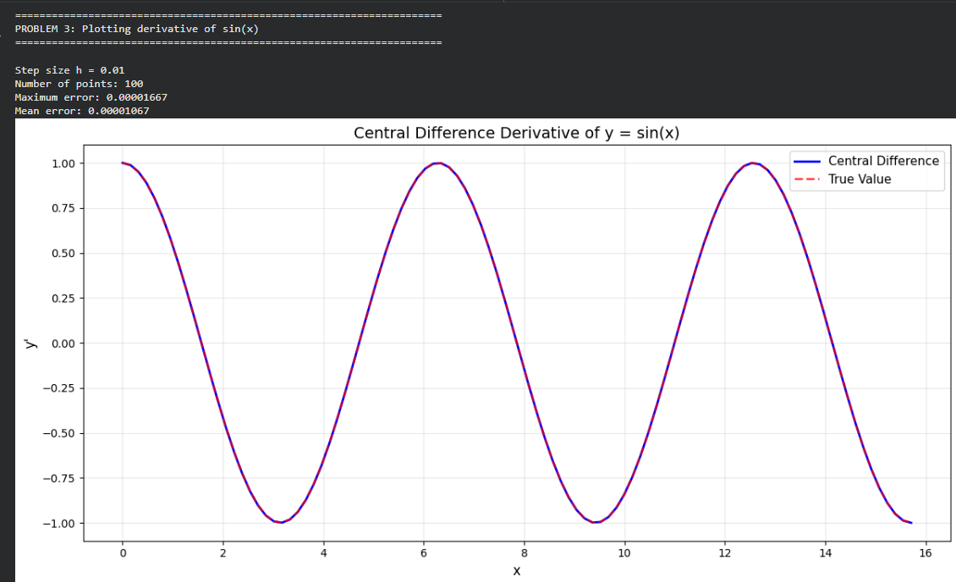
Output:-

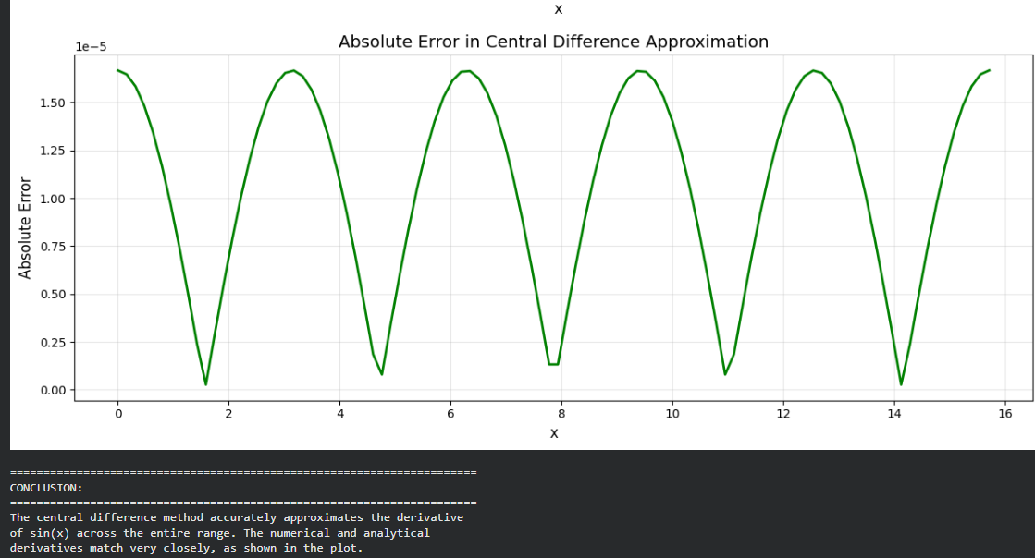

Problem 4: Try doing the same for other interesting functions you know.

Problem 4: Try doing the same for other interesting functions you know.

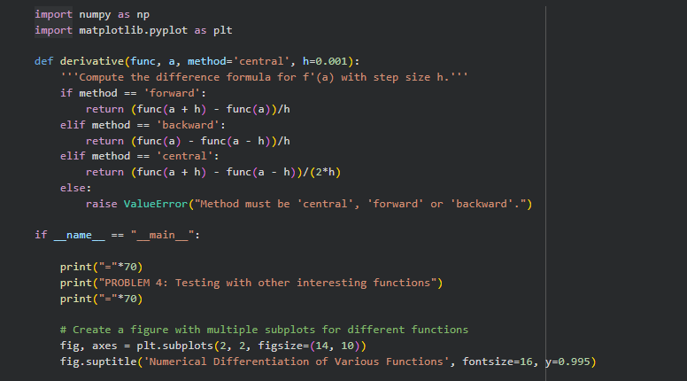

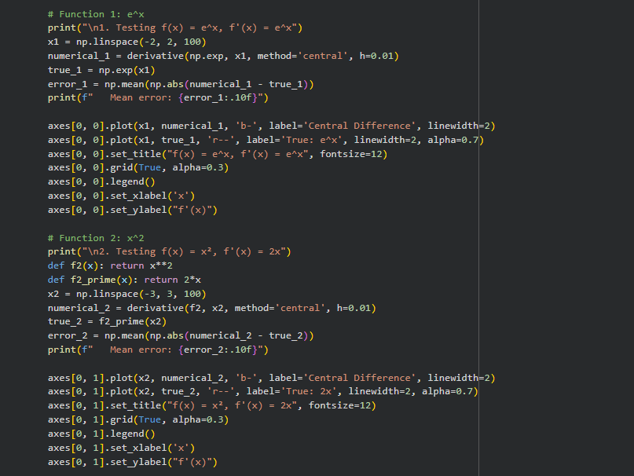

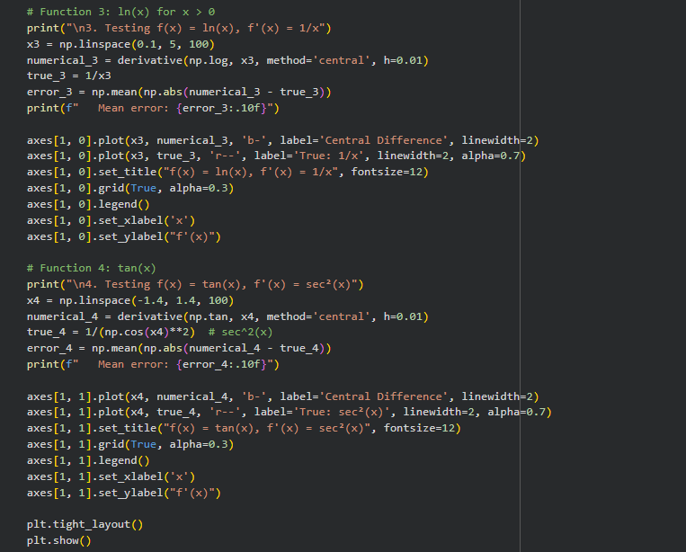



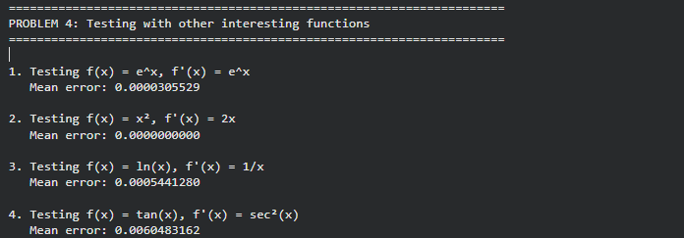
Output:-

