4MM013
Computational Mathematics
PYTHON_WORKSHOP-6

Name: - Rohit Sahani
Student Id: -NP02CS4A250027
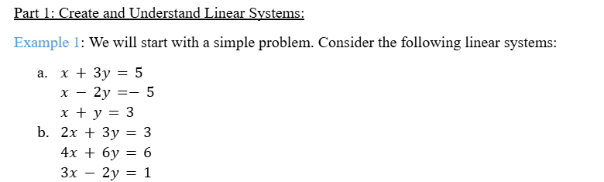
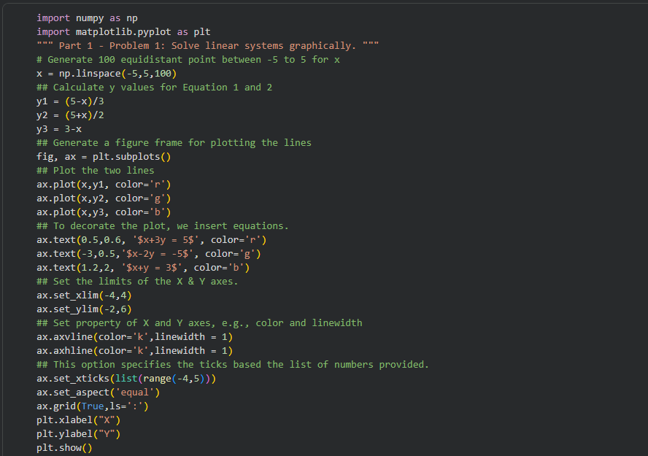
Solve the linear systems graphically.
Expected Output:

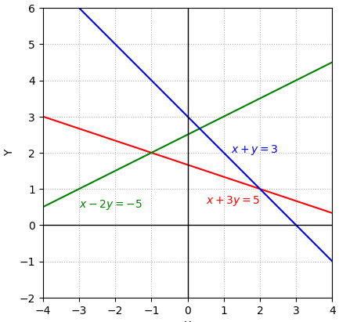

#Write the conclusion from the above graph.
Task 1:
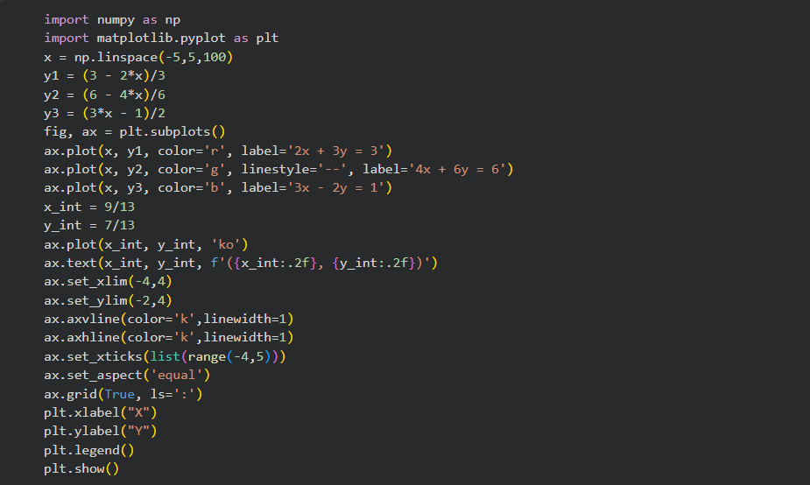
Plot the graph for linear system b and write the point of intersection between three lines.

Output:
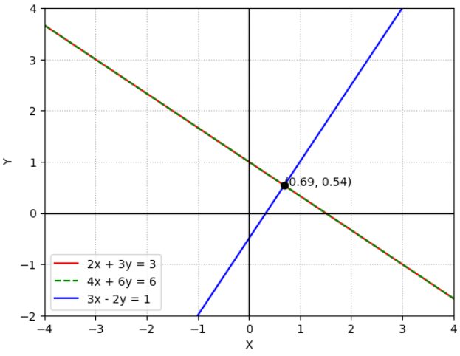

NumPy:
Task 2:
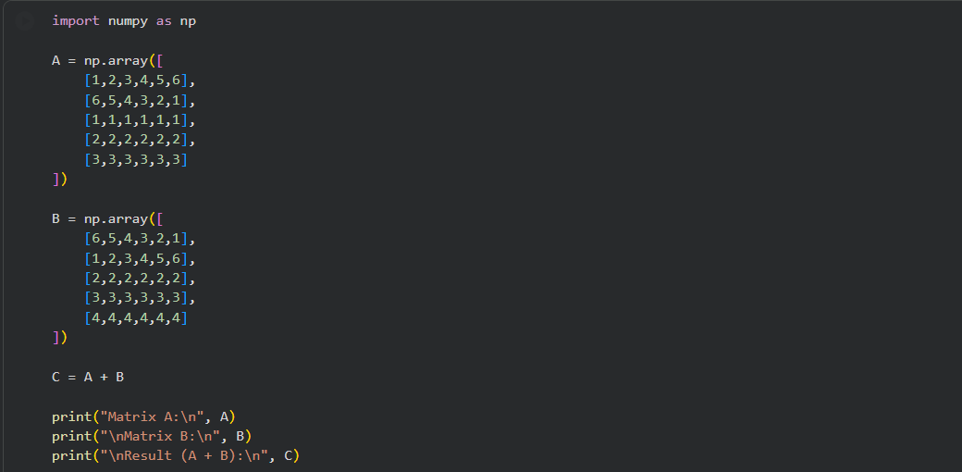
- Create a program that reads in two 5x6 numpy.arrays, adds them together, and then stores the result in a third 5x6 matrix. The program should then print out the first two matrices and the result matrix.

Output:
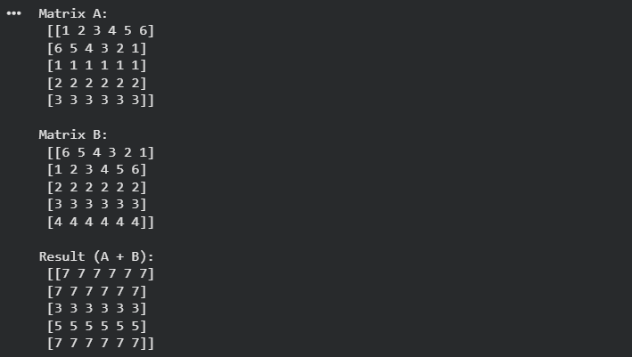

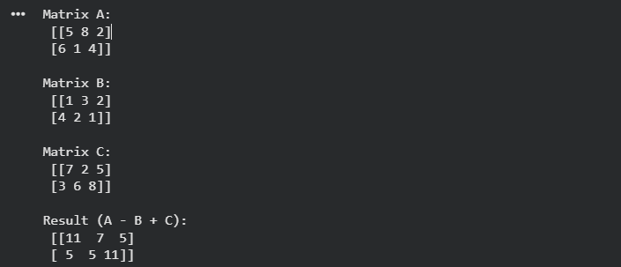
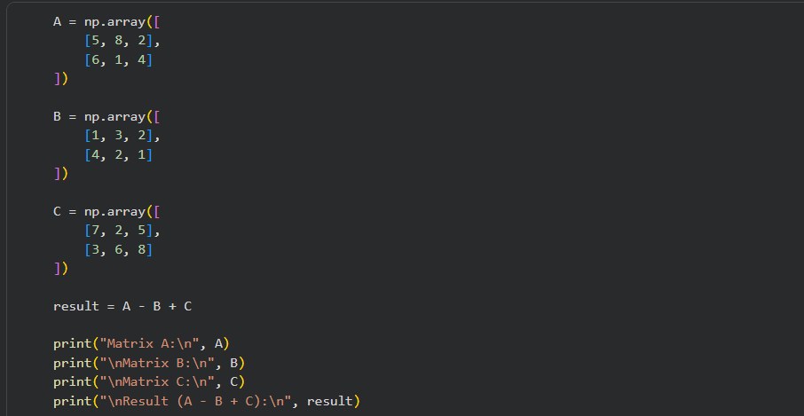
- Create a program that reads in three 2x3 numpy.arrays, subtracts the second from the first, and adds the third to the result. The program should then print out all three matrices and the result matrix.
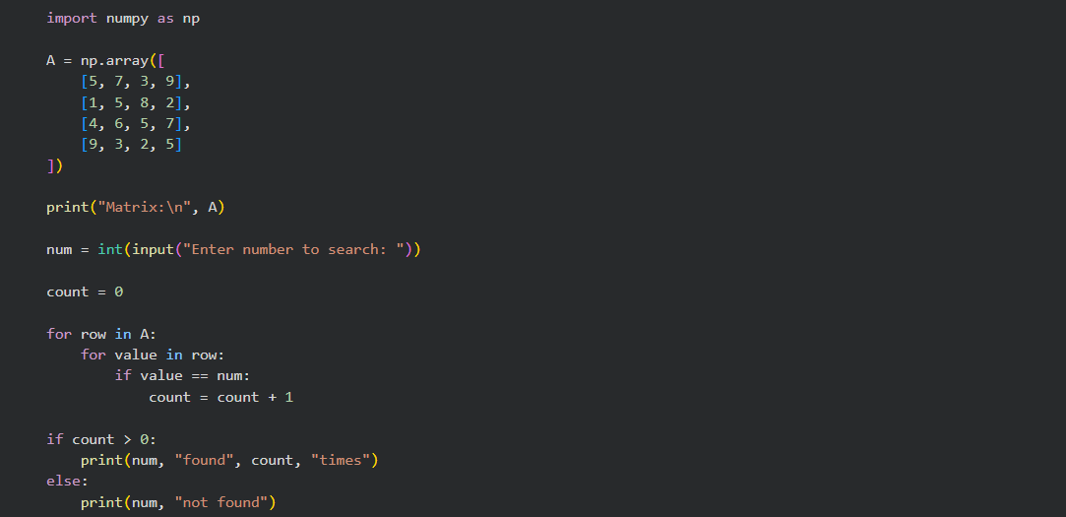
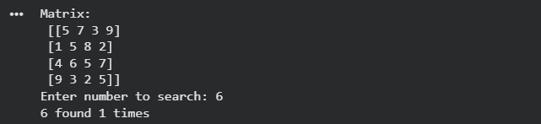
- Create a 4x4 matrix containing random numbers in the range of 1 to 20. Have the user prompted for a number, check that the imputed value is a number and then check if the number is in the matrix. If the number is in the matrix, return the number of times that number is in the matrix.

Numpy.linalg
linalg is a submodule in NumPy, a popular Python library used for numerical computations, particularly in the domain of linear algebra. linalg stands for "linear algebra". This submodule provides functions and classes for various linear algebra operations, such as matrix decompositions, eigenvalue computations, matrix multiplication, solving linear equations, and many others.
Some useful linalg functions:

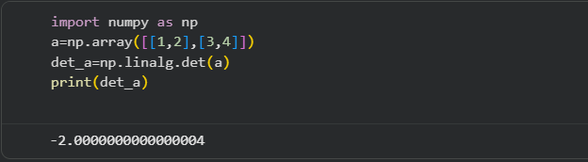
1.linalg.det(a): calculates the determinant of the matrix

- linalg.matrix_rank(a): computes the rank of the matrix
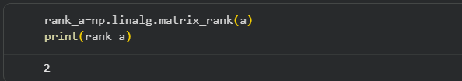

- linalg.inv(a): calculates the multiplicative inverse of a matrix
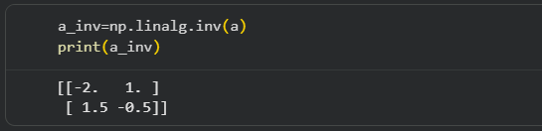

- linalg.solve(a,b): solve a linear system of equations ax=b
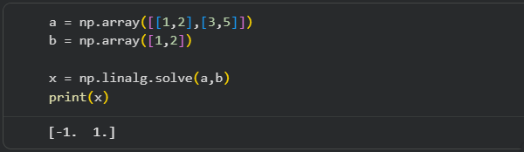

- linalg.pinv(a): compute the pseudo-inverse of a matrix.
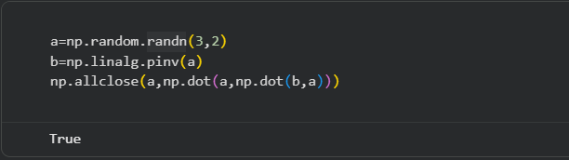

Task 3:
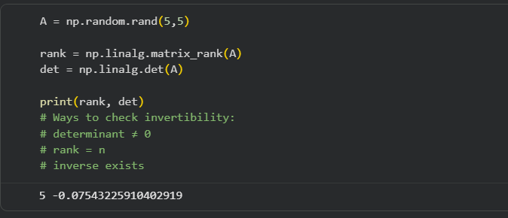
- Create a matrix 𝑨 of order 5 × 5 with random entries. Calculate the rank of the matrix 𝑨 to check the number of linearly independent columns or rows and to check if the matrix is invertible. What are the other ways to check if the matrix is invertible?

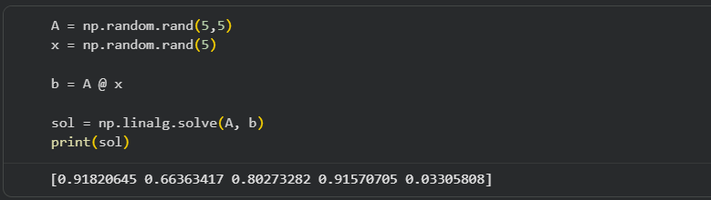
- Generate a matrix 𝑨 of order 5 × 5 with random entries and generate a vector (column) 𝒙 of length 5 with random entries. Calculate Matrix-vector product 𝒃 = 𝑨𝒙. Now, we have a linear system, i.e. the matrix 𝑨 and a vector 𝒃. Solve this Linear System.

- Solve the following system.
8x+3y−2z=9
−4x+7y+5z==15
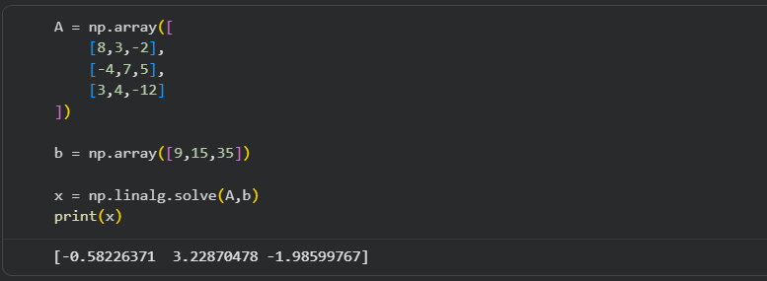
3x+4y−12z=35

Task 4:
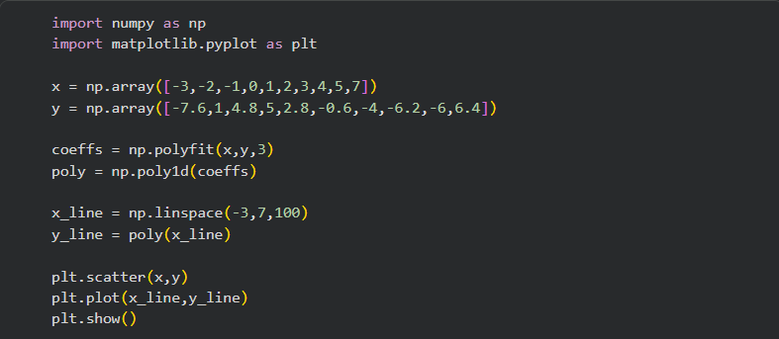
- Consider the following 10 points in X-Y plane: (−3, −7.6), (−2,1), (−1, 4.8), (0, 5), (1, 2.8), (2, −0.6), (3, −4), (4, −6.2), (5, −6), (7, 6.4). Plot these points in X-Y plane. Connect the points to guess the polynomial. Once you guess your polynomial, formulate a Linear System and then solve it to find the coefficient of the polynomial. Finally, check if the polynomial fits along with the above given points.
