4MM013
Computational Mathematics
PYTHON_WORKSHOP-5

Name: - Rohit Sahani
Student Id: -NP02CS4A250027

Example1:
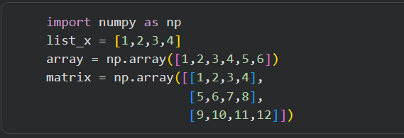

Task 1:
a. What are the results of print(array[0]), print(matrix[1]) and matrix[1,2]?
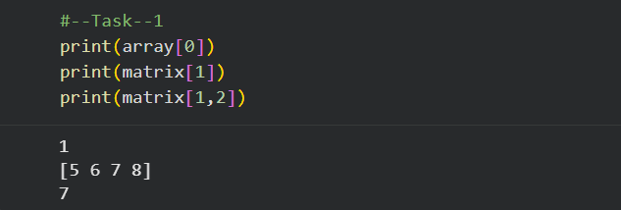

b. What are the differences between NumPy array and python list?
A NumPy array stores elements of the same data type, while a Python list can store mixed data types. NumPy arrays require importing the NumPy module, whereas lists are built-in. NumPy supports fast, direct numerical operations without loops, while lists require manual iteration. It also uses less memory and is faster and more efficient, making it more convenient for mathematical tasks compared to Python lists.
c. Using python function type(), find the type of above list/arrays.
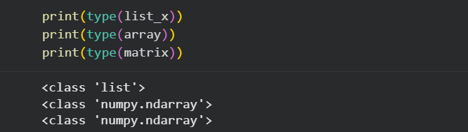

Example 2:
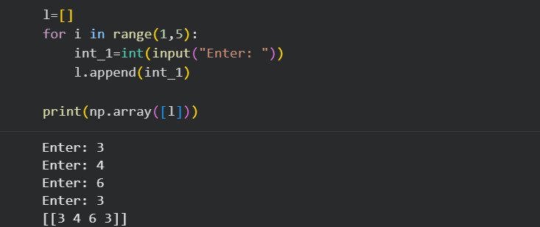

Task 2:
a. Write the result of print(np.ndim(l)) and print(np.shape()) what the functions ndim( ) and shape() do?
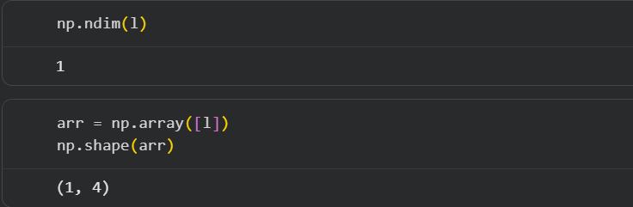

b. Write the result of np.array([1,2,3], ndmin=6).
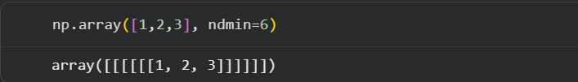

Example 3:
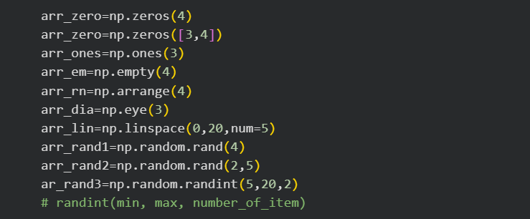
Task 3:
a. Print all of the arrays from example 3 and write the functions of each of the NumPy functions.
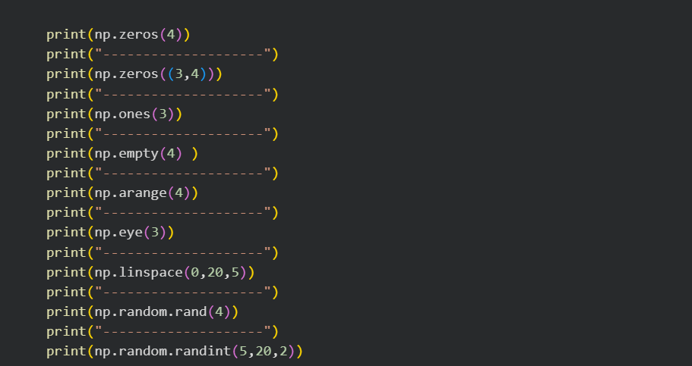
Output : -
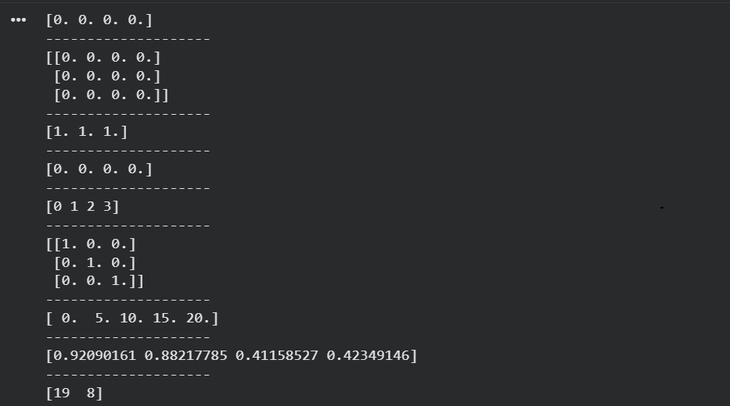
b. Create the 3*4 matrix with all elements equal to zero.
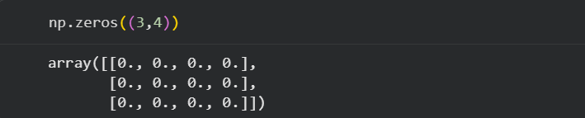
Example 4:
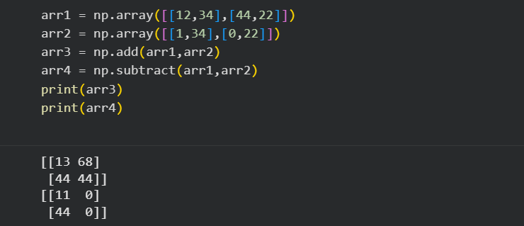Example 5:
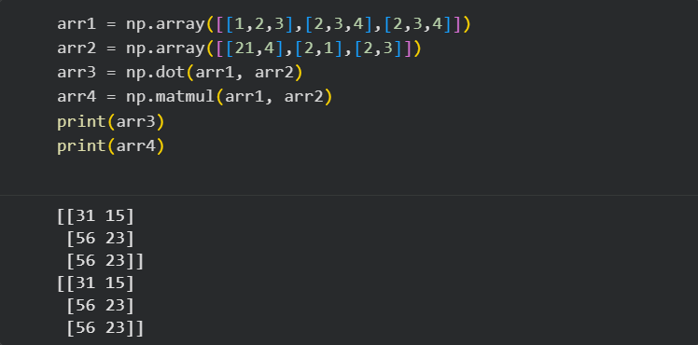
Task 4:
a. What is the difference between np.dot() and np.matmul().
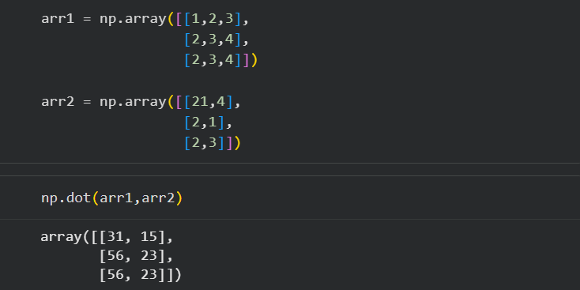
What is the result of np.dot(5,arr1)?
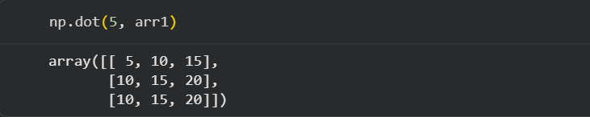
b. What is the result of np.transpose(arr3)?
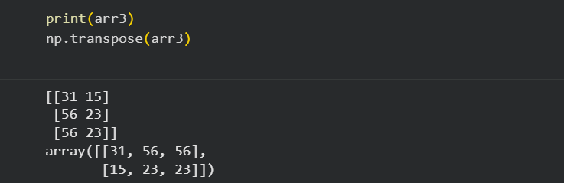
c. How would you scalar multiply the matrix np.array([[2,3],[4,5]]) by 3?
Plotting Arrays with Matplotlib:
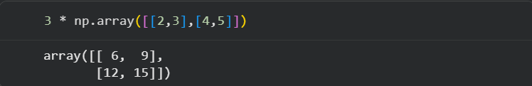
Example 6:
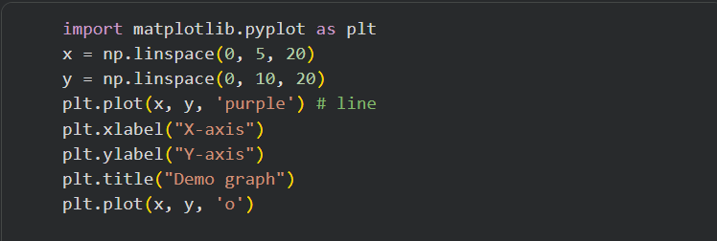
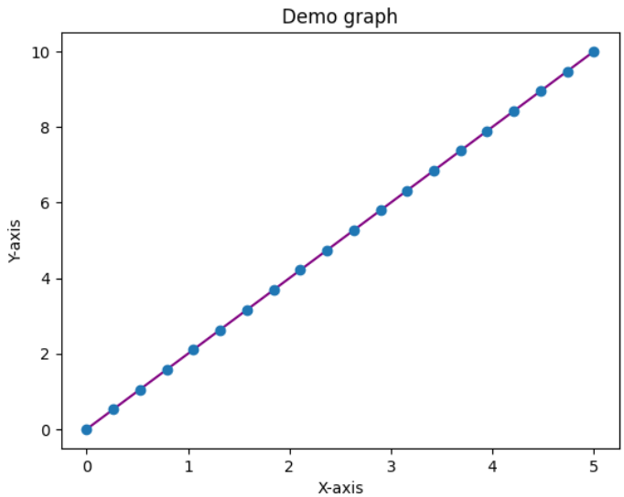

Task 5:
a. Prepare X and Y coordinates values for the function f(x) = 4x2+2 using NumPy array and plot the graph using Matplotlib.
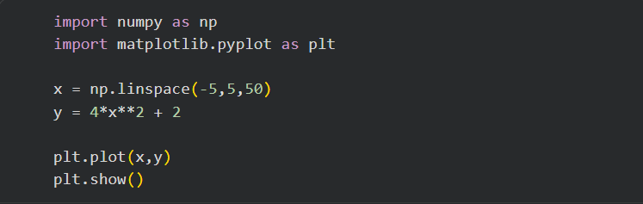

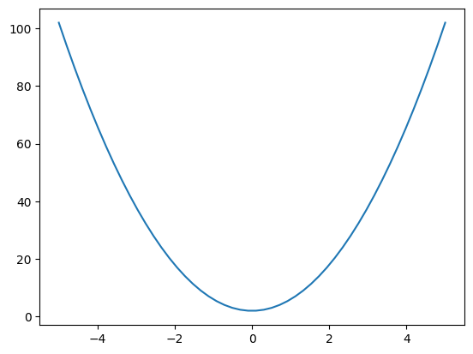

Example 7:
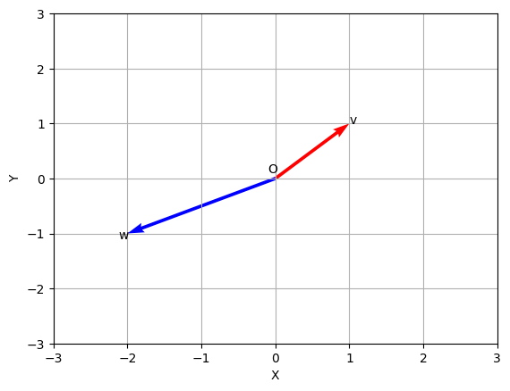
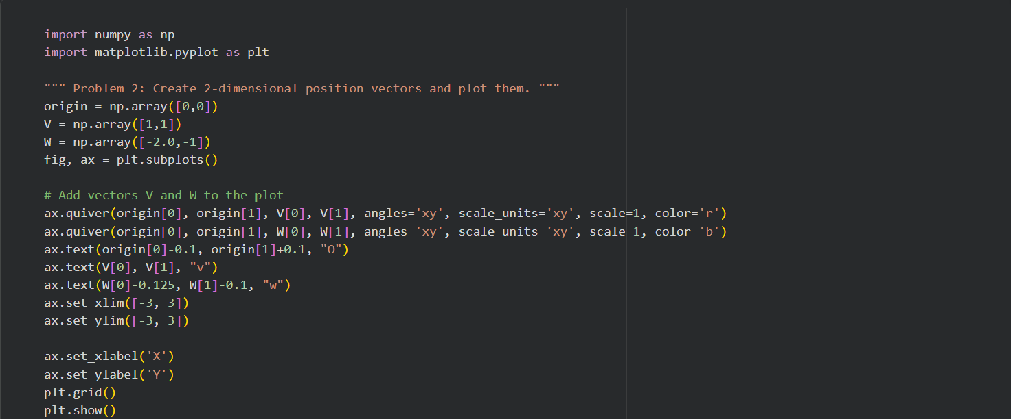
Create two vectors in 2-dimensional (2D) space and plot them using Matplotlib.

Task: 6
a. Create three vectors in 3D space and plot them using Matplotlib.
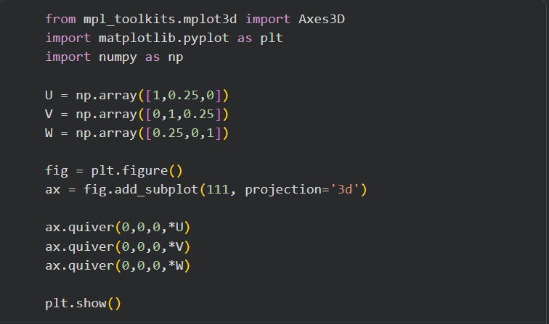
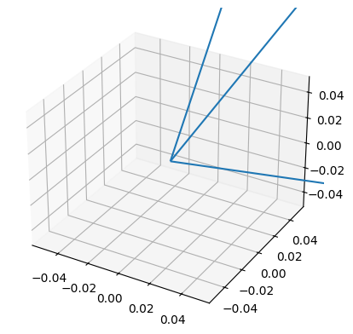

b. Create two vectors in 2D space, and add them to create a third vector, and plot all three vectors using Matplotlib.
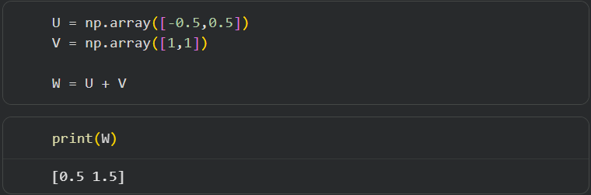

c. Write a function to calculate magnitude of a vector. For example, calculate the magnitude of the vector be U = (1.5, 1.5, 2.0).
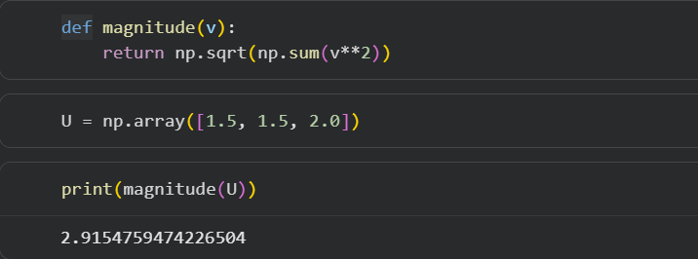

d. Write a function to calculate the direction cosines of the vector. For example, let the vector be O = (1.5, 1.5, 2.0).
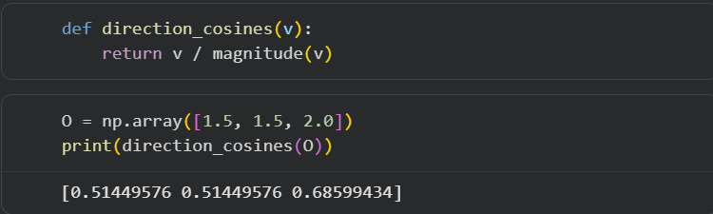

e. Write a function to calculate Scalar (dot) product of two vectors. For example, let the vectors be a= (1.5, 1.5, 2.0) and b = (−1.5, 0.5, 2.0).
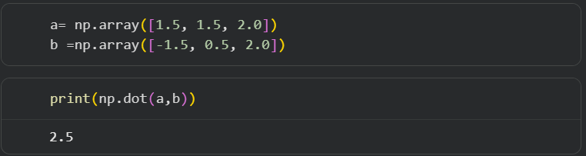

f. Write a function to calculate Vector (cross) product of two vectors. For example, let the vectors be a = (1.5, 1.5, 2.0) and b= (−1.5, 0.5, 2.0).
