4MM013
Computational Mathematics
WORKSHOP-1

Name: - Rohit Sahani
Student Id: -NP02CS4A250027

Examples
Example 1:
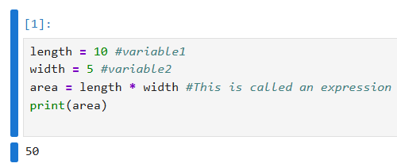

Example 2:
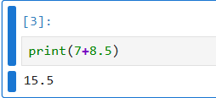

Example 3:
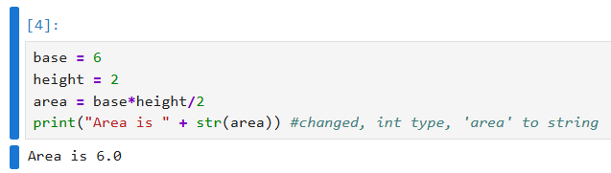

Example 4:
Write a program to prompt the user for hours and rate per hour using input () to compute gross pay. Pay the hourly rate for the hours up to 40 and 1.5 times the hourly rate for all hours worked above 40 hours. Use 45 hours and a rate of 10.50 per hour to test the program (the pay should be 498.75).
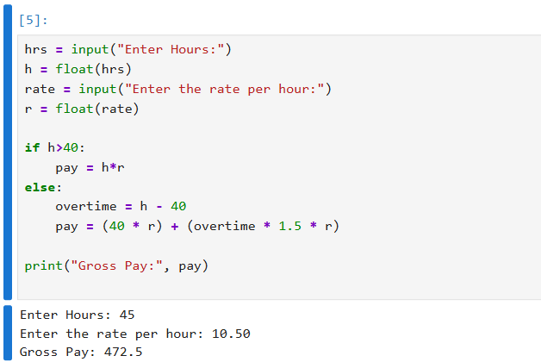

Example 5:
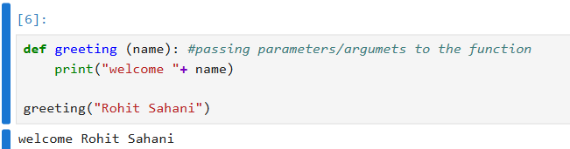

Example 7:
Write a function that compares two numbers and returns them in increasing order.
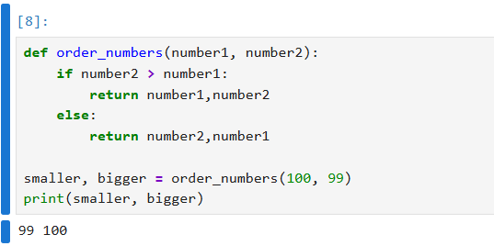

Example 8:
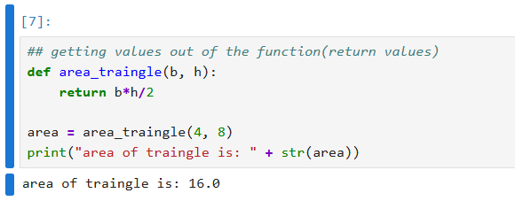

Example 9:
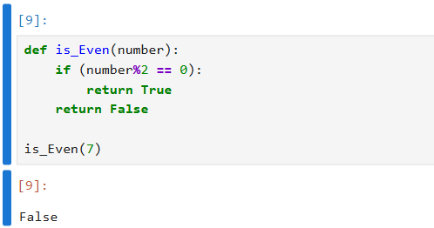

Example 10:
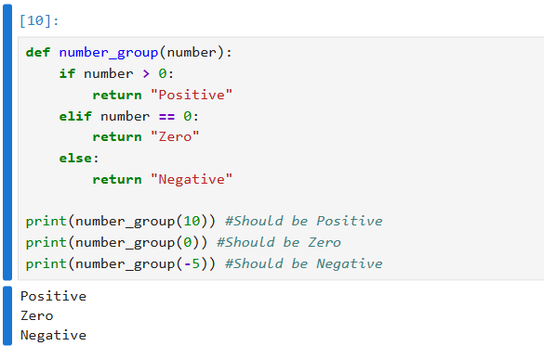

Example 11:
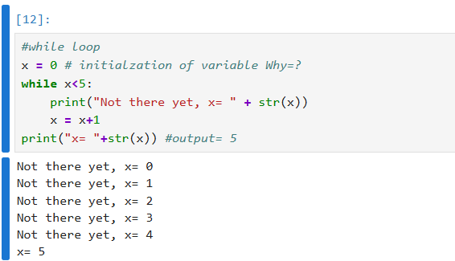

Example 12:
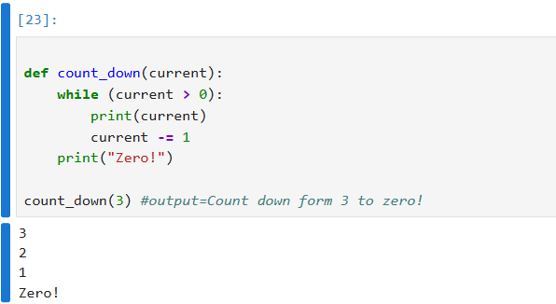

Example 13:
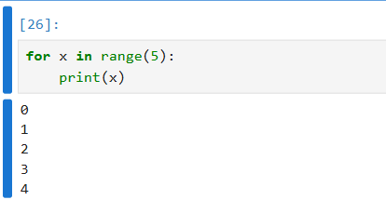

Example 14:
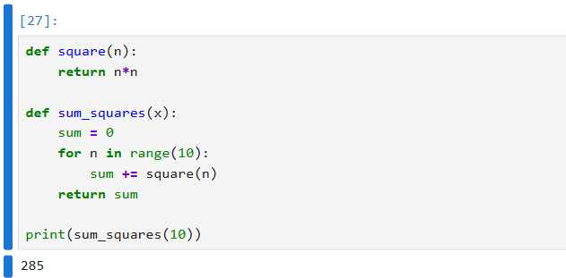

Example 15:
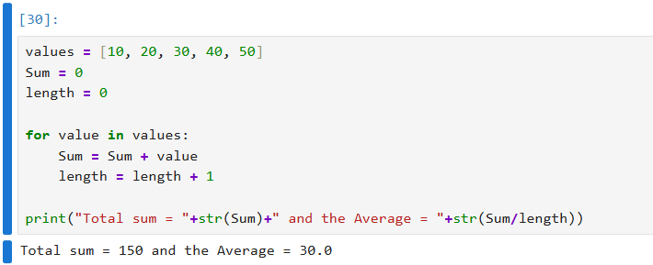

Example 16:
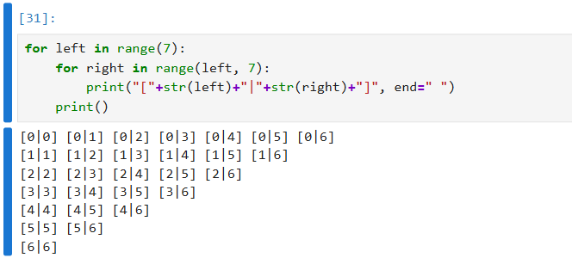

Exercise 1
- Write a function fib (n) that prompts the number of terms “n” from the user and displays first “n” terms of Fibonacci sequence iteratively.

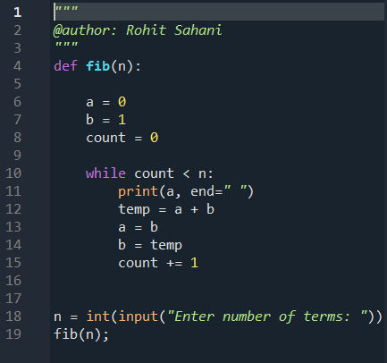
Output: -
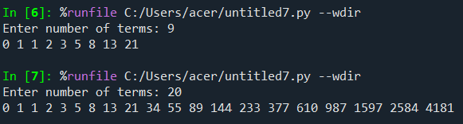
- Write a function myPow(x, n) that returns x n, where and n is a non-negative integer. Do not use the ** operator or the math.pow function - use one while loop.

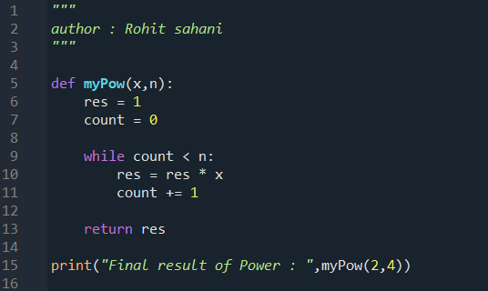
Output: -
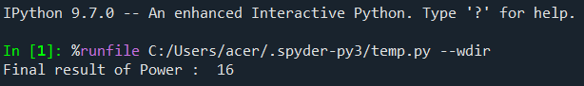

- Write a function SumDigits(n) that displays the sum of digits of “n”.
Hint: SumDigits(234) will be 2+3+4=9

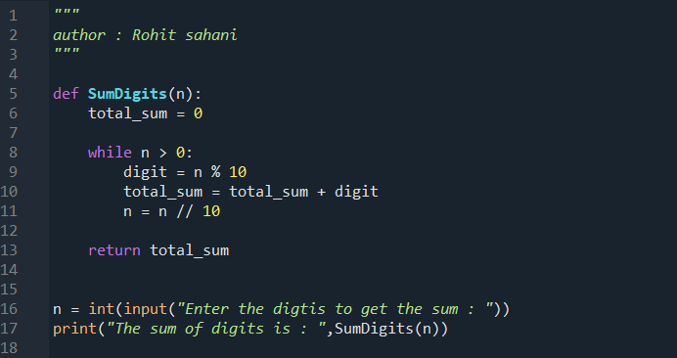
Output: -
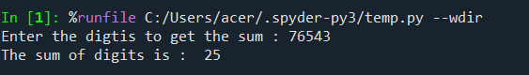

- Write a function squaredSum that returns the sum of the squares of an array/list of integers such that squaredSum([2,3,4]) gives 29. Write your solution in pure Python to show the logic in your solution, do not use any library functions.

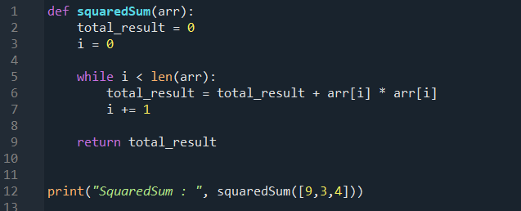
Output: -
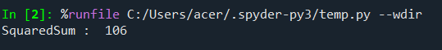

- Write a function called sumDigits that is given an integer num and returns the sum of the digits of num. E.g. sumDigits(6) gives 21.
Do not use any library functions (if there is one).
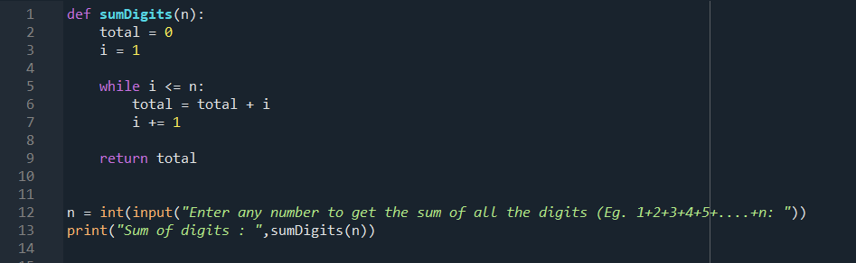

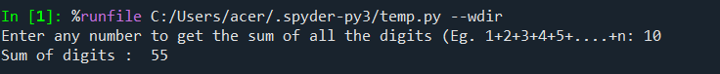
Output: -

