4MM013
Computational Mathematics
PYTHON_WORKSHOP-3

Name: - Rohit Sahani
Student Id: -NP02CS4A250027
Examples: -
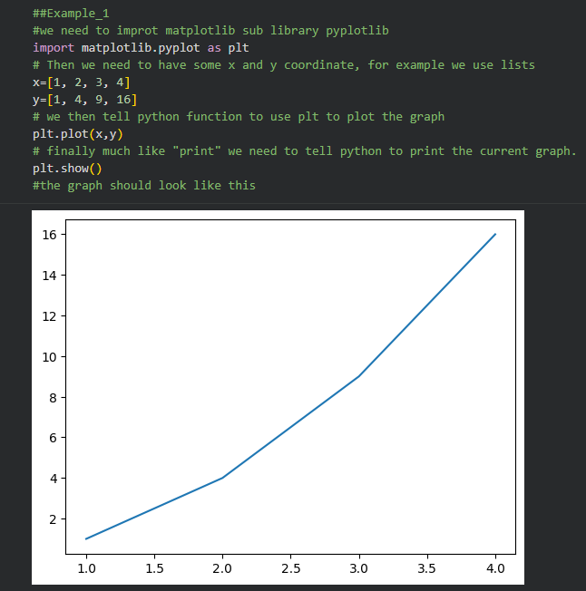
Example 2:
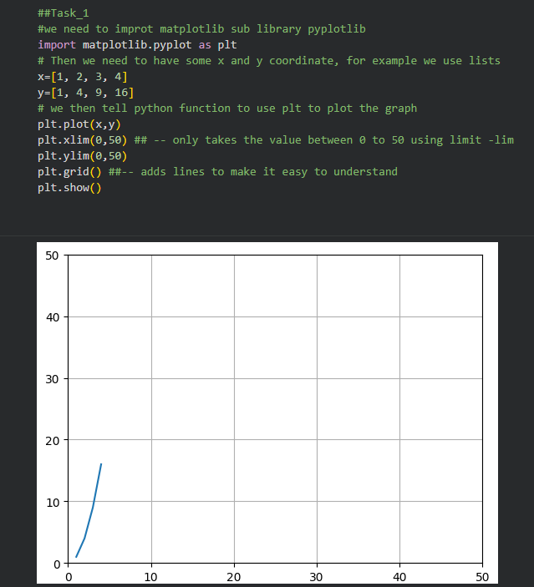
Task-1
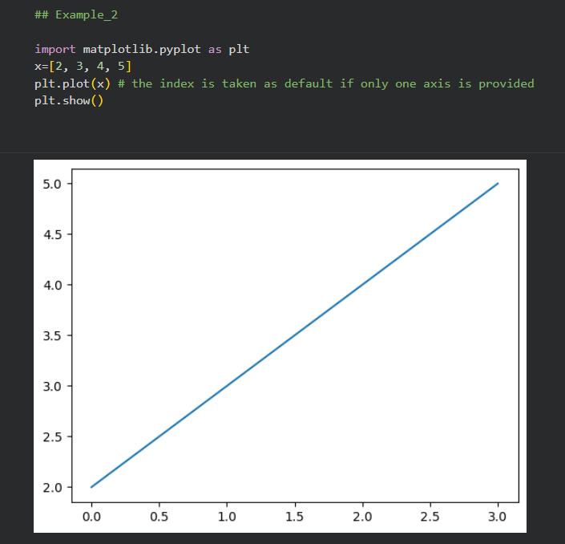
Example 2:
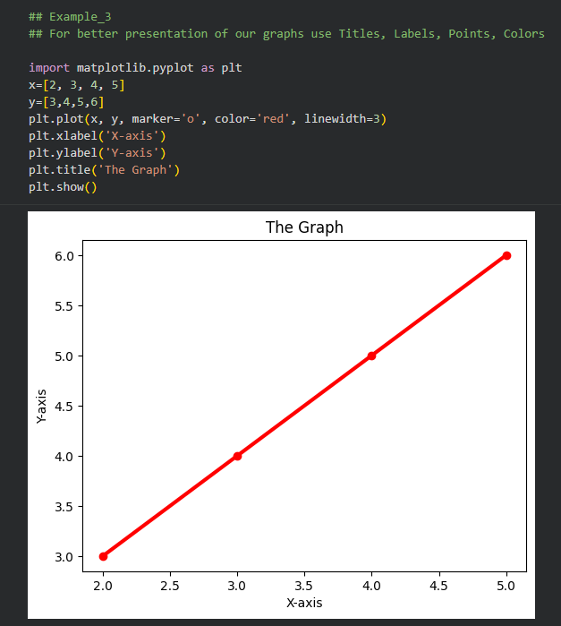
Example 3:
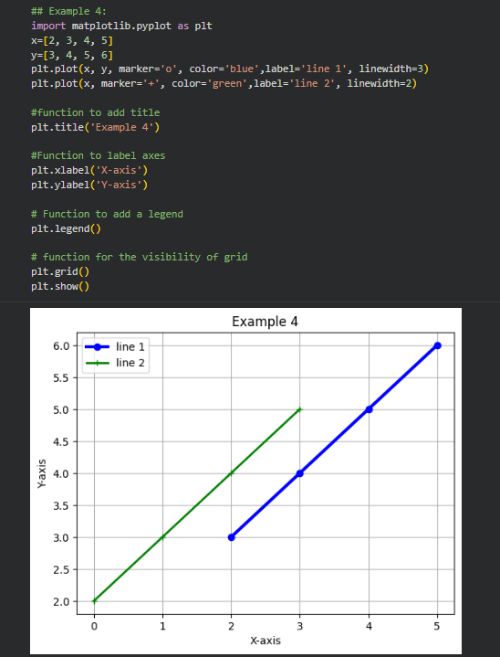
Example 4:
Task:2
The following table shows the different vehicles and the distance covered by them in the span of 5 days. Display the following table in line plot.
a. Plot “days” in X- axis and “distance covered” in Y- axis.
b. Title of the table “bike details in Plot”

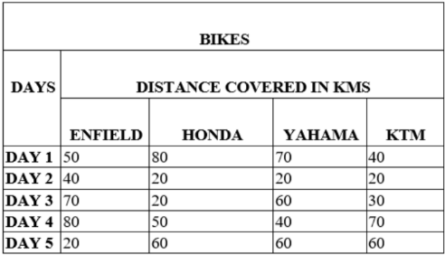

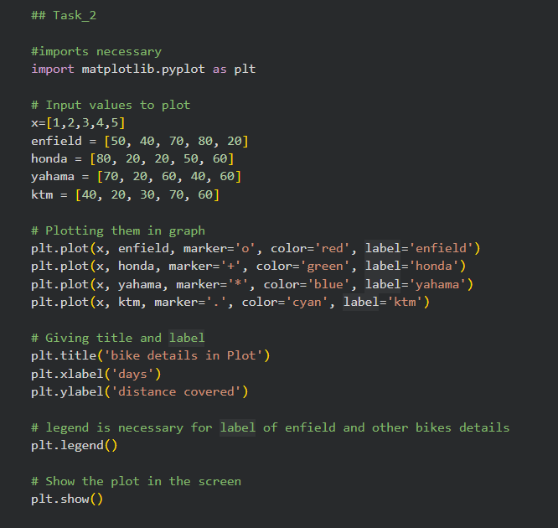

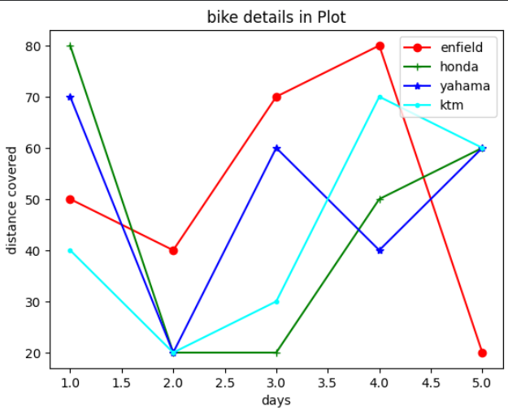

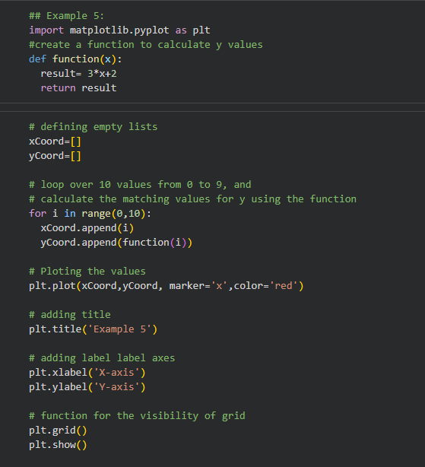
Example 5:

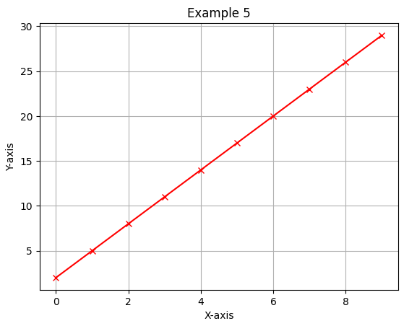

Exercise:
- Draw the line represented by the function y=x.
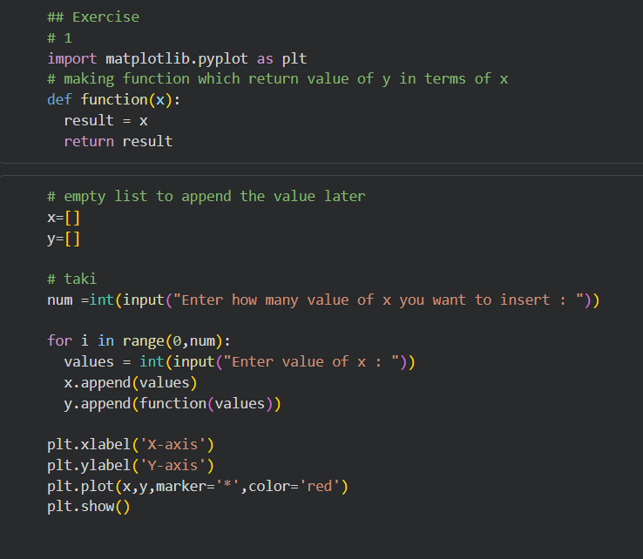

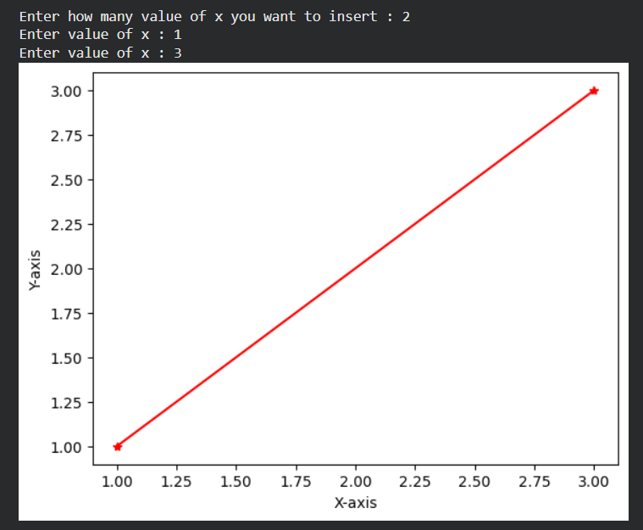

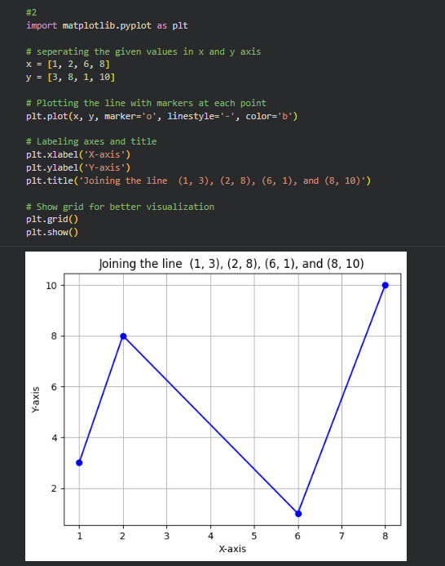
- Draw a line in a diagram that joins the position (1, 3), (2, 8), (6, 1) and (8, 10).

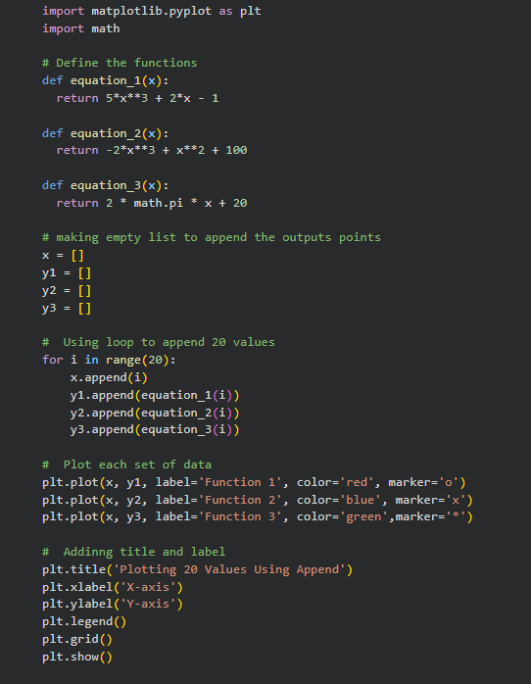
- Plot 20 values of x and y from the following functions.

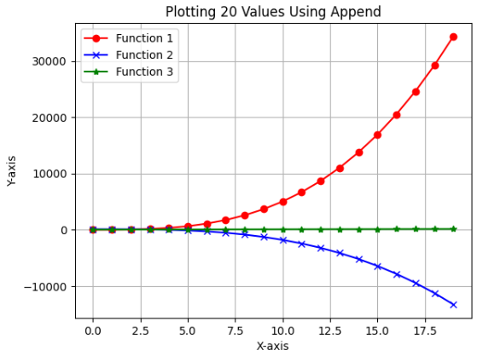

Example 6

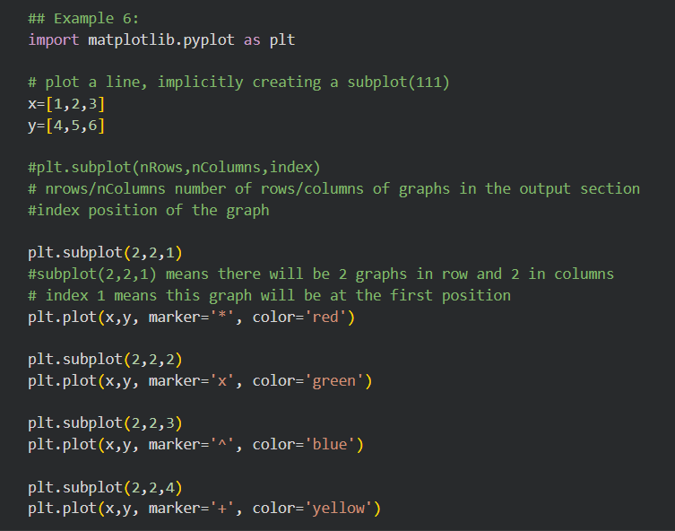

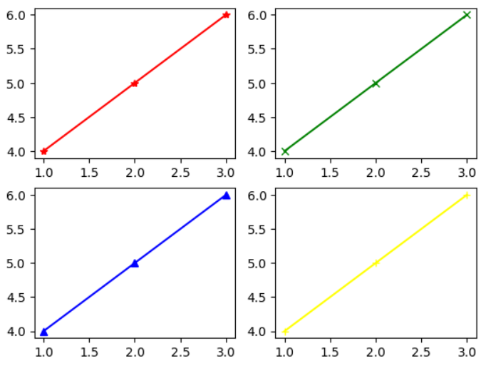

- Plot all the graph from Q no 3 on the same pane using subplot.
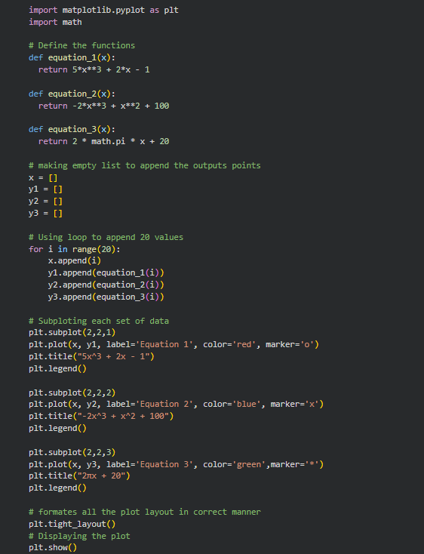

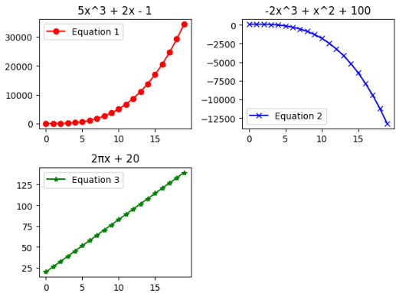

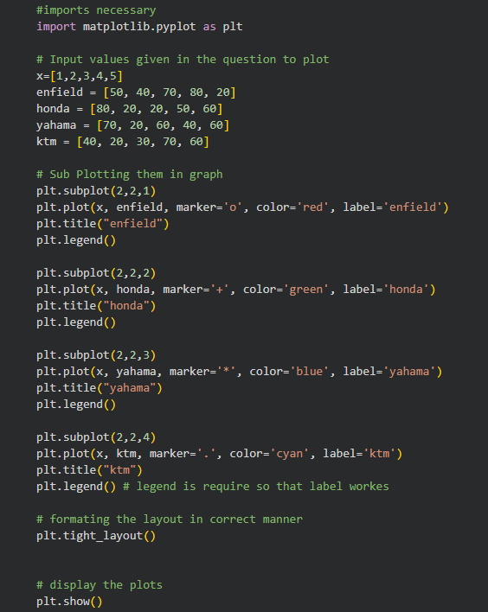
- Plot all the graph from Task 2 using subplot.

