4MM013
Computational Mathematics
PYTHON_WORKSHOP-4

Name: - Rohit Sahani
Student Id: -NP02CS4A250027

Example:
Example: -1
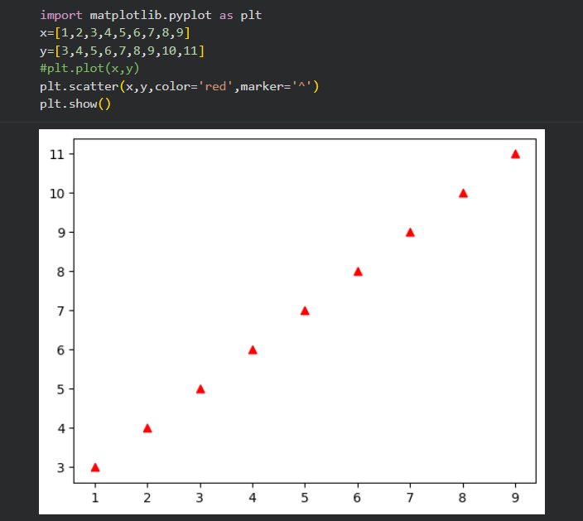

Example: -2
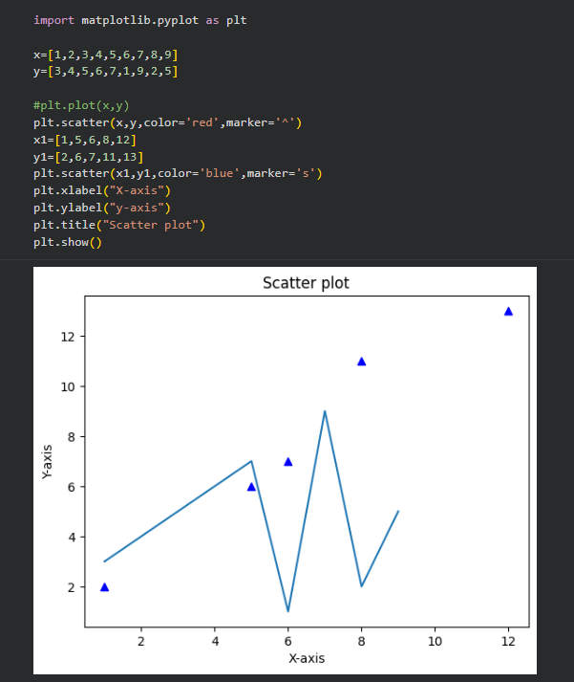

Example: -3
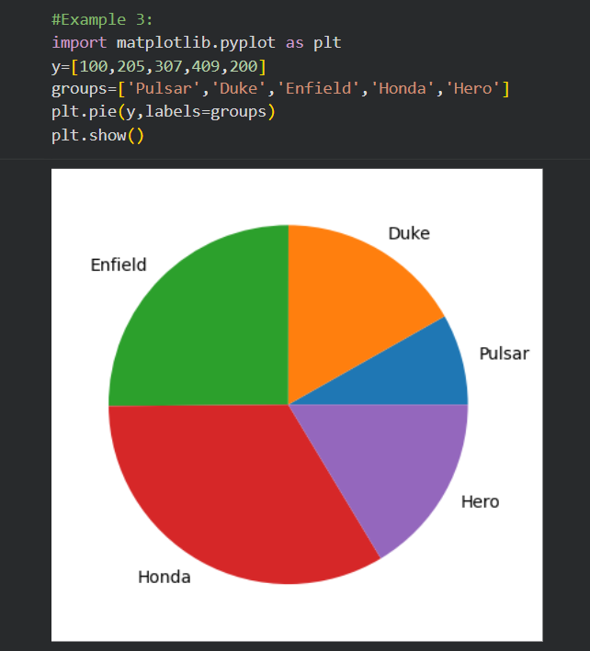
Example: -4

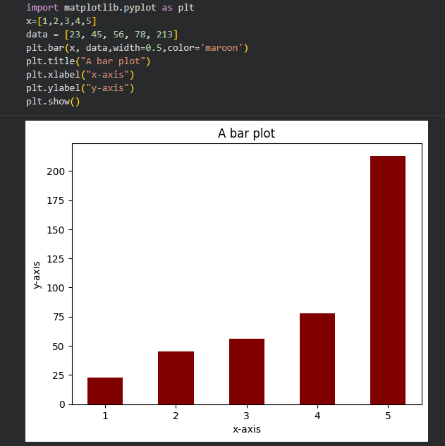

Tasks:
Task: -1
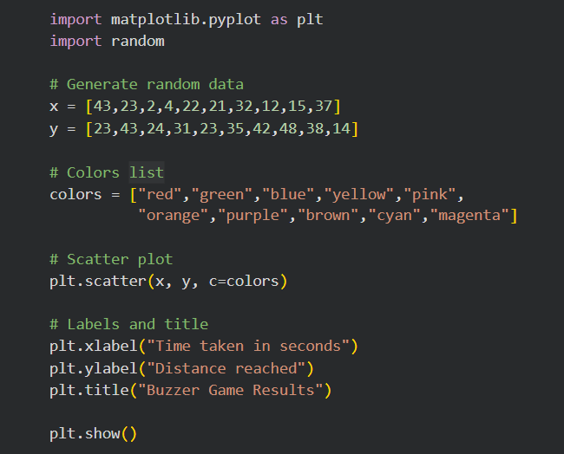
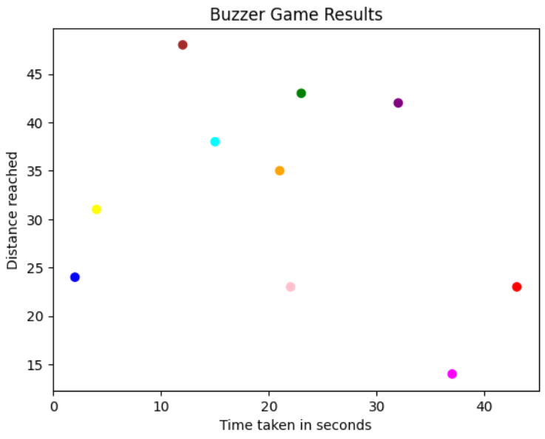

Task: -2
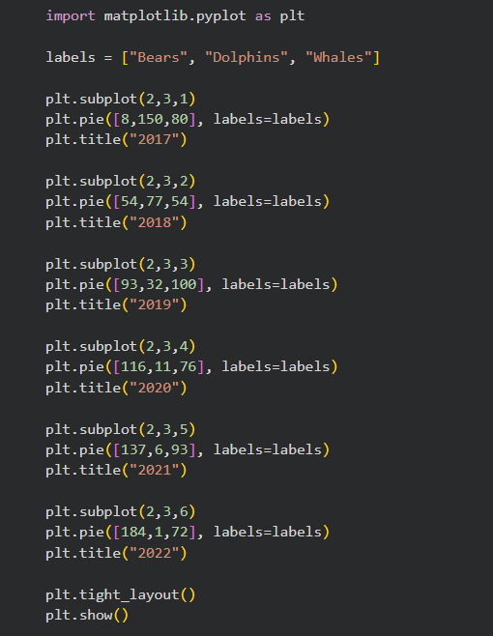

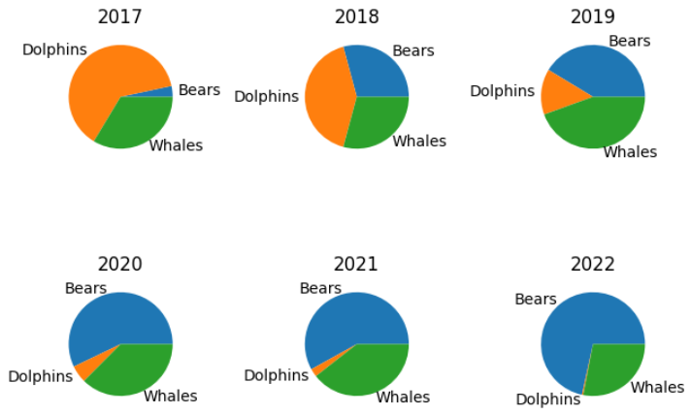

Task: -3

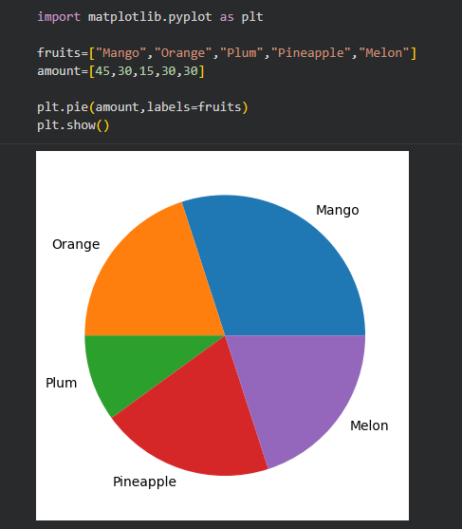

Task: -4
- Create a bar chart for the car data above.
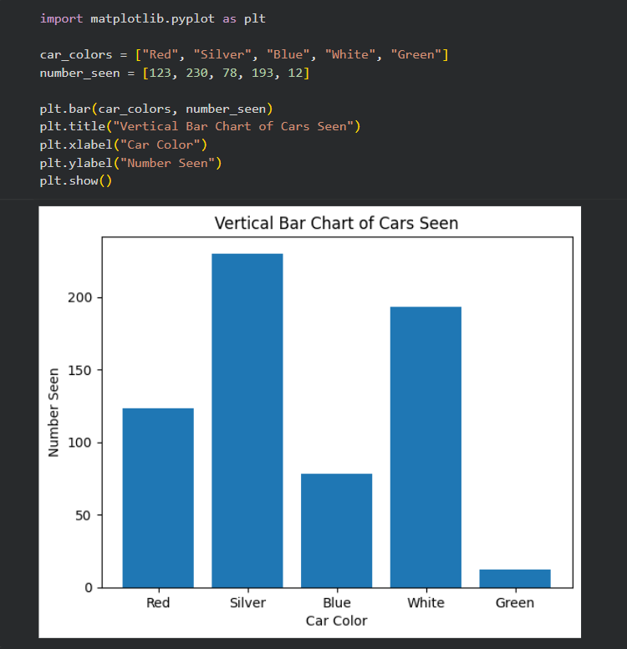

- Implement the code “ plt.bar(x, y, width = 0.3)” to plot the bar chart, what is the effect?
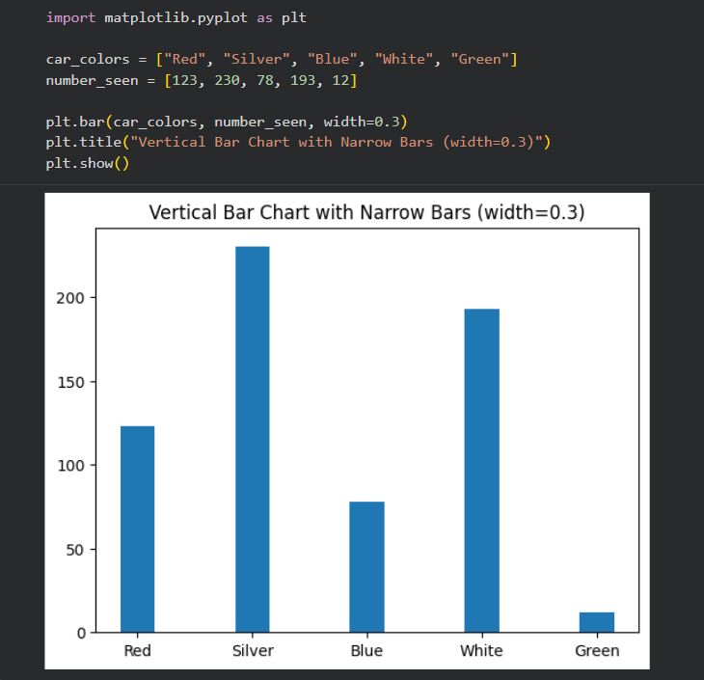

- Implement the code “ plt.barh(x, y)” to plot the bar chart, what is the effect?
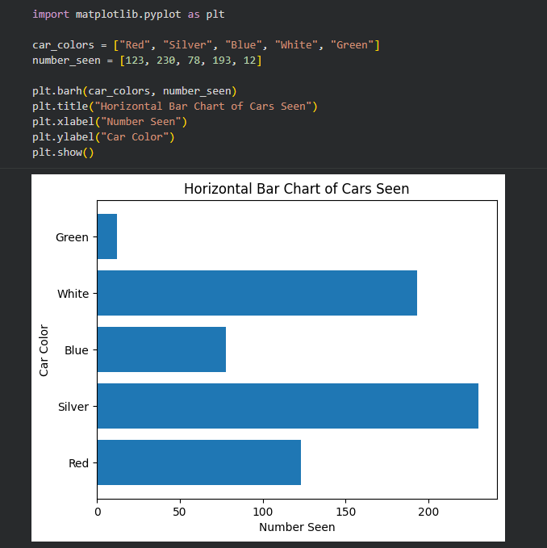

d) Create a list of colors and using the “ plt.bar(x, y, color = {you list here}) “set the bar chart colors to be the same as the car colors each bar represents.
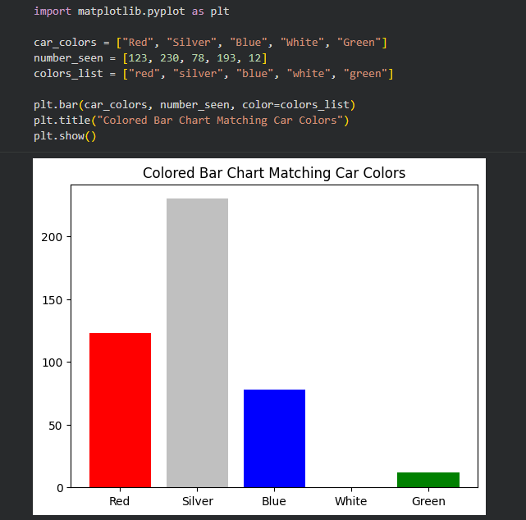

- Create a pie chart of the car data above and add a title.
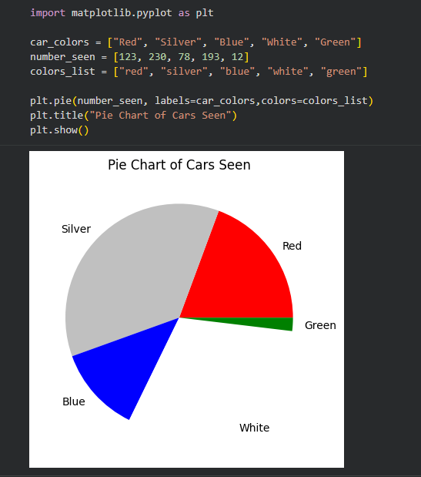

- Test out the following pie chart additional arguments / settings (“...” is for the normal code you have already)
