4CS021
Introduction to object-oriented programming
JAVA_WORKSHOP-7

Name: - Rohit Sahani
Student Id: -NP02CS4A250027

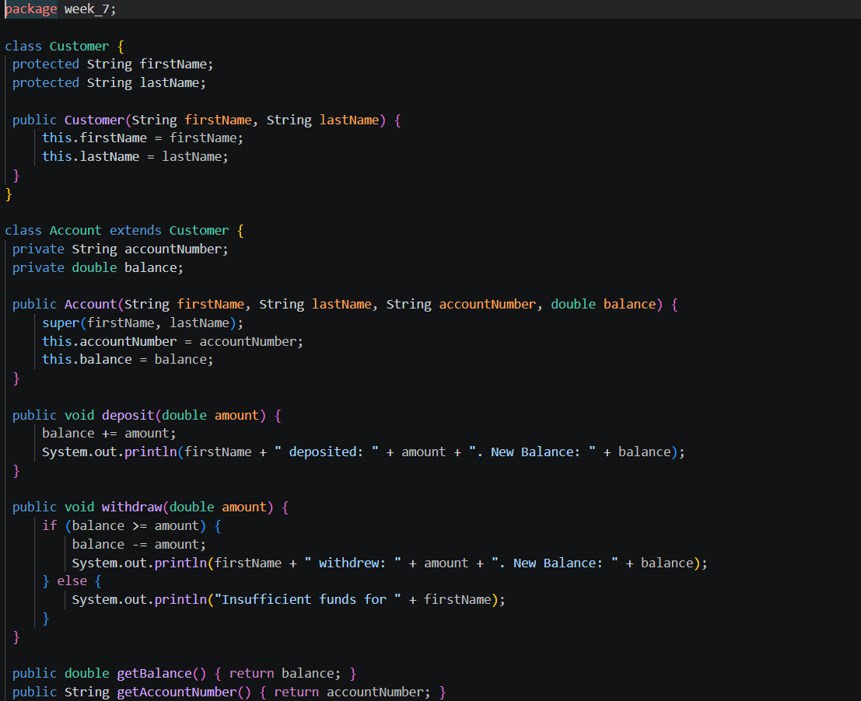
Test.java

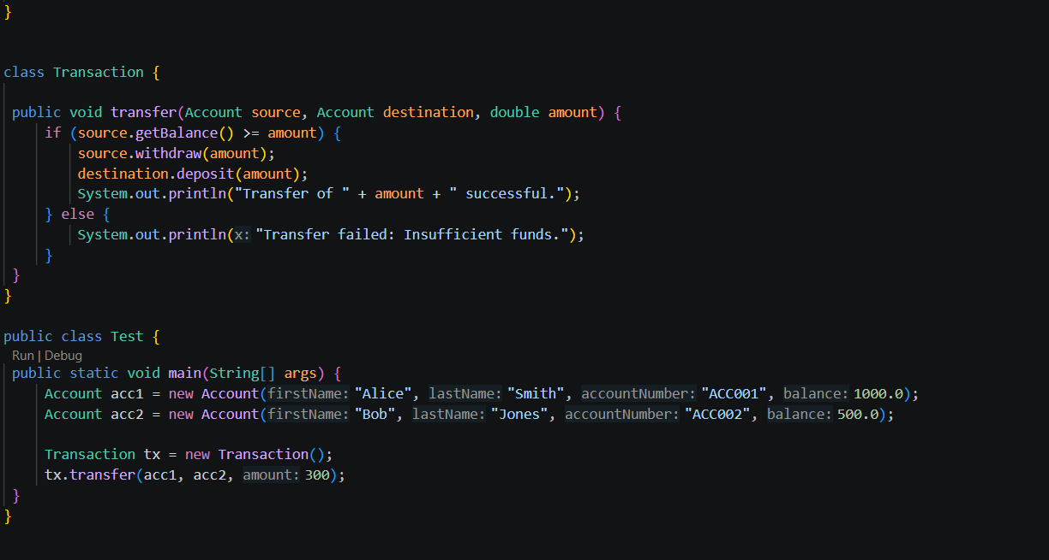

Class Diagram
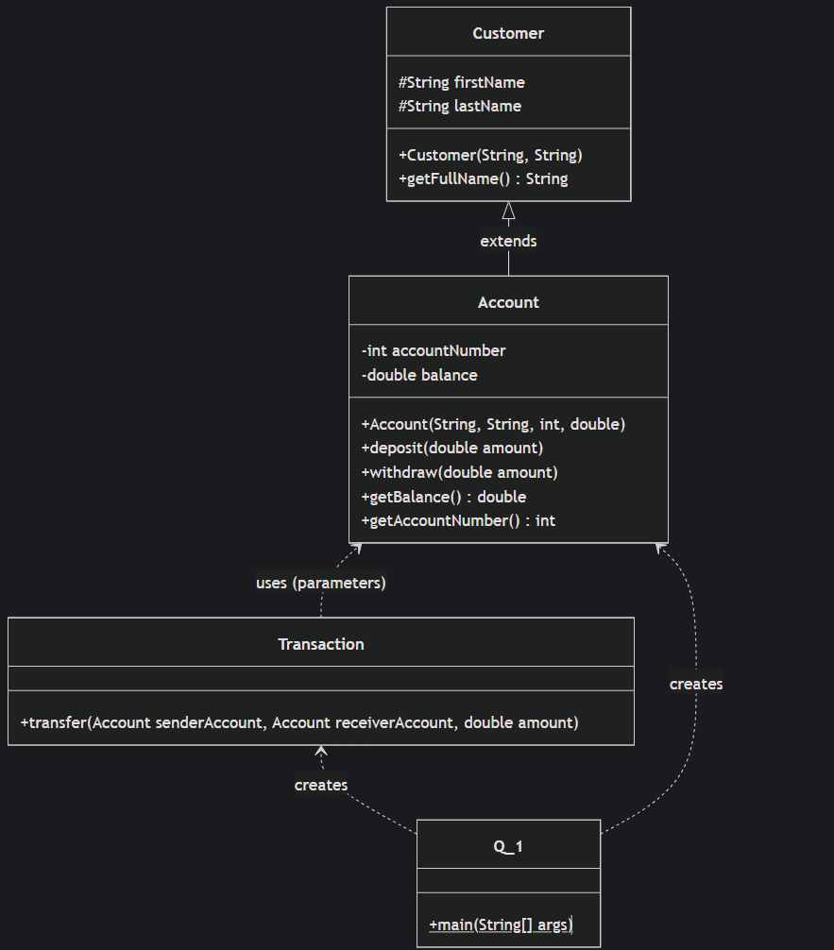

UseCase Diagram

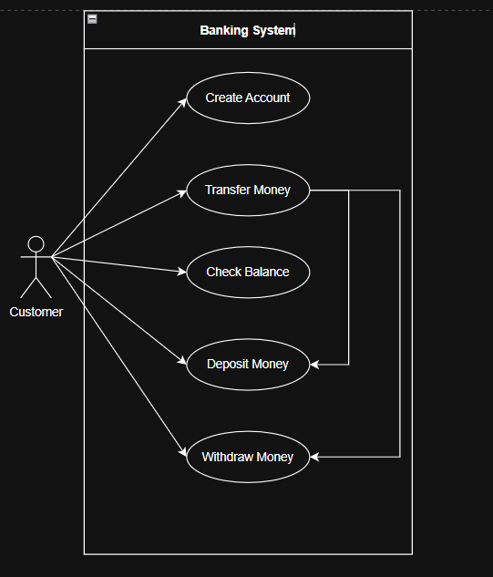
Sequence Diagram
