
COMPLAINT & CAPA
MANAGEMENT PORTAL
VISUAL STANDARD OPERATING PROCEDURE & TRAINING MANUAL
ONEPWS Private Limited · WMSPL · PWS Floors LLP
ISO 9001:2015 | AS9100 Rev D
Document No. | IMS-01-01-L4-05
Revision | 02
Effective Date | 30 April 2026
Classification | Confidential
Document Owner | QA & Process Department
Prepared By | Jatin Singh Chouhan, Sr. Manager QA & Process Dept
Approved By | Management, ONEPWS Group

Document Control

Revision History
Rev | Date | Prepared By | Approved By | Description of Change
00 | 01-01-2021 | Akhilesh Joshi | Management | First issue — baseline complaint management procedure
01 | 11-12-2023 | Akhilesh Joshi | Management | Added 8D concept and MS Access Complaint Management Portal steps
02 | 30-04-2026 | Jatin Singh Chouhan | Management | Updated the SOP as per Online Complaint Management Procedure and features.

Approvals
This document is issued under the Integrated Management System and shall not be modified without written approval of the Document Owner. The signatures below confirm that the Visual SOP accurately describes the use of the ONEPWS Complaint & CAPA Management Portal.

Prepared By  Jatin Singh Chouhan  (Sr. Manager QA & Process Dept)  Signature / Date | Reviewed By  Ritik Porwal  (Sr. Manager Quality Dept)  Signature / Date | Approved By  Management ONEPWS Group  Signature / Date

Distribution List
Copy | Holder | Format
01 | Master Admin — ONEPWS Group | Soft (DOCX)
02 | Quality Head — ONEPWS Private Limited | Soft (DOCX / PDF)
03 | Quality Head — WMSPL | Soft (DOCX / PDF)
04 | Quality Head — PWS Floors LLP | Soft (DOCX / PDF)
05 | All Department Heads | Soft (PDF — view only)
06 | HR — Training records | Soft (PDF)

Table of Contents
1. Introduction 5
1.1 Purpose 5
1.2 Scope 5
1.3 Definitions & Abbreviations 5
1.4 References 6
2. Getting Started 7
2.1 Logging In 7
2.2 Password Visibility & Recovery 8
3. Portal Navigation 9
3.1 Sidebar Menu 9
3.2 Top Bar 9
4. Dashboard 10
5. Registering a New Complaint 12
5.1 Opening the Form 12
5.2 Field-by-Field Guide 12
5.3 Multi-Image / Multi-Document Upload 14
6. Managing Complaints 15
6.1 Complaints List 15
6.2 Complaint Detail — Workflow Tab 16
7. External Complaints — 8D Report (D0 to D8) 18
7.1 D0 Emergency Response 18
7.2 D1 Cross-Functional Team 18
7.3 D2 Problem Description (5W1H) 19
7.4 D3 Interim Containment 19
7.5 D4 Root Cause Analysis 20
7.6 D5 Permanent Corrective Actions 20
7.7 D6 Verification & Horizontal Deployment 21
7.8 D7 Prevent Recurrence (Short & Long-Term) 21
7.9 D8 Closure & Team Recognition 22
7.10 Root Cause Category Taxonomy 22
7.11 Digital Signatures Workflow 23
8. Internal Complaints 25
9. CAPA Management 26
9.1 Adding a CAPA 26
9.2 Uploading Closure Evidence 27
9.3 Quality Review of Evidence 28
10. CAPA Dashboard & Tracker 29
10.1 CAPA Dashboard 29
10.2 CAPA Tracker 29
10.3 CAPA Master List 30
11. Notes / Minutes of Meeting 31
12. Attachments 32
13. TAT Dashboard 33
14. Reports 34
14.1 Report Catalog 34
14.2 Preview Before Download 34
14.3 Report Index 35
15. Master Admin 37
15.1 Companies 37
15.2 Users (and Password Reset) 38
15.3 Employees 39
15.4 Roles & Permissions 40
15.5 Departments 41
15.6 Categories, Priorities, TAT, Numbering 42
15.7 Delete Complaint 43
16. Audit Trail 44
17. Standard Operating Procedures (Step-by-Step) 45
17.1 SOP-01: Register an External Complaint 45
17.2 SOP-02: Complete an 8D Report 46
17.3 SOP-03: Close a Complaint 47
17.4 SOP-04: Quality Review of CAPA Evidence 48
17.5 SOP-05: Monthly Management Review 49
A. Appendix A — Keyboard & Mouse Shortcuts 50
B. Appendix B — Troubleshooting 51
C. Appendix C — Glossary 52

1. Introduction

1.1 Purpose
This Visual Standard Operating Procedure (SOP) and Training Manual describes how to use the ONEPWS Complaint & CAPA Management Portal end-to-end. It is intended for every person in the ONEPWS Group who will register, investigate, approve, verify or report on customer and internal complaints across ONEPWS Private Limited, Workspace Metal Solutions Private Limited (WMSPL) and PWS Floors LLP.
The portal is aligned with the requirements of ISO 9001:2015 (clauses 8.7, 9.1, 10.2) and AS9100 Rev D (clauses 8.7, 10.2) for the control of non-conforming outputs and the management of corrective action. This document is a controlled record under the Integrated Management System (IMS) and shall be used as the single source of truth for portal training.

1.2 Scope
This SOP covers:
- All functions, screens and buttons of the ONEPWS Complaint & CAPA Management Portal in its current release.
- The sequence of actions a user must perform to raise a complaint, carry out an 8D or 5-Why investigation, assign and verify CAPAs, record meeting minutes, review evidence, close a complaint and export reports.
- Role-based permissions and the digital signature workflow enforced inside the portal.
- Master Admin configuration tasks including user creation, password reset, role editing and department management.
It does NOT cover: the business logic behind the 8D methodology itself (refer to IMS procedures QP-10-02 and QP-10-03), nor the server infrastructure of the portal (refer to IT runbook).

1.3 Definitions & Abbreviations
Term | Meaning
8D | Eight Disciplines — the structured problem-solving methodology used for external customer complaints (D0 through D8).
AS9100 | Aerospace Quality Management Standard, Revision D, under which WMSPL is certified.
CAPA | Corrective Action and Preventive Action — the actions taken to remove a non-conformity and prevent its recurrence.
IMS | Integrated Management System covering quality, environment and occupational health & safety.
ISO 9001:2015 | International Standard for Quality Management Systems, 2015 edition.
LT / ST | Long-Term / Short-Term effectiveness verification windows (default 90 days / 60 days).
MOM | Minutes of Meeting.
RCA | Root Cause Analysis — the activity carried out in D4.
TAT | Turnaround Time — the time taken between two defined workflow milestones.
Repeat Complaint | A complaint auto-flagged by the portal as similar to another complaint received within the configured window (default 60 days).

1.4 References
- ISO 9001:2015 — Quality management systems — Requirements
- AS9100 Rev D — Quality Management Systems — Requirements for Aviation, Space and Defence Organisations
- IMS Document IMS-01-01-L4-05 — Complaint & CAPA procedure (parent document)
- QP-10-02 — Non-conforming output procedure
- QP-10-03 — Corrective action procedure
- Portal source file: complaint_portal.html (current revision)

2. Getting Started

2.1 Logging In
The portal is delivered as a single HTML file. To access it, open the file complaint_portal.html in any modern web browser (Google Chrome, Microsoft Edge, Firefox or Safari). No internet connection is required for the application itself.
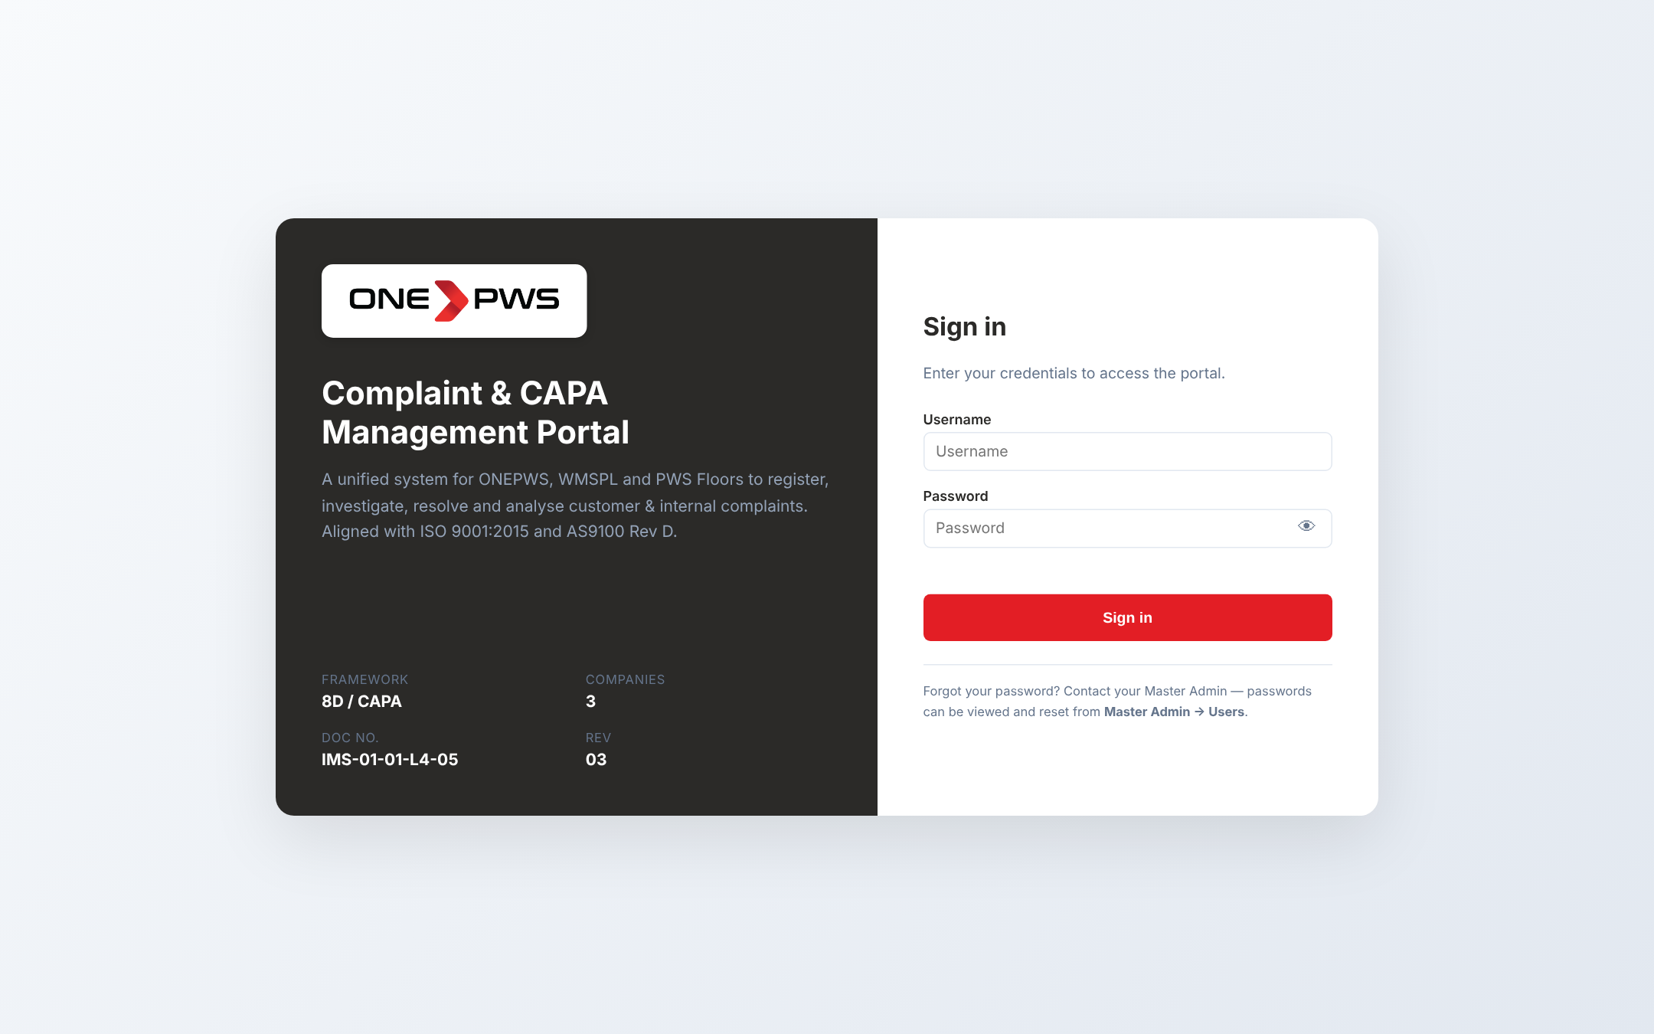
Figure 2.1 — Login screen
Step 1. Enter your assigned Username in the first field.
Step 2. Enter your Password in the second field. The password is case-sensitive.
Step 3. Click the Sign in button or press Enter.
Note
For security reasons the login screen no longer displays sample credentials. If you do not have an account, contact your Master Admin. If you have forgotten your password, the Master Admin can view and reset it from Master Admin → Users (see section 15.2).

2.2 Password Visibility
To verify what you have typed before signing in, click the eye icon (👁) at the right of the password field. The password will be shown as plain text and the icon changes to 🙈. Click again to hide.
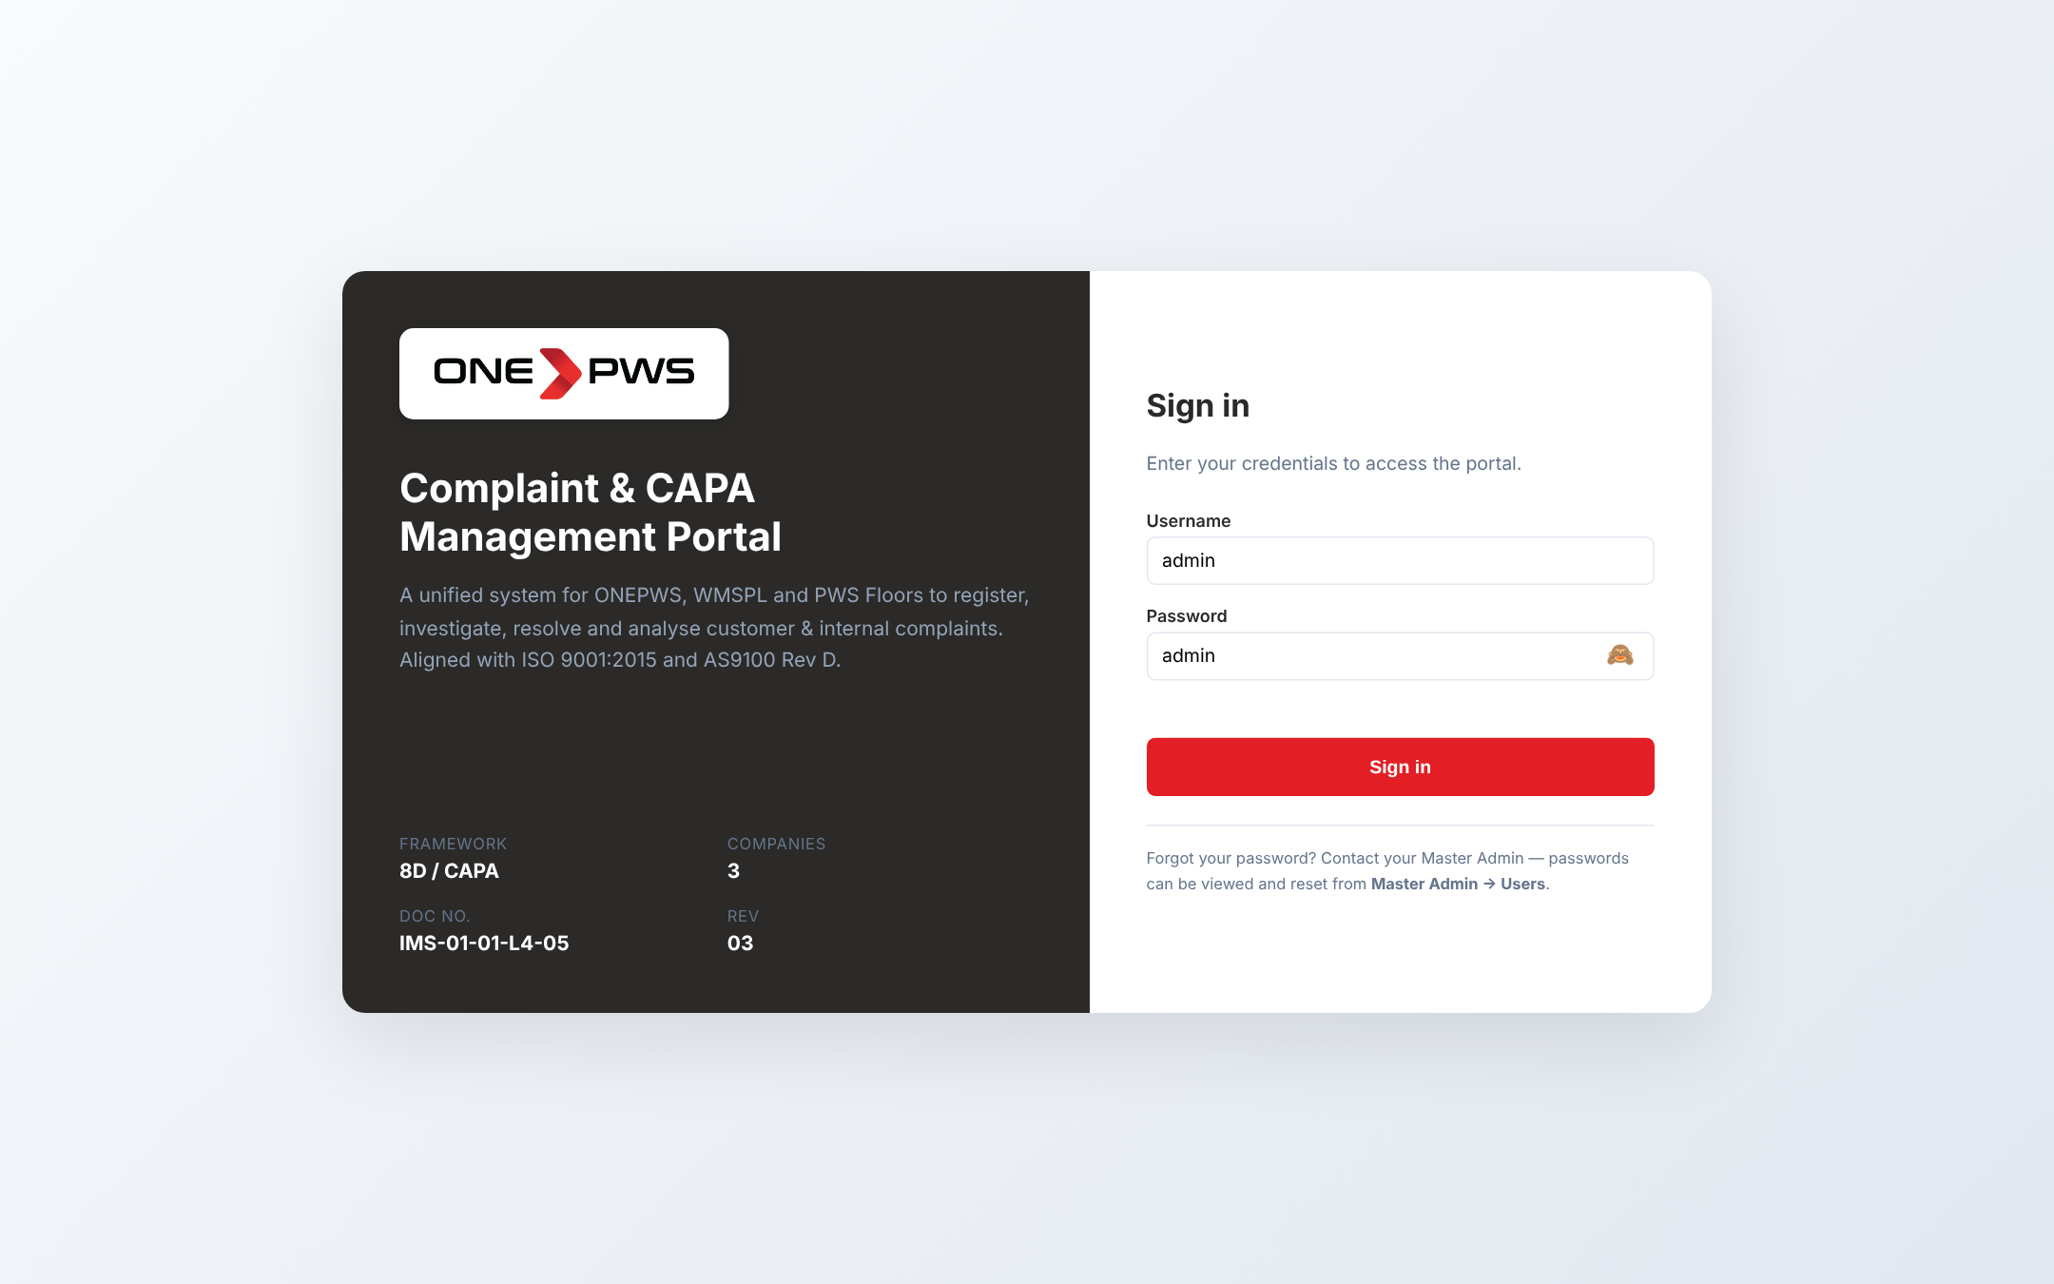
Figure 2.2 — Password made visible using the eye icon
Important
Never leave your password visible when another person can see your screen. Click the icon once more to hide it before pressing Sign in.

3. Portal Navigation

3.1 Sidebar Menu
After signing in you will see a dark sidebar on the left listing every section of the portal, and a white content area to the right. The sidebar is always visible and the active section is highlighted in red.
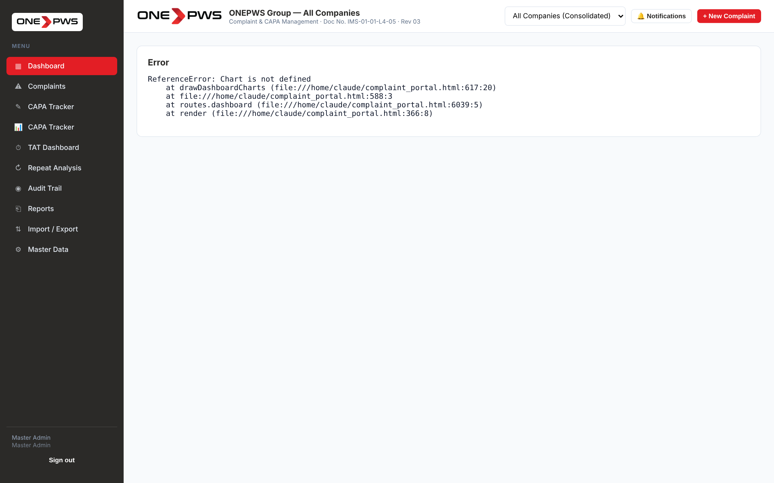
Figure 3.1 — Left sidebar navigation

Sidebar items and their purpose
Menu Item | Purpose
Dashboard | KPI overview, charts, root-cause breakdown, recent complaints
Complaints | Full list with filters; opens any complaint in detail view
CAPA Dashboard | Person-wise CAPA performance and monthly closure trends
CAPA Tracker | Filterable, exportable flat list of all CAPAs — for review meetings
TAT Dashboard | Turnaround-time compliance with delay drill-down and Pareto
Repeat Analysis | All complaints flagged as REPEAT within the configured window
Audit Trail | Chronological log of every create / edit / delete action
Reports | 15 standard reports with preview and Excel download
Import / Export | Backup / restore the full database; bulk import complaints from Excel
Master Data | Companies, Users, Roles, Departments, Categories, TAT and more

3.2 Top Bar
Across the top of every page you will see three controls on the right:
- Company Switcher — pick one company to filter all views to its data, or "All Companies (Consolidated)" to see the whole group.
- Notifications 🔔 — shows unread in-app notifications. The badge counts items that require your attention.
- + New Complaint — shortcut to register a complaint from anywhere in the portal.

4. Dashboard
The Dashboard is the first screen you see after signing in. It gives a one-glance view of all complaint activity, respecting the company filter chosen in the top bar.
Figure 4.1 — Dashboard — KPI cards, charts and recent complaints

4.1 KPI Cards
The row of coloured cards at the top shows the headline numbers: total complaints, open complaints, overdue complaints, closed complaints, CAPA closure percentage and the repeat rate. Each number is for the current company filter and is live — it refreshes as you work.

4.2 Charts
Below the KPIs you will see distribution charts:
- Status Distribution — doughnut split of complaints by their current status.
- Priority Mix — bar chart of Critical / High / Medium / Low volumes.
- Monthly Trend — line showing complaint intake month-by-month.
- Category Pareto — top categories ranked by count.

4.3 Root Cause Category Breakdown
At the bottom of the dashboard, a dedicated card shows how complaints are distributed across the 6M + 2 root cause taxonomy (Man, Machine, Method, Material, Measurement, Environment, Management, Supplier, Design/Specification, Other). This fulfils the requirement to visualise where defects systematically originate.
How to use it
If one category is clearly dominant (for example 40% "Man / Human error"), raise a systemic improvement project — training, SOP revision or jig-poka-yoke. The portal does not do this automatically; it only surfaces the pattern.

4.4 Recent Complaints Table
The bottom table lists the ten most recent complaints. Click any row to open its full detail.

5. Registering a New Complaint

5.1 Opening the Form
Click + New Complaint in the top right corner of any screen. A modal dialog opens with every field you need to register the complaint.
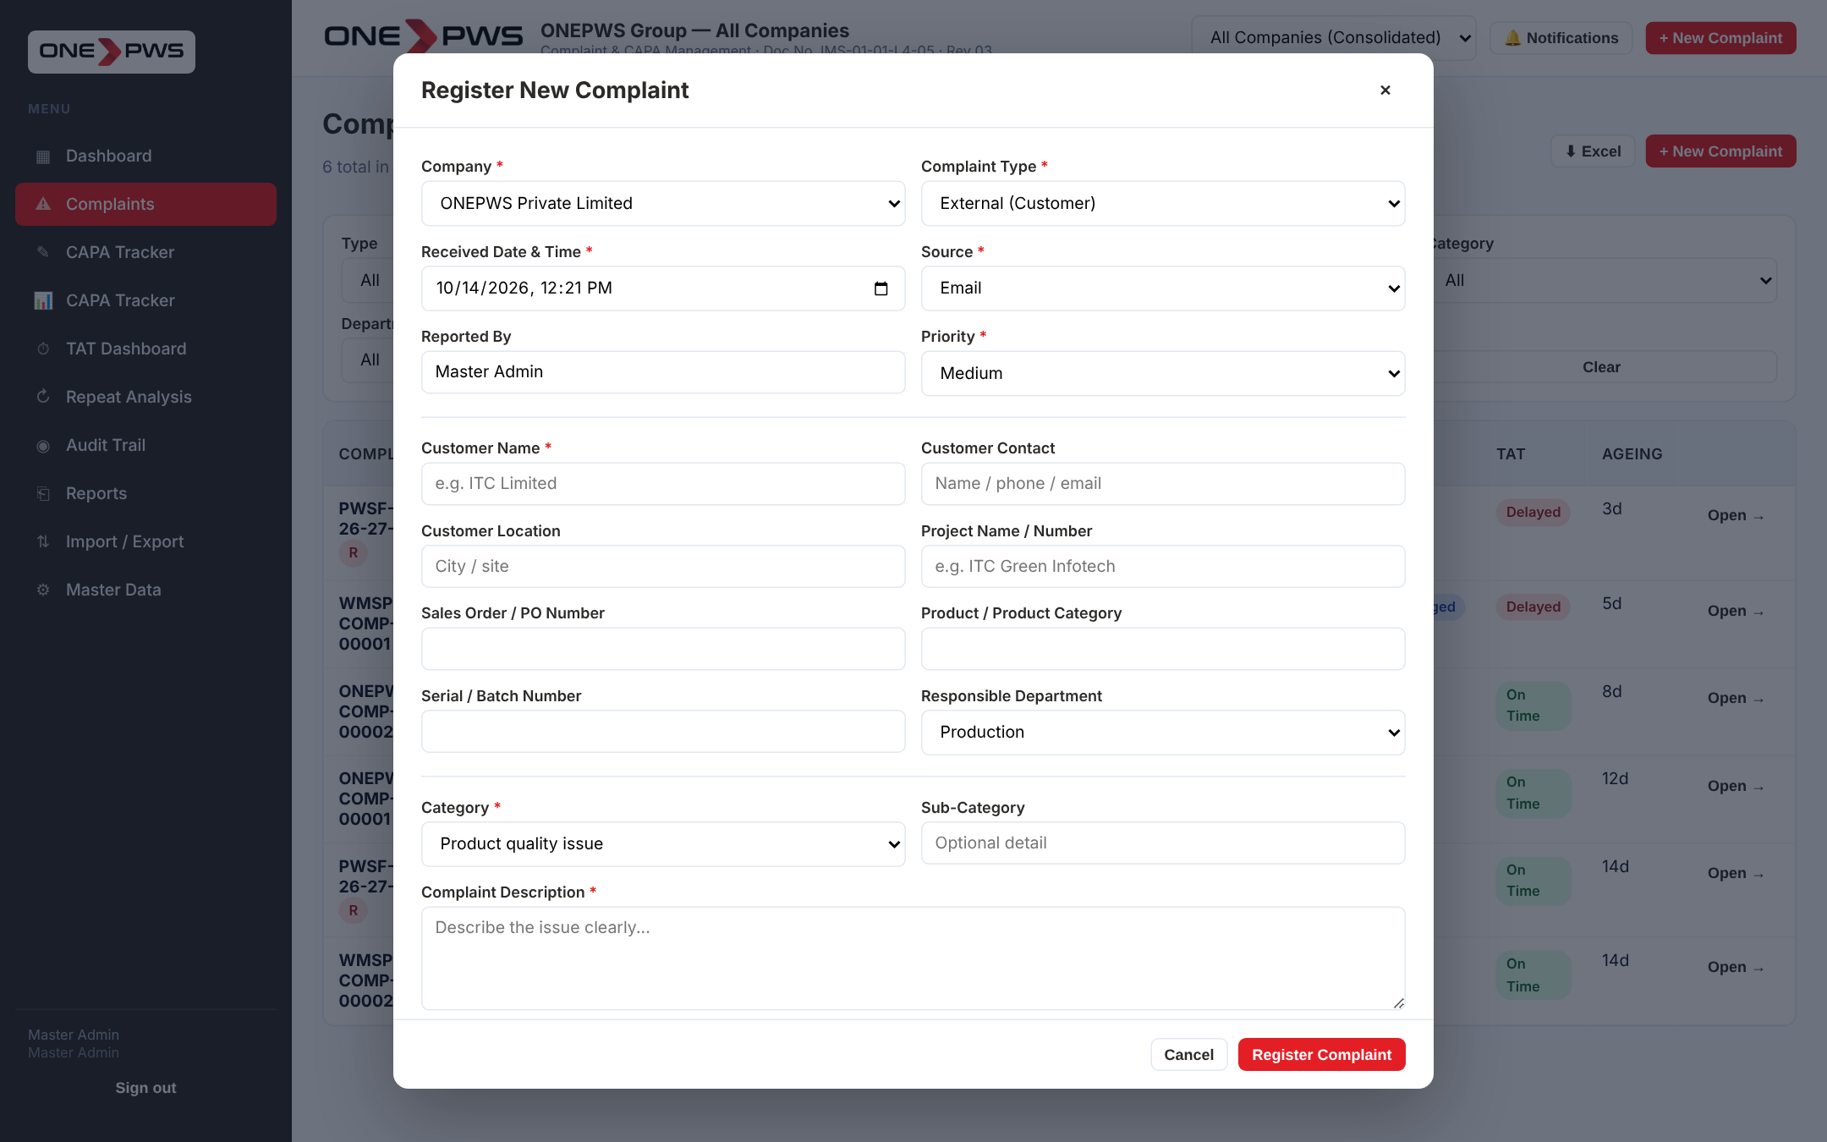
Figure 5.1 — New Complaint modal

5.2 Field-by-Field Guide
Fields marked with a red asterisk (*) are mandatory. The form will not submit until they are filled.
Field | What to Enter
Type * | External (customer complaint) or Internal (inter-department).
Company * | Which of the three group companies this complaint belongs to.
Received At * | Date and time the complaint was received. Defaults to now.
Priority * | Critical / High / Medium / Low based on business impact.
Customer Name * | External only. The customer organisation (e.g. ITC Limited).
Customer Contact | Name, phone or email of the contact person at customer end.
Customer Location | City or site where the issue is seen.
Project / PO | Reference to the project or purchase order.
Product | The product reported defective (e.g. "Console CR-Series").
Batch / Serial | If known, helps traceability.
Responsible Dept. | External: dept that must action. Internal: against whom.
Complaining Dept. | Internal only — department raising the complaint.
Category * | Pick from the master list; add new ones via Master Data.
Sub-Category | Optional detail.
Description * | A clear factual description. Avoid blame; state what, where, when.
Complaint Owner | Person who will drive this complaint through workflow.
Attachments | Photos, PDFs, Word, Excel — see section 5.3.

5.3 Multi-Image / Multi-Document Upload
Click 📤 Select Files in the Attachments section. You may pick multiple files at once. Each image is displayed as a live thumbnail; each non-image file (PDF, Word, Excel) is shown as an icon with its size.
Figure 5.2 — Multi-file upload with live preview
If you selected a file in error, click the red ✕ in its top-right corner to remove it BEFORE submitting. Removed files are not uploaded. The portal will warn you about any file larger than 10 MB.
What to attach
For external complaints: at least one photo of the defect, the customer email (as a PDF) and the delivery challan / invoice. For internal complaints: evidence of the non-conformity (QC report, inspection sheet, photograph).
When all fields are filled, click Register Complaint. The portal will generate the complaint number automatically (format: PREFIX-FY-00001) and open the complaint detail page.

6. Managing Complaints

6.1 Complaints List
Click Complaints in the sidebar. You will see the complete list with filters at the top. Use the filters to narrow by company, type, category, status, priority, owner or free-text search.
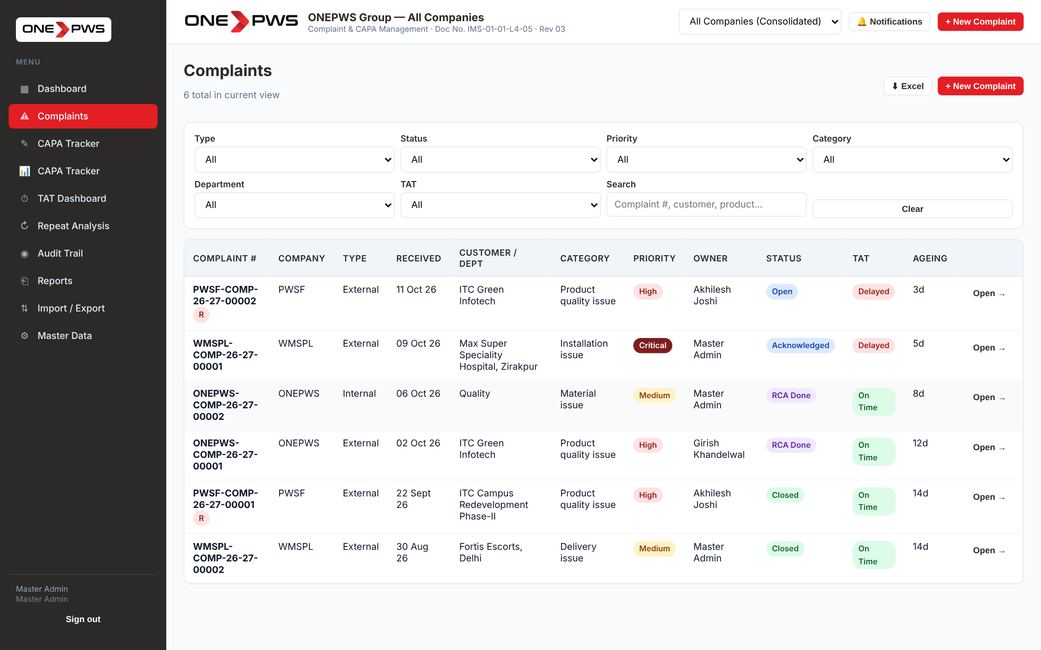
Figure 6.1 — Complaints list with filters
Click any row to open the full detail of that complaint.

6.2 Complaint Detail — Workflow Tab
Every complaint has a header with its number, company, type and category, plus action buttons on the right (8D PDF download, Audit view, Close Complaint, and Delete — Delete is visible only to Master Admin). Below the header are tabs: Workflow, 8D Report (or Internal Investigation), CAPA, Effectiveness, Attachments and Notes / MOM.
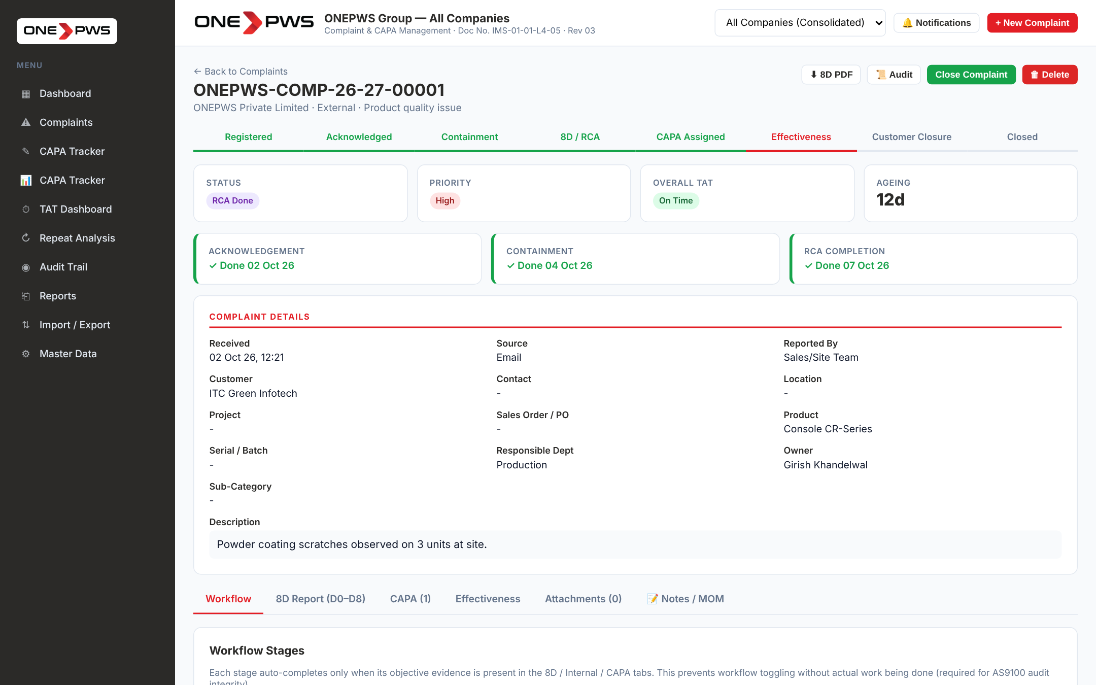
Figure 6.2 — Complaint detail — Workflow tab

Reading the workflow stages
The horizontal strip near the top shows the eight workflow stages: Registered → Acknowledged → Containment → 8D / RCA → CAPA Assigned → Effectiveness → Customer Closure → Closed. Completed stages are green; the current stage is red; future stages are grey.

TAT cards
Each major milestone (Acknowledgement, Containment, RCA Completion, CAPA Assignment) has a TAT card showing whether the stage was completed on time, is still within the window, or is overdue. Overdue cards turn red.
How TAT is calculated
Default windows (configurable in Master Data → TAT): Acknowledgement = 1 day; Containment = 3 days; RCA = 15 days; CAPA = 30 days. On a late action the portal will prompt for a Delay Reason, chosen from the configured master list.

7. External Complaints — 8D Report (D0 to D8)
For external complaints the portal enforces the full Eight-Disciplines methodology. Open the complaint and click the 8D Report (D0–D8) tab.
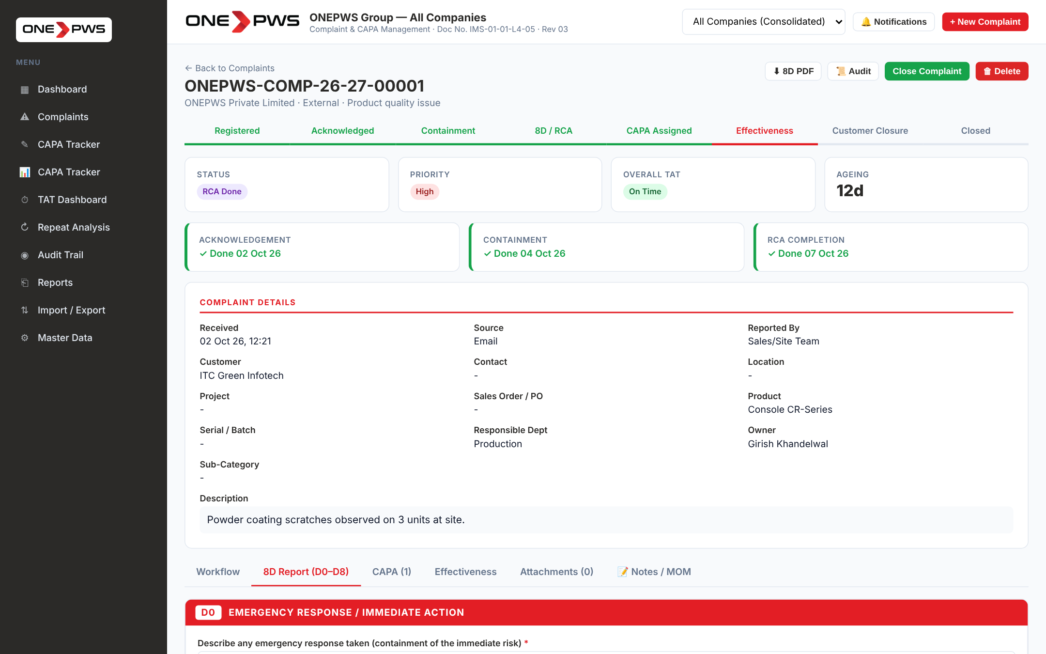
Figure 7.1 — 8D Report tab — top of the page

7.1 D0 — Emergency Response
Describe any immediate action taken to protect the customer, such as "Shipment held", "Material quarantined", "Replacement despatched". This is a free-text field saved on blur.

7.2 D1 — Cross-Functional Team
Add the people who will investigate. Click + Add Member. The dropdown is populated from the Employee Master — picking a name auto-fills department, designation and email. Add the role (e.g. "Team Leader", "Process Owner").

7.3 D2 — Problem Description (5W1H)
Fill the seven boxes: What, Where, When, Who detected, Who involved, How many, How. Be factual and specific. "Powder coating peeling off three units at ITC site, Noida, observed on 02-Oct-26 by site engineer" is better than "paint issue".

7.4 D3 — Interim Containment
Add containment actions in the table — Stage (incoming / WIP / finished / dispatched / at customer), Quantity contained, Action taken, Responsibility and Target date. Status defaults to Open; change to Closed when done.

7.5 D4 — Root Cause Analysis
D4 is the heart of the 8D. The portal provides three parallel 5-Why chains and a 6M fishbone:
- Occurrence 5-Why — why did it happen?
- Escape 5-Why — why did our quality system not catch it?
- Systemic 5-Why — why does our process allow this at all?
- Fishbone (6M) — cause categorisation across Man / Machine / Method / Material / Measurement / Environment.
At the bottom write the final Occurrence, Escape and Systemic root causes in the three text boxes.

7.6 D5 — Permanent Corrective Actions
For EACH of the three root causes (Occurrence, Escape, Systemic), add one or more actions in the respective block. Each row captures: action text, customer approval (Yes/No/Pending), responsibility, target date and status. Also record any Safety Concerns raised by these changes in the dedicated box.

7.7 D6 — Verification & Horizontal Deployment
Add verification activities in the top table. Below is the mandatory 8-document checklist — for each document type (Drawing, Process Spec, FMEA, Control Plan, Work Instruction, Config Matrix, Lessons Learnt, Training) mark the status as Attached (with revision number and date) or NA (with written justification). The portal blocks closure until every document is either attached or NA-justified.

7.8 D7 — Prevent Recurrence (Short & Long-Term)
The portal enforces two verification horizons:
- Short-term (ST, 60 days by default) — verification date, repeat observed yes/no.
- Long-term (LT, 90 days by default) — verification date, repeat observed yes/no, result (Effective / Not Effective), notes.
If the LT verification records "Not Effective", the complaint is automatically re-opened and must be re-worked.

7.9 D8 — Closure & Team Recognition
Add the team recognition / lessons-learnt remark, the reviewer name and the closure date. Together with the signatures (section 7.11) and the stage gates above, these drive the final closure.

7.10 Root Cause Category Taxonomy
At the bottom of the 8D tab, the Root Cause Category block requires you to classify the primary root cause into one of ten standard buckets:
- Man (Human error / Training)
- Machine (Equipment / Tooling)
- Method (Process / Procedure)
- Material (Raw material / Component)
- Measurement (Inspection / Gauging)
- Environment (Facility / Conditions)
- Management (Systemic / Resources)
- Supplier (Vendor / Subcontractor)
- Design / Specification
- Other
This drives the Root Cause Category Analysis report and the dashboard breakdown.

7.11 Digital Signatures Workflow
At the bottom of the 8D tab (and the Internal tab for internal complaints) the Digital Signatures panel enforces a three-stage sign-off before closure.
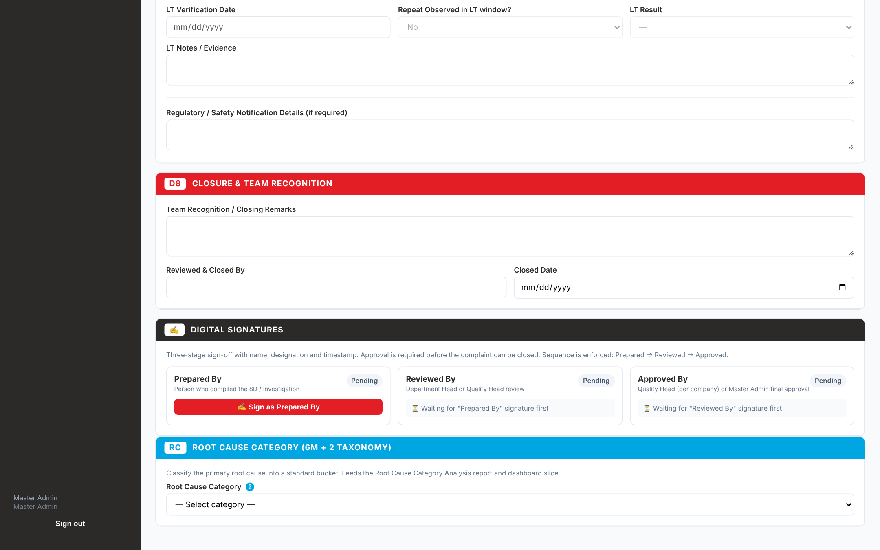
Figure 7.2 — Digital Signatures panel

Permission matrix
Signature | Who Can Sign
Prepared By | Complaint Coordinator, Owner, Dept. Head, CAPA Owner, Quality Head, Management or Master Admin.
Reviewed By | Department Head, Quality Head, Management or Master Admin.
Approved By | Quality Head of that company, or Master Admin only.

Rules enforced
- Sequence is enforced: Prepared → Reviewed → Approved. You cannot sign a later stage until the earlier is signed.
- If you try to sign the same report twice (e.g. as Preparer AND Reviewer), the portal warns you — this weakens the independence check.
- Approval is a HARD closure gate. The complaint cannot be closed until all three signatures are in place.
- Only Master Admin can revoke a signature. Revoking the Prepared signature also removes Reviewed and Approved. A written reason is mandatory and is recorded in the audit trail.
- Each signature captures name, designation (from Employee Master), department, timestamp and optional notes.
How to sign
Click "✍ Sign as Prepared By" (etc.). Enter any signing notes when prompted. The card turns green and shows your name, designation and timestamp.

8. Internal Complaints
For internal complaints (one department against another), the portal uses a simplified investigation rather than the full 8D. Open the complaint and click Internal Investigation.
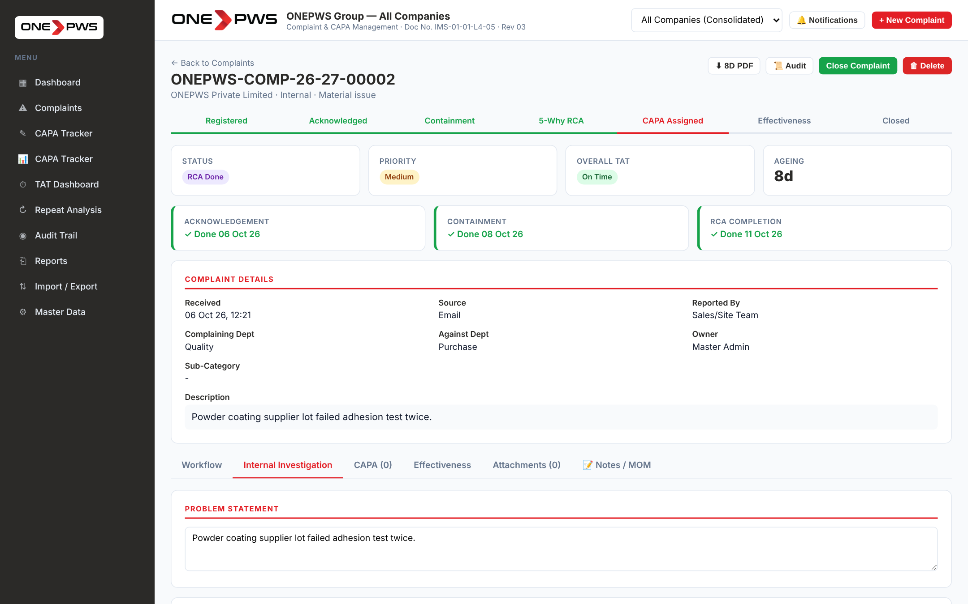
Figure 8.1 — Internal Investigation tab
The investigation requires:
- A single 5-Why chain (one line of reasoning, not three).
- A clear Root Cause text at the bottom.
- The same Root Cause Category classification as external complaints.
- The same three-stage digital signature workflow.
CAPAs, Notes, Attachments and Effectiveness verification work identically to external complaints.
Why the simpler form?
Internal complaints are process-improvement tickets. The full 8D paper trail is only needed when a customer or regulator may audit the response. The 5-Why + CAPA cycle is sufficient for internal non-conformities and keeps the admin burden low.

9. CAPA Management
Every complaint needs at least one CAPA. Open the complaint, click the CAPA tab.
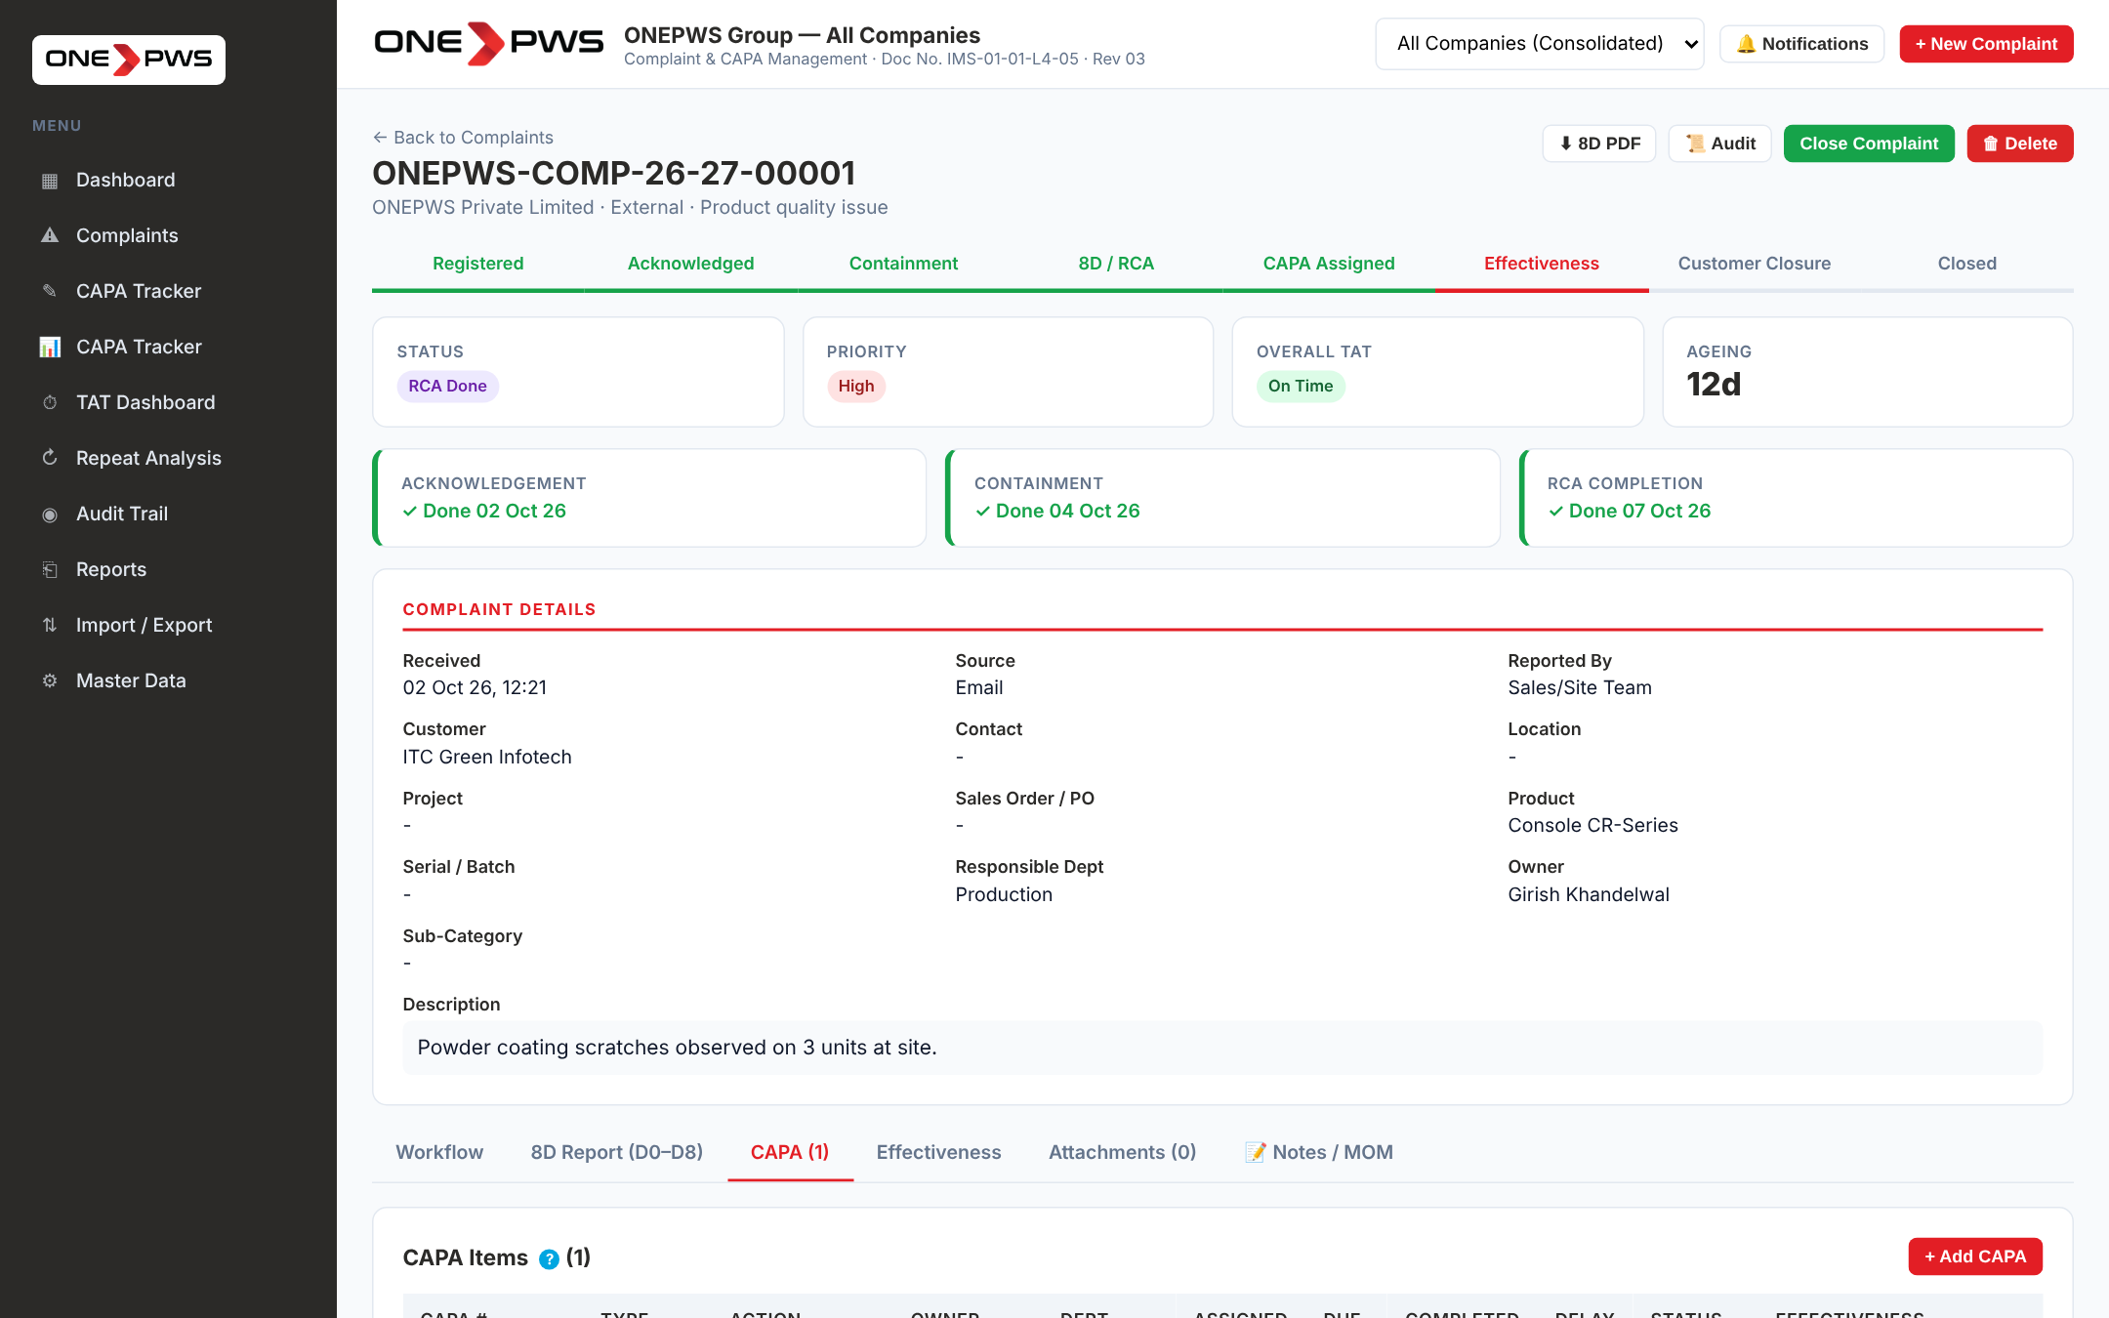
Figure 9.1 — CAPA tab on a complaint

9.1 Adding a CAPA
Click + Add CAPA. Fill in:
Field | What to Enter
Action Type | Corrective (removes cause), Preventive (stops recurrence), Systemic (fixes system), Containment (limits impact).
Priority | Defaults to the complaint priority — change if different.
Action Description | Specific, measurable, owned (SMART). "Train line operators on new SOP" is better than "improve training".
Owner | The person accountable. Email notification is sent on save.
Department | Owning department.
Due Date | Realistic target completion date.
Status | Starts Open; moves through In Progress → Completed → Closed.
Evidence Notes | Short text describing how completion will be proved.

9.2 Uploading Closure Evidence
Once the CAPA is Completed, edit it and scroll down to the 📎 Closure Evidence Files panel. Click + Upload Evidence Files and select image(s), PDF(s), Word or Excel files. Each file shows as a download link with uploader name and timestamp.
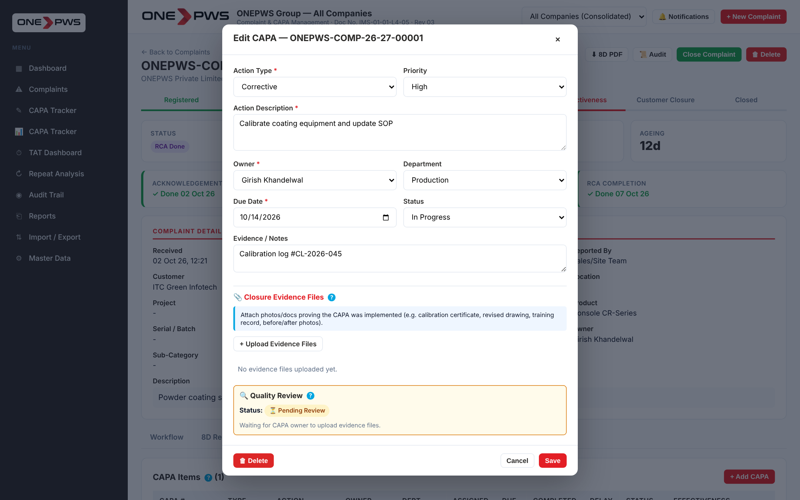
Figure 9.2 — CAPA modal with evidence attachments
What counts as evidence?
A photograph of the implemented change, a calibration certificate, a revised drawing with new revision number, a training attendance sheet, a test report, a procedure document. The rule: whatever a quality auditor would ask to see.

9.3 Quality Review of Evidence
The Quality Head of that company (or the Master Admin) reviews the uploaded evidence. In the same modal, scroll to the 🔍 Quality Review block.
Figure 9.3 — Quality Review block showing Accept / Reject buttons
- Accept Evidence — the CAPA is approved. The status badge turns green and the CAPA can proceed to closure.
- Reject Evidence — remarks are MANDATORY. Be specific: "Calibration cert is expired, upload one dated after 14-Oct-26." The CAPA owner receives an in-app notification and can re-upload. On re-upload the review status automatically resets to Pending.

9.4 Effectiveness Verification
Click the Effectiveness tab on the complaint. After the configured ST and LT windows, the Quality Head records whether a repeat was observed and marks the overall effectiveness as Effective or Not Effective. A Not Effective verdict re-opens the complaint and raises a new CAPA automatically.
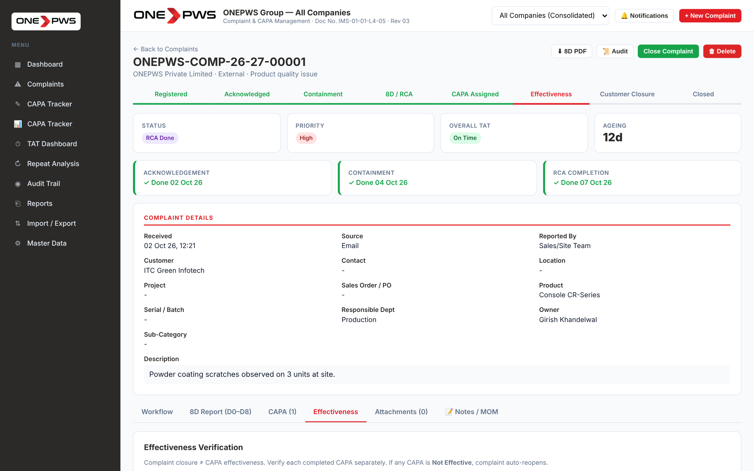
Figure 9.4 — Effectiveness verification tab

10. CAPA Dashboard & Tracker

10.1 CAPA Dashboard
Click CAPA Dashboard in the sidebar. This page gives management insights — person-wise performance, monthly closure trend, effectiveness distribution and ageing analysis.
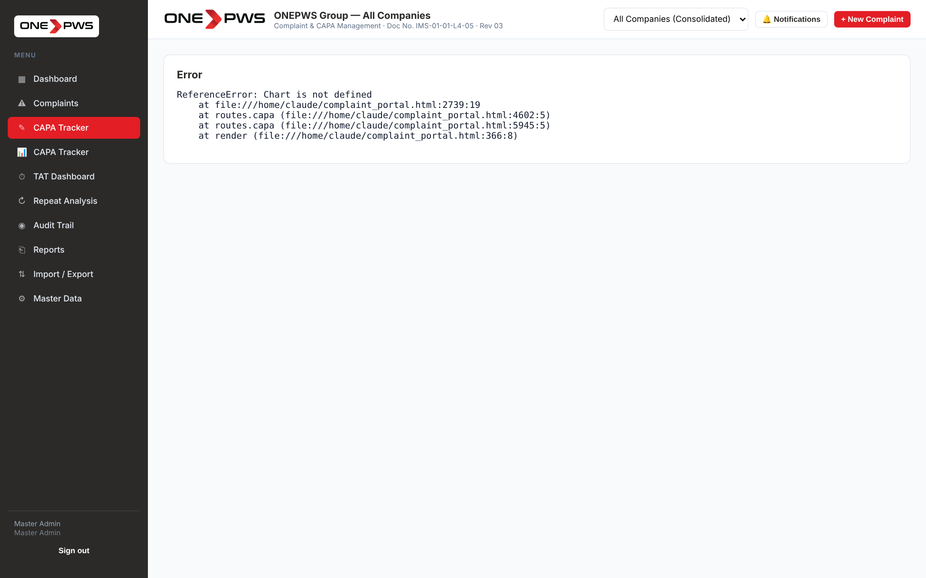
Figure 10.1 — CAPA Dashboard

10.2 CAPA Tracker
Click CAPA Tracker in the sidebar (or the 📊 CAPA Tracker button on the CAPA Dashboard). This page is designed for review meetings — a flat sortable list with six filters (Company, Type, Status, Owner, Evidence Review and Search) and an Export Filtered button that writes exactly the subset you have on screen to Excel.
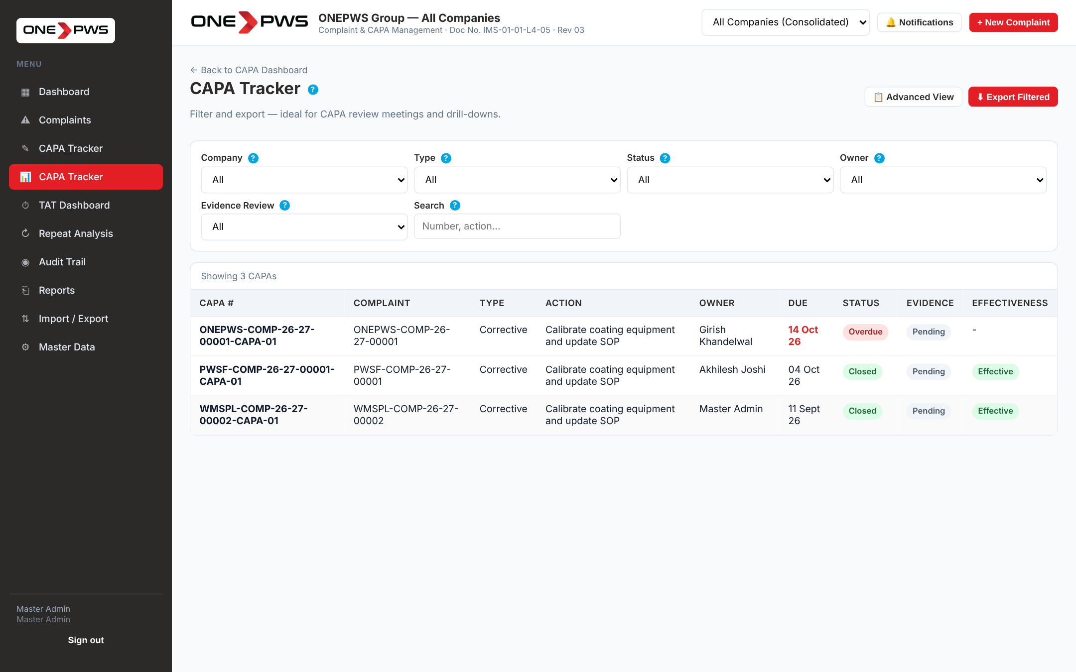
Figure 10.2 — CAPA Tracker (filtered)
Review meeting tip
Before each weekly CAPA review, open the Tracker, filter by Status = Overdue and Owner = (the person being reviewed). Click Export Filtered. The resulting Excel is the agenda for that person.

10.3 CAPA Master List
For deeper analysis, click Advanced View on the CAPA Dashboard. This opens the CAPA Master List with eight filters including effectiveness, date range, and evidence status, plus a dedicated Excel export.
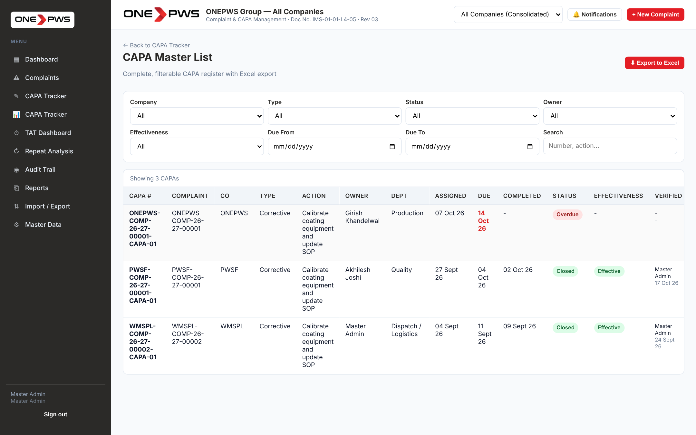
Figure 10.3 — CAPA Master List

11. Notes / Minutes of Meeting
On every complaint, the 📝 Notes / MOM tab lets you record timestamped progress updates and meeting minutes. Entries carry your name, the current date-time, and an optional reference date (for logging past meetings).
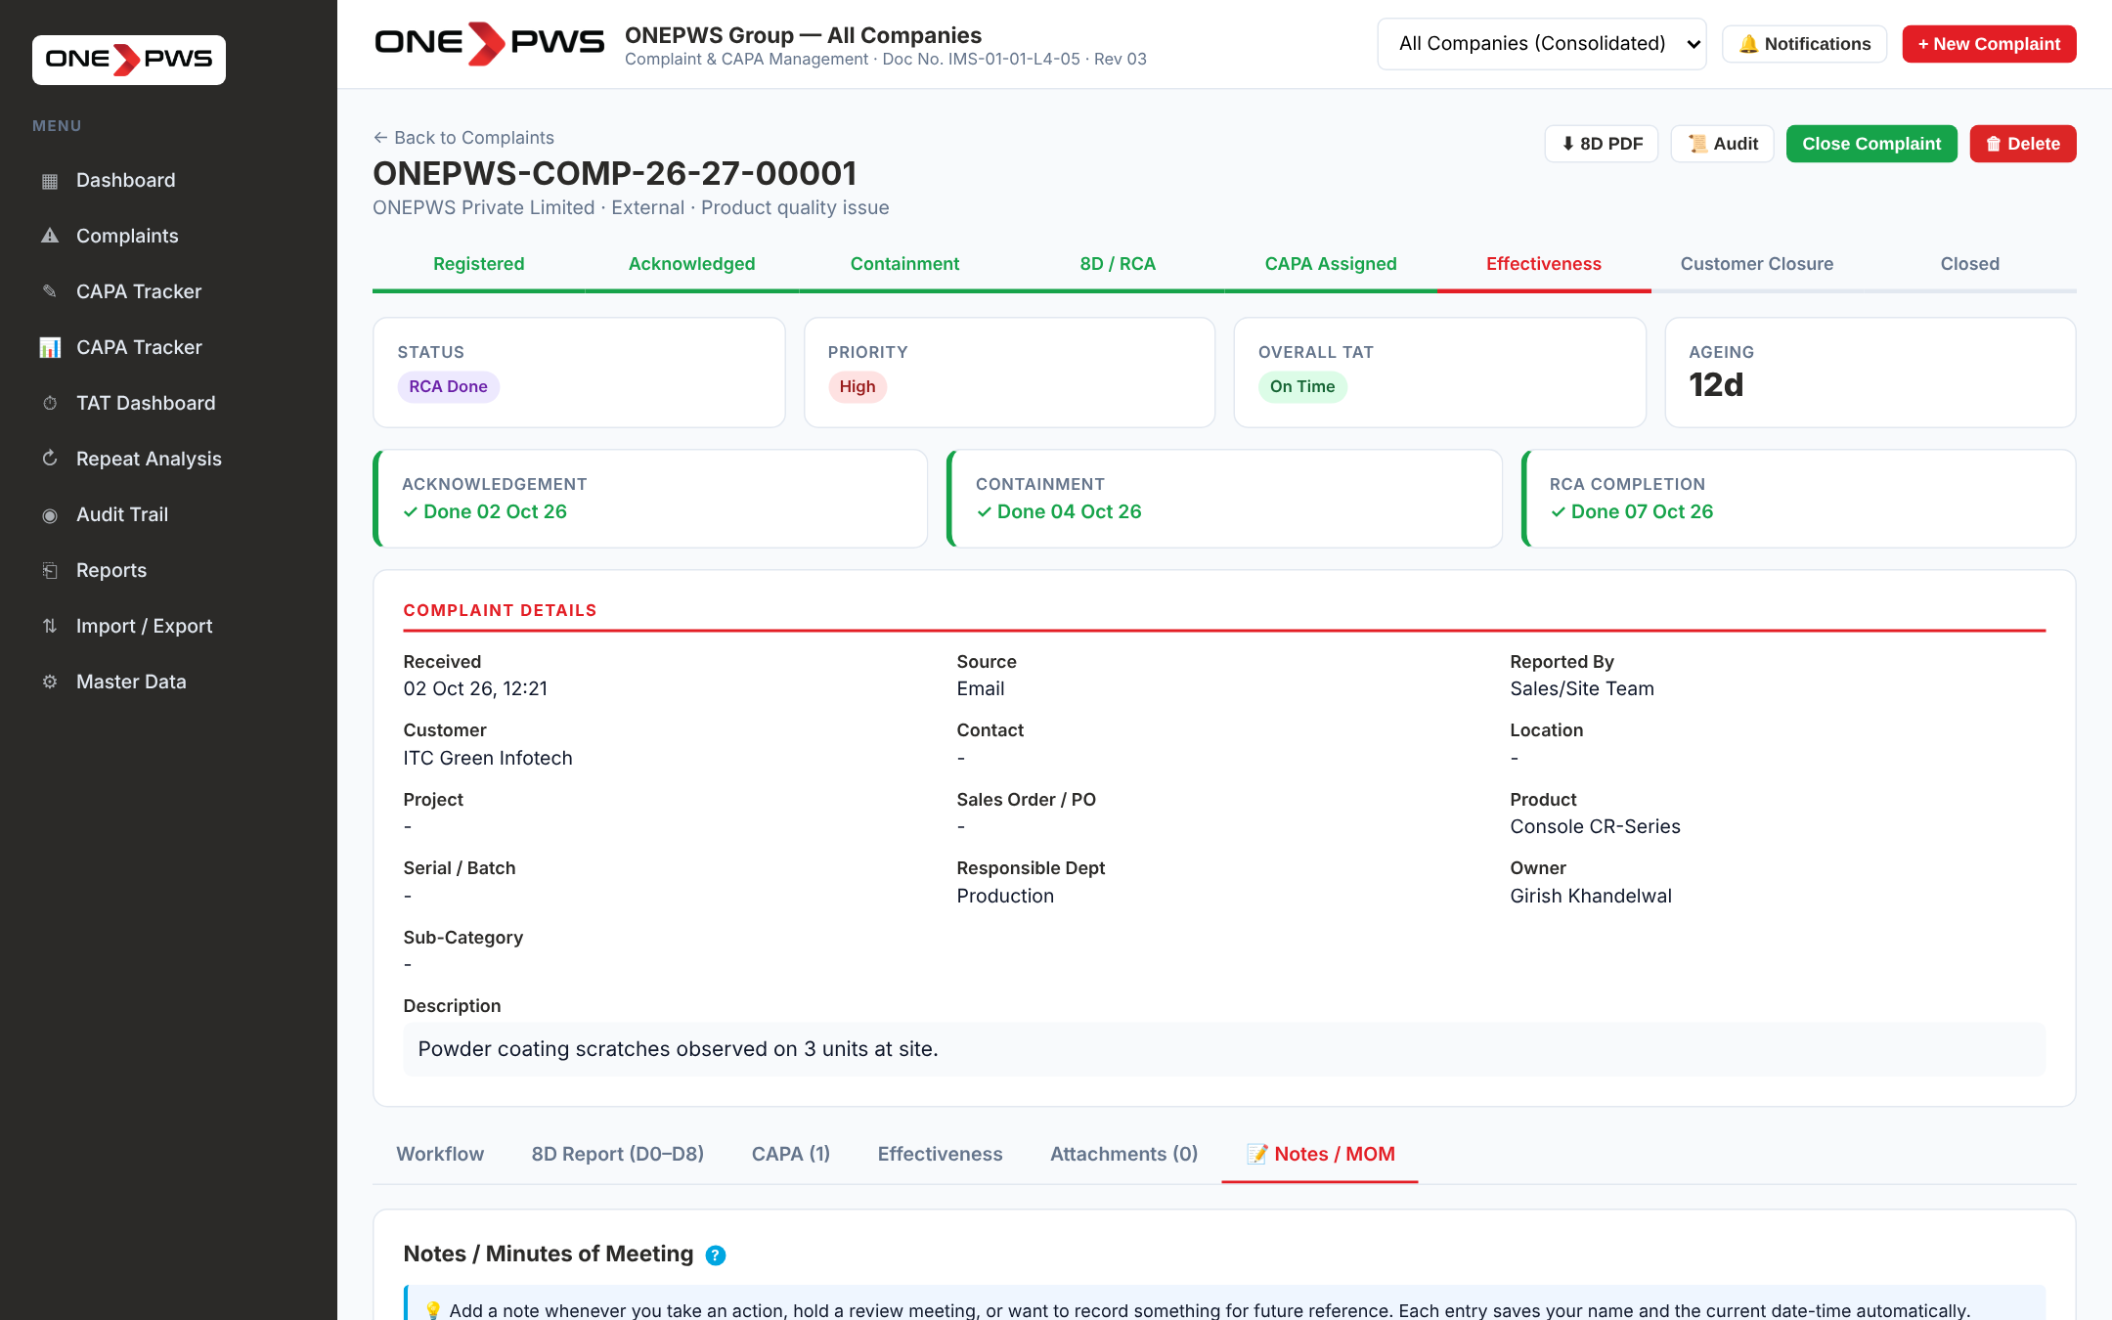
Figure 11.1 — Notes tab (empty state) with the Add Note form

11.1 Adding a Note
- Pick a Kind — 📝 Note (general), 🗓 MOM (meeting minutes), 🔍 Review (quality/management review) or ✓ Update (status change).
- Set the Reference Date — defaults to today. Change if you are logging minutes from a past meeting.
- Write the content — multi-line, free-form. Be descriptive.
- Click ➕ Add Note — the entry appears at the top of the history, colour-coded by kind.
Figure 11.2 — Notes tab with sample MOM and Update entries

11.2 Colour Coding
Kind | Border Colour | When to Use
📝 Note | Blue | General updates, phone call notes, miscellaneous progress.
🗓 MOM | Red | Minutes of a formal review meeting — must list attendees and decisions.
🔍 Review | Amber | Quality or Management review observations.
✓ Update | Green | Significant status change — e.g. "containment confirmed on site today".

11.3 Deleting and Exporting
A note author or the Master Admin can delete a note using the ✕ button on the entry. The deletion is recorded in the audit trail. Use ⬇ Export at the top of the history to download the full note log for that complaint as Excel.

12. Attachments
The Attachments tab shows all files attached to the complaint — those uploaded during registration AND those added later. Each row shows filename, size, uploader and upload timestamp.
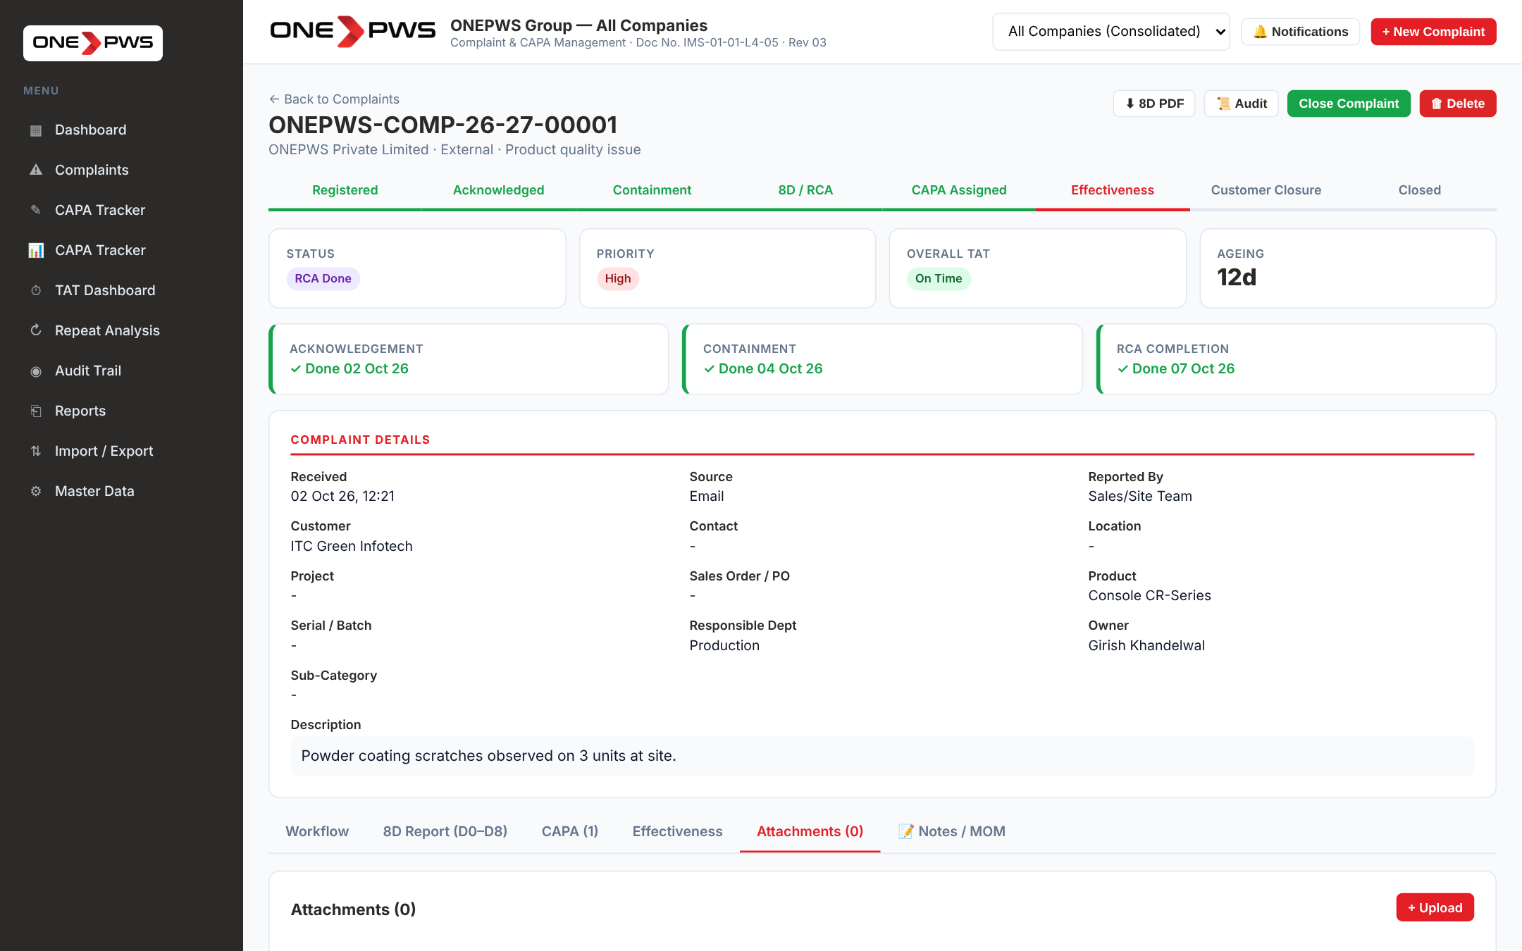
Figure 12.1 — Attachments tab
Click + Upload to add more files. Click any filename to download. Click ✕ to remove (audit-logged). The portal stores files inside the browser (localStorage) in this prototype — keep individual files under 5 MB for best performance.

13. TAT Dashboard
Click TAT Dashboard in the sidebar. This page shows turnaround-time compliance across all stages (Acknowledgement, Containment, RCA, CAPA) with a Pareto of delay reasons.
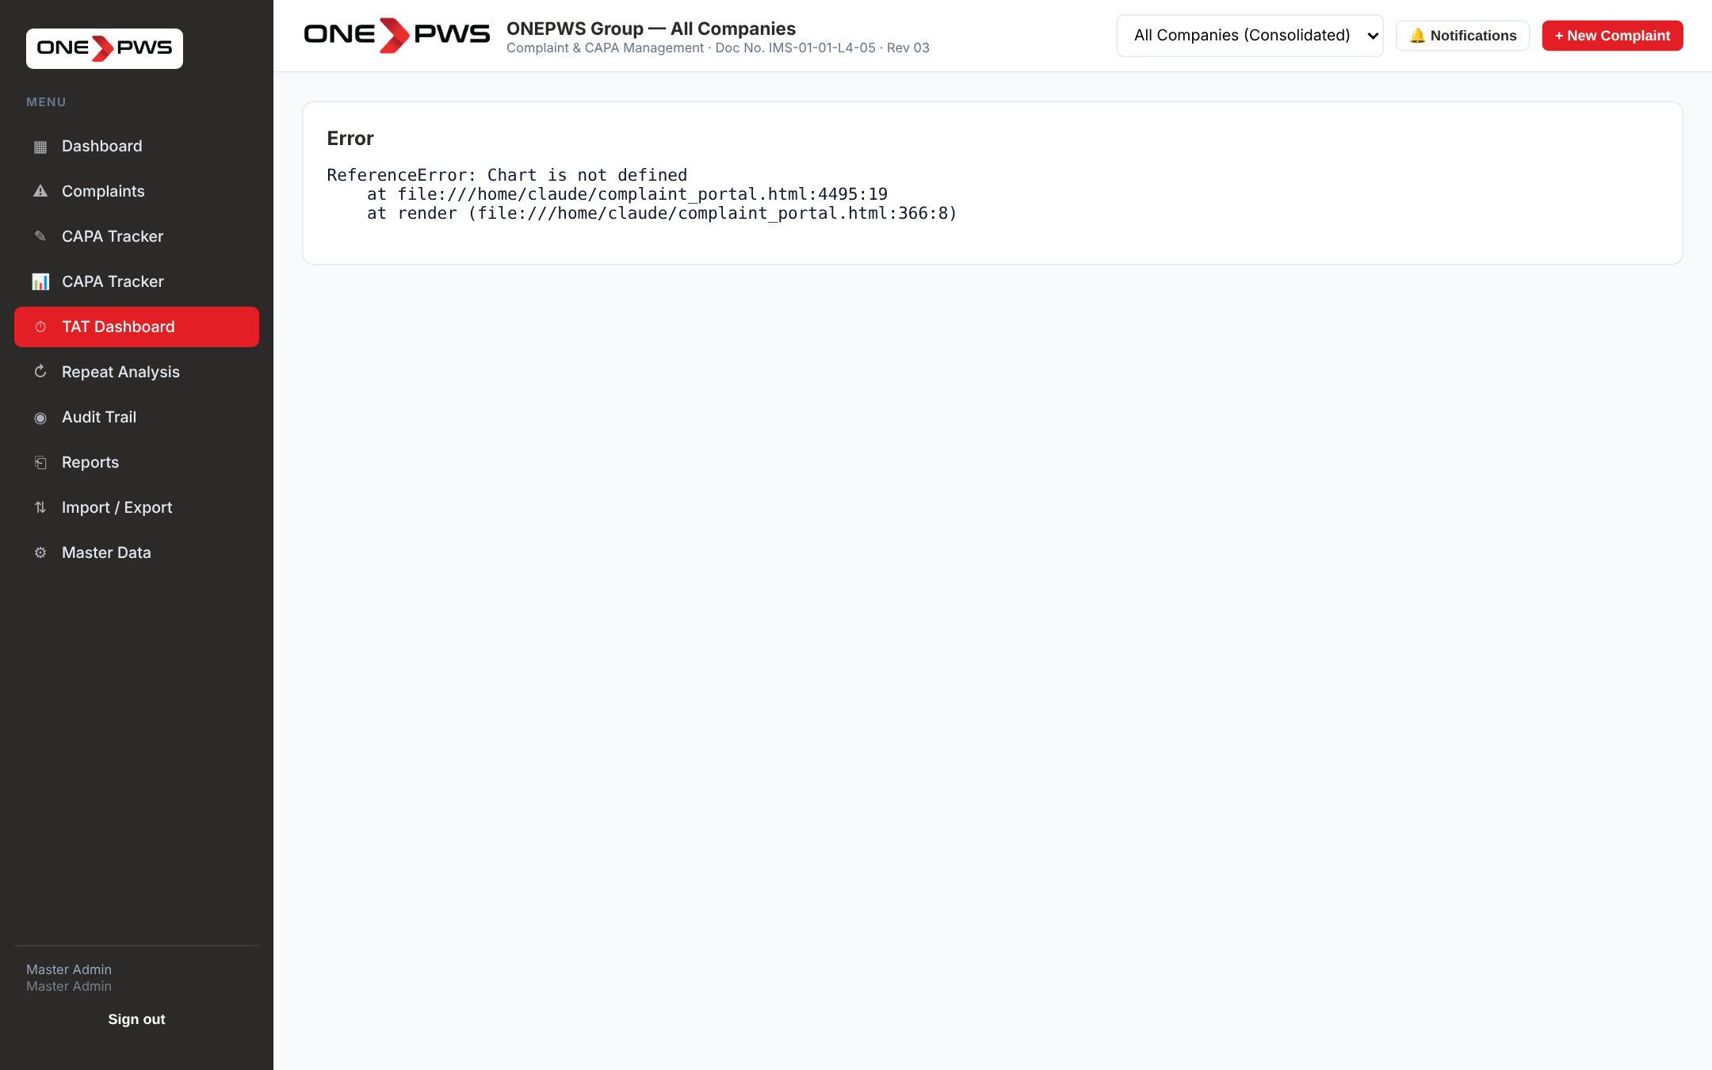
Figure 13.1 — TAT Dashboard
Click any delay reason bar in the Pareto chart to drill into the specific complaints that contributed to that delay. The 80/20 line is highlighted so you can see which few reasons cause the majority of overruns — that is where to focus annual improvement goals.

14. Reports

14.1 Report Catalog
Click Reports in the sidebar. You will see 15 report cards, each with a title, description and two buttons: 👁 Preview and ⬇ Excel.
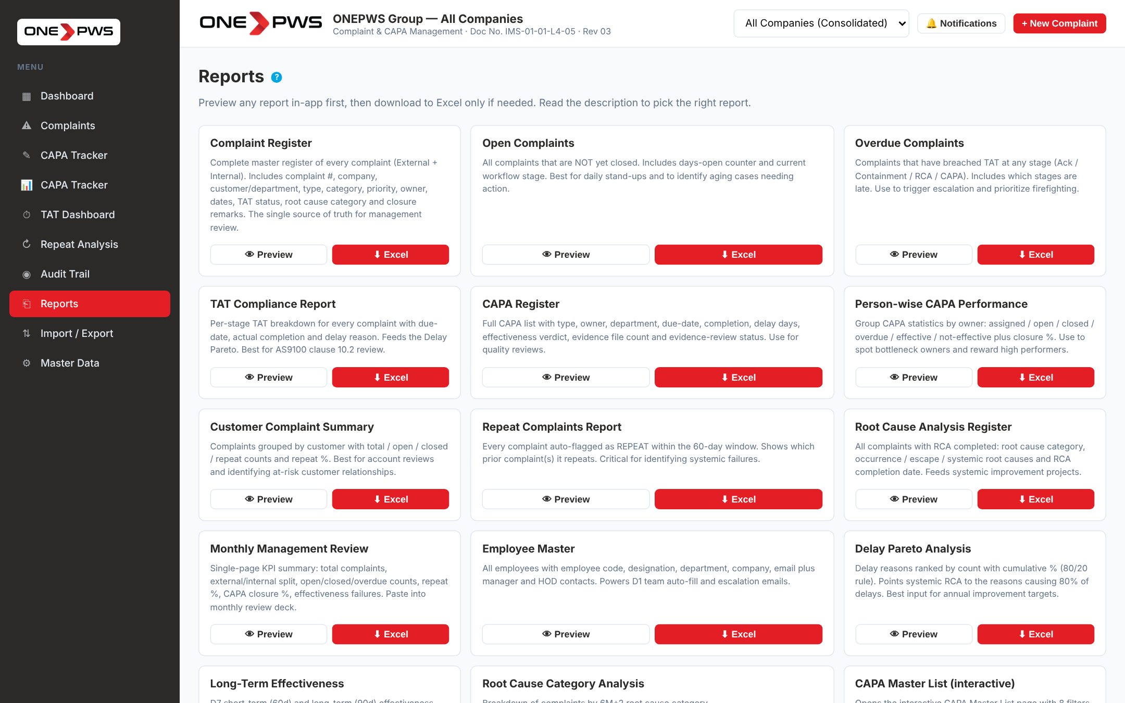
Figure 14.1 — Reports page — 15 report cards

14.2 Preview Before Download
Click 👁 Preview on any report to see the top 20 rows in a modal before downloading. Read the description, scan the sample, decide whether this is the right report. Click ⬇ Download Full Excel from inside the preview, or close and move on.
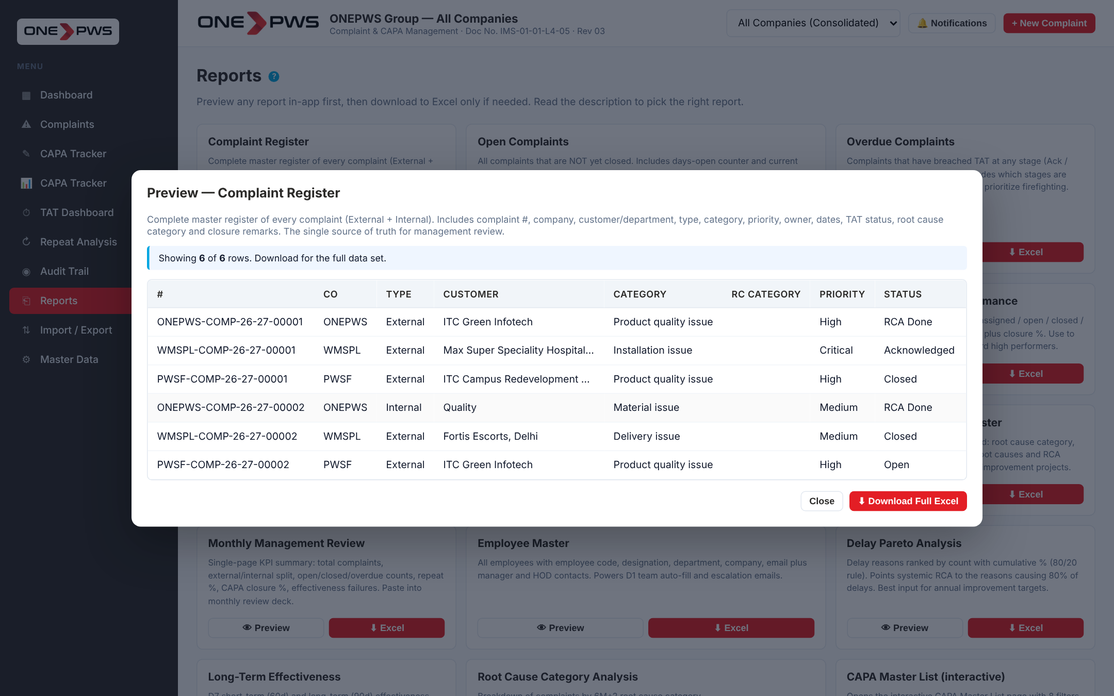
Figure 14.2 — Report preview modal

14.3 Report Index
Report | Purpose
Complaint Register | Master register of every complaint — single source of truth.
Open Complaints | All not-yet-closed complaints with days-open counter.
Overdue Complaints | Complaints that have breached TAT with the overdue stages listed.
TAT Compliance Report | Per-stage TAT breakdown — feeds AS9100 clause 10.2 review.
CAPA Register | Full CAPA list with evidence status and effectiveness.
Person-wise CAPA Performance | Owner-wise stats: Assigned / Open / Closed / Overdue / Effective.
Customer Complaint Summary | Grouped by customer with repeat % — for account reviews.
Repeat Complaints Report | All complaints auto-flagged as REPEAT inside the window.
Root Cause Analysis Register | All complaints with RCA complete and the three root causes.
Monthly Management Review | Single-page KPI summary — paste into MRM deck.
Employee Master | Employee codes, designation, department, manager and HOD.
Delay Pareto Analysis | Delay reasons ranked with cumulative % (80/20 rule).
Long-Term Effectiveness | ST and LT effectiveness status per complaint.
Root Cause Category Analysis | Count by 6M+2 taxonomy with External / Internal split.
CAPA Master List (interactive) | Opens the interactive filter-and-export page.

15. Master Admin
Click Master Data in the sidebar. The page has 11 tabs across the top. Only users with the appropriate permissions can edit — most roles can only view.

15.1 Companies
Add, edit or disable the three group companies. Each company has its own logo, document number, revision and effective date — these appear in the generated 8D PDF.
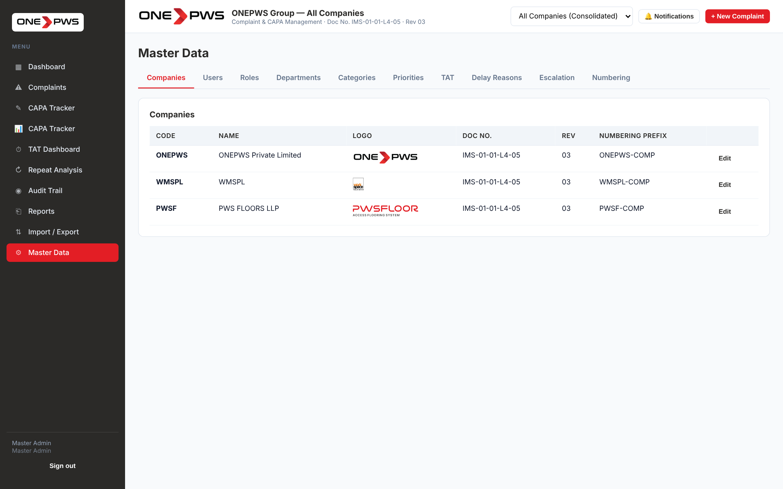
Figure 15.1 — Master Data — Companies tab

15.2 Users (and Password Reset)
Click + Add User to create a new account, or Edit to change an existing one. The modal captures Name, Email, Username, Password, Role, Department, Companies (multi-select; empty = all) and Active flag.
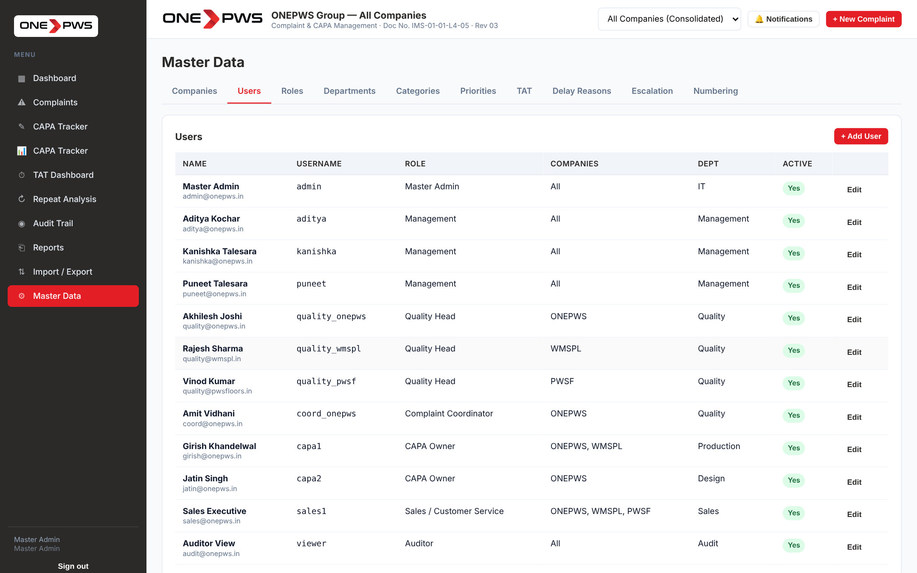
Figure 15.2 — Users tab
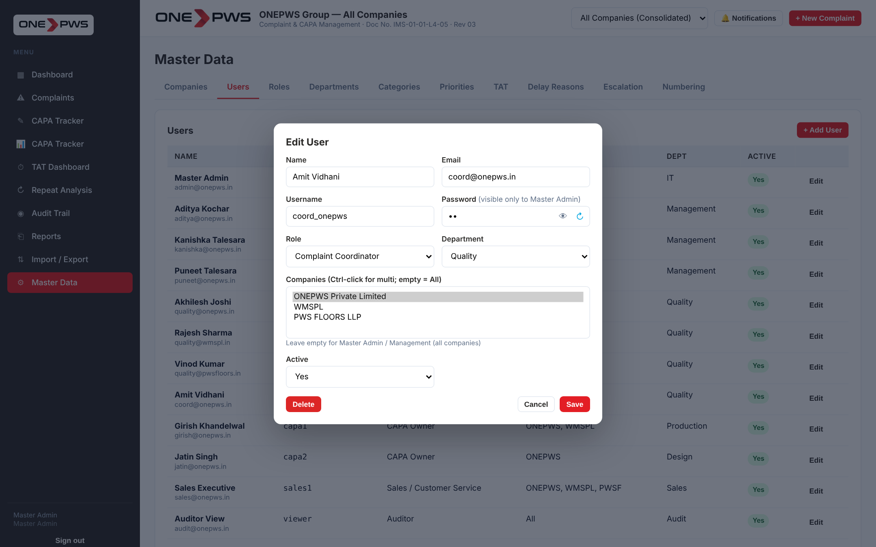
Figure 15.3 — Edit User modal

Showing and resetting a password
Only the Master Admin can see users' passwords. In the Edit User modal, click the eye icon 👁 to show the password; click again to hide.
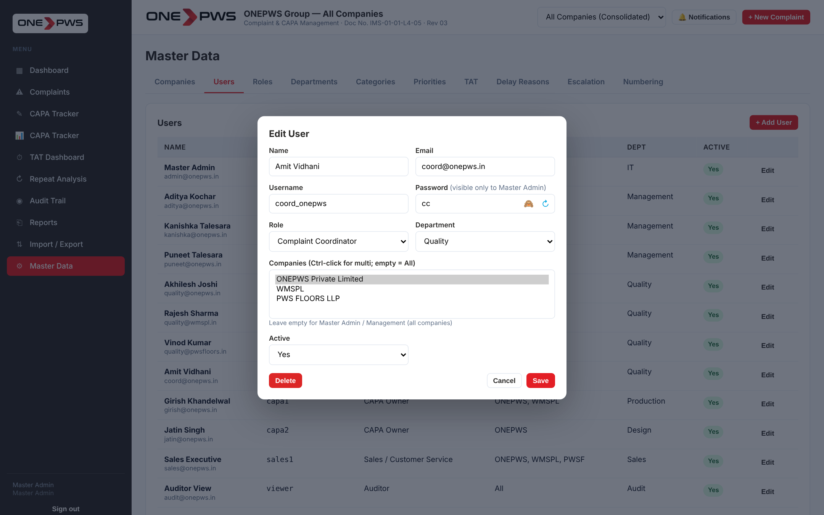
Figure 15.4 — Password visible in the Edit User modal
Click the circular arrow ↻ next to the eye to generate a new random memorable password (e.g. "bluegold47"). The portal shows the new password in an alert — note it down and share it securely with the user. Click Save to commit the change.
Security
Change the user's password immediately after they lose it. Do not use obvious passwords like the user's name or company. Encourage users to change their password after first login (future enhancement).

15.3 Employees
The Employee Master is distinct from the Users list — a user is a login account, an employee is a person who may or may not have an account. The Employee Master powers D1 team auto-fill, escalation emails and the designation field on digital signatures.
Figure 15.5 — Employee Master

15.4 Roles & Permissions
The Roles tab shows a toggle matrix — rows are roles, columns are permissions grouped under Admin / View / Reports / Complaints / CAPA / Audit. Flip the switch to grant or revoke a permission.
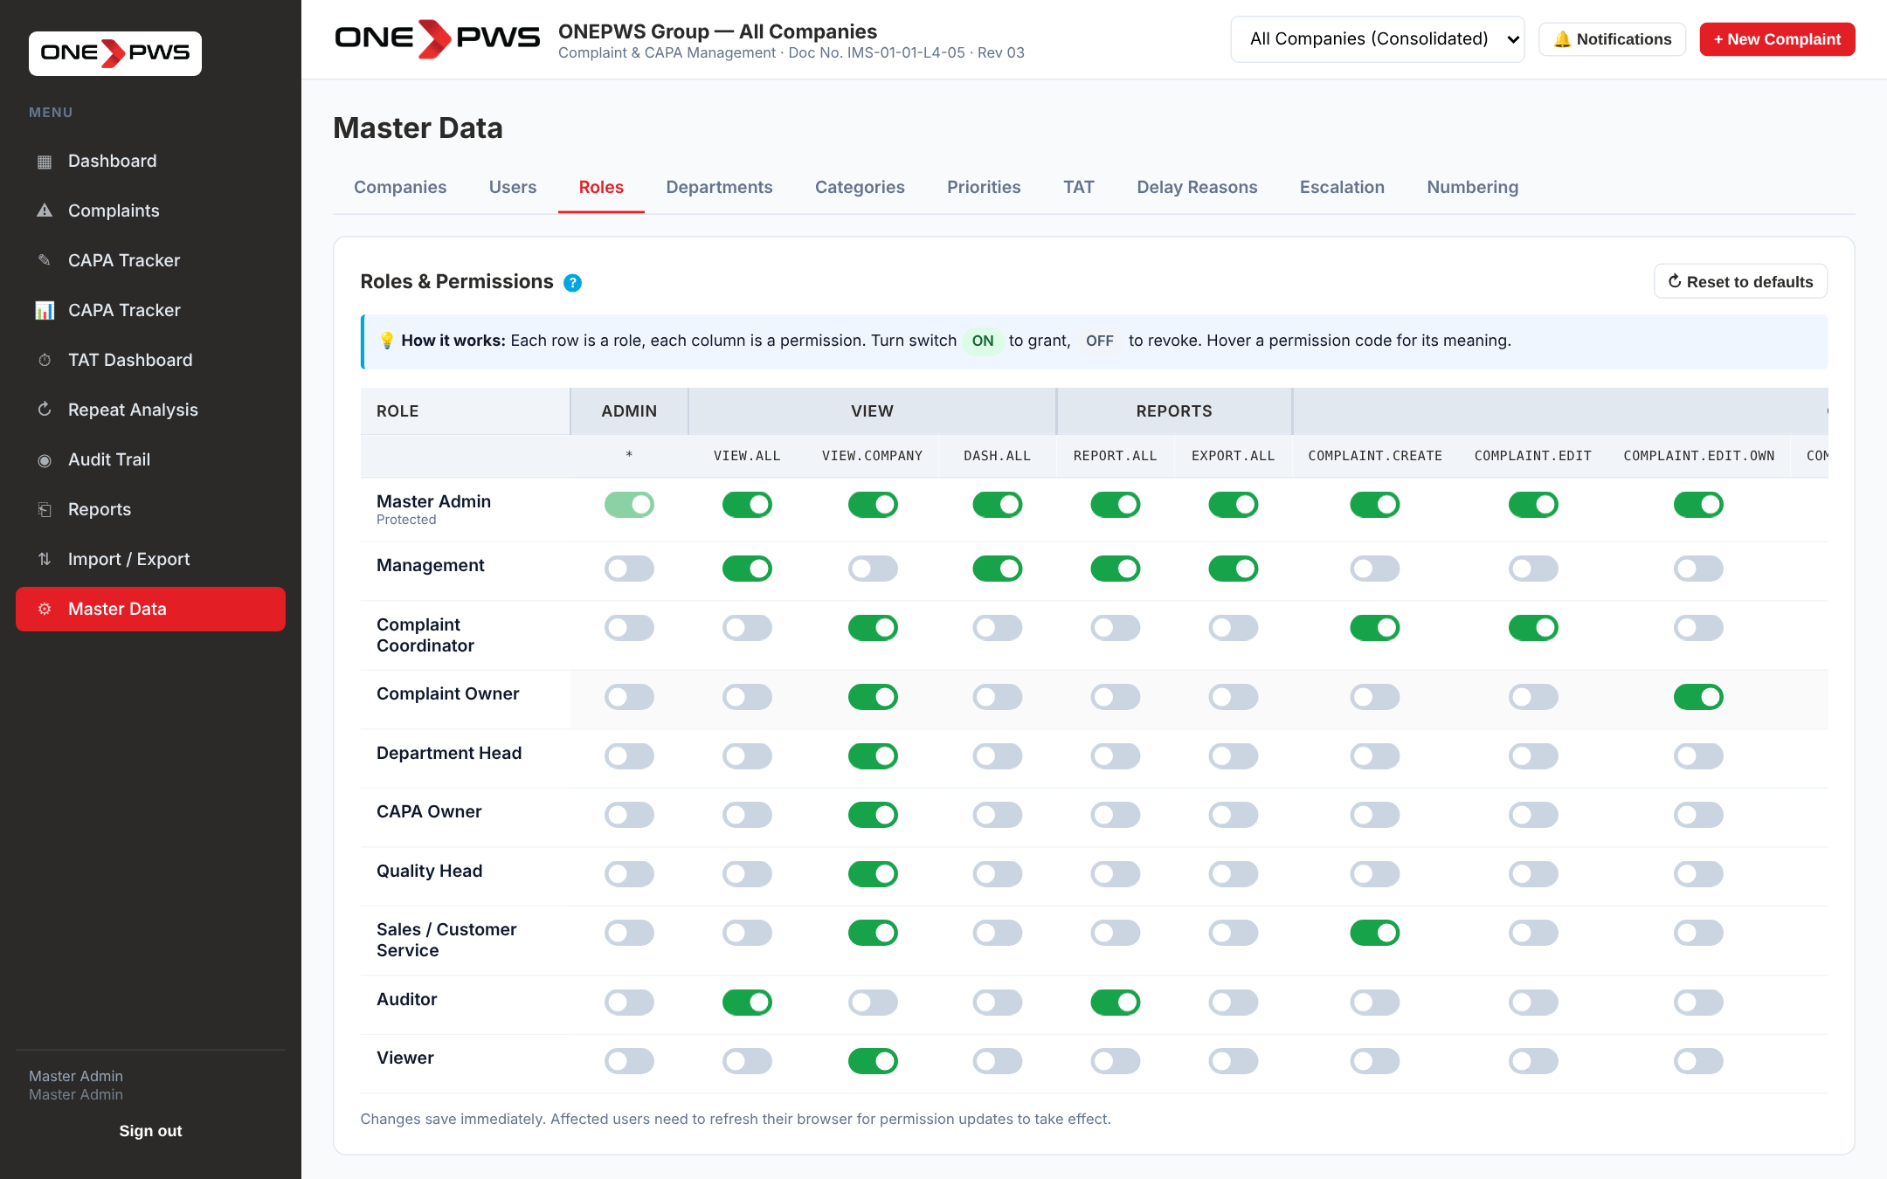
Figure 15.6 — Roles & Permissions matrix
- Hover any permission code (e.g. "complaint.edit.own") for its plain-English description.
- The Master Admin "*" (God Mode) toggle is protected so you cannot lock yourself out.
- Changes save immediately. Affected users must refresh their browser to see the change take effect.
- Click ↻ Reset to defaults to restore the factory permission set — this overwrites all customisation.

15.5 Departments
The Departments tab displays each department as a card with an icon and three usage counters (Complaints touching the dept, Users assigned, Employees in the Master). Click + Add Department to create a new one, Rename to change the name, or 🗑 to delete.
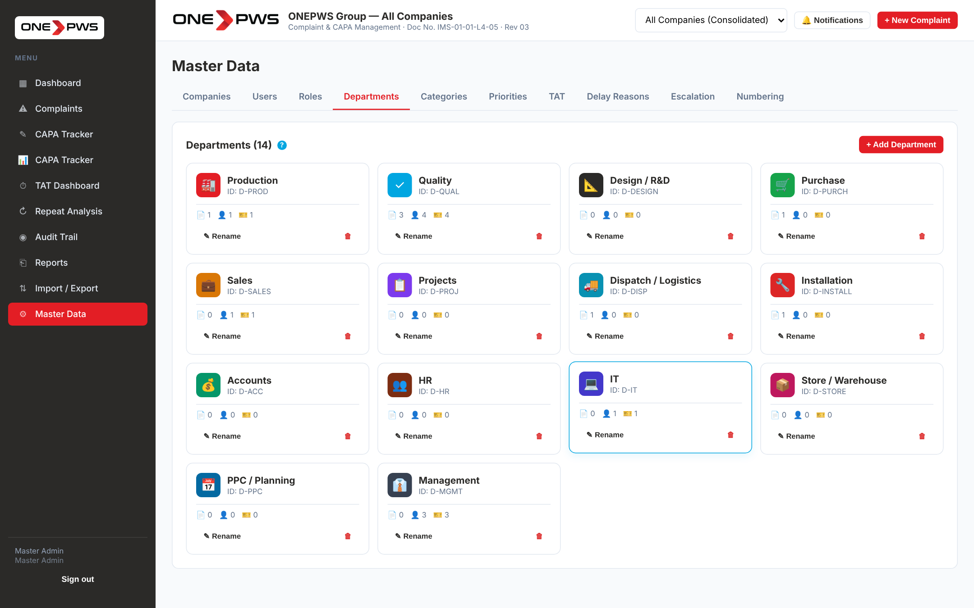
Figure 15.7 — Departments as cards
Caution
Do not delete a department that still has complaints or users assigned — the links will break. Rename first or reassign the records.

15.6 Categories, Priorities, TAT, Numbering
The remaining tabs are straightforward master-list editors:
- Categories — separate lists for External and Internal complaints. Keep them concise (<15 items each).
- Priorities — the four-level matrix (Critical / High / Medium / Low). Changing these affects the colour badges across the portal.
- TAT — configure target days for each milestone and the ST / LT effectiveness horizons.
- Delay Reasons — the standard reasons users will pick from when they are late at a milestone.
- Escalation — the ladder of escalation (hours overdue → whom to notify).
- Numbering — prefix per company and running counter. The counter resets to 00001 on 01 April of each financial year.
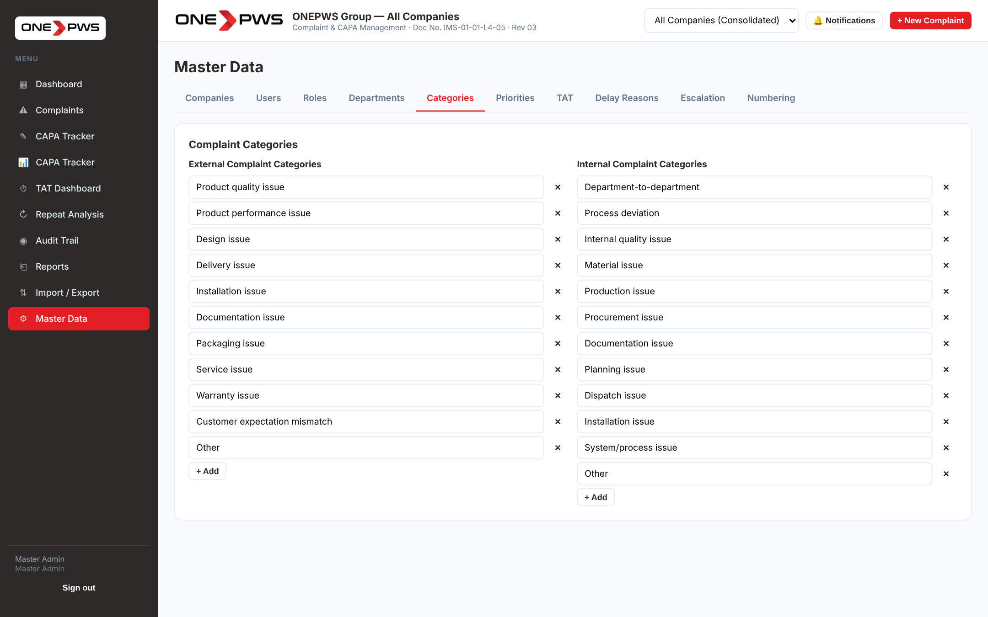
Figure 15.8 — Categories tab
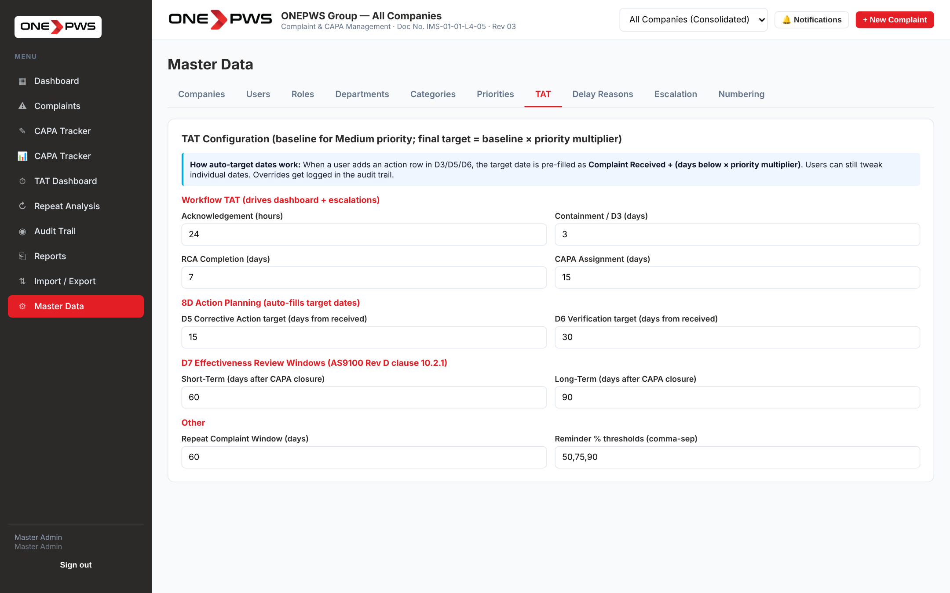
Figure 15.9 — TAT configuration
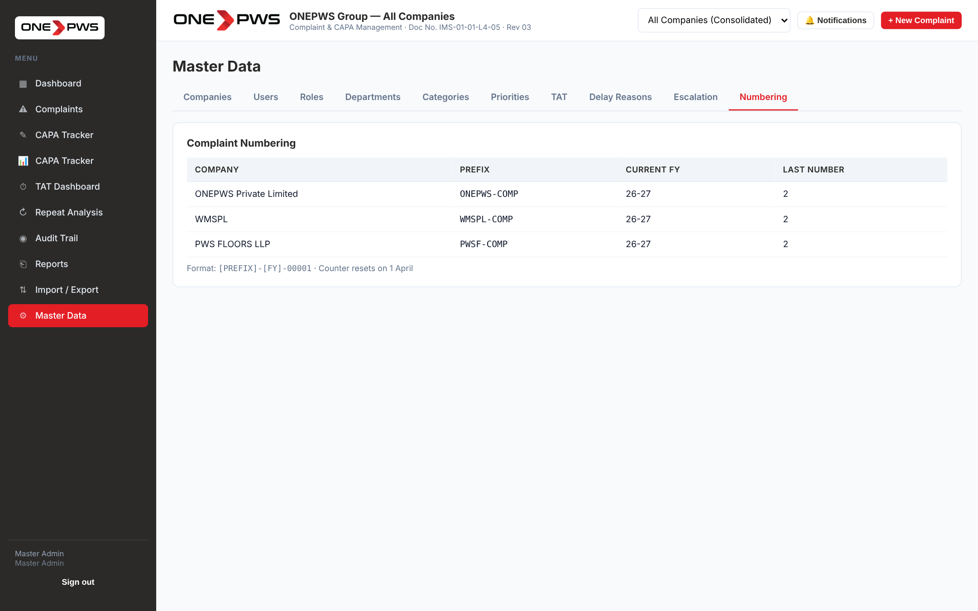
Figure 15.10 — Numbering configuration

15.7 Delete Complaint
Only the Master Admin sees a red 🗑 Delete button in the complaint header, next to the 8D PDF button. Use it ONLY to remove test data or an accidental duplicate. Clicking it opens a confirmation modal that:
- Lists what will be cascade-deleted (CAPAs, attachments, notes).
- Requires you to type the complaint number exactly to confirm.
- Keeps a permanent record in the Audit Trail with your name, timestamp and cascade summary — for AS9100 traceability.
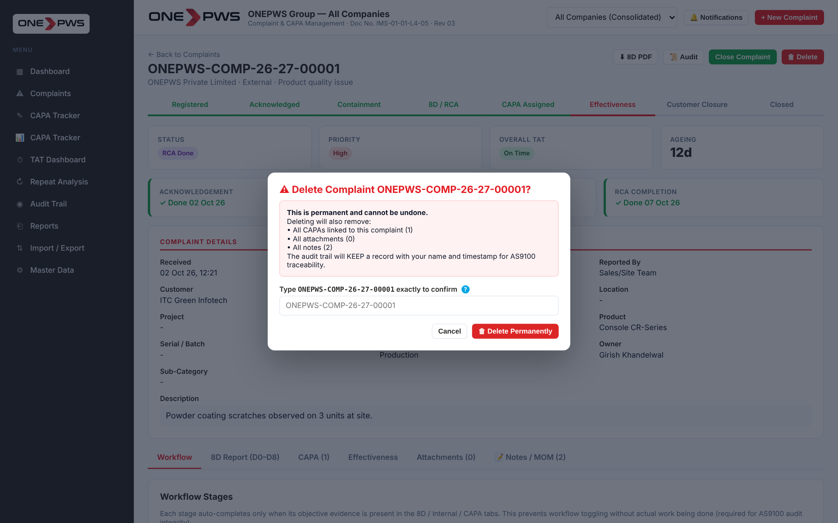
Figure 15.11 — Delete Complaint confirmation modal

16. Audit Trail
Click Audit Trail in the sidebar. Every create, edit, delete and system action is logged with user, timestamp, action type, entity type, entity ID and before/after snapshots. Use the search box to find any specific event (e.g. all actions on complaint "ONEPWS-COMP-26-27-00001").
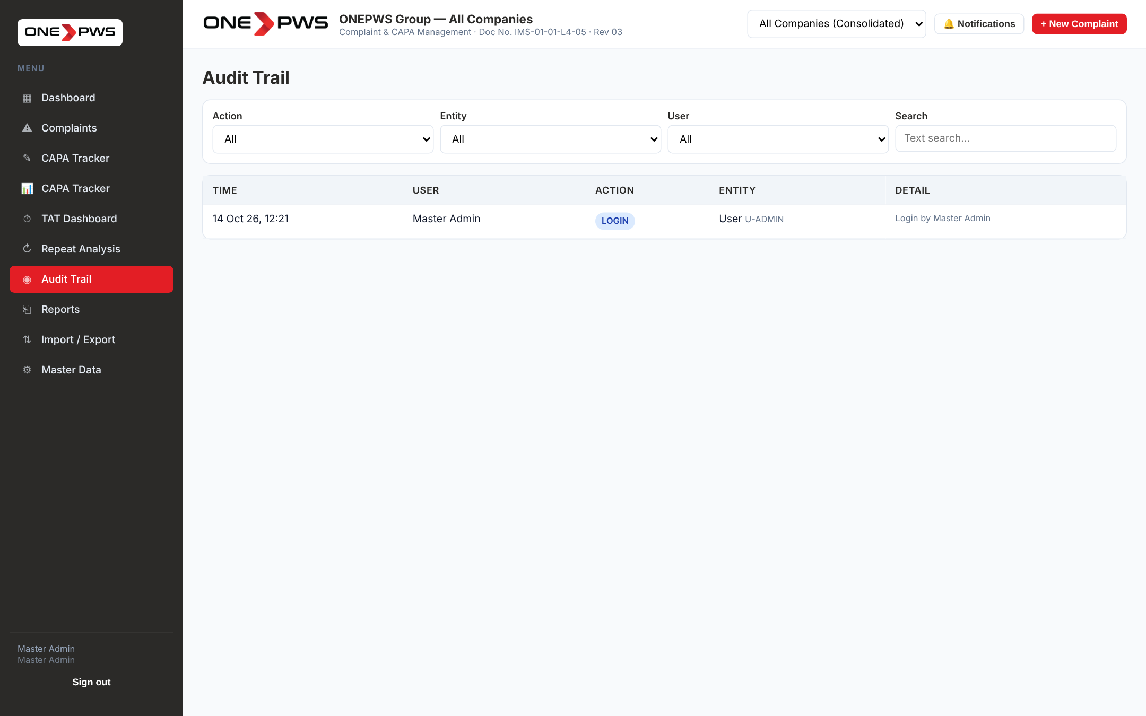
Figure 16.1 — Audit Trail
For auditors
The Audit Trail is the primary evidence for ISO/AS9100 external audits on data integrity. It cannot be edited or deleted by any user, including Master Admin. Export it from Reports → Audit Export for the audit evidence pack.

17. Standard Operating Procedures (Step-by-Step)
This section contains the end-to-end workflows a new user is most likely to run. Each SOP references the earlier chapters for detail.

17.1 SOP-01: Register an External Complaint
- Sign in to the portal.
- Click + New Complaint in the top right.
- Set Type = External. Pick the Company.
- Enter Customer Name, Contact and Location.
- Enter Project / PO, Product and Batch if known.
- Pick the Category and (optional) Sub-category.
- Write a factual Description — what, where, when.
- Set Priority based on impact.
- Assign a Complaint Owner.
- Click 📤 Select Files and attach any photo / email / document.
- Review the duplicate warning banner (if any). If this truly is a REPEAT, continue; otherwise reconsider the key fields.
- Click Register Complaint.

17.2 SOP-02: Complete an 8D Report
- Open the complaint from the Complaints list.
- Click the Workflow tab. Acknowledge the complaint, record Containment, then click RCA Completed.
- Click the 8D Report (D0–D8) tab.
- Fill D0 Emergency Response.
- In D1, add Team members using the Employee dropdown — department/designation auto-fill.
- Fill D2 — the seven boxes of 5W1H.
- Record all D3 Containment actions in the table with target dates.
- Work through D4 — three 5-Why chains plus the 6M Fishbone. Write the final Occurrence, Escape and Systemic root causes.
- For each root cause, add the D5 corrective actions.
- In D6, add verification activities and complete the 8-document checklist — attach each document with revision info or mark NA with justification.
- In D7, book the ST and LT verification dates.
- In D8, add team recognition remarks.
- Pick the Root Cause Category at the bottom.
- Scroll to Digital Signatures and sign as Prepared By.
- Click ⬇ 8D PDF in the header to download the printable report.

17.3 SOP-03: Close a Complaint
- Verify ALL CAPAs are Closed with Accepted evidence (CAPA tab).
- Verify Effectiveness is marked Effective at the LT window (Effectiveness tab).
- Have the Department Head sign as Reviewed By (8D tab → Digital Signatures).
- Have the Quality Head (or Master Admin) sign as Approved By.
- Click Close Complaint in the header.
- If any gate is missing, the portal shows a validation modal listing exactly what to fix. Resolve each item and try again.
- On successful closure the status badge turns to Closed and the complaint is read-only (except for Master Admin).

17.4 SOP-04: Quality Review of CAPA Evidence
- Open the complaint, click the CAPA tab, click Edit on the CAPA to review.
- Scroll to 📎 Closure Evidence Files. Download and inspect each file.
- Scroll to 🔍 Quality Review.
- If the evidence is sufficient, click ✓ Accept Evidence. (No remarks required but recommended.)
- If NOT sufficient, write specific remarks in the Remarks box and click ✗ Reject Evidence. The CAPA owner is notified.
- When the owner re-uploads, the review status automatically resets to Pending and you review again.

17.5 SOP-05: Monthly Management Review
- On the first Monday of the month, open the Dashboard.
- Change the Company Switcher to "All Companies (Consolidated)".
- Open Reports.
- Download Monthly Management Review (one-click Excel).
- Download Delay Pareto Analysis and Root Cause Category Analysis.
- Open CAPA Tracker, filter by Status = Overdue, click Export Filtered.
- Compile the four Excel files into the standard MRM deck.
- Present at MRM; capture action items as Notes/MOM on individual complaints and as new CAPAs where appropriate.

Appendix A — Keyboard & Mouse Shortcuts
Shortcut | Action
Enter (on login page) | Submits the Sign In form.
Click row in list | Opens the complaint / CAPA detail.
Click outside modal | Closes the current modal (same as Cancel).
Hover any ? icon | Shows the inline help tooltip.
Click 👁 on password | Toggle password visibility.
Click ↻ on password | Generate a new random memorable password (Master Admin only).
Click ✕ on an attachment | Remove the attachment (audit-logged).
Click + New Complaint (top-right) | Open the new complaint modal from anywhere.

Appendix B — Troubleshooting
Symptom | Cause / Resolution
"Invalid credentials or user inactive" after Sign In | Check Caps Lock. Ask Master Admin to confirm the Active flag is set and to show you the current password.
Close Complaint button shows a long validation list | Normal — the portal will not close a complaint while any mandatory item is missing. Work through the list in order and retry.
My CAPA evidence was rejected | Open the CAPA, read the reviewer remarks in the Quality Review block. Upload the corrected file; the review status will reset to Pending automatically.
I cannot see the Delete button | Delete is visible only to Master Admin. Ask your Master Admin if you really need to delete; prefer to re-use or re-assign.
The dashboard shows no data | Check the Company Switcher — you may have filtered to a company with no records.
Dashboard chart does not load | Refresh the browser (F5). Charts depend on an external chart library; if your network blocks the CDN the chart will not render but the data table alongside will.
My password reset button does not generate | The ↻ button is only visible to Master Admin. Only Master Admin can reset passwords in this release.
Attached file too large | The portal warns on files over 10 MB. In this prototype files are stored in browser localStorage; keep each file below 5 MB for best performance.

Appendix C — Glossary
Term | Meaning
Approve (signature) | The final of the three digital signatures, authorising closure. Only Quality Head or Master Admin can approve.
Audit Trail | Immutable chronological log of every action in the portal.
Containment | An immediate action to limit the impact of a non-conformity before the root cause is known.
Delay Reason | A standardised reason selected by the user when a milestone is completed after its due date.
Effectiveness | The verification (at ST and LT horizons) that the CAPA has actually removed the problem.
Fishbone | The 6M cause-categorisation diagram used in D4.
Horizontal Deployment | Applying the lesson learnt in one product/line to other similar products or lines.
Master Admin | The role with full administrative access to all data and configuration.
Pareto | The 80/20 ranking chart used in the Delay analysis — few causes drive most defects.
Prepare (signature) | The first of the three digital signatures, confirming the author completed the 8D content.
Review (signature) | The second signature, by a Department Head or Quality Head, before approval.
Scope Switcher | The company dropdown in the top bar that filters all views to one company or shows the consolidated group.

— End of Document —
ONEPWS Group · Complaint & CAPA Management Portal · Visual SOP Rev 00

