# **Big data analysis report**

# How will I know if my data is “big”? can you store Exa-bytes of Data and can still run with maximum efficiency through a system?........solution_here



**All that is going in your mind is Data which is huge and Big, unable to handle it and that problem is termed as *Big-Data***

**Areas of Data reframing from ??**

1. **Social Media**A single **Jet engine** can generate ***10+terabytes*** of data in ***30 minutes*** of flight time. With many thousand flights per day, generation of data reaches up to many ***Petabytes.***
2. The statistic shows that ***500+terabytes*** of new data get ingested into the databases of social media site **Facebook**, every day. This data is mainly generated in terms of photo and video uploads, message exchanges, putting comments etc.
3. The **New York Stock Exchange** generates about ***one terabyte*** of new trade data per day and many more areas of information is been gathered...

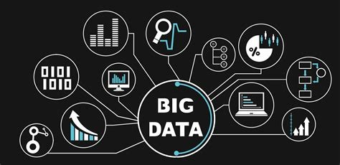

*How are we going to handle such Big-Data*

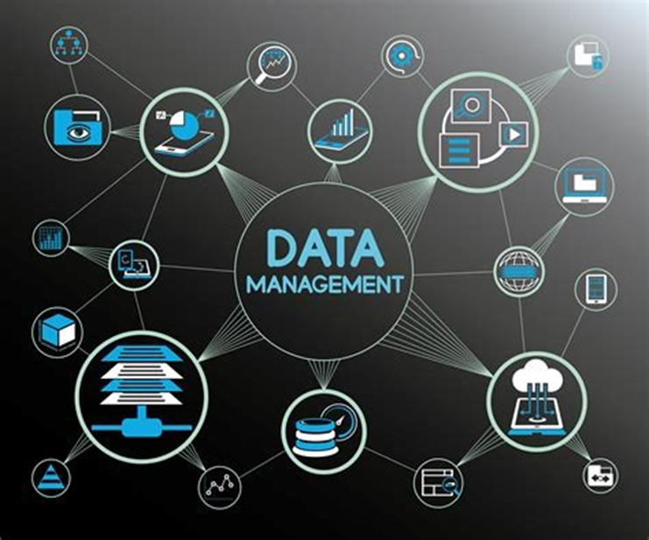

*Information is Power_and every one wants to be powerful in some or the other way...*



Why is the cloud the best platform for big data?

Every day, we feed Facebook’s data beast with mounds of information. Every 60 seconds, 136,000 photos are uploaded, 510,000 comments are posted, and 293,000 status updates are posted. That is a LOT of data. so active systems are used to do that using CLOUD

Tracking cookies

Facial recognition

Tag suggestions

Analyzing the Likes

Facebook Inc. analytics chief Ken Rudin says, “Big Data is crucial to the company’s very being.”

Learn What Matters to Your Audience

Data shows marketers what audiences are saying on Facebook about events, brands, subjects and activities, all in a way that keeps personal information private.

Marketers use the information from topic data to make better decisions about how they market on Facebook and other channels, and build product roadmaps.

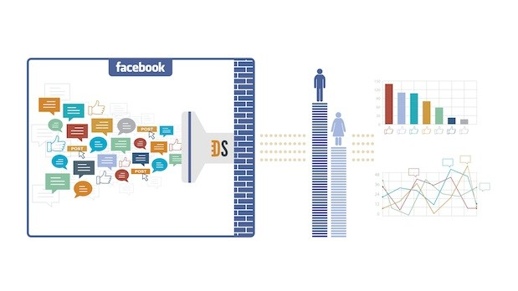

*Really.....*



***Facebook*** is vowing new steps ***to provide users with accurate climate change information and cut emissions,*** but activists say it's doing too little to confront the spread of false claims on its platform.

**How are they doing it and what are they doing on ?**

This takes us to the roller-coast ride of the Big-Data in details lets jump in.

**Types Of Big Data**

BigData could be found in three forms:

1. **Structured**
2. **Unstructured**
3. **Semi-structured**

Each having their own use-caseful, how is that linking up to my **UNDERSTNADING**

## Product Development Companies



like Netflix and Procter & Gamble use big data to anticipate customer demand. They build predictive models for new products and services by classifying key attributes of past and current products or services and **modeling the relationship** between those attributes and the commercial success of the offerings

In addition, P&G **uses data and analytics from focus groups, social media, test markets**, and early store rollouts to plan, produce, and launch new products.

## ****Machine learning****

ML is a hot topic right now. And data—specifically big data—is one of the reasons why. We are now able **to teach machines instead of program** them. The availability of big data to train machine learning models makes that possible.

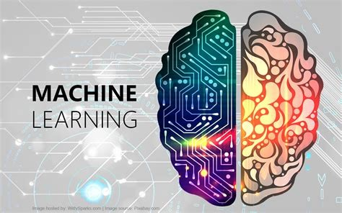

**First, big data is…big.** Although [new technologies](https://www.oracle.com/big-data/products.html) have been developed for data storage, data volumes are doubling in size about[every two years](https://www.emc.com/leadership/digital-universe/2014iview/executive-summary.htm). Organizations still struggle to keep pace with their data and find ways to effectively store it.

## How Big Data Works

Big data gives you new insights that open up new opportunities and business models. Getting started involves three key actions:

### 1. Integrate

Big data brings together data from many disparate sources and applications. Traditional data integration mechanisms, such as ETL (extract, transform, and load) generally aren’t up to the task. It requires new strategies and technologies to analyze big data sets at terabyte, or even petabyte, scale.

During integration, you need to bring in the data, process it, and make sure it’s formatted and available in a form that your business analysts can get started with.

### 2. Manage

Big data requires storage. Your storage solution can be in the cloud, on premises, or both. You can store your data in any form you want and bring your desired processing requirements and necessary process engines to those data sets on an on-demand basis. Many people choose their storage solution according to where their data is currently residing. The cloud is gradually gaining popularity because it supports your current compute requirements and enables you to spin up resources as needed.

### 3. Analyze

Your investment in big data pays off when you analyze and act on your data. Get new clarity with a visual analysis of your varied data sets. Explore the data further to make new discoveries. Share your findings with others. Build data models with machine learning and artificial intelligence. Put your data to work.

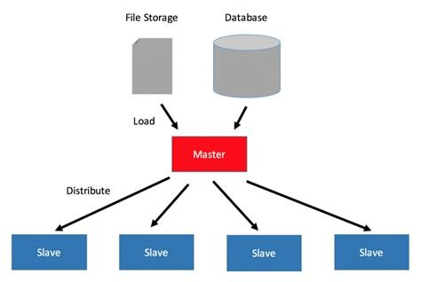

This is where our super computers comes into picture of SERVERS with optimized computing resources and more life-time for the resources.

*Costlier & Faster than Lambo..*



Riken

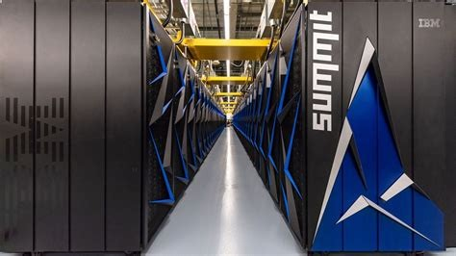

Supercomputers have become

[*a symbol for both technical and economic competitiveness*](https://www.nytimes.com/2018/06/08/technology/supercomputer-china-us.html)

The room-size systems are used for complex military and scientific tasks, including breaking codes, modeling climate change and simulating new designs for cars, weapons, aircraft and drugs. Riken has said Fugaku is already being used to help study, diagnose and treat Covid-19.

*Fascinated by Big Data? Interested in launching a career in Big Data? Want to learn more about how social media runs on Big Data?*

## "No one will care you have 100 petabytes of data in your warehouse”. The speed of ingestion keeps on increasing, and “the world is getting hungrier and hungrier for data.”

*Just remember if US elections are been able to manipulate by the Data of FaceBook analytica, what can else it change...*

## ****I want you all to think Because information is power, is your information going in a right way must also to be noted??****

**Benefits of Big Data and Data Analytics:**

* **Big data makes it possible for you to gain more complete answers because you have more information.**
* **More complete answers mean more confidence in the data—which means a completely different approach to tackling problems.**

