

/*

Name: Rohit Saini

Erp: 1032200897

Panel: C

RollNo: PC-41 */

**TITLE:** Create a resource for one of the cloud services like AWS Lambda or Azure Storage account, comprehend its usage and delete the same.

**AIM:**

To to able to Create a resource for one of the cloud services like AWS Lambda or Azure Storage account, comprehend its usage and delete the same.

**OBJECTIVE:**

To acquire knowledge of cloud services

**THEORY:**

**Service Models:**

**Infrastructure as a Service (IaaS):**

**Description:** IaaS provides virtualized computing resources over the internet. Users have access to virtual machines, storage, and networking components without managing the physical infrastructure.

**Use Cases:** Suitable for businesses that need scalable computing resources without the complexity of managing physical hardware. Example: Amazon EC2, Microsoft Azure Virtual Machines.

**Platform as a Service (PaaS):**

**Description:** PaaS offers a platform with development tools, databases, and middleware, enabling developers to build, deploy, and manage applications without dealing with the underlying infrastructure.

**Use Cases:** Ideal for developers focused on application development and deployment without managing the underlying infrastructure. Example: Google App Engine, Heroku.

**Software as a Service (SaaS):**

**Description**: SaaS delivers software applications over the internet on a subscription basis. Users can access applications through a web browser without worrying about installation, maintenance, or updates.

**Use Cases:** Commonly used for business applications, collaboration tools, and productivity software. Examples: Salesforce, Microsoft Office 365, Google Workspace.

**Creating a Lambda Function on AWS:**

1. AWS Lambda is a serverless computing service for running code without managing servers.

2. Lambda functions can be created through the AWS Management Console, AWS CLI, or SDKs.

3. Functions have triggers that define when and how they execute, such as Amazon S3 bucket events.

4. Each function has a handler function, the entry point for your code.

5. AWS Lambda provides an execution environment, including memory allocation and CPU power.

6. Lambda scales automatically based on incoming requests and is priced based on requests and execution time.

**Using Amazon S3 Buckets:**

1. Amazon S3 (Simple Storage Service) is a scalable and highly available object storage service by AWS.

2. S3 buckets, the containers for data storage, can be created through the AWS Management Console, AWS CLI, or SDKs.

3. Objects, such as files and data, are stored inside S3 buckets and have unique keys.

4. Bucket policies and access control lists (ACLs) are used to control access to objects in buckets.

5. S3 buckets can be configured to generate events based on object-related activities, like object creation.

6. Amazon S3 offers data lifecycle management, versioning, and high durability by replicating data across Availability Zones.

7. Events in S3 buckets can trigger Lambda functions, enabling serverless automation of tasks.

8. S3 is scalable, durable, and suitable for storing and retrieving data efficiently.

**INPUT:**

Creation of presentation on Cloud Computing

**OUTPUT:**

**Lambda Function:**

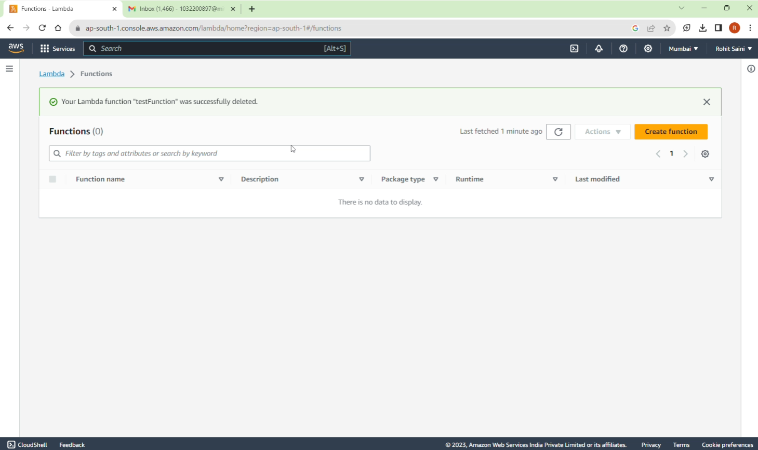

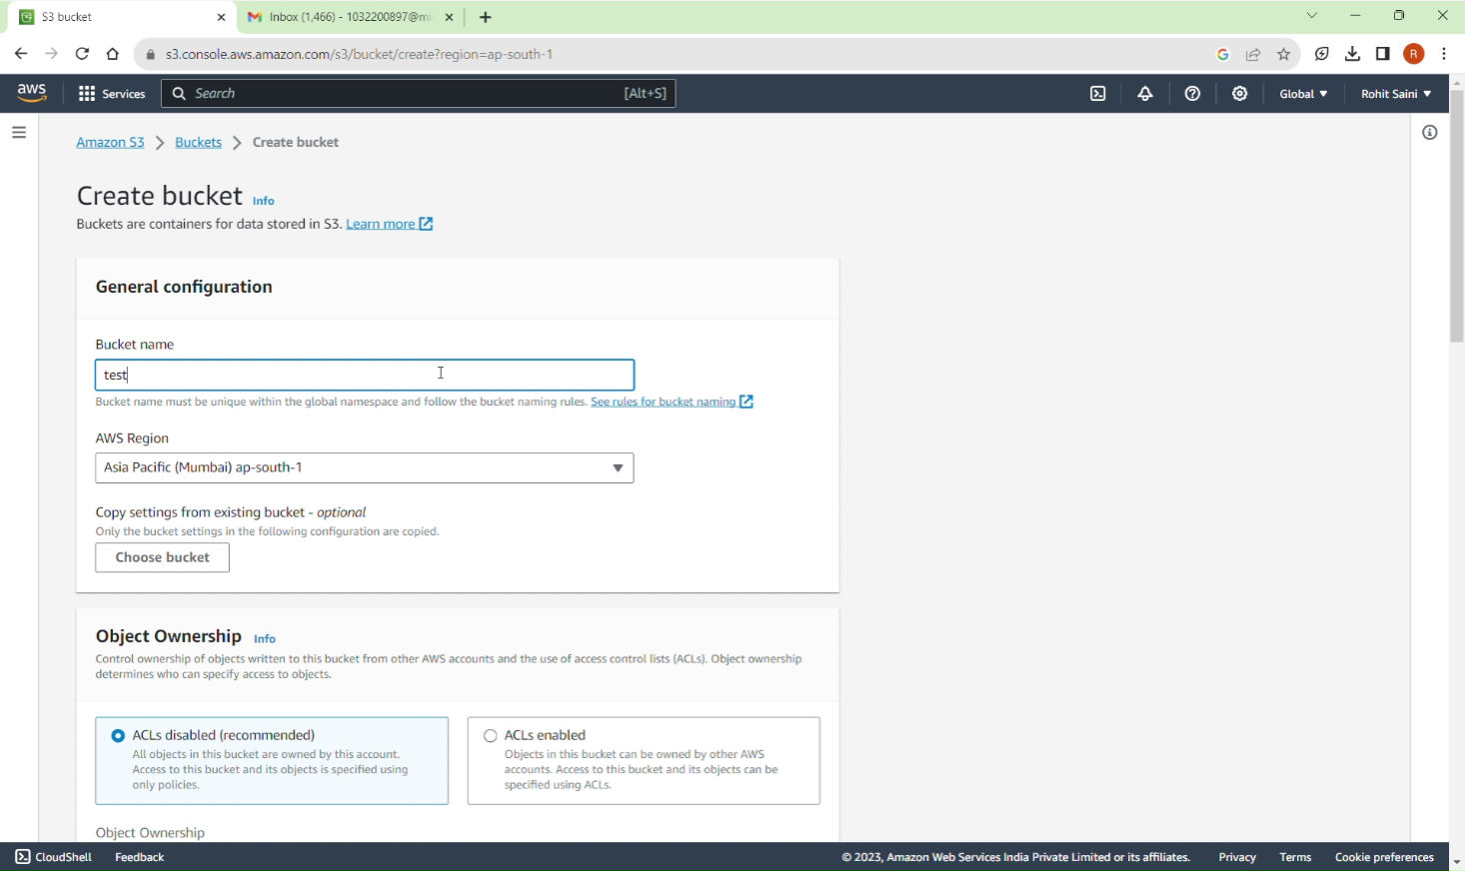 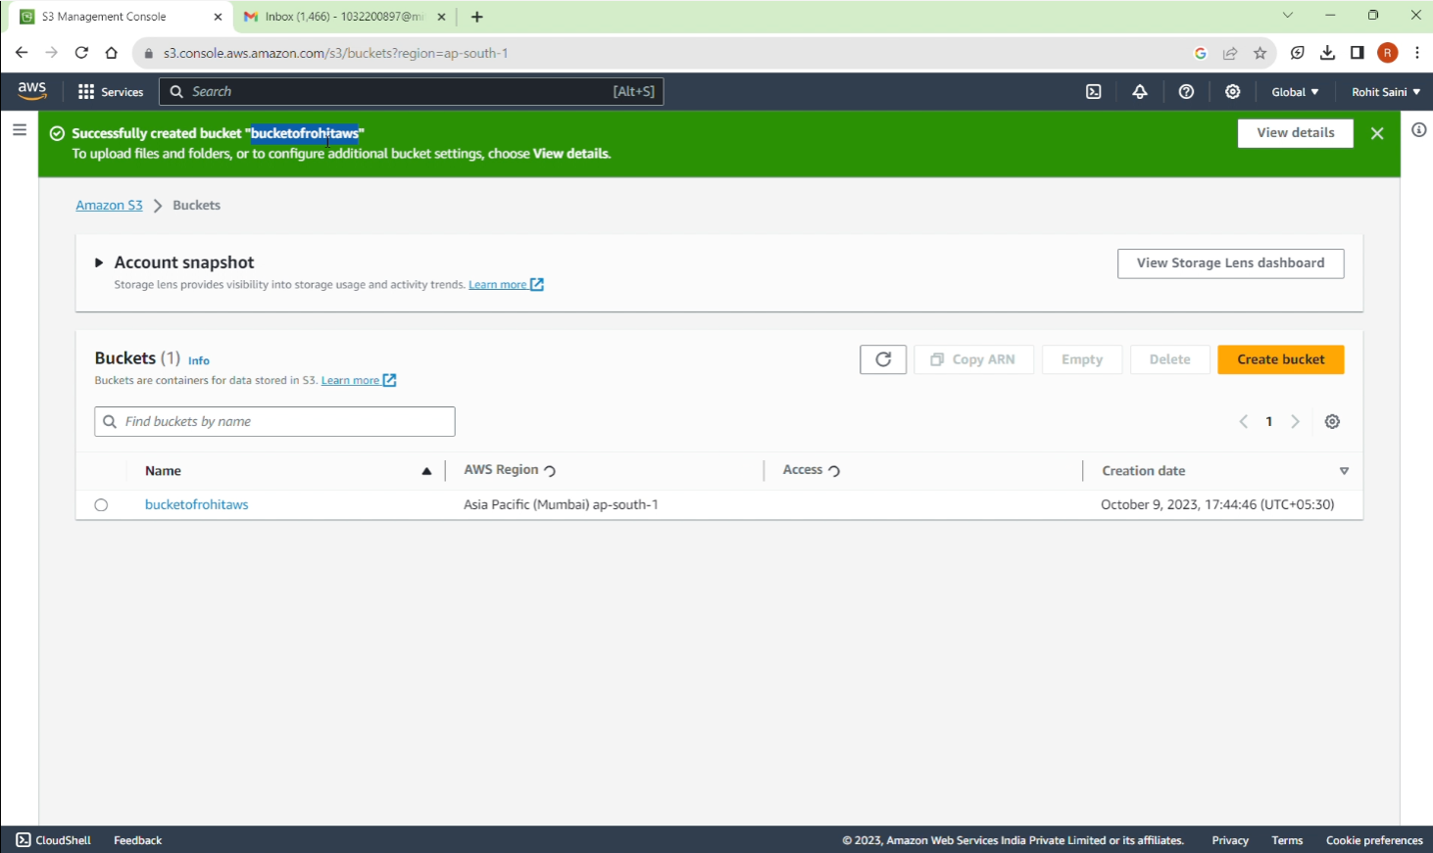 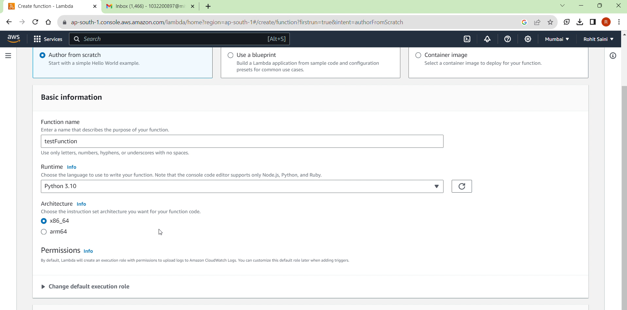 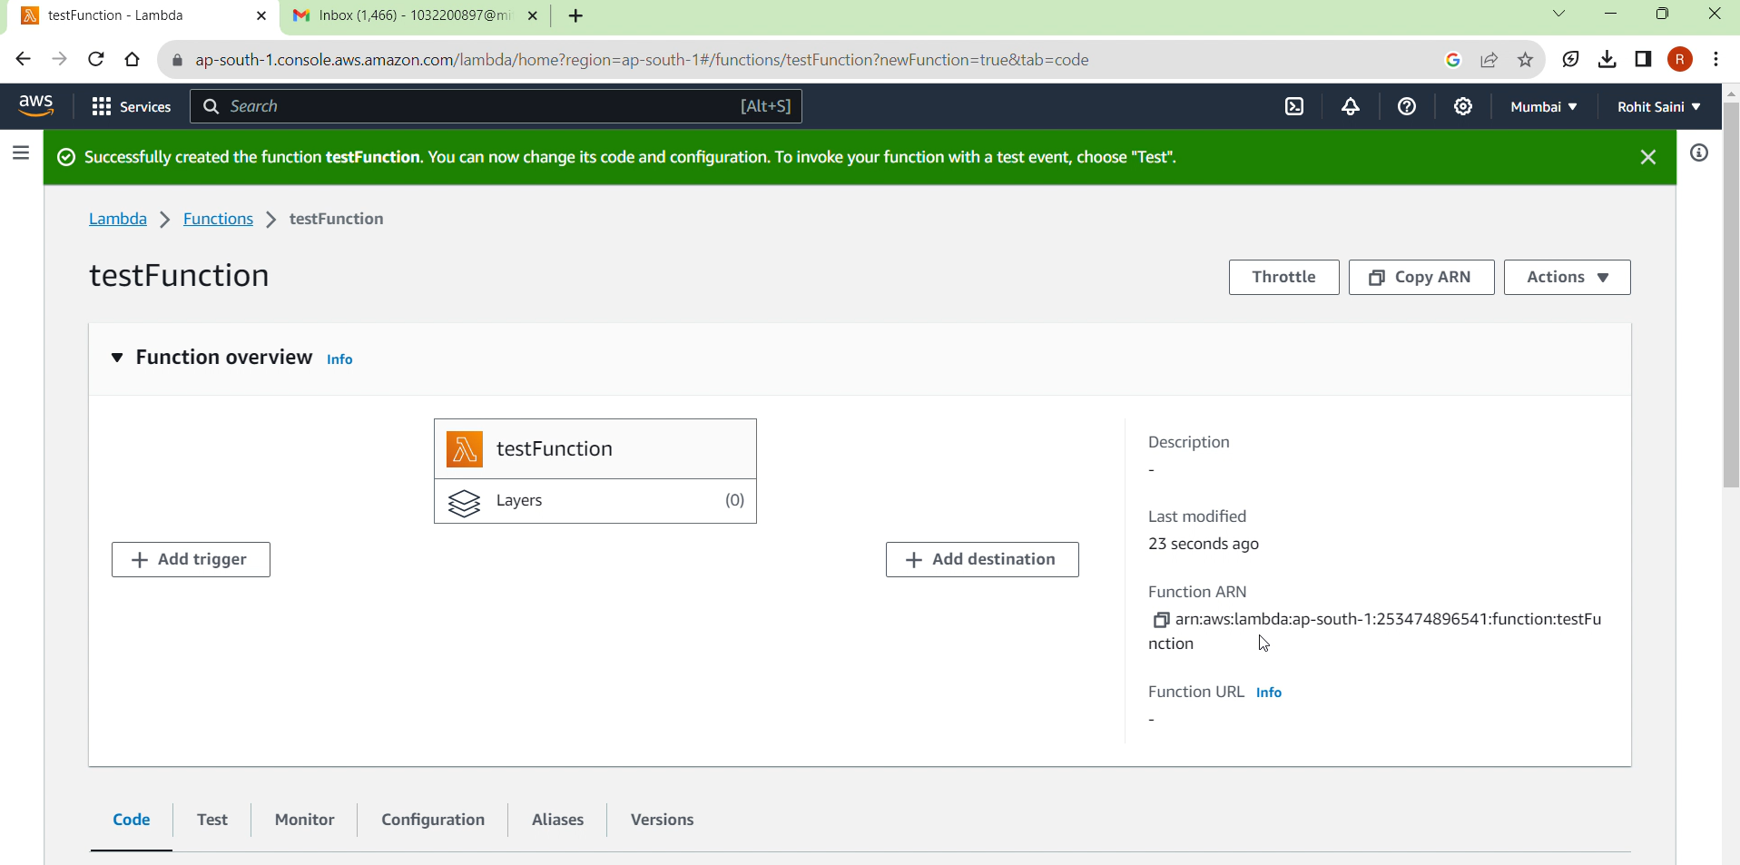 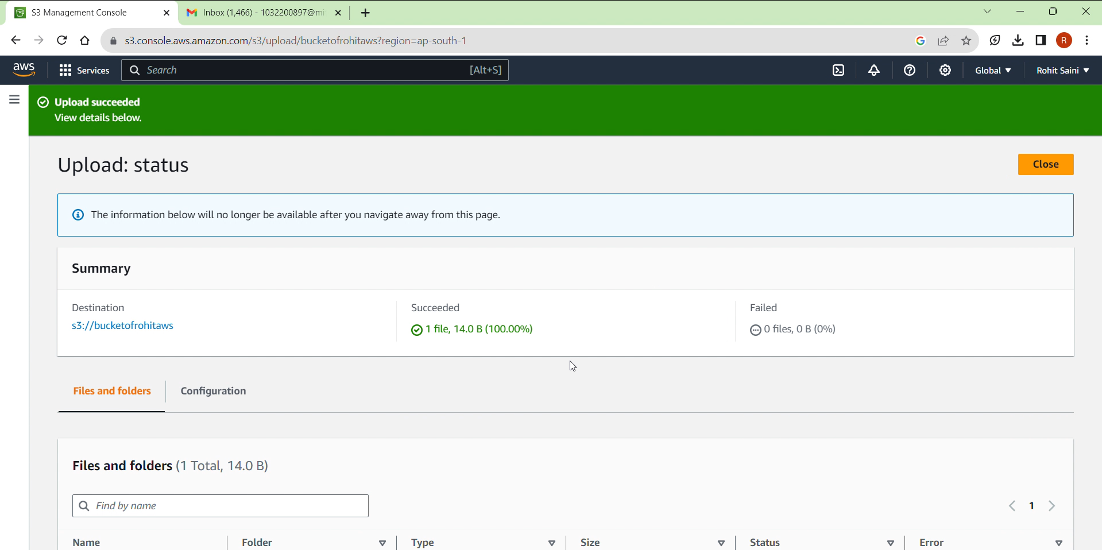 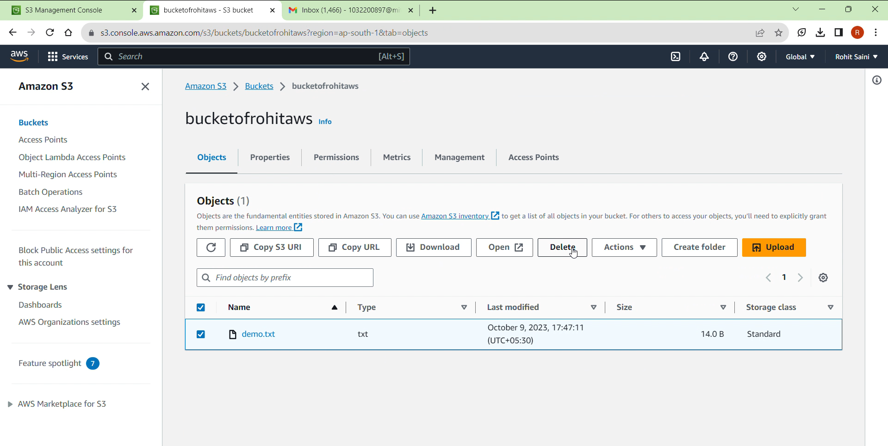

**CONCLUSION:**

**The Resource was successfully created and deleted**

**PLATFORM: windows**

FAQs

1. What is AWS ?
2. What are the different services of Cloud ?
3. What are public and private clouds ?

