

/*

Name: Rohit Saini

Erp: 1032200897

Panel: C

RollNo: PC-41 */

**TITLE :** Write a C Program to Implement Bully Election Algorithm.

**AIM :** To study and implement Bully Election Algorithm

**OBJECTIVES :**

1. To understand the working of election algorithms

2. To simulate bully algorithm

**THEORY :**

# Elections -

Bully Algorithm -

Types of messages -

There are basically 3 types of messages :

1. An election message to initiate the election

2. A reply/response message given in response to the election message

3. A coordinator message sent to inform other processes, the id of the coordinator process.

**INPUT :** Process IDS

**OUTPUT** : Selected Coordinator Process

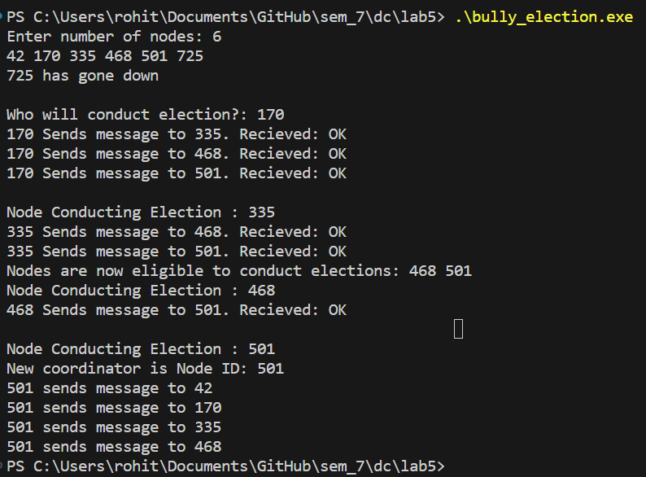

**PLATFORM** : UNIX,

**PROGRAMMING LANGUAGE :** C Language

**Code:**

#include <iostream>

#include <vector>

#include <windows.h>

#include <algorithm>

using namespace std;

class Node

{

public:

    int nodeId;

    bool isOnline;

    Node()

    {

        this->nodeId = rand() % 1000 + 1;

        this->isOnline = true;

    }

    int send(int initiatorId)

    {

        if (this->isOnline && this->nodeId > initiatorId)

        {

            cout << initiatorId << " Sends message to ";

            cout << this->nodeId << ". Recieved: OK" << endl;

            return 1;

        }

        return 0;

    }

    void shutDown()

    {

        Sleep(3);

        cout << this->nodeId << " has gone down" << endl;

        this->isOnline = false;

    }

};

class ElectionCoordinator

{

public:

    vector<Node *> network;

    Node *coordinatorNode;

    ElectionCoordinator(int numNodes)

    {

        for (int i = 0; i < numNodes; i++)

        {

            this->network.push_back(new Node());

        }

        sort(network.begin(), network.end(), [](Node *lhs, Node *rhs)

             { return lhs->nodeId < rhs->nodeId; });

        coordinatorNode = network[numNodes - 1];

    }

    void printNetwork()

    {

        for (Node *node : network)

        {

            cout << node->nodeId << " ";

        }

        cout << endl;

    }

    void final_msg(int nodeId)

    {

        for (Node *node : network)

        {

            if (node->nodeId < nodeId)

                cout << nodeId << " sends message to " << node->nodeId << endl;

        }

    }

    vector<Node *> conductElection(int initiatorId)

    {

        vector<Node *> responses;

        for (Node *node : network)

        {

            if (node->send(initiatorId) == 1)

            {

                responses.push_back(node);

            }

        }

        return responses;

    }

    void selectCoordinator(int nodeId)

    {

        for (Node *node : network)

        {

            if (node->nodeId == nodeId)

                coordinatorNode = node;

        }

    }

};

int main()

{

    int numNodes;

    cout << "Enter number of nodes: ";

    cin >> numNodes;

    ElectionCoordinator election(numNodes);

    election.printNetwork();

    election.coordinatorNode->shutDown();

    int initiatorId;

    vector<Node *> eligibleNodes;

    cout << "\nWho will conduct election?: ";

    cin >> initiatorId;

    eligibleNodes = election.conductElection(initiatorId);

    while (eligibleNodes.size())

    {

        initiatorId = eligibleNodes[0]->nodeId;

        cout << "\nNode Conducting Election : " << initiatorId << endl;

        eligibleNodes = election.conductElection(initiatorId);

        if (eligibleNodes.size() > 1)

        {

            cout << "Nodes are now eligible to conduct elections: ";

            for (Node *node : eligibleNodes)

            {

                cout << node->nodeId << " ";

            }

        }

    }

    cout << "New coordinator is Node ID: " << initiatorId << endl;

    election.selectCoordinator(initiatorId);

    election.final_msg(initiatorId);

    return 0;

}

**CONCLUSION** : Thus, bully algorithm is successfully implemented.

**FAQs**

1. What is the time complexity (best,avg,worst)of bully algorithm
2. Why do we have to elect the coordinator process
3. How did the name of “Bully” approach come up ?

