/*

Name: Rohit Saini

Erp: 1032200897

Panel: C

RollNo: PC-41 */

**TITLE:**

Implementation of Network File System [ NFS ]

**AIM:**

To implement Network File System [ NFS ] to show

1. Mouting, unmounting of a file system
2. Addition and Deletion of Files

**OBJECTIVE:**

To understand the concept of Network File System [ NFS ]

**THEORY:**

**Describe NFS:**

NFS, or Network File System, is a distributed file system protocol allowing a user on a client computer to access files over a network as if they were on a local device. Explain mounting and unmounting of remote files

**Mounting:** Attaching a remote file system onto a local directory, allowing the files from the remote system to be accessed as if they were part of the local file system.

**Unmounting:** Detaching the remote file system from the local directory, severing the connection and preventing further access to the remote files from that specific mount point.

**Give all steps to accomplish the NFS**

* Install NFS server software on the server machine.
* Configure shared directories to be accessed by NFS.
* Specify access permissions for the shared directories.
* Start the NFS server service.
* Install NFS client software on the client machine.
* Mount the remote NFS directory onto a local mount point on the client.
* Access and use files in the mounted directory as if they were local.
* Unmount the directory when finished to terminate the connection.

**INPUT:**

Addition or deletion of a file in the file system

**OUTPUT:**

The depiction of Addition or deletion of a file in the file system

**CONCLUSION:**

The NFS was accomplished for file related functionalities

**PLATFORM:**

Linux

**LANGUAGE:**

C language.

FAQs

1. Explain mounting and un-mounting of files
2. What are the other file systems like the NFS
3. What communication protocols are used for NFS

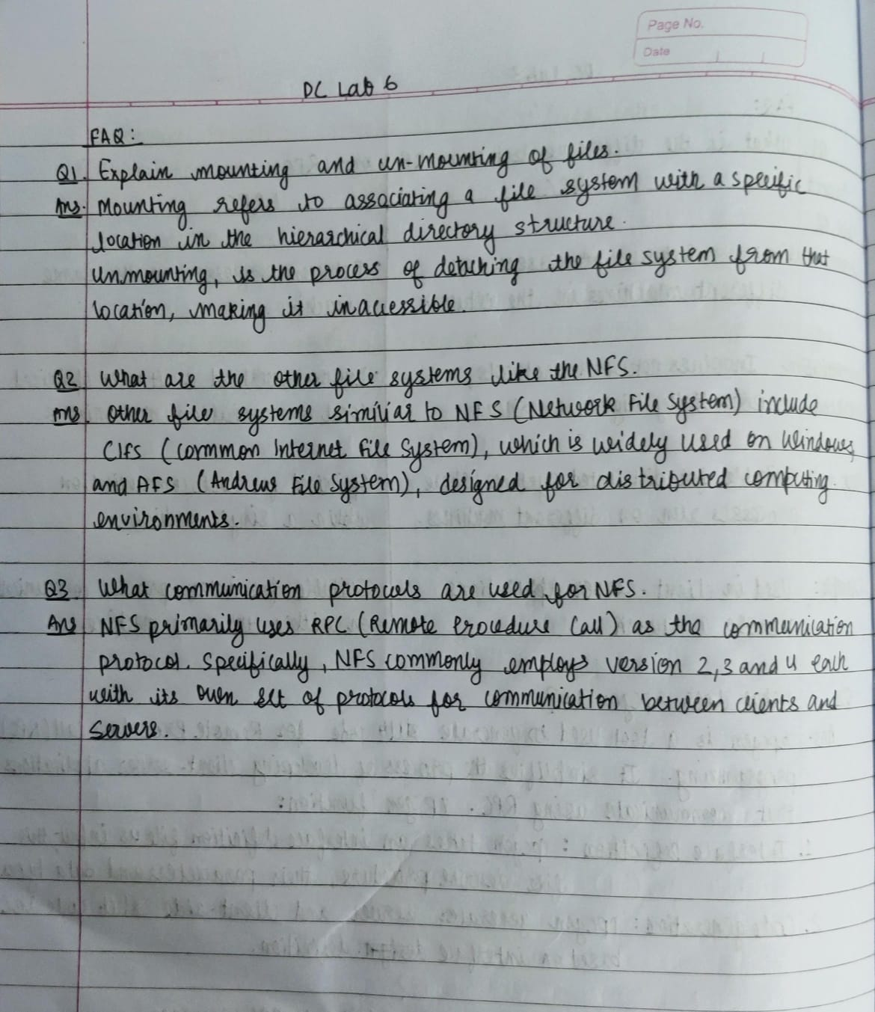

**Client NFS:**

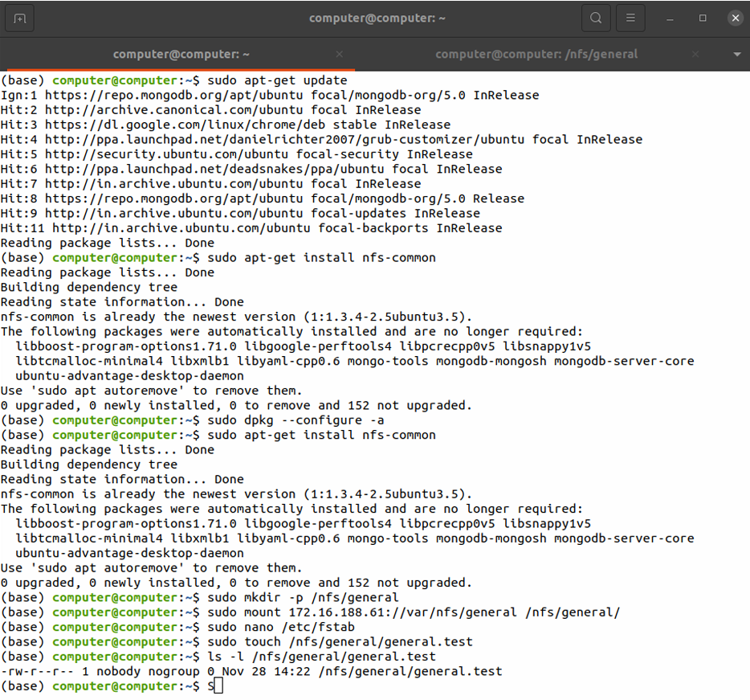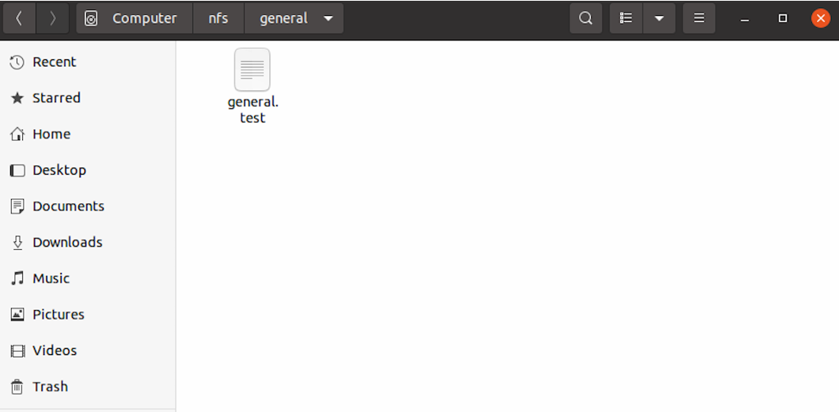

**Server NFS:**

