/*

Name: Rohit Saini

Erp: 1032200897

Panel: C

RollNo: PC-41 */

**TITLE:**

Installation of VMWare workstation on a windows or Ubuntu server platform as per requirement.

**AIM:**

To Install VMWare workstation on a windows or Ubuntu server platform

**OBJECTIVE:**

To understand the concept VMWare and its working

**THEORY:**

**Cloud Computing:**

Cloud computing is the delivery of computing services (e.g., storage, processing power, software) over the internet, allowing users to access and use resources on a pay-as-you-go basis.

**Virtualization:**

Virtualization involves creating virtual representations of computing resources (e.g., servers, storage) to abstract the underlying physical hardware, enabling efficient resource utilization.

**VMware:**

VMware is a company that specializes in virtualization and cloud computing. VMware's vSphere platform uses a type-1 hypervisor to create and manage virtual machines on a host server, providing benefits such as resource optimization and centralized management.

**INPUT:**

Decide the installation environment parameters

**OUTPUT:**

Accomplishment of the installation of VMWare

**CONCLUSION:**

The VMWare installation was accomplished.

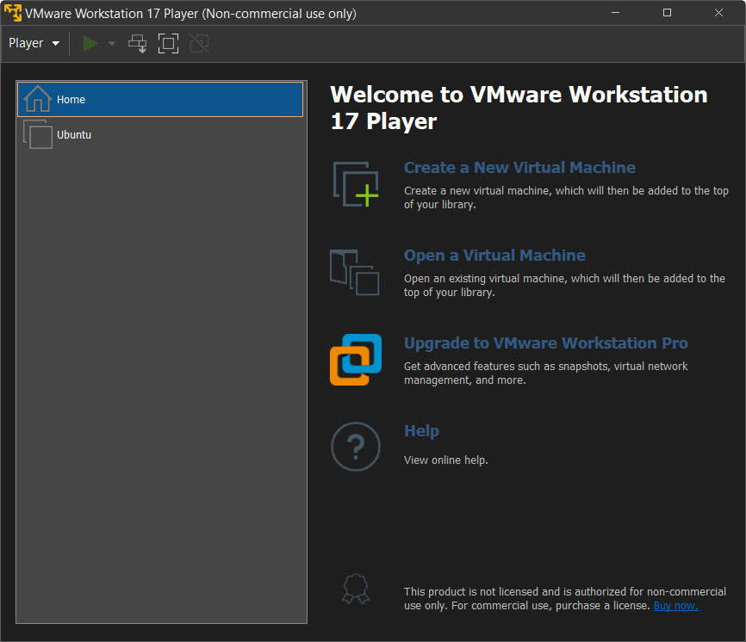 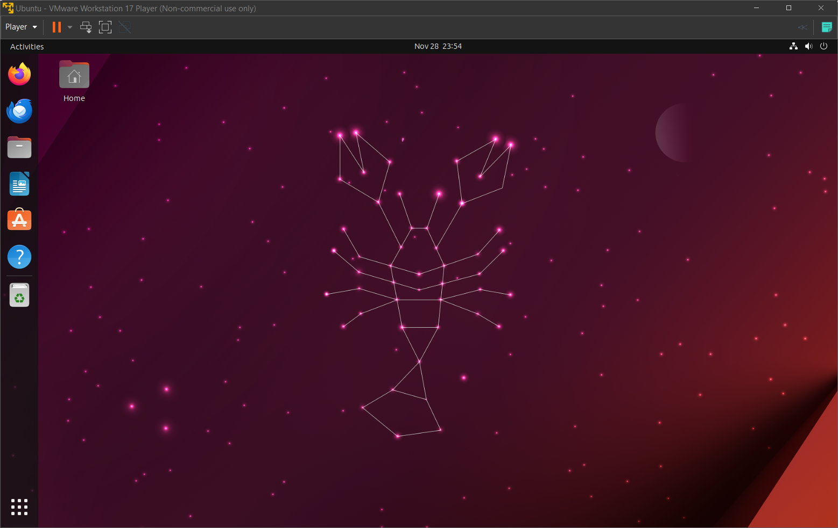

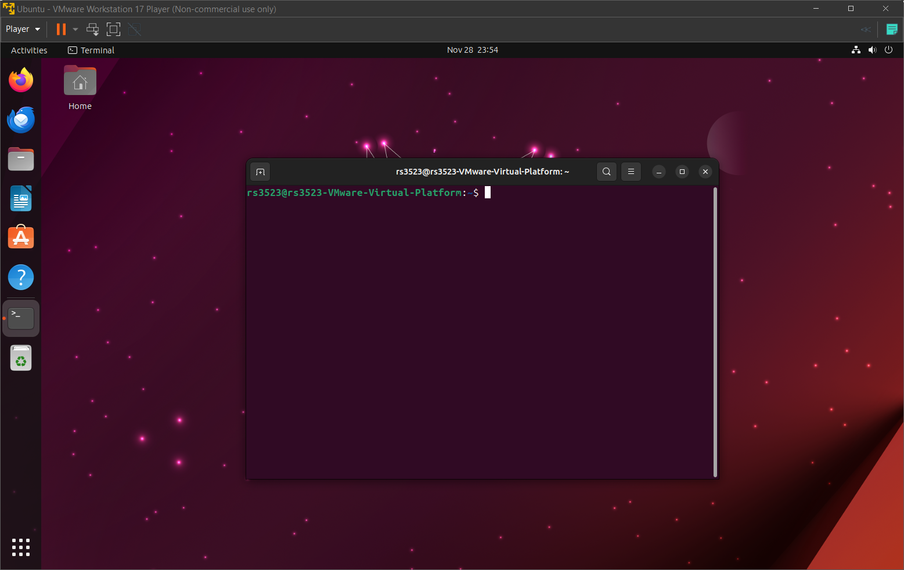

**PLATFORM:**

Linux

**LANGUAGE:**

C language.

FAQs

1. Explain the types of virtualization
2. What are the VMWare applications
3. Give example of a Virtual Server

