**LAB-8**

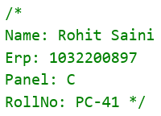

**TITLE:**

Case Study: Application of Cloud computing

**AIM:**

To create a presentation for any appropriate cloud computing application

**OBJECTIVE:**

To understand the importance of Cloud computing application

**THEORY:**

**Introduction to Case:**

Cloud computing has found widespread applications across various industries, and the healthcare sector is no exception. This case study explores the adoption of cloud computing in healthcare and the significant advantages it offers in terms of improving patient care, data management, and cost efficiency.

**Client Profile:**

Hospital XYZ, a medium-sized hospital located in a suburban area, has been providing healthcare services for several years. With increasing patient records, diagnostic data, and the need for secure and efficient information sharing, the hospital decided to transition to cloud computing.

**Challenges:**

**Data Management**: Hospital XYZ had accumulated a vast amount of patient data, including medical records, diagnostic images, and administrative information. Managing and securing this data was becoming increasingly complex.

**Scalability:** The hospital's IT infrastructure struggled to handle the growing volume of data and increasing demand for online services.

**Cost Efficiency:** Hospital XYZ aimed to reduce operational costs while improving the quality of patient care.

**Solution:**

Hospital XYZ decided to implement cloud computing solutions to address these challenges. They partnered with a reputable cloud service provider and adopted a multi-faceted approach:

**Electronic Health Records (EHR):** The hospital migrated its patient records to a cloud-based EHR system. This transition allowed authorized medical professionals to access patient data securely from any location, enhancing collaboration and reducing paperwork.

**Medical Imaging Storage**: Cloud storage was utilized to store and manage diagnostic images, such as X-rays and MRIs. This eliminated the need for physical film storage, reduced data retrieval times, and improved accessibility.

**Scalable Infrastructure:** The hospital's IT infrastructure was migrated to Infrastructure as a Service (IaaS) to ensure scalability. This ensured that resources could be easily adjusted to meet fluctuating demands, such as during the flu season or a public health crisis.

**Telemedicine:** Hospital XYZ embraced cloud-based telemedicine solutions, allowing doctors to conduct remote consultations with patients. This was particularly useful during the COVID-19 pandemic when in-person visits were restricted.

**Security and Compliance:** The cloud provider ensured that healthcare data remained compliant with the Health Insurance Portability and Accountability Act (HIPAA) regulations. Data encryption, access controls, and regular security audits were implemented.

**Results:**

The adoption of cloud computing brought about several notable results for Hospital XYZ:

**Improved Patient Care:** Healthcare providers gained quick and secure access to patient data, leading to more informed decisions and better patient care.

**Cost Reduction:** The hospital experienced significant cost savings due to reduced hardware maintenance, paperless operations, and optimized resource utilization.

**Scalability:** Hospital XYZ could easily scale its IT resources up or down, depending on demand, ensuring efficient resource utilization and cost management.

**Data Security:** Patient data remained secure and compliant with healthcare regulations, assuring patients of the safety of their information.

**Accessibility:** Doctors could provide telemedicine services, reaching patients in remote areas and during emergencies.

**Conclusion:**

The adoption of cloud computing has transformed Hospital XYZ's operations, leading to better patient care, cost efficiency, and streamlined data management. The cloud's scalability and accessibility have enabled the hospital to provide high-quality healthcare services even during challenging times, making it a valuable application of cloud computing in the healthcare industry.

**Creating a Lambda Function on AWS:**

1. AWS Lambda is a serverless computing service for running code without managing servers.

2. Lambda functions can be created through the AWS Management Console, AWS CLI, or SDKs.

3. Functions have triggers that define when and how they execute, such as Amazon S3 bucket events.

4. Each function has a handler function, the entry point for your code.

5. AWS Lambda provides an execution environment, including memory allocation and CPU power.

6. Lambda scales automatically based on incoming requests and is priced based on requests and execution time.

**Using Amazon S3 Buckets:**

1. Amazon S3 (Simple Storage Service) is a scalable and highly available object storage service by AWS.

2. S3 buckets, the containers for data storage, can be created through the AWS Management Console, AWS CLI, or SDKs.

3. Objects, such as files and data, are stored inside S3 buckets and have unique keys.

4. Bucket policies and access control lists (ACLs) are used to control access to objects in buckets.

5. S3 buckets can be configured to generate events based on object-related activities, like object creation.

6. Amazon S3 offers data lifecycle management, versioning, and high durability by replicating data across Availability Zones.

7. Events in S3 buckets can trigger Lambda functions, enabling serverless automation of tasks.

8. S3 is scalable, durable, and suitable for storing and retrieving data efficiently.

**INPUT:**

Creation of presentation on Cloud Computing

**OUTPUT:**

**Lambda Function:**

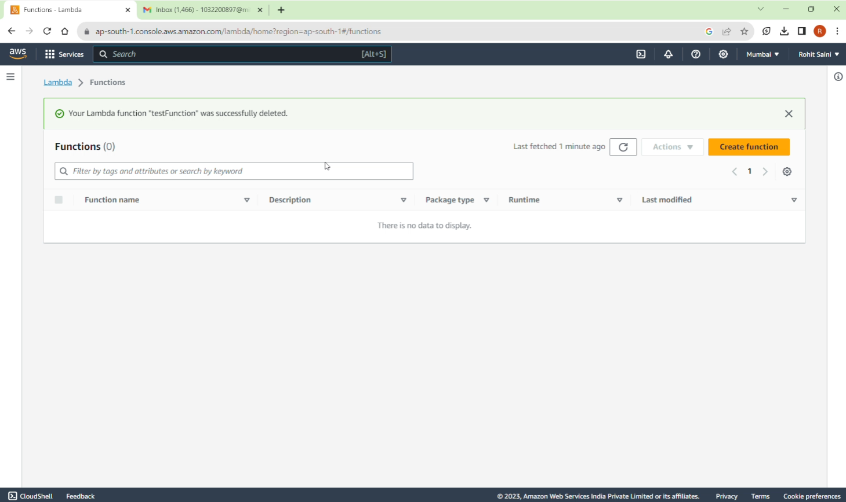

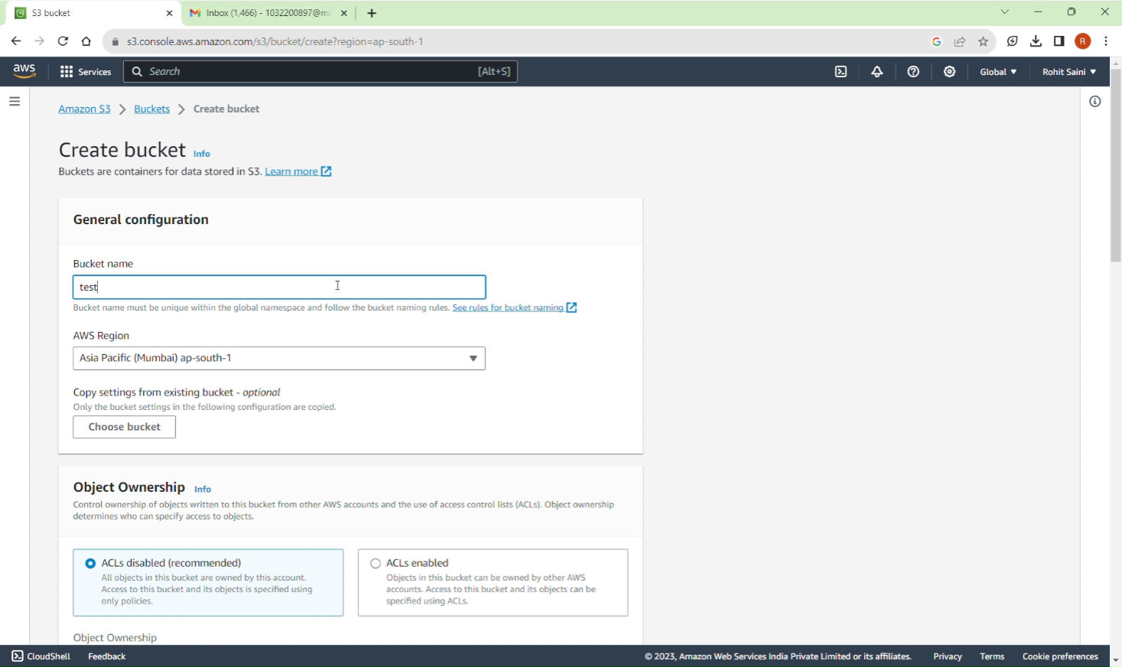 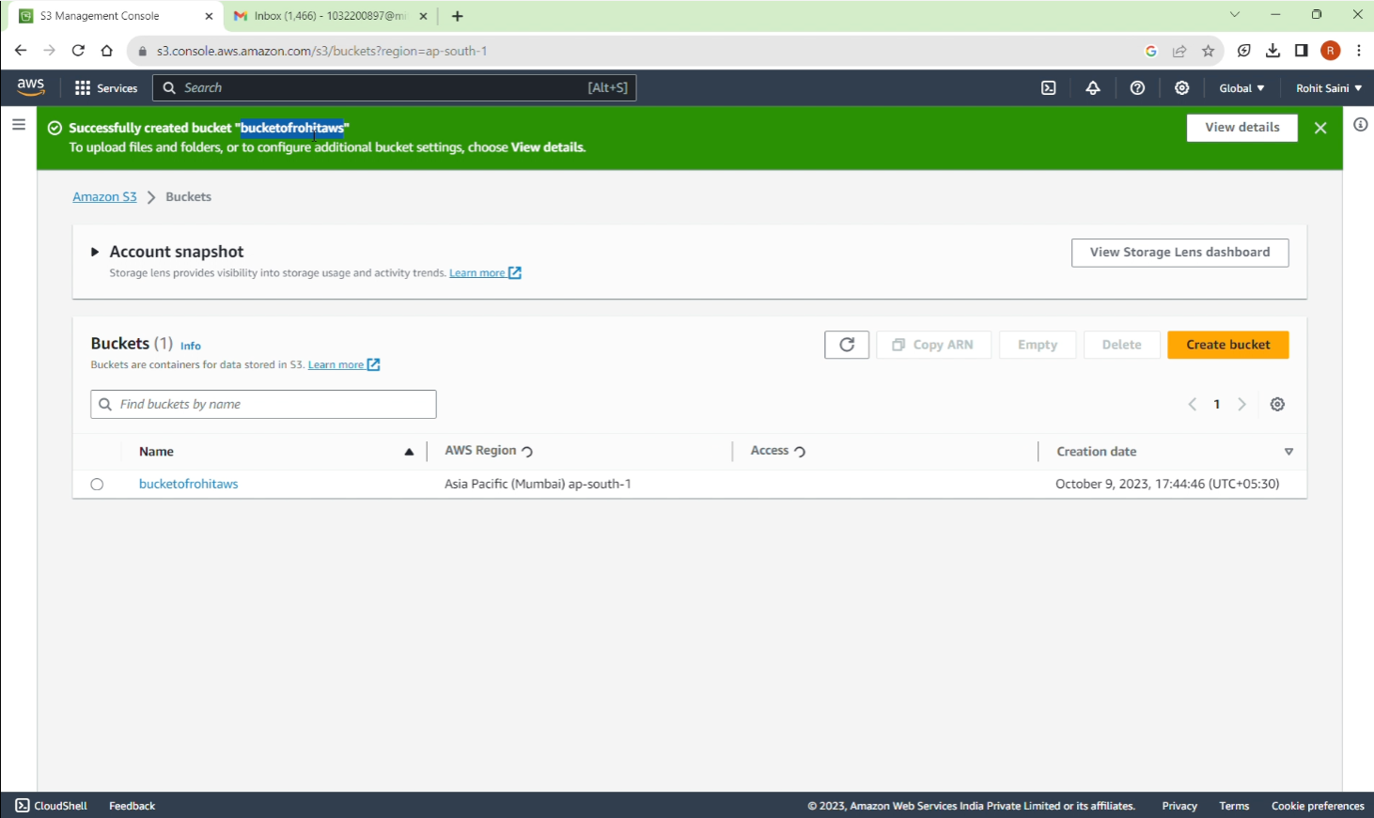 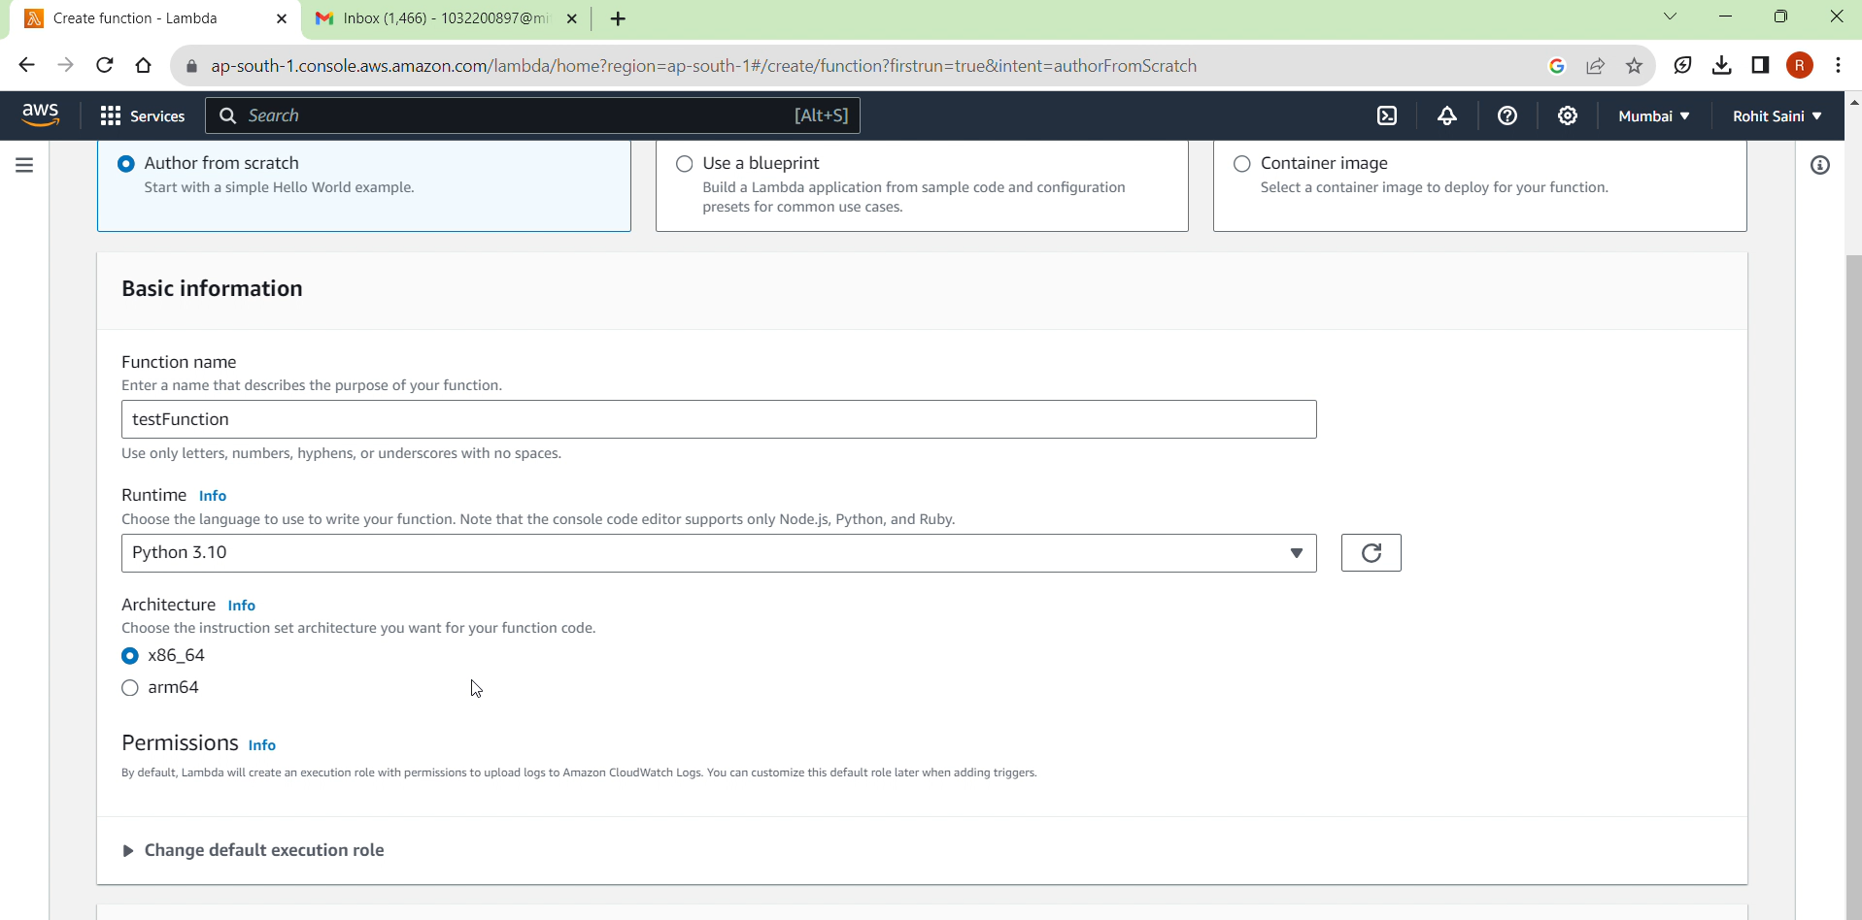 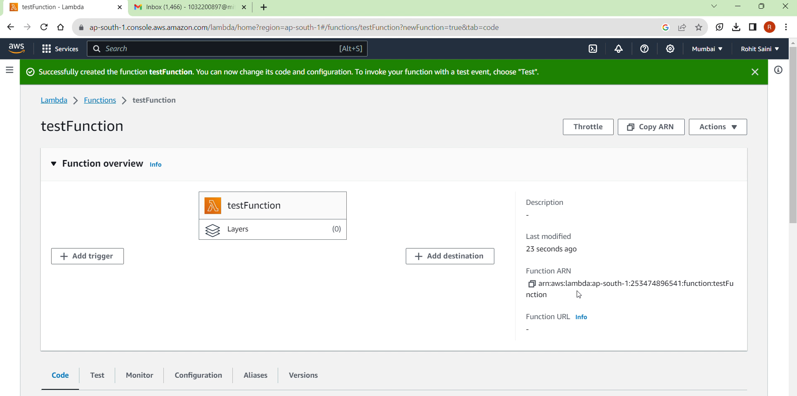 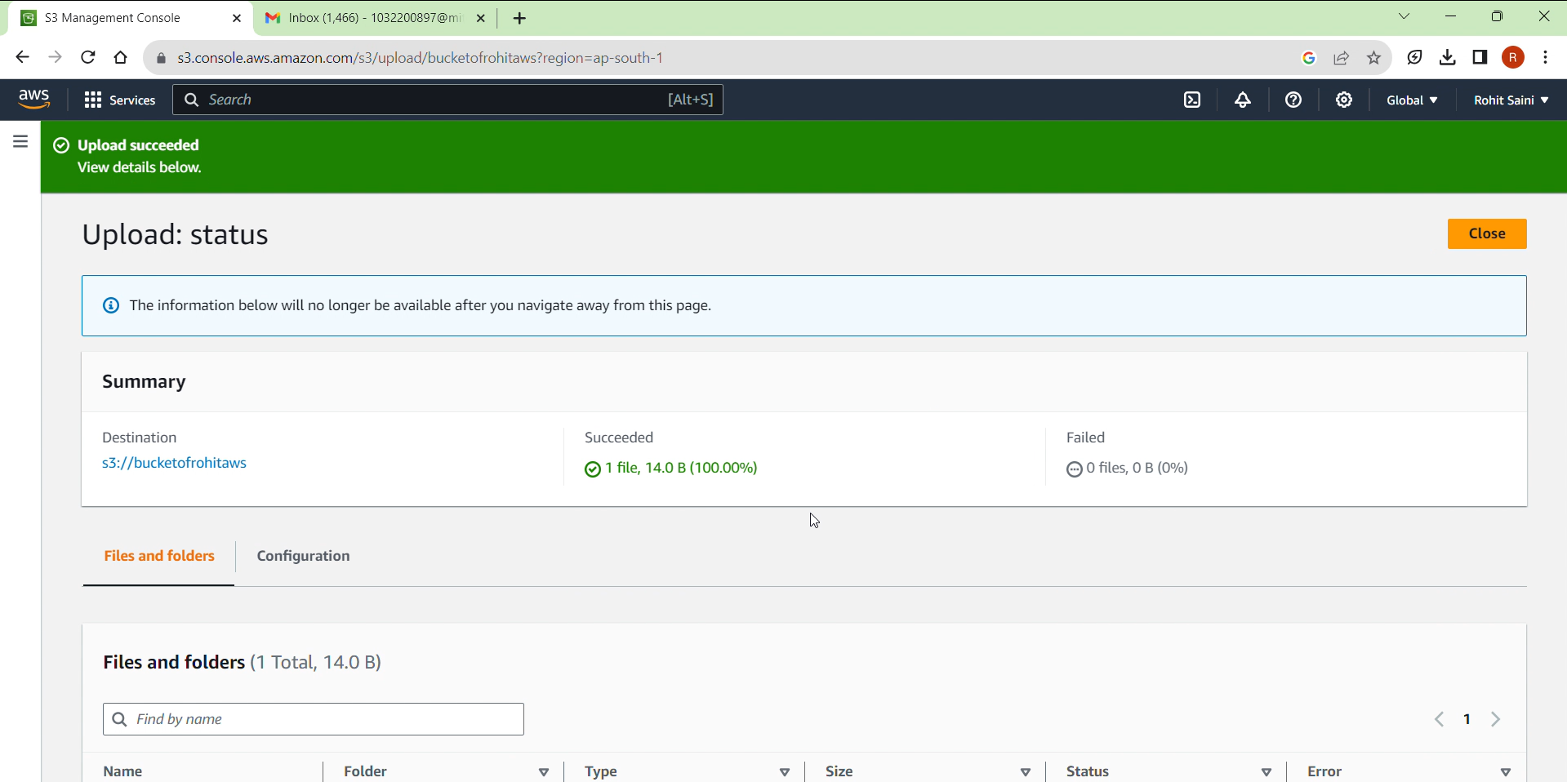 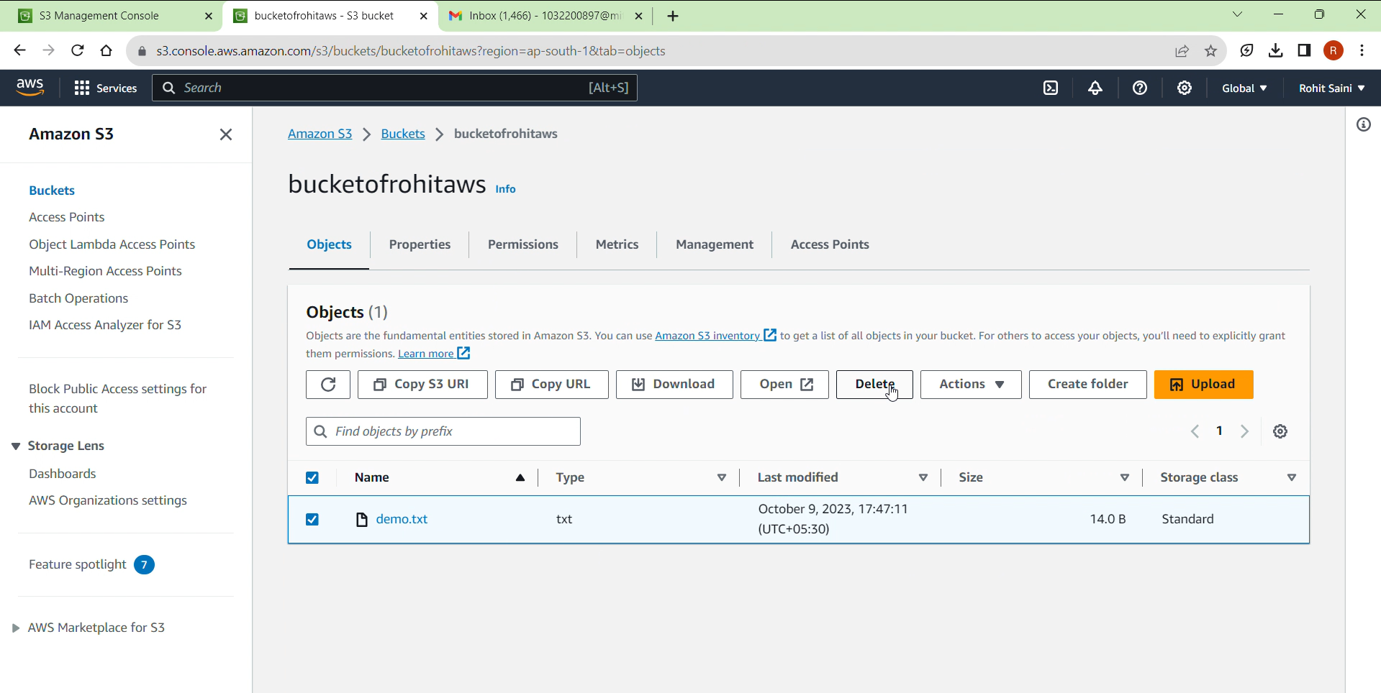

The presentation has been accomplished with important takeaways

**CONCLUSION:**

The presentation has been accomplished with knowledge gain

**PLATFORM:** Linux

**LANGUAGE:** C language.

FAQs

1. What are public and private clouds ?
2. What are the different types of services offered by clouds ?
3. How is distributed computing and cloud computing related ?

