/*

Name: Rohit Saini

Erp: 1032200897

Panel: C

RollNo: PC-41 */

**TITLE:**

To create a cluster of machines

**AIM:**

To create a cluster of machines and achieve a password less access

**OBJECTIVE:**

To understand the importance of clusters in distributed computing

**THEORY:**

**Cluster Computing:**

Cluster computing involves multiple interconnected computers (nodes) working together to solve computational problems, enhancing processing power. It's used for complex tasks and applications.

**Steps to Create Clusters:**

1. Define Purpose: Identify tasks and applications for the cluster.
2. Select Hardware: Choose compatible hardware for each node.
3. Install OS: Install an operating system on each node.
4. Set Up Network: Establish a reliable, high-speed network connection.
5. Install Middleware: Install cluster middleware for communication.
6. Configure Node Communication: Configure nodes to communicate effectively.
7. Set Up Shared Storage: Establish shared storage for all nodes.
8. Install Applications: Install and configure applications for parallel processing.
9. Testing: Conduct thorough testing of the cluster.
10. Monitoring and Management: Implement monitoring tools for performance tracking.
11. Documentation: Document cluster configuration and specifications.
12. Scale as Needed: Add more nodes if necessary, maintaining compatibility.

**INPUT:**

Creation of clusters

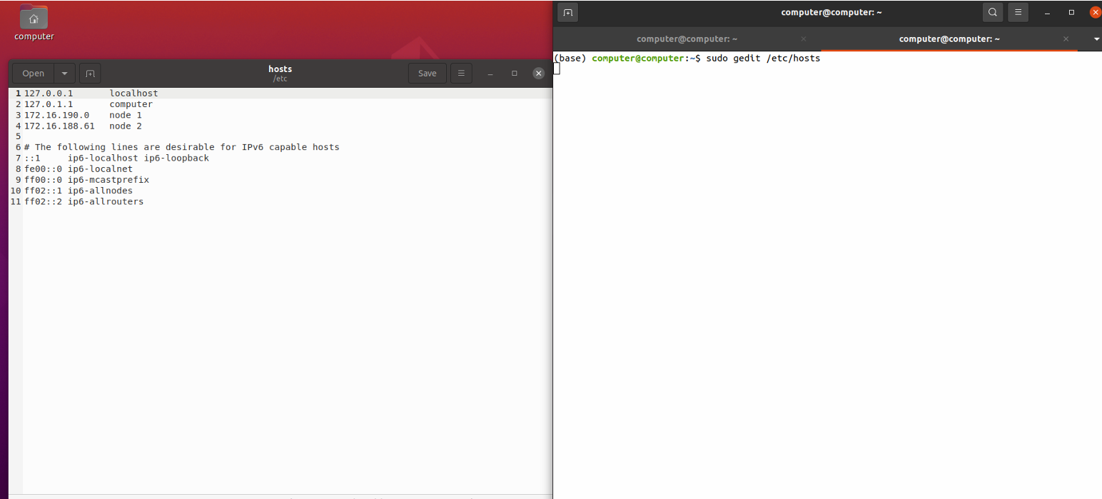

**OUTPUT:**

To get a password-less access to machines on the created cluster

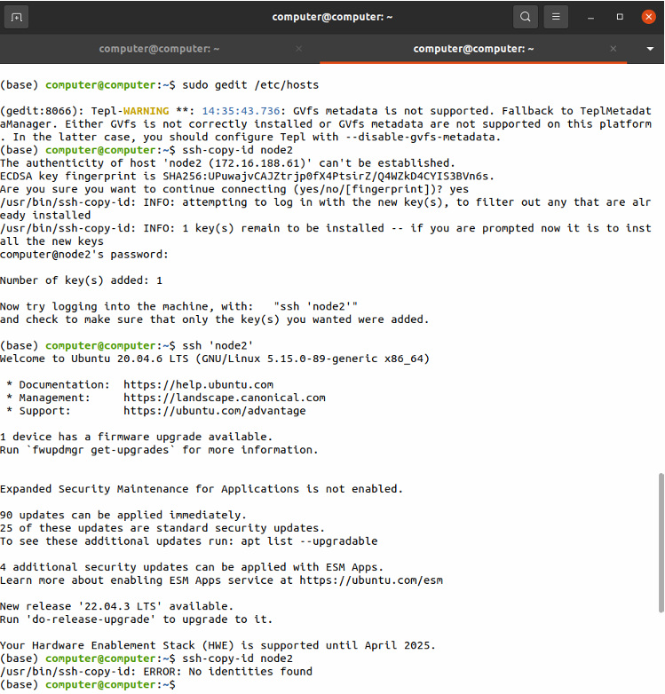

**CONCLUSION:**

The cluster of machines was accomplished

**PLATFORM:**

Linux

**LANGUAGE:**

C language.

FAQs

1. What is a cluster of machines ?
2. What is a grid of machines ?
3. Give applications of Cluster Computing

