**INVENTORY CONTROL SYSTEM**

**FOR**

**CALCULATION AND ORDERING OF AVAILABLE AND PROCESSED RESOURCES**



## GROUP 10

* **ROHIT SHARMA SCHOLAR NO: 22U02037**

## PANKAJ GUPTA SCHOLAR NO: 22U02038

* **GAURAV MAMGAIN SCHOLAR NO:22U02039**
* **MANOJ RAYUDU SCHOLAR NO: 22U02040**

**SUBMITTED TO: DR ASHISH KUMAR SAHU.**

UML DIAGRAMS OF THE PROJECT

1- USE CASE DIAGRAM

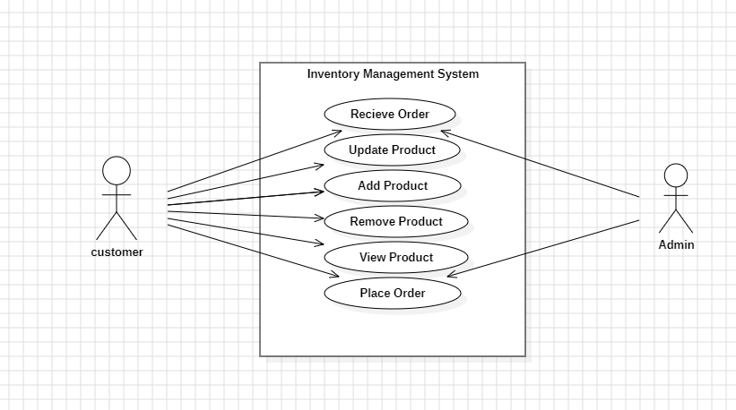

2-CLASS DIAGRAM

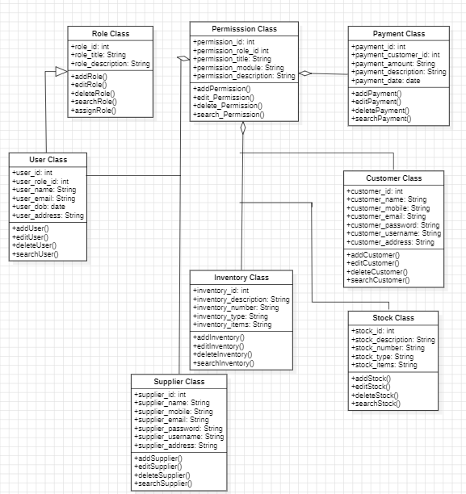

3- SEQUENCE DIAGRAM

