**Assignment of Micro frontend**

1. Github url - <https://github.com/rohitsharma2522/microfrontend-insurance-app>
2. Insurance container App : <https://rs-insurance.netlify.app/>
3. MFE App 1 : <https://rs-insurance-app1.netlify.app/>
   1. remoteEntryUrl : https://rs-insurance-app1.netlify.app/remoteEntry.js
4. MFE App 2 : <https://rs-insurance-app2.netlify.app/>
   1. remoteEntryUrl : https://rs-insurance-app2.netlify.app/remoteEntry.js

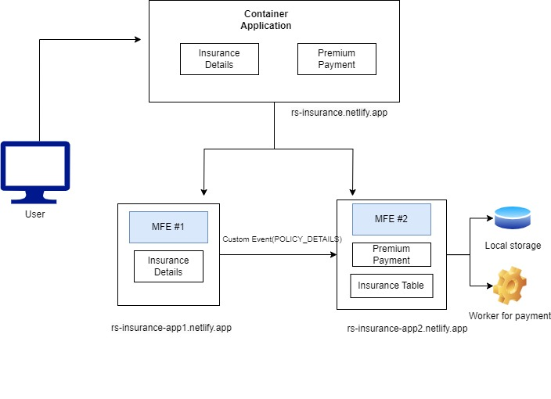

**To deploy this locally**

1. Clone the repo from Github
2. Run yarn install under the microfrontend app and container app
3. Run each application individually using yarn start
4. Microfrontend APP 1 will run on localhost:3001
5. Microfrontend APP 2 will run on localhost:3002
6. Container APP will run on localhost:3000
7. After doing the payment from the app data will be stored into the browser localstorage