**Propose´s app: Play Live streans, Videos on Demand and Radios.**

**On the very first time app loads should show this REGISTRATION screen. App will let access fur just users allowed.**

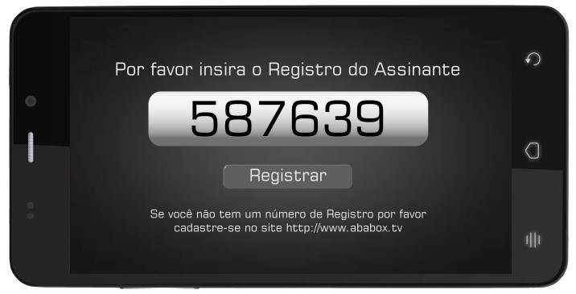

User insert his ID and app runs the PHP file that will return fill values . This Screen shows just one time for registration.

User´s ID should be saved on app for every time app is loaded should run this URL with his ID <http://broadkingdom.ddns.net:8085/scripts/gateway_mobile_android.php?ID=070307> , this PHP will return fill values one parameter per line

The values returned will be something like this:

//Show Splash Screen

http://broadkingdom.ddns.net:8085/scripts/abamob_logo.png  
1  
http://broadkingdom.ddns.net:8085/scripts/stb/live/mobile.xml  
http://broadkingdom.ddns.net:8085/scripts/stb/vod/000046_mob.xml <http://broadkingdom.ddns.net:8085/scripts/stb/radio/000046.xml>

<http://broadkingdom.ddns.net:8085/scripts/vod_logo.png>

http://broadkingdom.ddns.net:8085/scripts/radio_logo.png

*** this values may change for each user.

**1) When runs , after registration, should Show BROADKINGDOM LOGO for 3 seconds and after that runs the FIRST LINE URL, that line is the URL for the PARTNNER LOGO, this URL changes every day so every time app runs this URL should be loaded.**

**Example of First SCREEN BROADKINGDOM LOGO**

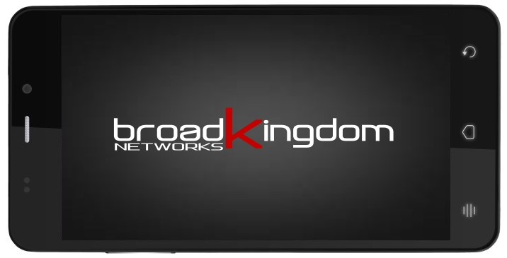

**Example of SECOND SCREEN PARTNNER LOGO “first line of PHP”**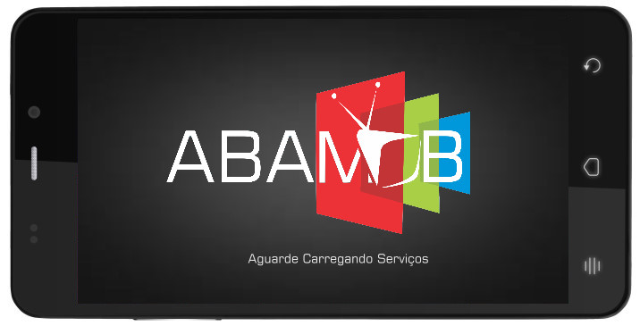

**2)The second Line is the USER STATUS, and app will proceed as value changes.**

If value is “**0”,**  user was not found on database or the input is wrong , so app should return to registration screen showing the message “Assinante não localizado, tente novamente.” As bellow.

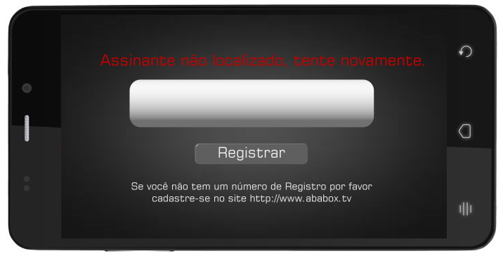

If value is “1” User is good to go! App will open live channels screen.

If value is “2” , user for some reason dosent have permition to run app and should show this message “Olá, sua licença expirou, por favor efetue o pagamento ou entre em contato com o suporte técnico.” When user touches screen app quits.

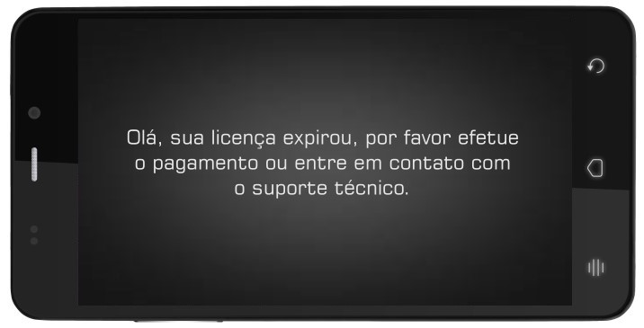

If value is “**3”, u**ser has too many app running at the same time with the same ID, so app should show this message. “Olá, sua licença permite apenas 2 usuários utilizando o sistema ao mesmo tempo.” When user touchs screen app quits.

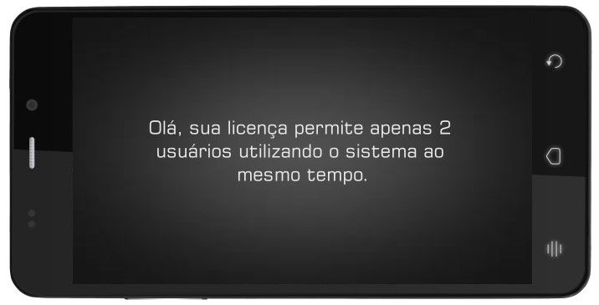

**2)** The third Line/Value is the xml file that will load all **LIVE channels**, **the name of file and his content changes every day and this need to be reloaded every time user loads app**.

**3)** The fourth Line/ Value is the xml file that will load all **VOD & PPV videos**, **the name of file and his content changes every day and this need to be reloaded every time user loads app**.

**4)** The fifth Line/ Value is the xml file that will load all **RADIO STATIONS**, **the name of file and his content changes every day and this need to be reloaded every time user loads app**.

***LIVE CHANNEL SCREEN***

After Registration is complete and user have acces to use app goes to the screen bellow, LIVE CHANNELS, the third line is the XML file where the Channels list is loaded.

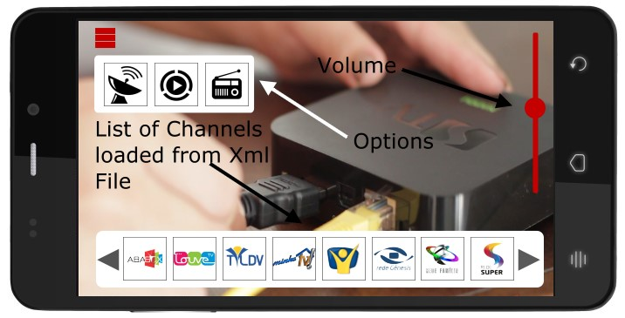

To check the XML format just run on your bowser the third line of php, on that particular example is <http://broadkingdom.ddns.net:8085/scripts/stb/live/mobile.xml>

Tags are

<video>

<chnunmber></chnunber> = **Channel Number**

<channel_status></channel_status> = **Channel Status, ON or OFF**

<icon></icon> = **Icon for when channel status is “on”**

<iconoff></iconoff> = **Icon for when channel status is “off”**

<LINK></LINK> = **The live stream channel.**

</video>

The three red bars on top left corner are to show options - LIVE, VOD, RADIO.

One screen touch calls list channels and 3 red bars, one touch on channel icon call channel, one touch on 3 red bars show the 3 options app have “LIVE-VOD-RADIO”.

On right side volume control.

App should show a red circle loading when something takes time to open.

NOT DONNE

*VIDEO ON DEMAND - VOD*

Now we have to insert on touch screen to the icons for LIVE - VOD and RADIO – Called Options

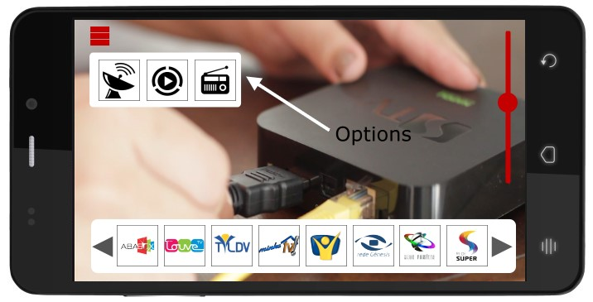

Every time user touch , open the options…. On channels and VOD PLAYBACK this  just show when user touch screen, on VOD SCREEN stay always on.

When user touch VOD “second icon from left app should first show VOD WELCOME SCREEN, this image is provided from php, is the 6TH line of php response. This will be same procedure as “second logo”.

On touch a red square should change on options icon, as live channels icons.

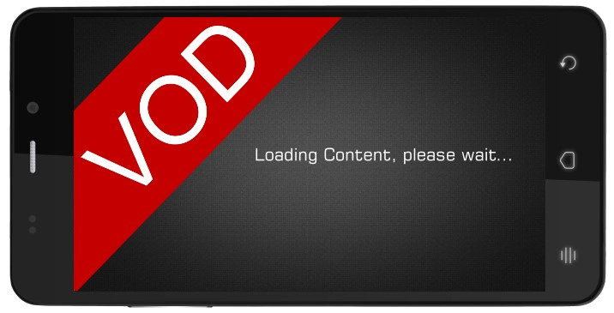

This screen will stay for how long takes to load the xml file for vod . This file is provided from php too and is the 6th line. Red circle loading applies.

REMEMBER ALL THIS LINE NEED TO BE CHECKED EVERY TIME VOD LOADS.

When vod xml file loads show this screen:

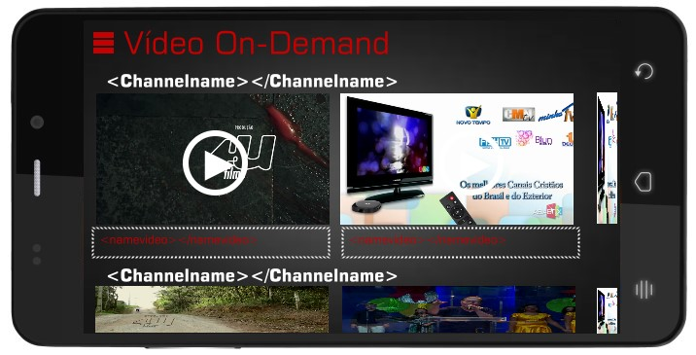

All info for this page is find on xml file provided from php. This screen will works as NETFLIX vod screen… side to side… up to bottom. Just one screen, touch and play.

<channelname></channelname> is the channel name.

<videologo></videologo> = Is the logo of all videos provided on xml.. when touched once icon get red square and shows under the videos list the VIDEOS NAME = <videoname></videoname> . When user touch twice loads video to playback.

App play first <urladd></urladd> and next will be <url></url>.

<urladd></urladd> Is the WELCOME VIDEO MESSAGE that plays before the real video content, this part is a flat playing with no controls, but audio control of course.

Soon <urladd></urladd> finishs start the <url></url> that is the real content that users is looking for.

Don’t forget red circle loading for bouth.

See image bellow:

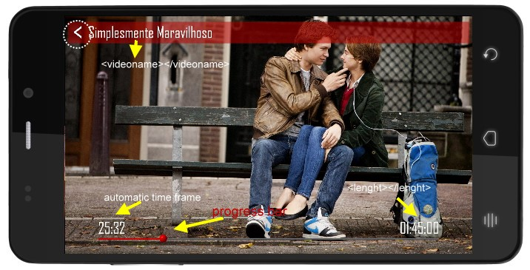

**The “<” is a return, when user touch this app should show message. “Deseja sair da exibição?” and bottons “YES”[SIM] and “NO” [NÃO].**

**Progress bar needs to move video playback PREVIOUS > NEXT... ON TOUCH SCREEN PAUSE, ANOTHER TOUCH PLAYS AGAIN**

*RADIO ON LINE*

The 7th line on PHP file is the RADIO WELCOME MESSAGE, and should stay on till XML RADIO loads, 5th line on PHP.

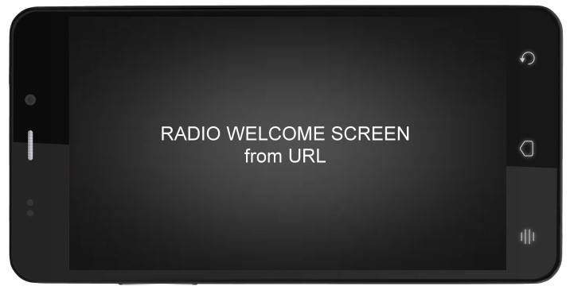

XML Looks Like

<radios>

<radio>Rádio do Cristão</radio>

<image>http://191.255.241.96/comerciais/720p/whynot.jpg</image>

<url>http://199.233.234.10:10514</url>

</radios>

<radio></radio> = Radio Name

<image></image> = Radio Logo

<url></url> = Radio Stream

Soon XML radio list loads app should show the RADIOS SCREEN.

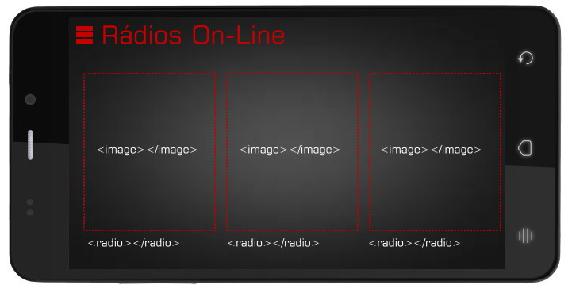

On touch, radio stream plays. After 15 seconds screen dim.