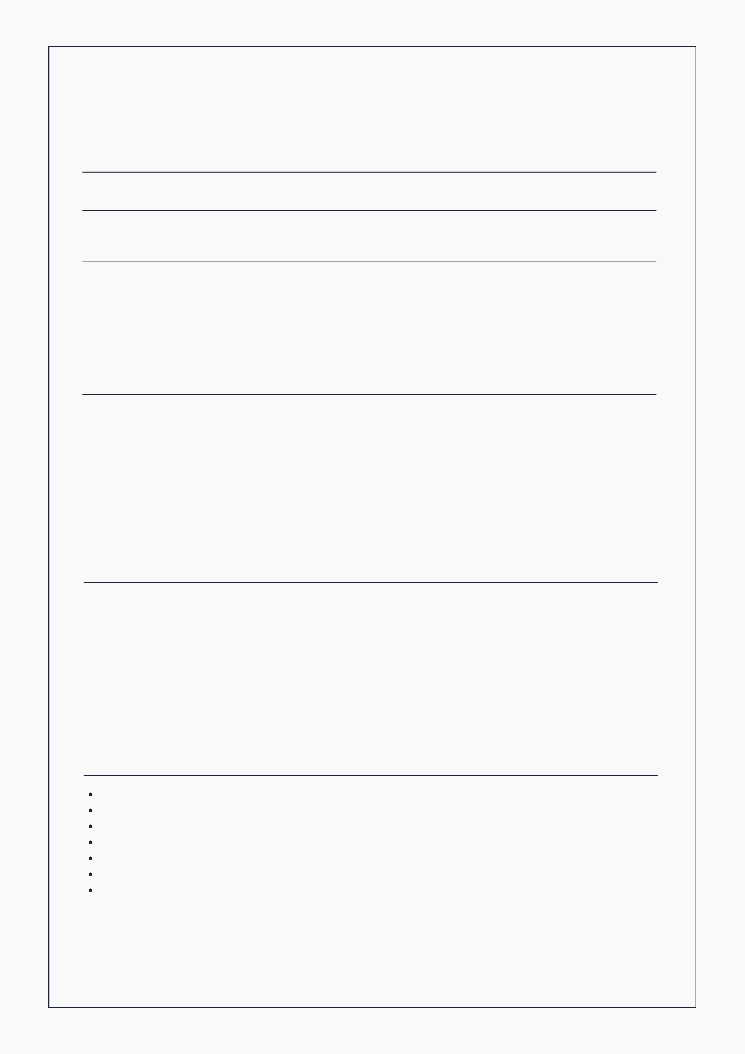

**ROHIT KUMAR** FULL STACK DEVELOPER

[+91 6203039479](tel://6203039479/) | [kumar.rohitsingh37@gmail.com](mailto:kumar.rohitsingh37@gmail.com) | [LinkedIn](https://www.linkedin.com/in/rohitsinghcodes/) | [Github](https://www.github.com/rohitsinghcodes/) | [Portfolio](https://rohitsinghcodes-portfolio.onrender.com/)

**ABOUT ME**

I am a passionate and results-driven Full Stack Developer with strong expertise in the MERN stack, C++, and Data Structures & Algorithms. With a problem-solving mindset and over 200+ LeetCode questions solved, I thrive in building efficient, scalable, and secure backend systems. I have hands-on experience in real-world projects like a Book Store app and a Hospital Management System, focusing on clean code, API integration, and responsive design. Eager to contribute to a dynamic development team and continue growing as a developer in a challenging, fast-paced environment.

**EDUCATION**

|  |  |
| --- | --- |
| **2020-2021**  R.L.S.Y College Aurangabad  **2021 - 2025**  Sri Dev Suman Uttarakhand | **intermediate**  Completed Intermediate with PCM from RLSY College, securing 74.2% and building a strong foundation in science and mathematics.  **Bachelor of Computer Application**  Pursuing BCA with a strong focus on full-stack development, data structures, algorithms, and backend technologies like Node.js and MongoDB. |

University

**PROJECT**

|  |  |
| --- | --- |
| **JAN-FAB(2025)** Book-Store | **Book Store**  Created a modern, responsive Book Store web app using React and Tailwind CSS. Features include dynamic banner, top sellers with filtering, and sidebar |

navigation. Emphasized component reusability and UI responsiveness.

|  |  |
| --- | --- |
| **April-present**  Hospital Management | **Hospital Management**  Designed and developed the responsive frontend using React and Tailwind CSS. Features include patient registration forms, doctor listings, appointment booking |

UI, and an intuitive admin dashboard. Backend development (Node.js, Express, MongoDB) is in progress.

**SKILLS**

**Programming Languages:** Python, C, C++, JavaScript

**Frameworks & Libraries:** React.js, Node.js, Express.js

**Databases:** MongoDB, MySQL

**Web Technologies:** HTML5, CSS3

**Tools & Platforms:** Git & GitHub, VS Code, Postman, Web3Forms

**Analytics:** Google Analytics

**Other Skills:** Data Visualization, REST API Integration, Problem Solving, Responsive Web Design.

Rohit Kumar