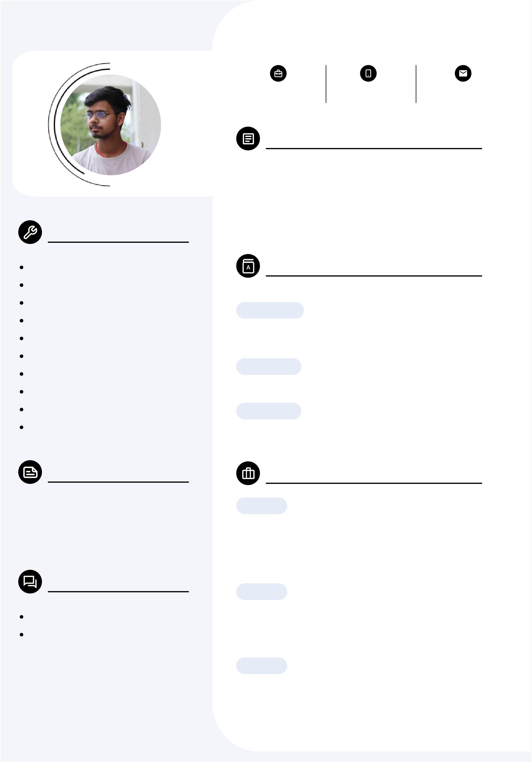

Rohit Singh

|  |  |  |
| --- | --- | --- |
| Fresher | (+91) | kumar.rohitsingh37 |
| 6203039479 | @gmail.com |

Profile Summary

I am a motivated individual with experience in developing projects using HTML, CSS, JavaScript and React. I aim to continue growing my skills in web development and   
contribute positively to tech projects. My vision is to excel

Key skills in creating innovative and user-friendly web applications.

HTML Education

CSS

|  |  |  |
| --- | --- | --- |
| Javascript  MongoDB  Express  React.js  Node.js  C++  DSA  Mern Stack  Personal Information | | **BCA, 2025**  **Phonics Group of Institutions,**  **Roorkee**  **12th, 2021**  **Bihar, Hindi**  **10th, 2019**  **Bihar, Hindi**  Projects  **5 Days**  **Portfolio Website**  A portfolio is a curated collection of work that showcases an |
| City | **Roorkee** |
| Country | **INDIA** |

individual's skills and achievements, used to demonstrate expertise to potential employers or clients.

Languages   
**3 Days**

**weather app**

|  |  |
| --- | --- |
| English  Hindi | I have made this project using html, css and javascript. in this project you can see the real weather detail among the world. |

**2 Days**

**Rock paper scissor**

This the basic rock paper scissor app where you can play this game with boat.