

2025 | HOSPITAL  MANAGEMENT
SYSTEM
[ Final Year Project Report ]
Phonics Group of Institutions, Roorkee,
PINCODE: 247667

A
PROJECT PREPORT
ON
“HOSPITAL MANAGEMENT SYSTEM”
FOR
PARTIAL FULFILMENT OF THE
DEGREE OF
BCA ( BACHELOR OF COMPUTER APPLICATION )

Submitted By: Project Guide:
Rohit Kumar Deepti Nagpal
Nitesh Panday Asst. Prof (C.S.E)
Priyanshu Mishra
Phonics Group of Institutions, Roorkee, Uttarakhand
PINCODE: 247667
Roll No: Enroll No:
183229285084 SV22025998
183229285066 SV22025980
183229285075 SV22025989


DISCLAIMER

We hereby declare that the project report titled “Hospital Management System” submitted in partial fulfillment of the requirements for the degree of Bachelor of Computer Application (BCA) is a bonafide work carried out by our group. This report has been prepared solely for academic purposes and is based on our personal research, references, and knowledge gained during the course of study. To the best of our knowledge and belief, the information contained in this report is true and accurate. This project has not been submitted, in part or in full, to any other institution or university for the award of any degree, diploma, or other qualification. We understand that any misrepresentation or falsification of data may lead to disqualification or disciplinary action as
per university norms.

)‘ACKNOWLEDGEMENT
We would like to express our sincere gratitude to all those who supported us throughout the development of this project titled “Hospital Management System.” This project has been an excellent learning experience and has helped us gain both technical and practical knowledge.
We are deeply thankful to our project guide, [Deepti Nagpal], for her valuable guidance, constant encouragement, and continuous support during the course of this project.
We would also like to thank the faculty members of the Department of Computer Applications, Sri Dev Suman Uttarakhand University, for their insightful suggestions and motivation, which helped us throughout the project development.
We are also grateful to our friends and classmates for their cooperation and moral support, and to our families for always encouraging us and believing in our capabilities.

Table of Contents – Hospital Management
Serial No. |  | Content | Pg No.
Chapter 1: Introduction Of Project
1.1 | Introduction To Hospital Management System |  | 2-4
1.2 | Objectives Of The Project |  | 5-8
1.3 | Scope Of The Project |  | 9-11
1.4 | Methodology Used |  | 12-13
1.5 | Tools And Technologies Used |  | 14-16
Chapter 2: Modules In Hospital Management System
2.1 |  | Patient Registration Module | 18-19
2.2 |  | Doctor Management Module | 19-21
2.3 |  | Appointment Scheduling | 21-23
2.4 |  | Billing And Payment Module | 23-25

2.5 | Pharmacy Management | 25-26
Chapter 3: Implementation And Workflow
3.1 | Admin Dashboard Overview | 28-29
3.2 | Frontend Design & Navigation | 29-33
3.3 | Backend Functionality | 33-33
3.4 | Data Flow And Storage | 33-34
3.5 | User Roles And Access Control | 34-36
Chapter 4: Testing, Results And Conclusion
4.1 | Testing Strategies And Tools | 38-39
4.2 | Results And Output Screenshots | 39-40
4.3 | Challenges Faced During Development | 40-42
4.4 | Conclusion And Future Enhancements | 42-43


Chapter : 1
Introduction Of Project
 | 1 | 

1.1Introduction to Hospital Management System
Introduction :
The Hospital Management System (HMS) is a web-based solution that simplifies and organizes the functioning of hospitals and healthcare facilities. In today’s digital era, manual processes are becoming outdated due to their inefficiency and risk of errors. HMS offers a structured and centralized system for managing various operations such as patient registration, doctor appointments, billing, pharmacy, laboratory, and medical records. With a focus on automation and real-time data access, it supports doctors, nurses, and administrative staff in delivering better healthcare services. This project is a frontend-based Hospital Management System developed using modern technologies such as React JS, Tailwind CSS, JavaScript, Framer Motion, and Locomotive Scroll. It features an intuitive and responsive user interface that allows easy navigation and interaction for both hospital staff and patients. The system enhances efficiency, transparency, and patient satisfaction. The primary goal of this project is to showcase how digital platforms can improve hospital workflows, reduce human errors, and ensure better data security and service quality. It also demonstrates how UI/UX-focused design plays a critical role in developing practical healthcare solutions. This documentation explains the system’s objectives, features, technologies used, and overall impact on hospital operations. Integrated software solution designed to manage the complex administrative, medical, and financial operations of hospitals and healthcare organizations efficiently. The primary goal of an HMS is to streamline hospital workflows, automate routine tasks, and provide accurate, real-time information to healthcare professionals, administrators, and patients.
2

Hospitals generate and handle large volumes of data daily — including patient records,
doctor schedules, appointments, billing information, pharmacy inventories, and diagnostic
reports. Managing this data manually or through paper-based systems is time-consuming,
error-prone, and inefficient. HMS automates these processes, helping to reduce human error,
improve communication between departments, and enhance overall hospital productivity.
Key Features of HMS :
• Patient Registration and Records Management: Efficiently captures and stores
patient demographics, medical histories, and treatment details.
• Appointment Scheduling: Enables patients to book, reschedule, or cancel
appointments easily, reducing waiting times.
• Billing and Financial Management: Automates billing processes, insurance claims,
and payment tracking.
• Pharmacy Management: Manages medicine inventory, stock levels, and expiry dates.
• Laboratory and Diagnostic Management: Records test orders and results, enabling
quick access for doctors.
• Staff Management: Organizes staff schedules, payroll, and human resource functions.
• Inventory and Supply Chain Management: Ensures timely availability of medical
supplies and equipment.
Benefits of Hospital Management System :
• Improves efficiency by automating manual tasks.
• Enhances patient care by providing instant access to patient data.
• Reduces paperwork and administrative overhead.
• Facilitates better communication across hospital departments.
• Supports compliance with healthcare regulations and standards.
3

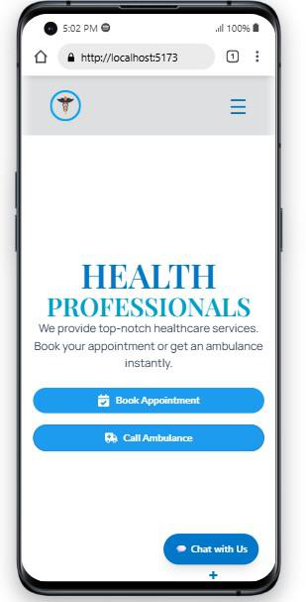

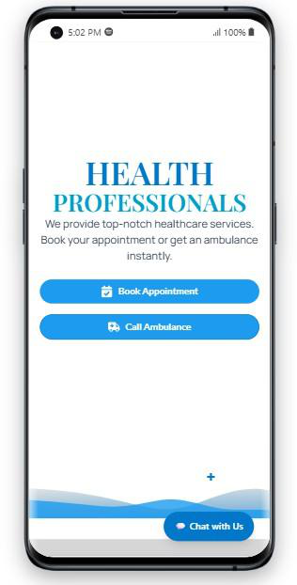

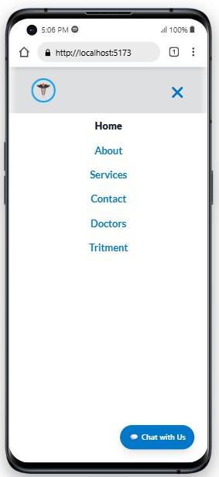
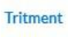
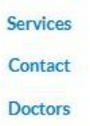

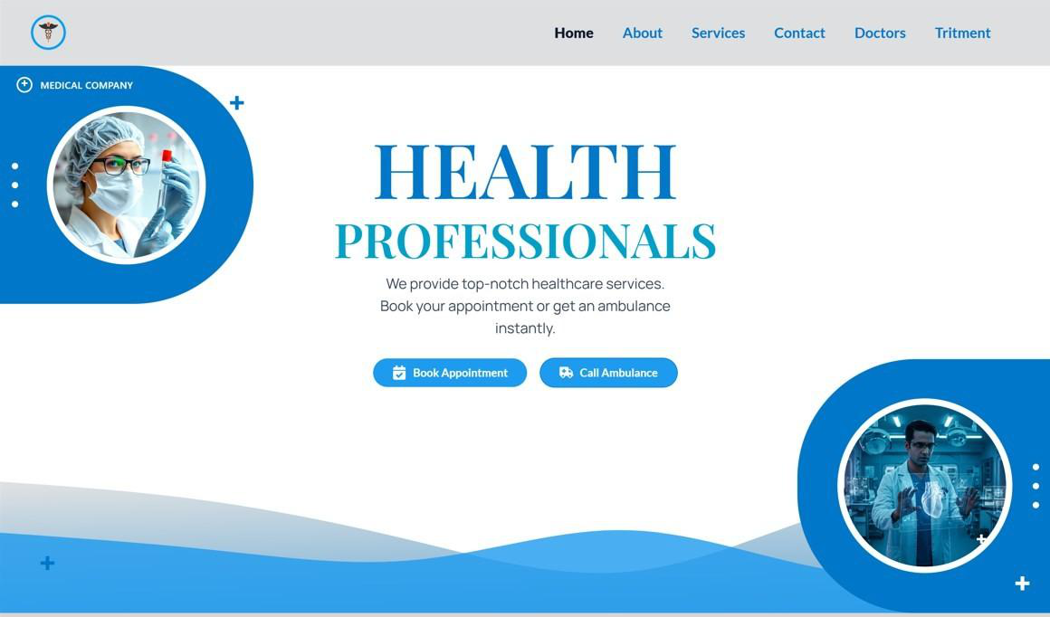
4

1.2Objectives of the Project
The primary objective of developing a Hospital Management System (HMS) is to design a comprehensive and user-friendly web-based platform that enables patients, doctors, and hospital staff to interact digitally and efficiently. In today’s digital era, where accessibility and speed are crucial, this system aims to simplify healthcare delivery by making it more responsive, transparent, and easily manageable through a centralized system. The project focuses on offering online doctor consultations, appointment scheduling, treatment planning, and health record maintenance in a seamless and secured digital environment.
Key Objectives:
1.To Enable Online Doctor Consultations
One of the major goals of this project is to allow patients to consult with doctors remotely using the internet. Many people are unable to travel due to age, distance, or health conditions. With the online consultation feature, patients can communicate directly with doctors via digital means (like chat or video call) and receive medical guidance without visiting the hospital. This saves both time and effort while improving healthcare
accessibility.
2.To Digitally Manage Treatment and Follow-ups
Through this system, patients can not only receive consultations but also get treatment plans, prescriptions, and follow-up instructions online. Doctors can monitor patients’ progress and provide updates or changes in treatment digitally. This ensures continuity of care and reduces the need for physical visits unless necessary.
3.To Simplify Appointment Booking System
The HMS provides a smooth interface for patients to book appointments with doctors based on their availability. Patients can view doctor profiles, select date and time slots, and book their consultation instantly. This feature also allows easy rescheduling or cancellation of appointments, which significantly reduces crowding and waiting times at hospitals.
5

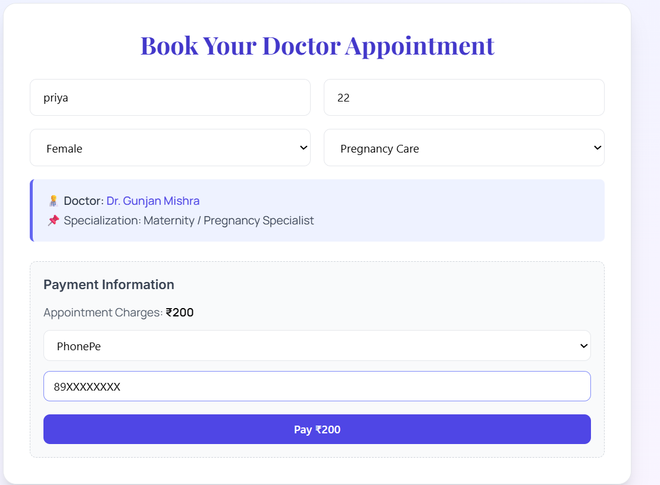
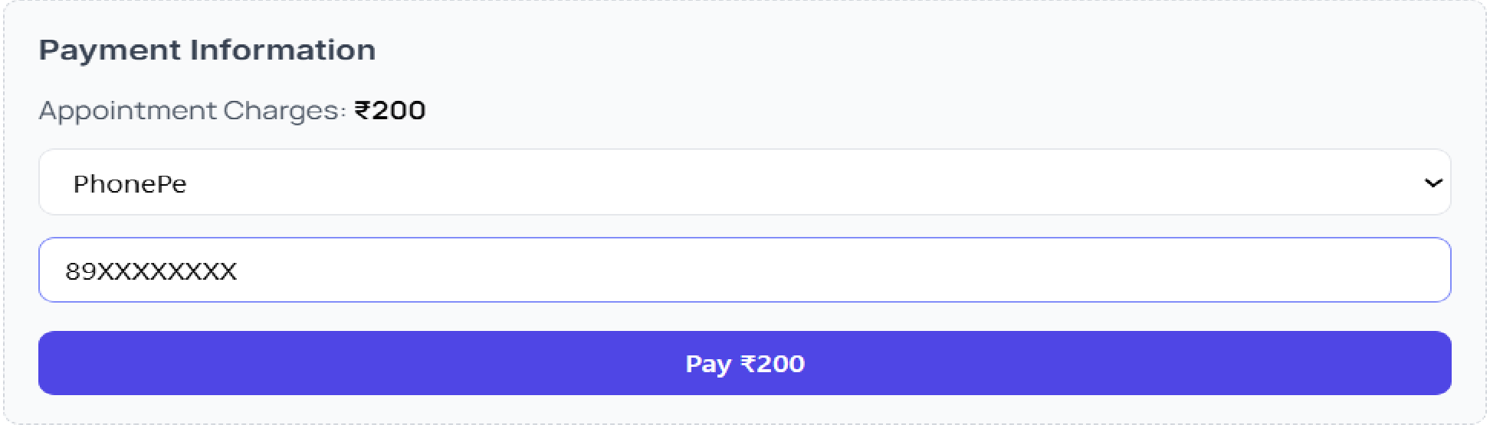








4.To Maintain Electronic Medical Records (EMR)
An essential objective is to maintain patients’ medical records in a centralized digital format. This includes personal information, health history, lab reports, prescriptions, and previous treatments. Both patients and doctors can access these records anytime, enabling quick diagnosis and informed decision-making.
5.To Improve Coordination Among Hospital Departments
The system ensures smooth coordination between departments like OPD, pharmacy, lab, billing, and administration. When all departments work on a shared platform, it eliminates delays, miscommunication, and data duplication. This enhances the overall efficiency of hospital operations.
6

6.To Enhance Transparency in Billing and Payments
Another goal is to provide a transparent and accurate billing system. Patients receive detailed invoices for consultations, treatments, and diagnostic tests. The platform supports multiple payment modes and records all transactions digitally, reducing billing errors and improving trust.
7.To Offer Real-time Notifications and Reminders
The system sends reminders for upcoming appointments, medication times, or follow-up sessions via SMS or email. This keeps patients informed and ensures they stay on track with their treatment plans, leading to better health outcomes.
8.To Ensure Data Privacy and Security
Patient data is highly sensitive and must be protected. The system includes authentication protocols, secure data storage, and role-based access to ensure that only authorized users can view or edit information. This builds trust and complies with healthcare data protection standards.
9.To Provide Ambulance Service Availability and Quick Emergency Response
One of the significant objectives of this project is to provide patients and their families with easy access to ambulance services during medical emergencies. The system includes a dedicated feature where users can request an ambulance online by submitting basic details like location, patient condition, and contact number. Once the request is submitted, the nearest available ambulance is notified in real-time and dispatched immediately.
This feature is especially useful for patients in critical condition who require urgent transport to the hospital. By integrating GPS tracking, real-time updates, and automatic alerts, the system ensures faster ambulance response time and saves precious lives. Moreover, the hospital administration can monitor ambulance movement, manage fleet allocation, and ensure that emergency care reaches the patient as quickly as possible.
7



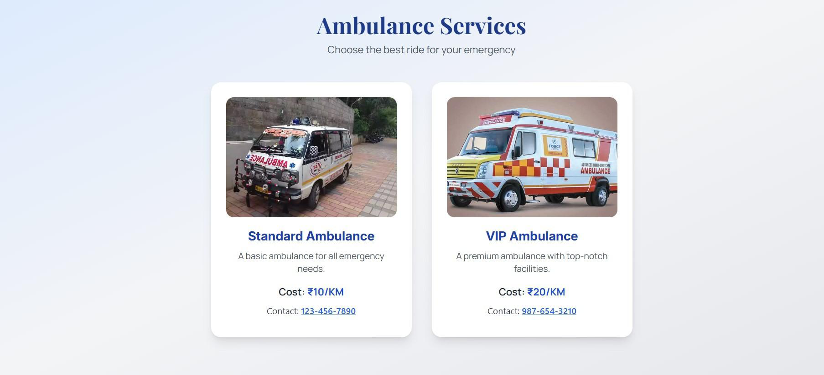
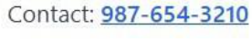







10.To Provide Direct Call Feature for Instant Communication
In a fast-paced healthcare environment, quick communication between patients and doctors can make a significant difference. The Direct Call feature integrated into this Hospital Management System allows patients to initiate real-time voice calls with their respective doctors or the hospital’s helpdesk directly from the website or mobile interface.This functionality is extremely useful in scenarios where the patient is confused, has an urgent question, or is not comfortable typing a message. Instead of waiting for chat replies or email responses, the patient can instantly connect to a doctor, nurse, or admin staff and seek immediate clarification .This saves time, reduces miscommunication, and provides a more human, personalized interaction in the treatment process.
Key Benefits of Direct Call Feature:
• Real-Time Voice Support: Patients can talk directly to doctors or staff.
• No Delay in Communication: Quick answers lead to better care and faster decisions.
• Useful in Emergency Situations: In case of sudden symptoms or panic, patients can call
instantly.
8

1.3Scope of the Project
The Hospital Management System (HMS) developed as a frontend project using React JS,
Tailwind CSS, and Framer Motion has a vast and practical scope in transforming traditional
hospital operations into a smart, efficient, and patient-friendly environment. The scope of
this project is not only limited to appointment booking and consultation, but it expands
across various departments of the hospital — including patient care, administration,
emergency services, and record management.
This web-based system is aimed to enhance the interaction between patients, doctors, and
hospital staff by offering digital solutions to problems such as long queues, delayed
appointments, manual errors, lack of data, and poor communication.
1.Covers Major Hospital Departments
The system’s design scope allows digital transformation of various hospital functions:
• Outpatient and Inpatient Management
• Doctor Scheduling and Profile Display
• Digital Appointments and Bookings
• Treatment Tracking and Medical Record Access
• Ambulance Request and Emergency Alerts
• Billing Interface and Online Payment Options
By integrating these modules into a single frontend platform, it minimizes complexity and
improves coordination across departments.
2.Online Consultation & Treatment Support
This HMS project allows patients to:
• View doctor profiles and expertise
• Book appointments
• Talk via direct call/chat
• Get follow-ups and prescriptions online
9

The scope extends to remote areas where doctors are not easily available. Hence, this project
helps in bridging the gap between urban healthcare and rural patients.
3.Scalable and Responsive Design
Built using React JS and Tailwind CSS, the system is highly scalable and can be extended
easily to include:
• Backend integration (Node.js, Firebase, MongoDB)
• Admin dashboard
• Multi-user login system (Patient, Doctor, Admin)
• Notifications via SMS or Email
• Mobile App version using React Native
Since it’s a frontend project, it can easily be connected to APIs and databases in the future,
making it ready for real-world deployment.
4.Emergency and Support Features
The inclusion of features like:
• Ambulance request
• Emergency call button
• Quick doctor contact
adds immense value to the hospital system. These features show the project’s
capability to act as a life-saving utility, not just a booking system.
5.User Roles and Real-time Functionality
Though currently frontend-based, the structure allows role-based access (Doctor, Patient,
Admin) once backend is attached. It can support:
• | Real-time chat/call | 10

• Treatment updates
• Prescription uploads
• Appointment status change
Thus, the project lays the foundation for a complete Hospital ERP (Enterprise Resource
Planning) system.
6.Contribution to Digital Health Mission
This project supports the government’s vision of Digital India and Digital Health Records
(DHRs) by providing:
•  •  •  • | Paperless registration  Online consultation  Patient portals  Cloud-based health records (future integration)
It reduces paperwork, errors, and manual handling, promoting faster and cleaner hospital
operations.
11

1.4Methodology Used
The methodology followed for the development of the Hospital Management System is based on a structured and modern software development approach. Since this is a frontend-based project developed using React JS, Tailwind CSS, and Framer Motion, the methodology focused on component-based UI design, responsive layout, performance optimization, and user experience enhancement.
This project follows a step-by-step development process, beginning with requirement analysis and ending with testing and final deployment. Let us understand the complete methodology in detail.
1.Requirement Analysis
Objective: Understand the need for a digital hospital interface. Process: Conducted basic research on hospital systems and patient journeys. Output: Finalized the required modules such as Doctor Profiles, Services, Appointments, and Emergency Features.
2.Planning & Tool Selection
Selected React JS for component-based UI development. Chose Tailwind CSS for utility-first styling and responsiveness. Used Framer Motion for smooth animations and transitions. Designed the layout to be mobile-first and responsive.
3.Designing the UI (User Interface)
Wireframes were created to design the overall structure.
Designed pages like:
• Home Page
• Services Page
• Doctor Slider Page
• Contact/Appointment Page
Used modern UI/UX practices like soft shadows, rounded corners, gradients, etc. Ensured accessibility and clean navigation.
4.Component-Based Development (React JS) Developed individual reusable components:
• | Navbar, Footer | 12
• | Doctor Cards | 12
• | Service Cards | 12

• Appointment Forms
Each component was styled with Tailwind CSS classes for better control and flexibility.
5.Animation Integration (Framer Motion) Used Framer Motion to:
• Animate doctor sliders
• Fade-in service sections
• Smooth page transitions
• Add scroll animations for modern feel
This made the system visually appealing and interactive for users.
6.Testing & Debugging
Manual testing was performed on mobile, tablet, and desktop views. Checked
responsiveness using browser dev tools. Fixed bugs in animations, layout alignment, and responsiveness.
7.Hosting and Deployment (Optional)
Project can be deployed using GitHub Pages, Netlify, or Vercel.
Hosting ensures real-time access and portfolio visibility. Added documentation and README for users.
13

1.5Tools and Technologies Used
The development of the Hospital Management System was accomplished using a combination of modern tools and technologies. These tools not only enhanced the system's functionality but also ensured its smooth operation and scalability. The following tools and technologies were used throughout the project:
1.React JS
React JS is a JavaScript library for building user interfaces, particularly for single-page applications. It enables the development of fast, dynamic, and interactive web applications by using a component-based architecture.
• Role in the Project:
React JS was used for building reusable UI components like doctor profiles, service cards, and the appointment form. It ensured that the web application remains responsive, interactive, and efficient in handling dynamic data updates.
• Why React JS:
React JS allows for fast rendering using its Virtual DOM and ensures real-time updates with a minimal performance overhead. This made it ideal for developing a hospital management system with multiple interactive components.
2.Tailwind CSS
Tailwind CSS is a utility-first CSS framework that provides a wide range of ready-to-use classes to create responsive, custom designs without writing custom CSS.
• Role in the Project:
Tailwind CSS was used to style the entire system, making it not only visually appealing but also responsive across devices. It helped in maintaining consistency throughout the application and provided quick styling without the need for external stylesheets.
• Why Tailwind CSS:
Tailwind CSS simplifies the design process by using predefined classes, which makes it easy to manage the layout and achieve responsive designs with minimal code. It also made the UI more maintainable and scalable as the project grows.
14

3.Framer Motion
Framer Motion is a powerful animation library for React that enables the creation of smooth animations with simple and declarative code.
• Role in the Project:
Framer Motion was used to animate various elements within the hospital management system, such as smooth page transitions, fading in sections, and sliding in doctor profiles. It added a level of interactivity and visual appeal, enhancing the user experience.
• Why Framer Motion:
The library offers easy-to-implement animations, which are highly customizable and help in making the interface more engaging. Its simple API and compatibility with React made it an ideal choice for adding smooth transitions and interactive animations.
4.Git & GitHub
Git is a distributed version control system that helps manage the source code of a project over time. GitHub is a platform for hosting Git repositories and collaborating with team members.
• Role in the Project:
Git was used to track code changes and manage the project’s version history. GitHub was used for hosting the project’s code and collaborating with other developers (if applicable). It also allowed for easy deployment and version control throughout the project’s development cycle.
• Why Git & GitHub:
Git enables collaborative development, providing a history of changes made to the code. GitHub offers a centralized location to store and share the project with others, making it easy for future enhancements and open-source contributions.
5.Visual Studio Code (VS Code)
Visual Studio Code (VS Code) is a lightweight and powerful code editor with built-in support for JavaScript, React, and many other languages.
15

•Role in the Project:
VS Code was the primary IDE used for writing and editing the codebase. It provided helpful extensions for React development, debugging, and code formatting, making the development process faster and more efficient.
•Why VS Code:
VS Code is highly customizable, supports React syntax, and has integrated tools like Git, which made it the perfect choice for building the project. Its lightweight nature and the vast ecosystem of extensions made it an ideal choice for development.
16


Chapter : 2
Modules Of Hospital Management
17

2.1.Patient Registration Module
Overview
The Patient Registration Module is a fundamental component of the Hospital
Management System (HMS), designed to manage the intake, documentation, and storage of patient information. It enables hospital staff to efficiently register new patients, maintain detailed records of returning patients, and generate a unique Patient ID (PID) for
identification and tracking. This module plays a critical role in ensuring that all relevant demographic and medical data is collected in a structured and accurate manner at the very first point of contact—whether during an outpatient visit, emergency admission, or scheduled appointment.
Key Features
1.Patient Details Entry:
• Captures basic patient information including full name, age, gender, date of
• birth, marital status, and nationality.
• Records complete contact details such as phone number, email address, and
• Inputs emergency contact details (name, relationship, mobile number) for critical .
• Allows uploading of identity proof like Aadhaar, PAN, Passport, or Driving License.
• Option to upload patient photograph for better identification in the hospital system.
2.Medical Information:
• Includes sections to record allergies, past surgeries, chronic illnesses (like
• Fields to record blood group, vaccination status, and other key health alerts.
• Ensures comprehensive storage of medical history for reference by doctors.
3.Unique ID Generation:
• Automatically generates a system-wide unique Patient ID (PID).
• Used across the hospital to associate the patient with appointments, prescriptions, lab reports, bills, and admission details.
18

4.Search & Update Functionality:
• Provides fast search options using name, mobile number, or patient ID.
• Only authorized staff can make updates to ensure accuracy and protection.
• Keeps a record of updates for traceability and audit purposes.
5.Seamless Integration:
• Connects directly to other critical modules like Appointments, Billing, Lab
• Enables automatic data sharing across departments to minimize manual entry
Security & Access
• Access to the module is strictly role-based (e.g., admin, receptionist, doctor).
• Implements data encryption during storage and transfer for security.
• Regular data backup systems and privacy compliance (e.g., HIPAA or local
• Audit logs ensure that all changes and access actions are traceable.
Benefits
• Reduces registration time and queues with a user-friendly interface.
• Ensures accurate patient data for better diagnosis and continuity of care.
• Minimizes duplication and human errors through validation and auto-
• Enhances patient experience by reducing repetition and improving service.
• Supports multi-department coordination and real-time data access for
2.2.Doctor Management Module
Overview
The Doctor Management Module is a vital component of the Hospital Management
System (HMS) that handles the onboarding, organization, and monitoring of doctorrelated
information and activities. It maintains a centralized record of all doctors working within
the hospital or associated on a contractual basis. This module facilitates the scheduling of
appointments, departmental assignments, shift management, and access control for
19

medical records and patient care tools. Its primary purpose is to ensure that the hospital
can operate efficiently with a clear structure for managing its medical staff.
Key Features
1.Doctor Profile Management:
• Collects and stores full doctor profiles, including name, gender, date of birth,
contact details, and address.
• Includes educational qualifications, medical specialization, certifications,
and license/registration numbers.
• Allows upload of important documents (degrees, ID proof, medical license).
• Assigns a unique Doctor ID for tracking appointments, patient cases, and
schedules.
2.Department & Specialization Mapping:
• Doctors are linked to specific departments such as Cardiology, Pediatrics,
• Each doctor can be mapped to multiple specializations.
• Enables filtered viewing of available doctors per department for both admin
3.Availability & Schedule Management:
•Allows admin to define working days, shift timings, weekly offs, and on-call
duty schedules.
•Doctors can update their availability status in real-time for emergency or online
consultations.
•Integrated with the Appointment Booking Module to avoid double bookings
and manage workload.
4.Roles & Access Control:
•Doctors have controlled access to medical records, test reports, and treatment
history of their patients.
•Admins can assign or revoke specific permissions.
•Maintains activity logs for audit and security.
5.Dashboard & Reporting:
20

Each doctor can access a personal dashboard displaying their appointments, patient queue, upcoming surgeries, and alerts.
Admin dashboard shows doctor performance reports, patient load, and availability status.
Useful for HR and Operations to monitor doctor engagement and departmental workload.
Security & Compliance
•Only admin or HR staff can edit doctor profiles.
•Sensitive data is encrypted, and all access is role-based.
•Doctors see only the data relevant to their patients or schedule.
•Complies with medical record confidentiality guidelines (e.g., HIPAA or regional laws).
Benefits
•Simplifies the management of hospital medical staff and consultants. •Ensures proper workload distribution and avoids appointment clashes. •Helps patients get timely care by showing doctor availability in real-time. •Provides doctors with an organized platform for patient management and case tracking.
•Enhances operational transparency and inter-department collaboration.
2.3.Appointment Scheduling
Overview
The Appointment Scheduling Module is a critical part of the Hospital Management System (HMS) that facilitates efficient booking, rescheduling, and cancellation of patient appointments with doctors and specialists. It acts as the bridge between patients and medical staff, ensuring that the consultation process is streamlined, wait times are
minimized, and doctor availability is effectively managed. The module supports both online and offline appointment booking and integrates seamlessly with other modules like Patient Management and Doctor Management.
21

Key Features
1.Appointment Booking:
• Enables patients or reception staff to book appointments by selecting doctor,
department, date, and time.
• Displays real-time availability of doctors to avoid double booking.
• Allows choosing between in-person consultation or online video
appointment (if supported).
• Immediate confirmation with appointment ID and summary sent via SMS or
email.
2.Doctor Availability Management:
• Syncs with doctor’s schedule from the Doctor Management Module.
• Automatically shows only available slots.
• Doctors can block certain time slots for emergencies, surgeries, or time off.
3.Patient Appointment History:
• Maintains complete appointment history for each patient.
• Allows easy access for future re-booking with the same doctor.
• Tracks missed, cancelled, or rescheduled appointments.
4.Reschedule & Cancel Options:
• Patients and staff can reschedule or cancel appointments before the cut-off
time.
• Automatically updates the doctor’s calendar and makes the slot available for
others.
• Sends notifications of changes via SMS/email/app alerts.
5.Queue Management:
• Displays real-time waiting queue in the doctor’s dashboard.
• Enables hospital staff to manage flow and reduce congestion in the OPD area.
• Optionally integrates with a token system or display board.
6.Walk-in Appointment Handling:
• Receptionists can enter walk-in patients manually.
22

• All walk-ins are time-stamped and slotted into the next available time slot
based on availability.
Security & Access Control
• Only authenticated users (patients, receptionists, doctors) can interact with the
module.
• Appointment data is encrypted and backed up regularly.
• Role-based access ensures patients can only view their own bookings, and
doctors see only their schedules.
Benefits
• Reduces waiting time for patients and improves hospital service efficiency.
• Helps avoid appointment clashes and manage patient load effectively.
• Increases patient satisfaction with easy booking, reminders, and fewer delays.
• Provides doctors with better visibility and preparation time for each patient.
• Supports telemedicine workflows through virtual appointment scheduling.
2.4Billing and Payment Module
Purpose
The Billing and Payment Module acts as the hospital’s financial nerve center. It manages
everything from generating patient bills to handling various modes of payment. Designed
for accuracy, transparency, and speed, this module ensures that all services—
consultations, diagnostics, procedures, room charges, and medications—are correctly
billed and settled, improving both the hospital's cash flow and patient experience.
Key Components
1.Auto-Generated Bills
23

•Bills are generated automatically when a service (consultation, test,
admission, etc.) is recorded in the system.
•Pulls real-time data from modules like Patient Registration, Pharmacy, Lab,
and Doctor Consultation.
•Shows itemized breakup with taxes, discounts, and additional charges.
2.Payment Processing
•Accepts multiple payment modes:
•Cash
•Credit/Debit Card
•UPI/Wallets
•Insurance or Corporate TPA
•Handles full and partial payments.
•Prints or emails digital receipts with hospital branding.
3.Advance & Deposit Tracking
• Patients can pay an advance amount during admission.
• The module keeps track of all advances, refunds, or remaining dues.
• Auto-adjusts remaining balance at discharge.
4.Insurance Billing
• Supports TPA integration for insured patients.
• Generates claim forms and links them to insurance partners.
• Handles co-pay and rejection settlements with proper audit trail.
Role-Based Access
Role Access Level
Admin Full access, revenue dashboards
Billing Staff Bill creation, updates, payment input
Doctor/Nurse View service cost, no edit access
Patient View own bill summary via portal/app
24

Workflow
1.Services Availed → Automatically pushed into billing.
2.Bill Review → Edited/verified by billing department.
3.Invoice Generated → Sent to patient or printed.
4.Payment Processed → Receipt issued.
5.Reports → Daily revenue, outstanding dues, department-wise income.
Security & Integrity
• Controlled access ensures no unauthorized billing edits.
• Every transaction is logged with user ID and timestamp.
• Regular financial audits and automated reporting available.
• Compliant with local tax laws (e.g., GST in India) and financial regulations.
Benefits
• Increases billing accuracy and reduces manual errors.
• Speeds up patient discharge process through automated settlement.
• Enables real-time revenue tracking for finance teams.
• Improves patient trust with transparent, itemized billing.
2.5 Pharmacy Management
Overview
The Pharmacy Management Module manages the hospital’s medicine inventory, sales, and
dispensing operations. It connects with doctor prescriptions, billing, and inventory systems
to ensure accurate and timely delivery of drugs to patients.
Key Features
Inventory Management:
25

• | Tracks stock levels, expiry dates, and batch numbers. | Supports new stock entries
• | Tracks stock levels, expiry dates, and batch numbers. | Supports new stock entries
• | Auto-alerts for low stock and near-expiry items. • | Supports new stock entries
and return tracking.
Prescription Integration:
• Receives digital prescriptions from doctors.
• Checks availability and suggests alternatives.
• Dispenses medicine with instant stock update.
Billing & Payment:
• Calculates medicine cost and integrates with patient billing.
• Accepts cash, cards, or digital payment.
• Generates printed or digital bills.
User Roles
Role Access
Pharmacist Manage stock, sales, returns
Admin Full control, reports, pricing
Doctor Prescribe medicines
Patient Buy medicine, receive bills
Security & Compliance
• Only authorized staff can edit inventory.
• Maintains logs and complies with drug regulations.
Benefits
• | Accurate stock and expiry tracking | 26
• | Fast medicine dispensing | 26


•
Chapter : 3
Implementation And
Workflow
27

3.1Admin Dashboard Overview
The Admin Dashboard is one of the most critical components of any web-based hospital management system. It serves as the central control unit from where the entire frontend functionalities can be managed, monitored, and updated by the administrator. In the context of this project, the admin dashboard is developed using React JS, styled with Tailwind CSS, and animated using Framer Motion, which together offer a highly interactive, responsive, and smooth user experience.
The primary objective of the Admin Dashboard is to give the administrator an organized view of the hospital’s operational information on a single screen. Through this dashboard, the admin can control and manage various sections of the frontend including Doctor Listings, Patient Consultations, Appointment Scheduling, Service Pages, Ambulance Availability, and Contact Form Responses.
The dashboard includes features like real-time updates, live analytics (if connected with a backend in future), dynamic routing, and instant component rendering. All modules are created as independent components in React JS to ensure maintainability and reusability. Each section, such as doctor profiles or emergency contact lists, can be easily updated through prebuilt interfaces.
Key Functional Areas of the Admin Dashboard:
1.Doctor Management:
Admin can add, remove, or update doctor profiles including name, specialization, experience, and profile picture. These updates reflect dynamically across the user- facing frontend.
2.Appointment Control:
Admins can monitor which appointments have been requested and respond accordingly. Though this project is frontend-only, placeholders for backend integration (like API data) are kept ready.
3.Emergency Services Monitoring:
Quick status updates on ambulance availability and emergency contact details can be displayed or changed from the dashboard.
4.Contact Forms Review:
User queries and contact messages are dynamically listed on the admin dashboard. Admins can respond or analyze them using table-like components.
28

5.Website UI Management:
Admin has control over the visibility of services, home page banners, contact sections, and testimonial sliders.
6.Interactive UI with Animations:
Framer Motion is used to add animations like fade-ins, smooth page transitions, hover effects, and interactive button responses. This enhances the user experience for the administrator.
3.2Frontend Design & Navigation
The Frontend Design & Navigation of a hospital management system plays a vital role in ensuring a seamless user experience for patients, doctors, and administrators. In this project, the frontend has been developed using modern technologies like React JS for building reusable and fast UI components, Tailwind CSS for styling, and Framer Motion for adding elegant and smooth animations.
The design of the frontend is clean, responsive, and user-friendly, allowing users to easily navigate through various sections such as the Home Page, Doctor Section, Services, Contact Us, About Us, and Appointment Form. The layout has been created keeping in mind accessibility, clarity, and responsiveness so that it looks great on desktop as well as mobile devices.
Key Features of Frontend Design:
1.Component-Based Architecture (React JS):
The entire frontend is built using reusable components in React. Each section such as Doctor Card, Header, Footer, and Service Blocks are modular, making the project easy to manage and update.
2.Utility-First CSS (Tailwind CSS):
Styling has been done using Tailwind CSS which allows for fast and responsive design. Classes like flex, grid, bg-gradient, rounded-xl, and hover:scale help in making the UI look professional and visually appealing.
3.Smooth Animation (Framer Motion):
Navigation transitions and hover effects are enhanced using Framer Motion. For example, the doctor slider uses smooth entry animations, service cards have hover effects, and pages fade in beautifully.
4.Mobile-First Design:
All sections are optimized using Tailwind's responsive breakpoints like md:, lg:, sm: to make sure the site works perfectly on mobile, tablet, and desktop screens.
29

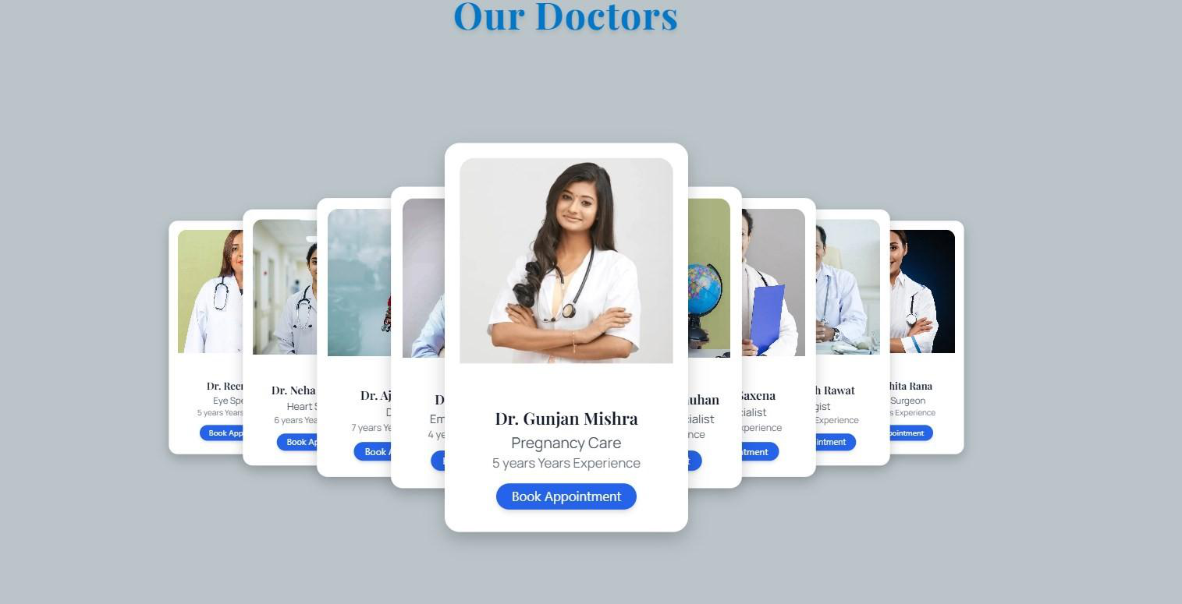
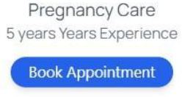


Navigation System Overview:
The navigation is designed with simplicity and speed in mind. The top header includes links to all major pages:
•Home
•Doctors
30

•Services
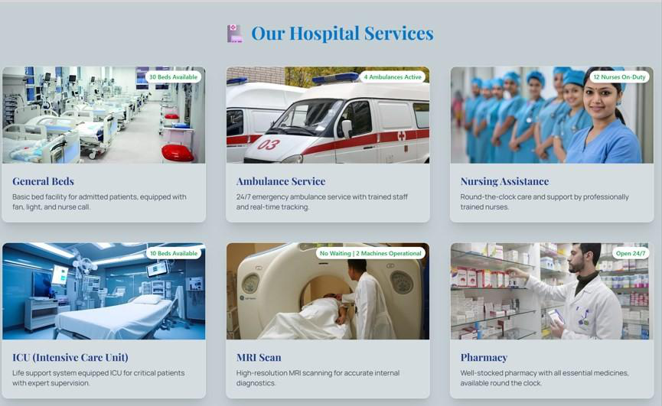
•About
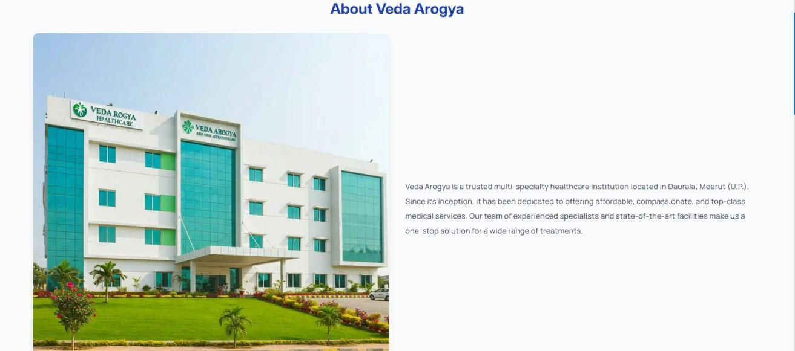
31

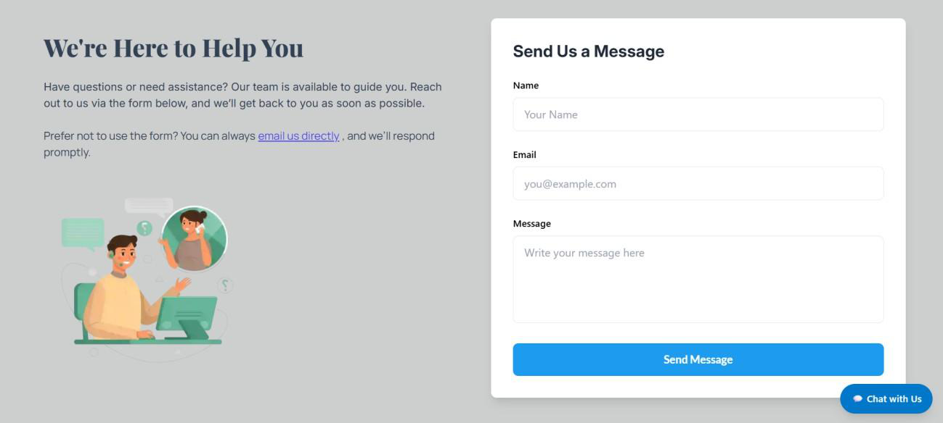



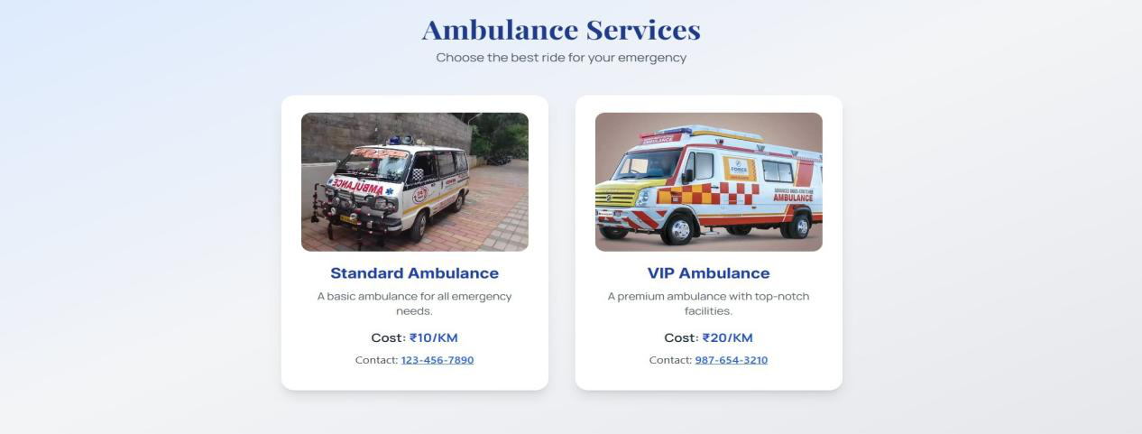
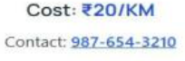





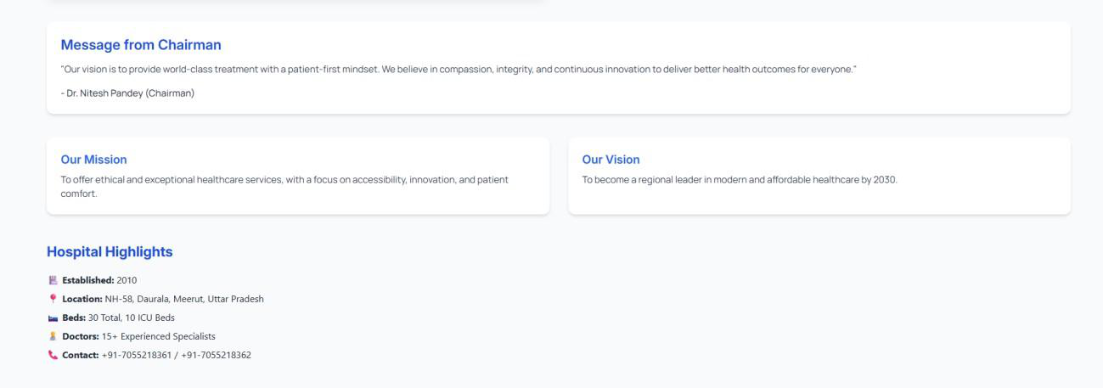
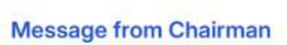
•Contact
•Emergency
32

Each navigation link uses React Router DOM for single-page application (SPA) style routing, which ensures that no full page reload happens — making navigation lightning- fast.
The footer also includes quick links, contact info, and social media buttons to allow users to connect instantly. Every link is interactive, with hover and active states, and designed to guide users intuitively through the website.
3.3Backend Functionality
In this project, no backend functionality has been implemented as the focus was entirely on designing a clean, interactive, and responsive frontend using React JS, Tailwind CSS, and Framer Motion. This is a frontend-only project that showcases the UI/UX design, navigation system, and structural layout of a Hospital Management System.
However, the project has been developed with a modular and scalable architecture, which allows easy integration of backend functionalities in the future. Features like appointment booking, doctor consultations, contact form handling, and service management are currently static but can be connected to databases or backend services like Node.js, Firebase, or Express.js for dynamic operations.
This approach allows the project to serve as a prototype or base structure for a full-stack hospital management system.
3.4Data Flow in Hospital Management System
Step 1: Data Input (Source)
• The patient fills out a form with details like name, age, symptoms, etc.
• The doctor enters availability and specialization data into the system.
• Staff members input patient appointment details and treatment records.
Step 2: Data Processing
• The system validates the patient data (for example, checking that all required fields are filled).
• Appointment scheduling logic runs, matching doctor availability with patient requests.
33

• Treatment and billing data are processed, such as updating diagnosis and calculating
payments.
Step 3: Data Storage
• All data is securely stored in the database:
oPatient details table
oDoctor details table
oAppointment records
oBilling records
• The data is organized and optimized for easy retrieval in the future.
Step 4: Data Output (Destination)
• Doctors access patient medical histories.
• Receptionists view and manage appointment schedules.
• Patients can view their reports online.
3.5User Roles and Access Control
1.Introduction
In any Hospital Management System, managing who can access what data and perform
certain functions is crucial. User Roles and Access Control ensure that the right users
have the appropriate permissions. This protects sensitive patient information and keeps
the system secure and reliable.
2.User Roles in Hospital Management System
a.Administrator
• Has complete control over the entire system.
• Can manage users, assign or change roles, and update system configurations.
• Responsible for system maintenance, backups, and security policies.
b.Doctor
• Can view and update patient medical records.
34

• Manages appointments within their availability.
• Can access diagnostic reports and prescribe treatments to patients.
c.Receptionist
• Handles patient registrations and schedules appointments.
• Can access basic patient information and appointment statuses.
• Does not have permission to view or edit detailed medical records.
d.Nurse/Staff
• Assists doctors with patient care.
• Can access patient treatment updates and vital signs.
• Has limited rights to modify sensitive medical data.
e.Patient
• Can view their own medical reports, appointments, and billing details.
• Cannot access other patients’ data or system administrative functions.
Access Control Mechanism
a.Role-Based Access Control (RBAC)
• Access rights are assigned based on predefined user roles.
• Each role has specific permissions tailored to the user’s responsibilities.
• Example: Only doctors have permission to update medical records, while
receptionists do not.
b.Authentication and Authorization
• Users must log in with their unique username and password.
• After login, the system verifies the user’s role and grants appropriate access.
c.Session Management
• Secure sessions keep users logged in to perform permitted actions without repeated
logins.
• Sessions automatically expire after a period of inactivity to prevent unauthorized
use.
35

4.Importance of User Roles and Access Control
• Security: Protects confidential patient data from unauthorized users.
• Data Integrity: Prevents unauthorized or accidental changes to critical data.
• Accountability: Tracks and logs user activities based on roles for auditing.
• Compliance: Helps the hospital comply with healthcare data privacy laws such as
HIPAA.
36

Chapter : 4
Testing, Results And Conclusion
37

4.1Testing Strategies and Tools
1.Functional Testing
What to Test:
•  •  •  • | Check login system for all roles (Admin, Doctor, Patient). Test appointment booking and viewing functionalities. Ensure correct display of doctor information.  Validate service and department listings.
What to Say:
"I tested every core functionality of my project — like login, appointments, and doctor listings — to make sure all features work exactly as required without failure."
2.User Role Testing (Access Control)
What to Test:
•  •  • | Admin should access admin dashboard only.  Doctors should manage only their appointments. Patients should only view or book their appointments.
What to Say:
"I tested different user roles and their access levels to ensure there is no unauthorized access and that every user sees only their permitted features."
3.UI/UX Testing
What to Test:
• Verify responsive design across devices.
• Check proper alignment and animation of components.
• Test navigation and overall user interface quality.
38

4.Responsiveness Testing
What to Test:
• Test layout on mobile, tablet, and large screens.
• Verify usability on touch interfaces.
What to Say:
"I tested the full project across different screen sizes using browser tools and real devices, ensuring complete mobile responsiveness."
5.Code Quality and Testing
What to Test:
•  • | Test each React component in isolation. Write unit tests for key components.
What to Say:
"I followed best practices in React component design and wrote unit tests using Jest and React Testing Library to maintain high code quality."
6.Final User Acceptance Testing (UAT)
What to Test:
• Let users interact with the app and gather feedback.
• Test ease of use, look, and feel.
What to Say:
"I performed User Acceptance Testing with real users to collect feedback and improve the interface and features based on real-world expectations."
4.2Results and Output Screenshots
This section displays the key output screenshots of the Hospital Management System to prove that each module and feature is working as expected. It includes visual results of functionalities like login, registration, dashboard, appointment booking, doctor listing, and service pages. These images act as a visual validation that the project is functional, responsive, and user-friendly.
39

Screenshots have been captured during the real-time execution of the system using browser and development tools. Each screenshot is labeled properly and accompanied by a short description to explain what it represents.
S. | Screenshot Title | Description
No. | Screenshot Title | Description
1 | Homepage | Shows the landing page with navigation and animated banner
1 | Homepage | section.
2 | Login Page | Displays the login form for users like Admin, Doctor, and
2 | Login Page | Patient.
3 | Doctor List Section | Lists all doctors with their name, image, experience, and
3 | Doctor List Section | specialization.
4 | Appointment Booking | Demonstrates the appointment form for patients to book a
4 | Page | doctor's visit.
5 | Admin Dashboard | Shows the admin panel with control over users, appointments,
5 | Admin Dashboard | and services.
6 | Responsive View | Displays how the UI looks and adapts on small mobile devices.
6 | (Mobile)

4.3Challenges Faced During Development
During the development of the Hospital Management System, several technical and design- related challenges were encountered. Each issue required research, debugging, or external library exploration to be resolved effectively. The following list outlines the key challenges and how they were addressed:
1.Designing a Responsive and Animated UI
Challenge:
Making a fully responsive layout that looks good on all screen sizes while also including smooth animations using Framer Motion and Tailwind CSS.
Solution:
Spent time learning responsive CSS classes and animation combinations. Used media queries, Flexbox, and Framer Motion properly to achieve seamless transitions and responsive design.
40

2.Managing Role-Based Access
Challenge:
Implementing role-based access control where Admin, Doctor, and Patient users have different views and permissions.
Solution:
Used React conditional rendering and user state management techniques to show/hide routes and components based on the user role.
3.Component Communication and Data Flow
Challenge:
Passing data between components (e.g., from appointment form to confirmation display) was confusing at first.
Solution:
Learned and implemented React props drilling and lifted state management properly. In some cases, used Context API for cleaner data flow.
4.Form Validation and Error Handling
Challenge:
Validating user input in multiple forms and showing meaningful error messages.
Solution:
Used custom JavaScript functions and HTML5 form validation. Also implemented try-catch blocks in event handlers to show proper alert messages on failures.
5.UI Performance and Animation Lag
Challenge:
Heavy animations caused slight lag in slower devices.
Solution:
Optimized animation duration and easing. Removed unnecessary animations from smaller elements to improve performance without compromising design.
6.Time Management
41

Challenge:
Balancing project development along with academic responsibilities and other subjects.
Solution:
Created a to-do list and divided the project into smaller milestones to stay organized and maintain consistency.
4.4Conclusion and Future Enhancements
Conclusion
The Hospital Management System developed using React JS, Tailwind CSS, and Framer Motion is a modern, responsive, and user-friendly frontend project. It successfully demonstrates essential features such as user login, doctor listings, appointment booking, and role-based access for Admin, Doctor, and Patient. All functionalities were carefully designed and tested to ensure smooth performance and attractive UI/UX.
Throughout the development process, I encountered various challenges which helped enhance my understanding of frontend development, state management, animation handling, and user-centric design. The project proved to be a great learning experience and gave me hands-on exposure to building real-world applications.
Future Enhancements
To further improve and expand the project, the following enhancements are proposed:
1.Backend Integration:
Connect the frontend to a backend server using Node.js or Firebase to enable real-
time data storage and retrieval.
2.Database Connection:
Use MongoDB or MySQL to store user details, appointments, and doctor data
dynamically.
3.Authentication System:
Implement secure login/signup with password encryption and role-based
authentication.
42

4.Admin Panel Features:
Add functionalities like add/edit/delete doctors, manage appointments, view user reports.
5.Notification System:
Integrate email/SMS notifications for appointment confirmations and reminders.
6.Dark Mode UI:
Add a toggle-based dark mode for better accessibility and UI customization.
7.Payment Gateway Integration:
Allow patients to make online payments for consultations using Razorpay or Stripe.
8.Multilingual Support:
Provide language selection feature to support users from different regions.
Final Statement:
This project lays a strong foundation for a fully functional hospital management application. With further enhancements, it can evolve into a production-grade system capable of serving hospitals and clinics efficiently.
Project Summary with Gratitude to Mentor
I would like to express my sincere gratitude to my respected teacher, Ms. Deepti Nagpal, for her constant guidance, support, and encouragement throughout the development of this project. Her valuable feedback and motivation helped me stay focused and complete the Hospital Management System successfully. This project is designed to manage the daily operations of a hospital efficiently, including functionalities like user login for Admin, Doctors, and Patients, appointment booking, and doctor information display. Using modern frontend technologies like React JS, Tailwind CSS, and Framer Motion, I created a responsive and user-friendly interface with smooth animations and clear navigation. The project has been an excellent learning opportunity that enhanced my skills in frontend development, state management, and UI/UX design. I am grateful for the knowledge and support I received and hope this project reflects my dedication and learning under the mentorship of Ms. Deepti Nagpal.

43

