**EXPERIMENT:1**

**AIM:** To demonstrate confusion matrix using python

**OUTPUT:**

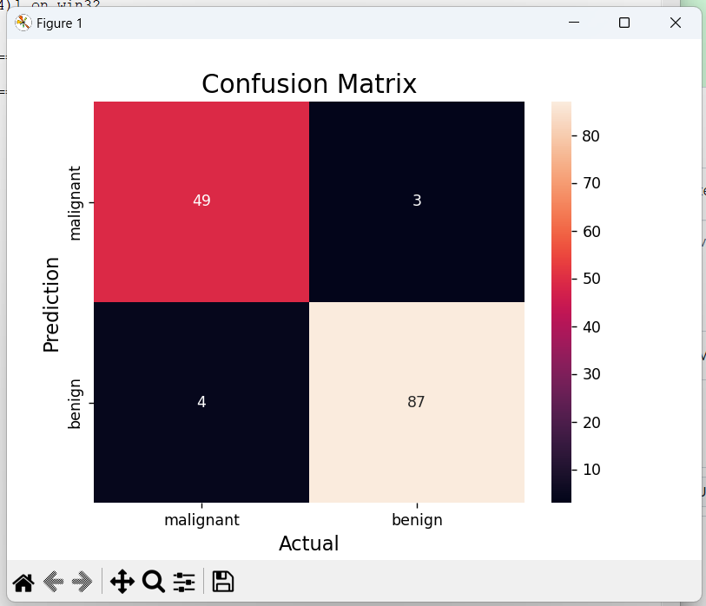

**EXPERIMENT:2**

**AIM:** To demonstrate 2 class confusion matrix using python

**OUTPUT:**

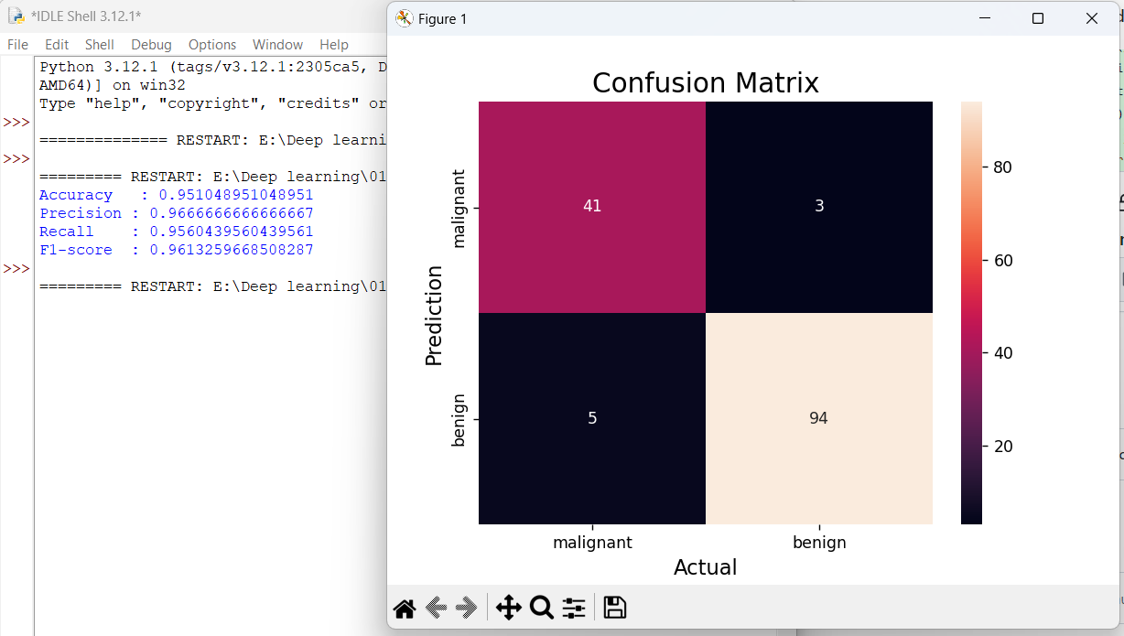

**EXPERIMENT:3**

**AIM:** Verifying the performance of a multi class confusion matrix by using choosen database with phython code

**OUTPUT:**

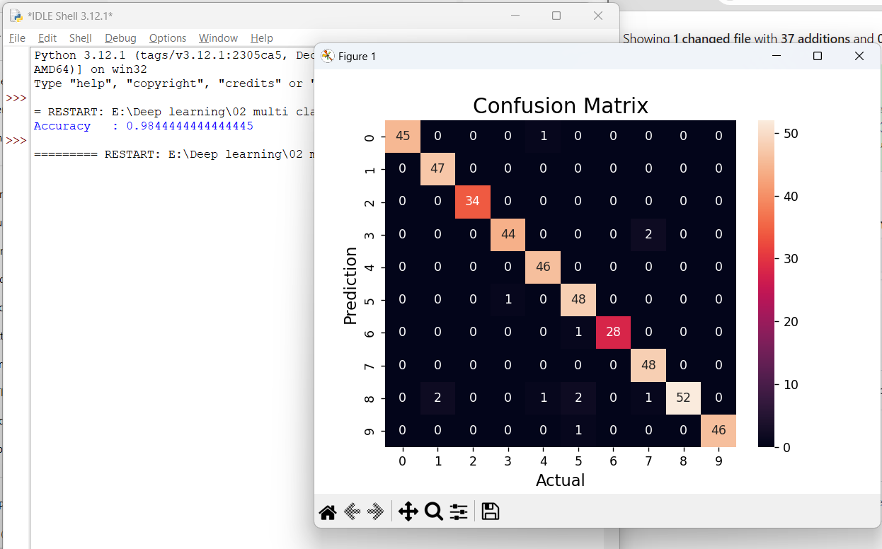

**EXPERIMENT:4**

**AIM:** : Verifying the performance of a over fitting by using choosen database with python code

**OUTPUT:**

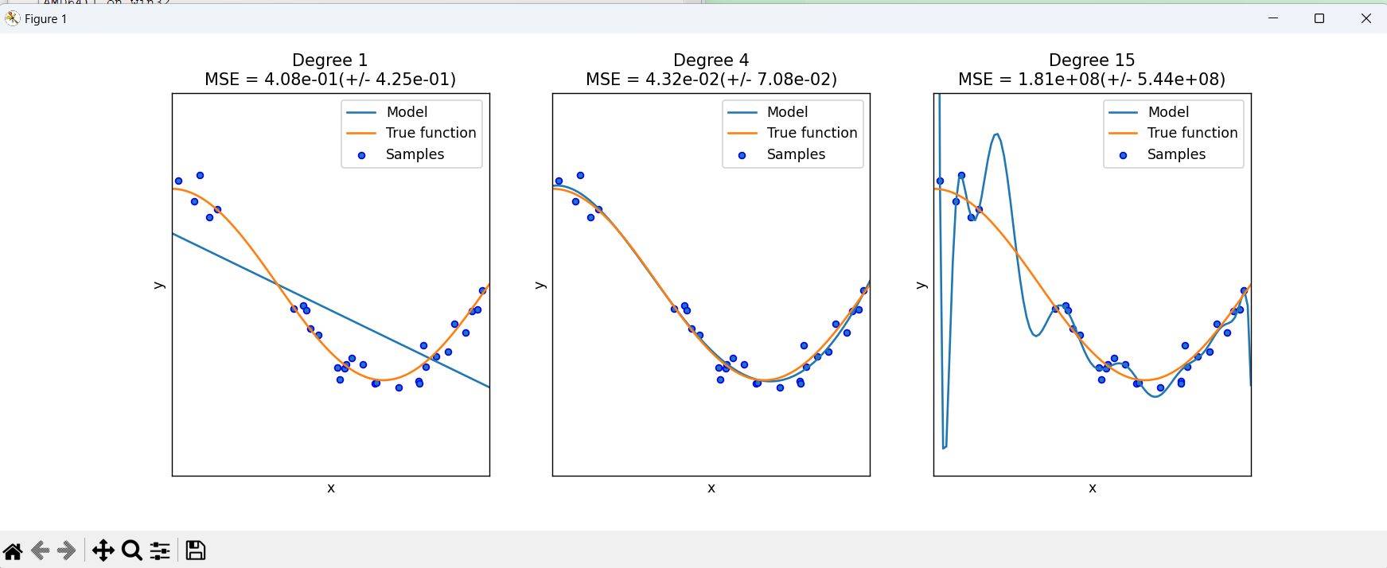

**EXPERIMENT:5**

**AIM:** To demonstrate the performance of a linear regression by using choosen database with python code

**OUTPUT:**

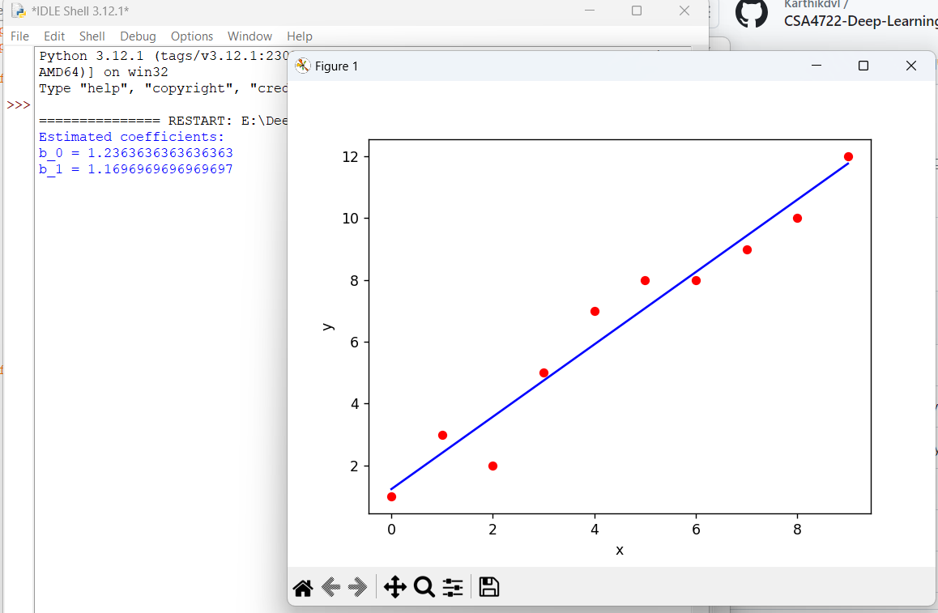

**EXPERIMENT:6**

**AIM:** : To demonstrate the performance of a logistic regression by using choosen database with python code.

**:** 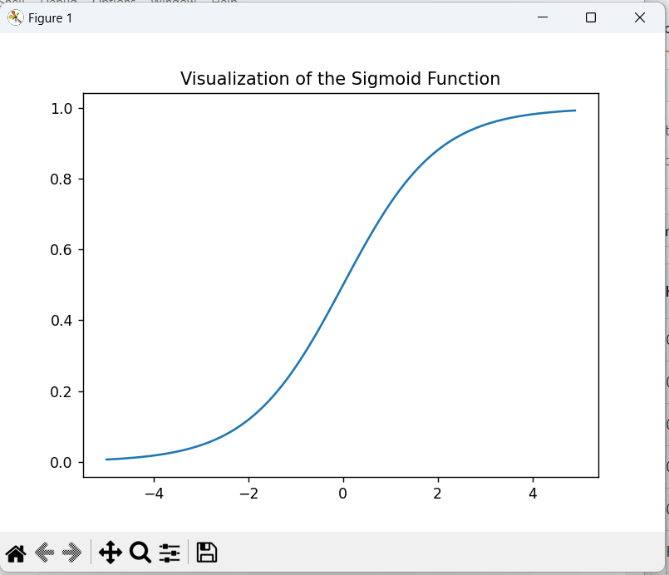

**EXPERIMENT:7**

**AIM:** Finding accuracy value of iris data set using KNN algorithm

**OUTPUT:**

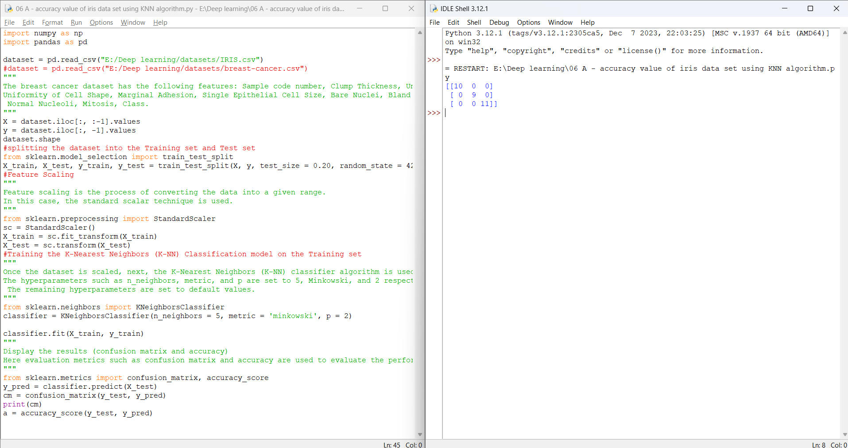

**EXPERIMENT:8**

**AIM: :** finding accuracy value of iris data set using NAVIE BAYES algorithm

**OUTPUT:**

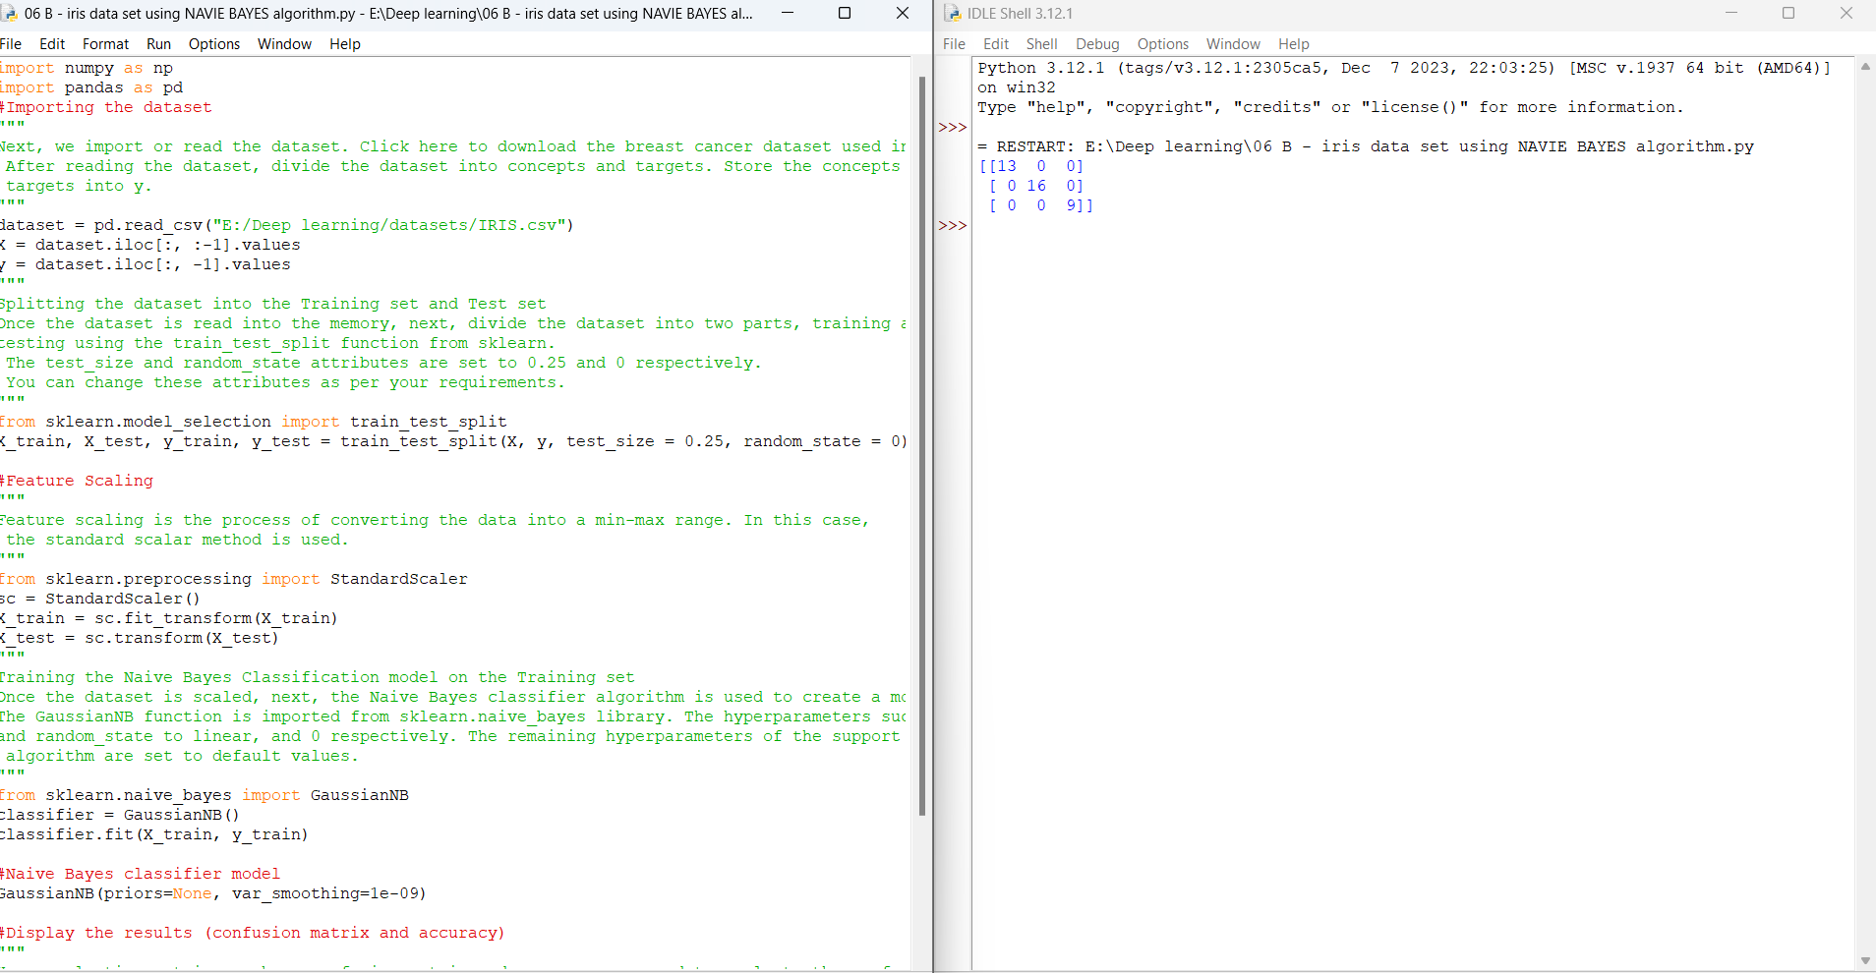

**EXPERIMENT:9**

**AIM: :** finding accuracy value of iris data set using LOGISTIC REGRESSION algorithm

**OUTPUT:**

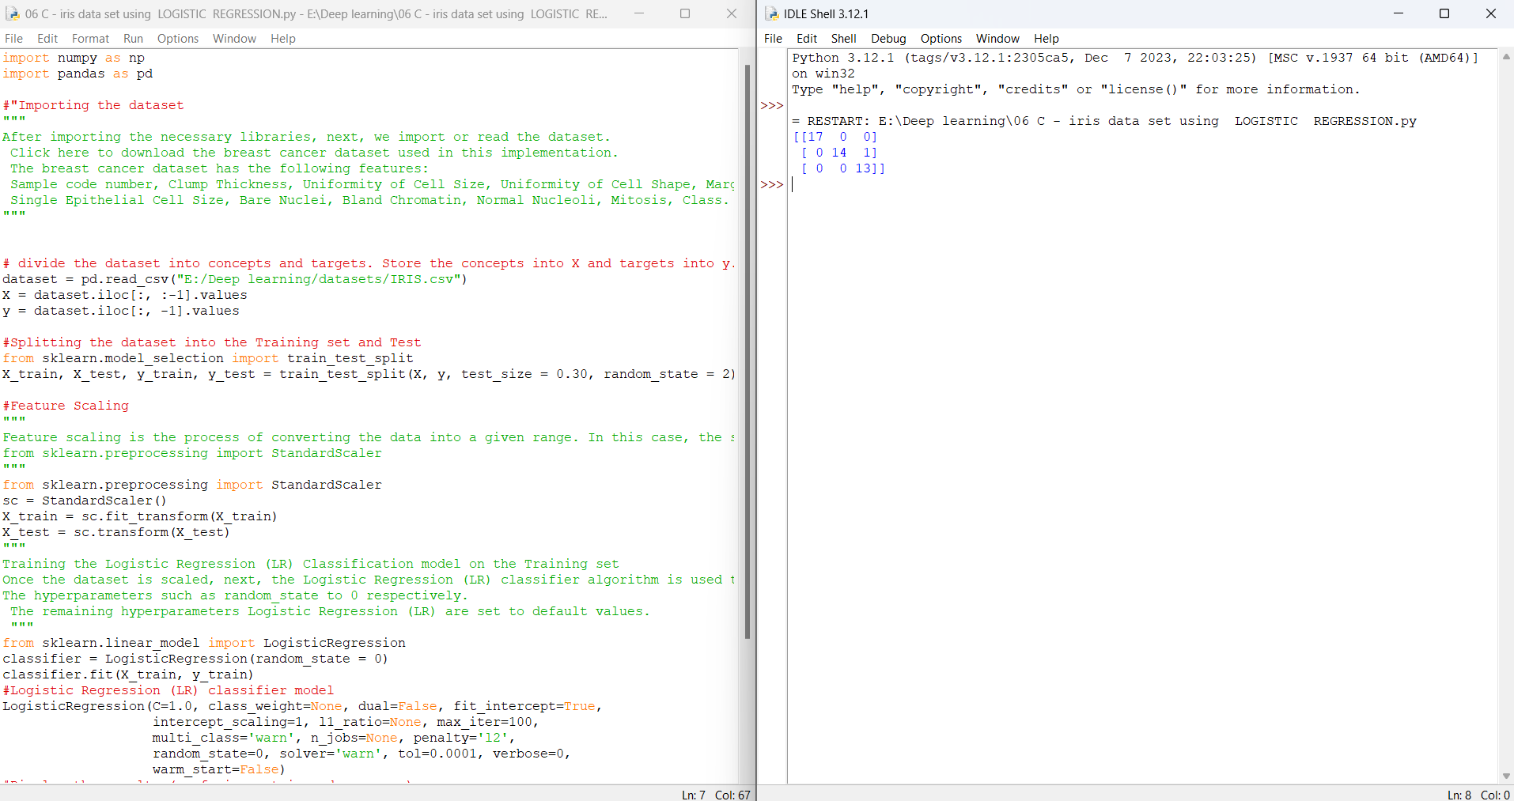

**EXPERIMENT:10**

**AIM: :** finding accuracy value of iris data set using DECISION TREE algorithm

**output:**

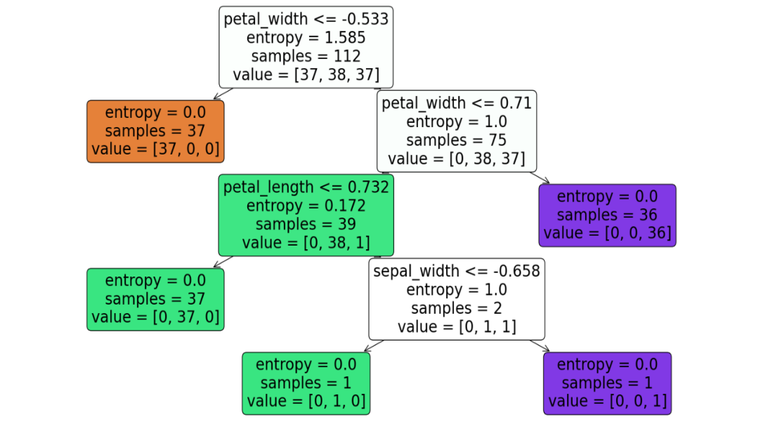

0.8947368421052632

[[13 0 0]

[ 0 11 1]

[ 0 3 10]]

**EXPERIMENT:11**

**AIM: :** finding accuracy value of iris data set using SVM algorithm

**OUTPUT:**

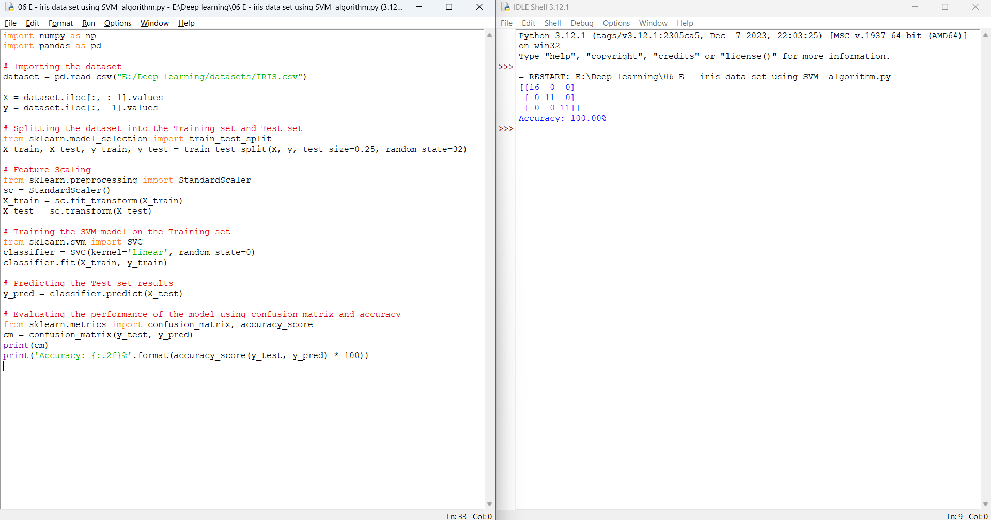

**EXPERIMENT:12**

**AIM: :** finding accuracy value of iris data set using RANDOM FOREST algorithm

**OUTPUT:**

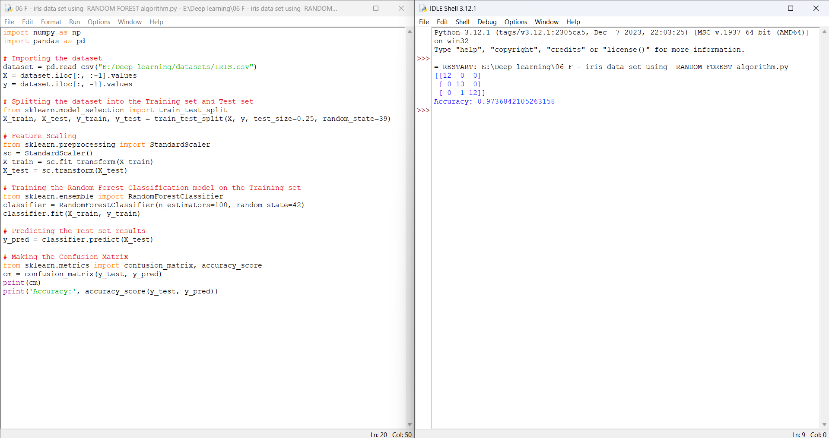

**EXPERIMENT:13**

**AIM:** To demonstrate gradient descent using python(actual data)

**output:**

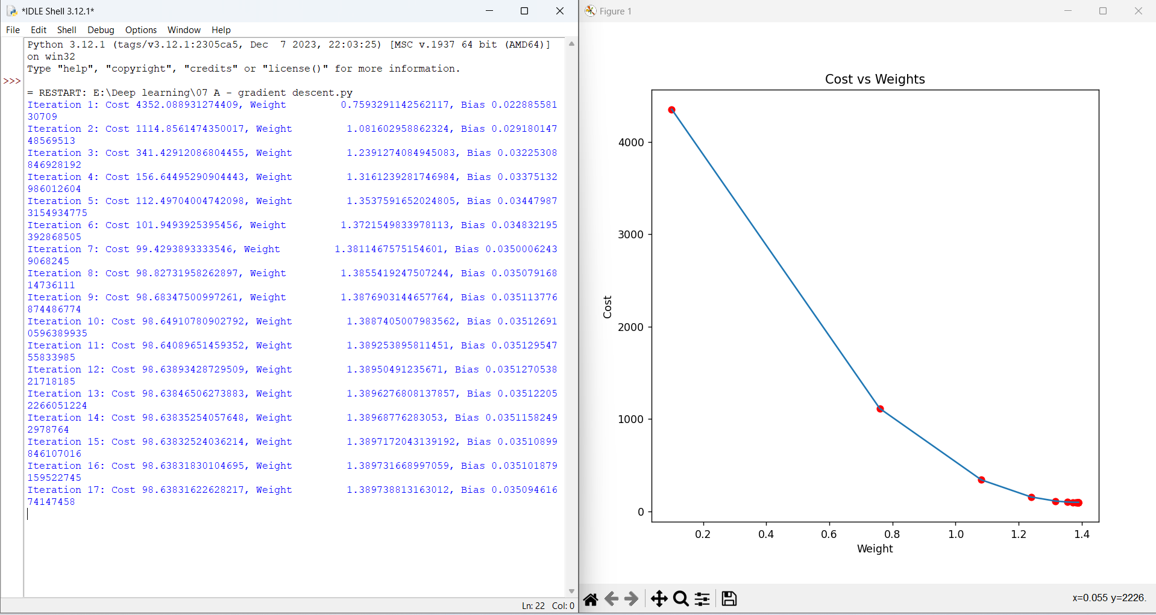

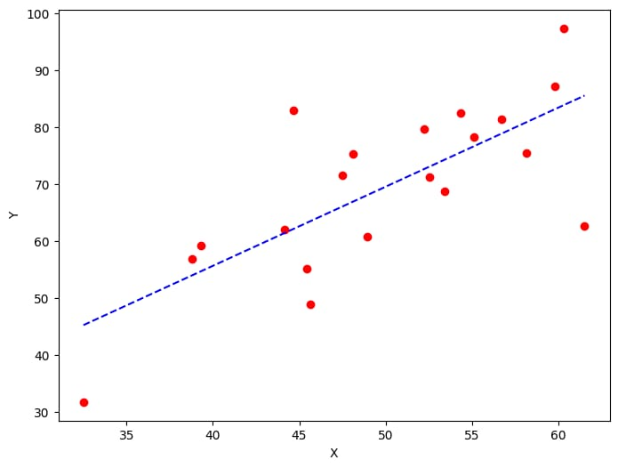**Experiment:14**

**AIM:** To demonstrate gradient descent using python( modified data)

**OUTPUT:**

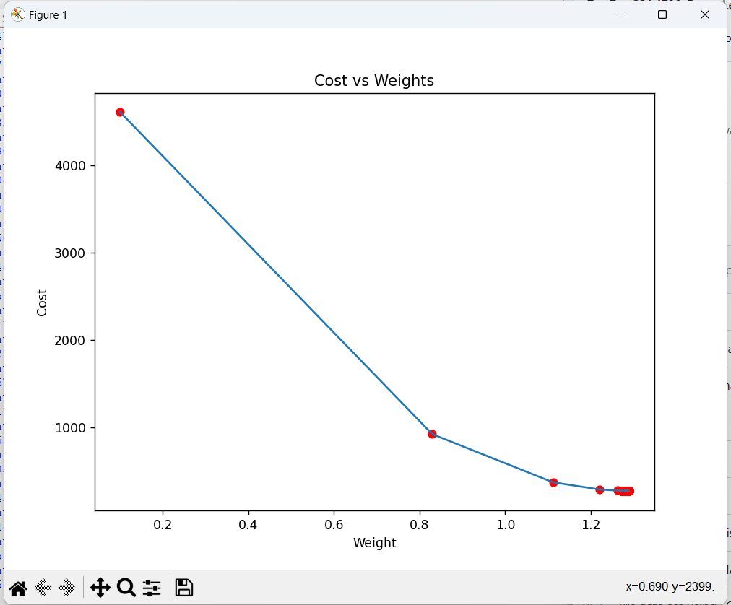

**EXPERIMENT:15**

**AIM:** : Verifying the performance of a image processing by using choosen database with phython code

**OUTPUT:**

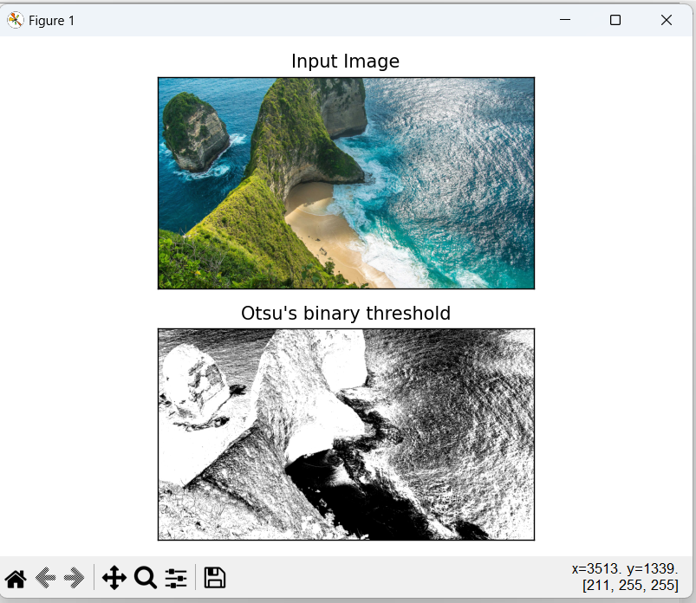

**EXPERIMENT:16**

**AIM:** : Verifying the performance of a image processing by using water shed database with python code

**OUTPUT:**

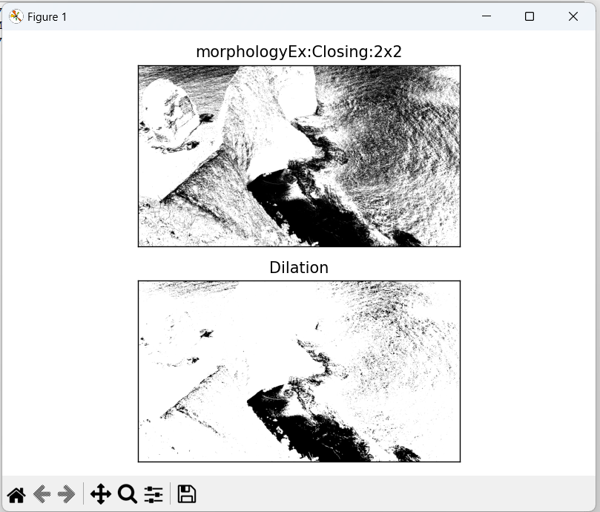

**EXPERIMENT:17**

**AIM:** Neural network analysis using TANH activation

**OUTPUT:**

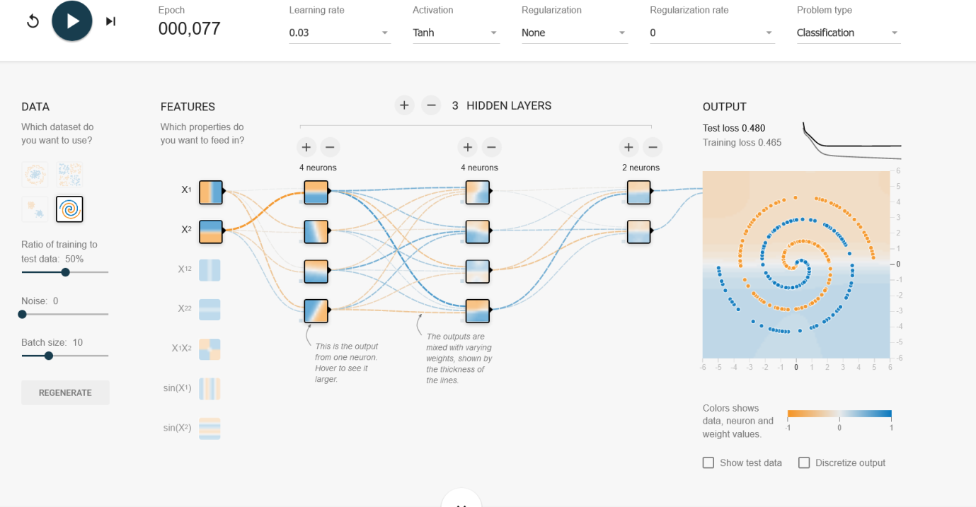

**EXPERIMENT:18**

**AIM:** Neural network analysis using SIGMOID activation

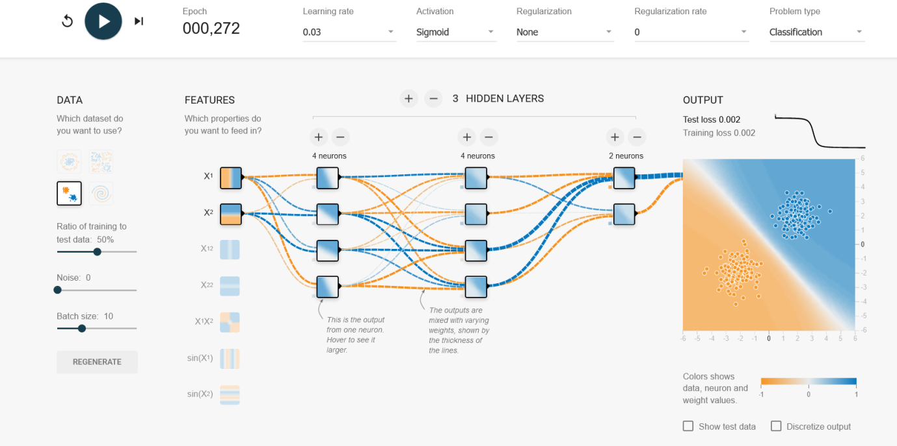

**EXPERIMENT:19**

**AIM:** Neural network analysis using LINEAR activation

**OUTPUT:** 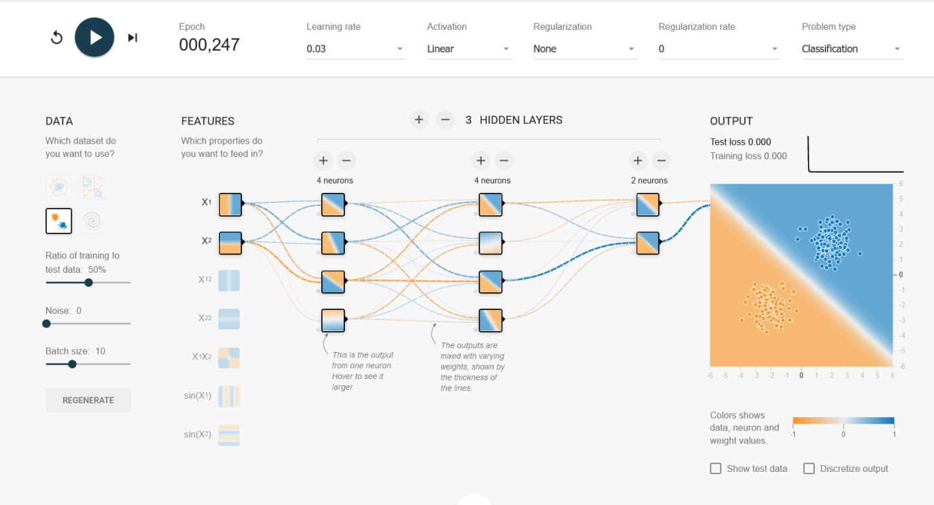

**EXPERIMENT:20**

**AIM:** Neural network analysis using ReLU activation

**OUTPUT:**

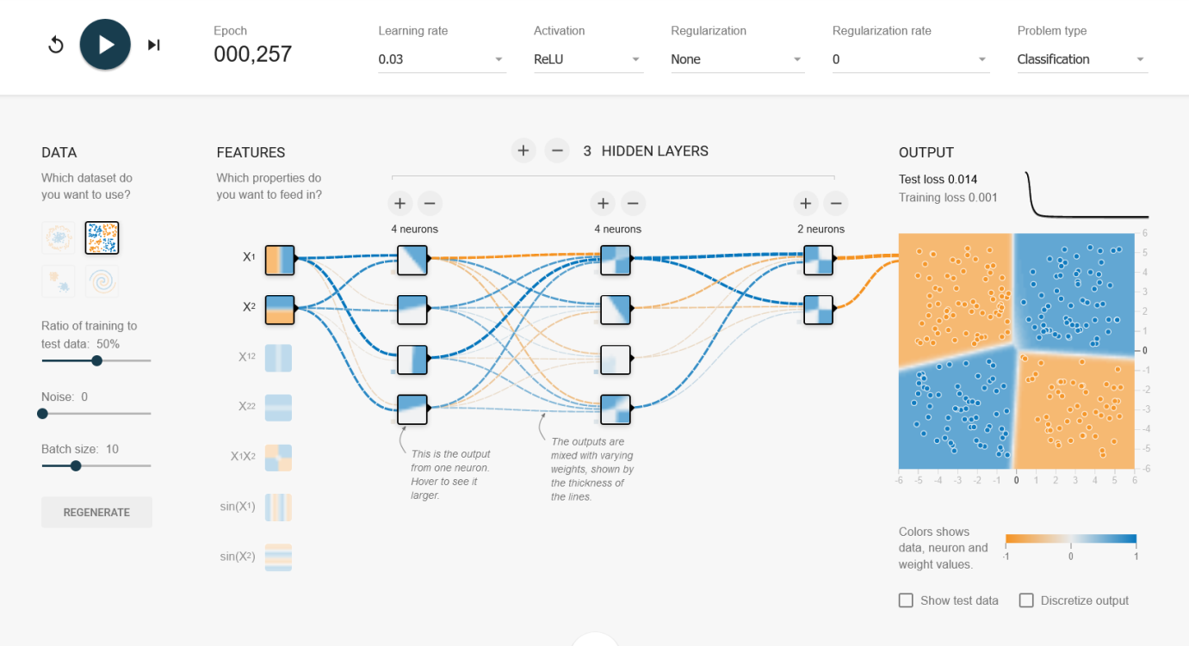

**EXPERIMENT:21**

**AIM:** To demonstrate linear separability using python code

**OUTPUT:**

