Jenkins Webhook-Based WAR Deployment Configuration

Step 1: Configure General Settings
In Jenkins, create a new job or open the existing one named 'jenkins-git-webhook'. Under the 'General' section, provide a clear description like 'using webhook deploying WAR web application hosting'. Enable 'Discard old builds' to maintain workspace health and set build retention policies. Example: Keep builds for 5 days and a maximum of 5 builds.
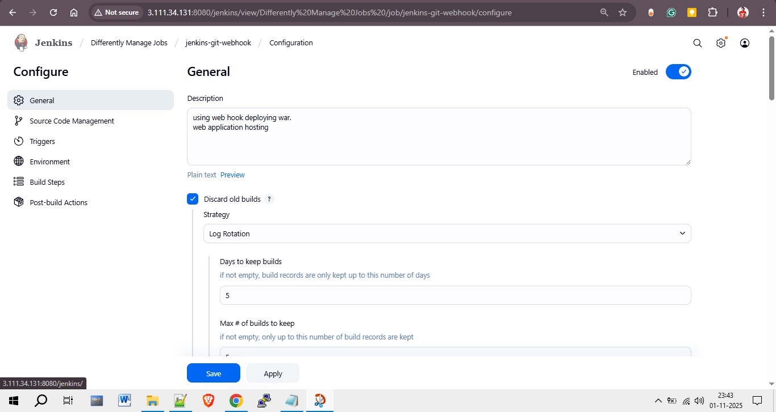

Step 2: Configure Source Code Management (Git)
In the 'Source Code Management' section, select 'Git' as your version control system. Provide the repository URL, such as 'https://github.com/rohitssonar/project.git'. If credentials are required, configure them here. Specify the branch to build as '*/master' to ensure Jenkins pulls code from the correct branch.
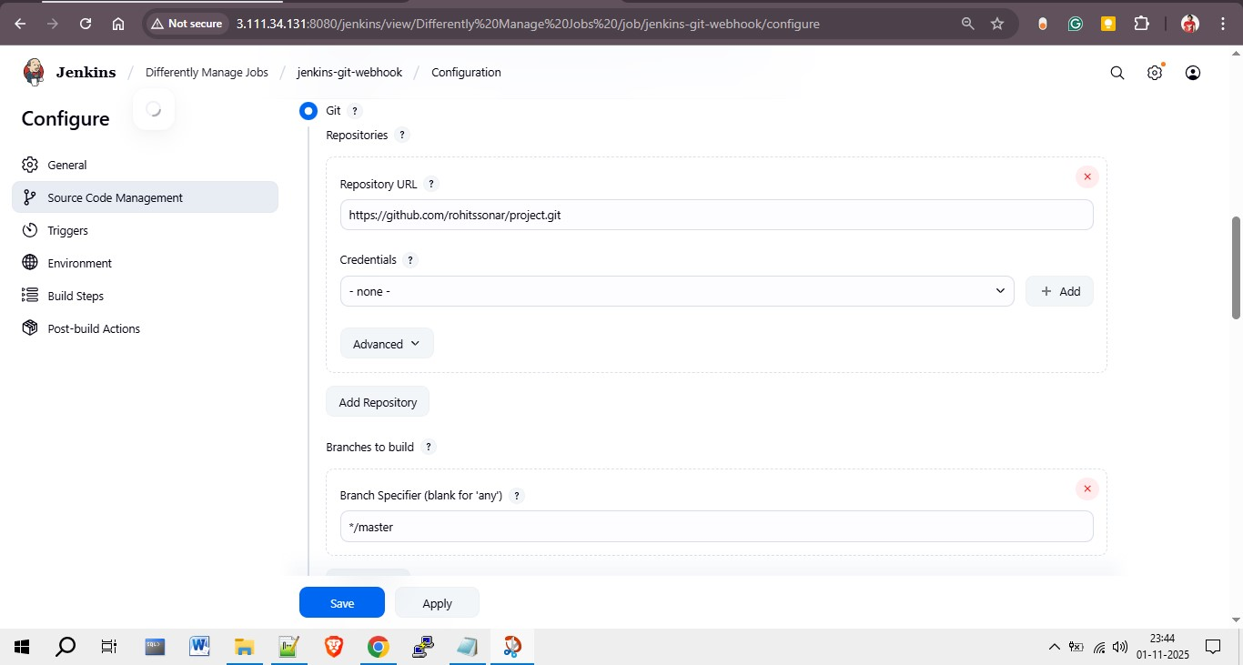

Step 3: Configure Build Triggers (GitHub Webhook)
In the 'Triggers' section, enable 'GitHub hook trigger for GITScm polling'. This allows Jenkins to automatically start the build whenever a new commit is pushed to the connected GitHub repository. Additionally, under 'Environment', check 'Delete workspace before build starts' to ensure a clean environment before each build.
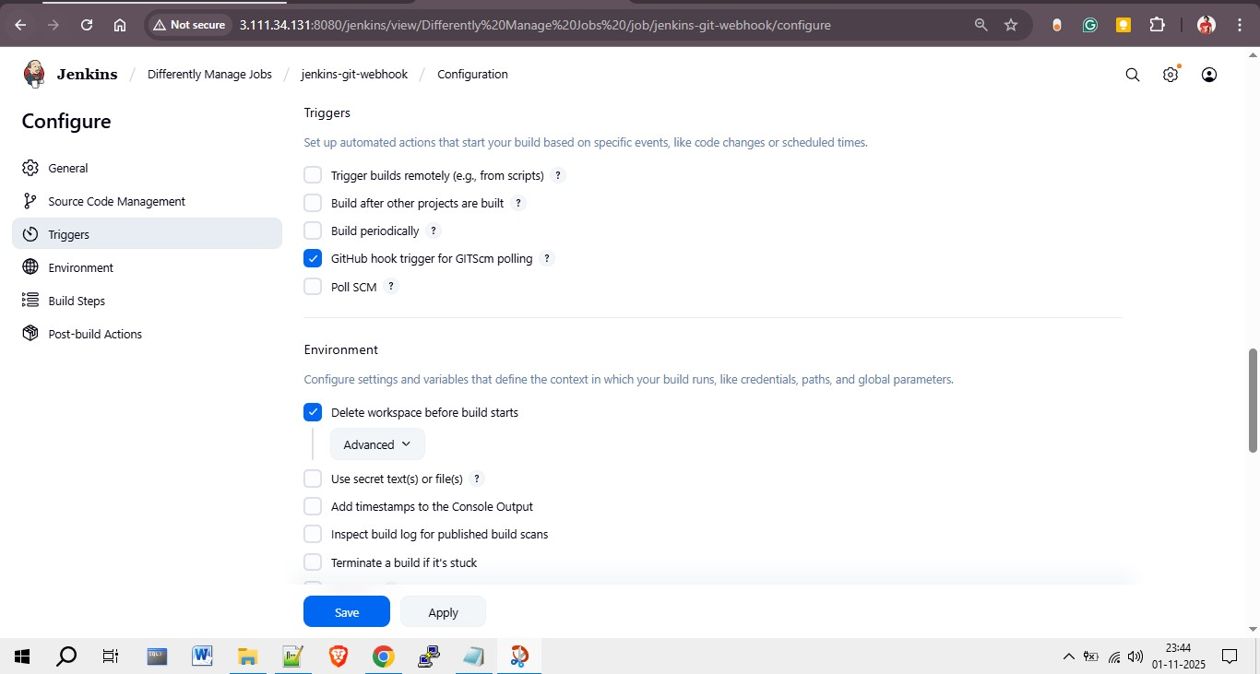

Step 4: Add Build Steps
In the 'Build Steps' section, add two key actions:
1. **Invoke top-level Maven targets:**
- Maven Version: apache-maven-3.9.11
- Goals: clean package
This step compiles the code and packages it into a WAR file.
2. **Execute Shell Command:**
Use the shell command below to copy the generated WAR file from the Jenkins workspace to the Tomcat webapps directory for deployment.
cp -r /root/.jenkins/workspace/jenkins-webhook/target/LoginWebApp.war /mnt/servers/apache-tomcat-10.1.48/webapps/LoginWebApp.war
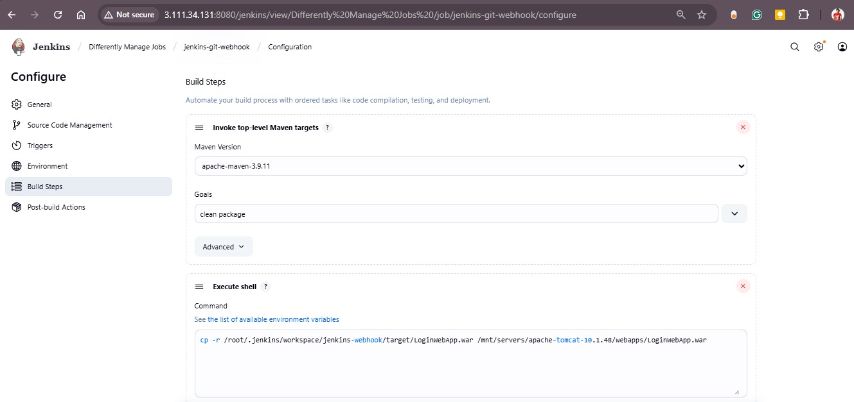

Step 5: Save and Verify Webhook Integration
After completing all configurations, click 'Save'. Go to your GitHub repository settings and add a new webhook with the following URL format:
http://<JENKINS_SERVER_IP>:8080/github-webhook/
Set the webhook content type to 'application/json'. Push a new commit to the repository — Jenkins will automatically trigger the build and deploy the WAR file. Finally, open the deployed web application in a browser to verify successful hosting.

