Jenkins WAR Deployment on a Different Machine

Step 1: Configure General Settings
In Jenkins, navigate to the job named 'Jenkins-war-Deploy-diff-machine'. Under the 'General' section, provide a description for the job and enable 'Discard old builds' to manage the build history efficiently. You can set a limit on the number of builds or days to retain old build data.
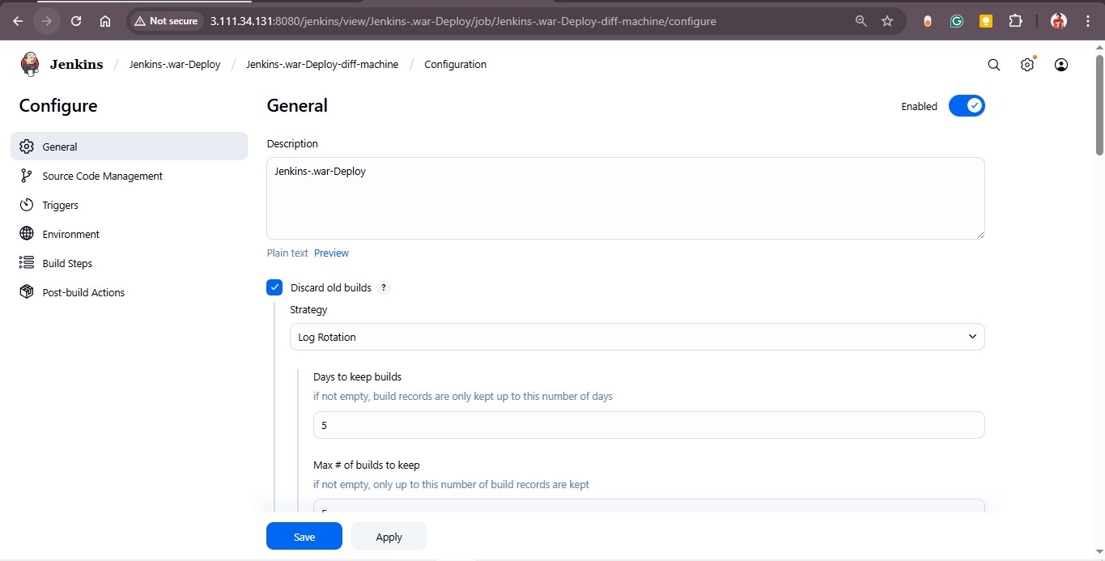

Step 2: Configure Source Code Management (Git)
Go to the 'Source Code Management' section and select 'Git'. Enter your repository URL, for example 'https://github.com/rohitssonar/project.git'. Choose the correct credentials for accessing the repository if required, and specify the branch to build (e.g., master).
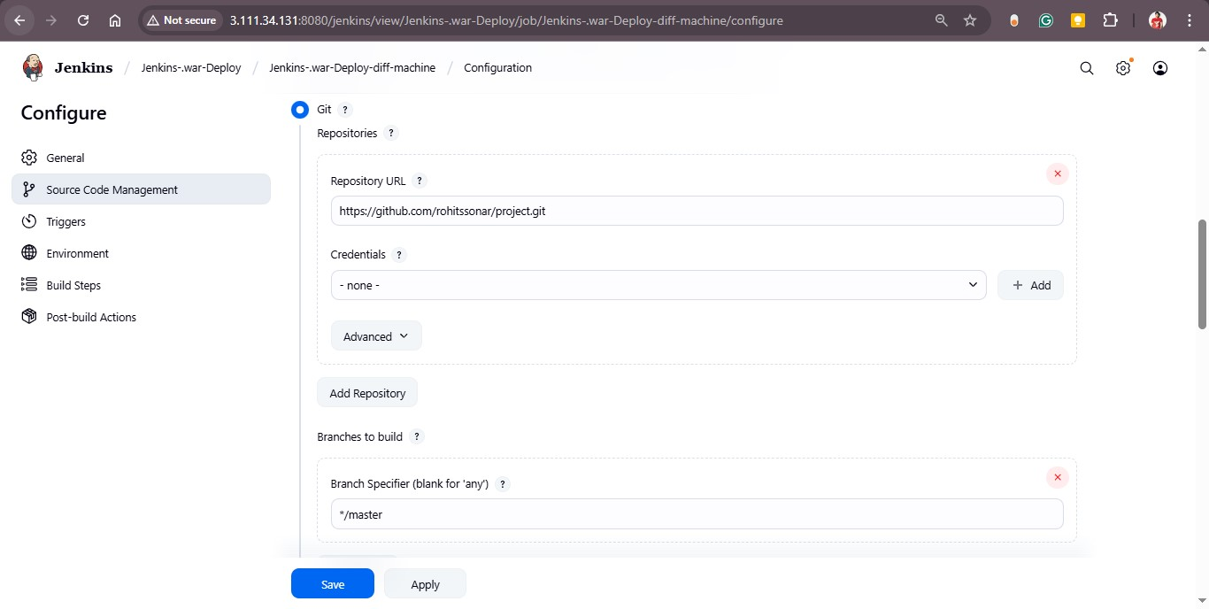

Step 3: Configure Environment and Build Triggers
In the 'Triggers' section, you can configure options like polling SCM or scheduling periodic builds if needed. Under the 'Environment' section, enable 'Delete workspace before build starts' to ensure a clean workspace before each build.
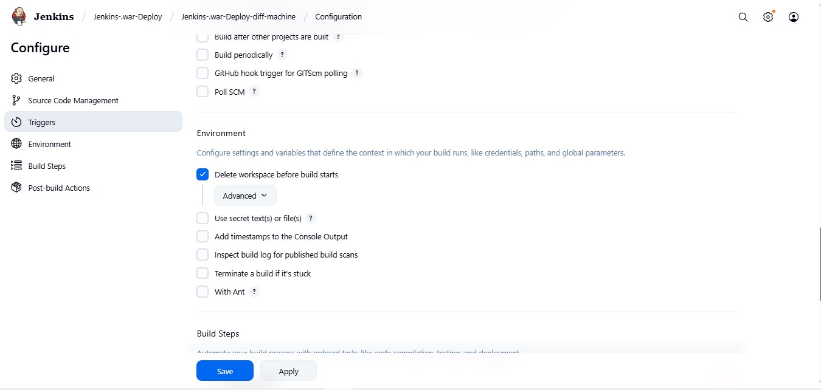

Step 4: Define Build Steps (Shell Command)
In the 'Build Steps' section, select 'Execute shell' to define commands for deployment. Here, Jenkins uses the SCP (Secure Copy) command to transfer the WAR file from the Jenkins server to a remote EC2 instance where the Tomcat server is hosted.
scp -i /root/Devops_key.pem /root/project/target/LoginWebApp.war ec2-user@172.31.11.151:/mnt/servers/apache-tomcat-10.1.48/webapps/LoginWebApp.war
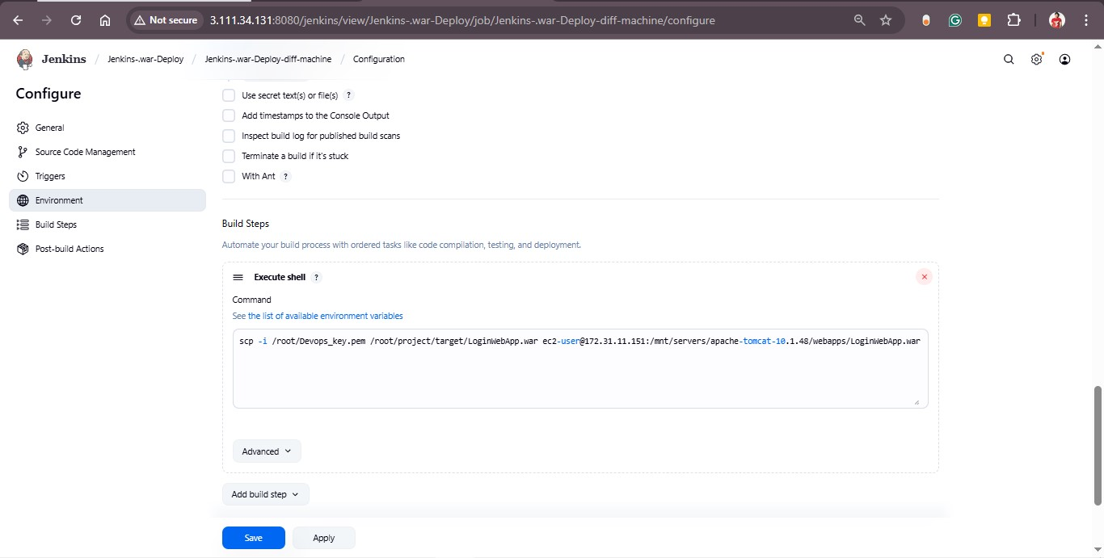

Step 5: Save and Execute Build
After configuring all the above settings, click 'Save' and then 'Build Now'. Jenkins will build the project, generate the WAR file, and securely copy it to the remote machine for deployment. You can verify deployment by accessing the application through the Tomcat server's IP address.

