Jenkins Slave Job Configuration Guide

Step 1: General Configuration
In this step, we configure the basic project details. Provide a meaningful description (e.g., "This is Slave 1")
to identify the purpose of the job. Enable 'Discard old builds' to manage storage by automatically deleting
older builds. Set 'Days to keep builds' to 5 and 'Max number of builds to keep' as 3.
This ensures your Jenkins workspace remains optimized.
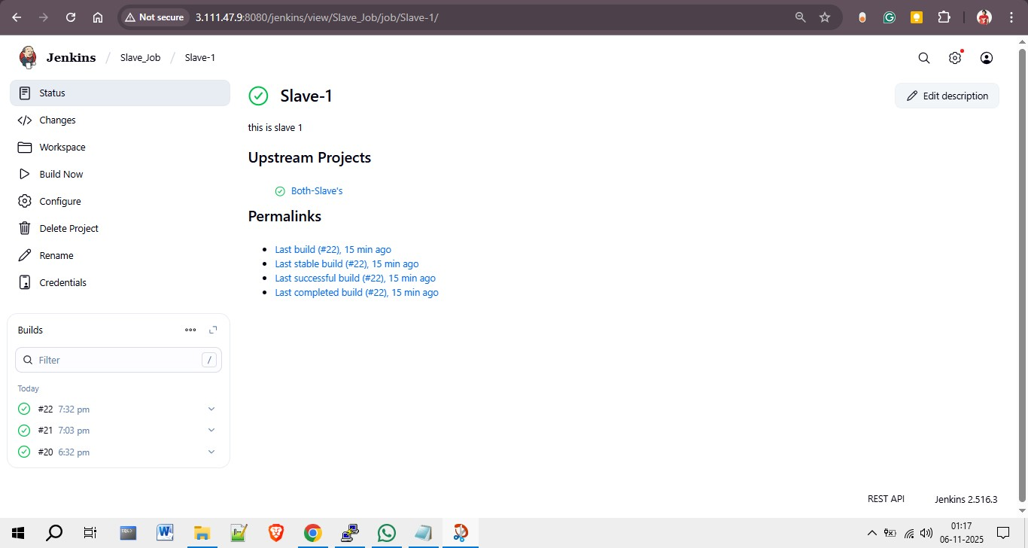
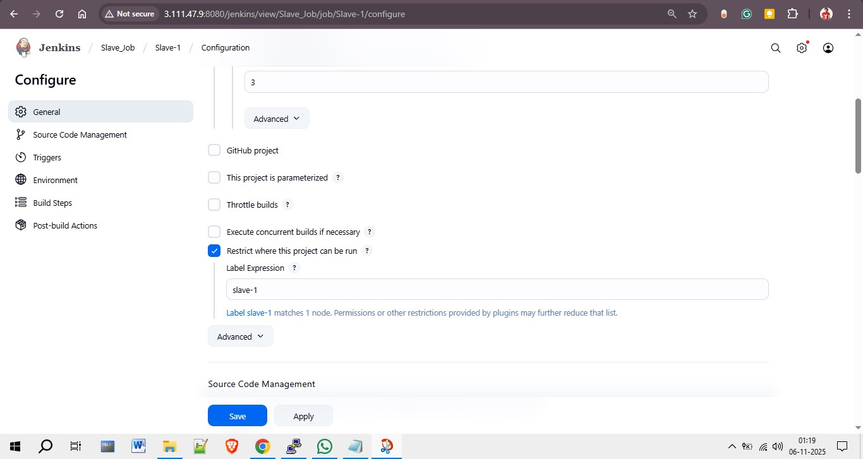

Step 2: Node Restriction Configuration
Check the option 'Restrict where this project can be run' and enter the label expression 'slave-1'.
This ensures that the job executes only on the Jenkins slave node that matches this label.
Such configuration helps distribute build workloads efficiently across different Jenkins nodes.
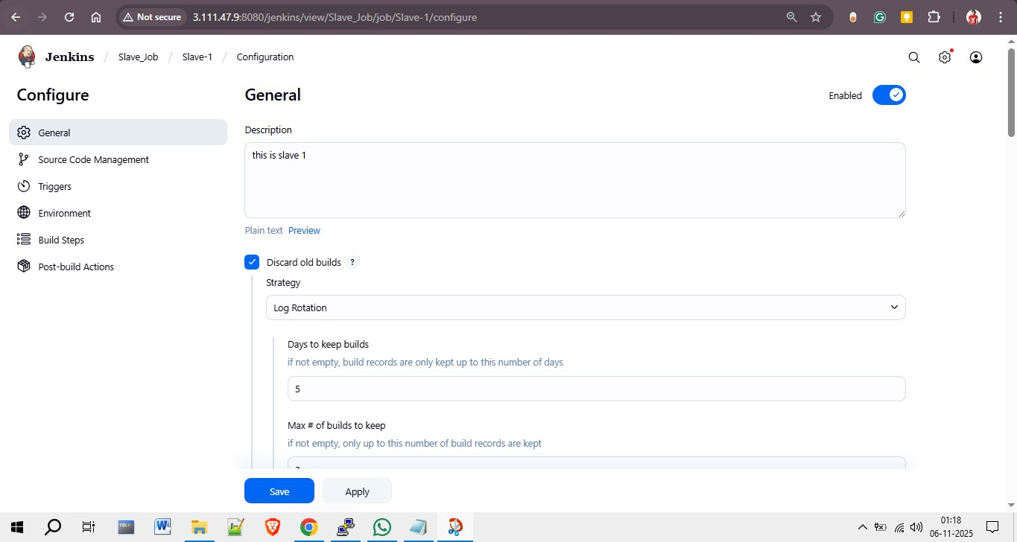

Step 3: Source Code Management (Git Configuration)
Under Source Code Management, select 'Git' and specify your repository URL
(e.g., https://github.com/rohitssonar/master.git). Add your Jenkins credentials
(for example, 'git-token') to enable Jenkins to access your private repositories securely.
Define the branch you want Jenkins to build — in this example, it's */2025Q1.
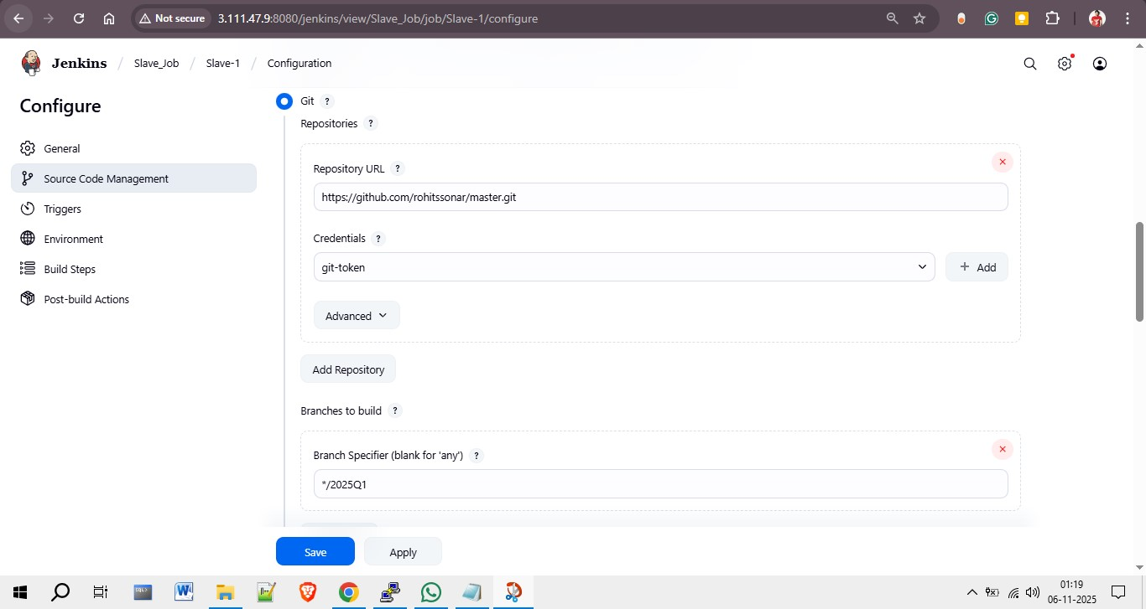

Step 4: Build Triggers & Environment
In this step, no GitHub webhook triggers are used. Instead, the environment settings are configured.
Enable 'Delete workspace before build starts' to ensure a clean environment for every new build.
This prevents conflicts caused by leftover files from previous builds.
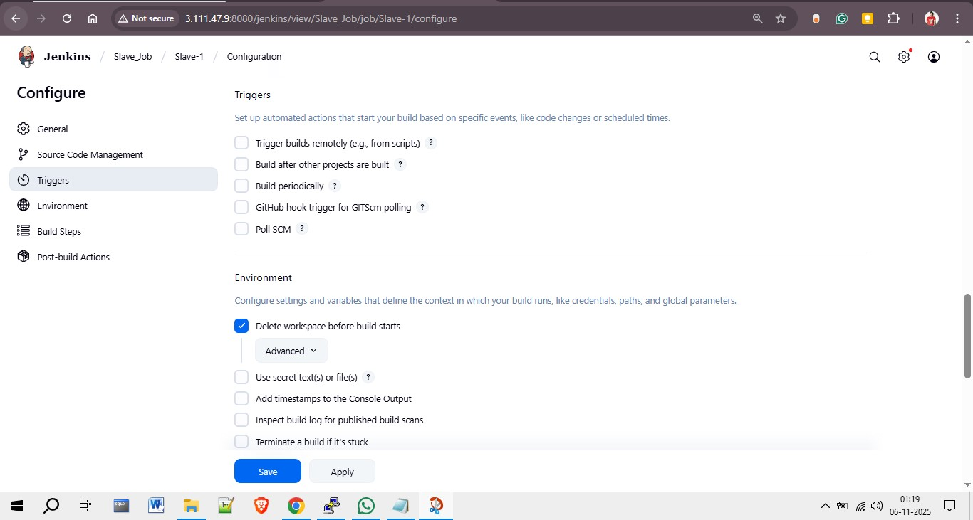

Step 5: Build Steps (Execute Shell Commands)
In the 'Build Steps' section, select 'Execute shell' and enter the deployment commands.
These commands copy the index.html file from the Jenkins workspace to the Apache web directory,
set the correct permissions, and restart the Apache HTTP service.
sudo cd /var/www/html/
sudo cp -r /mnt/jenkins-slave/workspace/Slave-1/index.html /var/www/html/index.html
sudo chmod -R 777 index.html
sudo systemctl restart httpd
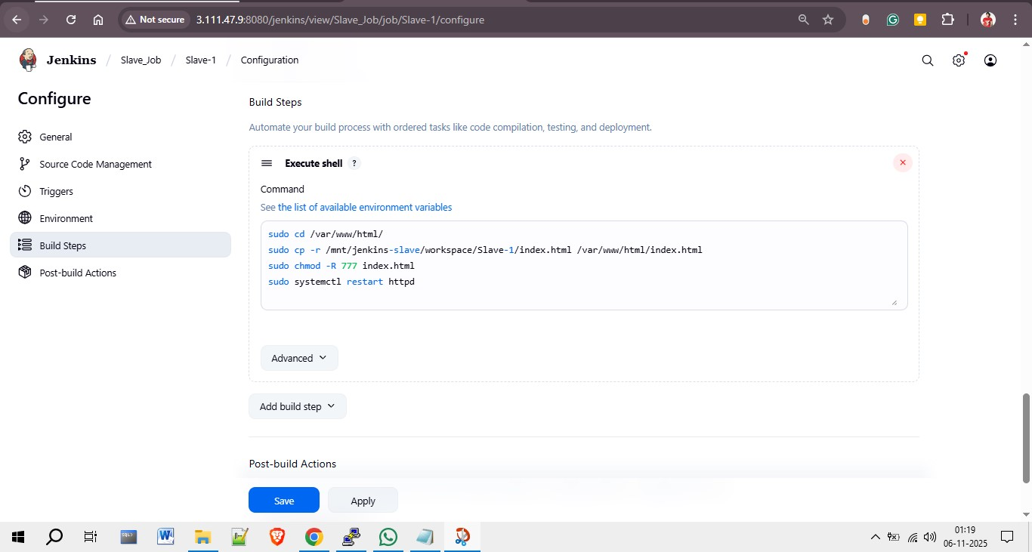

Step 6: Build Status & Results
Once the configuration is complete and builds are triggered, the Jenkins dashboard
displays the current build status, build history, and upstream/downstream project relationships.
The Slave Job status page confirms successful build execution on the assigned node (Slave-1).

