Jenkins Project Configuration for Different Deployment

Step 1: Configure General Settings
In Jenkins, open the project named 'project-Different'. Under the 'General' section, provide a description and enable 'Discard old builds'. This helps in maintaining workspace hygiene by limiting the number of stored builds.
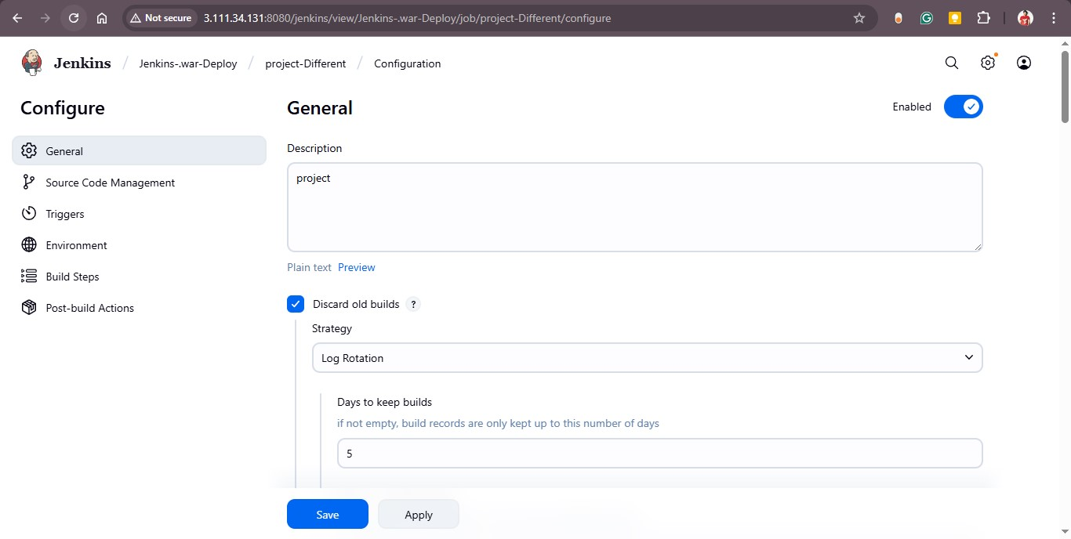

Step 2: Configure Source Code Management (Git)
In the 'Source Code Management' section, select 'Git' as the version control system. Provide your GitHub repository URL (e.g., https://github.com/rohitssonar/project.git). Leave credentials as 'none' if not required and specify the branch to build (e.g., master).
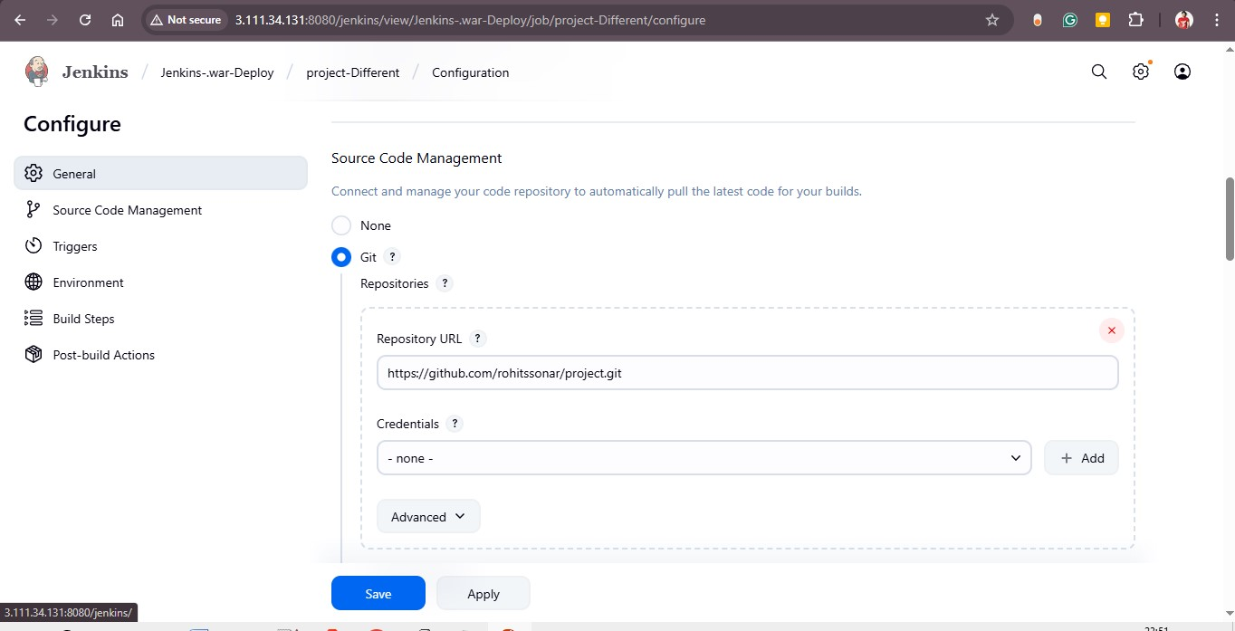
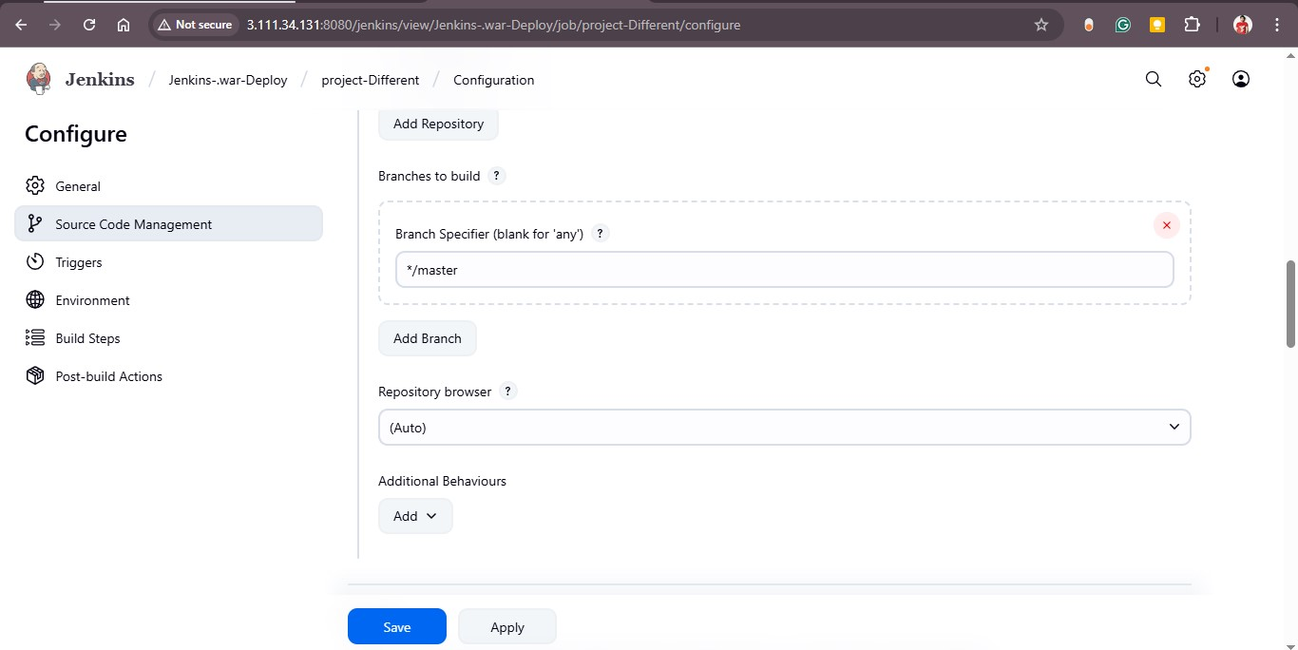

Step 3: Configure Environment Settings
In the 'Environment' section, enable 'Delete workspace before build starts'. This ensures that every build starts with a clean environment. You can also define additional options such as timestamps, secret text, or terminating stuck builds.
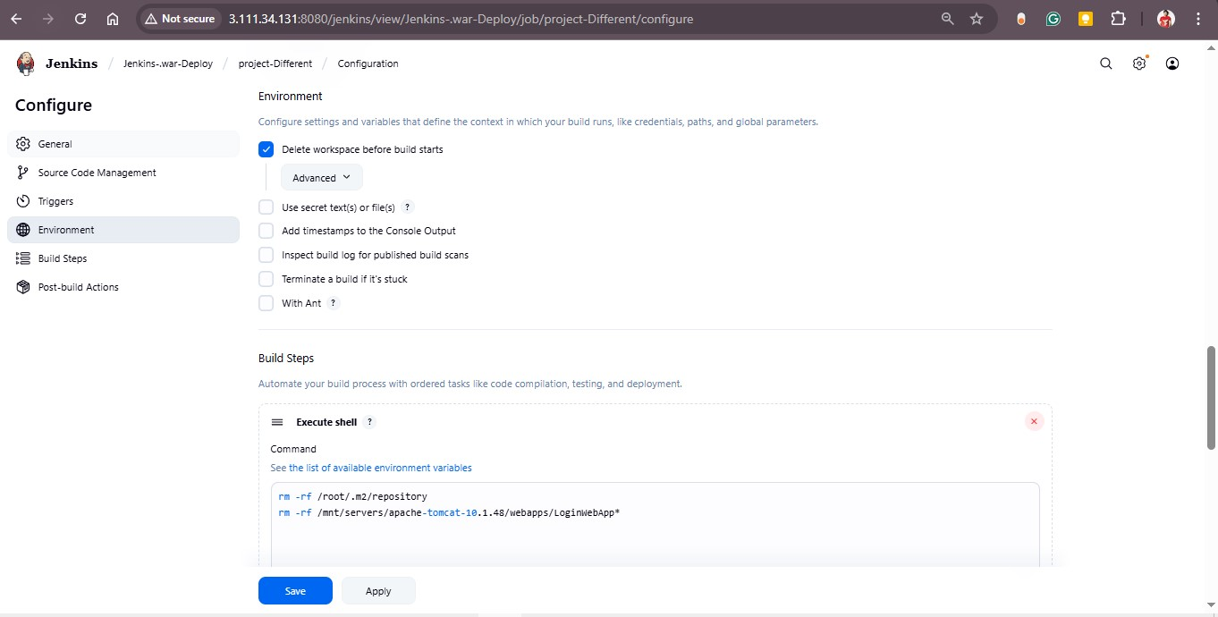

Step 4: Define Build Steps
In the 'Build Steps' section, add the following actions:
1. **Invoke top-level Maven targets:** Use Maven for build automation. Specify the Maven version (e.g., apache-maven-3.9.11) and set goals as 'clean install'.
2. **Execute Shell Command:** Use SCP to transfer the WAR file to the remote Tomcat server on a different machine.
scp -i /root/Devops_key.pem /root/.jenkins/workspace/project/target/LoginWebApp.war ec2-user@172.31.11.151:/mnt/servers/apache-tomcat-10.1.48/webapps/LoginWebApp.war
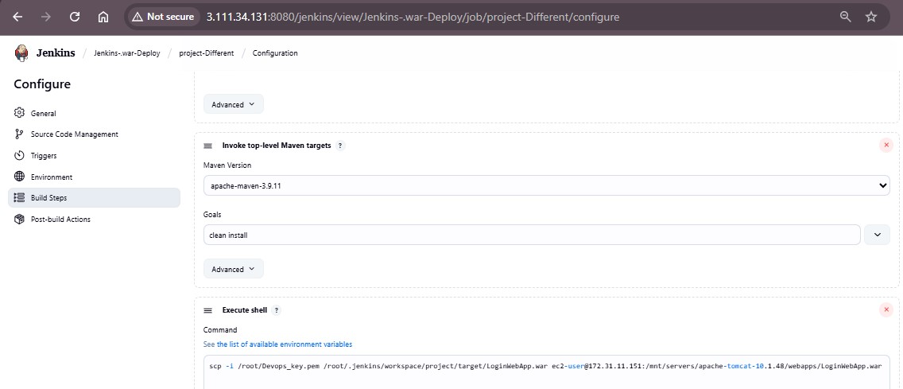

Step 5: Save and Execute the Job
After completing the configuration, click 'Save' and then select 'Build Now' from the Jenkins dashboard. Monitor the console output to ensure the build and deployment execute successfully. Finally, access the deployed application via the Tomcat server’s public IP address to confirm deployment.

