Jenkins S3 Job Configuration and Deployment Steps

Step 1: Open Jenkins S3 Job
Go to your Jenkins dashboard and select the job named 's3'. This job is responsible for handling S3 WAR file deployment. You can see the downstream projects and build history on this page.
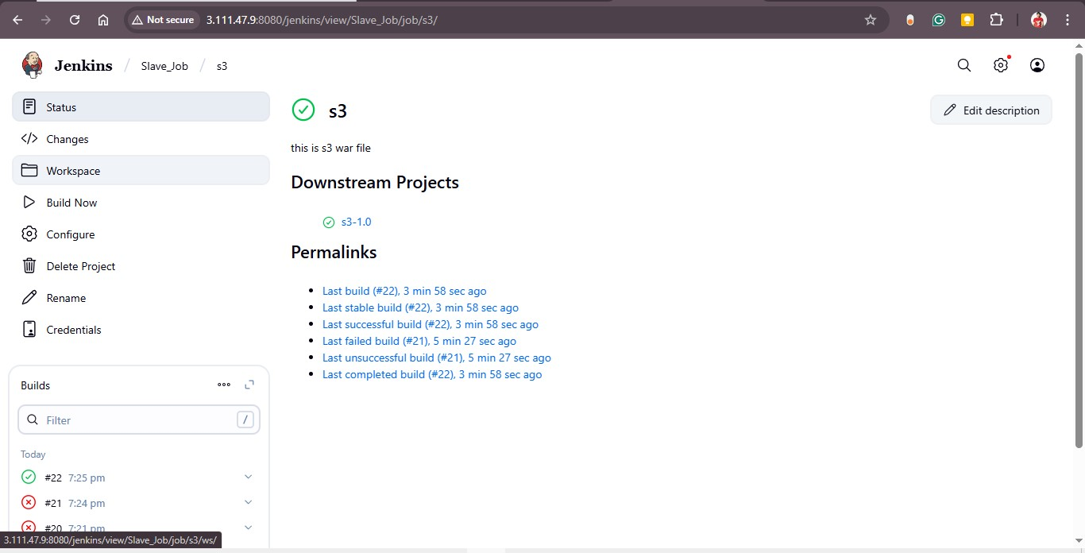

Step 2: Configure General Settings
In the General section, provide a description such as 'This is s3 war file'. Enable 'Discard old builds' and set log rotation parameters to manage build history efficiently.
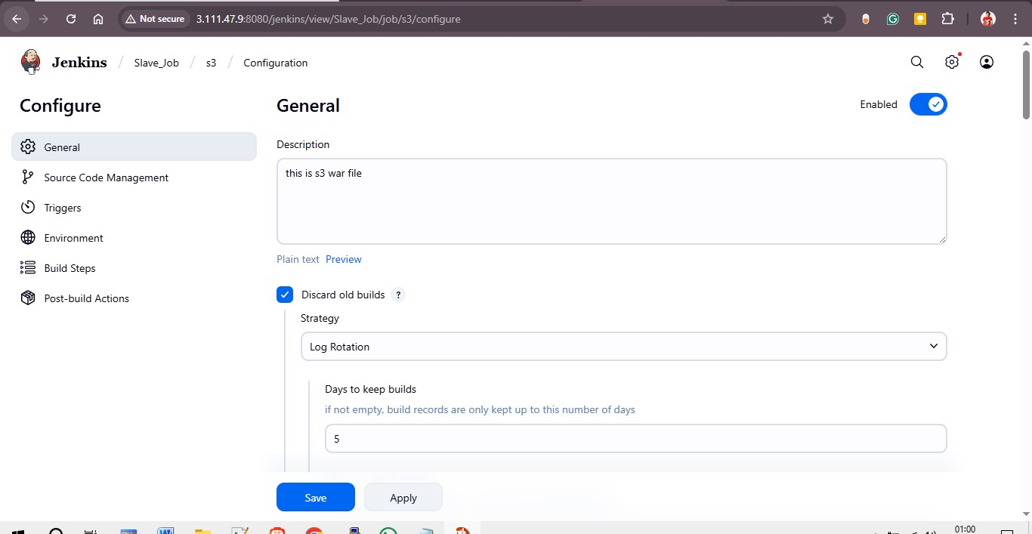
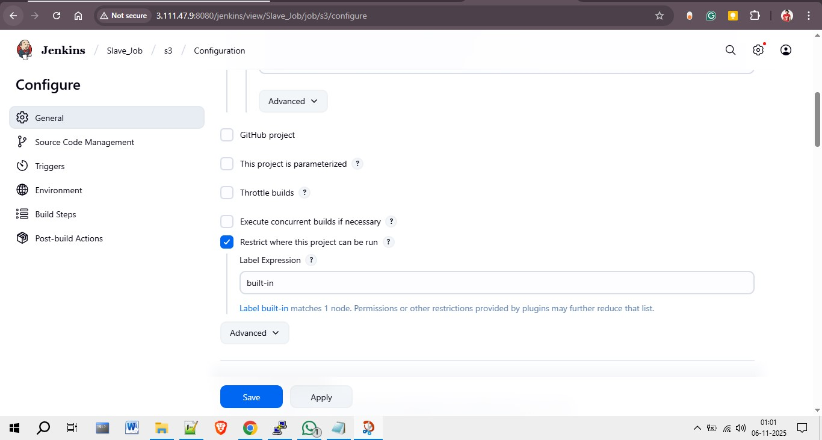

Step 3: Configure Source Code Management (Git)
Under Source Code Management, select 'Git' and add your repository URL. In this case, the GitHub repository is used for project version control. Specify the branch to build (e.g., master).
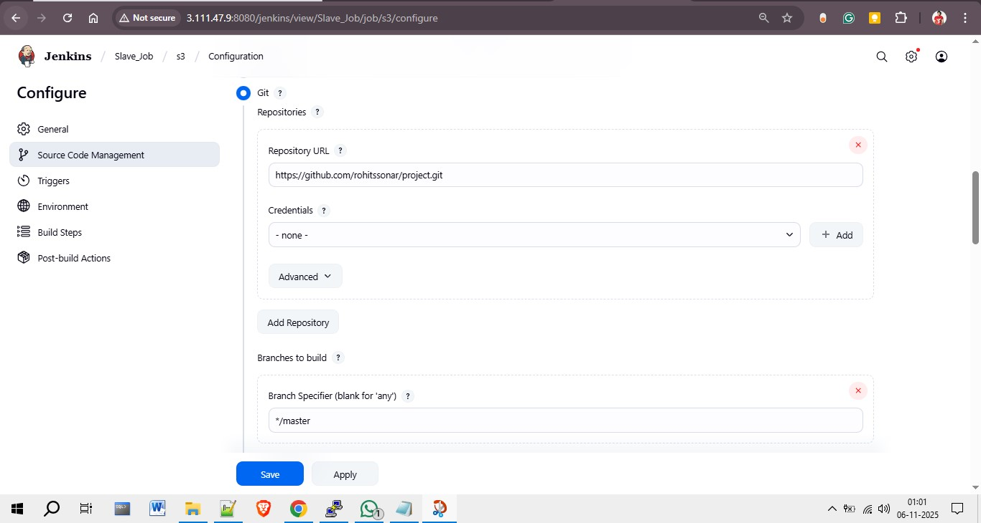

Step 4: Configure Triggers and Environment
In the Triggers section, you can automate builds based on conditions such as code changes or schedules. Enable 'Delete workspace before build starts' to ensure a clean build environment for every run.
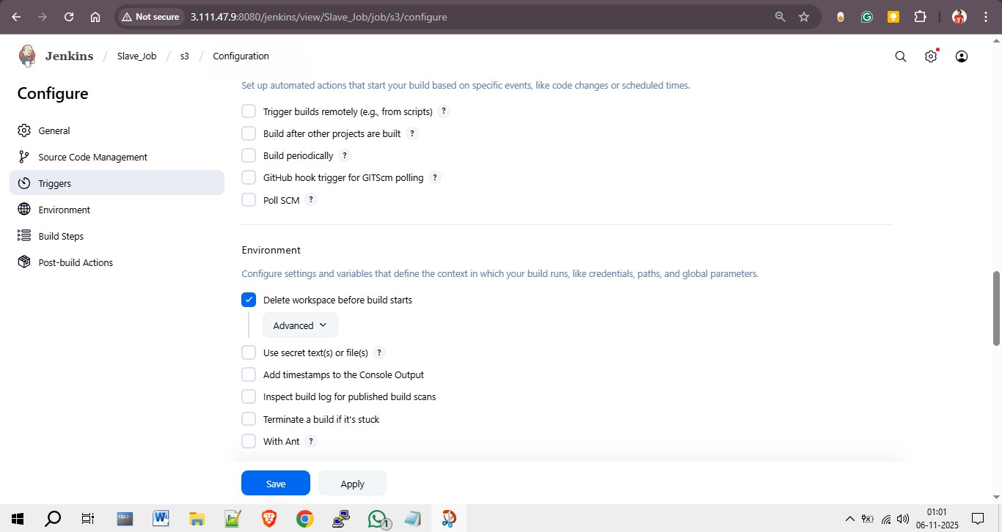

Step 5: Define Build Steps
In the Build Steps section, you can invoke Maven goals and execute shell commands. Here, the 'clean package' goal is used to build the project, followed by shell commands that upload the WAR file to S3 and deploy it to the Tomcat server.
aws s3 cp /root/.jenkins/workspace/s3/target/LoginWebApp.war s3://war-deploy-1111/ --region ap-south-1
aws s3 cp s3://war-deploy-1111/LoginWebApp.war /mnt/servers/apache-tomcat-10.1.48/webapps/LoginWebApp.war --region ap-south-1
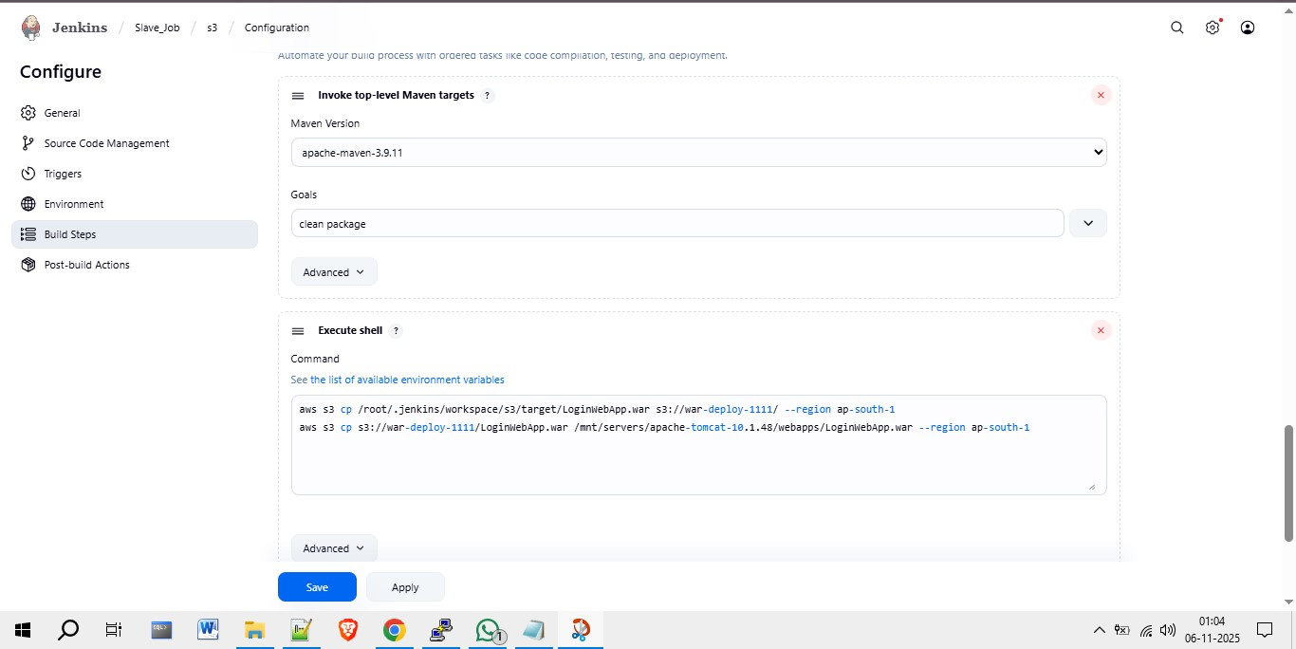

Step 6: Verify Deployment
Once the build and deployment process is completed successfully, open the web browser and access the deployed application URL. The application should load successfully, confirming that the WAR file deployment from S3 to Tomcat was successful.
