Jenkins Job Configuration for Build and Deployment
This document explains the step-by-step configuration of a Jenkins job for building and deploying a WAR file on a remote server. Each section includes the relevant screenshot and its description.

Step 1: General Configuration
In this step, the job is given a description and configured to discard old builds. The log rotation strategy keeps builds for 5 days.
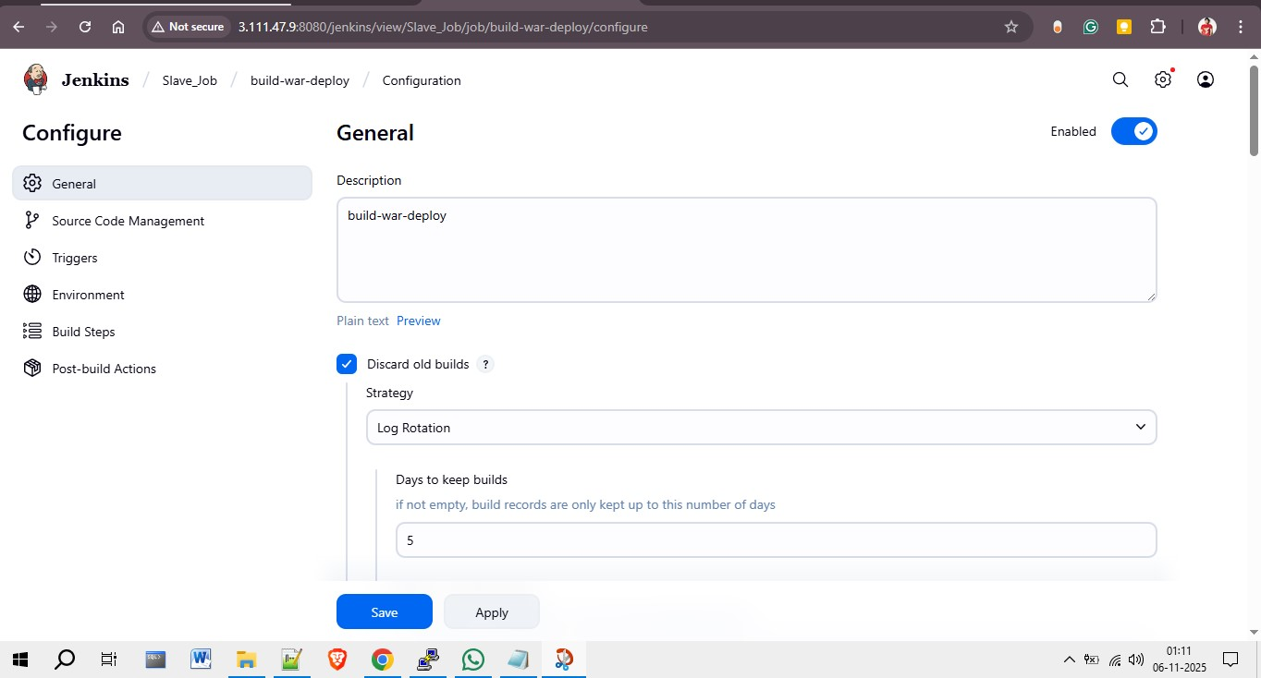

Step 2: Restrict Project Execution
Under the 'General' section, restrict where the project can be run by specifying the label expression. Here, the label 'slave-2' is used to ensure the job runs on the specified Jenkins slave node.
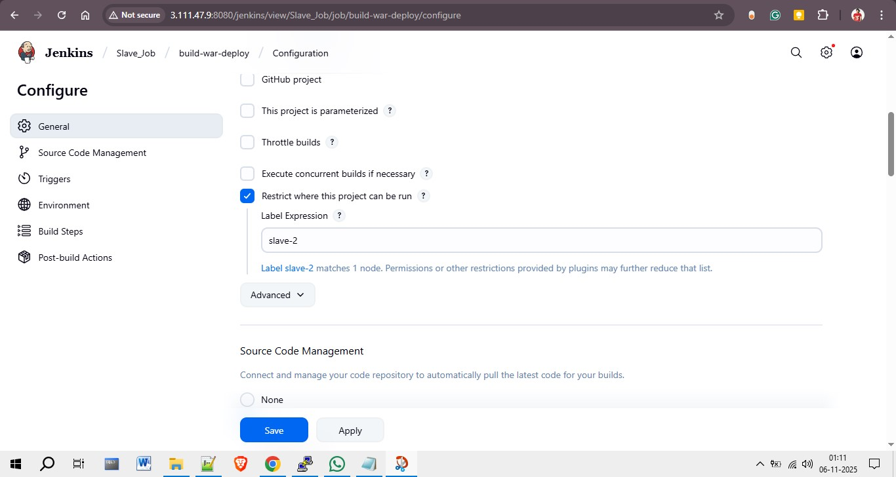

Step 3: Source Code Management (Git)
In this section, Git is selected as the Source Code Management option. The repository URL is entered as 'https://github.com/rohitssonar/project.git'. SSH credentials (ec2-user) are used for secure access to the repository.
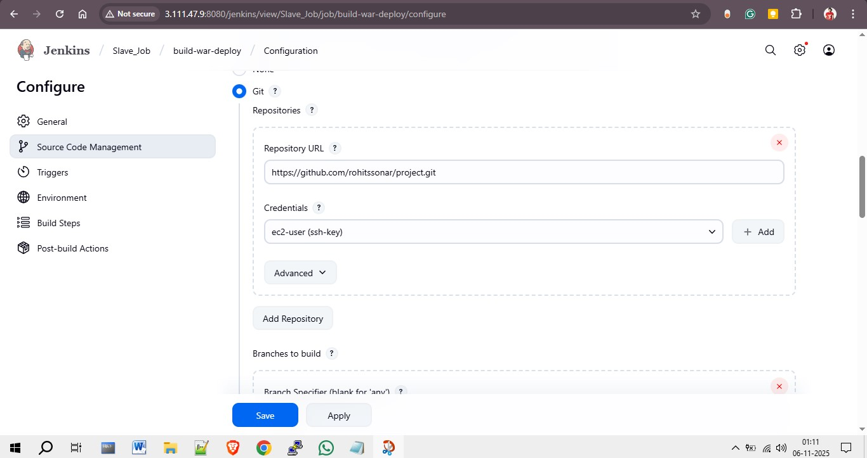

Step 4: Build Environment and Maven Configuration
The environment is configured to delete the workspace before the build starts. Maven is then used to clean and package the application. Maven version used: apache-maven-3.9.11. Goals specified: clean package.
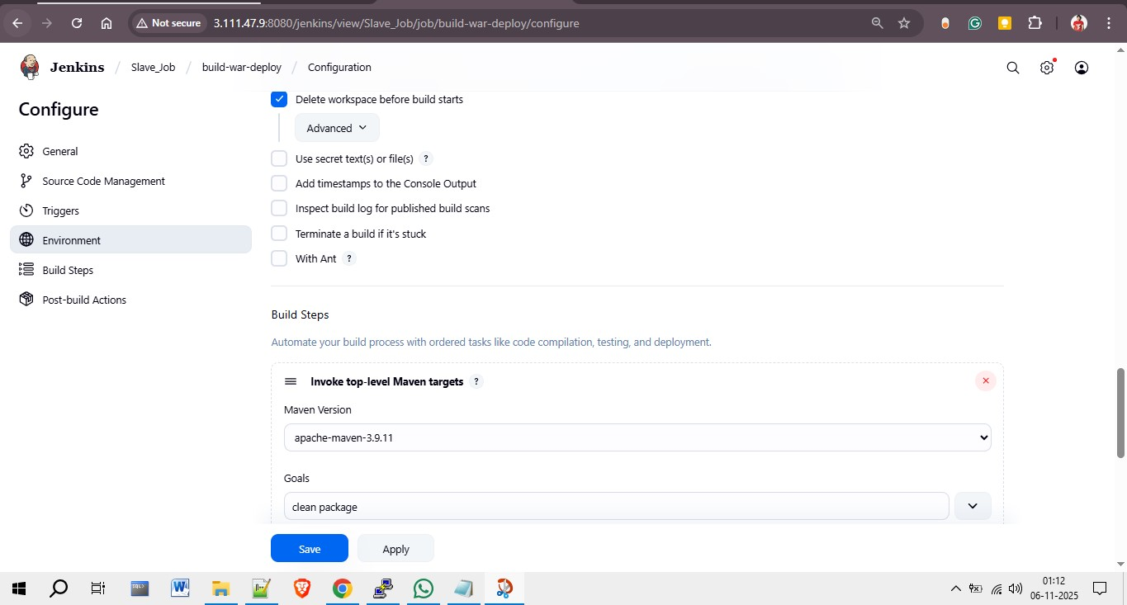

Step 5: Execute Shell Command
Finally, a shell command is executed to copy the generated WAR file from the Jenkins workspace to the Tomcat webapps directory for deployment.
