Jenkins Job Configuration Steps

Step 1: General Configuration
In the Jenkins job configuration page, provide a suitable description for the project
and enable 'Discard old builds' to manage workspace storage efficiently.
You can also set the number of days to keep builds.
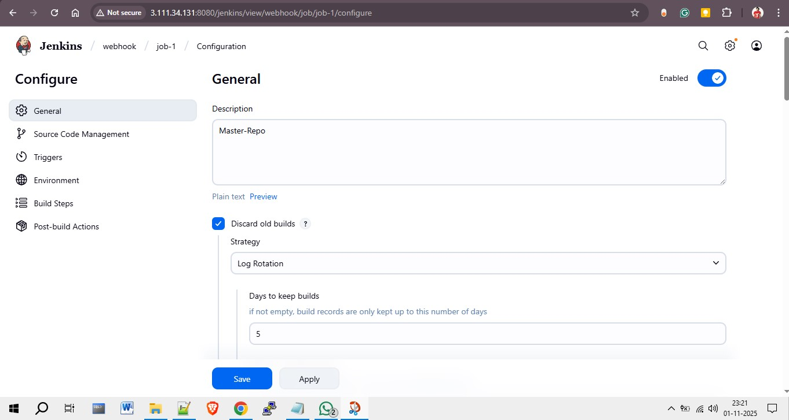

Step 2: Source Code Management
Select 'Git' under Source Code Management. Enter your GitHub repository URL
and select the correct credentials (for example, using a GitHub token).
This ensures Jenkins can access your repository to pull the latest code.
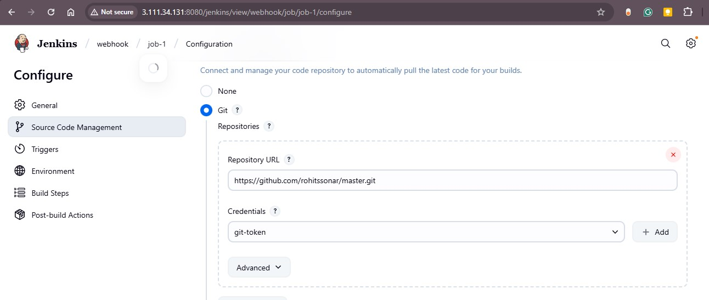

Step 3: Build Triggers
Enable 'GitHub hook trigger for GITScm polling' to automatically trigger a build
whenever code changes are pushed to the repository. This setup allows Jenkins to
integrate seamlessly with GitHub webhooks.
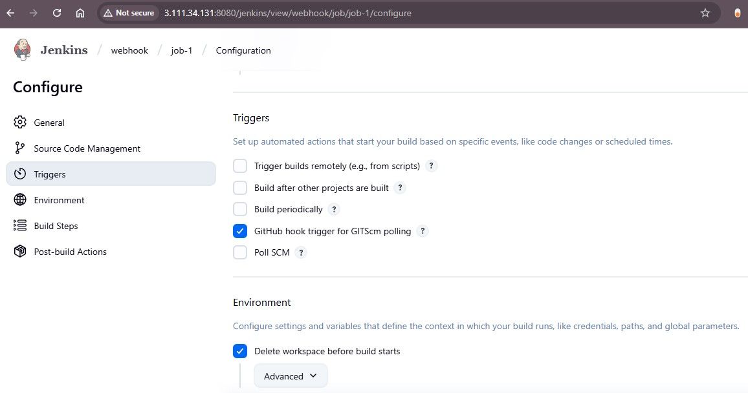

Step 4: Build Steps
In the 'Build Steps' section, choose 'Execute Shell' and enter the following commands:
This script copies the index.html file from Jenkins workspace to the web server directory,
sets proper permissions, and starts the Apache HTTP service.
cd /var/www/html/
cp -r /root/.jenkins/workspace/job-1/index.html .
chmod -R 777 index.html
service httpd start
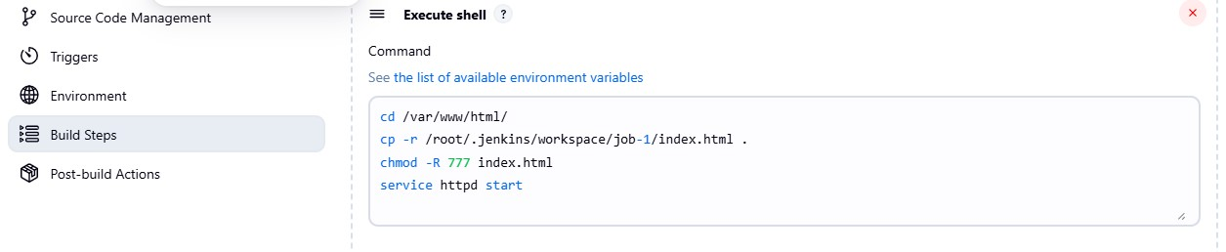

Jenkins Job-2 Configuration Steps

Step 1: General Configuration
In Job-2, enter a meaningful description (e.g., 'repo 2025Q1') to identify the project easily.
Enable 'Discard old builds' and set the Log Rotation policy to keep builds for a specific number of days
(e.g., 4 days) to manage storage effectively.
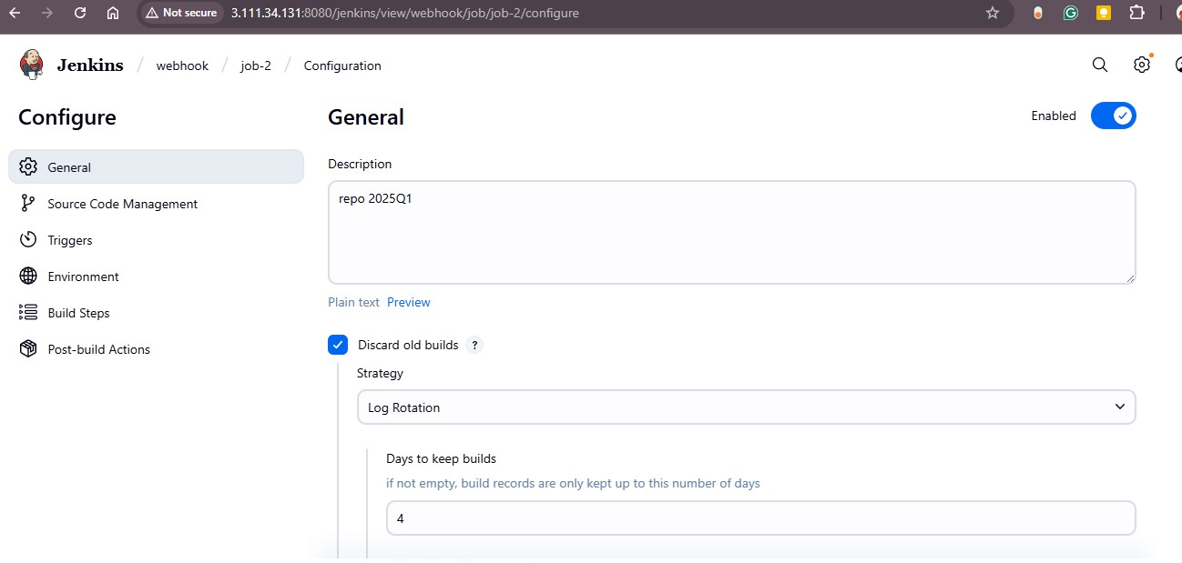

Step 2: Source Code Management
Select 'Git' as the Source Code Management option. Add the repository URL and provide credentials (using your Git token).
Under 'Branches to build', specify the branch you want Jenkins to build (e.g., */2025Q1).
This ensures that only this branch triggers a build.
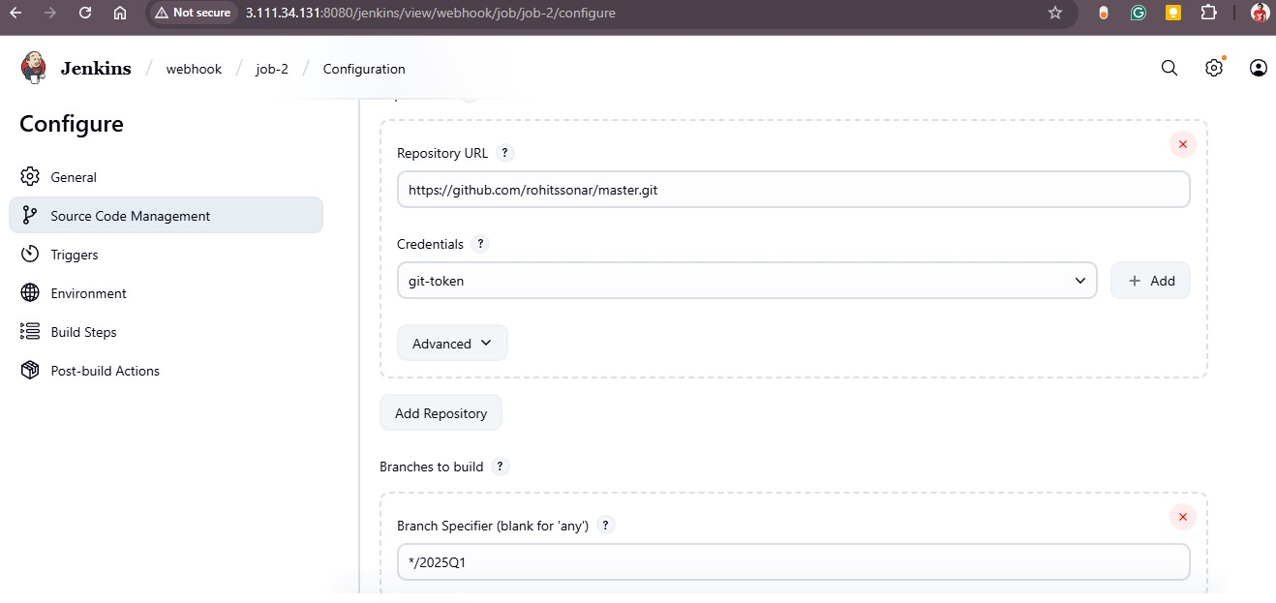

Step 3: Build Triggers
Enable 'GitHub hook trigger for GITScm polling' to automatically trigger a Jenkins build
when changes are pushed to the repository. Also, enable 'Delete workspace before build starts'
to ensure a clean environment for every build run.
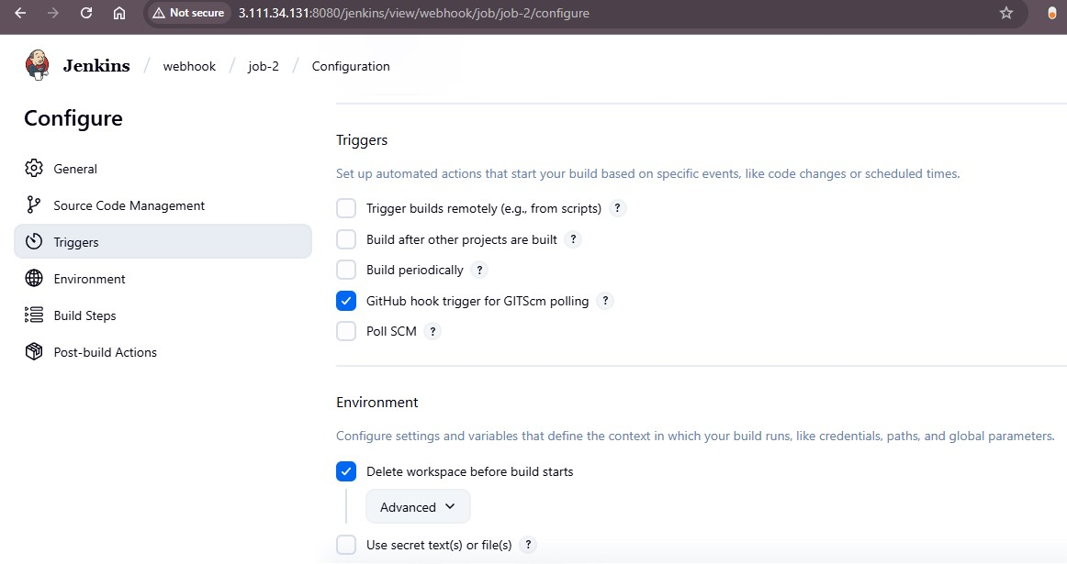

Step 4: Build Steps
Add a build step of type 'Execute Shell' and include the following commands to deploy the HTML file
to the Apache web server. The commands navigate to the web root, copy the HTML file from the Jenkins workspace,
set permissions, and restart the HTTP service.
cd /var/www/html/
cp -r /root/.jenkins/workspace/job-1/index.html .
chmod -R 777 index.html
service httpd restart
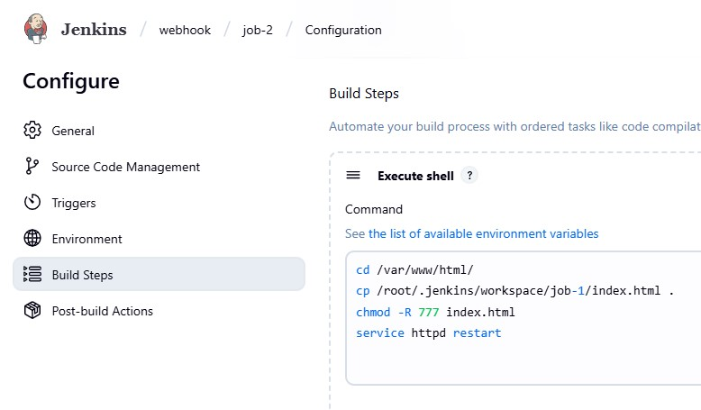

Jenkins Job-3 Configuration Steps

Step 1: Overview of Jenkins Jobs
The Jenkins setup contains multiple jobs (job-1, job-2, job-3) connected to different Git branches
and repositories. Each job uses GitHub Webhooks to trigger automatic builds upon code changes.
The diagram below represents how repositories connect to Jenkins through webhooks.
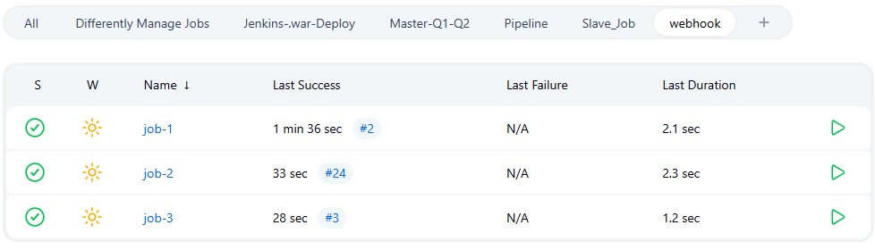

Step 2: General Configuration
In the General section of job-3, provide a descriptive name (e.g., '22025Q3') to identify the repository.
Enable 'Discard old builds' and set Log Rotation to remove builds older than 5 days.
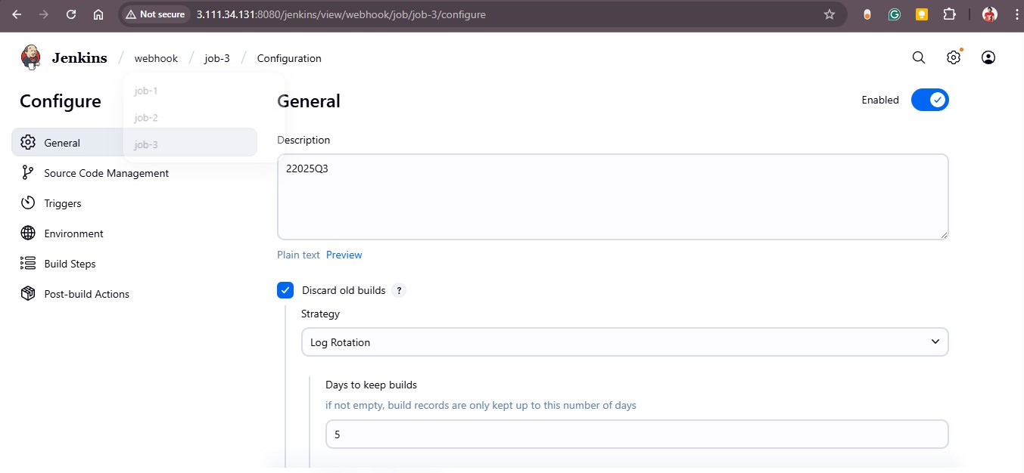

Step 3: Source Code Management
Select 'Git' and enter the repository URL. Use your Git credentials (e.g., 'git-token')
to authenticate Jenkins access. Specify the branch to build — in this case, */2025Q2 —
so Jenkins knows which branch changes to track and build.
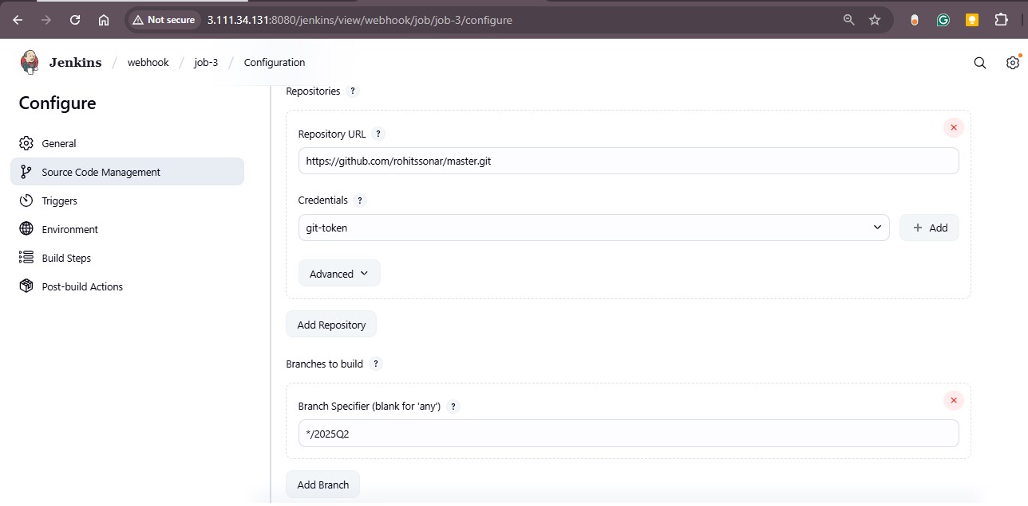

Step 4: Build Triggers
Enable 'GitHub hook trigger for GITScm polling' to automatically trigger a build when
a commit or pull request is pushed to GitHub.
Also, select 'Delete workspace before build starts' to ensure Jenkins starts from a clean environment.
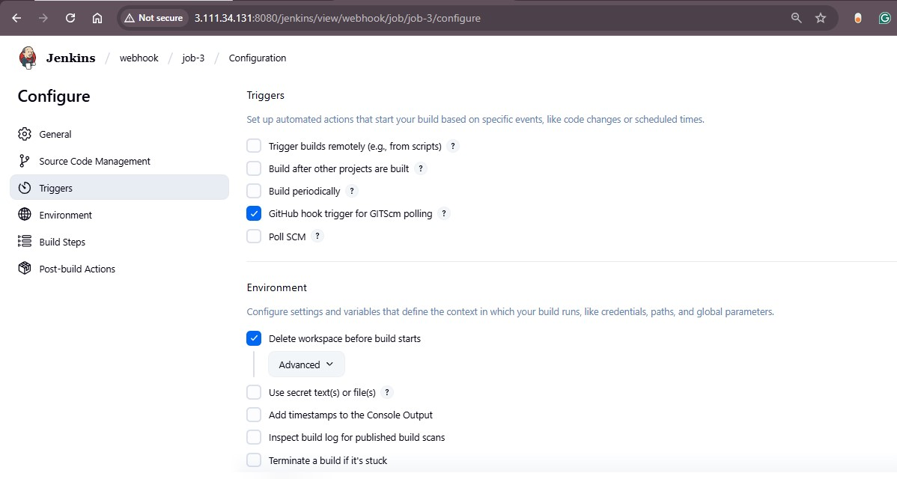

Step 5: Build Steps
Under 'Build Steps', select 'Execute shell' and provide deployment commands.
This script navigates to the Apache web directory, copies the HTML file from the Jenkins workspace,
sets permissions, and starts the Apache HTTP service.
cd /var/www/html/
cp -r /root/.jenkins/workspace/job-3/index.html .
chmod -R 777 index.html
service httpd start
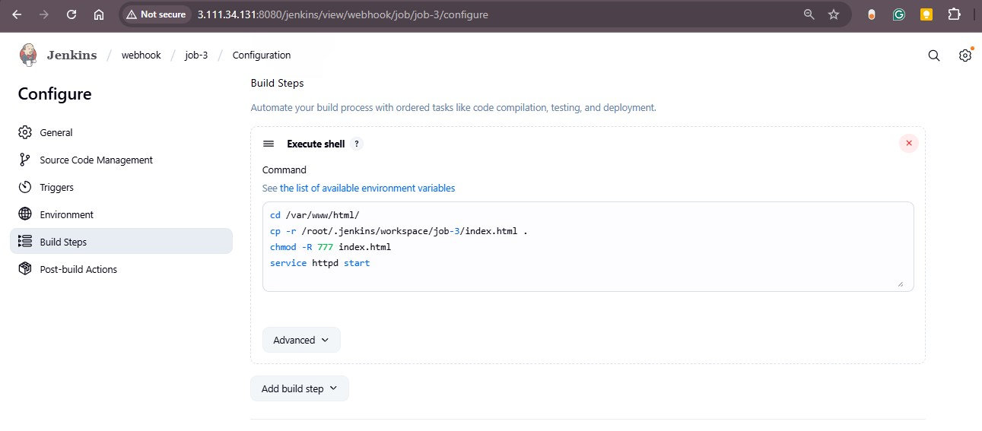

Step 6: Complete Webhook Job Architecture
The final architecture of Jenkins Webhook Jobs shows how repositories (Repo 1, Repo 2, Repo 3)
connect to their respective Jenkins jobs. Each job automatically builds and deploys its files to the
web server when changes are pushed to the repository.
