Jenkins Slave Job Configuration Steps

Step 1: Open Jenkins Slave Job
Navigate to your Jenkins dashboard and select the specific slave job you want to configure. Here, we are configuring 'Slave-2'. You can view the job status, upstream projects, and recent build details.
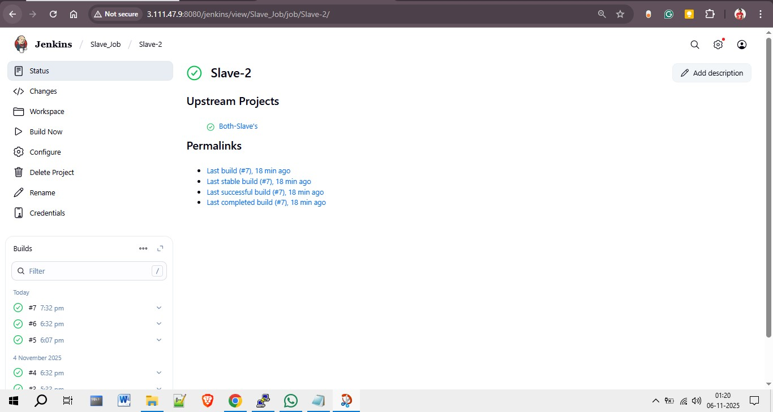

Step 2: Configure General Settings
In the configuration section, enable 'Discard old builds' to manage build storage efficiently. Specify the maximum number of builds or days to retain build records.
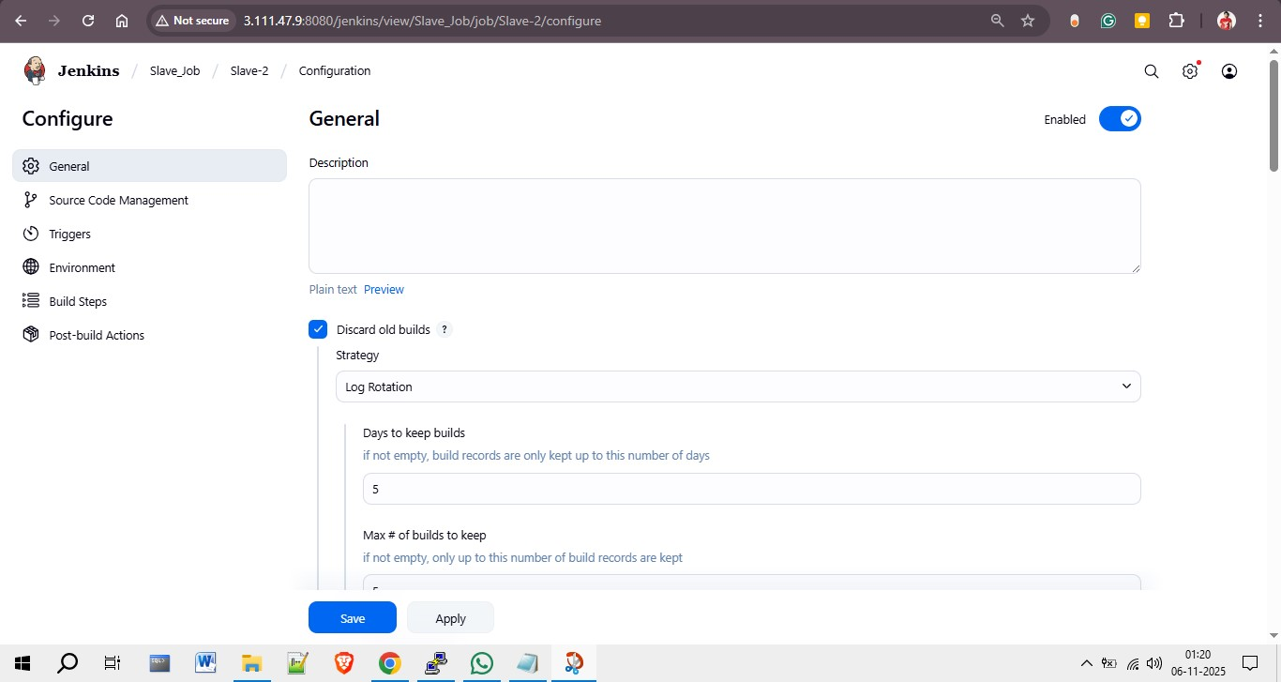
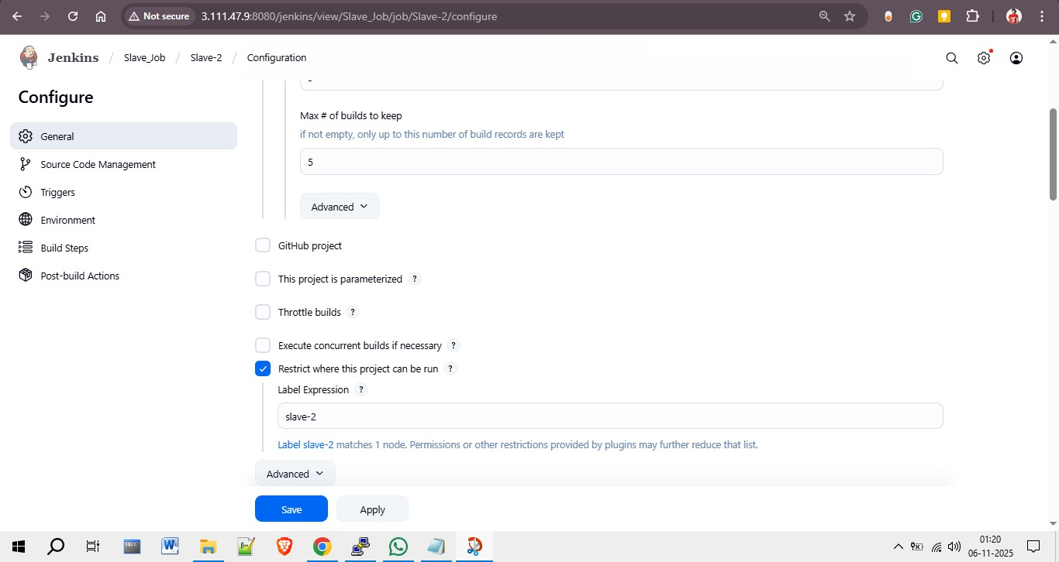

Step 3: Configure Source Code Management (Git)
Under the Source Code Management section, select 'Git' and enter the repository URL. Add the required credentials and specify the branch to build. This ensures Jenkins fetches the right codebase from GitHub.
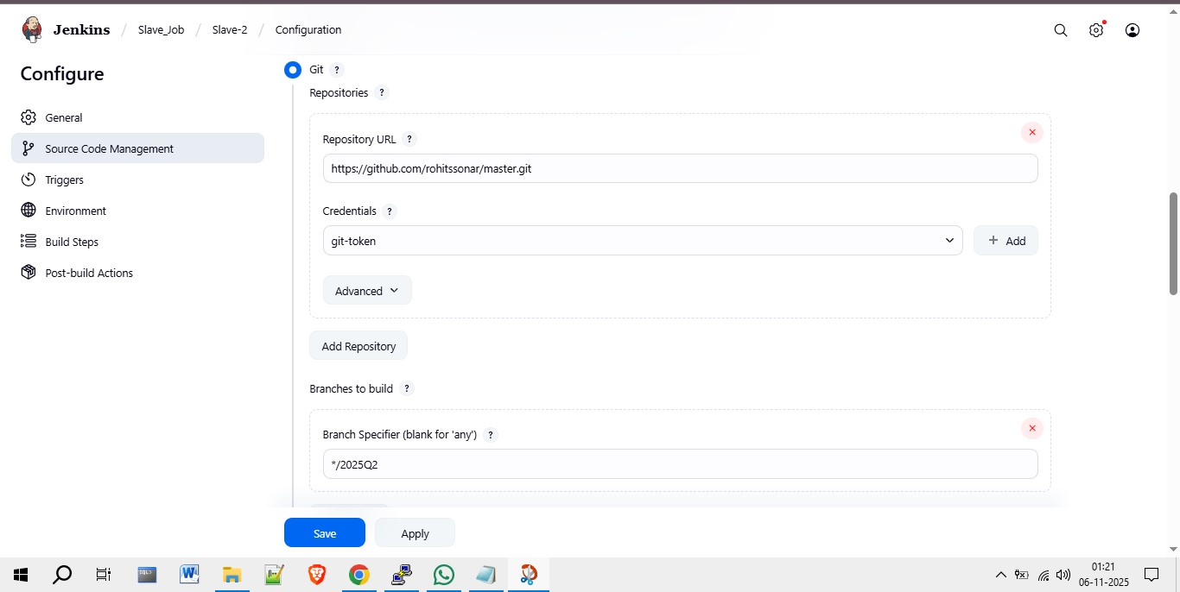

Step 4: Set Triggers and Environment
In this section, you can set automated build triggers such as periodic builds or GitHub hooks. Enable 'Delete workspace before build starts' to ensure a clean environment for each build.
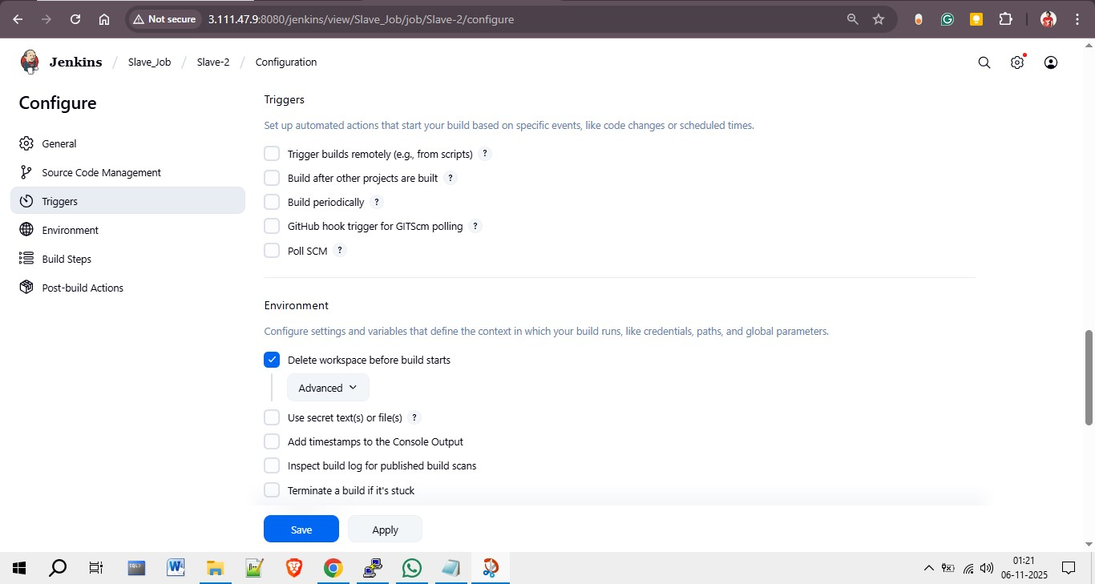

Step 5: Define Build Steps
Add a shell command under 'Build Steps' to deploy your files. In this example, the shell commands copy the index.html file from the workspace to the web server directory, set appropriate permissions, and restart the httpd service.
