Jenkins Build-WAR-Deploy Job Configuration and Execution

Step 1: Open Jenkins Build-WAR-Deploy Job
From the Jenkins dashboard, navigate to the job named 'build-war-deploy'. This job is configured to build and deploy a WAR file from the specified GitHub repository. The job status page displays the latest build information, including success or failure.
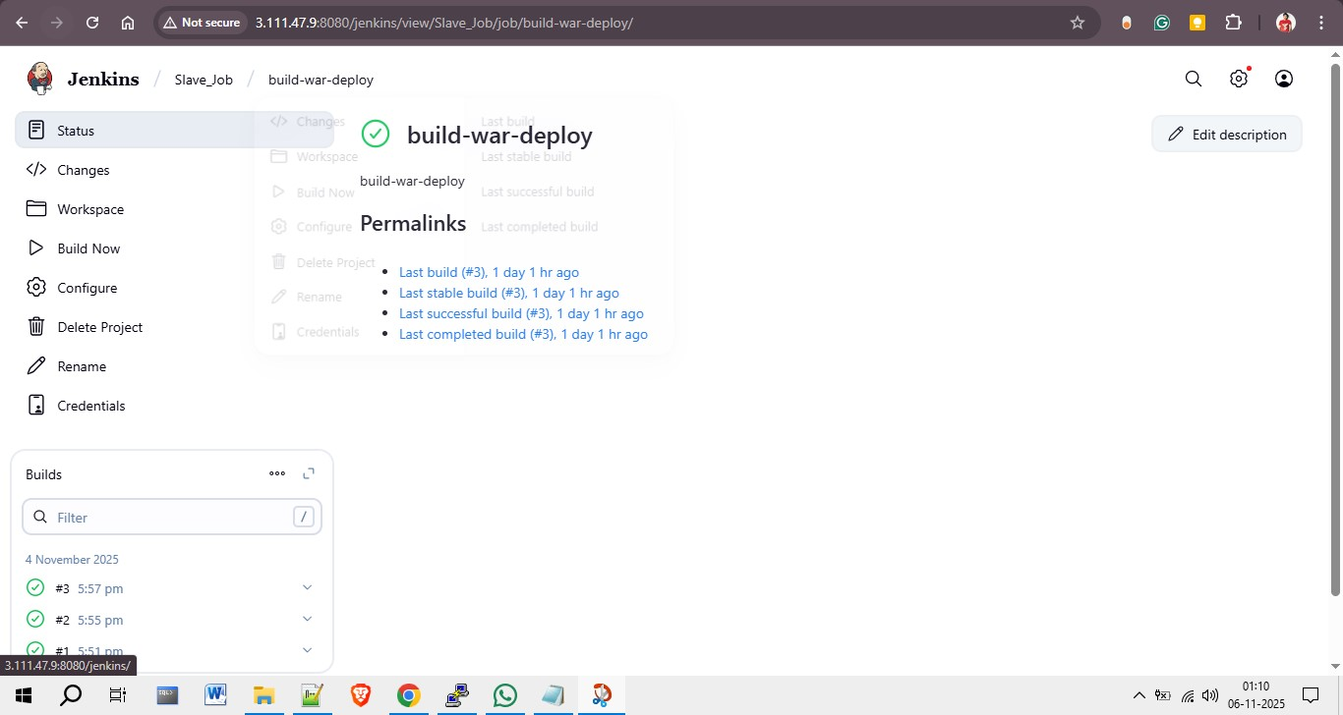

Step 2: Configure General Settings
In the configuration section, add a description for the job and enable 'Discard old builds'. This helps manage workspace storage efficiently by keeping only recent build data. Set log rotation limits, such as keeping builds for a specific number of days.
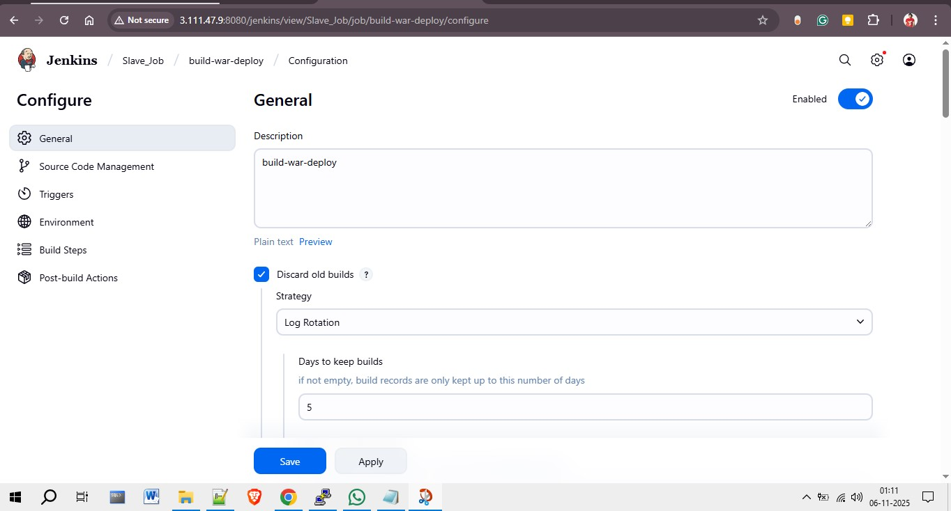

Step 3: Define Build Node and Restrictions
To ensure the job runs on a specific slave node, check 'Restrict where this project can be run' and specify the label expression (e.g., slave-2). This ensures that the build executes only on the assigned Jenkins node.
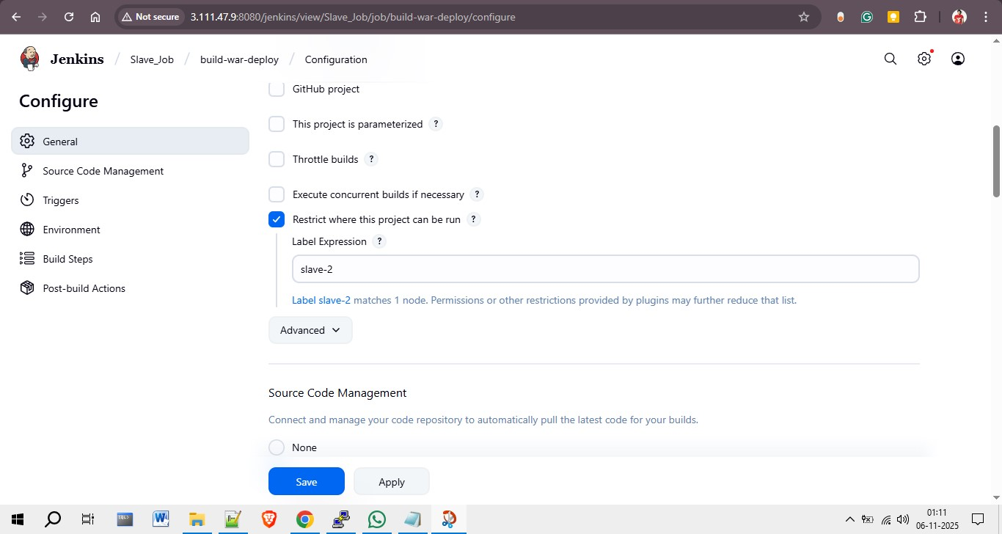

Step 4: Configure Source Code Management (Git)
Under the 'Source Code Management' tab, choose 'Git' as the version control option. Enter the GitHub repository URL, add credentials (e.g., EC2 SSH key), and specify the branch to build (e.g., master).
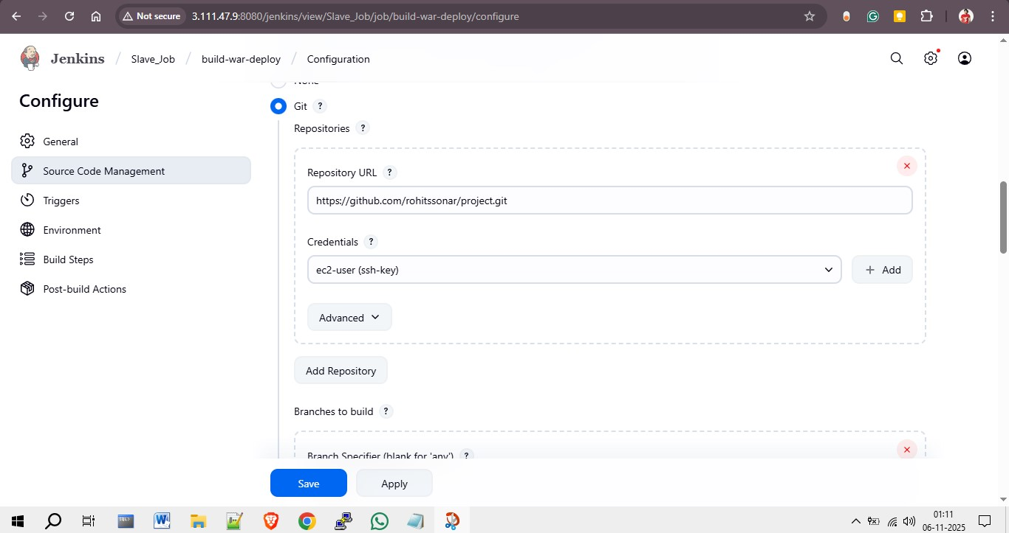

Step 5: Set Environment Configuration
Before running the build, enable 'Delete workspace before build starts' to ensure a clean environment. This helps prevent conflicts with previously built artifacts.
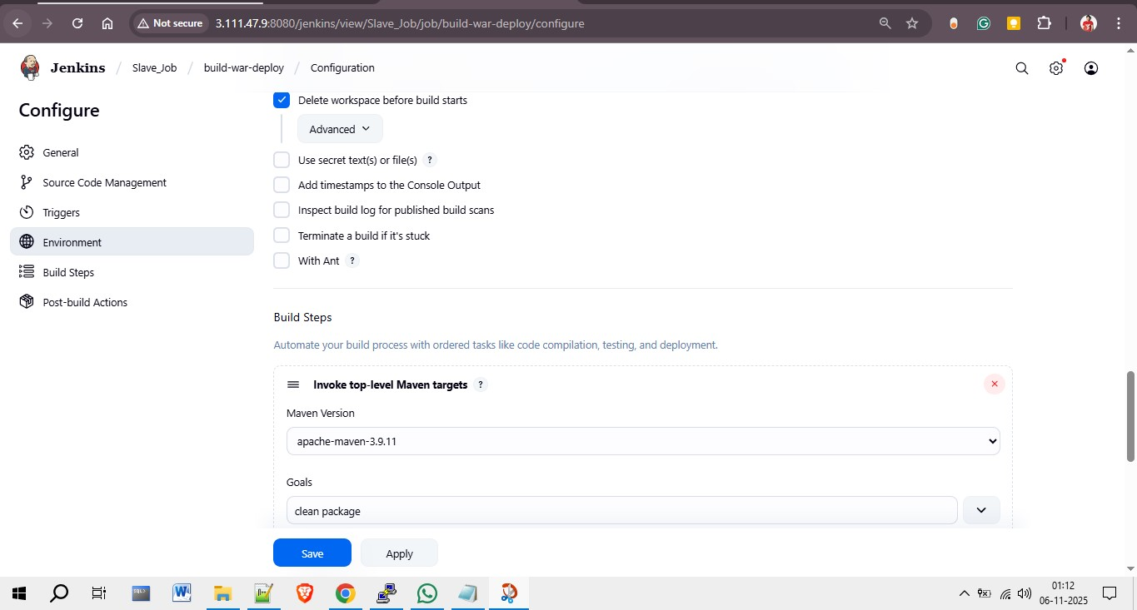

Step 6: Define Build Steps
Add Maven and shell commands under 'Build Steps'. First, select 'Invoke top-level Maven targets' and specify Maven Version and Goals (e.g., clean package). Then, add 'Execute Shell' to copy the generated WAR file to the Tomcat webapps directory on the slave server.
cp -r /mnt/jenkins-slave/workspace/build-war-deploy/target/LoginWebApp.war /mnt/servers/apache-tomcat-10.1.48/webapps/LoginWebApp.war
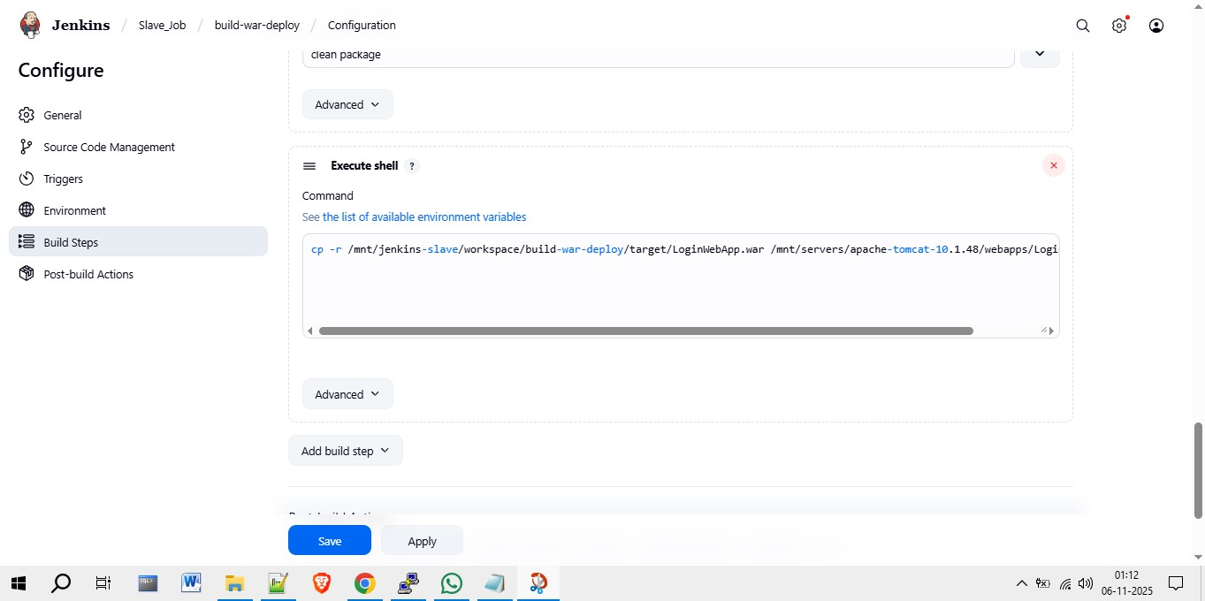

Step 7: Build and Verify Deployment
After configuring all sections, click 'Save' and then 'Build Now'. Once the build completes successfully, check the application deployment by accessing it through the browser URL.

