**COMPUTER VISION PROJECT 2**

**rus209**

**a) An MS Words file that contains your source code (with full comments and documentation), the language and compiler used, instructions on how to compile and run your program, and the following:**

**Source Code:**

**Ans: Python code can be run using any standard python interpreter**

*# coding: utf-8*

**from** matplotlib **import** pyplot **as** plt

**import** numpy **as** np

**from** scipy.ndimage **import** imread

**from** scipy.spatial.distance **import** euclidean **as** dist

*#Importing Training Images*

img1n = imread('/Users/rohitsuvarna/NYU/Comp Vision/CVProject2/Face dataset/subject01.normal.jpg')

img2n = imread('/Users/rohitsuvarna/NYU/Comp Vision/CVProject2/Face dataset/subject02.normal.jpg')

img3n = imread('/Users/rohitsuvarna/NYU/Comp Vision/CVProject2/Face dataset/subject03.normal.jpg')

img7n = imread('/Users/rohitsuvarna/NYU/Comp Vision/CVProject2/Face dataset/subject07.normal.jpg')

img10n = imread('/Users/rohitsuvarna/NYU/Comp Vision/CVProject2/Face dataset/subject10.normal.jpg')

img11n = imread('/Users/rohitsuvarna/NYU/Comp Vision/CVProject2/Face dataset/subject11.normal.jpg')

img14n = imread('/Users/rohitsuvarna/NYU/Comp Vision/CVProject2/Face dataset/subject14.normal.jpg')

img15n = imread('/Users/rohitsuvarna/NYU/Comp Vision/CVProject2/Face dataset/subject15.normal.jpg')

*#Importing Testing Images*

img1c = imread('/Users/rohitsuvarna/NYU/Comp Vision/CVProject2/Face dataset/subject01.centerlight.jpg')

img1h = imread('/Users/rohitsuvarna/NYU/Comp Vision/CVProject2/Face dataset/subject01.happy.jpg')

img7c = imread('/Users/rohitsuvarna/NYU/Comp Vision/CVProject2/Face dataset/subject07.centerlight.jpg')

img7h = imread('/Users/rohitsuvarna/NYU/Comp Vision/CVProject2/Face dataset/subject07.happy.jpg')

img11c = imread('/Users/rohitsuvarna/NYU/Comp Vision/CVProject2/Face dataset/subject11.centerlight.jpg')

img11h = imread('/Users/rohitsuvarna/NYU/Comp Vision/CVProject2/Face dataset/subject11.happy.jpg')

img12n = imread('/Users/rohitsuvarna/NYU/Comp Vision/CVProject2/Face dataset/subject12.normal.jpg')

img14h = imread('/Users/rohitsuvarna/NYU/Comp Vision/CVProject2/Face dataset/subject14.happy.jpg')

img14s = imread('/Users/rohitsuvarna/NYU/Comp Vision/CVProject2/Face dataset/subject14.sad.jpg')

img_apple = imread('/Users/rohitsuvarna/NYU/Comp Vision/CVProject2/Face dataset/apple1_gray.jpg')

*#Stacking rows together*

train_image_list = [img1n,img2n,img3n,img7n,img10n,img11n,img14n,img15n]

col_vecs = [img.flatten() **for** img **in** train_image_list]

col_vecs

*#Average Face*

m = np.average(col_vecs,axis=0)

m = np.average(col_vecs,axis=0)

mean_face = m.reshape((231,195))

plt.imshow(mean_face,plt.cm.gray)

*#Subtracting the average face*

col_vecs_reduced = [(vec - m) **for** vec **in** col_vecs ]

*#Computing matrix A*

A = np.vstack(col_vecs_reduced)

A = A.T

*#Covariance matrix C*

C = np.dot(A,A.T)

L = np.dot(A.T,A)

Eig_v = np.linalg.eig(L)

Eig_vals = Eig_v[0]

Eig_vecs = Eig_v[1]

V = Eig_vecs

Eig_vals

*#Finding Eigen Space U*

U = np.dot(A,V)

*#Projecting Training Faces on Face Space*

Omega_training = [np.dot(U.T,train_vec) **for** train_vec **in** col_vecs_reduced]

*#Face Recognition*

comp_image_list = [img1n,img2n,img3n,img7n,img10n,img11n,img14n,img15n,img1c,img1h,img7c,img7h,img11c,img11h,img12n,img14h,img14s,img_apple]

Img_dict = {0:1,1:2,2:3,3:7,4:10,5:11,6:14,7:15}

Actual = [1,2,3,7,10,11,14,15,1,1,7,7,11,11,12,14,14,0]

Predicted = []

*#Thresholds*

T_0 = 7000000000000

T_1 = 140000000

**def** face_detect(img,U,Omega_training,T_0,T_1):

'''

Returns the predicted subject if recognised

else returns 0 for a non-face, -1 for unknown face

'''

I = img.flatten()

I = I - m

Omega_I = np.dot(U.T,I)

I_R = np.dot(U,Omega_I)

d_0 = dist(I_R,I)

print('d_o is %d' % d_0)

dist_array = [dist(Omega_I,Omega) **for** Omega **in** Omega_training]

res = min(dist_array)

print('d_1 is %d' %res)

index = Img_dict[dist_array.index(res)]

**if** d_0 > T_0:

**return** 0

**else**:

**if** res > T_1:

**return** -1

**return** index

Predicted = [face_detect(img,U,Omega_training,T_0,T_1) **for** img **in** comp_image_list]

**def** print_results(act,pred):

total = len(act)

correct = 0

**for** i **in** range(len(act)):

print("Subject %d is identified as Subject %d"% (act[i],pred[i]))

**if** act[i] == pred[i]:

correct += 1

print("Got %d right out of %d" % (correct,total))

*#Predictions*

print_results(Actual,Predicted)

*#Eigenfaces:*

**for** i **in** range(8):

eigen_face = U[:,i]

eigen_face = eigen_face.reshape((231,195))

fig, ax = plt.subplots(1,1)

im2 = ax.imshow(eigen_face,plt.cm.gray)

plt.show()

*#Other output for test images:*

test_image_list = [img1c,img1h,img7c,img7h,img11c,img11h,img12n,img14h,img14s,img_apple]

*#Helper function to print output*

**def** output_func(img,U,Omega_training,T_0,T_1):

sh = img.shape

I = img.flatten()

I = I - m

I_res = I.reshape(sh)

fig, (ax1, ax2) = plt.subplots(1,2)

ax1.set_title('I - m face')

im1 = ax1.imshow(I_res,plt.cm.gray)

Omega_I = np.dot(U.T,I)

print('PCA coefficients are \n')

print(Omega_I)

I_R = np.dot(U,Omega_I)

Ir_res = I_R.reshape(sh)

ax2.set_title('Reconstructed face I_r')

im2 = ax2.imshow(Ir_res,plt.cm.gray)

dist_array = [dist(Omega_I,Omega) **for** Omega **in** Omega_training]

print('The distances are \n')

print(dist_array)

plt.show()

print('\n\n\n\n\n\n')

**for** img **in** test_image_list:

print('For %r we have the following results \n\n' %img)

output_func(img,U,Omega_training,T_0,T_1)

**Mean Face:**

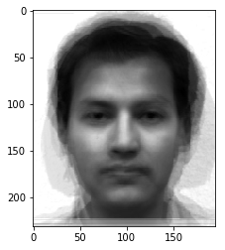

Eigen Faces: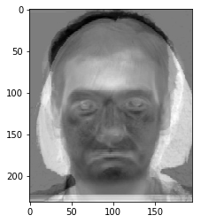

In order

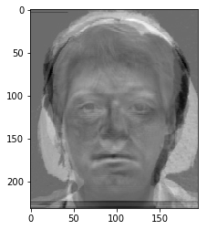

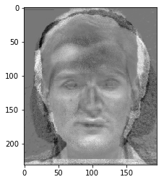

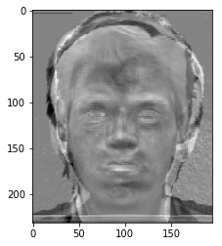

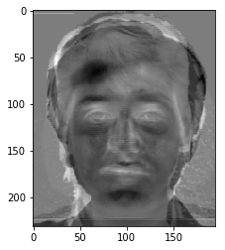

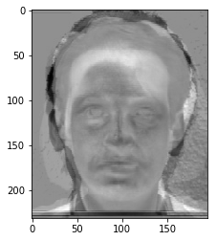

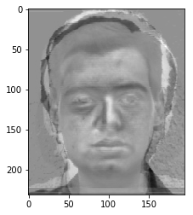

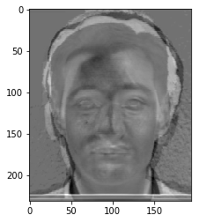

**(2) The PCA coefficients (**𝛺𝑖**) for each training image:**

Ans:

[array([ 7.45283569e+07, 3.00355322e+08, 6.08775242e-08,

-1.86486103e+08, 2.43272892e+07, -2.81183673e+07,

-4.79970158e+06, 1.99954727e+07]),

array([ 2.35959144e+08, 1.48419206e+08, 2.23977520e-08,

-1.12998840e+08, -6.30304611e+06, 2.37321739e+07,

-1.49498856e+07, -1.05723954e+07]),

array([ 2.18277162e+08, 2.30305748e+08, 4.30747679e-08,

-1.34152903e+08, -5.02106649e+06, -1.10471303e+08,

1.20529290e+07, -2.82610338e+07]),

array([ 3.09733059e+08, 1.41798513e+08, 2.37310788e-08,

-7.67160288e+07, 2.79303377e+07, -7.89909114e+07,

-2.24966723e+07, 3.00546705e+07]),

array([ 1.24666594e+08, 2.54799768e+08, 8.24925081e-09,

-3.62157505e+07, 1.53539668e+07, -2.76577806e+07,

5.65848466e+07, 6.64733438e+06]),

array([ -1.59597833e+08, 1.00126907e+08, 5.66612114e-08,

-1.20188087e+08, 4.33176243e+06, -6.28407792e+07,

1.26881806e+07, 1.57079311e+07]),

array([ 9.55641073e+07, 2.77313854e+08, 3.29310945e-08,

-7.21654833e+07, -2.12127268e+07, -5.89966615e+07,

-2.12443601e+07, 4.18677846e+07]),

array([ 3.03810810e+08, 1.60449738e+08, 5.82784758e-08,

-1.64718867e+08, -7.50063905e+06, -4.88507975e+07,

5.15186459e+07, 4.48709067e+07])]

(3) For each test image: the image after subtracting the mean face (𝐼),

its PCA coefficients (𝛺𝐼), the reconstructed face image (𝐼𝑅), distances 𝑑𝑖 for 𝑖 = 0 𝑡𝑜 𝑀, and classification result (non-face, unknown face, or identify of face.)

Ans:

**1 Centerlight**

PCA coefficients are

[ -4.19265944e+07 9.33435765e+06 4.46553506e-09 -1.96894052e+07

3.51175100e+06 2.33364673e+07 -4.53879945e+06 -2.45326164e+06]

The distances are

[111586822.41848011, 155242389.34017056, 146676511.3660945, 229591657.82398075, 119707328.1334251, 292870266.5065856, 107945627.81560327, 214023418.31487235]

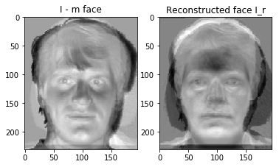

**1 happy**

PCA coefficients are

[ -2.84226819e+07 6.21657618e+07 1.44756247e-08 -5.58402336e+07

1.39551196e+07 2.39919521e+07 -1.56038461e+07 -4.88745009e+05]

The distances are

[63067848.62498437, 181936137.17792708, 147059539.1608555, 249271519.0750657, 147572653.64382246, 332324142.1820322, 117694790.26319712, 222118699.9686467]

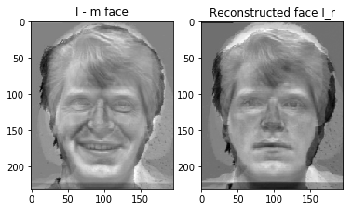

**7 Centerlight**

PCA coefficients are

[ 5.94280720e+06 1.09073119e+07 -2.00761307e-08 6.44391875e+07

-4.06118038e+06 -1.88646091e+06 -1.60012838e+07 1.25351205e+07]

The distances are

[186019216.48344228, 147462236.8534809, 136206359.70409366, 176510231.03979555, 90747702.06187524, 343932044.6814206, 96679844.91103761, 204454021.45323846]

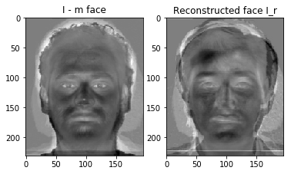

**7 Happy**

PCA coefficients are

[ 1.03893380e+08 -9.15597753e+06 -1.07347312e-08 2.31395182e+07

9.78874352e+05 -3.10262255e+06 -4.00701970e+06 6.01476791e+06]

The distances are

[233055760.2403581, 100426750.6450444, 103330781.053852, 88831686.49484487, 164784911.90361091, 425382239.23979646, 185795025.3343768, 109655903.29353152]

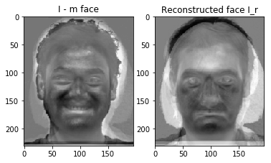

**11 Centerlight**

PCA coefficients are

[ -1.84458324e+08 -1.27514264e+08 9.22289043e-09 -3.94098492e+06

-4.82546087e+06 6.57524499e+06 -1.18073793e+07 -4.07760603e+06]

The distances are

[262141694.81047183, 288905361.76333904, 307856548.3060301, 356796012.7954678, 261538544.37455803, 130964036.02232766, 249090014.3271997, 357951333.85845053]

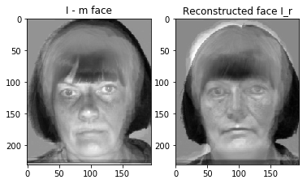

**11 Happy**

PCA coefficients are

[ -2.91280480e+08 -1.07981032e+08 1.76253199e-08 -8.07984970e+06

-3.16856693e+06 -8.84253231e+06 -2.77433359e+06 1.23549801e+06]

The distances are

[308163446.49942905, 391093302.1635501, 390729034.1051311, 457750024.72404075, 327812434.4398219, 21783094.363421325, 306425098.0061767, 455182031.45493424]

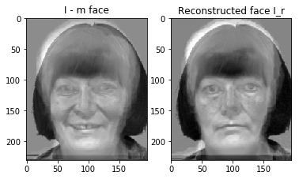

**12 Normal**

PCA coefficients are

[ -8.48151488e+07 2.39983394e+07 -2.25923212e-09 9.24693940e+06

1.09479841e+06 3.03539436e+07 -1.06420075e+07 1.14064585e+07]

The distances are

[114088420.68360247, 196373441.62815523, 189715468.36281228, 268302208.3295624, 113596022.11108254, 262703834.78576162, 86528212.38591179, 262709370.18400285]

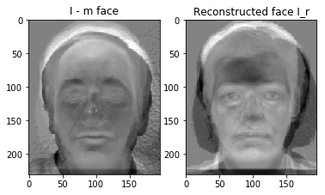

**14 Happy**

PCA coefficients are

[ -3.72003742e+07 7.23552596e+07 -1.41108835e-09 2.01072900e+07

-1.10391535e+07 -1.16749219e+07 -3.12504845e+07 1.93984877e+07]

The distances are

[116291957.18283445, 201198094.2003047, 149264366.4588196, 240762641.3781882, 111100562.01474124, 327302460.0456842, 31760601.24447625, 245267097.18086782]

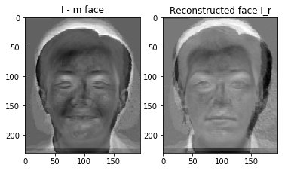

**14 SAD**

PCA coefficients are

[ -3.09557722e+07 6.21419290e+07 -8.93708875e-09 4.11282105e+07

-1.89530184e+07 -9.12193903e+06 -3.02355547e+07 1.57609187e+07]

The distances are

[139061618.92516568, 192702933.1697089, 149125741.22847518, 231118169.49102747, 99585049.07145986, 329821305.0914483, 30212478.883972634, 242904340.5481909]

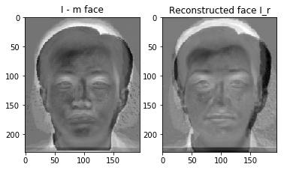

**APPLE**

PCA coefficients are

[ -2.40683176e+07 2.33966524e+07 1.91194543e-08 -5.18978138e+07

1.54361939e+07 -2.59415798e+06 -3.62456870e+07 1.56605404e+07]

The distances are

[100111536.8448275, 169692008.72081405, 136153029.87689295, 221814828.11369932, 160265519.12945694, 318666513.7422043, 118883680.68799105, 207071343.06062484]

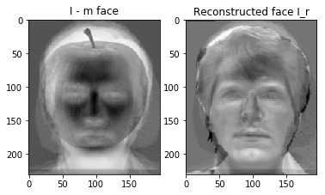

**Results**

Subject 1 center light is identified as Subject 14

Subject 1 happy is identified as Subject 1

Subject 7 center light is identified as Subject 10

Subject 7 happy is identified as Subject 7

Subject 11 center light is identified as Subject 11

Subject 11 happy is identified as Subject 11

Subject -1(12) Normal is identified as Subject 14

Subject 14 Happy is identified as Subject 14

Subject 14 Sad is identified as Subject 14

Subject 0(Apple) is identified as Subject 1