Harnessing EC2, VPC & MobaXterm for Cutting-Edge Entity Hosting
Project Objective: Deploy and host a static website on AWS EC2 using Ubuntu Server, Apache Web Server, VPC networking, and MobaXterm for remote administration.
Technologies Used: AWS EC2, AWS VPC, Ubuntu Server, Apache2, MobaXterm, HTML5, CSS3.
Key Features: Cloud hosting, secure SSH access, Apache deployment, public website hosting, and SFTP file transfer.

Project Architecture
Infrastructure Layer → AWS EC2 & VPC
Server Layer → Ubuntu + Apache
Management Layer → MobaXterm SSH/SFTP
Presentation Layer → HTML/CSS Website

Implementation Steps
- Create and configure an AWS EC2 Ubuntu instance.
- Configure VPC and Security Groups (SSH, HTTP, HTTPS).
- Connect to the server using MobaXterm and a PEM key.
- Update packages and install Apache2.
- Upload website files (index.html and style.css).
- Restart Apache and verify website accessibility.

Project Screenshots

Config.png
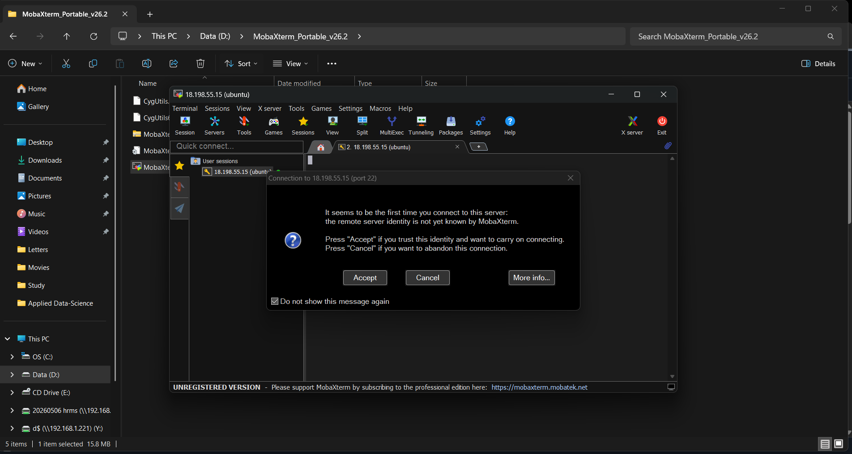

Instance.png
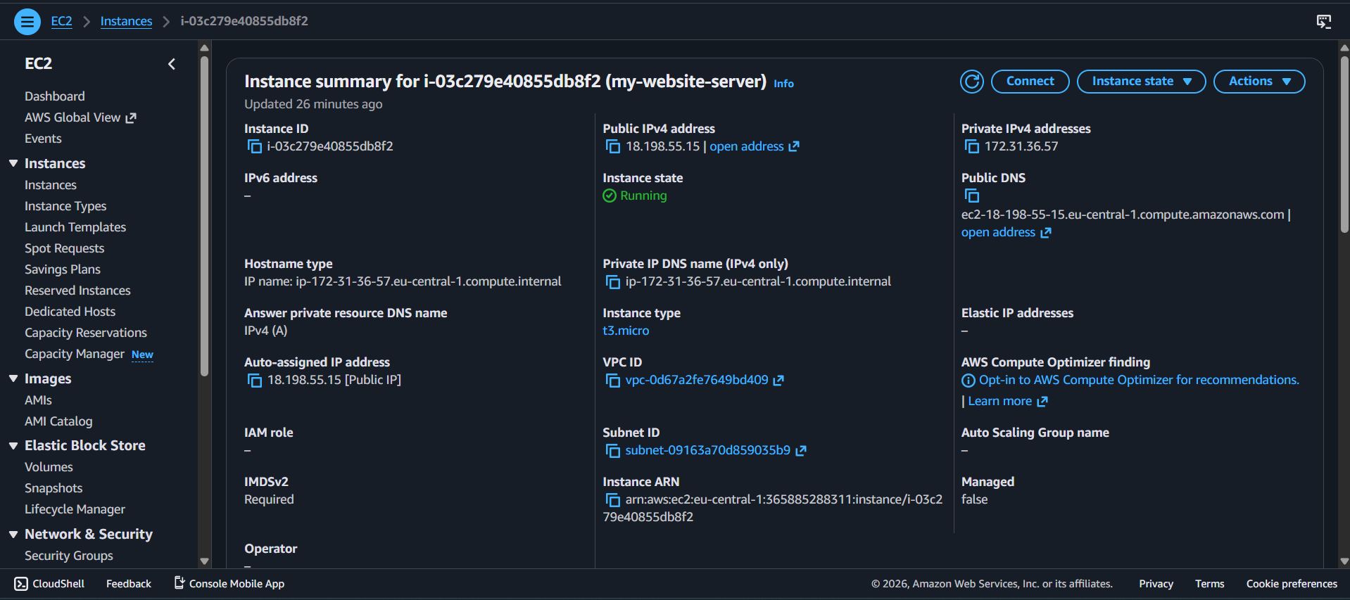

apache-install.png
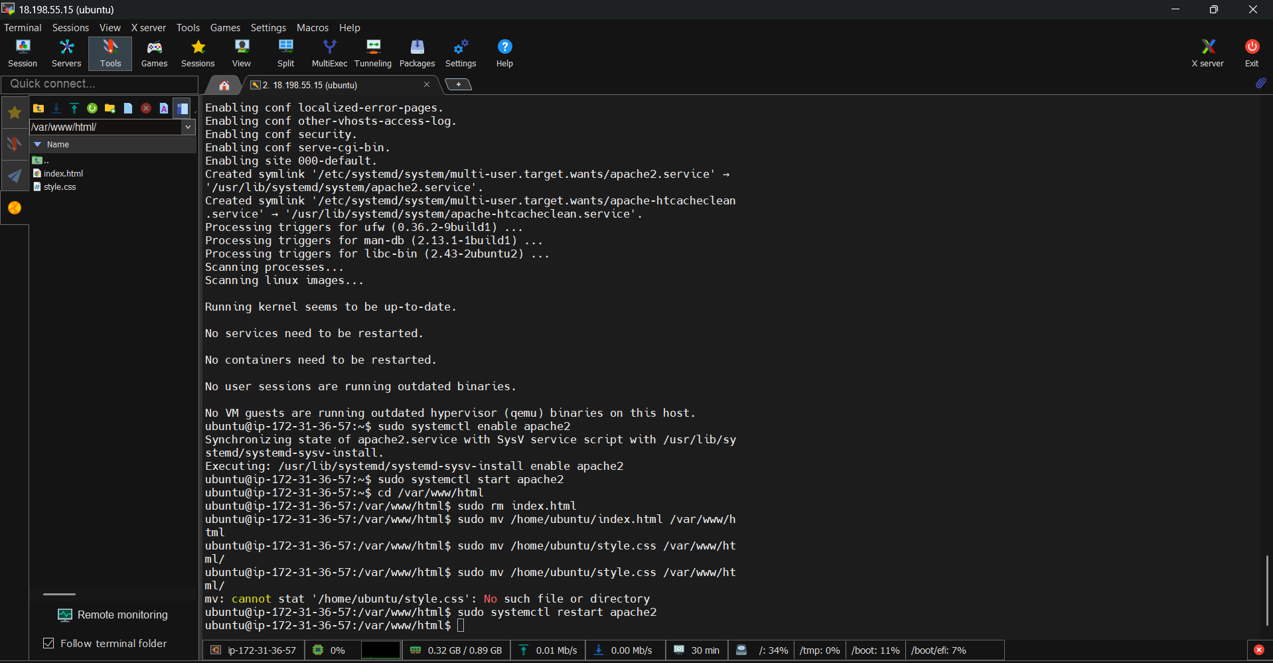

ubuntu_CLI-1.png
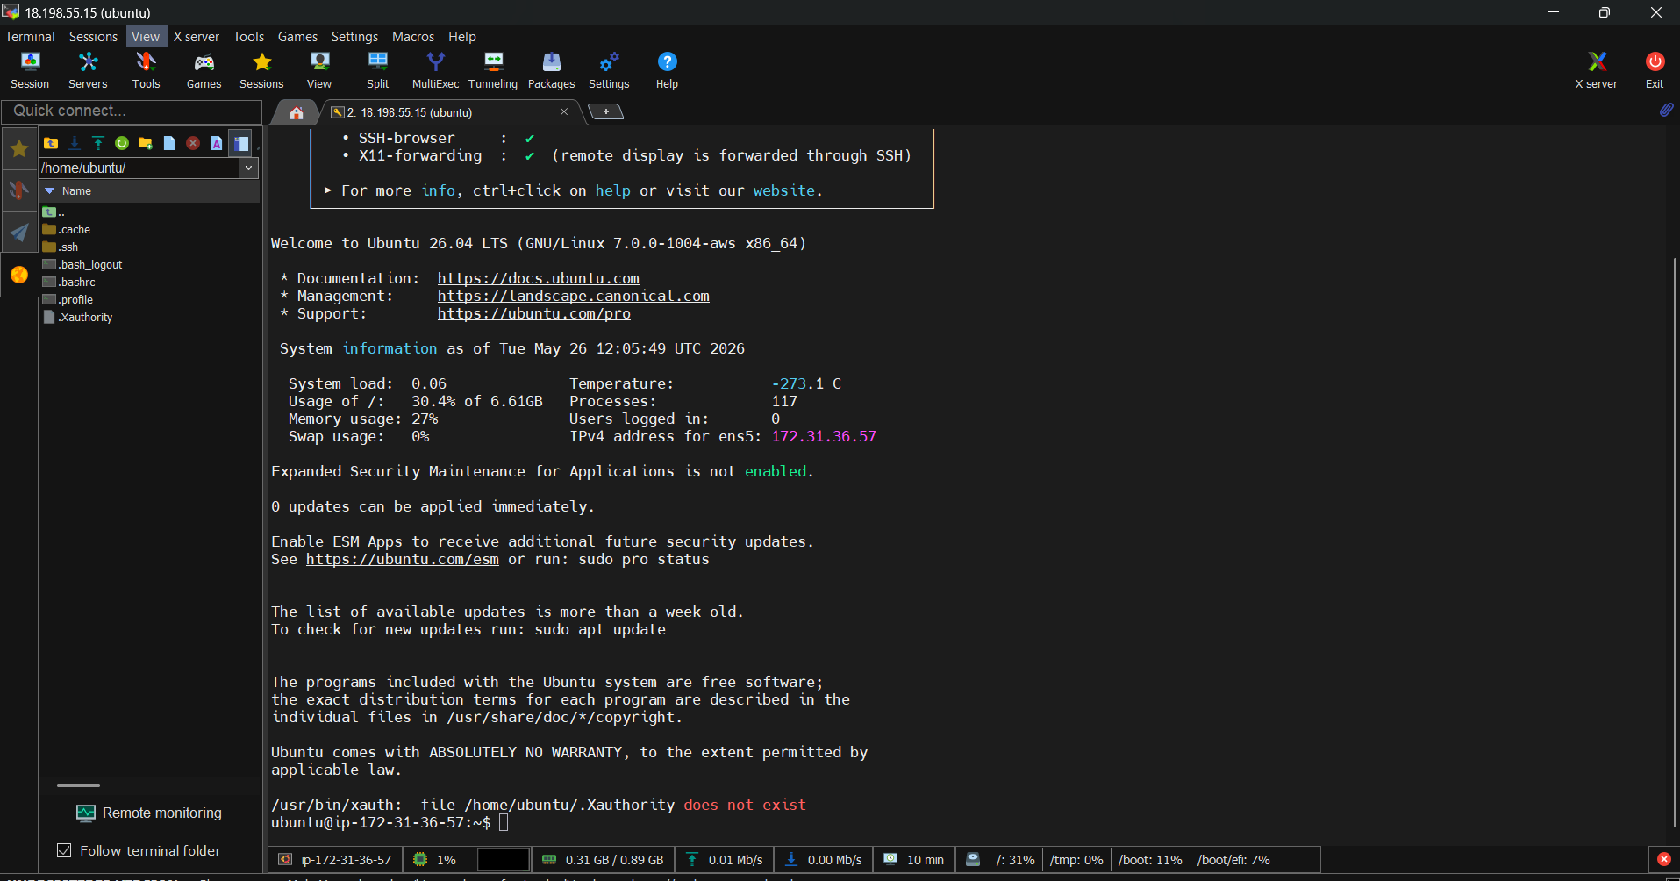

update-packages.png
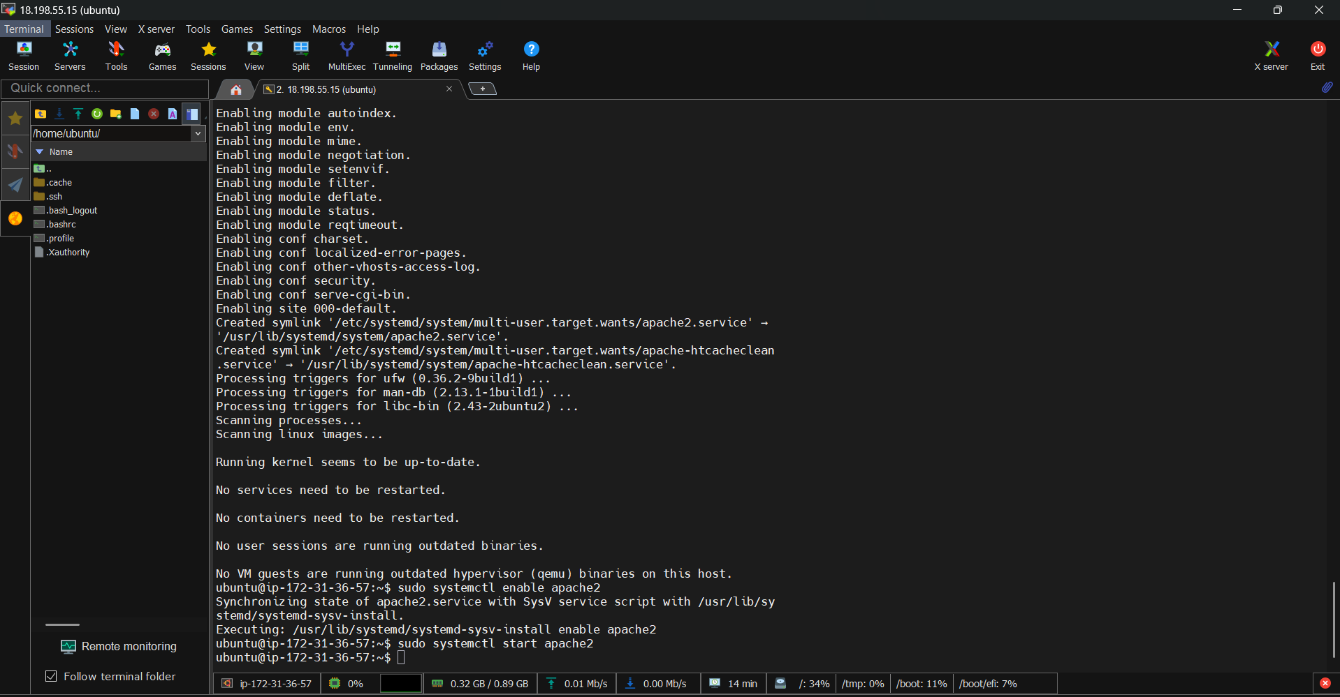

website-hosting.png
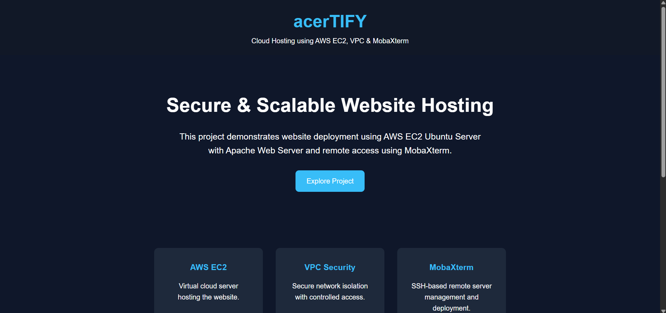

Future Enhancements
SSL integration, custom domain hosting, load balancing, auto scaling, monitoring with CloudWatch, and CI/CD pipeline automation.

