Marketing campaign: ads vs PSA
The ad campaign raises conversion by 43.1% vs the PSA (statistically significant)
Source: marketing_AB.csv; run 2026-10-01_marketing-ads

Executive summary
Recommendation: SHIP
The ad campaign raises conversion by 43.1% vs the PSA (statistically significant)
The primary metric improved significantly and by more than the practical threshold.

In plain terms: For every 1,000 users, about 7.7 more achieved conversion with the ad campaign than with the PSA. A difference this large is unlikely to be down to chance.
How sure we are: Very sure the ads raise conversion. The true lift is most likely between +29.3% and +56.8% (95% confidence interval); even the low end is well above the +5% lift we set in advance as worth acting on. The Bayesian view gives the ads a > 99.9% chance of beating the PSA.
Condition: This recommendation assumes users were randomly assigned to see ads or the PSA, which is not yet confirmed: PSA ids form a separate block (900,000 to 923,523); assignment unconfirmed. Data owner: confirm random assignment to ads vs PSA before scaling spend.
Only conversion was checked: No guardrail metrics defined; verdict rests on conversion alone. Guardrail metrics are checks that nothing else got worse (for example, users put off by the ads); none were available in the data.
- Relative lift in conversion: +43.1% (95% CI [+29.3%, +56.8%])
- Evidence: p < 0.001
- Conversion: the PSA vs the ad campaign: 1.79% vs 2.55%
- Units analysed: psa: 23,524 / ad: 564,577
- Incremental conversions per 1,000 users: 7.7 (95% CI 6.0 to 9.4)
- P(ads beat PSA): > 99.9%
Caveats: PSA ids form a separate block (900,000 to 923,523); assignment unconfirmed. Split confirmed as 96/4 only after a 95/5 check failed. Exposure breakdowns are exploratory, non-causal; 4 of 7 buckets inconclusive. No dates: novelty or wear-off cannot be checked. No guardrail metrics defined; verdict rests on conversion alone. Money impact needs a value per conversion.
Next step: Keep ads running: about 7.7 extra conversions per 1,000 users (6.0 to 9.4).

Business question and hypothesis

Business question
Would the ad campaign be successful, and how much of its success can be attributed to the ads?

Decision to be made
Whether the ads drive enough extra conversions to justify the campaign (continue / scale vs stop).

Hypothesis
Users who see the ad convert at a higher rate than users who see a public service announcement (PSA) in the same slot.

Context as described
Marketing A/B testing dataset Marketing companies want to run successful campaigns, but the market is complex and several options can work. So normally they tun A/B tests, that is a randomized experimentation process wherein two or more versions of a variable (web page, page element, banner, etc.) are shown to different segments of people at the same time to determine which version leaves the maximum impact and drive business metrics.
The companies are interested in answering two questions:
Would the campaign be successful? If the campaign was successful, how much of that success could be attributed to the ads? With the second question in mind, we normally do an A/B test. The majority of the people will be exposed to ads (the experimental group). And a small portion of people (the control group) would instead see a Public Service Announcement (PSA) (or nothing) in the exact size and place the ad would normally be.
The idea of the dataset is to analyze the groups, find if the ads were successful, how much the company can make from the ads, and if the difference between the groups is statistically significant.
Data dictionary:
Index: Row index user id: User ID (unique) test group: If "ad" the person saw the advertisement, if "psa" they only saw the public service announcement converted: If a person bought the product then True, else is False total ads: Amount of ads seen by person most ads day: Day that the person saw the biggest amount of ads most ads hour: Hour of day that the person saw the biggest amount of ads

Experiment design
Table 1: Experiment setup
Item | Detail
Variants (units) | ad: 564,577, psa: 23,524
Primary metric | converted (binary, goal: increase)
Statistical settings | alpha 0.05, two-sided, power 0.8
Multiple-testing correction | secondary: holm; segments: benjamini-hochberg
Analysis type | post test readout, bayesian readout, heterogeneous effects

Data and validation
Overall validation verdict: WARN. Checks follow; outliers are reported, never removed automatically.
Table 2: Validation checks
Check | Verdict | Detail
schema | PASS | 6 columns, 588,101 rows
dtypes | PASS | All metric columns numeric
missing values | PASS | No missing values
duplicates | PASS | 588,101 units, one row each
contamination | PASS | No unit appears in more than one variant
variants | PASS | Counts {'ad': 564577, 'psa': 23524}
SRM | PASS | p = 1.000 (threshold 0.001)
outliers | WARN | Extreme values (reported, not removed): total ads: max is 10x the 99th percentile. Consider winsorised or boot
impossible values | PASS | Metric values within valid ranges
pre-period data | PASS | None described (CUPED not possible)
covariate balance | WARN | Segment mix differs between variants: most ads day (p = 4.8e-48), most ads hour (p = 1.1e-28) (can indicate an

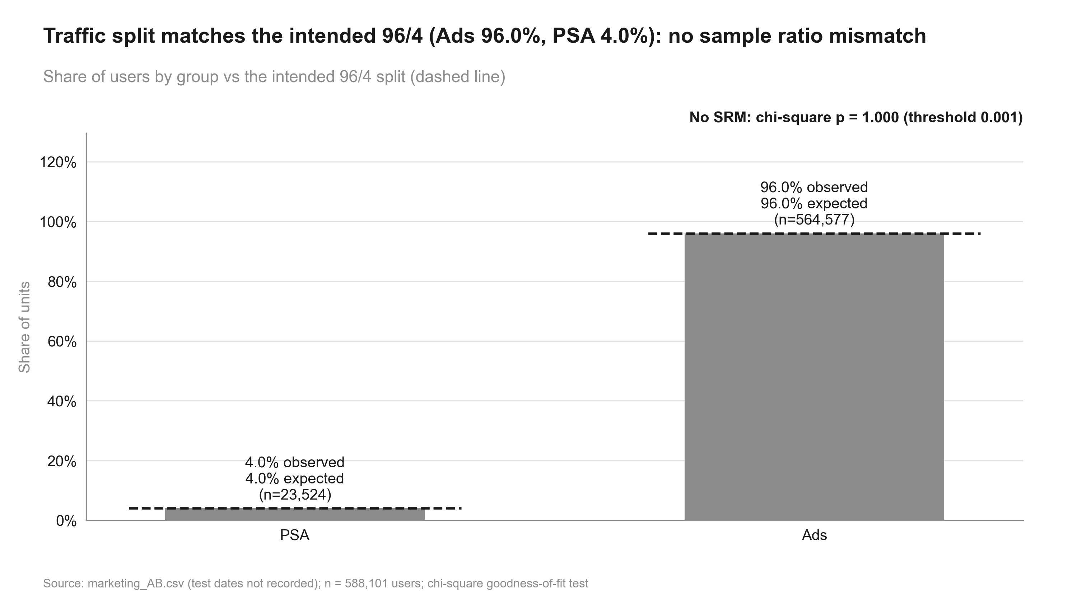
Figure 1: Traffic split matches the intended 96/4 (Ads 96.0%, PSA 4.0%): no sample ratio mismatch. Share of users by group vs the intended 96/4 split (dashed line)

Methodology
- srm: srm check (code/11_validate_srm.py)
- primary test: two proportion ztest (code/20_analysis_primary_test.py)
- bayesian: beta binomial (code/20_analysis_bayesian.py)
- impact: incremental impact (code/20_analysis_impact.py)
- exposure explore: segment effects, two proportion ztest, interaction test, simpsons check (code/20_analysis_exposure_explore.py)
Significance level 0.05 (two-sided), target power 0.8; corrections: primary none, secondary holm, segments benjamini-hochberg. SRM threshold p < 0.001.

Results
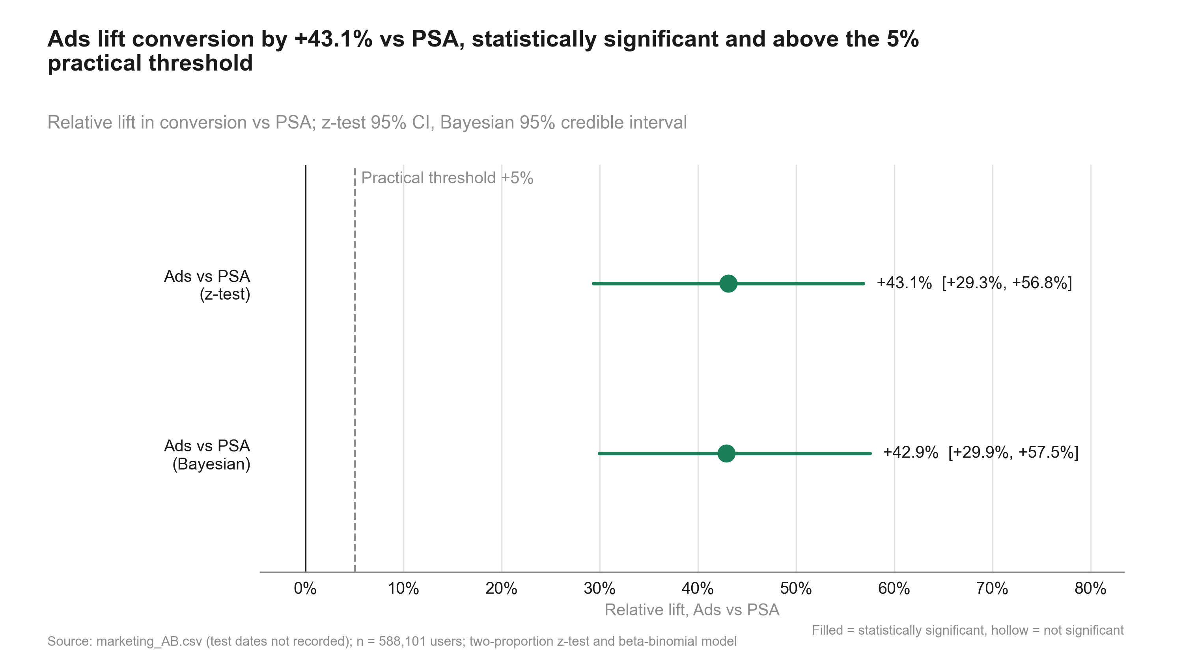
Figure 2: Ads lift conversion by +43.1% vs PSA, statistically significant and above the 5% practical threshold. Relative lift in conversion vs PSA; z-test 95% CI, Bayesian 95% credible interval
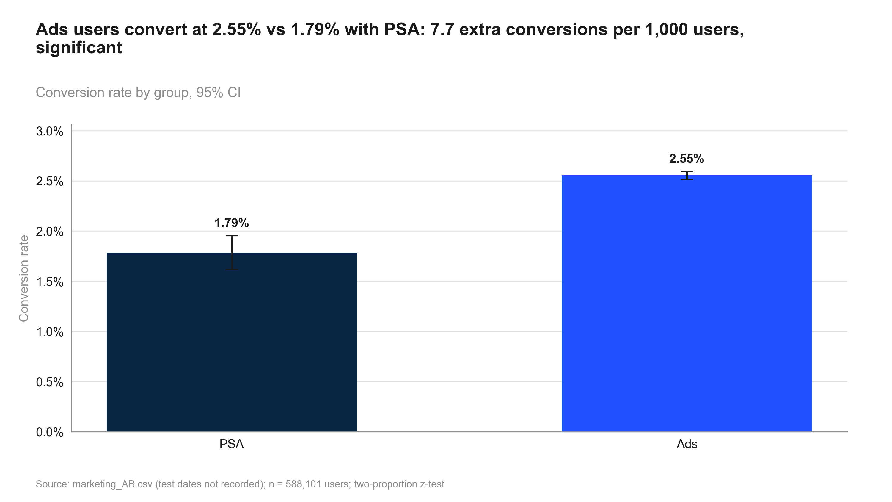
Figure 3: Ads users convert at 2.55% vs 1.79% with PSA: 7.7 extra conversions per 1,000 users, significant. Conversion rate by group, 95% CI
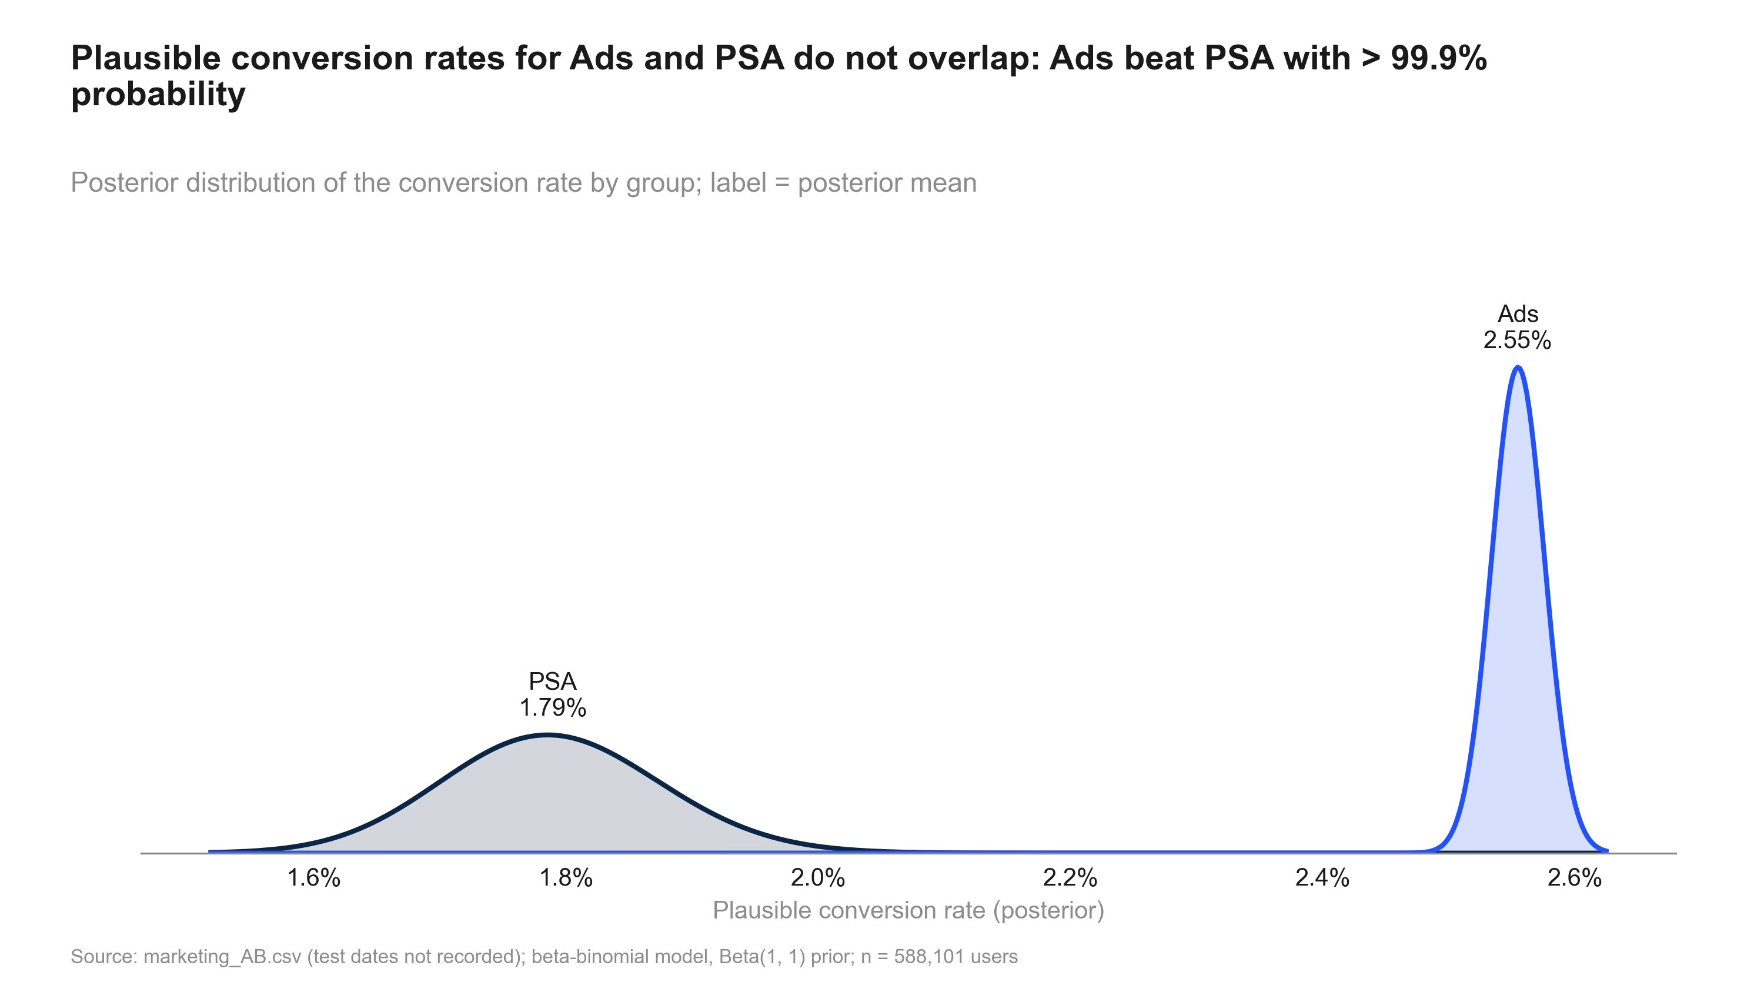
Figure 4: Plausible conversion rates for Ads and PSA do not overlap: Ads beat PSA with > 99.9% probability. Posterior distribution of the conversion rate by group; label = posterior mean
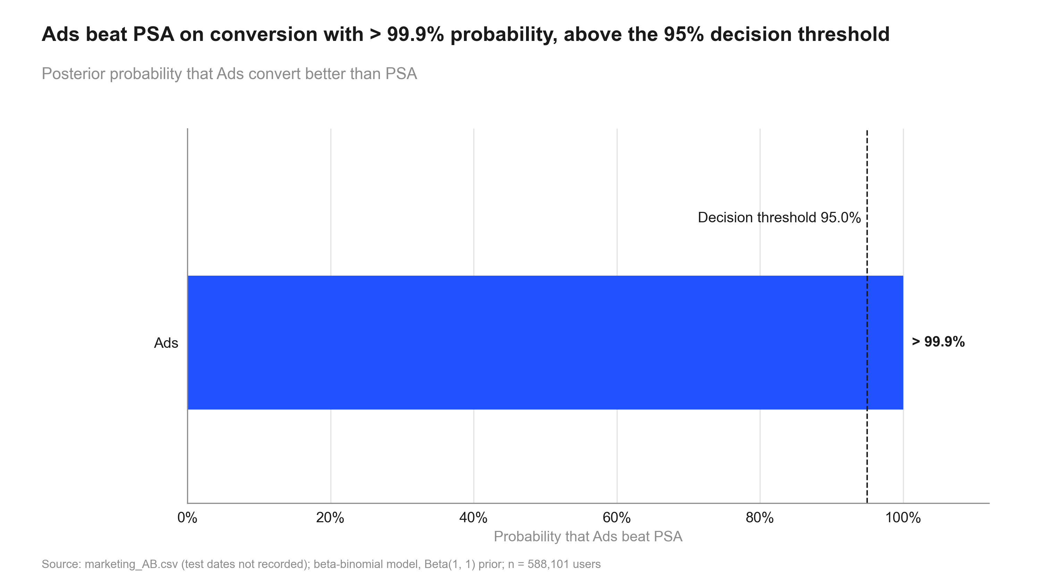
Figure 5: Ads beat PSA on conversion with > 99.9% probability, above the 95% decision threshold. Posterior probability that Ads convert better than PSA
Table 3: Primary and secondary metrics
Metric | Comparison | Control | Treatment | Rel. lift | CI | p / P(beat) | Method
converted | ad vs psa | 1.79% | 2.55% | +43.1% | [+29.3%, +56.8%] | <0.001 (adj.) | two proportion ztest
converted | ad vs psa | 1.79% | 2.55% | +42.9% | [+29.9%, +57.5%] | 100.0% | beta binomial

Segments
Exploratory, non-causal: exposure variables are measured during the test. No segments were pre-specified: these breakdowns (by number of ads seen and by the day a user saw most ads) were added for exploration only. P-values are corrected within each breakdown (Benjamini-Hochberg). Users who saw more ads are different people from those who saw few, so these results do not show that more ads cause more lift. Buckets that are not significant are inconclusive (wide ranges), not evidence of no effect.
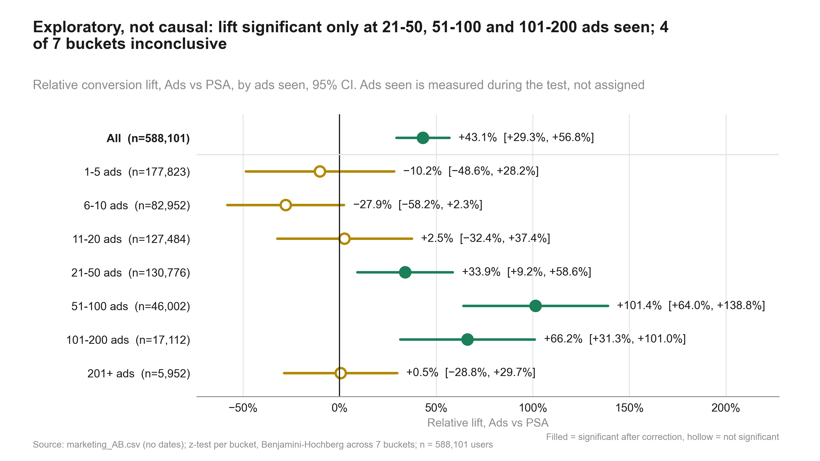
Figure 6: Exploratory, not causal: lift significant only at 21-50, 51-100 and 101-200 ads seen; 4 of 7 buckets inconclusive. Relative conversion lift, Ads vs PSA, by ads seen, 95% CI. Ads seen is measured during the test, not assigned
Table 4: Effect by segment
Metric | Segment | Comparison | Control | Treatment | Rel. lift | CI | p / P(beat) | Method
converted | All | ad vs psa | 1.79% | 2.55% | +43.1% | [+29.3%, +56.8%] | <0.001 | two proportion ztest
converted | 1-5 | ad vs psa | 0.28% | 0.25% | −10.2% | [−48.6%, +28.2%] | 0.869 (adj.) | two proportion ztest
converted | 101-200 | ad vs psa | 10.64% | 17.68% | +66.2% | [+31.3%, +101.0%] | <0.001 (adj.) | two proportion ztest
converted | 11-20 | ad vs psa | 0.82% | 0.84% | +2.5% | [−32.4%, +37.4%] | 0.974 (adj.) | two proportion ztest
converted | 201+ | ad vs psa | 15.50% | 15.58% | +0.5% | [−28.8%, +29.7%] | 0.974 (adj.) | two proportion ztest
converted | 21-50 | ad vs psa | 2.18% | 2.92% | +33.9% | [+9.2%, +58.6%] | 0.004 (adj.) | two proportion ztest
converted | 51-100 | ad vs psa | 5.77% | 11.63% | +101.4% | [+64.0%, +138.8%] | <0.001 (adj.) | two proportion ztest
converted | 6-10 | ad vs psa | 0.67% | 0.49% | −27.9% | [−58.2%, +2.3%] | 0.217 (adj.) | two proportion ztest
converted | Friday | ad vs psa | 1.63% | 2.25% | +37.8% | [+3.3%, +72.3%] | 0.016 (adj.) | two proportion ztest
converted | Monday | ad vs psa | 2.26% | 3.32% | +47.4% | [+14.8%, +79.9%] | 0.001 (adj.) | two proportion ztest
converted | Saturday | ad vs psa | 1.40% | 2.13% | +52.2% | [+4.8%, +99.6%] | 0.013 (adj.) | two proportion ztest
converted | Sunday | ad vs psa | 2.06% | 2.46% | +19.5% | [−10.1%, +49.2%] | 0.183 (adj.) | two proportion ztest
converted | Thursday | ad vs psa | 2.02% | 2.16% | +7.0% | [−16.9%, +30.8%] | 0.555 (adj.) | two proportion ztest
converted | Tuesday | ad vs psa | 1.44% | 3.04% | +110.7% | [+46.9%, +174.5%] | <0.001 (adj.) | two proportion ztest
converted | Wednesday | ad vs psa | 1.58% | 2.54% | +60.9% | [+18.1%, +103.7%] | 0.001 (adj.) | two proportion ztest

Interaction test for total ads bucket: p < 0.001 (Wald chi-square 158.0). The lift differs across ads-seen buckets, but because ads seen is measured during the test this is descriptive, not a dose-response. Test ad frequency directly in a new randomised test before acting on it.

Risks, limitations and assumptions
- PSA ids form a separate block (900,000 to 923,523); assignment unconfirmed.
- Split confirmed as 96/4 only after a 95/5 check failed.
- Exposure breakdowns are exploratory, non-causal; 4 of 7 buckets inconclusive.
- No dates: novelty or wear-off cannot be checked.
- No guardrail metrics defined; verdict rests on conversion alone.
- Money impact needs a value per conversion.

Recommendation and next steps
Ship. The primary metric improved significantly and by more than the practical threshold.
- Keep ads running: about 7.7 extra conversions per 1,000 users (6.0 to 9.4).
- Data owner: confirm random assignment to ads vs PSA before scaling spend.
- Agree a value per conversion to price the 4,343 extra conversions.
- Test ad frequency in a new randomised test before changing it.
- Keep a small PSA holdout when scaling to track the lift.

Appendix

Settings
Table 5: Statistical settings used
Setting | Value
alpha | 0.05
sidedness | two-sided
power | 0.8
confidence_level | 0.95
correction_primary | none
correction_secondary | holm
correction_segments | benjamini-hochberg
srm_test | chi-square
srm_threshold | 0.001
min_days | 7
prefer_full_weeks | True
bayes_prior | weakly_informative
bayes_decision_threshold | 0.95
bootstrap_n_resamples | 10000
bootstrap_seed | 42
noninferiority_margin_relative | 0.01

Reviewer findings
Review: 2026-10-01_marketing-ads (round 2). Earlier rounds are in review.md.
- Verdict: PASS
- All five round-1 fixes are resolved. Every artefact now uses the intended split of 96/4, and the old 95/5 split appears only as a clearly labelled audit-trail record. None of the numbers or the verdict changed.
- #1 plan.md still said 95/5: status resolved; evidence plan.md l.5-6 dated "Plan note (2026-10-01)"; approach, step 2 and assumptions now say 96/4; the risk section is marked "SRM (resolved)" and keeps the 95/5 history
- #2 Stale failure note on the SRM step in state.json: status resolved; evidence plan.steps[srm].note = "SRM vs 96/4 (user-corrected): p = 0.9998; passes. Originally stated 95/5: p = 3.2e-271". 11_validate_srm.py now always writes the note (l.114-118)
- #3 data_profile.md SRM localisation section: status resolved; evidence Labels are built from design.expected_split ("Intended split 96/4 ... p = 0.9998"). The 95/5 check is given only as an audit-trail line. Per-level lines say "differ from the intended share"; the Reading paragraph now says there is no shortfall and the variation is post-treatment. share_of_total_missing is only computed if SRM fails and is gone from the tables
- #4 results.json step srm and the validation scripts: status resolved; evidence shortfall keys are now split-neutral (intended_split "96/4", expected_control 23,524.04); notes: "Checked against the intended split 96/4 ..." and "corrected by the user from 95/5 to 96/4 ... p = 3.2e-271"; heterogeneity key levels_with_control_share_ge_intended. 10_validate_profile.py and 11_validate_srm.py read the split only from state.json (10: l.24-25; 11: l.32-50; the original split is parsed from the state history, for the record only). Validation verdict WARN, blocking []
- #5 Caveat on the split being confirmed after the 95/5 check failed: status resolved; evidence summary.caveats[1] "Split confirmed as 96/4 only after a 95/5 check failed." The assignment caveat is first. A no-guardrails caveat was added (covers note #9)
- #10 Bookkeeping (note): status resolved; evidence Segment rows' independent-units assumptions are now passed = true. The Bayesian SRM assumption reads step srm ("SRM p = 1.000"); Bayesian alpha = 0.05. The interaction-test estimate still holds the Wald statistic (157.96) but carries the note "do not plot it as an effect" (acceptable)
- #11 Inconclusive wording (note): status resolved; evidence Every non-significant segment row notes "inconclusive (relative lift CI [...]), not evidence of no effect". The caveat says "4 of 7 buckets inconclusive" (1-5, 6-10, 11-20, 201+: correct count)
- Re-checks this round:
- Verdict re-derived: abkit.decision.recommend(primary, [], mde_rel=0.05) returns ship with the same reason as summary.reason. The build_summary change affects display labels only: the headline reads "The ad campaign raises conversion by 43.1% vs the PSA", and plain_english gives 7.7 per 1,000, which matches impact.estimate 7.692.
- The primary test, impact and exposure numbers are unchanged from round 1 (abs diff 0.0076925, CI low 0.0059509, rel lift 0.43085, p 1.705e-13; impact 7.69 / 4,343 / 0.3011). The SRM p-values are unchanged: 0.99979 against 96/4 and 3.16e-271 against 95/5.
- Traceability: validation -> code/10_validate_profile.py; srm, primary_test, bayesian, impact, exposure_explore and summary each point to an existing script in code/.
- Remaining notes (no action; carry into caveats as already done): #6 the SRM pass is weak evidence of random assignment (the split is matched almost exactly and PSA ids form a separate block), so the verdict depends on the data owner confirming assignment. #7 the PSA share varies across post-treatment levels, but there is no sign of Simpson paradox. #8 with no dates, peeking and novelty cannot be checked.
- SRM - ok (96/4 used consistently in all artefacts; 95/5 kept as a labelled audit record only)
- Test vs metric type - ok
- Unit of analysis - ok
- Multiple testing - ok
- Practical vs statistical - ok (CI low +29.3% > 5%)
- Inconclusive wording - ok
- Peeking - ok / note #8
- Novelty - not checkable; caveat present
- Simpson / mix - note #7
- Guardrails - none defined; caveat now present
- Conclusion follows - ok (ship)
- Traceability - ok
- Failed assumptions - ok (none false or null)
Table 6: All estimates
Metric | Segment | Comparison | Control | Treatment | Rel. lift | CI | p / P(beat) | Method
converted |  | ad vs psa | 1.79% | 2.55% | +43.1% | [+29.3%, +56.8%] | <0.001 (adj.) | two proportion ztest
converted |  | ad vs psa | 1.79% | 2.55% | +42.9% | [+29.9%, +57.5%] | 100.0% | beta binomial
converted | All | ad vs psa | 1.79% | 2.55% | +43.1% | [+29.3%, +56.8%] | <0.001 | two proportion ztest
converted | 1-5 | ad vs psa | 0.28% | 0.25% | −10.2% | [−48.6%, +28.2%] | 0.869 (adj.) | two proportion ztest
converted | 101-200 | ad vs psa | 10.64% | 17.68% | +66.2% | [+31.3%, +101.0%] | <0.001 (adj.) | two proportion ztest
converted | 11-20 | ad vs psa | 0.82% | 0.84% | +2.5% | [−32.4%, +37.4%] | 0.974 (adj.) | two proportion ztest
converted | 201+ | ad vs psa | 15.50% | 15.58% | +0.5% | [−28.8%, +29.7%] | 0.974 (adj.) | two proportion ztest
converted | 21-50 | ad vs psa | 2.18% | 2.92% | +33.9% | [+9.2%, +58.6%] | 0.004 (adj.) | two proportion ztest
converted | 51-100 | ad vs psa | 5.77% | 11.63% | +101.4% | [+64.0%, +138.8%] | <0.001 (adj.) | two proportion ztest
converted | 6-10 | ad vs psa | 0.67% | 0.49% | −27.9% | [−58.2%, +2.3%] | 0.217 (adj.) | two proportion ztest
converted | Friday | ad vs psa | 1.63% | 2.25% | +37.8% | [+3.3%, +72.3%] | 0.016 (adj.) | two proportion ztest
converted | Monday | ad vs psa | 2.26% | 3.32% | +47.4% | [+14.8%, +79.9%] | 0.001 (adj.) | two proportion ztest
converted | Saturday | ad vs psa | 1.40% | 2.13% | +52.2% | [+4.8%, +99.6%] | 0.013 (adj.) | two proportion ztest
converted | Sunday | ad vs psa | 2.06% | 2.46% | +19.5% | [−10.1%, +49.2%] | 0.183 (adj.) | two proportion ztest
converted | Thursday | ad vs psa | 2.02% | 2.16% | +7.0% | [−16.9%, +30.8%] | 0.555 (adj.) | two proportion ztest
converted | Tuesday | ad vs psa | 1.44% | 3.04% | +110.7% | [+46.9%, +174.5%] | <0.001 (adj.) | two proportion ztest
converted | Wednesday | ad vs psa | 1.58% | 2.54% | +60.9% | [+18.1%, +103.7%] | 0.001 (adj.) | two proportion ztest

Code index
- 10_validate_profile.py: Validate and profile the marketing ads-vs-PSA CSV (schema, duplicates, SRM vs the intended split in state.json, outliers, balance) and write data_profile.md.
- 11_validate_srm.py: SRM check against the intended split (read from state.json design.expected_split) and its localisation:
- 20_analysis_bayesian.py: Bayesian readout of conversion (ads vs PSA): beta-binomial, prior from settings. Step: bayesian.
- 20_analysis_exposure_explore.py: EXPLORATORY, non-causal: ads-vs-PSA conversion lift by total-ads bucket and by most-ads day (BH), plus an
- 20_analysis_impact.py: Incremental impact of the ads, translated from the primary conversion effect. Step: impact.
- 20_analysis_primary_test.py: Primary test: conversion, ads vs PSA, two-proportion z-test (one pre-registered primary, no correction). Step: primary_test.
- 20_analysis_summary.py: Decision summary for the ads-vs-PSA test: verdict vs the practical threshold, key numbers, caveats and next steps.
- 30_charts_bayes.py: Charts for 2026-10-01_marketing-ads: posterior_distributions, prob_to_beat_control (numbers from results.json).
- 30_charts_results.py: Charts for 2026-10-01_marketing-ads: srm_bar, lift_ci, metric_by_variant (all numbers from results.json).
- 30_charts_segments.py: Charts for 2026-10-01_marketing-ads: segment_forest by ads-seen bucket (exploratory, not causal).
- 40_deck_build.py: Build deck.pptx from results.json and charts/manifest.json.
- 50_report_build.py: Build summary.docx from results.json, intake.md, review.md and charts/manifest.json.

