Single-button checkout test
Treatment raises checkout conversion by 3.2% vs control (statistically significant)
Source: checkout_ab.csv, 2026-09-01 to 2026-09-14; run 2026-10-01_checkout-sample

Executive summary
Recommendation: SHIP
Treatment raises checkout conversion by 3.2% vs control (statistically significant)
The primary metric improved significantly and no guardrail was breached.

In plain terms: For every 1,000 users, about 11 more achieved checkout conversion with treatment than with control. A difference this large is unlikely to be down to chance.
- Relative lift in checkout conversion: +3.2% (95% CI [+1.2%, +5.2%])
- Evidence: p = 0.001
- Checkout conversion: control vs treatment: 34.25% vs 35.34%
- Units analysed: control: 40,183 / treatment: 39,817
- Guardrail revenue: pass (+2.2%)
Next step: Roll out the single-button checkout to 100% of users

Business question and hypothesis

Business question
Should we ship the single-button checkout?

Hypothesis
A single 'Pay now' button raises checkout conversion without lowering revenue per user.

Context as described
We ran an A/B test on the checkout page: the treatment replaces the multi-step checkout with a single "Pay now" button. File: checkout_ab.csv, one row per user. Columns: user_id, variant (control / treatment), exposure_date (first day the user saw checkout, 2026-09-01 to 2026-09-14), platform (iOS / Android / Web), country (US / UK / DE / IN), converted (1 if the user completed a purchase within the test), revenue (USD revenue from that user during the test, 0 if no purchase). Traffic was split 50/50 at user level. Primary metric is conversion; revenue per user is a guardrail - we don't want it to drop. We'd like to know if we should ship it, and whether the effect differs by platform.

Experiment design
Table 1: Experiment setup
Item | Detail
Variants (units) | control: 40,183, treatment: 39,817
Test period | 2026-09-01 to 2026-09-14 (14 days)
Primary metric | converted (binary, goal: increase)
Guardrail metric | revenue (continuous, goal: no decrease)
Statistical settings | alpha 0.05, two-sided, power 0.8
Multiple-testing correction | secondary: holm; segments: benjamini-hochberg
Analysis type | post test readout, heterogeneous effects, guardrail check

Data and validation
Overall validation verdict: PASS. Checks follow; outliers are reported, never removed automatically.
Table 2: Validation checks
Check | Verdict | Detail
schema | PASS | 7 columns, 80,000 rows
dtypes | PASS | All metric columns numeric
missing values | PASS | No missing values
duplicates | PASS | 80,000 units, one row each
contamination | PASS | No unit appears in more than one variant
variants | PASS | Counts {'control': 40183, 'treatment': 39817}
SRM | PASS | p = 0.196 (threshold 0.001)
dates | PASS | 2026-09-01 to 2026-09-14 (14 days)
outliers | PASS | No extreme outliers in continuous metrics
impossible values | PASS | Metric values within valid ranges
pre-period data | PASS | None described (CUPED not possible)
covariate balance | PASS | Segment mix similar across variants

Methodology
- primary test: two proportion ztest (code/20_analysis_sample.py)
- guardrails: noninferiority test (code/20_analysis_sample.py)
- segments: two proportion ztest, interaction test (code/20_analysis_sample.py)
- time trends: cumulative effects (code/20_analysis_sample.py)
Significance level 0.05 (two-sided), target power 0.8; corrections: primary none, secondary holm, segments benjamini-hochberg. SRM threshold p < 0.001.

Results
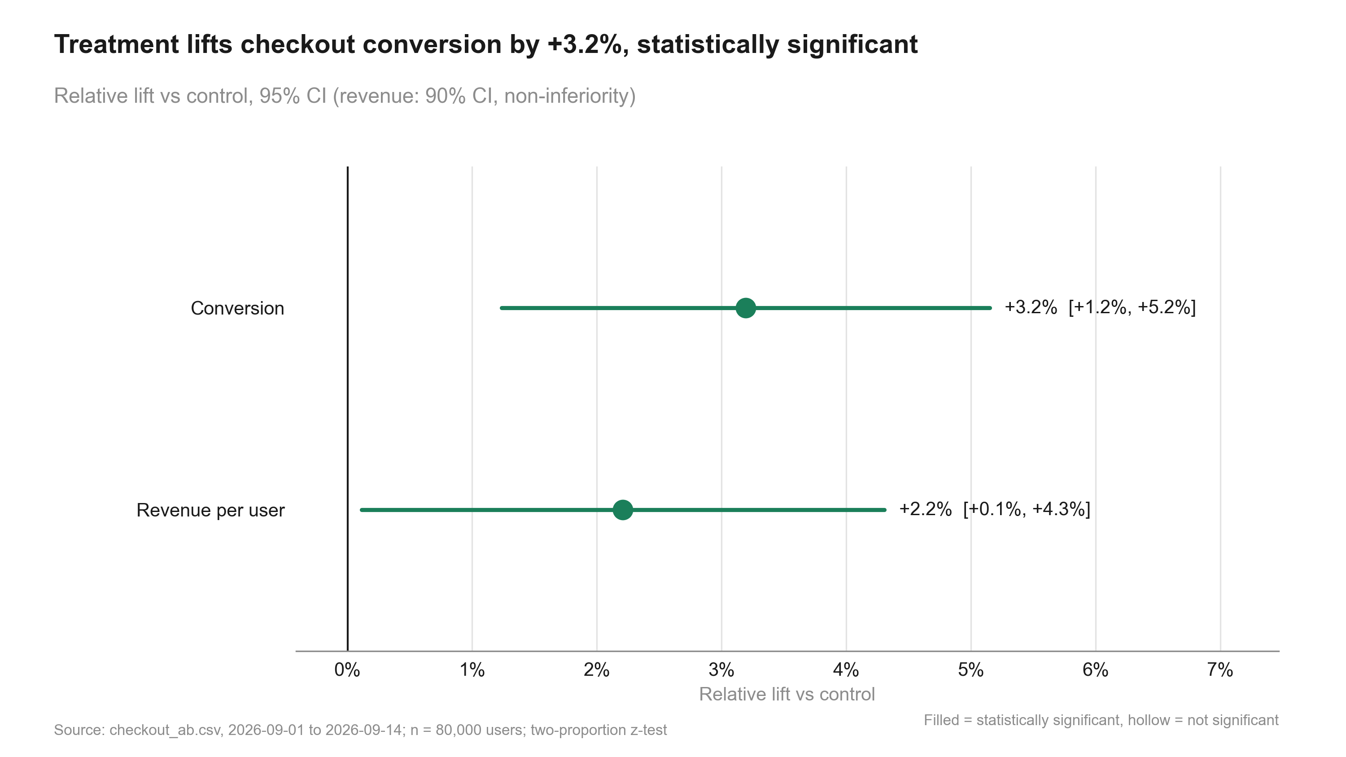
Figure 1: Treatment lifts checkout conversion by +3.2%, statistically significant.
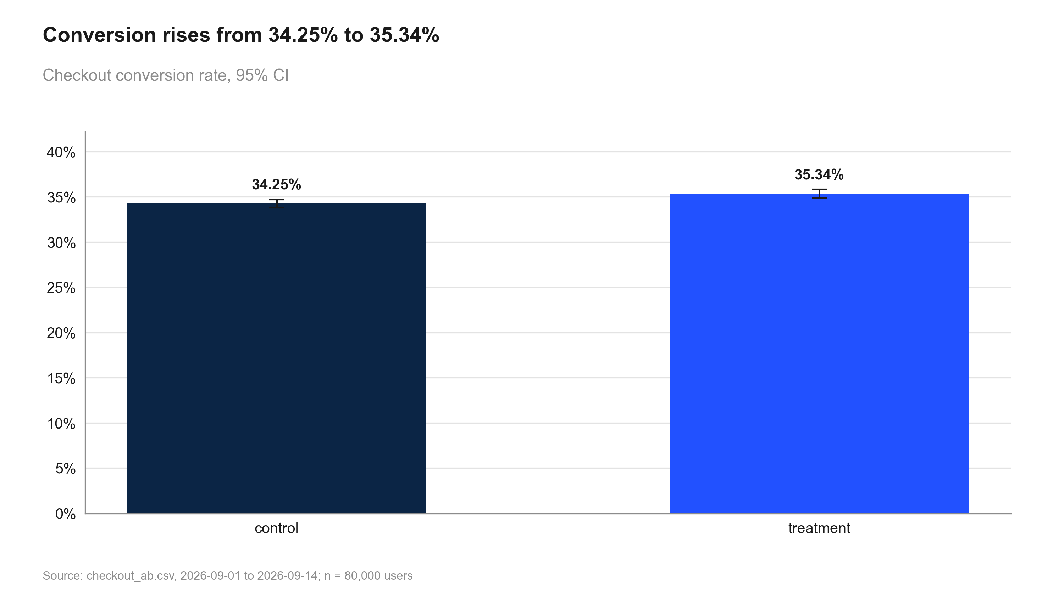
Figure 2: Conversion rises from 34.25% to 35.34%.
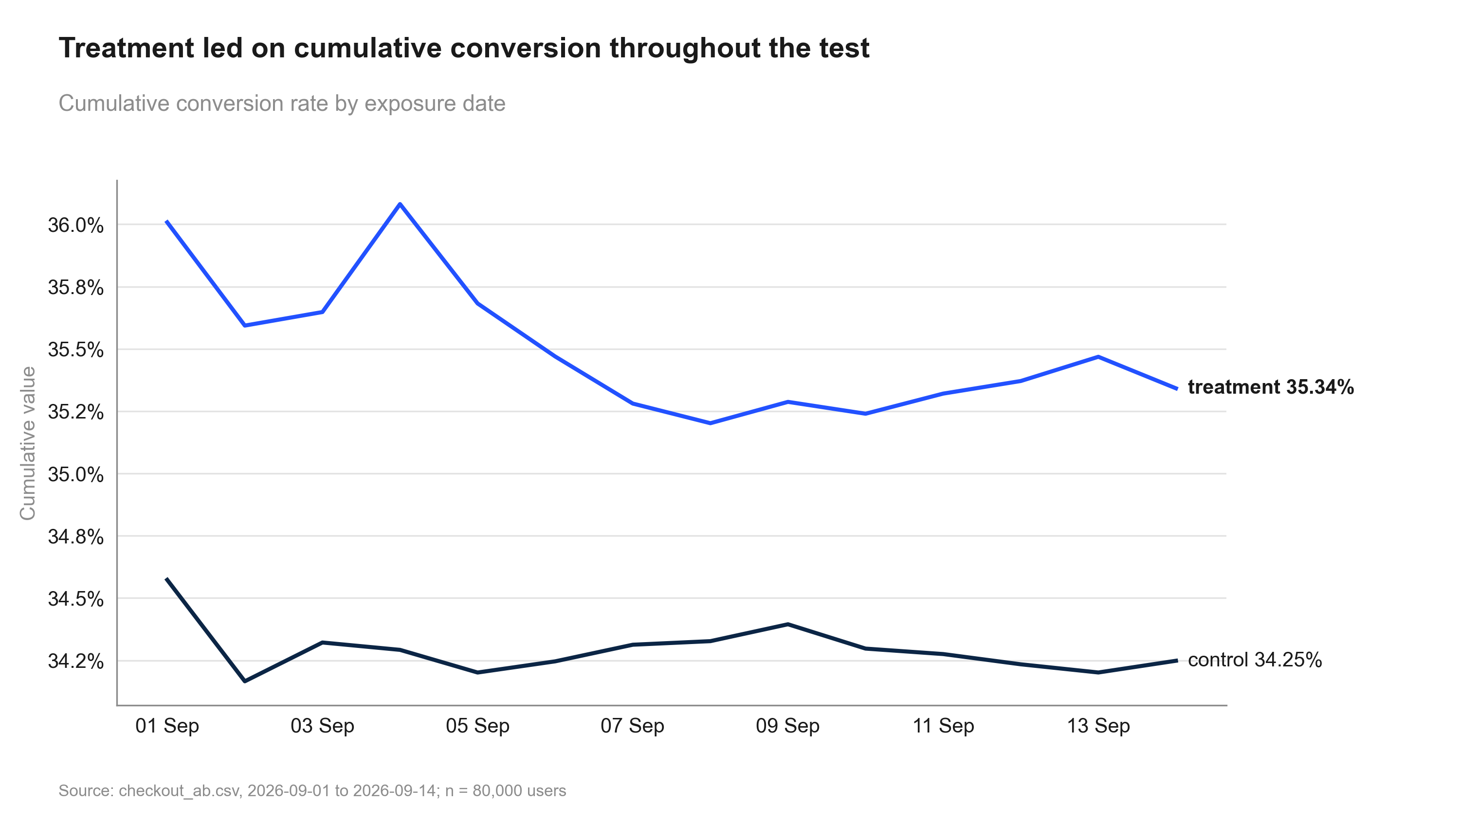
Figure 3: Treatment led on cumulative conversion throughout the test.
Table 3: Primary and secondary metrics
Metric | Comparison | Control | Treatment | Rel. lift | CI | p / P(beat) | Method
converted | treatment vs control | 34.25% | 35.34% | +3.2% | [+1.2%, +5.2%] | 0.001 | two proportion ztest

Guardrails
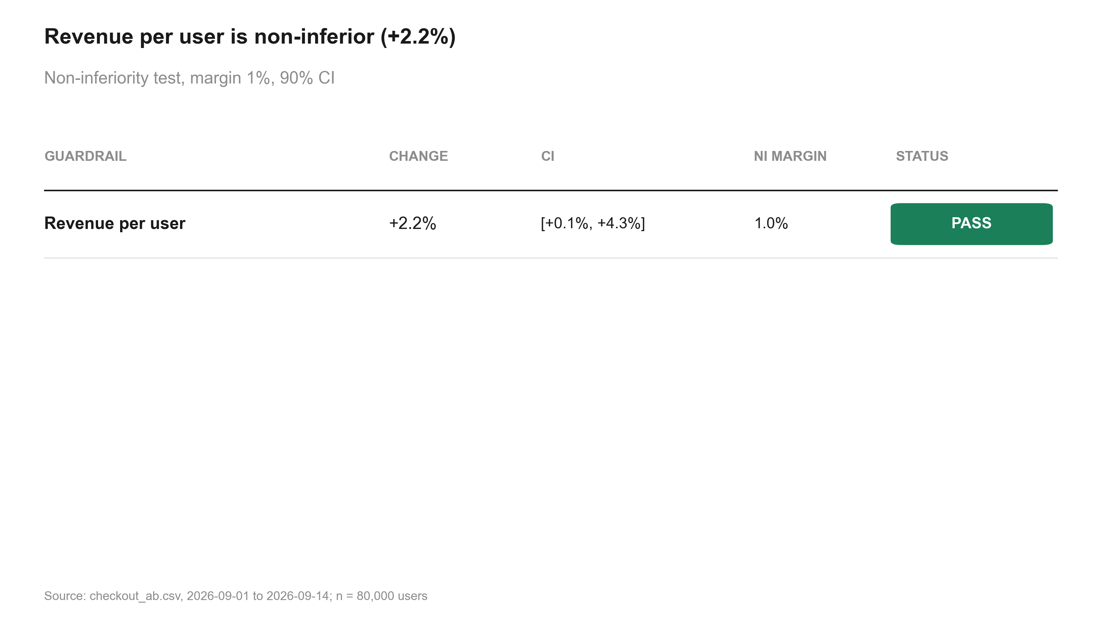
Figure 4: Revenue per user is non-inferior (+2.2%).
Table 4: Guardrail non-inferiority tests
Metric | Comparison | Control | Treatment | Rel. lift | CI | p / P(beat) | Method | Status
revenue | treatment vs control | 22.73 | 23.23 | +2.2% | [+0.1%, +4.3%] | 0.005 | noninferiority test | PASS

Segments
No segments were pre-specified, so these breakdowns are exploratory; p-values are corrected across segments. A difference between segments is only claimed when the interaction test supports it.
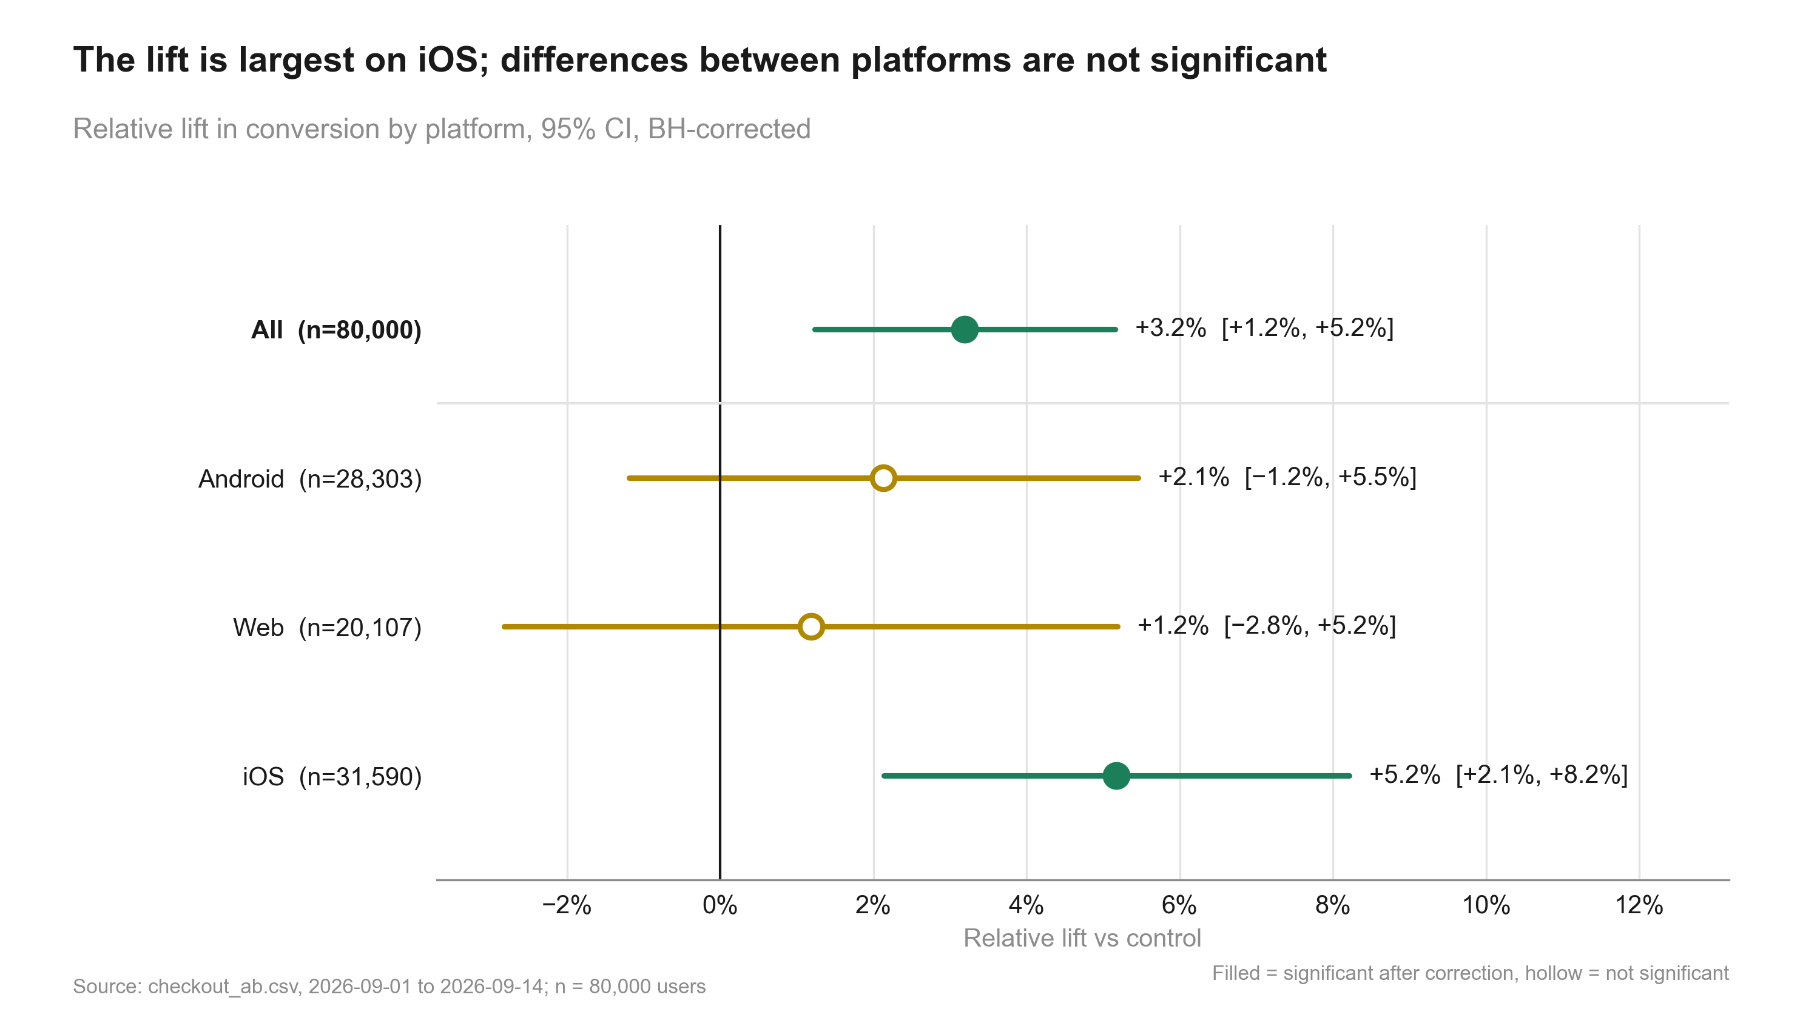
Figure 5: The lift is largest on iOS; differences between platforms are not significant.
Table 5: Effect by segment
Metric | Segment | Comparison | Control | Treatment | Rel. lift | CI | p / P(beat) | Method
converted | Android | treatment vs control | 33.53% | 34.24% | +2.1% | [−1.2%, +5.5%] | 0.306 (adj.) | two proportion ztest
converted | Web | treatment vs control | 32.63% | 33.02% | +1.2% | [−2.8%, +5.2%] | 0.561 (adj.) | two proportion ztest
converted | iOS | treatment vs control | 35.93% | 37.79% | +5.2% | [+2.1%, +8.2%] | 0.002 (adj.) | two proportion ztest

Interaction test for platform: p = 0.168. Tests heterogeneity of the absolute effect; no evidence the effect differs by segment.

Risks, limitations and assumptions
- No material risks identified by the analysis or the review.

Recommendation and next steps
Ship. The primary metric improved significantly and no guardrail was breached.
- Roll out the single-button checkout to 100% of users
- Keep monitoring revenue per user for four weeks after rollout
- Investigate why the Web lift is smaller before the next checkout test

Appendix

Settings
Table 6: Statistical settings used
Setting | Value
alpha | 0.05
sidedness | two-sided
power | 0.8
confidence_level | 0.95
correction_primary | none
correction_secondary | holm
correction_segments | benjamini-hochberg
srm_test | chi-square
srm_threshold | 0.001
min_days | 7
prefer_full_weeks | True
bayes_prior | weakly_informative
bayes_decision_threshold | 0.95
bootstrap_n_resamples | 10000
bootstrap_seed | 42
noninferiority_margin_relative | 0.01

Reviewer findings
Review. Earlier rounds are in review.md.
- note: sample run built by demo_data/sample_run.py
Table 7: All estimates
Metric | Segment | Comparison | Control | Treatment | Rel. lift | CI | p / P(beat) | Method
converted |  | treatment vs control | 34.25% | 35.34% | +3.2% | [+1.2%, +5.2%] | 0.001 | two proportion ztest
revenue |  | treatment vs control | 22.73 | 23.23 | +2.2% | [+0.1%, +4.3%] | 0.005 | noninferiority test
converted | Android | treatment vs control | 33.53% | 34.24% | +2.1% | [−1.2%, +5.5%] | 0.306 (adj.) | two proportion ztest
converted | Web | treatment vs control | 32.63% | 33.02% | +1.2% | [−2.8%, +5.2%] | 0.561 (adj.) | two proportion ztest
converted | iOS | treatment vs control | 35.93% | 37.79% | +5.2% | [+2.1%, +8.2%] | 0.002 (adj.) | two proportion ztest

Code index
- No scripts.

