Technical report: Single-button checkout test
Companion to summary.docx: how the result was obtained, for data scientists
Source: checkout_ab.csv, 2026-09-01 to 2026-09-14; run 2026-10-01_checkout-sample

1. Technical summary
Verdict: Ship. The primary metric improved significantly and no guardrail was breached.
Headline: Treatment raises checkout conversion by 3.2% vs control (statistically significant)
Decision rule (abkit.decision.recommend): ship if the primary metric is significantly better and the relative lift is at least the practical threshold with no guardrail breach; don't ship if it is significantly worse or a guardrail is breached (iterate if the primary also won); iterate if significant but below the threshold, or if not significant with the CI excluding the threshold; otherwise extend (inconclusive). Bayesian results use P(beat) against 0.95.
Table 1: Primary estimate
Step | Metric | Segment | Method | Estimate [CI] | Relative lift [CI] | Evidence | n
primary_test | converted |  | two proportion ztest | 0.0109 [0.0043, 0.0175] | +3.2% [+1.2%, +5.2%] | p = 0.001 | control: 40,183 / treatment: 39,817

2. Problem framing and design
Business question: Should we ship the single-button checkout?
Formal hypotheses for the primary metric:
H0: p_T = p_C H1: p_T != p_C (two-sided, alpha = 0.05)
Table 2: Design
Item | Value
Problem types | post_test_readout, heterogeneous_effects, guardrail_check
Period | 2026-09-01 to 2026-09-14

Table 3: Metrics
Metric | Label | Role | Type | Direction | Threshold / margin (rel.)
converted |  | primary | binary | increase
revenue |  | guardrail | continuous | no_decrease

Table 4: Statistical settings used
Setting | Value
alpha | 0.05
sidedness | two-sided
power | 0.8
confidence_level | 0.95
correction_primary | none
correction_secondary | holm
correction_segments | benjamini-hochberg
srm_test | chi-square
srm_threshold | 0.001
min_days | 7
prefer_full_weeks | True
bayes_prior | weakly_informative
bayes_decision_threshold | 0.95
bootstrap_n_resamples | 10000
bootstrap_seed | 42
noninferiority_margin_relative | 0.01

3. Data and validation
Table 5: Data lineage (the original file is never modified)
Item | Value
Original file | D:\VS-Code\AB-Testing\demo_data\checkout_ab.csv
Run copy (analysed) | data/checkout_ab.csv
SHA-256 of run copy | 22b6ed6b100df60f65c6a42a2b0bab071de9563d4e4e027aeed38548ed153567
Shape | 7 columns, 80,000 rows

Validation verdict: overall PASS (script code/10_validate_sample.py). Outliers are reported, never removed automatically.
Table 6: Validation checks
Check | Verdict | Detail
schema | PASS | 7 columns, 80,000 rows
dtypes | PASS | All metric columns numeric
missing values | PASS | No missing values
duplicates | PASS | 80,000 units, one row each
contamination | PASS | No unit appears in more than one variant
variants | PASS | Counts {'control': 40183, 'treatment': 39817}
SRM | PASS | p = 0.196 (threshold 0.001)
dates | PASS | 2026-09-01 to 2026-09-14 (14 days)
outliers | PASS | No extreme outliers in continuous metrics
impossible values | PASS | Metric values within valid ranges
pre-period data | PASS | None described (CUPED not possible)
covariate balance | PASS | Segment mix similar across variants

4. Methods, step by step

validate: validation.full_profile (done)
Script: code/10_validate_sample.py
Data validation profile: Schema, dtypes, missing values, duplicates, contamination, variants, SRM, dates, outliers, impossible values, pre-period data, covariate balance.
pass / warn / block per check. Assumptions: None. Reference: abkit.validation.full_profile.

primary_test: frequentist.two_proportion_ztest (done)
Script: code/20_analysis_sample.py
Two-proportion z-test: Compares conversion rates between two independent groups of randomisation units.
p_hat = x / n per group; diff = p_T - p_C
z = diff / sqrt( p_pool (1 - p_pool) (1/n_C + 1/n_T) ), p_pool = (x_C + x_T) / (n_C + n_T)
CI(diff) = diff +/- z_crit * sqrt( p_C(1-p_C)/n_C + p_T(1-p_T)/n_T ) (unpooled)
rel = p_T/p_C - 1; Var(rel) ~ se_T^2/p_C^2 + p_T^2 se_C^2/p_C^4 (delta method)
Pooled SE for the test, unpooled SE for the CI; one-sided tests use a (1 - 2 alpha) two-sided CI. Assumptions: Independent units (one row per randomisation unit); at least 10 successes and failures per group. Reference: abkit.frequentist.two_proportion_ztest; ab-methods/frequentist_tests.md.
Settings applied: alpha 0.05; sidedness two-sided; correction none.
Table 7: Assumptions checked in step primary_test
Assumption | Status | Detail
independent units (one row per randomisation unit) | NOT CHECKED | verify in validation
normal approximation: >= 10 successes and failures per group | PASS | min cell = 13762

guardrails: frequentist.noninferiority_test (done)
Script: code/20_analysis_sample.py
Non-inferiority test (guardrail): Tests that the treatment is not worse than control by more than a pre-agreed relative margin m.
H0: diff <= -m * mean_C (no_decrease) vs H1: diff > -m * mean_C
z = (diff + m * mean_C) / se; one-sided p = 1 - Phi(z); CI at 1 - 2 alpha
status: pass if p < alpha; breach if the whole CI is beyond the margin; else inconclusive
One-sided normal test. Assumptions: Normal approximation for the difference. Reference: abkit.frequentist.noninferiority_test; ab-methods/guardrails.md.
Settings applied: alpha 0.05; sidedness one-sided; correction none.
Table 8: Assumptions checked in step guardrails
Assumption | Status | Detail
normal approximation for the difference | NOT CHECKED

- Non-inferiority margin 1.0% relative (no_decrease); CI at 90%.

segments: segments.segment_effects (done)
Script: code/20_analysis_sample.py
Two-proportion z-test: Compares conversion rates between two independent groups of randomisation units.
p_hat = x / n per group; diff = p_T - p_C
z = diff / sqrt( p_pool (1 - p_pool) (1/n_C + 1/n_T) ), p_pool = (x_C + x_T) / (n_C + n_T)
CI(diff) = diff +/- z_crit * sqrt( p_C(1-p_C)/n_C + p_T(1-p_T)/n_T ) (unpooled)
rel = p_T/p_C - 1; Var(rel) ~ se_T^2/p_C^2 + p_T^2 se_C^2/p_C^4 (delta method)
Pooled SE for the test, unpooled SE for the CI; one-sided tests use a (1 - 2 alpha) two-sided CI. Assumptions: Independent units (one row per randomisation unit); at least 10 successes and failures per group. Reference: abkit.frequentist.two_proportion_ztest; ab-methods/frequentist_tests.md.
Treatment x segment interaction test: Joint Wald test that the absolute treatment effect is equal in every segment.
Y = b0 + b1 T + sum_s g_s S_s + sum_s d_s (T x S_s) + e (OLS, HC1); H0: all d_s = 0
Wald chi-square; the stored 'estimate' is the test statistic, not an effect. Assumptions: Linear probability model for binary metrics. Reference: abkit.segments.interaction_test.
Settings applied: alpha 0.05; sidedness two-sided; correction benjamini-hochberg, none.
Table 9: Assumptions checked in step segments
Assumption | Status | Detail
independent units (one row per randomisation unit) | NOT CHECKED | verify in validation
normal approximation: >= 10 successes and failures per group | PASS | min cell = 4739

- benjamini-hochberg correction across 3 tests (alpha 0.05).
- Tests heterogeneity of the absolute effect; no evidence the effect differs by segment.

time_trends: time_effects.cumulative_effects (done)
Script: code/20_analysis_sample.py

summary: decision.build_summary (done)
Decision rule and summary: Turns the primary result and guardrail statuses into a verdict.
significantly worse -> don't ship; guardrail breach -> don't ship (iterate if the primary won)
significantly better and rel. lift >= threshold -> ship; significant but < threshold -> iterate
not significant: CI excludes the threshold -> iterate; otherwise -> extend (inconclusive)
Bayesian primary: P(beat) >= threshold counts as significantly better
Deterministic rule applied to stored results. Assumptions: A practical threshold agreed at intake. Reference: abkit.decision.recommend / build_summary; ab-methods/interpretation_and_decisions.md.

5. Results
Table 10: All effect estimates
Step | Metric | Segment | Method | Estimate [CI] (abs.) | Relative [CI] | Evidence | n
primary_test | converted |  | two proportion ztest | 0.0109 [0.0043, 0.0175] | +3.2% [+1.2%, +5.2%] | p = 0.001 | control: 40,183 / treatment: 39,817
guardrails | revenue |  | noninferiority test | 0.5021 [0.0312, 0.9729] | +2.2% [+0.1%, +4.3%] | p = 0.005 | control: 40,183 / treatment: 39,817
segments | converted | Android | two proportion ztest | 0.0071 [−0.0039, 0.0182] | +2.1% [−1.2%, +5.5%] | p = 0.306 (adj., benjamini-hochberg) | control: 14,134 / treatment: 14,169
segments | converted | Web | two proportion ztest | 0.0039 [−0.0091, 0.0168] | +1.2% [−2.8%, +5.2%] | p = 0.561 (adj., benjamini-hochberg) | control: 10,210 / treatment: 9,897
segments | converted | iOS | two proportion ztest | 0.0186 [0.0079, 0.0292] | +5.2% [+2.1%, +8.2%] | p = 0.002 (adj., benjamini-hochberg) | control: 15,839 / treatment: 15,751

Table 11: Diagnostic tests
Step | Test | Statistic / estimate | Evidence | Interpretation
segments | interaction test | 3.57 | p = 0.168 | Tests heterogeneity of the absolute effect; no evidence the effect differs by segment.

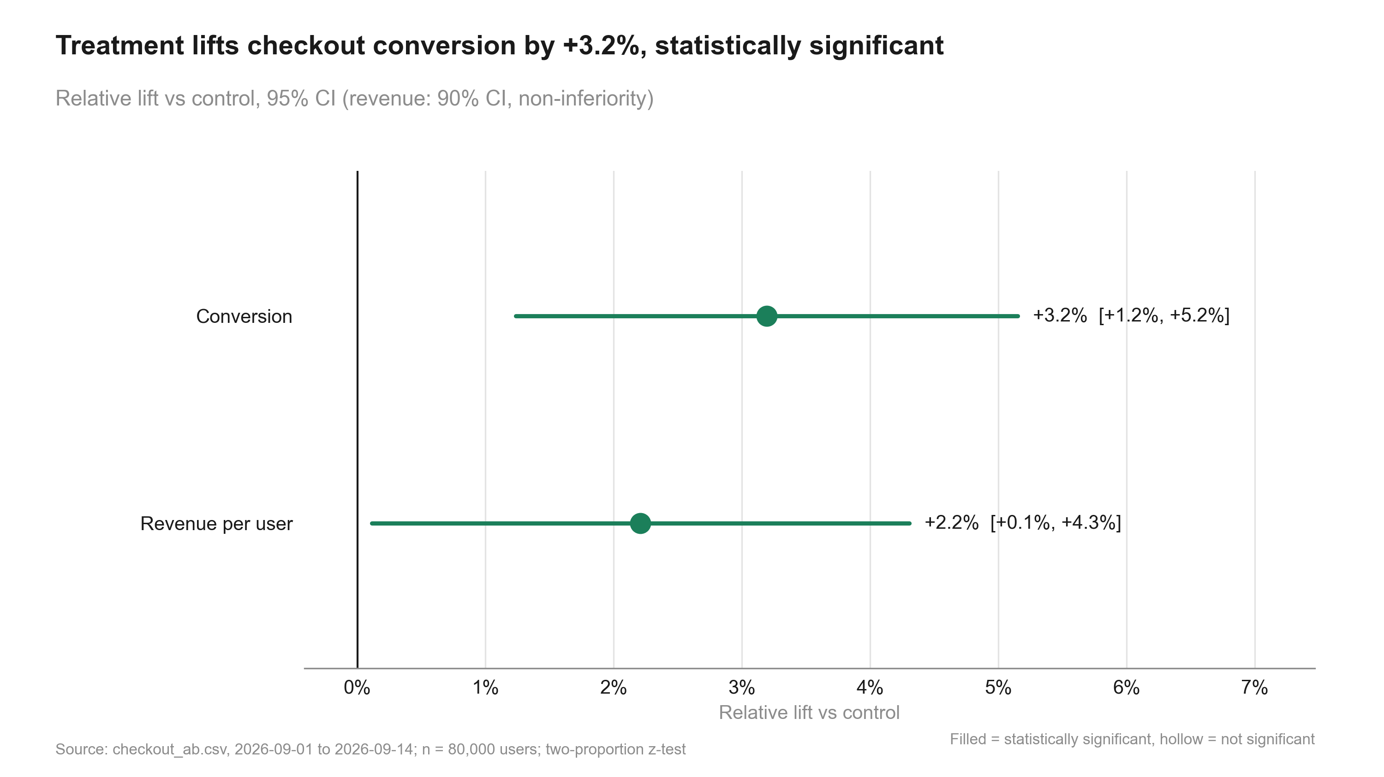
Figure 1: Treatment lifts checkout conversion by +3.2%, statistically significant.
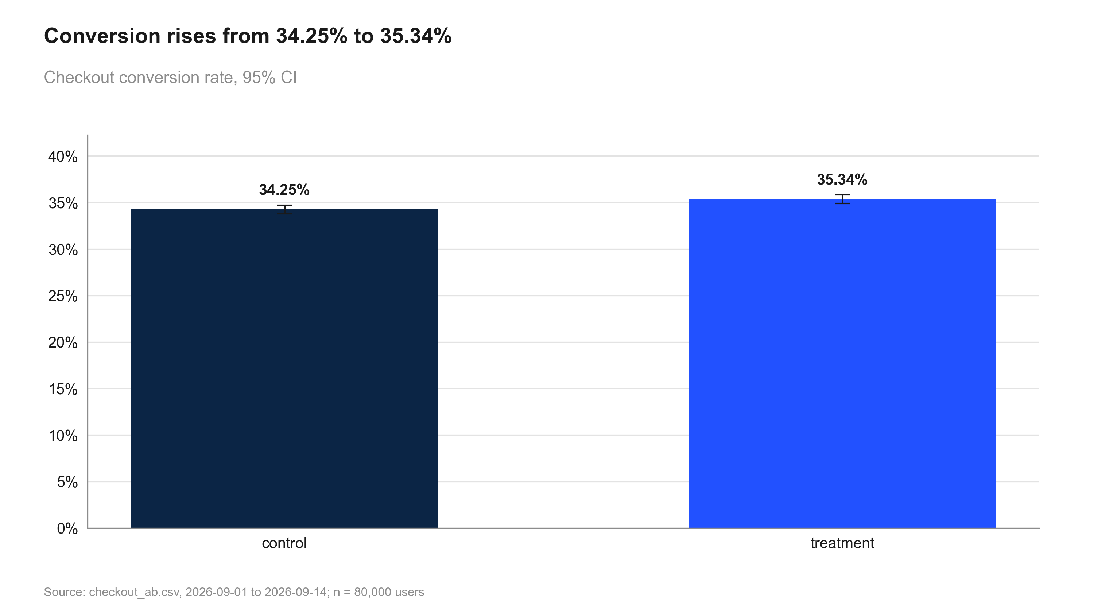
Figure 2: Conversion rises from 34.25% to 35.34%.
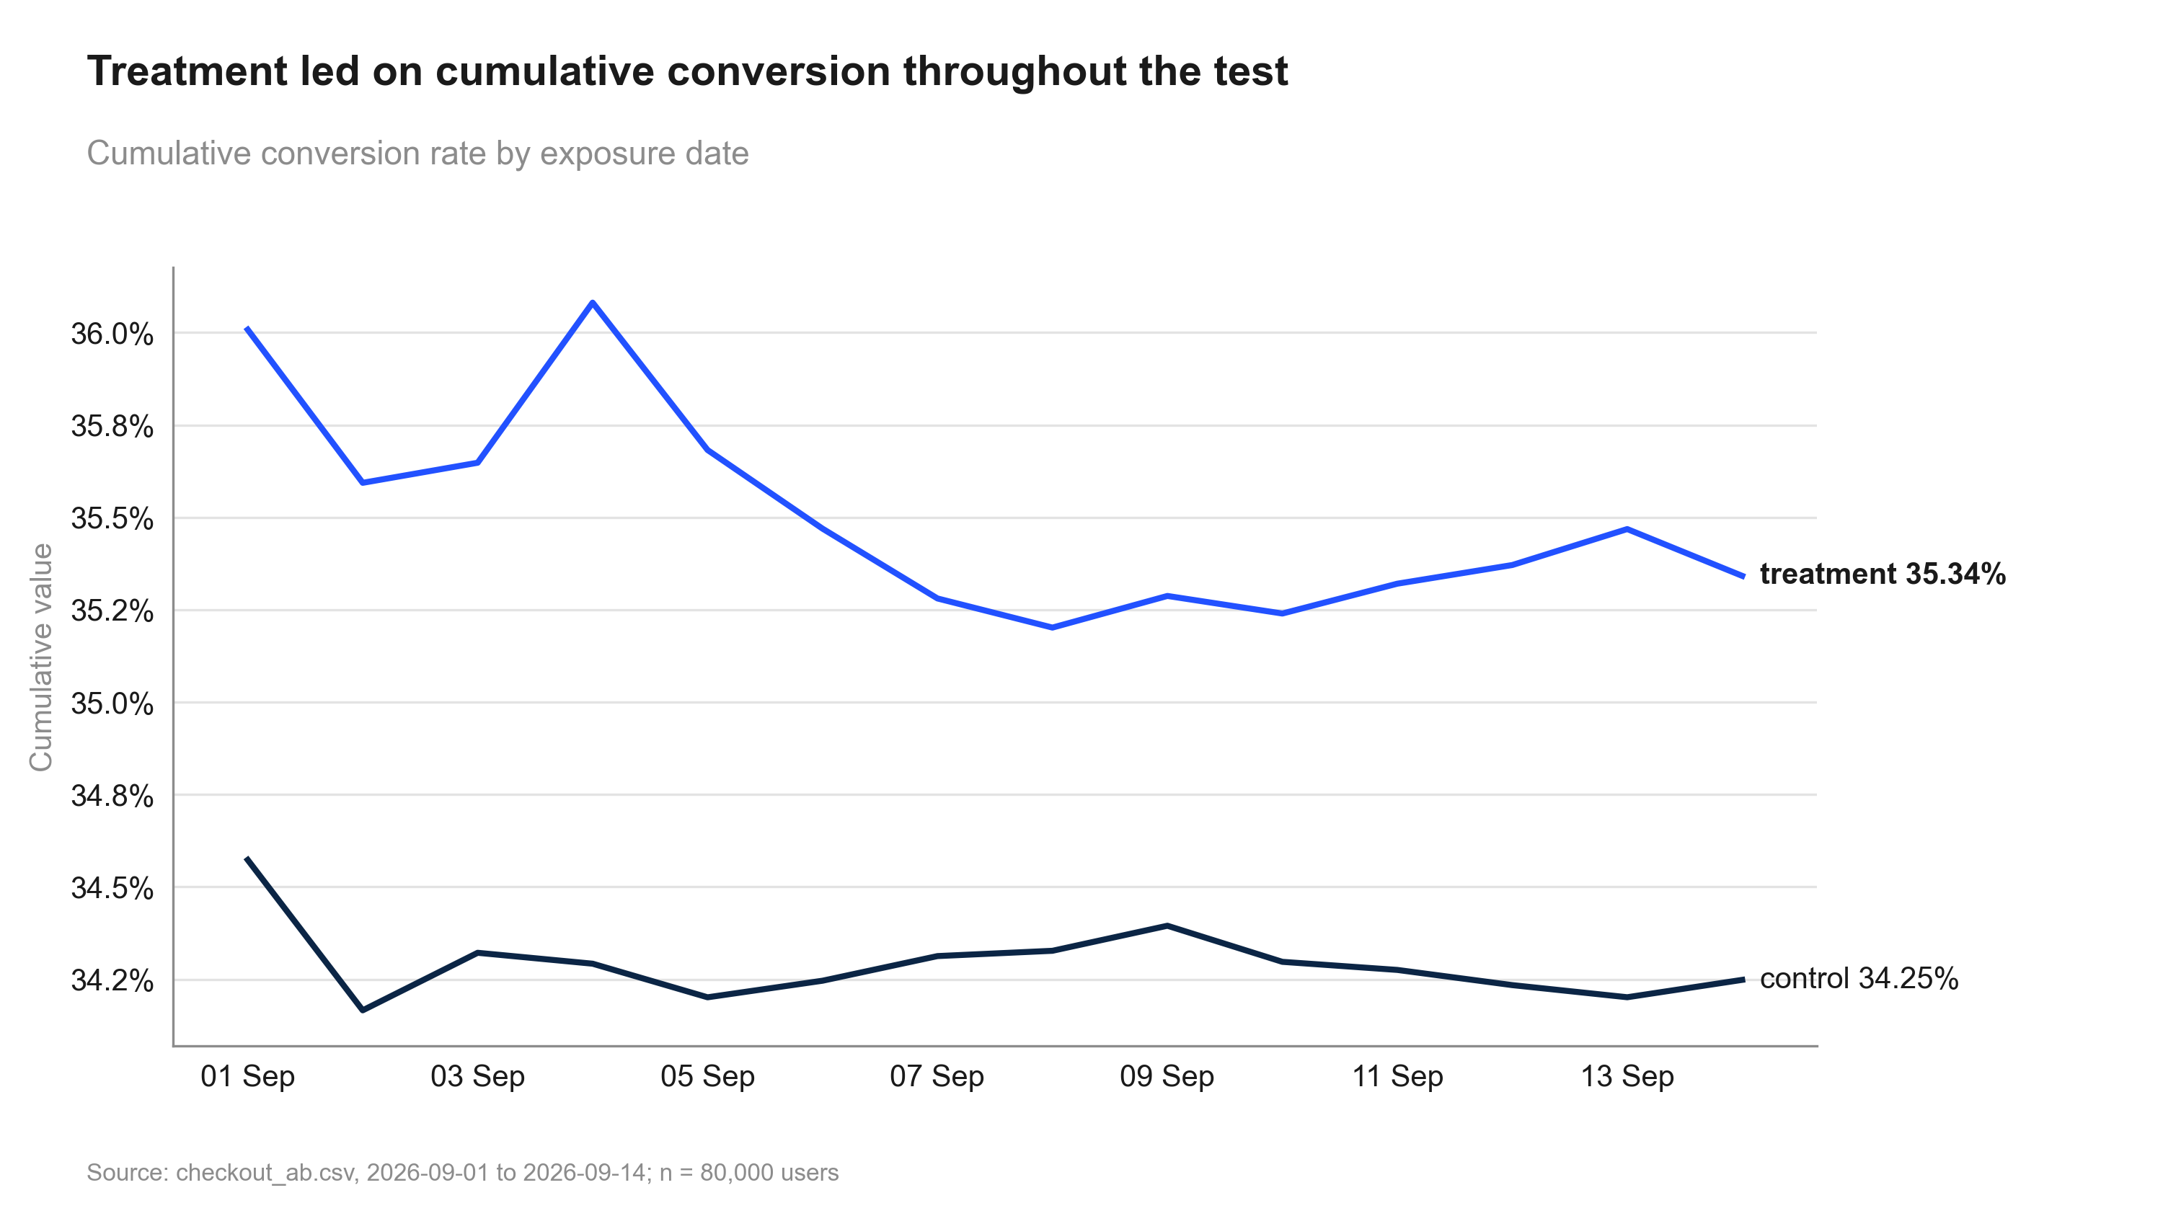
Figure 3: Treatment led on cumulative conversion throughout the test.
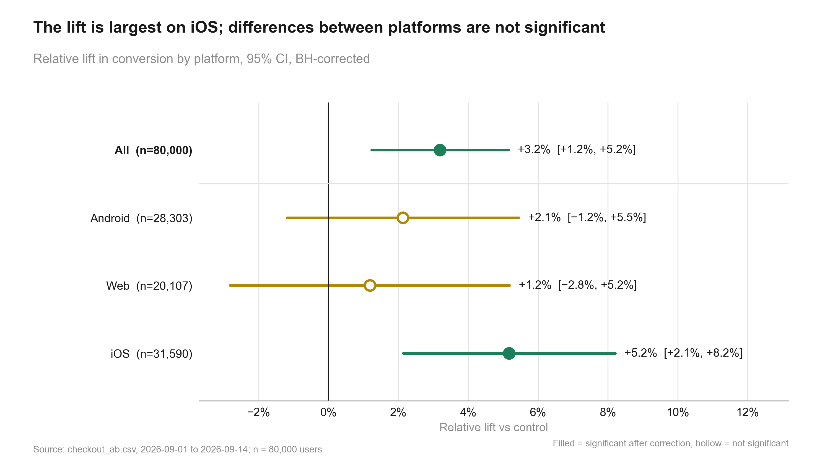
Figure 4: The lift is largest on iOS; differences between platforms are not significant.
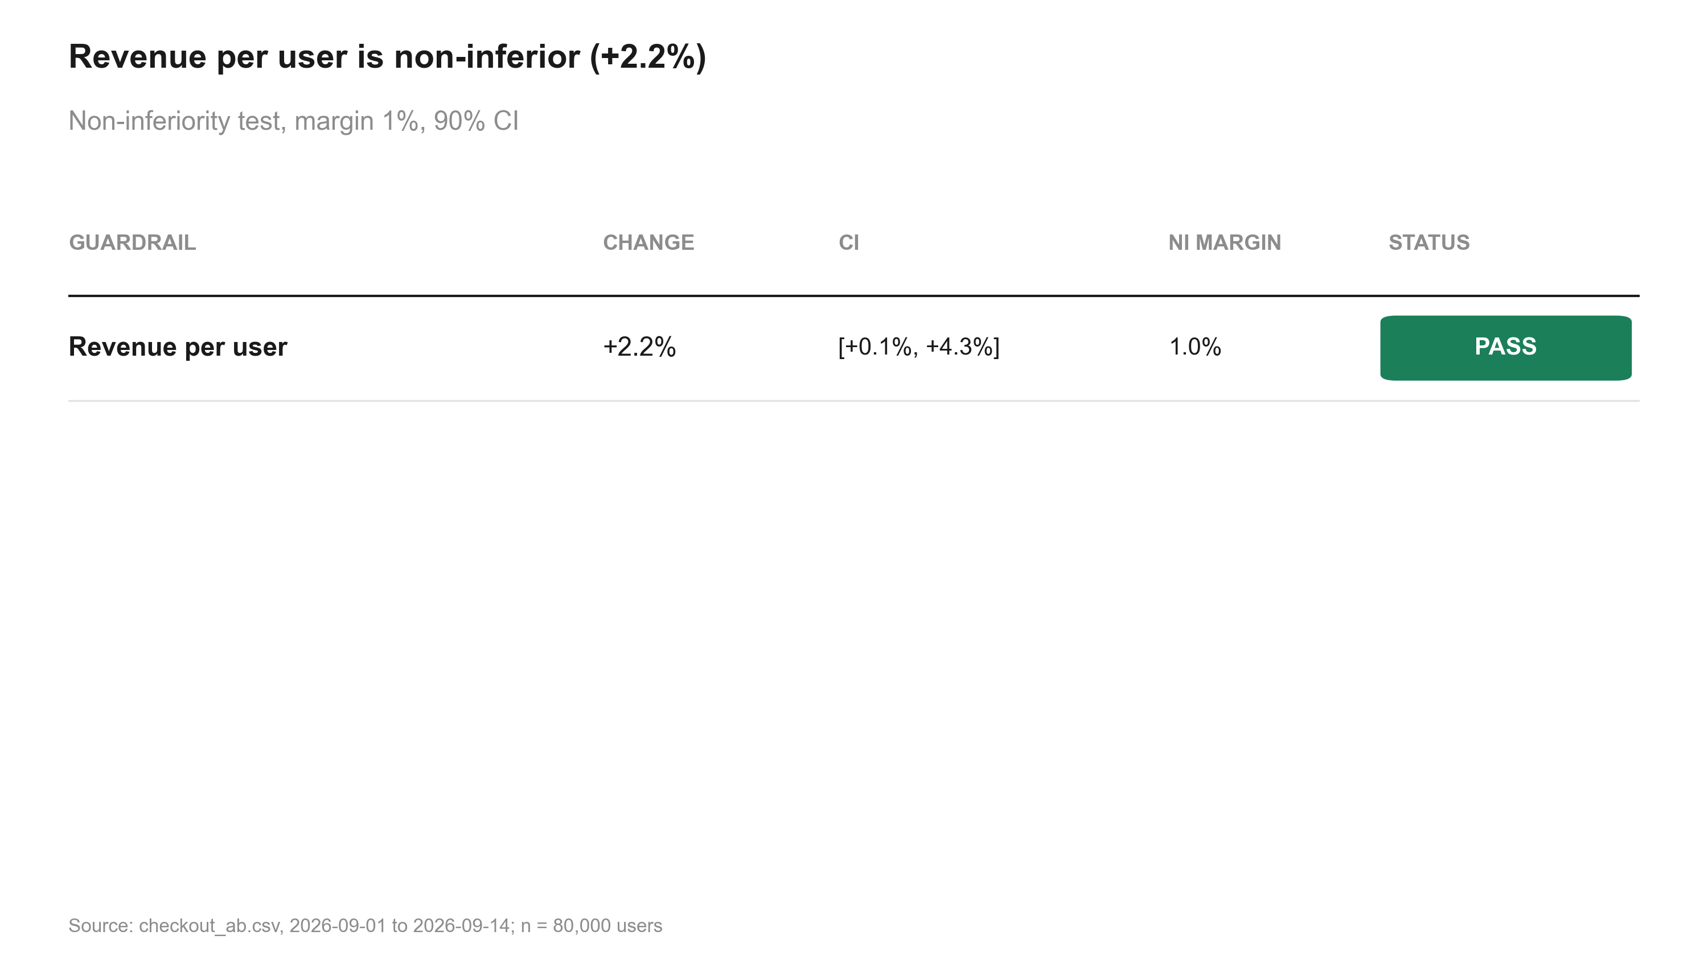
Figure 5: Revenue per user is non-inferior (+2.2%).

6. Robustness and sensitivity
Only one method was applied per metric; no cross-method comparison is available.

Distance to the decision boundaries
- Relative lift +3.2%; CI lower bound +1.2% vs the 2% practical threshold: the whole CI is not above it (the true lift may be below the threshold).
- Evidence p = 0.001 vs alpha 0.05.

What could change the conclusion
- No caveats recorded.

7. Decision log
Verbatim records (in quote style) may mention values that were later superseded; the current numbers are those in sections 1-6.

State history
Table 12: state.json history
When (UTC) | Event
2026-10-01T11:21:20+00:00 | run created

Review rounds
Review -

8. Reproducibility
Table 13: Environment
Item | Value
Python | 3.13.2
Platform | Windows-11-10.0.26200-SP0
Packages | pandas 2.3.0, numpy 2.3.0, scipy 1.15.3, statsmodels 0.15.0, matplotlib 3.10.5, python-pptx 1.0.2, python-docx 1.2.0, PyYAML 6.0.2
abkit | 0.1.0
results.json schema | 1
Seeds | bootstrap seed 42 (10000 resamples); Bayesian draws seed 42 (abkit default)

Table 14: Code index
Script | Purpose | Writes results for

How to rerun
From the repository root, in this order (the plan_gate hook requires the run's gates to be open for 20_-50_ scripts):
Then check every printed number against results.json:
python -m abkit.tracecheck 2026-10-01_checkout-sample
Table 15: Run artefacts
Artefact | Size
charts/cumulative_daily.png | 189.9 KB
charts/guardrail_scorecard.png | 98.3 KB
charts/lift_ci.png | 138.8 KB
charts/manifest.json | 3.0 KB
charts/metric_by_variant.png | 110.6 KB
charts/segment_forest.png | 170.2 KB
context.md | 0.7 KB
data/checkout_ab.csv | 3,447.5 KB
intake.md | 0.2 KB
results.json | 29.0 KB
review.md | 0.1 KB
state.json | 2.8 KB

