Technical report: Single-button checkout test
Companion to summary.docx: how the result was obtained, for data scientists
Source: checkout_ab.csv, 2026-09-01 to 2026-09-14; run 2026-10-01_checkout-button

1. Technical summary
Verdict: Ship. The primary metric improved significantly and no guardrail was breached.
Headline: Treatment raises checkout conversion by 3.2% vs control (statistically significant)
Decision rule (abkit.decision.recommend): ship if the primary metric is significantly better and the relative lift is at least the practical threshold with no guardrail breach; don't ship if it is significantly worse or a guardrail is breached (iterate if the primary also won); iterate if significant but below the threshold, or if not significant with the CI excluding the threshold; otherwise extend (inconclusive). Bayesian results use P(beat) against 0.95.
Table 1: Primary estimate
Step | Metric | Segment | Method | Estimate [CI] | Relative lift [CI] | Evidence | n
primary_test | converted |  | two proportion ztest | 0.0109 [0.0023, 0.0196] | +3.2% [+0.6%, +5.8%] | p = 0.001 | control: 40,183 / treatment: 39,817

Caveats
- CI lower bound +0.6% is below the 2% threshold: the true lift may be smaller than needed (review finding 1).
- Platforms: iOS +5.2%, Web +1.2%; interaction p = 0.168, no evidence they differ.
- Revenue is heavy-tailed; bootstrap CI [−1.0%, +5.4%] agrees with the guardrail pass.
- Daily lift: stable (no significant trend) (p = 0.794).

2. Problem framing and design
Business question: Should we ship the single-button ("Pay now") checkout to all users?
Formal hypotheses for the primary metric:
H0: p_T = p_C H1: p_T != p_C (two-sided, alpha = 0.01)
Table 2: Design
Item | Value
Problem types | post_test_readout, guardrail_check, heterogeneous_effects, novelty_check
Period | 2026-09-01 to 2026-09-14

Table 3: Metrics
Metric | Label | Role | Type | Direction | Threshold / margin (rel.)
converted | checkout conversion | primary | binary | increase | 0.02
revenue | revenue per user | guardrail | continuous | no_decrease | 0.01

Table 4: Statistical settings used
Setting | Value
alpha | 0.01
sidedness | two-sided
power | 0.8
confidence_level | 0.95
correction_primary | none
correction_secondary | holm
correction_segments | benjamini-hochberg
srm_test | chi-square
srm_threshold | 0.001
min_days | 7
prefer_full_weeks | True
bayes_prior | weakly_informative
bayes_decision_threshold | 0.95
bootstrap_n_resamples | 10000
bootstrap_seed | 42
noninferiority_margin_relative | 0.01

- alpha: 0.05 -> 0.01 (2026-09-30T21:00:57+00:00)

3. Data and validation
Table 5: Data lineage (the original file is never modified)
Item | Value
Original file | D:\VS-Code\AB-Testing\demo_data\checkout_ab.csv
Run copy (analysed) | data/checkout_ab.csv
SHA-256 of run copy | 22b6ed6b100df60f65c6a42a2b0bab071de9563d4e4e027aeed38548ed153567
Shape | 7 columns, 80,000 rows

Validation verdict: overall PASS (script code/10_validate_profile.py). Outliers are reported, never removed automatically.
Table 6: Validation checks
Check | Verdict | Detail
schema | PASS | 7 columns, 80,000 rows
dtypes | PASS | All metric columns numeric
missing values | PASS | No missing values
duplicates | PASS | 80,000 units, one row each
contamination | PASS | No unit appears in more than one variant
variants | PASS | Counts {'control': 40183, 'treatment': 39817}
SRM | PASS | p = 0.196 (threshold 0.001)
dates | PASS | 2026-09-01 to 2026-09-14 (14 days)
outliers | PASS | No extreme outliers in continuous metrics
impossible values | PASS | Metric values within valid ranges
pre-period data | PASS | None described (CUPED not possible)
covariate balance | PASS | Segment mix similar across variants

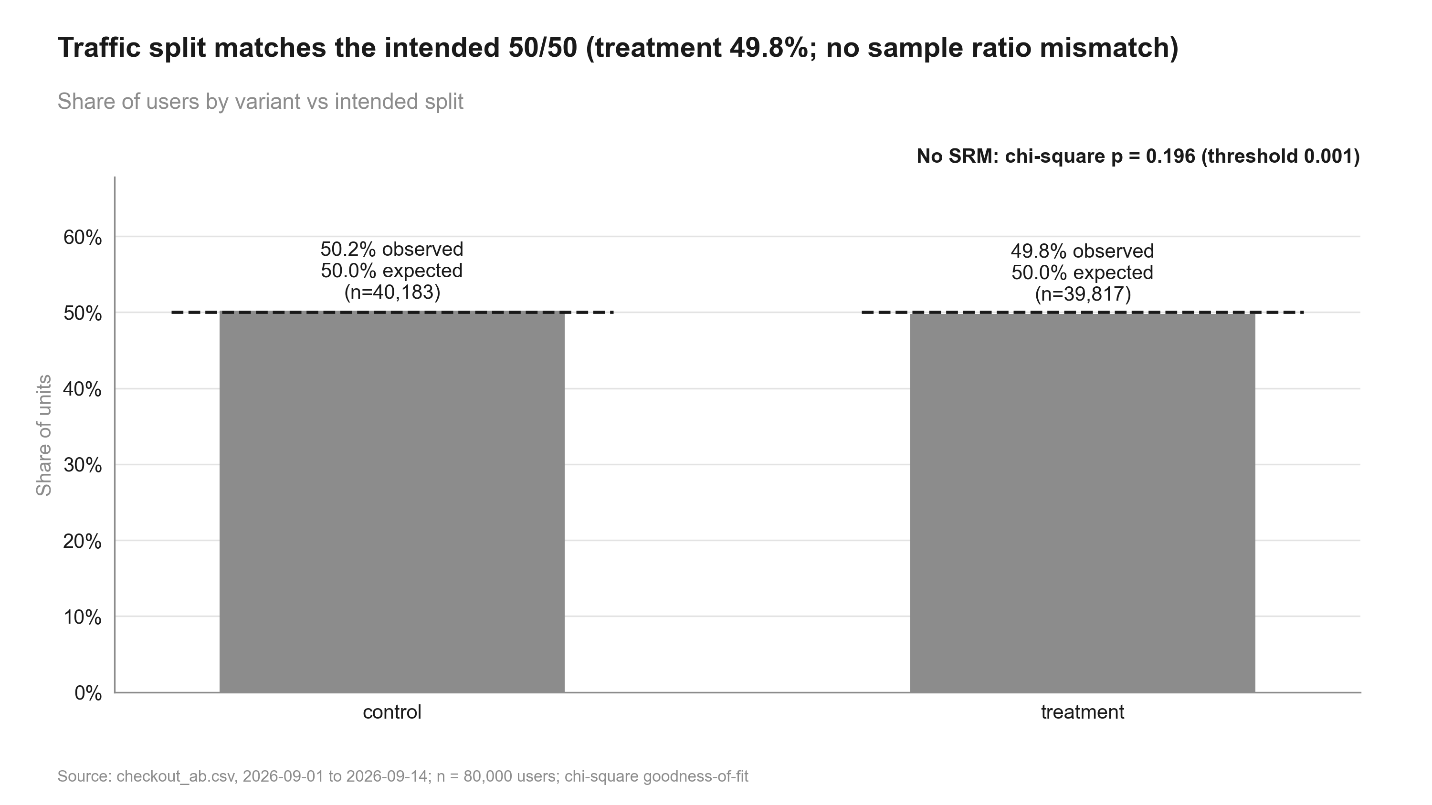
Figure 1: Traffic split matches the intended 50/50 (treatment 49.8%; no sample ratio mismatch). Share of users by variant vs intended split

4. Methods, step by step

validate: validation.full_profile (done)
Why (plan): schema, duplicates, contamination, dates, outliers before any estimate
Script: code/10_validate_profile.py
Data validation profile: Schema, dtypes, missing values, duplicates, contamination, variants, SRM, dates, outliers, impossible values, pre-period data, covariate balance.
pass / warn / block per check. Assumptions: None. Reference: abkit.validation.full_profile.

srm: validation.srm_check (done)
Why (plan): 50/50 intended split; SRM would invalidate the comparison
Script: code/10_validate_profile.py
Sample ratio mismatch test: Chi-square goodness of fit of unit counts against the intended split.
chi2 = sum_v (n_v - N s_v)^2 / (N s_v), s_v = intended share; SRM if p < threshold (default 0.001)
Asymptotic chi-square. Assumptions: Counts of randomisation units. Reference: abkit.validation.srm_check.
Settings applied: alpha 0.001; sidedness n/a; correction none.

primary_test: frequentist.two_proportion_ztest (done)
Why (plan): binary unit-level primary metric; no correction (single primary)
Script: code/20_analysis_primary_test.py
Two-proportion z-test: Compares conversion rates between two independent groups of randomisation units.
p_hat = x / n per group; diff = p_T - p_C
z = diff / sqrt( p_pool (1 - p_pool) (1/n_C + 1/n_T) ), p_pool = (x_C + x_T) / (n_C + n_T)
CI(diff) = diff +/- z_crit * sqrt( p_C(1-p_C)/n_C + p_T(1-p_T)/n_T ) (unpooled)
rel = p_T/p_C - 1; Var(rel) ~ se_T^2/p_C^2 + p_T^2 se_C^2/p_C^4 (delta method)
Pooled SE for the test, unpooled SE for the CI; one-sided tests use a (1 - 2 alpha) two-sided CI. Assumptions: Independent units (one row per randomisation unit); at least 10 successes and failures per group. Reference: abkit.frequentist.two_proportion_ztest; ab-methods/frequentist_tests.md.
Settings applied: alpha 0.01; sidedness two-sided; correction none.
Table 7: Assumptions checked in step primary_test
Assumption | Status | Detail
independent units (one row per randomisation unit) | NOT CHECKED | verify in validation
normal approximation: >= 10 successes and failures per group | PASS | min cell = 13762

guardrail_revenue: frequentist.noninferiority_test (done)
Why (plan): revenue per user must not fall more than 1% (one-sided, 90% CI)
Script: code/20_analysis_guardrail_revenue.py
Non-inferiority test (guardrail): Tests that the treatment is not worse than control by more than a pre-agreed relative margin m.
H0: diff <= -m * mean_C (no_decrease) vs H1: diff > -m * mean_C
z = (diff + m * mean_C) / se; one-sided p = 1 - Phi(z); CI at 1 - 2 alpha
status: pass if p < alpha; breach if the whole CI is beyond the margin; else inconclusive
One-sided normal test. Assumptions: Normal approximation for the difference. Reference: abkit.frequentist.noninferiority_test; ab-methods/guardrails.md.
Settings applied: alpha 0.01; sidedness one-sided; correction none.
Table 8: Assumptions checked in step guardrail_revenue
Assumption | Status | Detail
normal approximation for the difference | NOT CHECKED

- Non-inferiority margin 1.0% relative (no_decrease); CI at 98%.

revenue_sensitivity: frequentist.bootstrap_diff (done)
Why (plan): heavy-tailed revenue: confirm the Welch-based CI with a bootstrap
Script: code/20_analysis_revenue_sensitivity.py
Percentile bootstrap: Resamples units with replacement within each group to get the sampling distribution of the difference.
for b = 1..B: diff_b = stat(resample_T) - stat(resample_C)
CI = [quantile(diff_b, alpha/2), quantile(diff_b, 1 - alpha/2)]; p = 2 min(P(diff_b <= 0), P(diff_b >= 0))
Non-parametric; used as a robustness check for heavy-tailed metrics. Assumptions: Independent units; the sample represents the population. Reference: abkit.frequentist.bootstrap_diff.
Welch's t-test: Compares means of a continuous or count metric without assuming equal variances.
diff = mean_T - mean_C; se = sqrt( s_T^2/n_T + s_C^2/n_C )
t = diff / se; df = se^4 / ( (s_T^2/n_T)^2/(n_T-1) + (s_C^2/n_C)^2/(n_C-1) ) (Welch-Satterthwaite)
CI(diff) = diff +/- t_crit(df) * se; relative CI by the delta method
Large-sample t inference on the difference in means. Assumptions: Independent units; approximately normal sampling distribution of the mean (CLT; skew checked). Reference: abkit.frequentist.welch_ttest; ab-methods/frequentist_tests.md.
Percentile bootstrap: Resamples units with replacement within each group to get the sampling distribution of the difference.
for b = 1..B: diff_b = stat(resample_T) - stat(resample_C)
CI = [quantile(diff_b, alpha/2), quantile(diff_b, 1 - alpha/2)]; p = 2 min(P(diff_b <= 0), P(diff_b >= 0))
Non-parametric; used as a robustness check for heavy-tailed metrics. Assumptions: Independent units; the sample represents the population. Reference: abkit.frequentist.bootstrap_diff.
Settings applied: alpha 0.01; sidedness two-sided; correction none.
Table 9: Assumptions checked in step revenue_sensitivity
Assumption | Status | Detail
independent units | NOT CHECKED | verify in validation
sampling distribution of the mean ~ normal (CLT) | PASS | n = 40,183/39,817, max |skew| = 2.7
independent units; sample represents population | NOT CHECKED

segments_platform: segments.segment_effects (done)
Why (plan): platform pre-specified; BH across segments; the interaction test decides whether effects differ
Script: code/20_analysis_segments_platform.py
Two-proportion z-test: Compares conversion rates between two independent groups of randomisation units.
p_hat = x / n per group; diff = p_T - p_C
z = diff / sqrt( p_pool (1 - p_pool) (1/n_C + 1/n_T) ), p_pool = (x_C + x_T) / (n_C + n_T)
CI(diff) = diff +/- z_crit * sqrt( p_C(1-p_C)/n_C + p_T(1-p_T)/n_T ) (unpooled)
rel = p_T/p_C - 1; Var(rel) ~ se_T^2/p_C^2 + p_T^2 se_C^2/p_C^4 (delta method)
Pooled SE for the test, unpooled SE for the CI; one-sided tests use a (1 - 2 alpha) two-sided CI. Assumptions: Independent units (one row per randomisation unit); at least 10 successes and failures per group. Reference: abkit.frequentist.two_proportion_ztest; ab-methods/frequentist_tests.md.
Treatment x segment interaction test: Joint Wald test that the absolute treatment effect is equal in every segment.
Y = b0 + b1 T + sum_s g_s S_s + sum_s d_s (T x S_s) + e (OLS, HC1); H0: all d_s = 0
Wald chi-square; the stored 'estimate' is the test statistic, not an effect. Assumptions: Linear probability model for binary metrics. Reference: abkit.segments.interaction_test.
Simpson's paradox check: Compares the pooled difference with a segment-standardised difference.
standardised = sum_s w_s (mean_T,s - mean_C,s), w_s = overall segment share; flag if signs differ
Descriptive diagnostic. Assumptions: None. Reference: abkit.segments.simpsons_check.
Settings applied: alpha 0.01; sidedness two-sided; correction none, benjamini-hochberg.
Table 10: Assumptions checked in step segments_platform
Assumption | Status | Detail
independent units (one row per randomisation unit) | NOT CHECKED | verify in validation
normal approximation: >= 10 successes and failures per group | PASS | min cell = 4739

- benjamini-hochberg correction across 3 tests (alpha 0.01).
- Tests heterogeneity of the absolute effect; no evidence the effect differs by segment.
- Pooled and segment-standardised effects agree in direction.

time_trends: time_effects.cumulative_effects (done)
Why (plan): visible UI change: rule out a novelty spike
Script: code/20_analysis_time_trends.py
Novelty / primacy trend test: Inverse-variance weighted regression of per-period lift on period index.
lift_t = a + b t + e, weights 1/se_t^2; decaying (novelty) if b is significant and opposite in sign to the lift
WLS t-test on b. Assumptions: Enough units per period. Reference: abkit.time_effects.trend_test.
Settings applied: alpha 0.01; sidedness n/a; correction none.
- Slope of rel_lift per period; pattern: stable (no significant trend).

summary: decision.build_summary (done)
Why (plan): verdict against the 2% threshold and guardrail status
Decision rule and summary: Turns the primary result and guardrail statuses into a verdict.
significantly worse -> don't ship; guardrail breach -> don't ship (iterate if the primary won)
significantly better and rel. lift >= threshold -> ship; significant but < threshold -> iterate
not significant: CI excludes the threshold -> iterate; otherwise -> extend (inconclusive)
Bayesian primary: P(beat) >= threshold counts as significantly better
Deterministic rule applied to stored results. Assumptions: A practical threshold agreed at intake. Reference: abkit.decision.recommend / build_summary; ab-methods/interpretation_and_decisions.md.

5. Results
Table 11: All effect estimates
Step | Metric | Segment | Method | Estimate [CI] (abs.) | Relative [CI] | Evidence | n
primary_test | converted |  | two proportion ztest | 0.0109 [0.0023, 0.0196] | +3.2% [+0.6%, +5.8%] | p = 0.001 | control: 40,183 / treatment: 39,817
guardrail_revenue | revenue |  | noninferiority test | 0.5021 [−0.1639, 1.17] | +2.2% [−0.8%, +5.2%] | p = 0.005 | control: 40,183 / treatment: 39,817
revenue_sensitivity | revenue |  | welch ttest | 0.5021 [−0.2353, 1.24] | +2.2% [−1.1%, +5.5%] | p = 0.079 | control: 40,183 / treatment: 39,817
revenue_sensitivity | revenue |  | bootstrap mean diff | 0.5021 [−0.2300, 1.21] | +2.2% [−1.0%, +5.4%] | p = 0.082 | control: 40,183 / treatment: 39,817
segments_platform | converted | Android | two proportion ztest | 0.0071 [−0.0073, 0.0216] | +2.1% [−2.2%, +6.5%] | p = 0.306 (adj., benjamini-hochberg) | control: 14,134 / treatment: 14,169
segments_platform | converted | Web | two proportion ztest | 0.0039 [−0.0132, 0.0209] | +1.2% [−4.1%, +6.4%] | p = 0.561 (adj., benjamini-hochberg) | control: 10,210 / treatment: 9,897
segments_platform | converted | iOS | two proportion ztest | 0.0186 [0.0046, 0.0326] | +5.2% [+1.2%, +9.2%] | p = 0.002 (adj., benjamini-hochberg) | control: 15,839 / treatment: 15,751

Table 12: Diagnostic tests
Step | Test | Statistic / estimate | Evidence | Interpretation
srm | srm check | 0.0023 | p = 0.196
segments_platform | interaction test | 3.57 | p = 0.168 | Tests heterogeneity of the absolute effect; no evidence the effect differs by segment.
segments_platform | simpsons check | 0.0108 | n/a | Pooled and segment-standardised effects agree in direction.
time_trends | trend test | −0.0007 | p = 0.794 | Slope of rel_lift per period; pattern: stable (no significant trend).

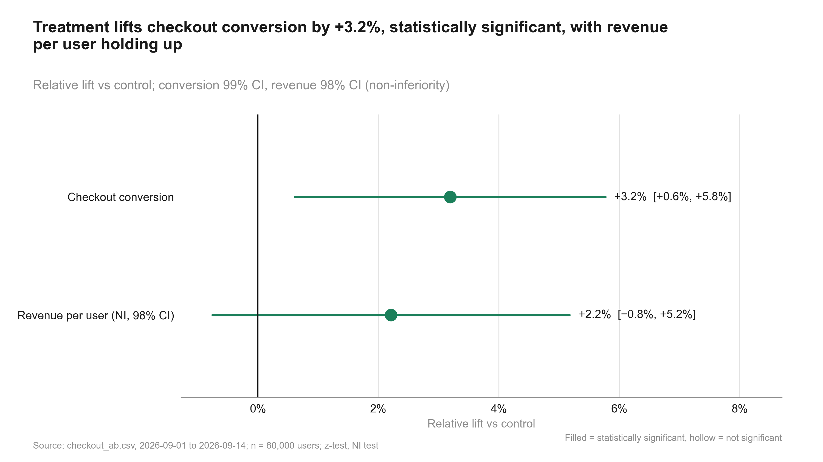
Figure 2: Treatment lifts checkout conversion by +3.2%, statistically significant, with revenue per user holding up. Relative lift vs control
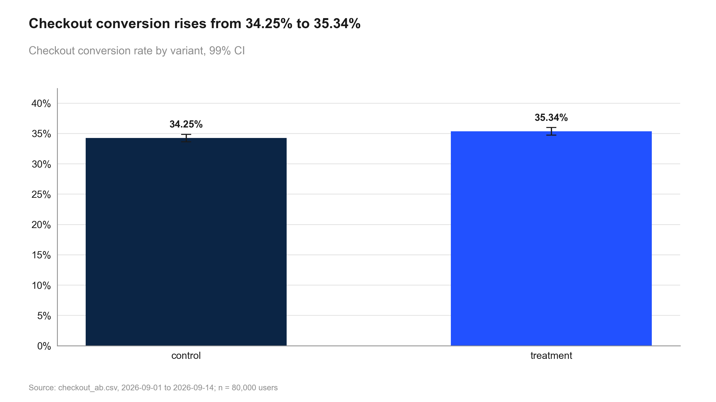
Figure 3: Checkout conversion rises from 34.25% to 35.34%. Checkout conversion rate by variant, 99% CI
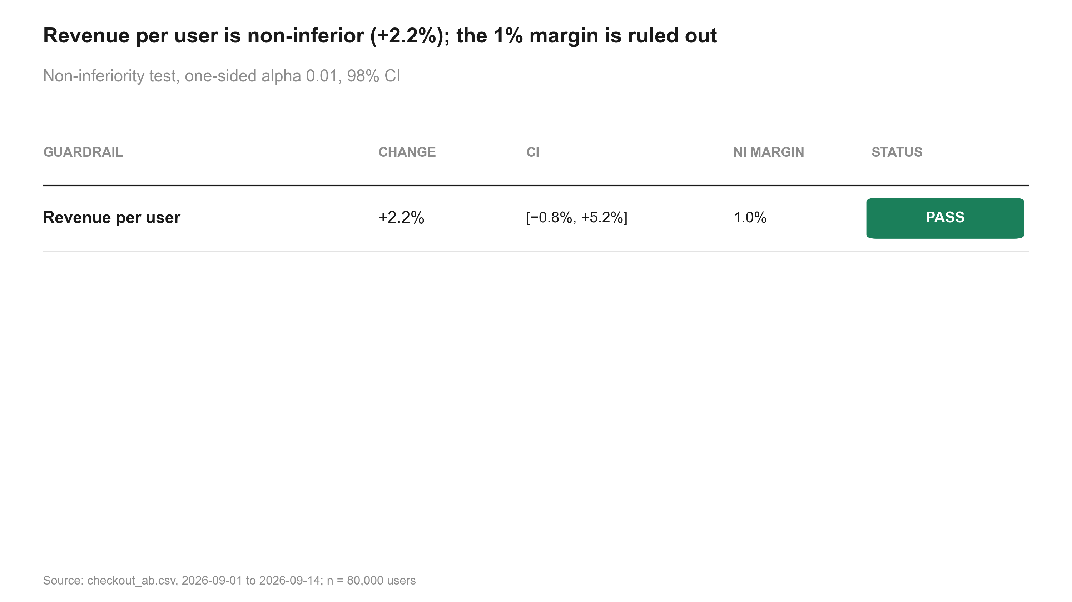
Figure 4: Revenue per user is non-inferior (+2.2%); the 1% margin is ruled out. Non-inferiority test
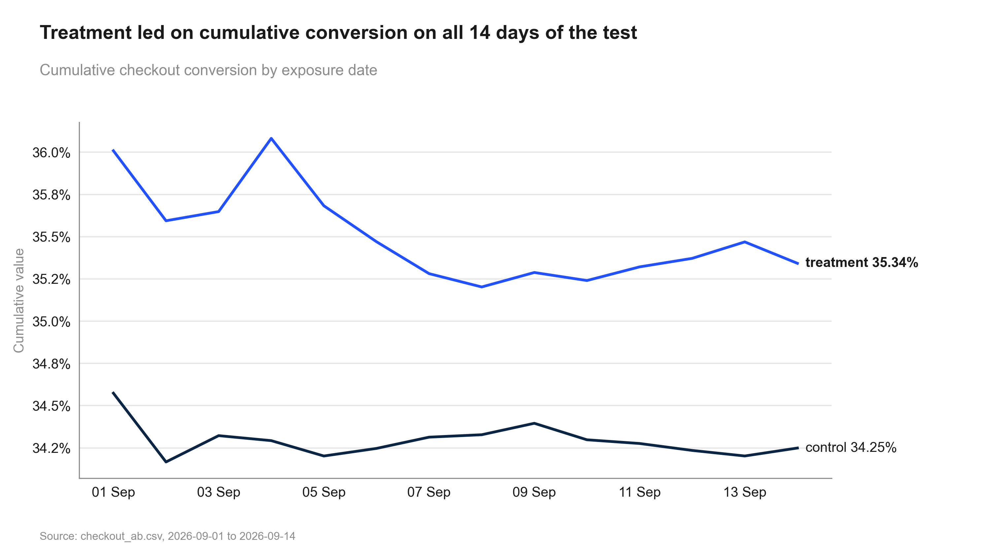
Figure 5: Treatment led on cumulative conversion on all 14 days of the test. Cumulative conversion by exposure date
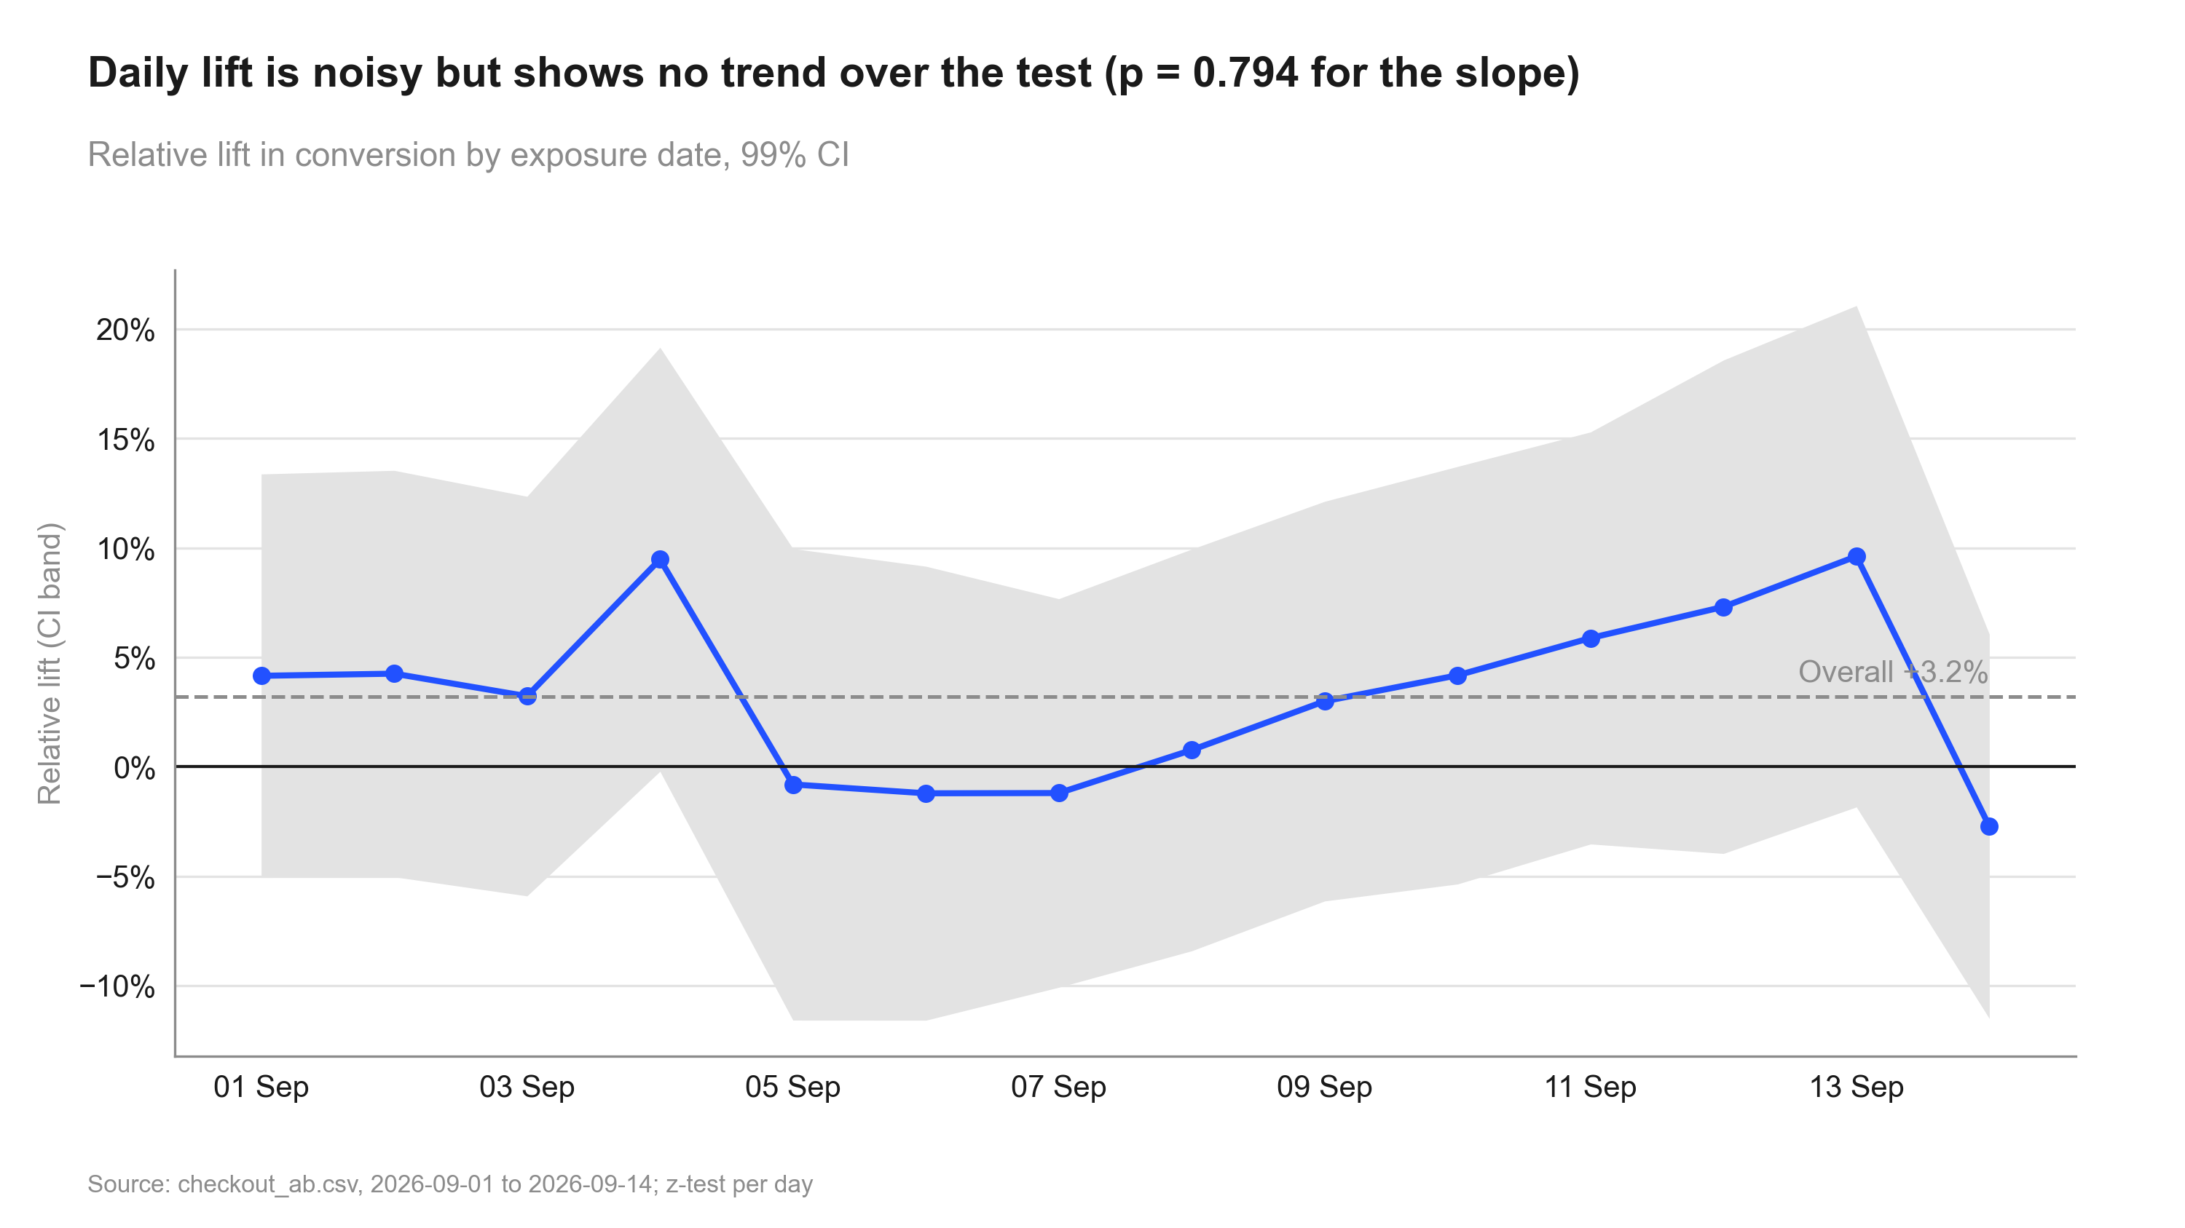
Figure 6: Daily lift is noisy but shows no trend over the test (p = 0.794 for the slope). Daily relative lift
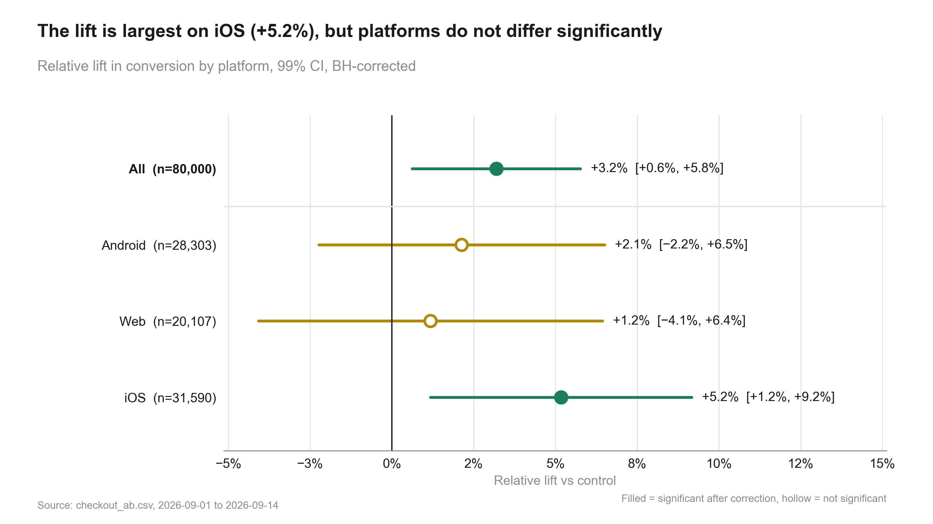
Figure 7: The lift is largest on iOS (+5.2%), but platforms do not differ significantly. Lift by platform

6. Robustness and sensitivity
Table 13: revenue: the same metric across methods
Step | Metric | Segment | Method | Estimate [CI] (abs.) | Relative [CI] | Evidence | n
guardrail_revenue | revenue |  | noninferiority test | 0.5021 [−0.1639, 1.17] | +2.2% [−0.8%, +5.2%] | p = 0.005 | control: 40,183 / treatment: 39,817
revenue_sensitivity | revenue |  | welch ttest | 0.5021 [−0.2353, 1.24] | +2.2% [−1.1%, +5.5%] | p = 0.079 | control: 40,183 / treatment: 39,817
revenue_sensitivity | revenue |  | bootstrap mean diff | 0.5021 [−0.2300, 1.21] | +2.2% [−1.0%, +5.4%] | p = 0.082 | control: 40,183 / treatment: 39,817

Distance to the decision boundaries
- Relative lift +3.2%; CI lower bound +0.6% vs the 2% practical threshold: the whole CI is not above it (the true lift may be below the threshold).
- Evidence p = 0.001 vs alpha 0.01.

What could change the conclusion
- CI lower bound +0.6% is below the 2% threshold: the true lift may be smaller than needed (review finding 1).
- Platforms: iOS +5.2%, Web +1.2%; interaction p = 0.168, no evidence they differ.
- Revenue is heavy-tailed; bootstrap CI [−1.0%, +5.4%] agrees with the guardrail pass.
- Daily lift: stable (no significant trend) (p = 0.794).

7. Decision log
Verbatim records (in quote style) may mention values that were later superseded; the current numbers are those in sections 1-6.

Intake questions and answers
Already answered by the description or the data (not asked): variants (control / treatment), 50/50 split,
user-level randomisation, one row per user, primary metric conversion, guardrail revenue per user, dates
2026-09-01 to 2026-09-14 (14 days = 2 full weeks), platform and country columns.
Asked:
1. Practical threshold. What is the smallest conversion lift worth shipping? [2% relative] -> "2% is fine."
2. Guardrail margin. How much can revenue per user drop before it matters? [1% relative, the default] -> "1%."
3. Segments. Platform is pre-specified. Is country also a decision segment, or exploratory? [exploratory] -> "Platform only; skip country."
4. Peeking. Was the test checked and possibly stopped early, or run to its planned 14 days? [planned 14 days] -> "Ran the full two weeks, nobody stopped it."
5. Incidents. Any outages, campaigns or logging changes during 1-14 Sep? [none] -> "None that we know of."
6. Revenue outliers. Any agreed capping of revenue? [no capping; bootstrap sensitivity] -> "No capping."
7. Statistical defaults (table shown: alpha 0.05 two-sided, power 0.80, corrections none/holm/BH, SRM p < 0.001,
bootstrap 10,000, NI margin 1%) -> "Keep them."
8. Depth. Deck for the product team, standard readout? [standard] -> "Standard, with an appendix."

User decisions at gates
Decision to be made: Ship / don't ship the single-button checkout; whether a platform-specific rollout is needed.

State history
Table 14: state.json history
When (UTC) | Event
2026-09-30T20:46:09+00:00 | run created
2026-09-30T20:47:22+00:00 | gate plan_approved = True
2026-09-30T20:47:22+00:00 | phase -> validation
2026-09-30T20:47:45+00:00 | gate validation_passed = True
2026-09-30T20:47:45+00:00 | phase -> analysis
2026-09-30T20:49:26+00:00 | phase -> review
2026-09-30T20:49:57+00:00 | gate review_passed = False
2026-09-30T20:50:16+00:00 | gate review_passed = True
2026-09-30T20:50:17+00:00 | phase -> deliverables
2026-09-30T20:53:00+00:00 | phase -> done
2026-09-30T21:00:57+00:00 | setting alpha: 0.05 -> 0.01
2026-09-30T21:00:57+00:00 | reset to analysis
2026-09-30T21:01:28+00:00 | phase -> review
2026-09-30T21:01:44+00:00 | gate review_passed = True
2026-09-30T21:01:44+00:00 | phase -> deliverables
2026-09-30T21:02:03+00:00 | phase -> done

Review rounds
Review: 2026-10-01_checkout-button (round 1) - Verdict: FIXES NEEDED
#1 [fix] The summary does not say that the CI's lower bound is below the 2% practical threshold. The point estimate clears the threshold; the whole interval does not. | fix: Add a caveat that the true lift could be as low as the CI lower bound, below the threshold; keep the verdict (the recommendation rule uses the point estimate).
#2 [note] iOS is significant after BH and Android / Web are not, but the interaction test is not significant. The summary words this correctly. | fix: None. Keep the single-rollout recommendation.
#3 [note] The revenue guardrail passes with the NI test (90% CI); the two-sided Welch and bootstrap 95% CIs include 0 but stay above the -1% margin. | fix: None. Already in caveats.
Review: 2026-10-01_checkout-button (round 2) - Verdict: PASS
#1 [resolved] Caveat added: the CI lower bound is below the 2% practical threshold. | fix: none
Review: 2026-10-01_checkout-button (round 3, follow-up "rerun with alpha 0.01") - Verdict: PASS
#1 [note] At alpha 0.01 the primary result stays significant (p = 0.001) and its 99% CI [+0.6%, +5.8%] is wider; the lower bound is further below the 2% threshold, and the caveat reflects it. | fix: none
#2 [note] The revenue guardrail still passes non-inferiority at one-sided alpha 0.01 (98% CI). iOS stays significant after BH (adjusted p = 0.002). | fix: none
#3 [resolved] Chart subtitles had hard-coded "95% CI" / "90% CI"; they now derive the level from alpha (30_charts_*.py). | fix: none

8. Reproducibility
Table 15: Environment
Item | Value
Python | 3.13.2
Platform | Windows-11-10.0.26200-SP0
Packages | pandas 2.3.0, numpy 2.3.0, scipy 1.15.3, statsmodels 0.15.0, matplotlib 3.10.5, python-pptx 1.0.2, python-docx 1.2.0, PyYAML 6.0.2
abkit | 0.1.0
results.json schema | 1
Seeds | bootstrap seed 42 (10000 resamples); Bayesian draws seed 42 (abkit default)

Table 16: Code index
Script | Purpose | Writes results for
10_validate_profile.py | Validate checkout_ab.csv against context.md and intake.md; write data_profile.md and results.json validation. | srm, validation
20_analysis_guardrail_revenue.py | Guardrail: non-inferiority of revenue per user (margin from settings, one-sided). Step: guardrail_revenue. | guardrail_revenue
20_analysis_primary_test.py | Primary metric: two-proportion z-test on checkout conversion (user level). Step: primary_test. | primary_test
20_analysis_revenue_sensitivity.py | Revenue sensitivity: Welch vs percentile bootstrap for revenue per user, plus distribution data. Step: revenue_sensitivity. | revenue_sensitivity
20_analysis_segments_platform.py | Platform segments: per-platform lift (BH-corrected), interaction test, Simpson's check. Step: segments_platform. | segments_platform
20_analysis_summary.py | Decision and summary: verdict against the practical threshold and the revenue guardrail. Step: summary. | summary
20_analysis_time_trends.py | Stability over time: cumulative conversion by day, daily lift, and a trend test for novelty. Step: time_trends. | time_trends
30_charts_detail.py | Charts: cumulative and daily conversion, platform forest plot, revenue distribution (all numbers from results.json). | -
30_charts_results.py | Charts: SRM, primary lift, conversion by variant, guardrail scorecard (all numbers from results.json). | -
40_deck_build.py | Build deck.pptx from results.json, state.json (deck sections) and charts/manifest.json. | -
50_report_build.py | Build summary.docx from results.json, intake.md, review.md and charts/manifest.json. | -
50_technical_report.py | Build technical_report.docx: methods, formulas, decision log, robustness and reproducibility for data scientists. | -

How to rerun
From the repository root, in this order (the plan_gate hook requires the run's gates to be open for 20_-50_ scripts):
python runs/2026-10-01_checkout-button/code/10_validate_profile.py
python runs/2026-10-01_checkout-button/code/20_analysis_guardrail_revenue.py
python runs/2026-10-01_checkout-button/code/20_analysis_primary_test.py
python runs/2026-10-01_checkout-button/code/20_analysis_revenue_sensitivity.py
python runs/2026-10-01_checkout-button/code/20_analysis_segments_platform.py
python runs/2026-10-01_checkout-button/code/20_analysis_summary.py
python runs/2026-10-01_checkout-button/code/20_analysis_time_trends.py
python runs/2026-10-01_checkout-button/code/30_charts_detail.py
python runs/2026-10-01_checkout-button/code/30_charts_results.py
python runs/2026-10-01_checkout-button/code/40_deck_build.py
python runs/2026-10-01_checkout-button/code/50_report_build.py
python runs/2026-10-01_checkout-button/code/50_technical_report.py
Then check every printed number against results.json:
python -m abkit.tracecheck 2026-10-01_checkout-button
Run log: 30 commands logged while this run was active (2 failed); see run_log.jsonl.
Table 17: Run artefacts
Artefact | Size
charts/cumulative_daily.png | 189.3 KB
charts/daily_lift.png | 191.1 KB
charts/distribution_compare.png | 116.8 KB
charts/guardrail_scorecard.png | 110.0 KB
charts/lift_ci.png | 159.2 KB
charts/manifest.json | 6.2 KB
charts/metric_by_variant.png | 117.1 KB
charts/segment_forest.png | 169.1 KB
charts/srm_bar.png | 175.2 KB
context.md | 0.7 KB
data/checkout_ab.csv | 3,447.5 KB
data_profile.md | 1.1 KB
deck.pptx | 1,122.6 KB
deck_storyline.md | 1.8 KB
intake.md | 2.7 KB
plan.md | 2.6 KB
results.json | 50.0 KB
review.md | 3.2 KB
state.json | 4.9 KB
summary.docx | 1,077.1 KB

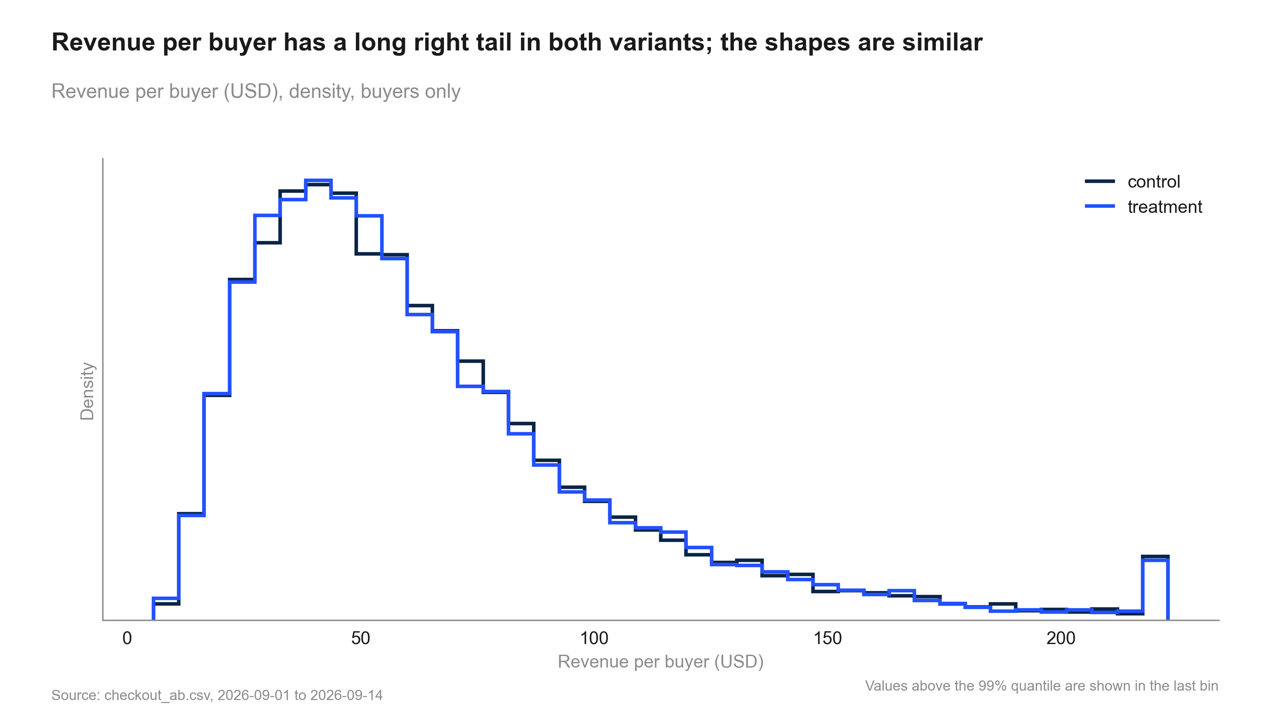
Figure 8: Revenue per buyer has a long right tail in both variants; the shapes are similar. Revenue per buyer distribution

