Technical report: Home feed redesign
Companion to summary.docx: how the result was obtained, for data scientists
Source: cuped_engagement.csv; run 2026-10-01_home-feed-redesign

1. Technical summary
Verdict: Ship. The primary metric improved significantly and by more than the practical threshold.
Headline: Treatment raises minutes per user by 1.7% vs control (statistically significant)
Decision rule (abkit.decision.recommend): ship if the primary metric is significantly better and the relative lift is at least the practical threshold with no guardrail breach; don't ship if it is significantly worse or a guardrail is breached (iterate if the primary also won); iterate if significant but below the threshold, or if not significant with the CI excluding the threshold; otherwise extend (inconclusive). Bayesian results use P(beat) against 0.95.
Table 1: Primary estimate
Step | Metric | Segment | Method | Estimate [CI] | Relative lift [CI] | Evidence | n
cuped_test | minutes |  | cuped | 1.07 [0.0372, 2.10] | +1.7% [+0.0%, +3.3%] | p = 0.042 | control: 9,902 / treatment: 10,098

Caveats
- CUPED chosen after the unadjusted result (p = 0.081) was seen; both reported.
- CI [+0.0%, +3.3%] includes lifts below the 1% threshold.
- CUPED lift +1.7% vs unadjusted +2.1%: treatment had a small pre-period head start by chance (review finding 2).
- Regression adjustment agrees: +1.7% (p = 0.042).
- No dates in the data: novelty not checked.

2. Problem framing and design
Business question: Does the redesigned home feed increase time spent in the app?
Formal hypotheses for the primary metric:
H0: mu_T = mu_C H1: mu_T != mu_C (two-sided, alpha = 0.05)
Table 2: Design
Item | Value
Problem types | cuped_reanalysis, post_test_readout
Period | not recorded

Table 3: Metrics
Metric | Label | Role | Type | Direction | Threshold / margin (rel.)
minutes | minutes per user | primary | continuous | increase | 0.01

Table 4: Statistical settings used
Setting | Value
alpha | 0.05
sidedness | two-sided
power | 0.8
confidence_level | 0.95
correction_primary | none
correction_secondary | holm
correction_segments | benjamini-hochberg
srm_test | chi-square
srm_threshold | 0.001
min_days | 7
prefer_full_weeks | True
bayes_prior | weakly_informative
bayes_decision_threshold | 0.95
bootstrap_n_resamples | 10000
bootstrap_seed | 42
noninferiority_margin_relative | 0.01

3. Data and validation
Table 5: Data lineage (the original file is never modified)
Item | Value
Original file | D:\VS-Code\AB-Testing\demo_data\cuped_engagement.csv
Run copy (analysed) | data/cuped_engagement.csv
SHA-256 of run copy | c27605ec40839b6bdb767375b83542c25ad0926a0603184fbc8f7ec8e28a1e9a
Shape | 5 columns, 20,000 rows

Validation verdict: overall PASS (script code/10_validate_profile.py). Outliers are reported, never removed automatically.
Table 6: Validation checks
Check | Verdict | Detail
schema | PASS | 5 columns, 20,000 rows
dtypes | PASS | All metric columns numeric
missing values | PASS | No missing values
duplicates | PASS | 20,000 units, one row each
contamination | PASS | No unit appears in more than one variant
variants | PASS | Counts {'treatment': 10098, 'control': 9902}
SRM | PASS | p = 0.166 (threshold 0.001)
outliers | PASS | No extreme outliers in continuous metrics
impossible values | PASS | Metric values within valid ranges
pre-period data | PASS | Available; correlations with metrics pre_minutes~minutes=0.73
covariate balance | PASS | Segment mix similar across variants

4. Methods, step by step

validate: validation.full_profile (done)
Why (plan): includes pre-period availability, correlation and balance
Script: code/10_validate_profile.py
Data validation profile: Schema, dtypes, missing values, duplicates, contamination, variants, SRM, dates, outliers, impossible values, pre-period data, covariate balance.
pass / warn / block per check. Assumptions: None. Reference: abkit.validation.full_profile.

srm: validation.srm_check (done)
Why (plan): intended 50/50
Script: code/10_validate_profile.py
Sample ratio mismatch test: Chi-square goodness of fit of unit counts against the intended split.
chi2 = sum_v (n_v - N s_v)^2 / (N s_v), s_v = intended share; SRM if p < threshold (default 0.001)
Asymptotic chi-square. Assumptions: Counts of randomisation units. Reference: abkit.validation.srm_check.
Settings applied: alpha 0.001; sidedness n/a; correction none.

naive_test: frequentist.welch_ttest (done)
Why (plan): the unadjusted result (borderline, seen before CUPED was chosen)
Script: code/20_analysis_naive_test.py
Welch's t-test: Compares means of a continuous or count metric without assuming equal variances.
diff = mean_T - mean_C; se = sqrt( s_T^2/n_T + s_C^2/n_C )
t = diff / se; df = se^4 / ( (s_T^2/n_T)^2/(n_T-1) + (s_C^2/n_C)^2/(n_C-1) ) (Welch-Satterthwaite)
CI(diff) = diff +/- t_crit(df) * se; relative CI by the delta method
Large-sample t inference on the difference in means. Assumptions: Independent units; approximately normal sampling distribution of the mean (CLT; skew checked). Reference: abkit.frequentist.welch_ttest; ab-methods/frequentist_tests.md.
Percentile bootstrap: Resamples units with replacement within each group to get the sampling distribution of the difference.
for b = 1..B: diff_b = stat(resample_T) - stat(resample_C)
CI = [quantile(diff_b, alpha/2), quantile(diff_b, 1 - alpha/2)]; p = 2 min(P(diff_b <= 0), P(diff_b >= 0))
Non-parametric; used as a robustness check for heavy-tailed metrics. Assumptions: Independent units; the sample represents the population. Reference: abkit.frequentist.bootstrap_diff.
Settings applied: alpha 0.05; sidedness two-sided; correction none.
Table 7: Assumptions checked in step naive_test
Assumption | Status | Detail
independent units | NOT CHECKED | verify in validation
sampling distribution of the mean ~ normal (CLT) | PASS | n = 9,902/10,098, max |skew| = 2.2
independent units; sample represents population | NOT CHECKED

cuped_test: variance_reduction.cuped (done)
Why (plan): pre_minutes, same metric pre-period; variance reduction ~ corr^2
Script: code/20_analysis_cuped_test.py
CUPED (variance reduction): Removes the part of the metric explained by a pre-period covariate X before comparing groups.
theta = cov(Y, X) / var(X) (pooled); Y_adj = Y - theta (X - mean(X))
Welch test on Y_adj; variance reduction ~ corr(X, Y)^2
Unbiased because X is measured before assignment; relative lift against the unadjusted control mean. Assumptions: Covariate pre-assignment and balanced across groups. Reference: abkit.variance_reduction.cuped; ab-methods/cuped.md.
Settings applied: alpha 0.05; sidedness two-sided; correction none.
Table 8: Assumptions checked in step cuped_test
Assumption | Status | Detail
independent units | NOT CHECKED | verify in validation
sampling distribution of the mean ~ normal (CLT) | PASS | n = 9,902/10,098, max |skew| = 1.8
covariate measured before assignment (unaffected by treatment) | NOT CHECKED | pre_minutes: confirm it is pre-period
covariate balanced across variants | PASS | mean 63.6 vs 64

- CUPED chosen after the unadjusted result was seen (not pre-registered); both are reported.

regression_check: variance_reduction.regression_adjustment (done)
Why (plan): sensitivity: Lin (2013) adjustment, HC2 SEs
Script: code/20_analysis_regression_check.py
Regression adjustment (Lin 2013): OLS of Y on treatment, centred covariates and their interactions.
Y = b0 + b1 T + b2' Xc + b3' (T x Xc) + e; effect = b1; HC2 robust SEs
Robust t inference on b1. Assumptions: Covariates measured pre-assignment. Reference: abkit.variance_reduction.regression_adjustment.
Settings applied: alpha 0.05; sidedness two-sided; correction none.
Table 9: Assumptions checked in step regression_check
Assumption | Status | Detail
covariates measured pre-assignment | NOT CHECKED | pre_minutes

summary: decision.build_summary (done)
Why (plan): verdict on the CUPED estimate vs the 1% threshold
Decision rule and summary: Turns the primary result and guardrail statuses into a verdict.
significantly worse -> don't ship; guardrail breach -> don't ship (iterate if the primary won)
significantly better and rel. lift >= threshold -> ship; significant but < threshold -> iterate
not significant: CI excludes the threshold -> iterate; otherwise -> extend (inconclusive)
Bayesian primary: P(beat) >= threshold counts as significantly better
Deterministic rule applied to stored results. Assumptions: A practical threshold agreed at intake. Reference: abkit.decision.recommend / build_summary; ab-methods/interpretation_and_decisions.md.

5. Results
Table 10: All effect estimates
Step | Metric | Segment | Method | Estimate [CI] (abs.) | Relative [CI] | Evidence | n
naive_test | minutes |  | welch ttest | 1.34 [−0.1628, 2.84] | +2.1% [−0.3%, +4.5%] | p = 0.081 | control: 9,902 / treatment: 10,098
naive_test | minutes |  | bootstrap mean diff | 1.34 [−0.1709, 2.82] | +2.1% [−0.3%, +4.5%] | p = 0.081 | control: 9,902 / treatment: 10,098
cuped_test | minutes |  | cuped | 1.07 [0.0372, 2.10] | +1.7% [+0.0%, +3.3%] | p = 0.042 | control: 9,902 / treatment: 10,098
regression_check | minutes |  | regression adjustment | 1.07 [0.0372, 2.10] | +1.7% [+0.1%, +3.3%] | p = 0.042 | control: 9,902 / treatment: 10,098

Table 11: Diagnostic tests
Step | Test | Statistic / estimate | Evidence | Interpretation
srm | srm check | 0.0049 | p = 0.166

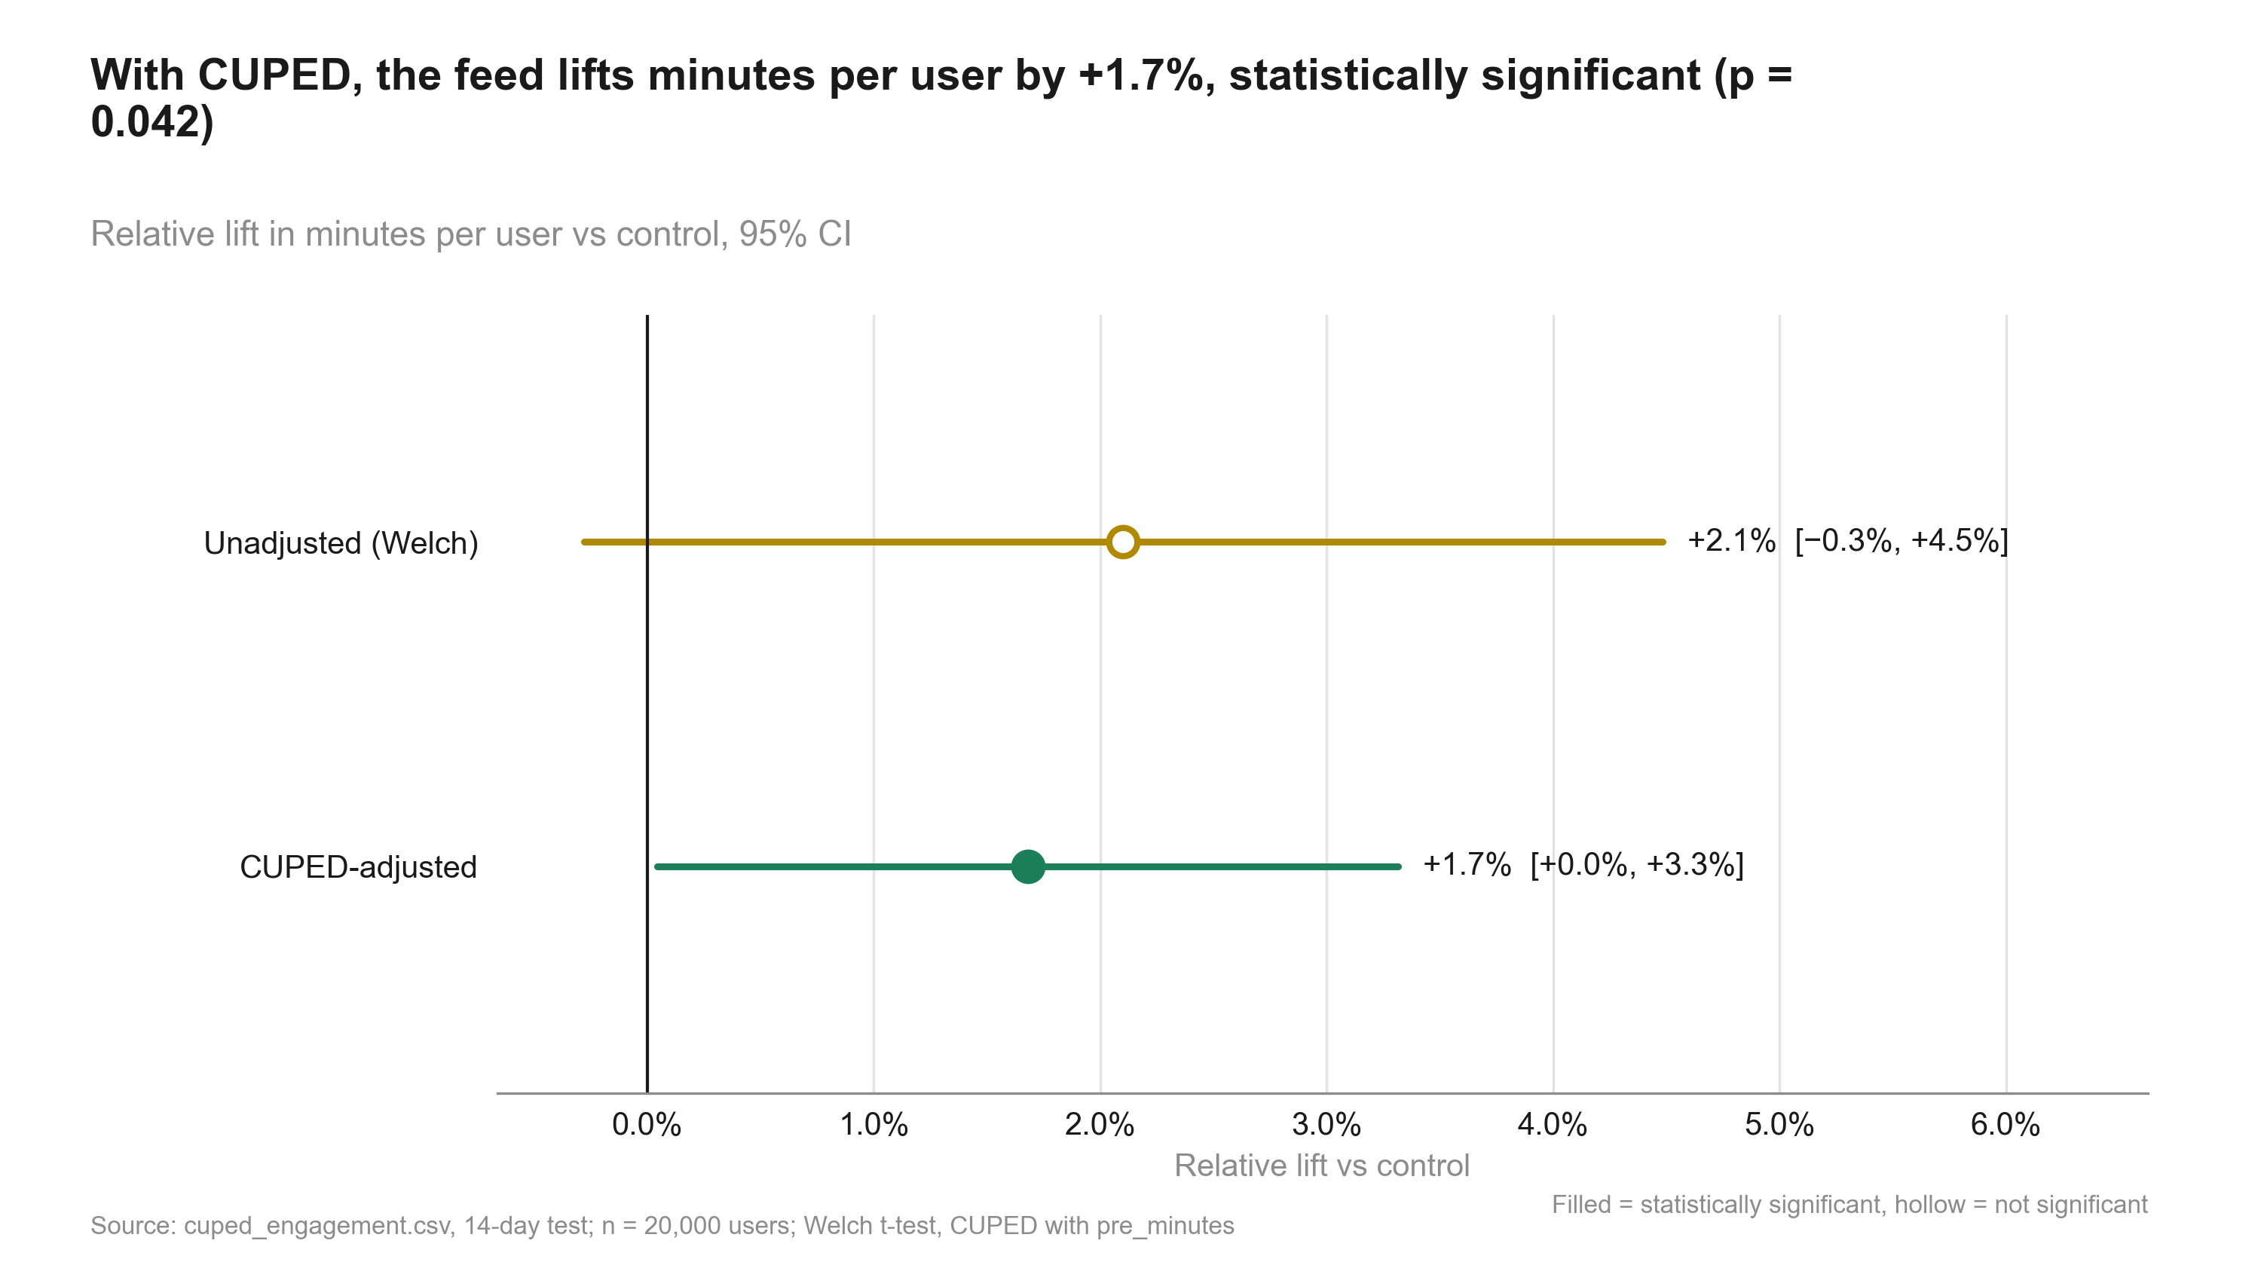
Figure 1: With CUPED, the feed lifts minutes per user by +1.7%, statistically significant (p = 0.042). Relative lift, 95% CI
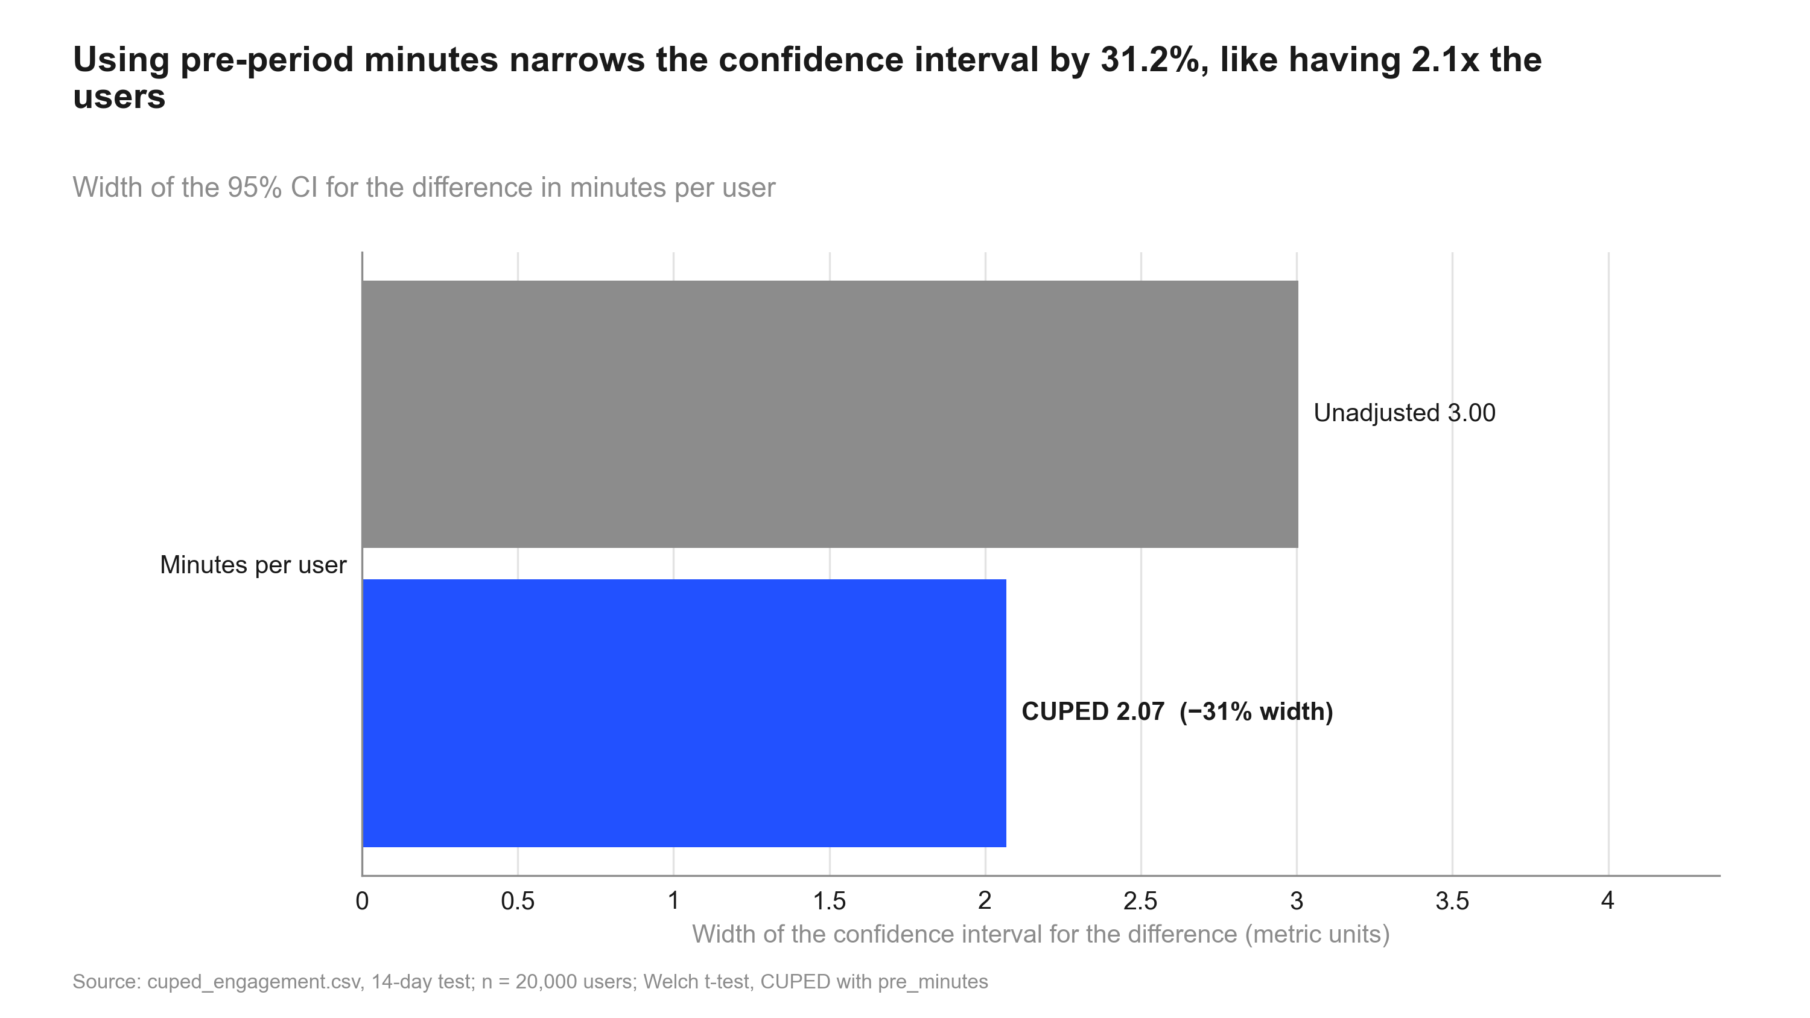
Figure 2: Using pre-period minutes narrows the confidence interval by 31.2%, like having 2.1x the users. CI width before vs after CUPED
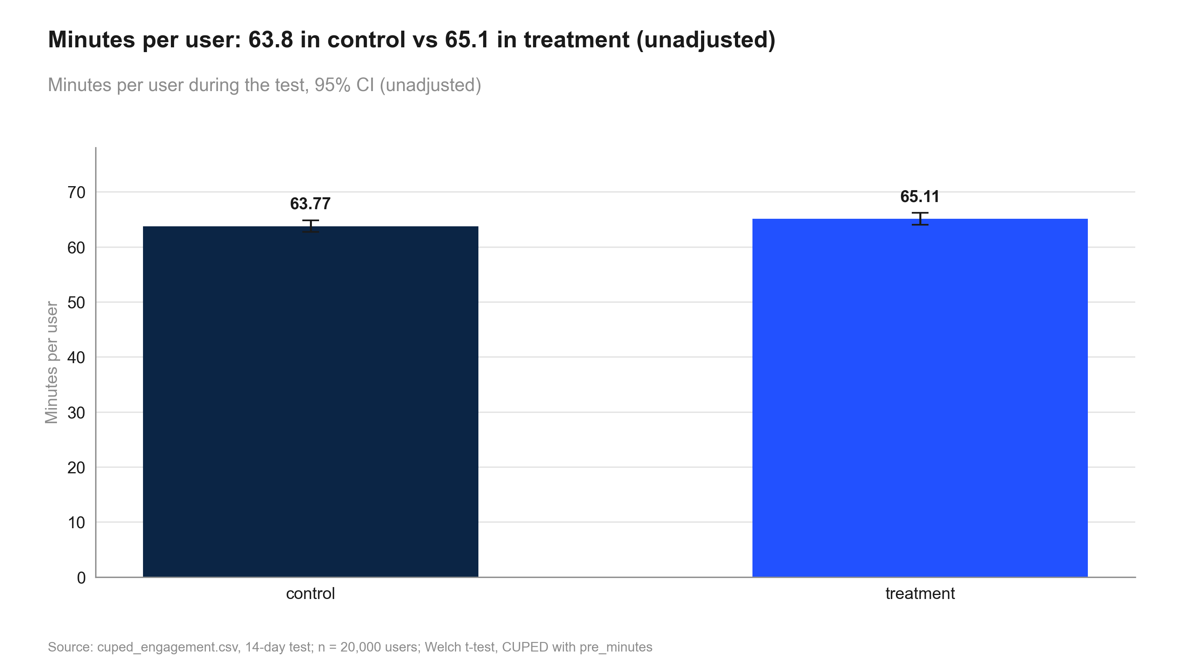
Figure 3: Minutes per user: 63.8 in control vs 65.1 in treatment (unadjusted). Minutes per user

6. Robustness and sensitivity
Table 12: minutes: the same metric across methods
Step | Metric | Segment | Method | Estimate [CI] (abs.) | Relative [CI] | Evidence | n
naive_test | minutes |  | welch ttest | 1.34 [−0.1628, 2.84] | +2.1% [−0.3%, +4.5%] | p = 0.081 | control: 9,902 / treatment: 10,098
naive_test | minutes |  | bootstrap mean diff | 1.34 [−0.1709, 2.82] | +2.1% [−0.3%, +4.5%] | p = 0.081 | control: 9,902 / treatment: 10,098
cuped_test | minutes |  | cuped | 1.07 [0.0372, 2.10] | +1.7% [+0.0%, +3.3%] | p = 0.042 | control: 9,902 / treatment: 10,098
regression_check | minutes |  | regression adjustment | 1.07 [0.0372, 2.10] | +1.7% [+0.1%, +3.3%] | p = 0.042 | control: 9,902 / treatment: 10,098

Distance to the decision boundaries
- Relative lift +1.7%; CI lower bound +0.0% vs the 1% practical threshold: the whole CI is not above it (the true lift may be below the threshold).
- Evidence p = 0.042 vs alpha 0.05.

What could change the conclusion
- CUPED chosen after the unadjusted result (p = 0.081) was seen; both reported.
- CI [+0.0%, +3.3%] includes lifts below the 1% threshold.
- CUPED lift +1.7% vs unadjusted +2.1%: treatment had a small pre-period head start by chance (review finding 2).
- Regression adjustment agrees: +1.7% (p = 0.042).
- No dates in the data: novelty not checked.

7. Decision log
Verbatim records (in quote style) may mention values that were later superseded; the current numbers are those in sections 1-6.

Intake questions and answers
Already answered: variants (control / treatment), 50/50 by user, one row per user, primary metric minutes per
user during the 14-day test, pre-period covariate `pre_minutes` (14 days before the test), segment column
signup_country. The user says the naive t-test was borderline.
Asked:
1. Pre-period definition. Is `pre_minutes` measured strictly before each user's assignment, with the same
definition as `minutes`? [yes] -> "Yes, same event, the 14 days before the test started."
2. Users without history. Do new users have pre_minutes = 0, or are they missing? [missing -> mean-imputed] ->
"Every user in the file existed before the test; no missing values."
3. Pre-registration. Was CUPED planned before you saw the borderline result? [no] -> "No, we only thought of it
after the t-test came out at p = 0.08." *(Recorded as a risk: the adjustment was chosen after seeing results.)*
4. Practical threshold. Smallest lift in minutes per user worth shipping? [1% relative] -> "1% is enough; the
feed is cheap to maintain."
5. Guardrails. Anything that must not drop? [none] -> "No guardrails for this one."
6. Segments. signup_country for decisions? [no] -> "No."
7. Statistical defaults (table shown) -> "Keep them."
8. Depth. [standard] -> "Standard, but explain CUPED simply for the product team."

User decisions at gates
Decision to be made: Ship / don't ship the redesigned feed.
Decision on review blocker 1 (2026-10-01): Claude explained that the ship decision depends on CUPED (p = 0.042) while the unadjusted test was not significant (p = 0.081), and that CUPED was chosen after seeing that result. Options: (a) accept CUPED as primary and state the post-hoc choice prominently; (b) call the result inconclusive and rerun with CUPED pre-registered. User chose (a): "CUPED on same-metric pre-period is our standard from now on. Use it, but put the caveat first, and recommend pre-registering it."

State history
Table 13: state.json history
When (UTC) | Event
2026-09-30T20:56:23+00:00 | run created
2026-09-30T20:56:49+00:00 | gate plan_approved = True
2026-09-30T20:56:49+00:00 | phase -> validation
2026-09-30T20:57:09+00:00 | gate validation_passed = True
2026-09-30T20:57:09+00:00 | phase -> analysis
2026-09-30T20:57:42+00:00 | phase -> review
2026-09-30T20:58:07+00:00 | gate review_passed = False
2026-09-30T20:58:43+00:00 | gate review_passed = True
2026-09-30T20:58:43+00:00 | phase -> deliverables
2026-09-30T21:00:41+00:00 | phase -> done

Review rounds
Review: 2026-10-01_home-feed-redesign (round 1) - Verdict: BLOCKED (1 blocker, 1 fix)
#1 [blocker] The recommendation depends on an adjustment chosen after the result was seen. Unadjusted: p = 0.081, not significant. CUPED: p = 0.042, just below alpha. Choosing the analysis after seeing results inflates the false-positive rate, so this could change the conclusion. | fix: User decision needed: accept CUPED as the primary analysis (standard method, covariate fixed by design, regression adjustment agrees) and say so prominently; or treat the result as inconclusive and confirm with a pre-registered rerun.
#2 [fix] The lift moves from +2.1% (unadjusted) to +1.7% (CUPED), but the summary does not explain why. Treatment users had slightly higher pre-period minutes by chance (64.0 vs 63.6), and CUPED removes that head start. | fix: Add a caveat explaining the shift.
#3 [note] The CUPED CI lower bound is at +0.0%, so the lift could be close to zero and is only marginally above the 1% threshold. The summary's threshold caveat covers this. | fix: none
Review: 2026-10-01_home-feed-redesign (round 2) - Verdict: PASS
#1 [resolved by user decision] CUPED accepted as primary; the post-hoc choice is the first caveat and pre-registration is a next step. | fix: none
#2 [resolved] The caveat explaining the +2.1% to +1.7% shift has been added. | fix: none

8. Reproducibility
Table 14: Environment
Item | Value
Python | 3.13.2
Platform | Windows-11-10.0.26200-SP0
Packages | pandas 2.3.0, numpy 2.3.0, scipy 1.15.3, statsmodels 0.15.0, matplotlib 3.10.5, python-pptx 1.0.2, python-docx 1.2.0, PyYAML 6.0.2
abkit | 0.1.0
results.json schema | 1
Seeds | bootstrap seed 42 (10000 resamples); Bayesian draws seed 42 (abkit default)

Table 15: Code index
Script | Purpose | Writes results for
10_validate_profile.py | Validate cuped_engagement.csv incl. pre-period availability, correlation and balance; write data_profile.md. | srm, validation
20_analysis_cuped_test.py | CUPED-adjusted Welch test of minutes per user using pre_minutes. Step: cuped_test. | cuped_test
20_analysis_naive_test.py | Unadjusted comparison of minutes per user: Welch t-test plus a bootstrap check. Step: naive_test. | naive_test
20_analysis_regression_check.py | Sensitivity: Lin (2013) regression adjustment with pre_minutes, HC2 robust SEs. Step: regression_check. | regression_check
20_analysis_summary.py | Decision and summary on the CUPED estimate, with the unadjusted result and post-hoc caveat. Step: summary. | summary
30_charts_cuped.py | Charts: naive vs CUPED lift, CI width reduction, minutes by variant, distribution (numbers from results.json). | -
40_deck_build.py | Build deck.pptx. | -
50_report_build.py | Build summary.docx. | -
50_technical_report.py | Build technical_report.docx: methods, formulas, decision log, robustness and reproducibility for data scientists. | -

How to rerun
From the repository root, in this order (the plan_gate hook requires the run's gates to be open for 20_-50_ scripts):
python runs/2026-10-01_home-feed-redesign/code/10_validate_profile.py
python runs/2026-10-01_home-feed-redesign/code/20_analysis_cuped_test.py
python runs/2026-10-01_home-feed-redesign/code/20_analysis_naive_test.py
python runs/2026-10-01_home-feed-redesign/code/20_analysis_regression_check.py
python runs/2026-10-01_home-feed-redesign/code/20_analysis_summary.py
python runs/2026-10-01_home-feed-redesign/code/30_charts_cuped.py
python runs/2026-10-01_home-feed-redesign/code/40_deck_build.py
python runs/2026-10-01_home-feed-redesign/code/50_report_build.py
python runs/2026-10-01_home-feed-redesign/code/50_technical_report.py
Then check every printed number against results.json:
python -m abkit.tracecheck 2026-10-01_home-feed-redesign
Run log: 16 commands logged while this run was active (1 failed); see run_log.jsonl.
Table 16: Run artefacts
Artefact | Size
charts/cuped_variance_reduction.png | 137.9 KB
charts/distribution_compare.png | 117.5 KB
charts/lift_ci.png | 148.4 KB
charts/manifest.json | 3.2 KB
charts/metric_by_variant.png | 118.6 KB
context.md | 0.4 KB
data/cuped_engagement.csv | 610.8 KB
data_profile.md | 1.1 KB
deck.pptx | 500.6 KB
deck_storyline.md | 1.3 KB
intake.md | 3.2 KB
plan.md | 1.7 KB
results.json | 23.7 KB
review.md | 2.6 KB
state.json | 3.6 KB
summary.docx | 467.7 KB

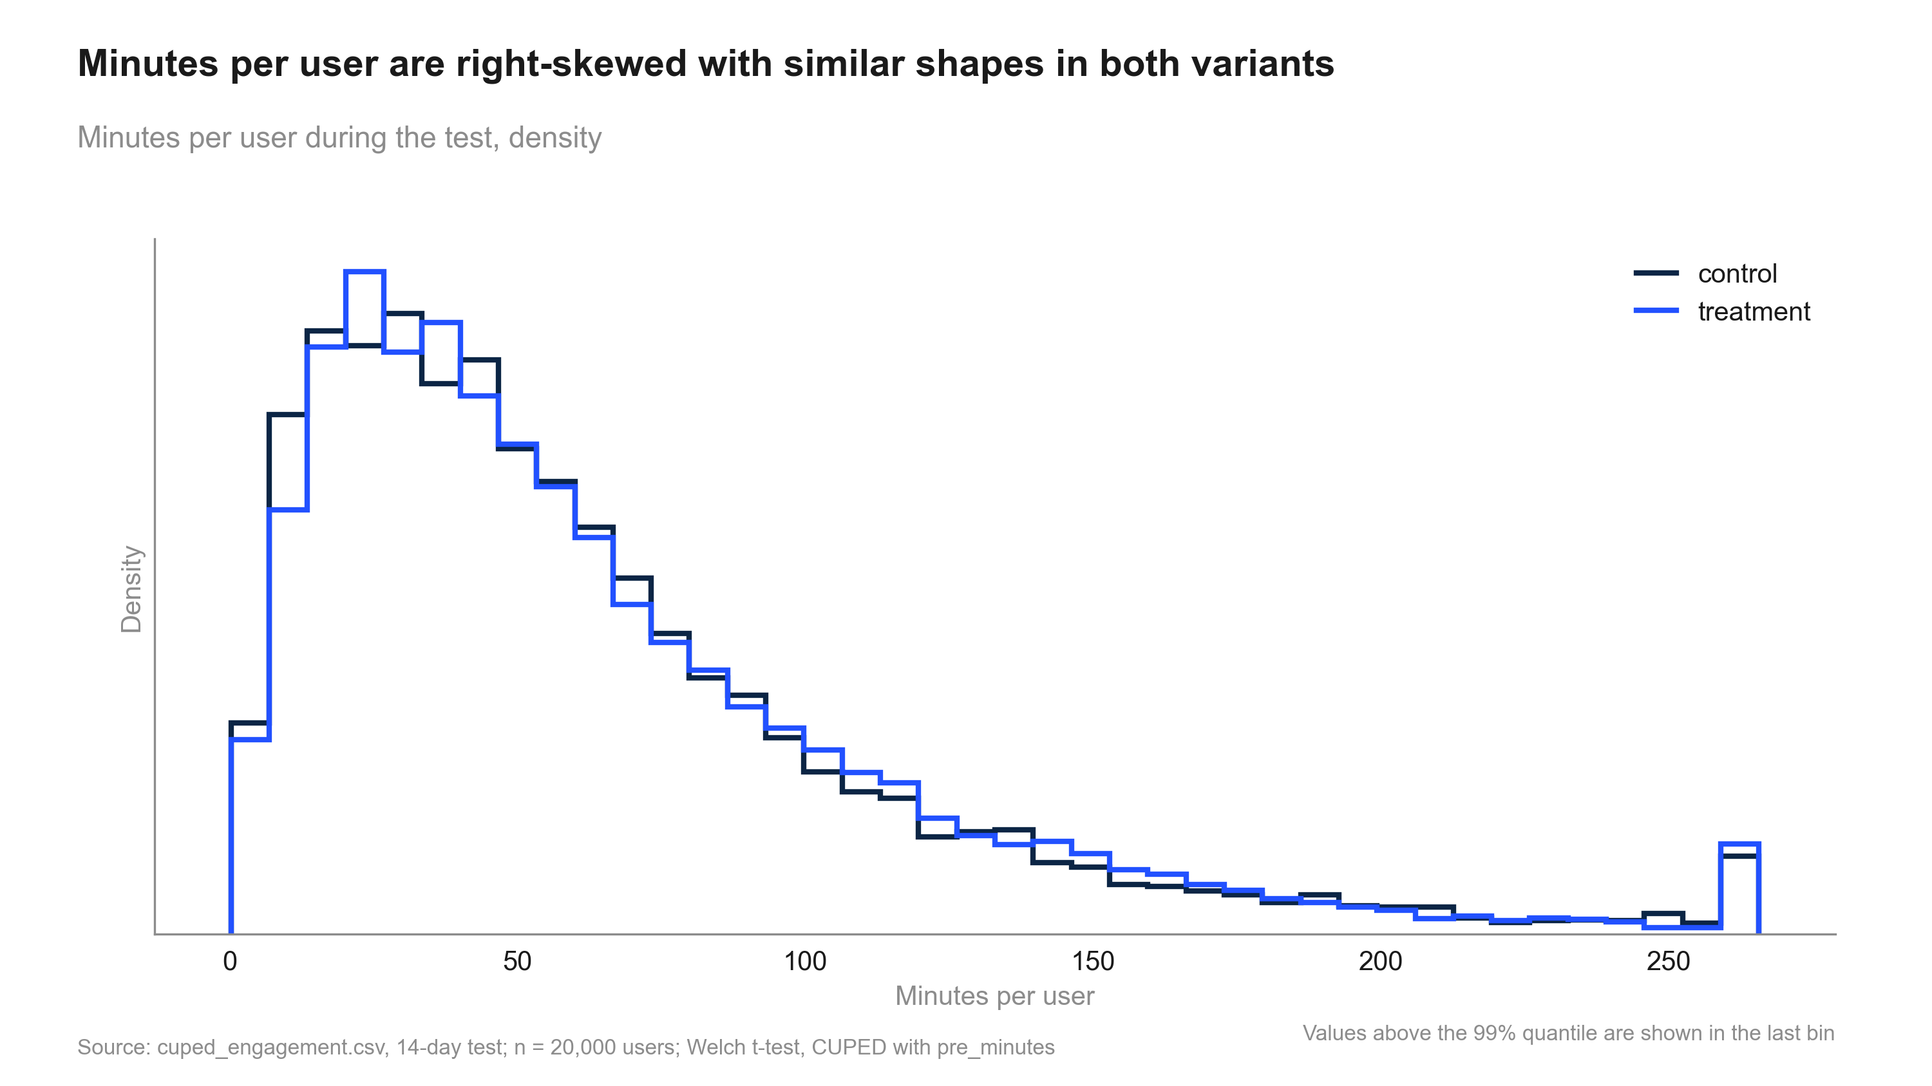
Figure 4: Minutes per user are right-skewed with similar shapes in both variants. Distribution of minutes

