Technical report: Marketing campaign: ads vs PSA
Companion to summary.docx: how the result was obtained, for data scientists
Source: marketing_AB.csv; run 2026-10-01_marketing-ads

1. Technical summary
Verdict: Ship. The primary metric improved significantly and by more than the practical threshold.
Headline: The ad campaign raises conversion by 43.1% vs the PSA (statistically significant)
Decision rule (abkit.decision.recommend): ship if the primary metric is significantly better and the relative lift is at least the practical threshold with no guardrail breach; don't ship if it is significantly worse or a guardrail is breached (iterate if the primary also won); iterate if significant but below the threshold, or if not significant with the CI excluding the threshold; otherwise extend (inconclusive). Bayesian results use P(beat) against 0.95.
Table 1: Primary estimate
Step | Metric | Segment | Method | Estimate [CI] | Relative lift [CI] | Evidence | n
primary_test | converted |  | two proportion ztest | 0.0077 [0.0060, 0.0094] | +43.1% [+29.3%, +56.8%] | p < 0.001 | psa: 23,524 / ad: 564,577

Caveats
- PSA ids form a separate block (900,000 to 923,523); assignment unconfirmed.
- Split confirmed as 96/4 only after a 95/5 check failed.
- Exposure breakdowns are exploratory, non-causal; 4 of 7 buckets inconclusive.
- No dates: novelty or wear-off cannot be checked.
- No guardrail metrics defined; verdict rests on conversion alone.
- Money impact needs a value per conversion.

2. Problem framing and design
Business question: Would the ad campaign be successful, and how much of its success can be attributed to the ads?
Formal hypotheses for the primary metric:
H0: p_T = p_C H1: p_T != p_C (two-sided, alpha = 0.05)
Table 2: Design
Item | Value
Problem types | post_test_readout, bayesian_readout, heterogeneous_effects
Variant column / control / treatment | test group / psa / ad
Randomisation unit | user id
Intended split | ad: 0.96, psa: 0.04
Period | not recorded

Table 3: Metrics
Metric | Label | Role | Type | Direction | Threshold / margin (rel.)
converted | conversion | primary | binary | increase | 0.05

Table 4: Statistical settings used
Setting | Value
alpha | 0.05
sidedness | two-sided
power | 0.8
confidence_level | 0.95
correction_primary | none
correction_secondary | holm
correction_segments | benjamini-hochberg
srm_test | chi-square
srm_threshold | 0.001
min_days | 7
prefer_full_weeks | True
bayes_prior | weakly_informative
bayes_decision_threshold | 0.95
bootstrap_n_resamples | 10000
bootstrap_seed | 42
noninferiority_margin_relative | 0.01

3. Data and validation
Table 5: Data lineage (the original file is never modified)
Item | Value
Original file | D:\VS-Code\AB-Testing\data\marketing_AB.csv
Run copy (analysed) | data/marketing_AB.csv
SHA-256 of run copy | 3c06948f67690d9bd6b46f87010f71d364bf31385d5a8629a91ba3fc064f82c8
Shape | 6 columns, 588,101 rows

Validation verdict: overall WARN (script code/10_validate_profile.py). Outliers are reported, never removed automatically.
Table 6: Validation checks
Check | Verdict | Detail
schema | PASS | 6 columns, 588,101 rows
dtypes | PASS | All metric columns numeric
missing values | PASS | No missing values
duplicates | PASS | 588,101 units, one row each
contamination | PASS | No unit appears in more than one variant
variants | PASS | Counts {'ad': 564577, 'psa': 23524}
SRM | PASS | p = 1.000 (threshold 0.001)
outliers | WARN | Extreme values (reported, not removed): total ads: max is 10x the 99th percentile. Consider winsorised or boot
impossible values | PASS | Metric values within valid ranges
pre-period data | PASS | None described (CUPED not possible)
covariate balance | WARN | Segment mix differs between variants: most ads day (p = 4.8e-48), most ads hour (p = 1.1e-28) (can indicate an

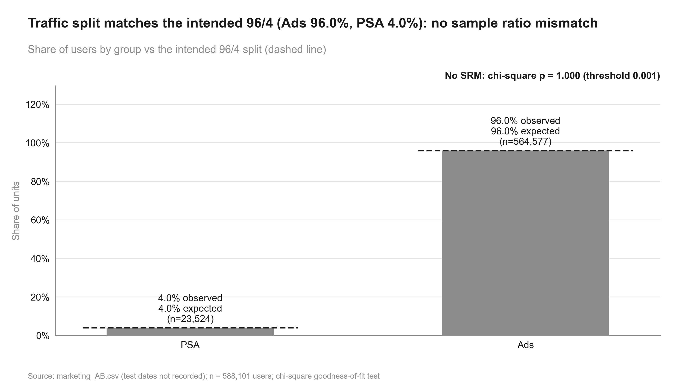
Figure 1: Traffic split matches the intended 96/4 (Ads 96.0%, PSA 4.0%): no sample ratio mismatch. Share of users by group vs the intended 96/4 split (dashed line)

4. Methods, step by step

validate: validation.full_profile (done)
Why (plan): schema, duplicates, impossible values, outliers in total ads
Script: code/10_validate_profile.py
Data validation profile: Schema, dtypes, missing values, duplicates, contamination, variants, SRM, dates, outliers, impossible values, pre-period data, covariate balance.
pass / warn / block per check. Assumptions: None. Reference: abkit.validation.full_profile.

srm: validation.srm_check (done)
Why (plan): intended split 96/4; the unbalanced design makes the split check essential
Script: code/11_validate_srm.py
Sample ratio mismatch test: Chi-square goodness of fit of unit counts against the intended split.
chi2 = sum_v (n_v - N s_v)^2 / (N s_v), s_v = intended share; SRM if p < threshold (default 0.001)
Asymptotic chi-square. Assumptions: Counts of randomisation units. Reference: abkit.validation.srm_check.
Settings applied: alpha 0.001; sidedness n/a; correction none.
- Checked against the intended split 96/4 from state.json: p = 1.000 (threshold 0.001).
- Intended split corrected by the user from 95/5 to 96/4 (intake.md). For the record, the check against 95/5 gives p = 3.2e-271.

primary_test: frequentist.two_proportion_ztest (done)
Why (plan): binary unit-level primary metric; one primary, no correction
Script: code/20_analysis_primary_test.py
Two-proportion z-test: Compares conversion rates between two independent groups of randomisation units.
p_hat = x / n per group; diff = p_T - p_C
z = diff / sqrt( p_pool (1 - p_pool) (1/n_C + 1/n_T) ), p_pool = (x_C + x_T) / (n_C + n_T)
CI(diff) = diff +/- z_crit * sqrt( p_C(1-p_C)/n_C + p_T(1-p_T)/n_T ) (unpooled)
rel = p_T/p_C - 1; Var(rel) ~ se_T^2/p_C^2 + p_T^2 se_C^2/p_C^4 (delta method)
Pooled SE for the test, unpooled SE for the CI; one-sided tests use a (1 - 2 alpha) two-sided CI. Assumptions: Independent units (one row per randomisation unit); at least 10 successes and failures per group. Reference: abkit.frequentist.two_proportion_ztest; ab-methods/frequentist_tests.md.
Settings applied: alpha 0.05; sidedness two-sided; correction none.
Table 7: Assumptions checked in step primary_test
Assumption | Status | Detail
independent units (one row per randomisation unit) | PASS | 588,101 rows, 588,101 unique users; unit = randomisation unit
normal approximation: >= 10 successes and failures per group | PASS | min cell = 420
no sample ratio mismatch vs intended split (96/4, corrected by the user) | PASS | SRM p = 1.000 (step srm, threshold 0.001)

- none correction across 1 tests (alpha 0.05).
- Covariate balance WARN in validation (PSA share varies by most-ads day / hour / exposure bucket); these are measured during the test, so they do not change this user-level comparison but are noted as a caveat.

bayesian: bayesian.beta_binomial (done)
Why (plan): P(ads beat PSA) and expected loss, as requested; weakly informative prior
Script: code/20_analysis_bayesian.py
Bayesian beta-binomial model: Posterior distribution of each group's conversion rate; probability that treatment is better.
prior p ~ Beta(a0, b0); posterior p ~ Beta(a0 + x, b0 + n - x) per group
P(beat) = P(p_T > p_C) by Monte Carlo draws; expected loss = E[max(p_C - p_T, 0)]
credible intervals = posterior quantiles of p_T - p_C and p_T/p_C - 1
Monte Carlo with a fixed seed; decision: P(beat) >= threshold and negligible expected loss. Assumptions: Independent units; prior fixed before seeing results (weakly informative by default). Reference: abkit.bayesian.beta_binomial; ab-methods/bayesian.md.
Settings applied: alpha 0.05; sidedness n/a; correction none.
Table 8: Assumptions checked in step bayesian
Assumption | Status | Detail
prior chosen before seeing results (settings.bayes_prior) | PASS | weakly_informative -> Beta(1, 1)
no sample ratio mismatch vs intended split | PASS | SRM p = 1.000 (step srm, threshold 0.001)

- Credible interval: there is a 95% posterior probability the true lift lies inside it.
- Prior sensitivity: without a historical baseline the weakly informative prior is Beta(1, 1), identical to the flat prior, so a flat-prior rerun gives the same answer. With this many users the prior has negligible weight.

impact: custom.incremental_impact (done)
Why (plan): incremental conversions per 1,000 users, total incremental conversions in the ad group, and the share of ad-group conversions attributable to the ads (with CIs). Not in abkit yet, so it is written in code/ and flagged for promotion
Script: code/20_analysis_impact.py
Custom method (not in abkit; documented by its script): Incremental impact of the ads, translated from the primary conversion effect. Step: impact. Run from the project root: python runs/2026-10-01_marketing-ads/code/20_analysis_impact.py Not in abkit yet: `incremental_impact` below is registered as a promotion candidate (target abkit.decision). It returns three StatResults with CIs: (a) incremental conversions per 1,000 exposed users = 1000 * (p_t - p_c) (b) total incremental conversions in the treated group = n_t * (p_t - p_c) (n_t treated as fixed) (c) share of treated-group conversions attributable to the treatment (attributable fraction among the exposed) = (p_t - p_c) / p_t, delta-method CI: Var = Var(p_c)/p_t^2 + p_c^2 Var(p_t)/p_t^4 (a) and (b) scale the unpooled z-test CI for the absolute difference, so they agree exactly with the primary test. The function is checked by simulation (CI coverage at the observed rates and sample sizes) before use.
Settings applied: alpha 0.05; sidedness two-sided; correction none.
Table 9: Assumptions checked in step impact
Assumption | Status | Detail
normal approximation: >= 10 successes and failures per group | PASS | min cell = 420
independent units at the randomisation level | PASS | one row per user
CI coverage by simulation at the observed rates and n | PASS | 4,000 simulated tests

- Derived from the primary conversion comparison (same data, same null hypothesis); not an additional test, so no multiple-testing correction applies.
- Causal only to the extent assignment was random (see the user-id block caveat).
- control_value = conversions expected in the ad group without the treatment (n_ad * p_psa); treatment_value = observed conversions. n_ad treated as fixed.
- Delta-method CI; a log-ratio (Katz) interval is stored as a sensitivity check.

exposure_explore: segments.segment_effects (done)
Why (plan): ad vs PSA lift by total-ads bucket and by most-ads day (BH-corrected), plus an interaction test; exploratory and non-causal (measured during the test)
Script: code/20_analysis_exposure_explore.py
Two-proportion z-test: Compares conversion rates between two independent groups of randomisation units.
p_hat = x / n per group; diff = p_T - p_C
z = diff / sqrt( p_pool (1 - p_pool) (1/n_C + 1/n_T) ), p_pool = (x_C + x_T) / (n_C + n_T)
CI(diff) = diff +/- z_crit * sqrt( p_C(1-p_C)/n_C + p_T(1-p_T)/n_T ) (unpooled)
rel = p_T/p_C - 1; Var(rel) ~ se_T^2/p_C^2 + p_T^2 se_C^2/p_C^4 (delta method)
Pooled SE for the test, unpooled SE for the CI; one-sided tests use a (1 - 2 alpha) two-sided CI. Assumptions: Independent units (one row per randomisation unit); at least 10 successes and failures per group. Reference: abkit.frequentist.two_proportion_ztest; ab-methods/frequentist_tests.md.
Treatment x segment interaction test: Joint Wald test that the absolute treatment effect is equal in every segment.
Y = b0 + b1 T + sum_s g_s S_s + sum_s d_s (T x S_s) + e (OLS, HC1); H0: all d_s = 0
Wald chi-square; the stored 'estimate' is the test statistic, not an effect. Assumptions: Linear probability model for binary metrics. Reference: abkit.segments.interaction_test.
Simpson's paradox check: Compares the pooled difference with a segment-standardised difference.
standardised = sum_s w_s (mean_T,s - mean_C,s), w_s = overall segment share; flag if signs differ
Descriptive diagnostic. Assumptions: None. Reference: abkit.segments.simpsons_check.
Settings applied: alpha 0.05; sidedness two-sided; correction none, benjamini-hochberg.
Table 10: Assumptions checked in step exposure_explore
Assumption | Status | Detail
independent units (one row per randomisation unit) | PASS | validation duplicates check: 588,101 units, one row each
normal approximation: >= 10 successes and failures per group | PASS | min cell = 420

- exploratory: measured during the test
- benjamini-hochberg correction across 7 tests (alpha 0.05).
- Not significant after correction: inconclusive (relative lift CI [−48.6%, +28.2%]), not evidence of no effect.
- Covariate balance WARN: the PSA share in this level is 4.4% vs 4.0% overall (equal-share test across levels p < 0.001); groups within a level may not be comparable.
- benjamini-hochberg correction within the `total ads bucket` family; not causal (post-treatment variable).
- Not significant after correction: inconclusive (relative lift CI [−32.4%, +37.4%]), not evidence of no effect.

summary: decision.build_summary (done)
Why (plan): verdict vs the 5% threshold, plain-English impact statement
Decision rule and summary: Turns the primary result and guardrail statuses into a verdict.
significantly worse -> don't ship; guardrail breach -> don't ship (iterate if the primary won)
significantly better and rel. lift >= threshold -> ship; significant but < threshold -> iterate
not significant: CI excludes the threshold -> iterate; otherwise -> extend (inconclusive)
Bayesian primary: P(beat) >= threshold counts as significantly better
Deterministic rule applied to stored results. Assumptions: A practical threshold agreed at intake. Reference: abkit.decision.recommend / build_summary; ab-methods/interpretation_and_decisions.md.

5. Results
Table 11: All effect estimates
Step | Metric | Segment | Method | Estimate [CI] (abs.) | Relative [CI] | Evidence | n
primary_test | converted |  | two proportion ztest | 0.0077 [0.0060, 0.0094] | +43.1% [+29.3%, +56.8%] | p < 0.001 | psa: 23,524 / ad: 564,577
bayesian | converted |  | beta binomial | 0.0077 [0.0059, 0.0094] | +42.9% [+29.9%, +57.5%] | P(beat) > 99.9% | psa: 23,524 / ad: 564,577
impact | incremental conversions per 1,000 users |  | incremental impact | 7.69 [5.95, 9.43] | n/a | p < 0.001 | psa: 23,524 / ad: 564,577
impact | total incremental conversions in the ad group |  | incremental impact | 4,343 [3,360, 5,326] | n/a | p < 0.001 | psa: 23,524 / ad: 564,577
impact | share of ad-group conversions attributable to the ads |  | incremental impact | 0.3011 [0.2339, 0.3683] | n/a | p < 0.001 | psa: 23,524 / ad: 564,577
exposure_explore | converted | All | two proportion ztest | 0.0077 [0.0060, 0.0094] | +43.1% [+29.3%, +56.8%] | p < 0.001 | psa: 23,524 / ad: 564,577
exposure_explore | converted | 1-5 | two proportion ztest | −0.0003 [−0.0015, 0.0009] | −10.2% [−48.6%, +28.2%] | p = 0.869 (adj., benjamini-hochberg) | psa: 7,861 / ad: 169,962
exposure_explore | converted | 101-200 | two proportion ztest | 0.0704 [0.0476, 0.0932] | +66.2% [+31.3%, +101.0%] | p < 0.001 (adj., benjamini-hochberg) | psa: 752 / ad: 16,360
exposure_explore | converted | 11-20 | two proportion ztest | 0.0002 [−0.0026, 0.0030] | +2.5% [−32.4%, +37.4%] | p = 0.974 (adj., benjamini-hochberg) | psa: 4,150 / ad: 123,334
exposure_explore | converted | 201+ | two proportion ztest | 0.0007 [−0.0444, 0.0459] | +0.5% [−28.8%, +29.7%] | p = 0.974 (adj., benjamini-hochberg) | psa: 258 / ad: 5,694
exposure_explore | converted | 21-50 | two proportion ztest | 0.0074 [0.0033, 0.0114] | +33.9% [+9.2%, +58.6%] | p = 0.004 (adj., benjamini-hochberg) | psa: 5,235 / ad: 125,541
exposure_explore | converted | 51-100 | two proportion ztest | 0.0586 [0.0475, 0.0696] | +101.4% [+64.0%, +138.8%] | p < 0.001 (adj., benjamini-hochberg) | psa: 1,853 / ad: 44,149
exposure_explore | converted | 6-10 | two proportion ztest | −0.0019 [−0.0047, 0.0009] | −27.9% [−58.2%, +2.3%] | p = 0.217 (adj., benjamini-hochberg) | psa: 3,415 / ad: 79,537
exposure_explore | converted | Friday | two proportion ztest | 0.0062 [0.0020, 0.0103] | +37.8% [+3.3%, +72.3%] | p = 0.016 (adj., benjamini-hochberg) | psa: 3,803 / ad: 88,805
exposure_explore | converted | Monday | two proportion ztest | 0.0107 [0.0056, 0.0157] | +47.4% [+14.8%, +79.9%] | p = 0.001 (adj., benjamini-hochberg) | psa: 3,502 / ad: 83,571
exposure_explore | converted | Saturday | two proportion ztest | 0.0073 [0.0029, 0.0117] | +52.2% [+4.8%, +99.6%] | p = 0.013 (adj., benjamini-hochberg) | psa: 2,858 / ad: 78,802
exposure_explore | converted | Sunday | two proportion ztest | 0.0040 [−0.0011, 0.0092] | +19.5% [−10.1%, +49.2%] | p = 0.183 (adj., benjamini-hochberg) | psa: 3,059 / ad: 82,332
exposure_explore | converted | Thursday | two proportion ztest | 0.0014 [−0.0031, 0.0059] | +7.0% [−16.9%, +30.8%] | p = 0.555 (adj., benjamini-hochberg) | psa: 3,905 / ad: 79,077
exposure_explore | converted | Tuesday | two proportion ztest | 0.0160 [0.0115, 0.0205] | +110.7% [+46.9%, +174.5%] | p < 0.001 (adj., benjamini-hochberg) | psa: 2,907 / ad: 74,572
exposure_explore | converted | Wednesday | two proportion ztest | 0.0096 [0.0053, 0.0139] | +60.9% [+18.1%, +103.7%] | p = 0.001 (adj., benjamini-hochberg) | psa: 3,490 / ad: 77,418

Table 12: Bayesian outputs
Metric | P(beat) | Expected loss (treatment) | Expected loss (control) | Credible level | Prior
converted | > 99.9% | 0 | 0.0077 | 95.0% | Beta(1.0, 1.0)

Table 13: Diagnostic tests
Step | Test | Statistic / estimate | Evidence | Interpretation
srm | srm check | 0.0000 | p = 1.000 | Checked against the intended split 96/4 from state.json: p = 1.000 (threshold 0.001). Intended split corrected by the user from 95/5 to 96/4 (intake.md). For the record, the check against 95/5 gives p = 3.2e-271.
exposure_explore | interaction test | 158 | p < 0.001 | exploratory: measured during the test Tests heterogeneity of the absolute effect; evidence that the effect differs by segment. estimate holds the Wald chi-square statistic, not a lift: do not plot it as an effect. Linear probability model ...
exposure_explore | simpsons check | 0.0080 | n/a | exploratory: measured during the test Pooled and segment-standardised effects agree in direction. Diagnostic only: the bucket is post-treatment, so the standardised difference is not a causal estimate.

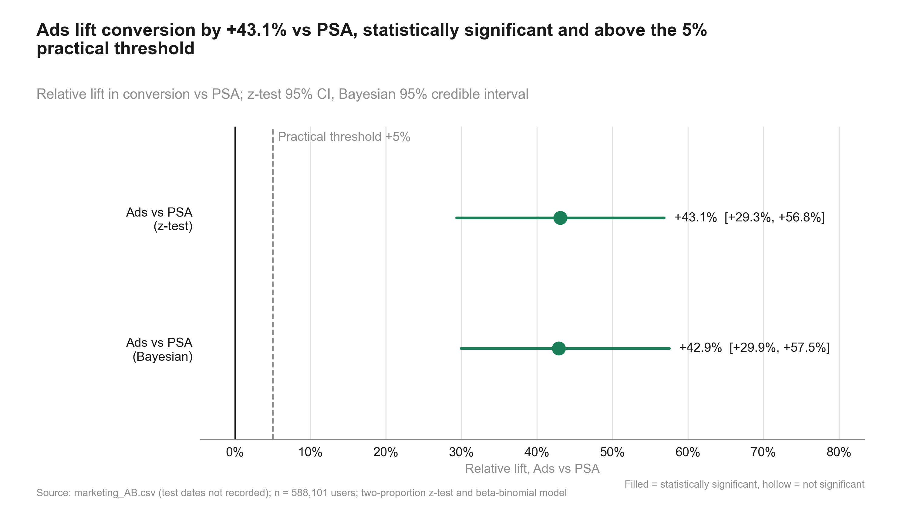
Figure 2: Ads lift conversion by +43.1% vs PSA, statistically significant and above the 5% practical threshold. Relative lift in conversion vs PSA; z-test 95% CI, Bayesian 95% credible interval
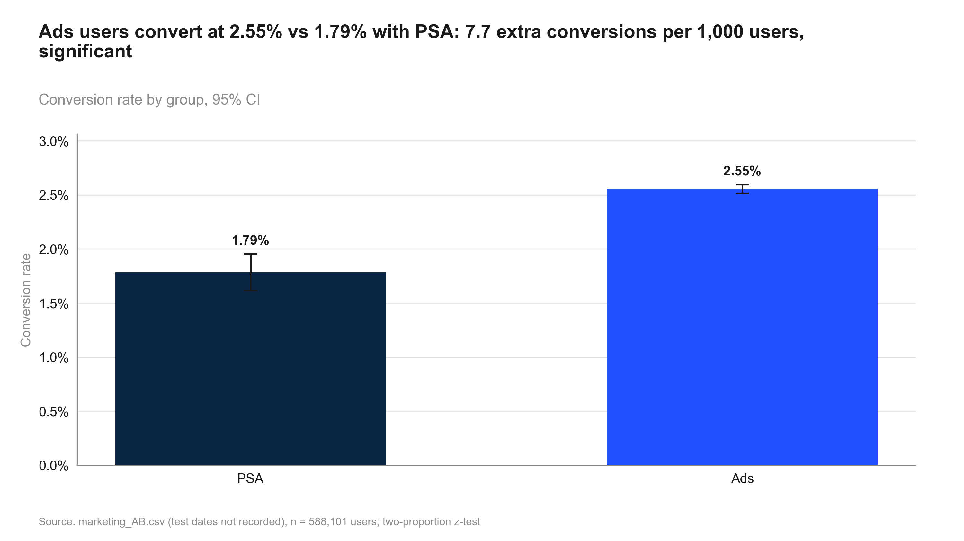
Figure 3: Ads users convert at 2.55% vs 1.79% with PSA: 7.7 extra conversions per 1,000 users, significant. Conversion rate by group, 95% CI
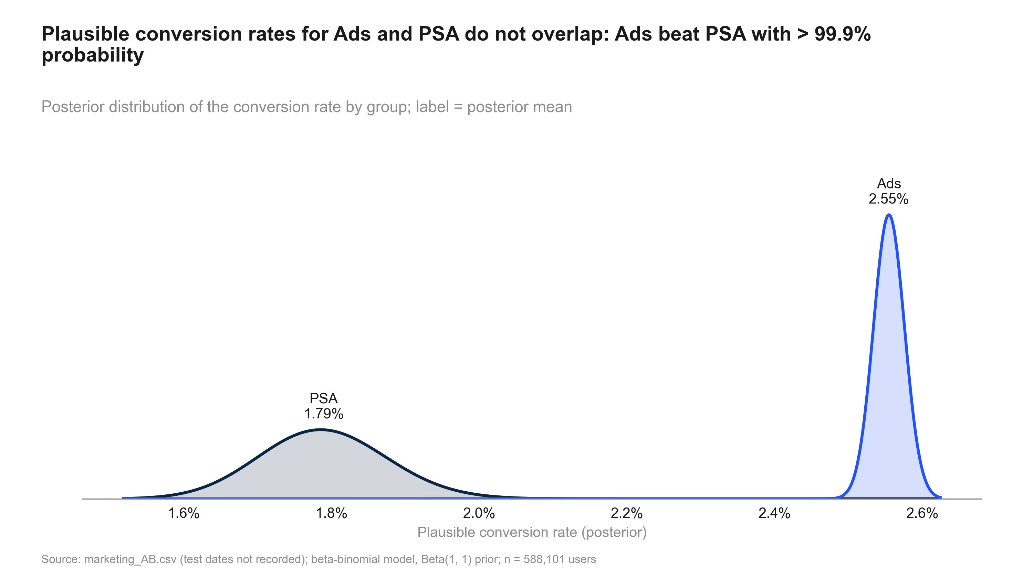
Figure 4: Plausible conversion rates for Ads and PSA do not overlap: Ads beat PSA with > 99.9% probability. Posterior distribution of the conversion rate by group; label = posterior mean
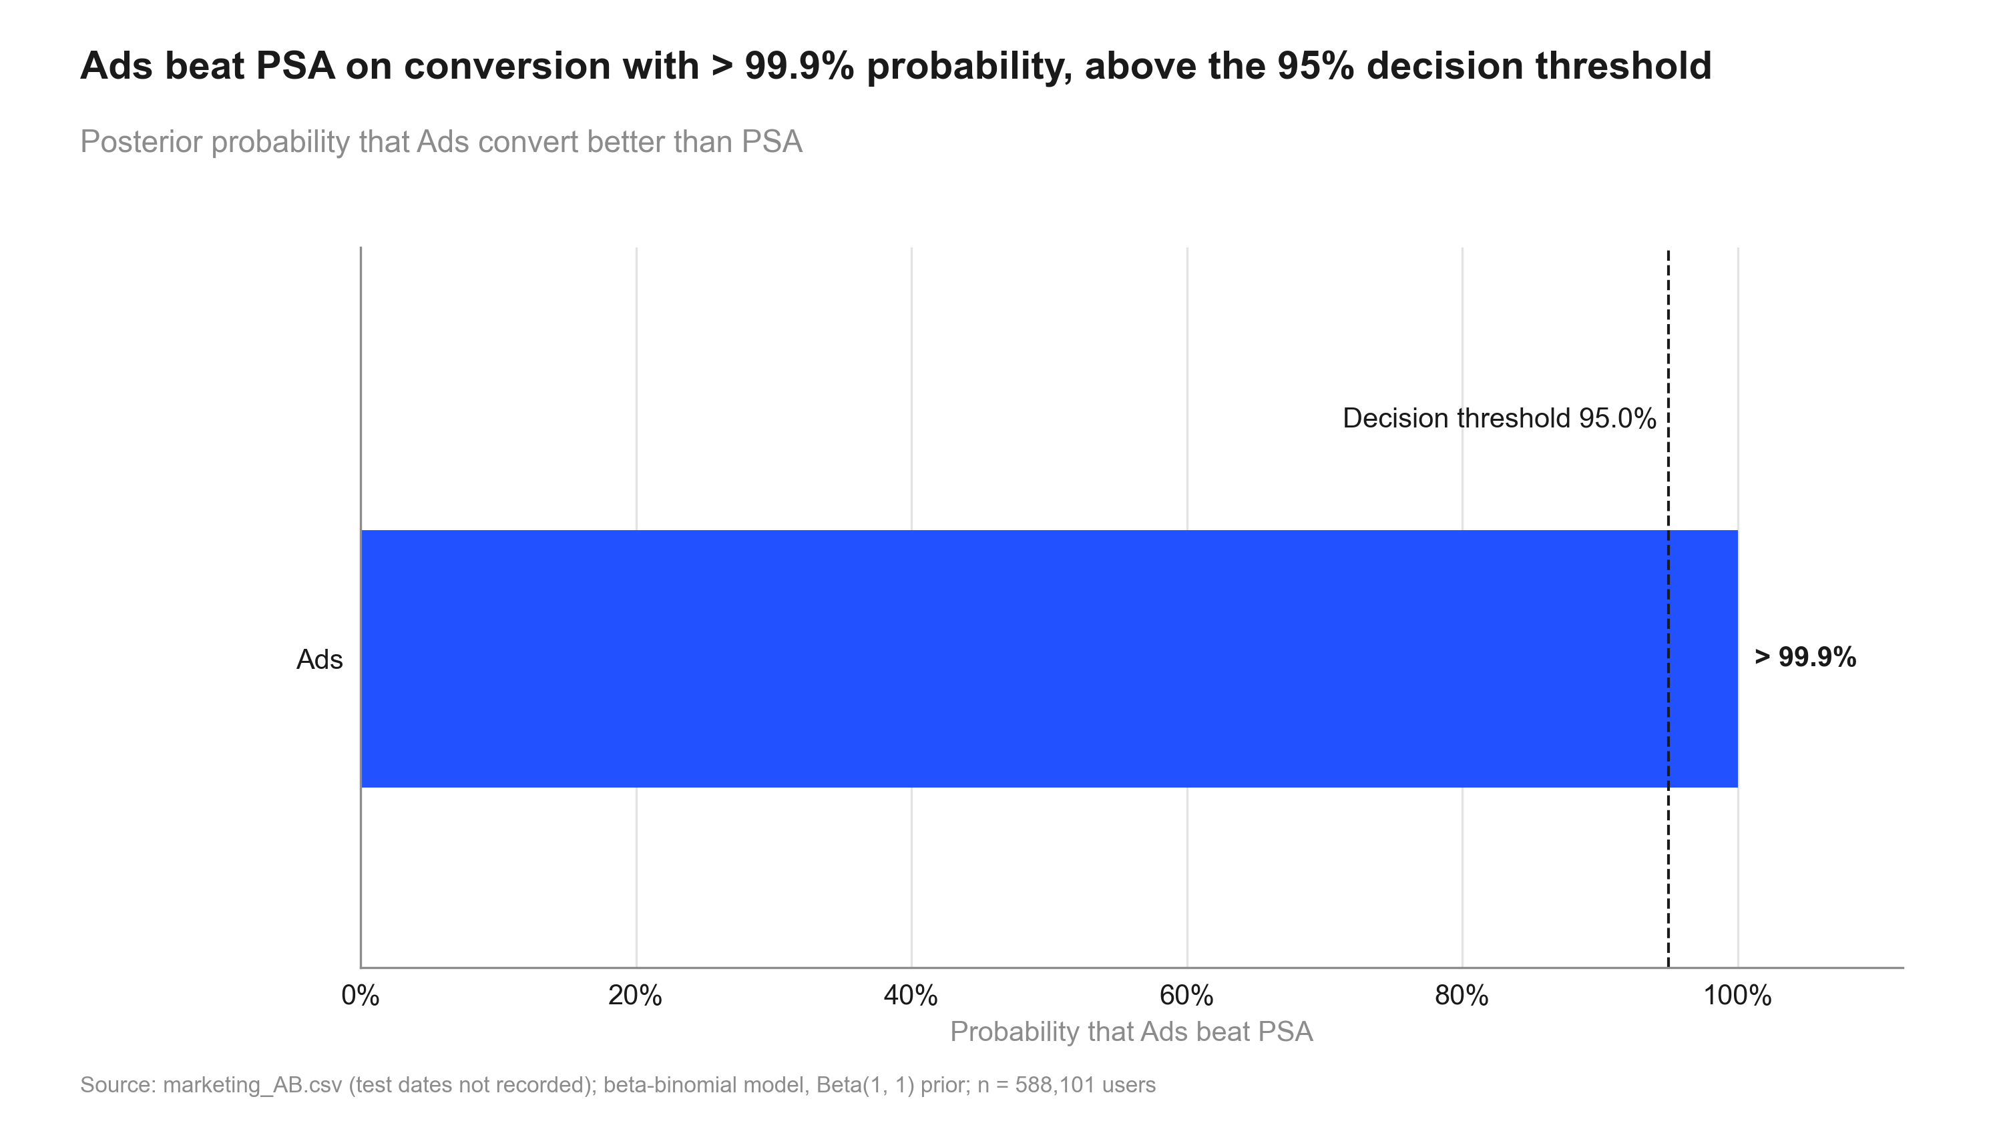
Figure 5: Ads beat PSA on conversion with > 99.9% probability, above the 95% decision threshold. Posterior probability that Ads convert better than PSA
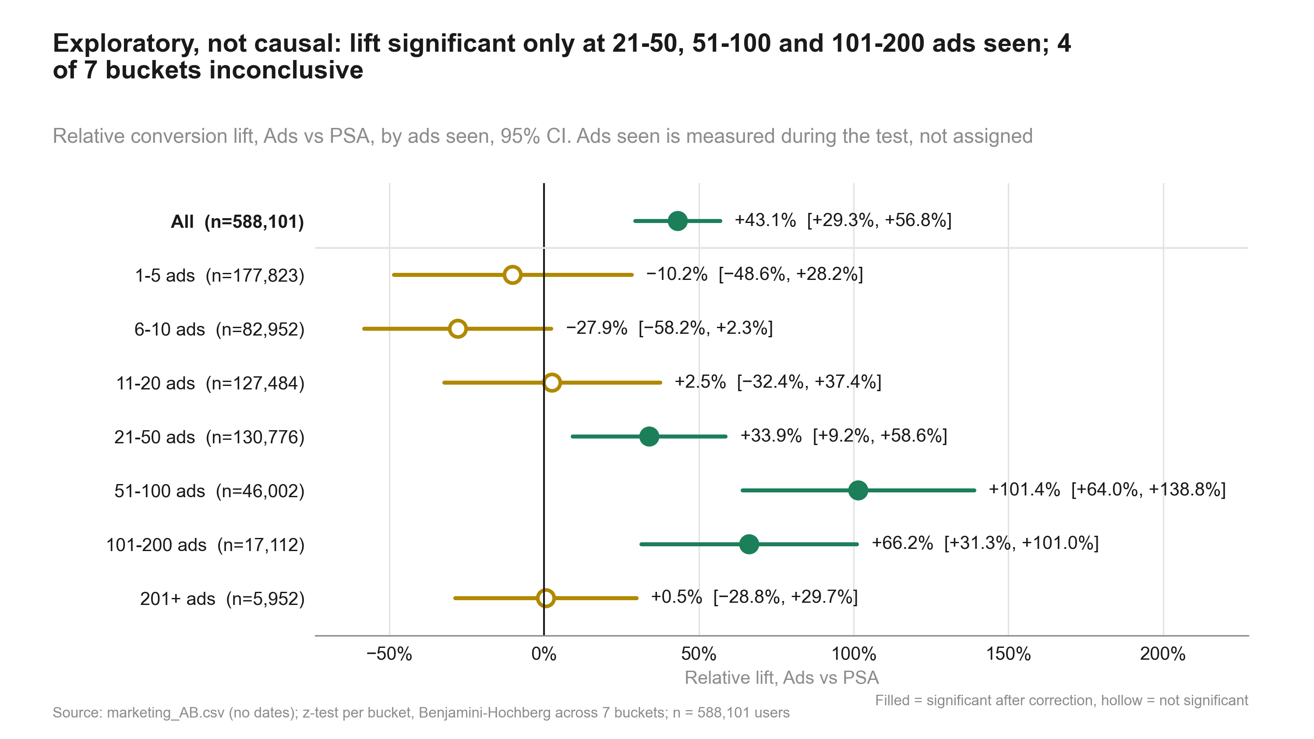
Figure 6: Exploratory, not causal: lift significant only at 21-50, 51-100 and 101-200 ads seen; 4 of 7 buckets inconclusive. Relative conversion lift, Ads vs PSA, by ads seen, 95% CI. Ads seen is measured during the test, not assigned

6. Robustness and sensitivity
Table 14: converted: the same metric across methods
Step | Metric | Segment | Method | Estimate [CI] (abs.) | Relative [CI] | Evidence | n
primary_test | converted |  | two proportion ztest | 0.0077 [0.0060, 0.0094] | +43.1% [+29.3%, +56.8%] | p < 0.001 | psa: 23,524 / ad: 564,577
bayesian | converted |  | beta binomial | 0.0077 [0.0059, 0.0094] | +42.9% [+29.9%, +57.5%] | P(beat) > 99.9% | psa: 23,524 / ad: 564,577

Distance to the decision boundaries
- Relative lift +43.1%; CI lower bound +29.3% vs the 5% practical threshold: the whole CI is above it.
- Evidence p < 0.001 vs alpha 0.05.

What could change the conclusion
- PSA ids form a separate block (900,000 to 923,523); assignment unconfirmed.
- Split confirmed as 96/4 only after a 95/5 check failed.
- Exposure breakdowns are exploratory, non-causal; 4 of 7 buckets inconclusive.
- No dates: novelty or wear-off cannot be checked.
- No guardrail metrics defined; verdict rests on conversion alone.
- Money impact needs a value per conversion.

7. Decision log
Verbatim records (in quote style) may mention values that were later superseded; the current numbers are those in sections 1-6.

Intake questions and answers
Already answered by the description and the data: user-level randomisation (user id unique, one row per user),
treatment = `ad`, control = `psa`, primary metric = `converted` (binary), 588,101 users, no date column.
1. Intended split? -> 95/5 at first; corrected to 96/4 after validation (see below).
2. Value per conversion / rollout audience? -> No. Report incremental conversions per 1,000 users plus a formula.
3. Practical threshold? -> 5% relative lift in conversion.
4. Test period / early stopping or peeking? -> No early stopping or repeated checking. Dates not provided.
5. Exploratory breakdown by exposure (total ads, day, hour)? -> Yes, labelled descriptive / non-causal.
6. Bayesian view as well? -> Both frequentist and Bayesian.
7. Statistical defaults -> Keep.
8. Audience / depth -> Stakeholders: standard readout, plain language first, appendix for detail.

User decisions at gates
Decision to be made: Whether the ads drive enough extra conversions to justify the campaign (continue / scale vs stop).
Decision after validation block (2026-10-01): Validation found SRM against 95/5 (23,524 psa users vs 29,405 expected, p < 0.001), and the observed split matched 96/4 almost exactly. The user confirmed: the intended split was 96/4. Validation is re-run against 96/4. Open caveat for the report: psa user ids are one contiguous block (900,000-923,523) separate from ad ids (1,000,000+). Either ids were renumbered per group (harmless) or assignment was by id range (not random). The data owner should confirm.

Plan changes
Plan note (2026-10-01). After validation, the user corrected the intended split from 95/5 to 96/4. The 95/5
- SRM (resolved): the originally stated 95/5 split did not match the data (23,524 PSA users vs about 29,405 expected).

State history
Table 15: state.json history
When (UTC) | Event
2026-09-30T21:20:17+00:00 | run created
2026-09-30T21:28:05+00:00 | gate plan_approved = True
2026-09-30T21:28:05+00:00 | phase -> validation
2026-09-30T21:30:23+00:00 | gate validation_passed = False
2026-09-30T21:34:52+00:00 | intended split corrected by user: 95/5 -> 96/4
2026-09-30T21:35:03+00:00 | gate validation_passed = True
2026-09-30T21:35:04+00:00 | phase -> analysis
2026-09-30T21:38:55+00:00 | phase -> review
2026-09-30T21:43:22+00:00 | gate review_passed = False
2026-09-30T21:46:03+00:00 | phase -> review
2026-09-30T21:48:19+00:00 | gate review_passed = True
2026-09-30T21:48:19+00:00 | phase -> deliverables
2026-09-30T21:58:12+00:00 | phase -> done

Review rounds
Review: 2026-10-01_marketing-ads (round 1) - Verdict: FIXES NEEDED
#1 [fix] plan.md still describes the design as 95/5 and does not mention the correction | fix: Add a dated "Amendment" note to plan.md: the user confirmed 96/4 after validation, SRM is re-checked against 96/4, and the 95/5 risk is resolved. Keep the original text for the audit trail but mark it as superseded
#2 [fix] An old failure note is still attached to the SRM step in state.json. The step is marked done and now passes, but the note still says it failed | fix: Re-set the step note through the state CLI/API, e.g. "SRM vs 96/4 (user-corrected): p = 1.000", and make the script always write the note
#3 [fix] data_profile.md, "SRM localisation" section: 96/4 numbers are labelled 95/5, and the text contradicts the tables | fix: In 11_validate_srm.py, build every split label from EXPECTED instead of hard-coding 95/5. Remove the "Reading"/shortfall text, or make it depend on SRM failing. Rename levels_with_psa_share_ge_5pct -> levels_with_psa_share_ge_intended. Drop share_of_total_missing when the total shortfall is about 0. Reword the per-level result: the PSA share varies across post-treatment levels (3.0-4.8%) around an overall 4.00%. Then re-run 11_validate_srm.py
#4 [fix] results.json step srm has the same stale 95/5 wording in its keys and notes | fix: Same script fix as #3: rename the keys to be split-neutral (expected_control), replace the note with "Intended split corrected by user to 96/4 (intake.md); p = 1.000; vs 95/5 p = 3.2e-271 for the record". Parameterise the text in 10_validate_profile.py. Re-run both validation scripts, then the summary script (the downstream numbers do not change)
#5 [fix] The summary caveats do not say that the intended split was confirmed only after the data had been checked | fix: Add one caveat of 15 words or fewer, e.g. "Intended split confirmed as 96/4 after the 95/5 check failed; observed split matches exactly."
#6 [note] Treat the SRM pass as weak evidence of random assignment. The observed split matches 96/4 to within 0.04 users (chi-square p = 0.9998). Under independent 4% assignment, P(PSA count = 23,524 exactly) is about 0.27% (SD about 150 users). Combined with PSA ids forming one fully filled block (900,000-923,523, fill 100%) apart from the ad ids, this suggests fixed-quota or id-range assignment, or re-keyed ids | fix: No analyst action beyond #5. The verdict should be shown as conditional on the data owner confirming random assignment. The summary already has this as caveat 1 and next step 2; keep it prominent on the exec slide
#7 [note] The PSA share differs by exposure level (most ads day p = 4.8e-48, hour p = 1.1e-28, total-ads bucket p = 4.7e-57). These variables are measured after treatment, so the pattern may reflect the treatment itself. It is not Simpson paradox | fix: Optionally store the day-level Simpson check too. The caveat is already in the notes
#8 [note] No dates, so peeking and novelty cannot be checked from the data; "no early stopping" rests on the statement of the user | fix: Caveat already present ("No dates in the data ...")
#9 [note] No guardrail metrics were defined (none are available in the data), so the verdict rests on the primary metric alone | fix: Mention it in the methodology/risks section of the report
#10 [note] Minor bookkeeping issues. None of them changes a result | fix: Chart and deck code must not plot the interaction estimate as a lift. Optionally clean up in the same pass as #3-4
#11 [note] Exposure breakdown: non-significant buckets should be called inconclusive, not "no effect" | fix: Use "inconclusive" wording on the segment slide
Review: 2026-10-01_marketing-ads (round 2) - Verdict: PASS
#1 [plan.md still said 95/5] resolved
#2 [Stale failure note on the SRM step in state.json] resolved
#3 [data_profile.md SRM localisation section] resolved
#4 [results.json step srm and the validation scripts] resolved
#5 [Caveat on the split being confirmed after the 95/5 check failed] resolved
#10 [Bookkeeping (note)] resolved
#11 [Inconclusive wording (note)] resolved

8. Reproducibility
Table 16: Environment
Item | Value
Python | 3.13.2
Platform | Windows-11-10.0.26200-SP0
Packages | pandas 2.3.0, numpy 2.3.0, scipy 1.15.3, statsmodels 0.15.0, matplotlib 3.10.5, python-pptx 1.0.2, python-docx 1.2.0, PyYAML 6.0.2
abkit | 0.1.0
results.json schema | 1
Seeds | bootstrap seed 42 (10000 resamples); Bayesian draws seed 42 (abkit default)

Table 17: Code index
Script | Purpose | Writes results for
10_validate_profile.py | Validate and profile the marketing ads-vs-PSA CSV (schema, duplicates, SRM vs the intended split in state.json, outliers, balance) and write data_profile.md. | validation
11_validate_srm.py | SRM check against the intended split (read from state.json design.expected_split) and its localisation: | srm
20_analysis_bayesian.py | Bayesian readout of conversion (ads vs PSA): beta-binomial, prior from settings. Step: bayesian. | bayesian
20_analysis_exposure_explore.py | EXPLORATORY, non-causal: ads-vs-PSA conversion lift by total-ads bucket and by most-ads day (BH), plus an | exposure_explore
20_analysis_impact.py | Incremental impact of the ads, translated from the primary conversion effect. Step: impact. | impact
20_analysis_primary_test.py | Primary test: conversion, ads vs PSA, two-proportion z-test (one pre-registered primary, no correction). Step: primary_test. | primary_test
20_analysis_summary.py | Decision summary for the ads-vs-PSA test: verdict vs the practical threshold, key numbers, caveats and next steps. | summary
30_charts_bayes.py | Charts for 2026-10-01_marketing-ads: posterior_distributions, prob_to_beat_control (numbers from results.json). | -
30_charts_results.py | Charts for 2026-10-01_marketing-ads: srm_bar, lift_ci, metric_by_variant (all numbers from results.json). | -
30_charts_segments.py | Charts for 2026-10-01_marketing-ads: segment_forest by ads-seen bucket (exploratory, not causal). | -
40_deck_build.py | Build deck.pptx from results.json and charts/manifest.json. | -
50_report_build.py | Build summary.docx from results.json, intake.md, review.md and charts/manifest.json. | -
50_technical_report.py | Build technical_report.docx: methods, formulas, decision log, robustness and reproducibility for data scientists. | -

How to rerun
From the repository root, in this order (the plan_gate hook requires the run's gates to be open for 20_-50_ scripts):
python runs/2026-10-01_marketing-ads/code/10_validate_profile.py
python runs/2026-10-01_marketing-ads/code/11_validate_srm.py
python runs/2026-10-01_marketing-ads/code/20_analysis_bayesian.py
python runs/2026-10-01_marketing-ads/code/20_analysis_exposure_explore.py
python runs/2026-10-01_marketing-ads/code/20_analysis_impact.py
python runs/2026-10-01_marketing-ads/code/20_analysis_primary_test.py
python runs/2026-10-01_marketing-ads/code/20_analysis_summary.py
python runs/2026-10-01_marketing-ads/code/30_charts_bayes.py
python runs/2026-10-01_marketing-ads/code/30_charts_results.py
python runs/2026-10-01_marketing-ads/code/30_charts_segments.py
python runs/2026-10-01_marketing-ads/code/40_deck_build.py
python runs/2026-10-01_marketing-ads/code/50_report_build.py
python runs/2026-10-01_marketing-ads/code/50_technical_report.py
Then check every printed number against results.json:
python -m abkit.tracecheck 2026-10-01_marketing-ads
Run log: 151 commands logged while this run was active (9 failed); see run_log.jsonl.
Table 18: Run artefacts
Artefact | Size
charts/lift_ci.png | 189.0 KB
charts/manifest.json | 5.9 KB
charts/metric_by_variant.png | 135.5 KB
charts/posterior_distributions.png | 166.8 KB
charts/prob_to_beat_control.png | 131.6 KB
charts/segment_forest.png | 284.2 KB
charts/srm_bar.png | 183.4 KB
context.md | 1.5 KB
data/marketing_AB.csv | 18,128.4 KB
data_profile.md | 8.6 KB
deck.pptx | 1,019.3 KB
deck_storyline.md | 1.7 KB
intake.md | 3.3 KB
plan.md | 3.1 KB
results.json | 178.3 KB
review.md | 13.4 KB
state.json | 4.4 KB
summary.docx | 981.6 KB
technical_report.docx | 986.6 KB

Promotion candidates
- incremental_impact (code/20_analysis_impact.py) -> abkit.decision: Translate a two-proportion comparison into incremental conversions per N users, total incremental conversions in the treated group and the attributable share of treated conversions, each with a CI (scaled Wald / delta method); validated by simulated CI coverage.

