Technical report: Onboarding checklist test
Companion to summary.docx: how the result was obtained, for data scientists
Source: srm_broken.csv, 2026-09-01 to 2026-09-14; run 2026-10-01_onboarding-checklist

1. Technical summary
Verdict: Blocked: data issue. The data failed a blocking validation check, so treatment effects cannot be trusted.
Headline: Results withheld: treatment has 7.1% fewer units than the intended split (p < 0.001, sample ratio mismatch)
Decision rule (abkit.decision.recommend): ship if the primary metric is significantly better and the relative lift is at least the practical threshold with no guardrail breach; don't ship if it is significantly worse or a guardrail is breached (iterate if the primary also won); iterate if significant but below the threshold, or if not significant with the CI excluding the threshold; otherwise extend (inconclusive). Bayesian results use P(beat) against 0.95.

Caveats
- iOS + Web alone show no mismatch (p = 0.323), but an iOS + Web-only readout would answer a different question (it excludes a whole platform); treat it as a sensitivity check only.
- Activation results were not computed: with units missing non-randomly, any difference could be caused by the loss.

2. Problem framing and design
Business question: Does the new onboarding checklist increase 7-day activation?
Formal hypotheses for the primary metric:
H0: p_T = p_C H1: p_T != p_C (two-sided, alpha = 0.05)
Table 1: Design
Item | Value
Problem types | srm_investigation
Period | 2026-09-01 to 2026-09-14

Table 2: Metrics
Metric | Label | Role | Type | Direction | Threshold / margin (rel.)
converted | 7-day activation | primary | binary | increase | 0.03

Table 3: Statistical settings used
Setting | Value
alpha | 0.05
sidedness | two-sided
power | 0.8
confidence_level | 0.95
correction_primary | none
correction_secondary | holm
correction_segments | benjamini-hochberg
srm_test | chi-square
srm_threshold | 0.001
min_days | 7
prefer_full_weeks | True
bayes_prior | weakly_informative
bayes_decision_threshold | 0.95
bootstrap_n_resamples | 10000
bootstrap_seed | 42
noninferiority_margin_relative | 0.01

3. Data and validation
Table 4: Data lineage (the original file is never modified)
Item | Value
Original file | D:\VS-Code\AB-Testing\demo_data\srm_broken.csv
Run copy (analysed) | data/srm_broken.csv
SHA-256 of run copy | 3813692b5976aeadb85a6b7b274094c72a0189a6025691119b3a6677bcf67d0e
Shape | 5 columns, 38,911 rows

Validation verdict: overall BLOCK (script code/10_validate_profile.py). Outliers are reported, never removed automatically.
Table 5: Validation checks
Check | Verdict | Detail
schema | PASS | 5 columns, 38,911 rows
dtypes | PASS | All metric columns numeric
missing values | PASS | No missing values
duplicates | PASS | 38,911 units, one row each
contamination | PASS | No unit appears in more than one variant
variants | PASS | Counts {'control': 20838, 'treatment': 18073}
SRM | BLOCK | Sample ratio mismatch: p = 1.22e-44 < 0.001; observed shares {'control': 0.5355, 'treatment': 0.4645}. Concent
dates | PASS | 2026-09-01 to 2026-09-14 (14 days)
outliers | PASS | No continuous metrics
impossible values | PASS | Metric values within valid ranges
pre-period data | PASS | None described (CUPED not possible)
covariate balance | WARN | Segment mix differs between variants: platform (p = 5.6e-119) (can indicate an assignment or logging problem,

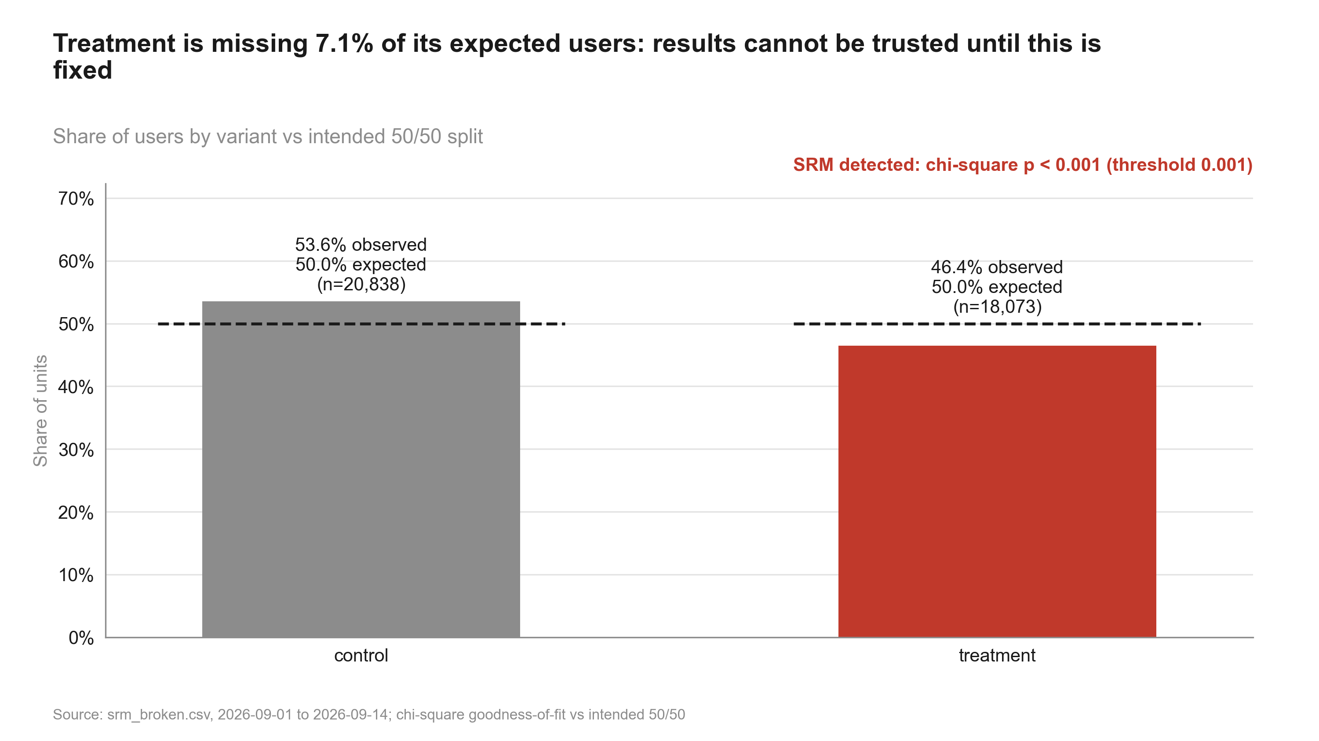
Figure 1: Treatment is missing 7.1% of its expected users: results cannot be trusted until this is fixed. Share of users by variant
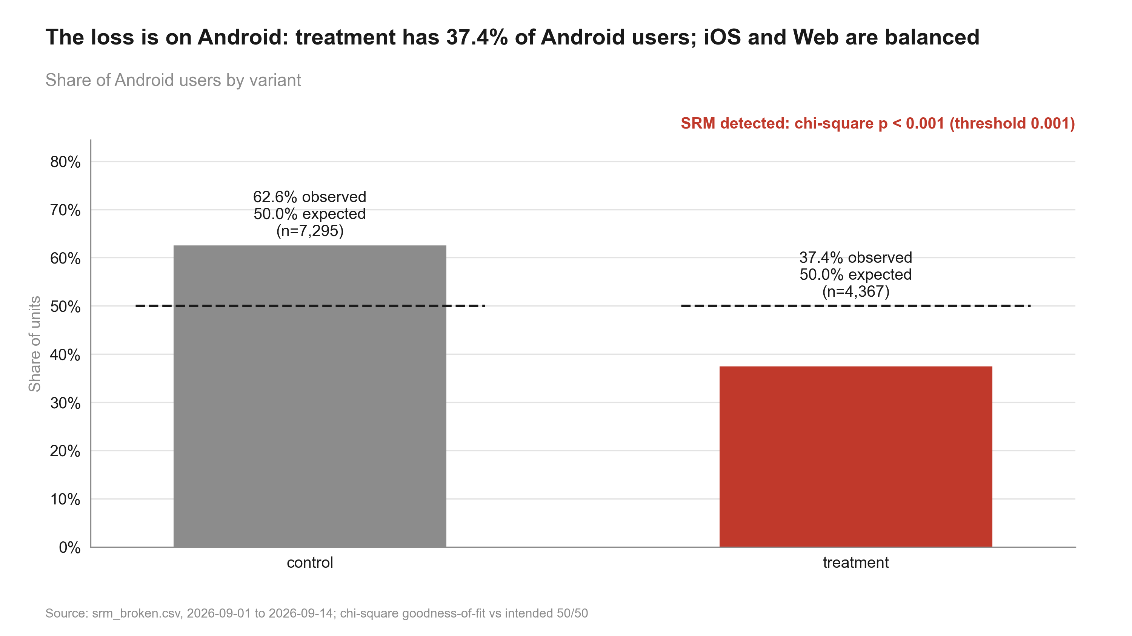
Figure 2: The loss is on Android: treatment has 37.4% of Android users; iOS and Web are balanced. Android users by variant

4. Methods, step by step

validate: validation.full_profile (done)
Why (plan): done (verdict BLOCK)
Script: code/10_validate_profile.py
Data validation profile: Schema, dtypes, missing values, duplicates, contamination, variants, SRM, dates, outliers, impossible values, pre-period data, covariate balance.
pass / warn / block per check. Assumptions: None. Reference: abkit.validation.full_profile.

srm: validation.srm_check (done)
Why (plan): done (SRM detected)
Script: code/10_validate_profile.py
Sample ratio mismatch test: Chi-square goodness of fit of unit counts against the intended split.
chi2 = sum_v (n_v - N s_v)^2 / (N s_v), s_v = intended share; SRM if p < threshold (default 0.001)
Asymptotic chi-square. Assumptions: Counts of randomisation units. Reference: abkit.validation.srm_check.
Settings applied: alpha 0.001; sidedness n/a; correction none.
- Sample ratio mismatch: do not trust effect estimates until the cause is understood.

primary_test: frequentist.two_proportion_ztest (skipped)
Two-proportion z-test: Compares conversion rates between two independent groups of randomisation units.
p_hat = x / n per group; diff = p_T - p_C
z = diff / sqrt( p_pool (1 - p_pool) (1/n_C + 1/n_T) ), p_pool = (x_C + x_T) / (n_C + n_T)
CI(diff) = diff +/- z_crit * sqrt( p_C(1-p_C)/n_C + p_T(1-p_T)/n_T ) (unpooled)
rel = p_T/p_C - 1; Var(rel) ~ se_T^2/p_C^2 + p_T^2 se_C^2/p_C^4 (delta method)
Pooled SE for the test, unpooled SE for the CI; one-sided tests use a (1 - 2 alpha) two-sided CI. Assumptions: Independent units (one row per randomisation unit); at least 10 successes and failures per group. Reference: abkit.frequentist.two_proportion_ztest; ab-methods/frequentist_tests.md.

srm_localise: validation.srm_by (done)
Why (plan): quantify the loss by platform and by day, before vs after 2026-09-05
Script: code/20_analysis_srm_localise.py
Sample ratio mismatch test: Chi-square goodness of fit of unit counts against the intended split.
chi2 = sum_v (n_v - N s_v)^2 / (N s_v), s_v = intended share; SRM if p < threshold (default 0.001)
Asymptotic chi-square. Assumptions: Counts of randomisation units. Reference: abkit.validation.srm_check.
Settings applied: alpha 0.001; sidedness n/a; correction none.
- Sample ratio mismatch: do not trust effect estimates until the cause is understood.

summary: decision.build_blocked_summary (done)
Why (plan): "Blocked: data issue" verdict with the SRM evidence and next steps

5. Results
Table 6: Diagnostic tests
Step | Test | Statistic / estimate | Evidence | Interpretation
srm | srm check | 0.0355 | p < 0.001 | Sample ratio mismatch: do not trust effect estimates until the cause is understood.
srm_localise | srm check | 0.1255 | p < 0.001 | Sample ratio mismatch: do not trust effect estimates until the cause is understood.
srm_localise | srm check | 0.0030 | p = 0.323

6. Robustness and sensitivity
Only one method was applied per metric; no cross-method comparison is available.

What could change the conclusion
- iOS + Web alone show no mismatch (p = 0.323), but an iOS + Web-only readout would answer a different question (it excludes a whole platform); treat it as a sensitivity check only.
- Activation results were not computed: with units missing non-randomly, any difference could be caused by the loss.

7. Decision log
Verbatim records (in quote style) may mention values that were later superseded; the current numbers are those in sections 1-6.

Intake questions and answers
Already answered: variants (control / treatment), intended 50/50 split by user, one row per user, primary metric
activation (`converted`, activated within 7 days), dates 2026-09-01 to 2026-09-14, platform column.
Noticed in the data header (not yet a finding): about 20.8k control vs 18.1k treatment users. Validation will
test this formally, so the question below asks how exposure is logged.
Asked:
1. Practical threshold. Smallest activation lift worth shipping? [3% relative] -> "3%."
2. Exposure logging. How is a user recorded as exposed: server-side at assignment, or a client event when the
checklist renders? [client event] -> "Client event from the app when onboarding starts."
3. Changes during the test. Any app releases, SDK changes or incidents between 1 and 14 Sep? [none] ->
"There was an Android release around 4-5 Sep, not related to the test as far as I know."
4. Guardrails. Any guardrail metric? [none] -> "No."
5. Segments. Platform pre-specified for any decision? [no, diagnostics only] -> "Only if something looks off."
6. Statistical defaults (table shown) -> "Keep them."
7. Depth. [standard readout] -> "Standard."

User decisions at gates
Decision to be made: Ship / don't ship the checklist.
Decision after validation block (2026-10-01): Claude stopped at validation and explained: treatment has 18,073 users where 19,456 were expected (chi-square p < 0.001). The loss is concentrated in Android treatment users from 2026-09-05, matching the Android release. Options offered: (1) fix the Android exposure logging and re-extract the data; (2) a restricted sensitivity analysis on iOS + Web only, clearly labelled; (3) rerun the test after the fix; (4) a short "analysis blocked" readout for the team. User chose (4) now and (1)/(3) next: produce a blocked readout with the SRM evidence and no activation estimates, then re-extract after engineering fixes the logging.

Plan changes
Why the plan changed. Validation found a sample ratio mismatch: p < 0.001, concentrated in Android from

State history
Table 7: state.json history
When (UTC) | Event
2026-09-30T20:53:36+00:00 | run created
2026-09-30T20:54:01+00:00 | gate plan_approved = True
2026-09-30T20:54:01+00:00 | phase -> validation
2026-09-30T20:54:18+00:00 | gate validation_passed = False
2026-09-30T20:54:56+00:00 | gate plan_approved = True
2026-09-30T20:54:56+00:00 | gate validation_passed = True
2026-09-30T20:54:57+00:00 | phase -> analysis
2026-09-30T20:55:20+00:00 | phase -> review
2026-09-30T20:55:52+00:00 | gate review_passed = True
2026-09-30T20:55:52+00:00 | phase -> deliverables
2026-09-30T20:56:23+00:00 | phase -> done

Review rounds
Review: 2026-10-01_onboarding-checklist (round 1) - Verdict: PASS
#1 [note] Handling is correct: SRM blocked the analysis and no activation estimate was produced or reported. | fix: none
#2 [note] The loss is specific to Android from 2026-09-05; iOS + Web are balanced. An iOS + Web-only readout would change the population, and the caveat says so. | fix: none
#3 [note] The covariate-balance warning (platform mix differs by variant) is a symptom of the same loss, not a separate issue. | fix: none

8. Reproducibility
Table 8: Environment
Item | Value
Python | 3.13.2
Platform | Windows-11-10.0.26200-SP0
Packages | pandas 2.3.0, numpy 2.3.0, scipy 1.15.3, statsmodels 0.15.0, matplotlib 3.10.5, python-pptx 1.0.2, python-docx 1.2.0, PyYAML 6.0.2
abkit | 0.1.0
results.json schema | 1
Seeds | bootstrap seed 42 (10000 resamples); Bayesian draws seed 42 (abkit default)

Table 9: Code index
Script | Purpose | Writes results for
10_validate_profile.py | Validate srm_broken.csv: full profile with SRM localised by date and platform; write data_profile.md. | srm, validation
20_analysis_srm_localise.py | SRM localisation: split counts by platform and by period (before / from 2026-09-05). Step: srm_localise. | srm_localise
20_analysis_summary.py | Blocked readout summary: verdict 'Blocked: data issue' built from the validation and SRM localisation results. Step: summary. | summary
30_charts_srm.py | Charts for the blocked readout: overall SRM and Android-only SRM (numbers from results.json). | -
40_deck_build.py | Build deck.pptx for the blocked readout. | -
50_report_build.py | Build summary.docx for the blocked readout. | -
50_technical_report.py | Build technical_report.docx: methods, formulas, decision log, robustness and reproducibility for data scientists. | -

How to rerun
From the repository root, in this order (the plan_gate hook requires the run's gates to be open for 20_-50_ scripts):
python runs/2026-10-01_onboarding-checklist/code/10_validate_profile.py
python runs/2026-10-01_onboarding-checklist/code/20_analysis_srm_localise.py
python runs/2026-10-01_onboarding-checklist/code/20_analysis_summary.py
python runs/2026-10-01_onboarding-checklist/code/30_charts_srm.py
python runs/2026-10-01_onboarding-checklist/code/40_deck_build.py
python runs/2026-10-01_onboarding-checklist/code/50_report_build.py
python runs/2026-10-01_onboarding-checklist/code/50_technical_report.py
Then check every printed number against results.json:
python -m abkit.tracecheck 2026-10-01_onboarding-checklist
Run log: 11 commands logged while this run was active (0 failed); see run_log.jsonl.
Table 10: Run artefacts
Artefact | Size
charts/manifest.json | 1.6 KB
charts/srm_bar.png | 181.8 KB
charts/srm_bar_android.png | 183.2 KB
context.md | 0.3 KB
data/srm_broken.csv | 1,372.9 KB
data_profile.md | 3.7 KB
deck.pptx | 371.7 KB
deck_storyline.md | 1.0 KB
intake.md | 3.0 KB
plan.md | 1.0 KB
results.json | 23.7 KB
review.md | 1.3 KB
state.json | 3.4 KB
summary.docx | 350.2 KB

