Single-button checkout test
Treatment raises checkout conversion by 3.2% vs control (statistically significant)
Source: checkout_ab.csv, 2026-09-01 to 2026-09-14; run 2026-10-01_checkout-button

Executive summary
Recommendation: SHIP
Treatment raises checkout conversion by 3.2% vs control (statistically significant)
The primary metric improved significantly and no guardrail was breached.

In plain terms: For every 1,000 users, about 11 more achieved checkout conversion with treatment than with control. A difference this large is unlikely to be down to chance.
- Relative lift in checkout conversion: +3.2% (99% CI [+0.6%, +5.8%])
- Evidence: p = 0.001
- Checkout conversion: control vs treatment: 34.25% vs 35.34%
- Units analysed: control: 40,183 / treatment: 39,817
- Guardrail revenue: pass (+2.2%)
Caveats: CI lower bound +0.6% is below the 2% threshold: the true lift may be smaller than needed (review finding 1). Platforms: iOS +5.2%, Web +1.2%; interaction p = 0.168, no evidence they differ. Revenue is heavy-tailed; bootstrap CI [−1.0%, +5.4%] agrees with the guardrail pass. Daily lift: stable (no significant trend) (p = 0.794).
Next step: Roll out the single-button checkout to all users on every platform

Business question and hypothesis

Business question
Should we ship the single-button ("Pay now") checkout to all users?

Decision to be made
Ship / don't ship the single-button checkout; whether a platform-specific rollout is needed.

Hypothesis
Replacing the multi-step checkout with a single "Pay now" button increases checkout conversion without lowering revenue per user.

Context as described
We ran an A/B test on the checkout page: the treatment replaces the multi-step checkout with a single "Pay now" button. File: checkout_ab.csv, one row per user. Columns: user_id, variant (control / treatment), exposure_date (first day the user saw checkout, 2026-09-01 to 2026-09-14), platform (iOS / Android / Web), country (US / UK / DE / IN), converted (1 if the user completed a purchase within the test), revenue (USD revenue from that user during the test, 0 if no purchase). Traffic was split 50/50 at user level. Primary metric is conversion; revenue per user is a guardrail - we don't want it to drop. We'd like to know if we should ship it, and whether the effect differs by platform.

Experiment design
Table 1: Experiment setup
Item | Detail
Variants (units) | control: 40,183, treatment: 39,817
Test period | 2026-09-01 to 2026-09-14 (14 days)
Primary metric | converted (binary, goal: increase)
Guardrail metric | revenue (continuous, goal: no decrease)
Statistical settings | alpha 0.01, two-sided, power 0.8
Multiple-testing correction | secondary: holm; segments: benjamini-hochberg
Analysis type | post test readout, guardrail check, heterogeneous effects, novelty check

Data and validation
Overall validation verdict: PASS. Checks follow; outliers are reported, never removed automatically.
Table 2: Validation checks
Check | Verdict | Detail
schema | PASS | 7 columns, 80,000 rows
dtypes | PASS | All metric columns numeric
missing values | PASS | No missing values
duplicates | PASS | 80,000 units, one row each
contamination | PASS | No unit appears in more than one variant
variants | PASS | Counts {'control': 40183, 'treatment': 39817}
SRM | PASS | p = 0.196 (threshold 0.001)
dates | PASS | 2026-09-01 to 2026-09-14 (14 days)
outliers | PASS | No extreme outliers in continuous metrics
impossible values | PASS | Metric values within valid ranges
pre-period data | PASS | None described (CUPED not possible)
covariate balance | PASS | Segment mix similar across variants

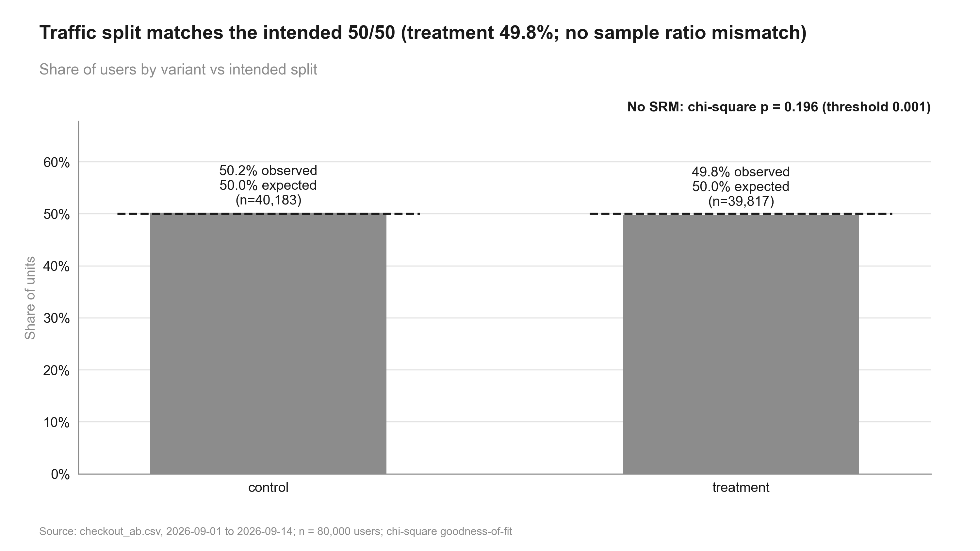
Figure 1: Traffic split matches the intended 50/50 (treatment 49.8%; no sample ratio mismatch). Share of users by variant vs intended split

Methodology
- srm: srm check (code/10_validate_profile.py)
- primary test: two proportion ztest (code/20_analysis_primary_test.py)
- guardrail revenue: noninferiority test (code/20_analysis_guardrail_revenue.py)
- revenue sensitivity: welch ttest, bootstrap mean diff (code/20_analysis_revenue_sensitivity.py)
- segments platform: segment effects, two proportion ztest, interaction test, simpsons check (code/20_analysis_segments_platform.py)
- time trends: cumulative effects, trend test (code/20_analysis_time_trends.py)
Significance level 0.01 (two-sided), target power 0.8; corrections: primary none, secondary holm, segments benjamini-hochberg. SRM threshold p < 0.001.

Results
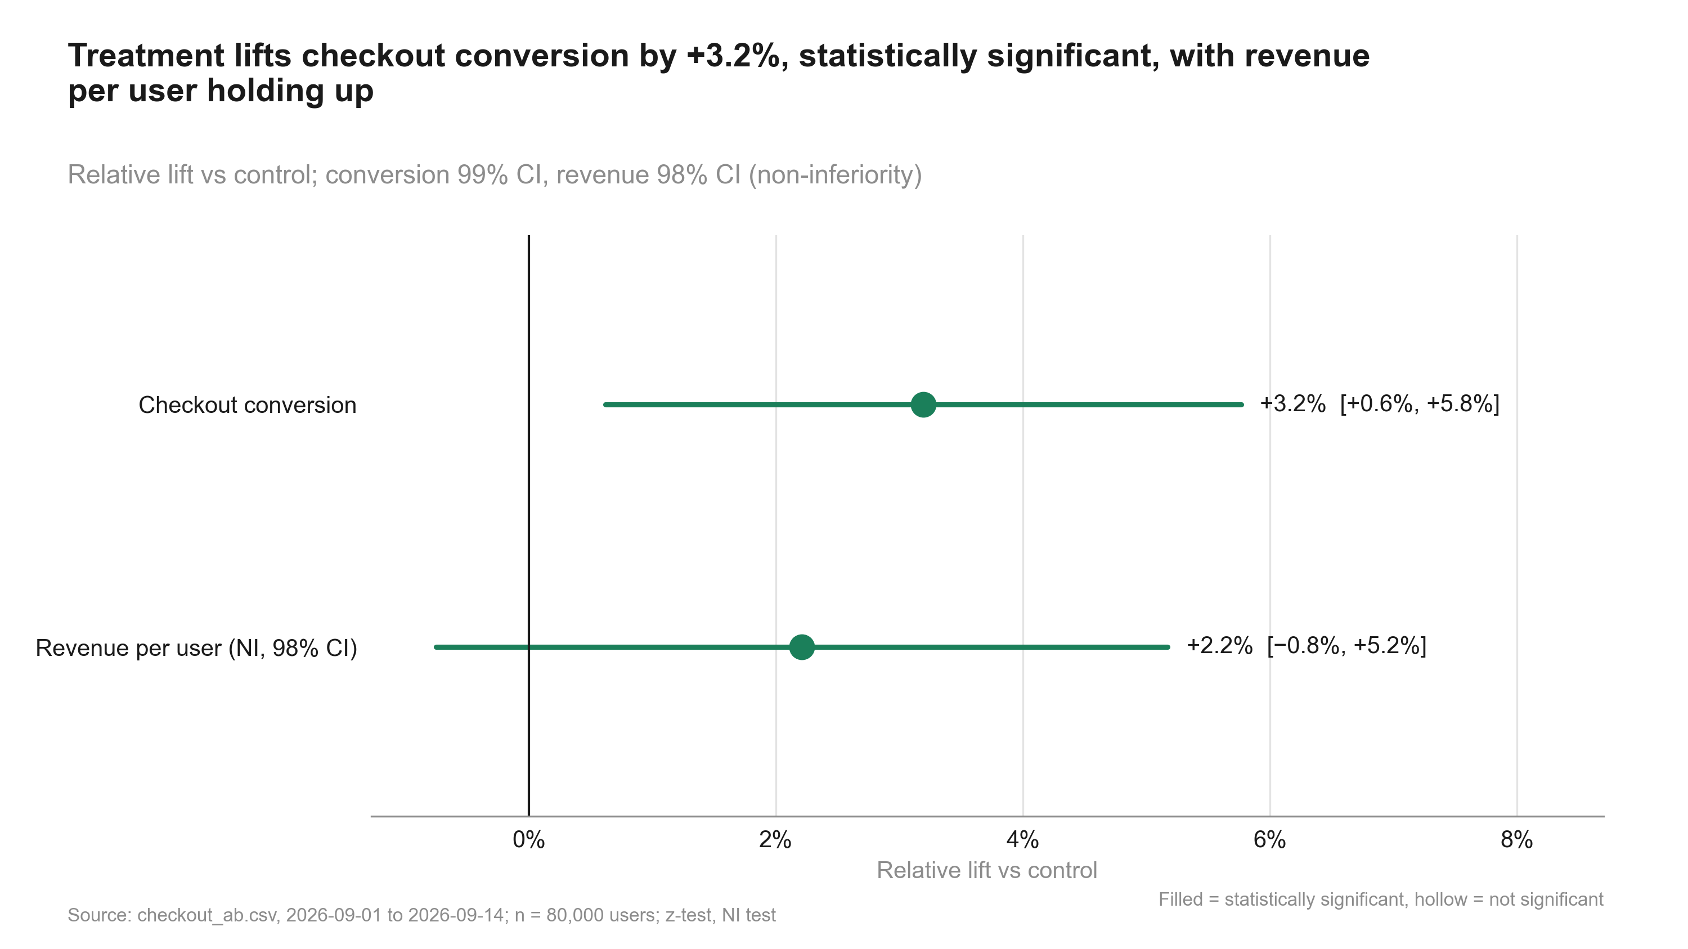
Figure 2: Treatment lifts checkout conversion by +3.2%, statistically significant, with revenue per user holding up. Relative lift vs control
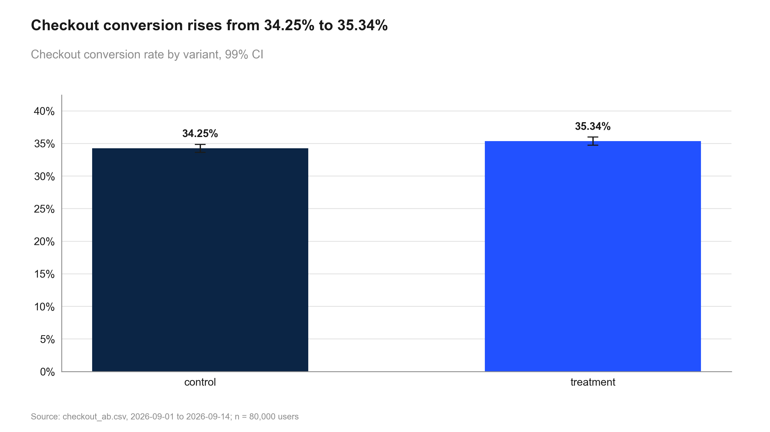
Figure 3: Checkout conversion rises from 34.25% to 35.34%. Checkout conversion rate by variant, 99% CI
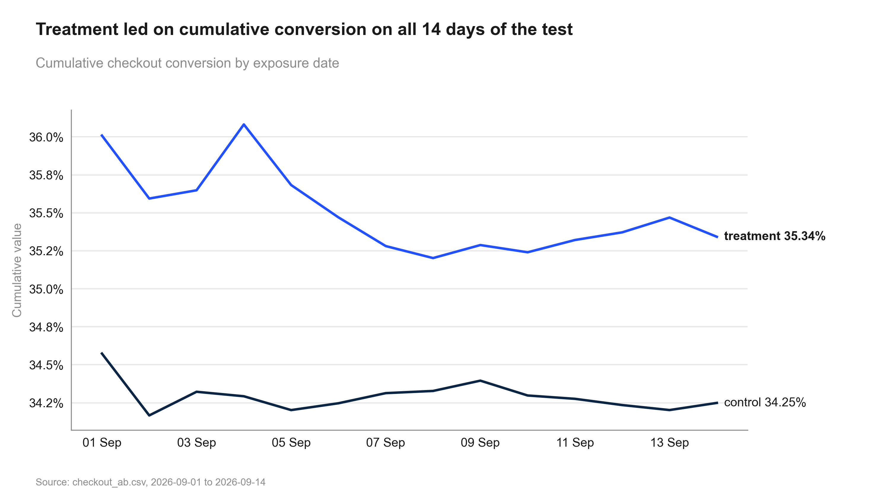
Figure 4: Treatment led on cumulative conversion on all 14 days of the test. Cumulative conversion by exposure date
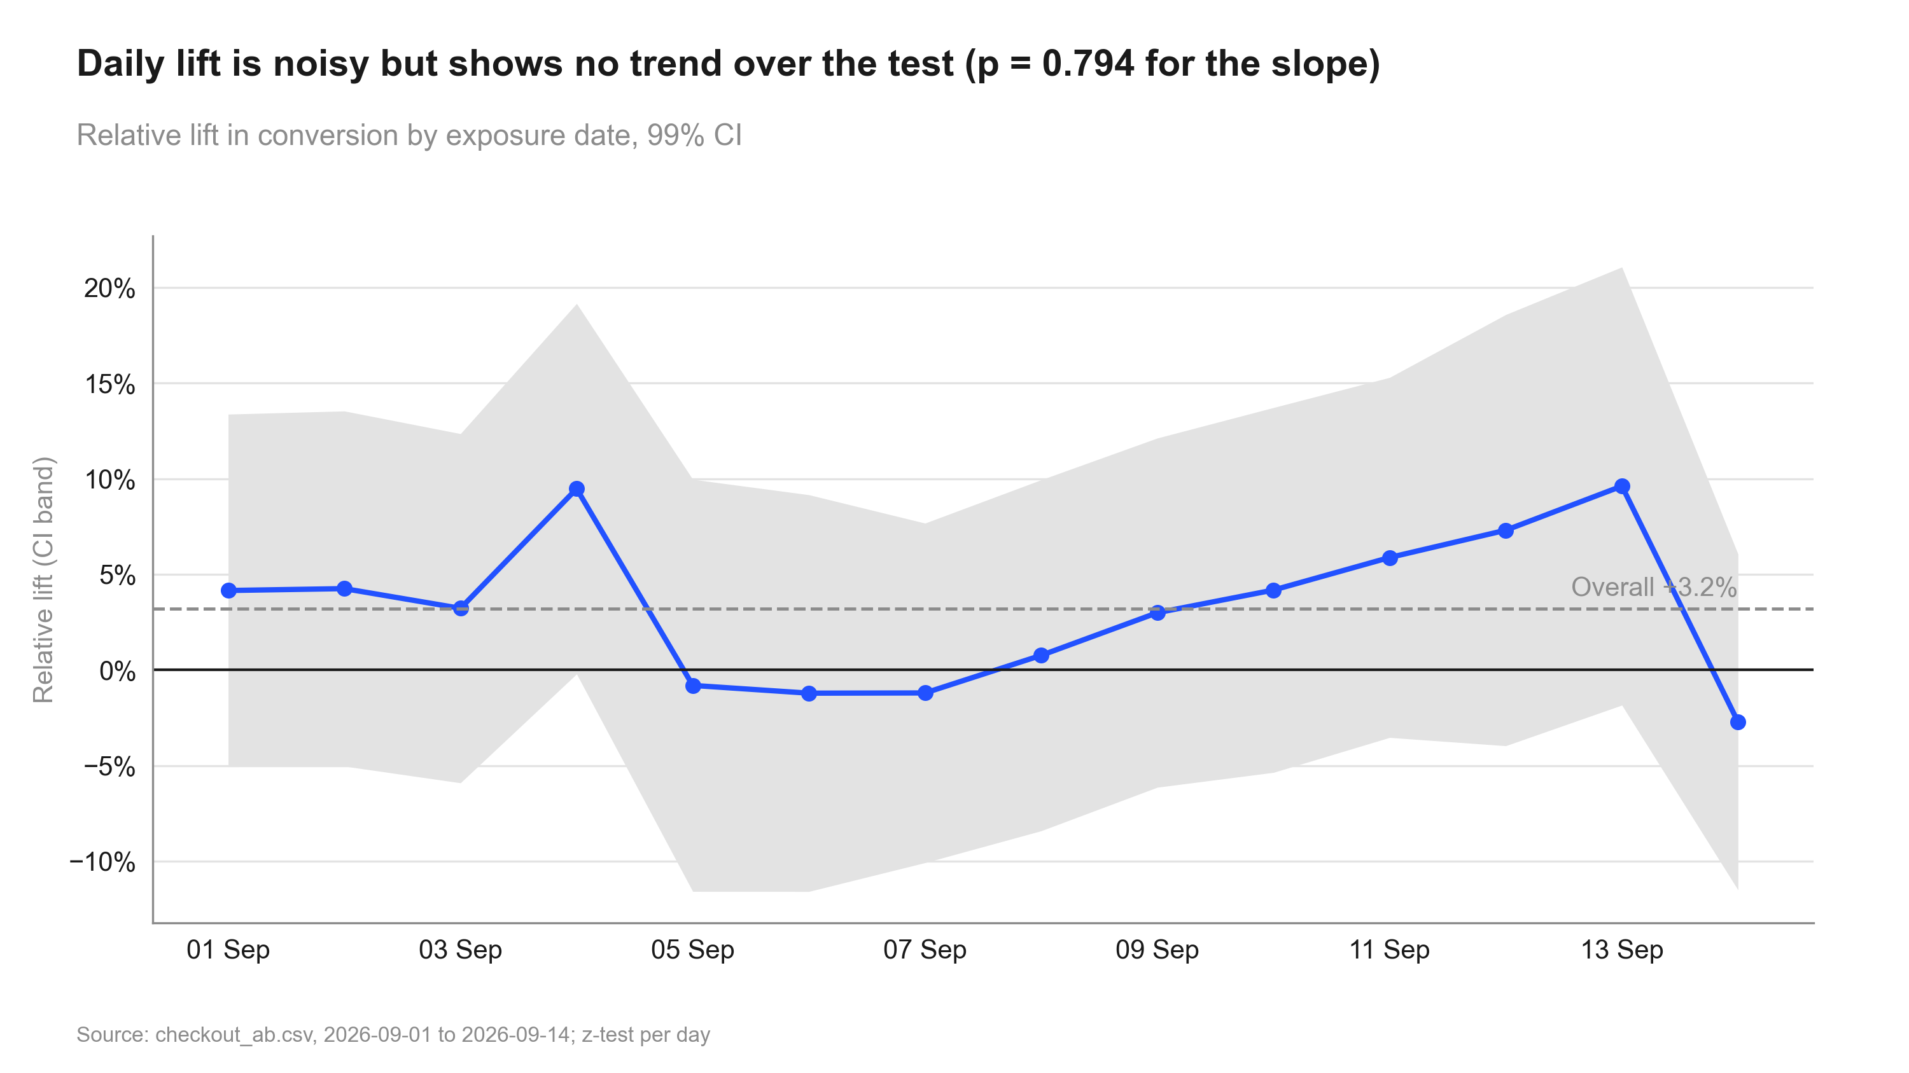
Figure 5: Daily lift is noisy but shows no trend over the test (p = 0.794 for the slope). Daily relative lift
Table 3: Primary and secondary metrics
Metric | Comparison | Control | Treatment | Rel. lift | CI | p / P(beat) | Method
converted | treatment vs control | 34.25% | 35.34% | +3.2% | [+0.6%, +5.8%] | 0.001 | two proportion ztest

Guardrails
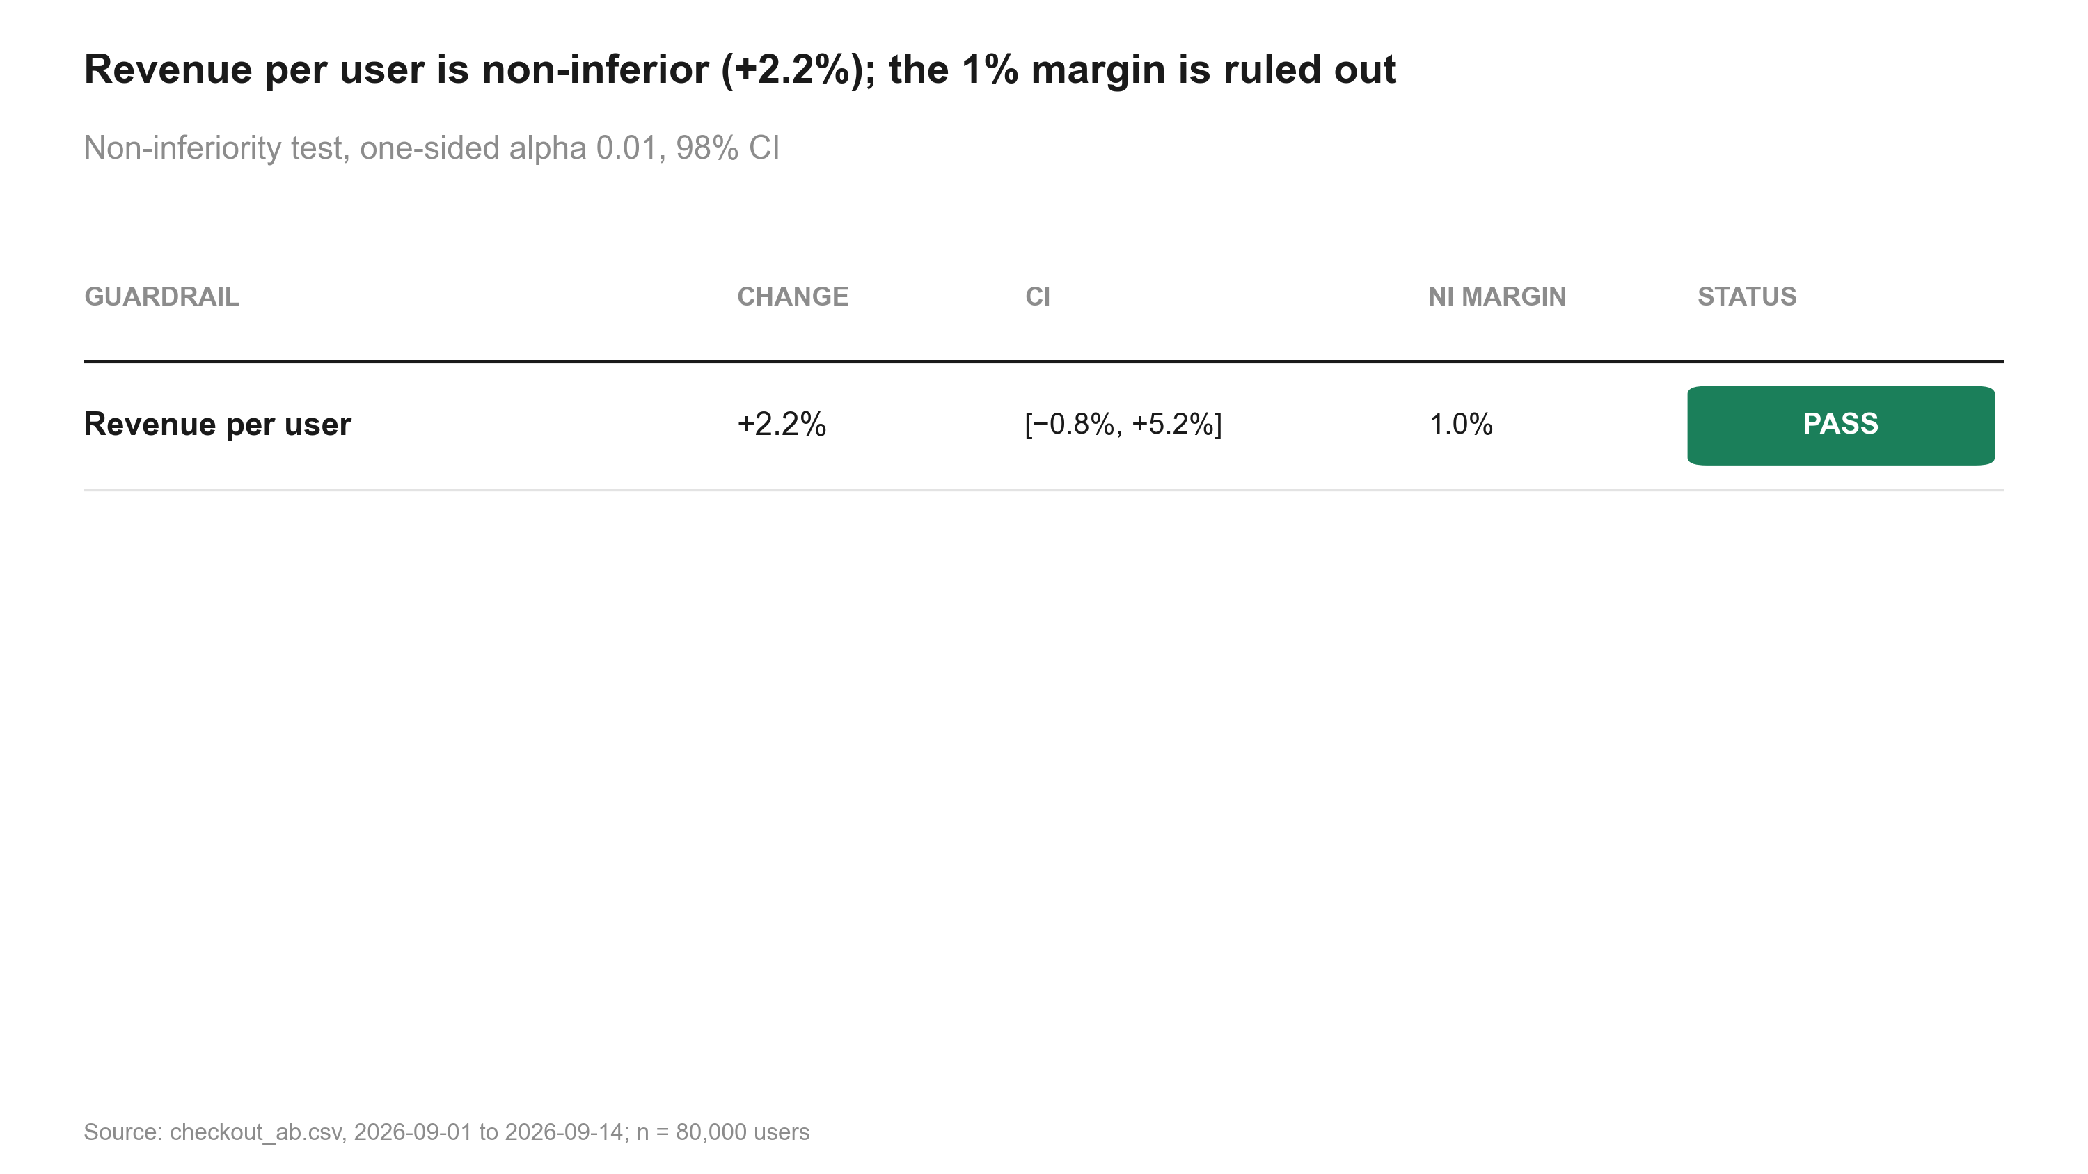
Figure 6: Revenue per user is non-inferior (+2.2%); the 1% margin is ruled out. Non-inferiority test
Table 4: Guardrail non-inferiority tests
Metric | Comparison | Control | Treatment | Rel. lift | CI | p / P(beat) | Method | Status
revenue | treatment vs control | 22.73 | 23.23 | +2.2% | [−0.8%, +5.2%] | 0.005 | noninferiority test | PASS

Segments
Segments were pre-specified; p-values are corrected across segments. A difference between segments is only claimed when the interaction test supports it.
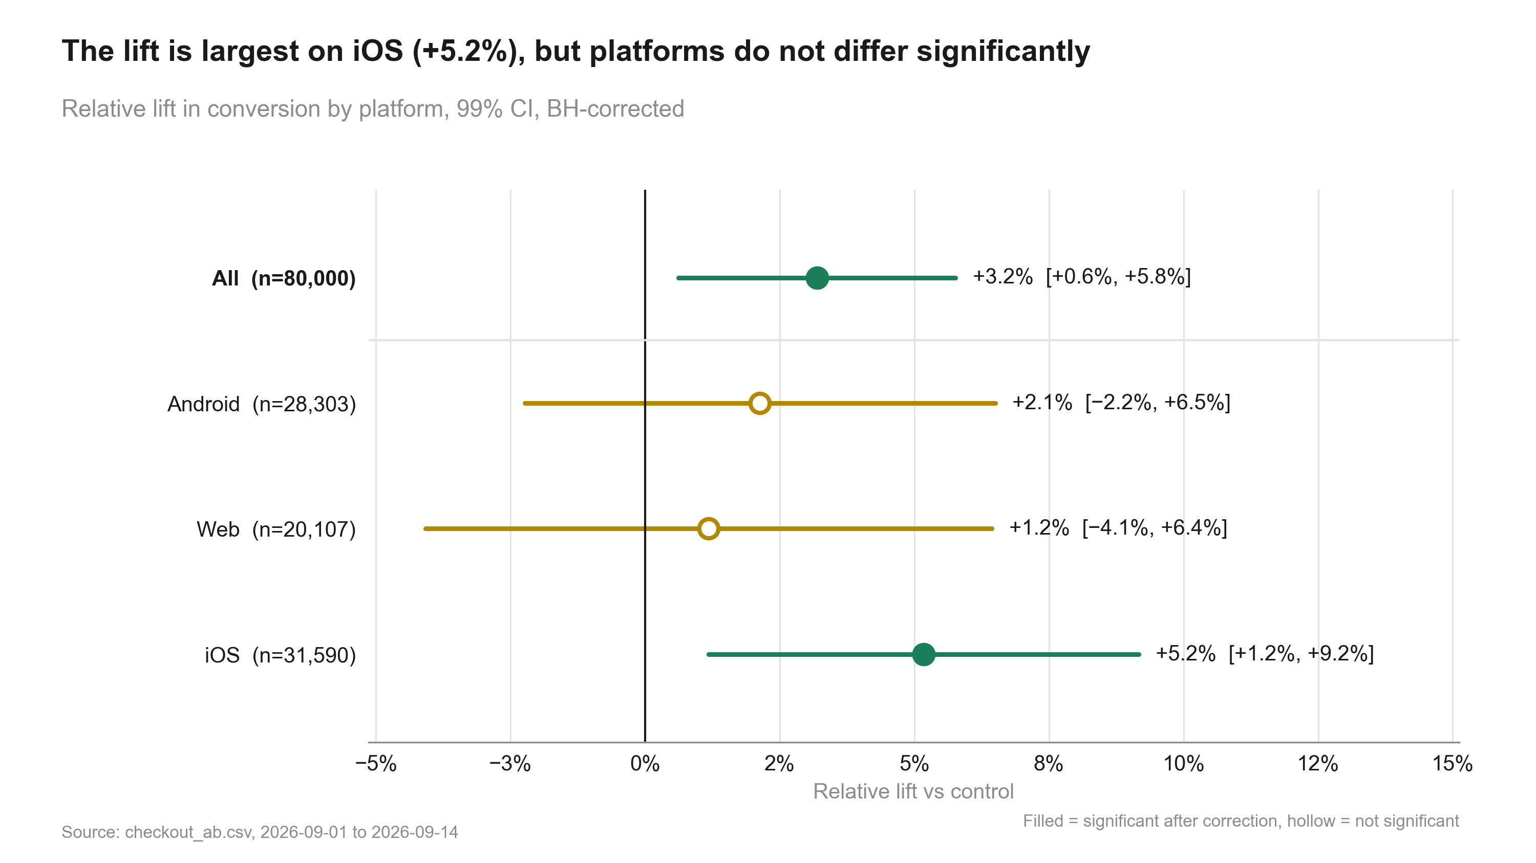
Figure 7: The lift is largest on iOS (+5.2%), but platforms do not differ significantly. Lift by platform
Table 5: Effect by segment
Metric | Segment | Comparison | Control | Treatment | Rel. lift | CI | p / P(beat) | Method
converted | Android | treatment vs control | 33.53% | 34.24% | +2.1% | [−2.2%, +6.5%] | 0.306 (adj.) | two proportion ztest
converted | Web | treatment vs control | 32.63% | 33.02% | +1.2% | [−4.1%, +6.4%] | 0.561 (adj.) | two proportion ztest
converted | iOS | treatment vs control | 35.93% | 37.79% | +5.2% | [+1.2%, +9.2%] | 0.002 (adj.) | two proportion ztest

Interaction test for platform: p = 0.168. Tests heterogeneity of the absolute effect; no evidence the effect differs by segment.

Risks, limitations and assumptions
- CI lower bound +0.6% is below the 2% threshold: the true lift may be smaller than needed (review finding 1).
- Platforms: iOS +5.2%, Web +1.2%; interaction p = 0.168, no evidence they differ.
- Revenue is heavy-tailed; bootstrap CI [−1.0%, +5.4%] agrees with the guardrail pass.
- Daily lift: stable (no significant trend) (p = 0.794).

Recommendation and next steps
Ship. The primary metric improved significantly and no guardrail was breached.
- Roll out the single-button checkout to all users on every platform
- Track conversion and revenue per user for four weeks after rollout against this test's estimates
- Use a follow-up test if a platform-specific design is wanted (Web shows the smallest lift)

Appendix

Settings
Table 6: Statistical settings used
Setting | Value
alpha | 0.01
sidedness | two-sided
power | 0.8
confidence_level | 0.95
correction_primary | none
correction_secondary | holm
correction_segments | benjamini-hochberg
srm_test | chi-square
srm_threshold | 0.001
min_days | 7
prefer_full_weeks | True
bayes_prior | weakly_informative
bayes_decision_threshold | 0.95
bootstrap_n_resamples | 10000
bootstrap_seed | 42
noninferiority_margin_relative | 0.01

Overrides: alpha: 0.05 -> 0.01

Reviewer findings
Review: 2026-10-01_checkout-button (round 3, follow-up "rerun with alpha 0.01"). Earlier rounds are in review.md.
- Verdict: PASS
- | # | Severity | Finding | Evidence | Suggested fix |
- |---|---|---|---|---|
- | 1 | note | At alpha 0.01 the primary result stays significant (p = 0.001) and its 99% CI [+0.6%, +5.8%] is wider; the lower bound is further below the 2% threshold, and the caveat reflects it. | primary_test | none |
- | 2 | note | The revenue guardrail still passes non-inferiority at one-sided alpha 0.01 (98% CI). iOS stays significant after BH (adjusted p = 0.002). | guardrail_revenue, segments_platform | none |
- | 3 | resolved | Chart subtitles had hard-coded "95% CI" / "90% CI"; they now derive the level from alpha (30_charts_*.py). | code diff | none |
- Override recorded in state.json (alpha 0.05 -> 0.01). Verdict unchanged: Ship.
Table 7: All estimates
Metric | Segment | Comparison | Control | Treatment | Rel. lift | CI | p / P(beat) | Method
converted |  | treatment vs control | 34.25% | 35.34% | +3.2% | [+0.6%, +5.8%] | 0.001 | two proportion ztest
revenue |  | treatment vs control | 22.73 | 23.23 | +2.2% | [−0.8%, +5.2%] | 0.005 | noninferiority test
revenue |  | treatment vs control | 22.73 | 23.23 | +2.2% | [−1.1%, +5.5%] | 0.079 | welch ttest
revenue |  | treatment vs control | 22.73 | 23.23 | +2.2% | [−1.0%, +5.4%] | 0.082 | bootstrap mean diff
converted | Android | treatment vs control | 33.53% | 34.24% | +2.1% | [−2.2%, +6.5%] | 0.306 (adj.) | two proportion ztest
converted | Web | treatment vs control | 32.63% | 33.02% | +1.2% | [−4.1%, +6.4%] | 0.561 (adj.) | two proportion ztest
converted | iOS | treatment vs control | 35.93% | 37.79% | +5.2% | [+1.2%, +9.2%] | 0.002 (adj.) | two proportion ztest

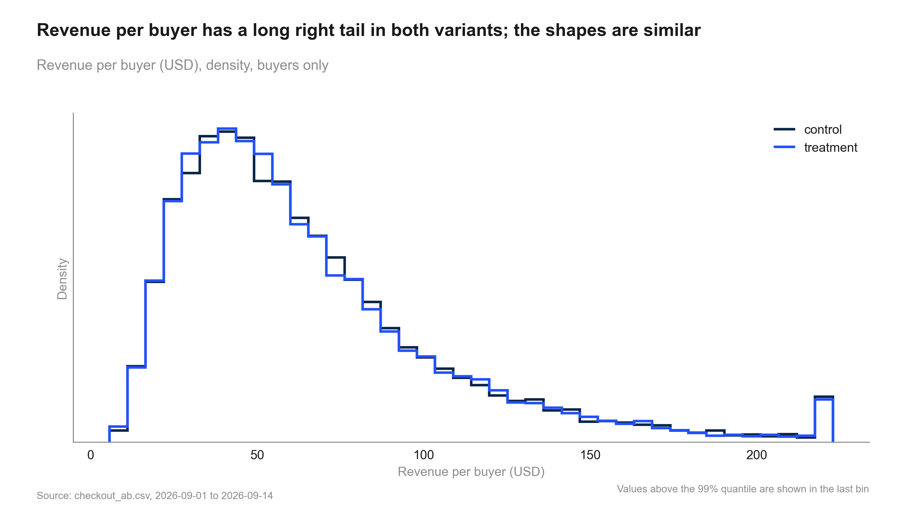
Figure 8: Revenue per buyer has a long right tail in both variants; the shapes are similar. Revenue per buyer distribution

Code index
- 10_validate_profile.py: Validate checkout_ab.csv against context.md and intake.md; write data_profile.md and results.json validation.
- 20_analysis_guardrail_revenue.py: Guardrail: non-inferiority of revenue per user (margin from settings, one-sided). Step: guardrail_revenue.
- 20_analysis_primary_test.py: Primary metric: two-proportion z-test on checkout conversion (user level). Step: primary_test.
- 20_analysis_revenue_sensitivity.py: Revenue sensitivity: Welch vs percentile bootstrap for revenue per user, plus distribution data. Step: revenue_sensitivity.
- 20_analysis_segments_platform.py: Platform segments: per-platform lift (BH-corrected), interaction test, Simpson's check. Step: segments_platform.
- 20_analysis_summary.py: Decision and summary: verdict against the practical threshold and the revenue guardrail. Step: summary.
- 20_analysis_time_trends.py: Stability over time: cumulative conversion by day, daily lift, and a trend test for novelty. Step: time_trends.
- 30_charts_detail.py: Charts: cumulative and daily conversion, platform forest plot, revenue distribution (all numbers from results.json).
- 30_charts_results.py: Charts: SRM, primary lift, conversion by variant, guardrail scorecard (all numbers from results.json).
- 40_deck_build.py: Build deck.pptx from results.json, state.json (deck sections) and charts/manifest.json.
- 50_report_build.py: Build summary.docx from results.json, intake.md, review.md and charts/manifest.json.

