Home feed redesign
Treatment raises minutes per user by 1.7% vs control (statistically significant)
Source: cuped_engagement.csv; run 2026-10-01_home-feed-redesign

Executive summary
Recommendation: SHIP
Treatment raises minutes per user by 1.7% vs control (statistically significant)
The primary metric improved significantly and by more than the practical threshold.

In plain terms: Average minutes per user was 1.07 higher with treatment than with control. A difference this large is unlikely to be down to chance.
- Relative lift in minutes per user: +1.7% (95% CI [+0.0%, +3.3%])
- Evidence: p = 0.042
- Minutes per user: control vs treatment (adjusted): 63.77 vs 64.84
- Units analysed: control: 9,902 / treatment: 10,098
- Unadjusted test (for comparison): +2.1%, p = 0.081
- CI narrower with CUPED: 31%
Caveats: CUPED chosen after the unadjusted result (p = 0.081) was seen; both reported. CI [+0.0%, +3.3%] includes lifts below the 1% threshold. CUPED lift +1.7% vs unadjusted +2.1%: treatment had a small pre-period head start by chance (review finding 2). Regression adjustment agrees: +1.7% (p = 0.042). No dates in the data: novelty not checked.
Next step: Ship the redesigned home feed

Business question and hypothesis

Business question
Does the redesigned home feed increase time spent in the app?

Decision to be made
Ship / don't ship the redesigned feed.

Hypothesis
The redesigned feed increases minutes per user.

Context as described
We tested a redesigned home feed. File cuped_engagement.csv, one row per user: user_id, variant (control / treatment), signup_country, pre_minutes (minutes in app in the 14 days before the test), minutes (minutes in app during the 14-day test). Randomised 50/50 by user. Primary metric is minutes per user. The naive t-test was borderline - can we use the pre-period data to get a more precise answer?

Experiment design
Table 1: Experiment setup
Item | Detail
Variants (units) | treatment: 10,098, control: 9,902
Primary metric | minutes (continuous, goal: increase)
Statistical settings | alpha 0.05, two-sided, power 0.8
Multiple-testing correction | secondary: holm; segments: benjamini-hochberg
Analysis type | cuped reanalysis, post test readout

Data and validation
Overall validation verdict: PASS. Checks follow; outliers are reported, never removed automatically.
Table 2: Validation checks
Check | Verdict | Detail
schema | PASS | 5 columns, 20,000 rows
dtypes | PASS | All metric columns numeric
missing values | PASS | No missing values
duplicates | PASS | 20,000 units, one row each
contamination | PASS | No unit appears in more than one variant
variants | PASS | Counts {'treatment': 10098, 'control': 9902}
SRM | PASS | p = 0.166 (threshold 0.001)
outliers | PASS | No extreme outliers in continuous metrics
impossible values | PASS | Metric values within valid ranges
pre-period data | PASS | Available; correlations with metrics pre_minutes~minutes=0.73
covariate balance | PASS | Segment mix similar across variants

Methodology
- srm: srm check (code/10_validate_profile.py)
- naive test: welch ttest, bootstrap mean diff (code/20_analysis_naive_test.py)
- cuped test: cuped (code/20_analysis_cuped_test.py)
- regression check: regression adjustment (code/20_analysis_regression_check.py)
Significance level 0.05 (two-sided), target power 0.8; corrections: primary none, secondary holm, segments benjamini-hochberg. SRM threshold p < 0.001.

Results
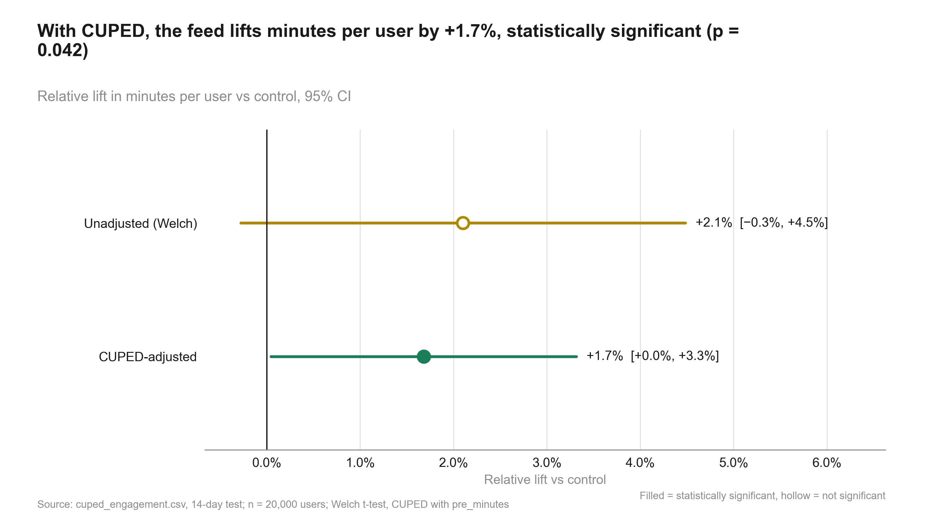
Figure 1: With CUPED, the feed lifts minutes per user by +1.7%, statistically significant (p = 0.042). Relative lift, 95% CI
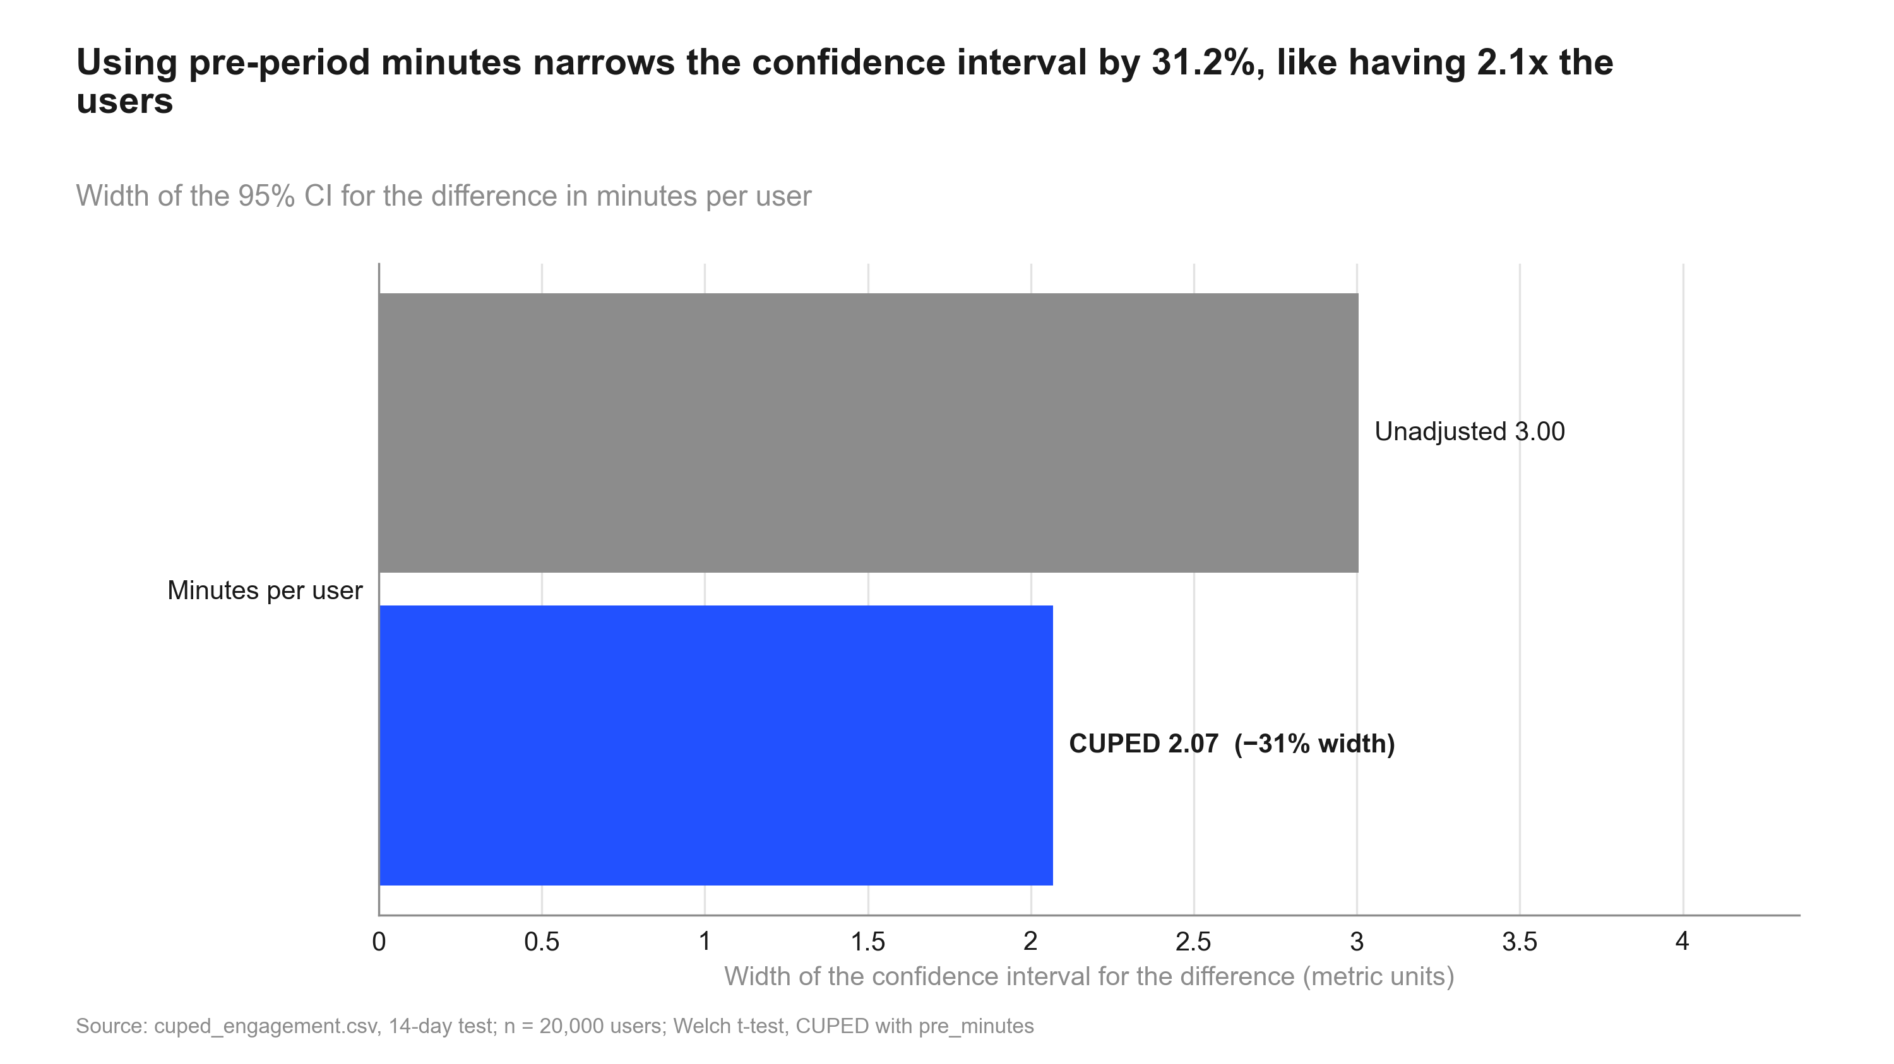
Figure 2: Using pre-period minutes narrows the confidence interval by 31.2%, like having 2.1x the users. CI width before vs after CUPED
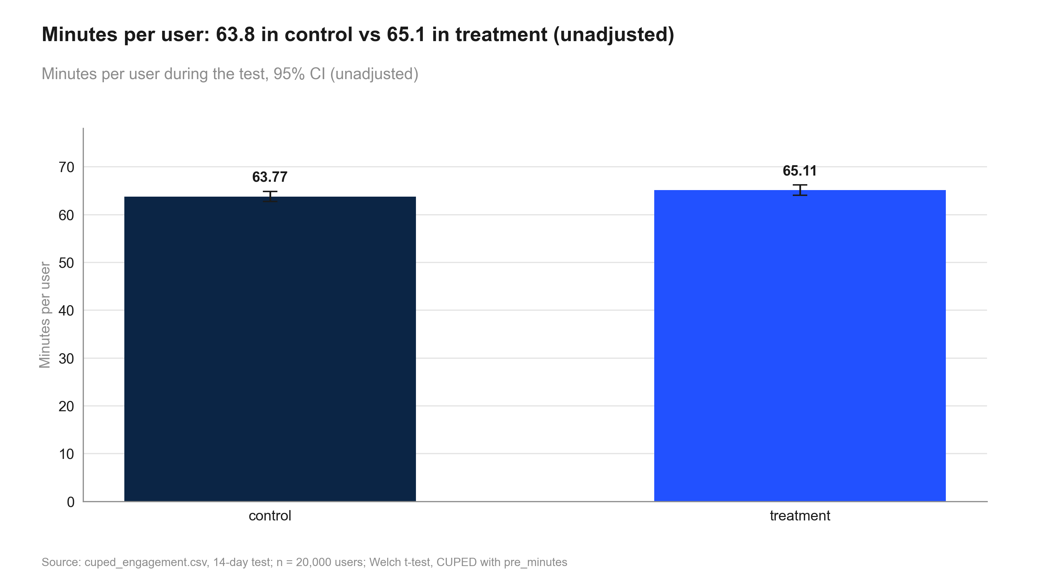
Figure 3: Minutes per user: 63.8 in control vs 65.1 in treatment (unadjusted). Minutes per user
Table 3: Primary and secondary metrics
Metric | Comparison | Control | Treatment | Rel. lift | CI | p / P(beat) | Method
minutes | treatment vs control | 63.77 | 64.84 | +1.7% | [+0.0%, +3.3%] | 0.042 | cuped

Risks, limitations and assumptions
- CUPED chosen after the unadjusted result (p = 0.081) was seen; both reported.
- CI [+0.0%, +3.3%] includes lifts below the 1% threshold.
- CUPED lift +1.7% vs unadjusted +2.1%: treatment had a small pre-period head start by chance (review finding 2).
- Regression adjustment agrees: +1.7% (p = 0.042).
- No dates in the data: novelty not checked.

Recommendation and next steps
Ship. The primary metric improved significantly and by more than the practical threshold.
- Ship the redesigned home feed
- Pre-register CUPED with pre-period minutes as the default analysis for future engagement tests
- Check minutes per user again four weeks after launch, as novelty could not be ruled out

Appendix

Settings
Table 4: Statistical settings used
Setting | Value
alpha | 0.05
sidedness | two-sided
power | 0.8
confidence_level | 0.95
correction_primary | none
correction_secondary | holm
correction_segments | benjamini-hochberg
srm_test | chi-square
srm_threshold | 0.001
min_days | 7
prefer_full_weeks | True
bayes_prior | weakly_informative
bayes_decision_threshold | 0.95
bootstrap_n_resamples | 10000
bootstrap_seed | 42
noninferiority_margin_relative | 0.01

Reviewer findings
Review: 2026-10-01_home-feed-redesign (round 2). Earlier rounds are in review.md.
- Verdict: PASS
- | # | Severity | Finding | Evidence | Suggested fix |
- |---|---|---|---|---|
- | 1 | resolved by user decision | CUPED accepted as primary; the post-hoc choice is the first caveat and pre-registration is a next step. | intake.md "Decision on review blocker 1"; summary.caveats[0] | none |
- | 2 | resolved | The caveat explaining the +2.1% to +1.7% shift has been added. | summary.caveats | none |
- Addendum (round 2): caveat wording shortened for the deck word limit; numbers and verdict unchanged. Re-checked: ok.
Table 5: All estimates
Metric | Comparison | Control | Treatment | Rel. lift | CI | p / P(beat) | Method
minutes | treatment vs control | 63.77 | 65.11 | +2.1% | [−0.3%, +4.5%] | 0.081 | welch ttest
minutes | treatment vs control | 63.77 | 65.11 | +2.1% | [−0.3%, +4.5%] | 0.081 | bootstrap mean diff
minutes | treatment vs control | 63.77 | 64.84 | +1.7% | [+0.0%, +3.3%] | 0.042 | cuped
minutes | treatment vs control | 63.77 | 64.84 | +1.7% | [+0.1%, +3.3%] | 0.042 | regression adjustment

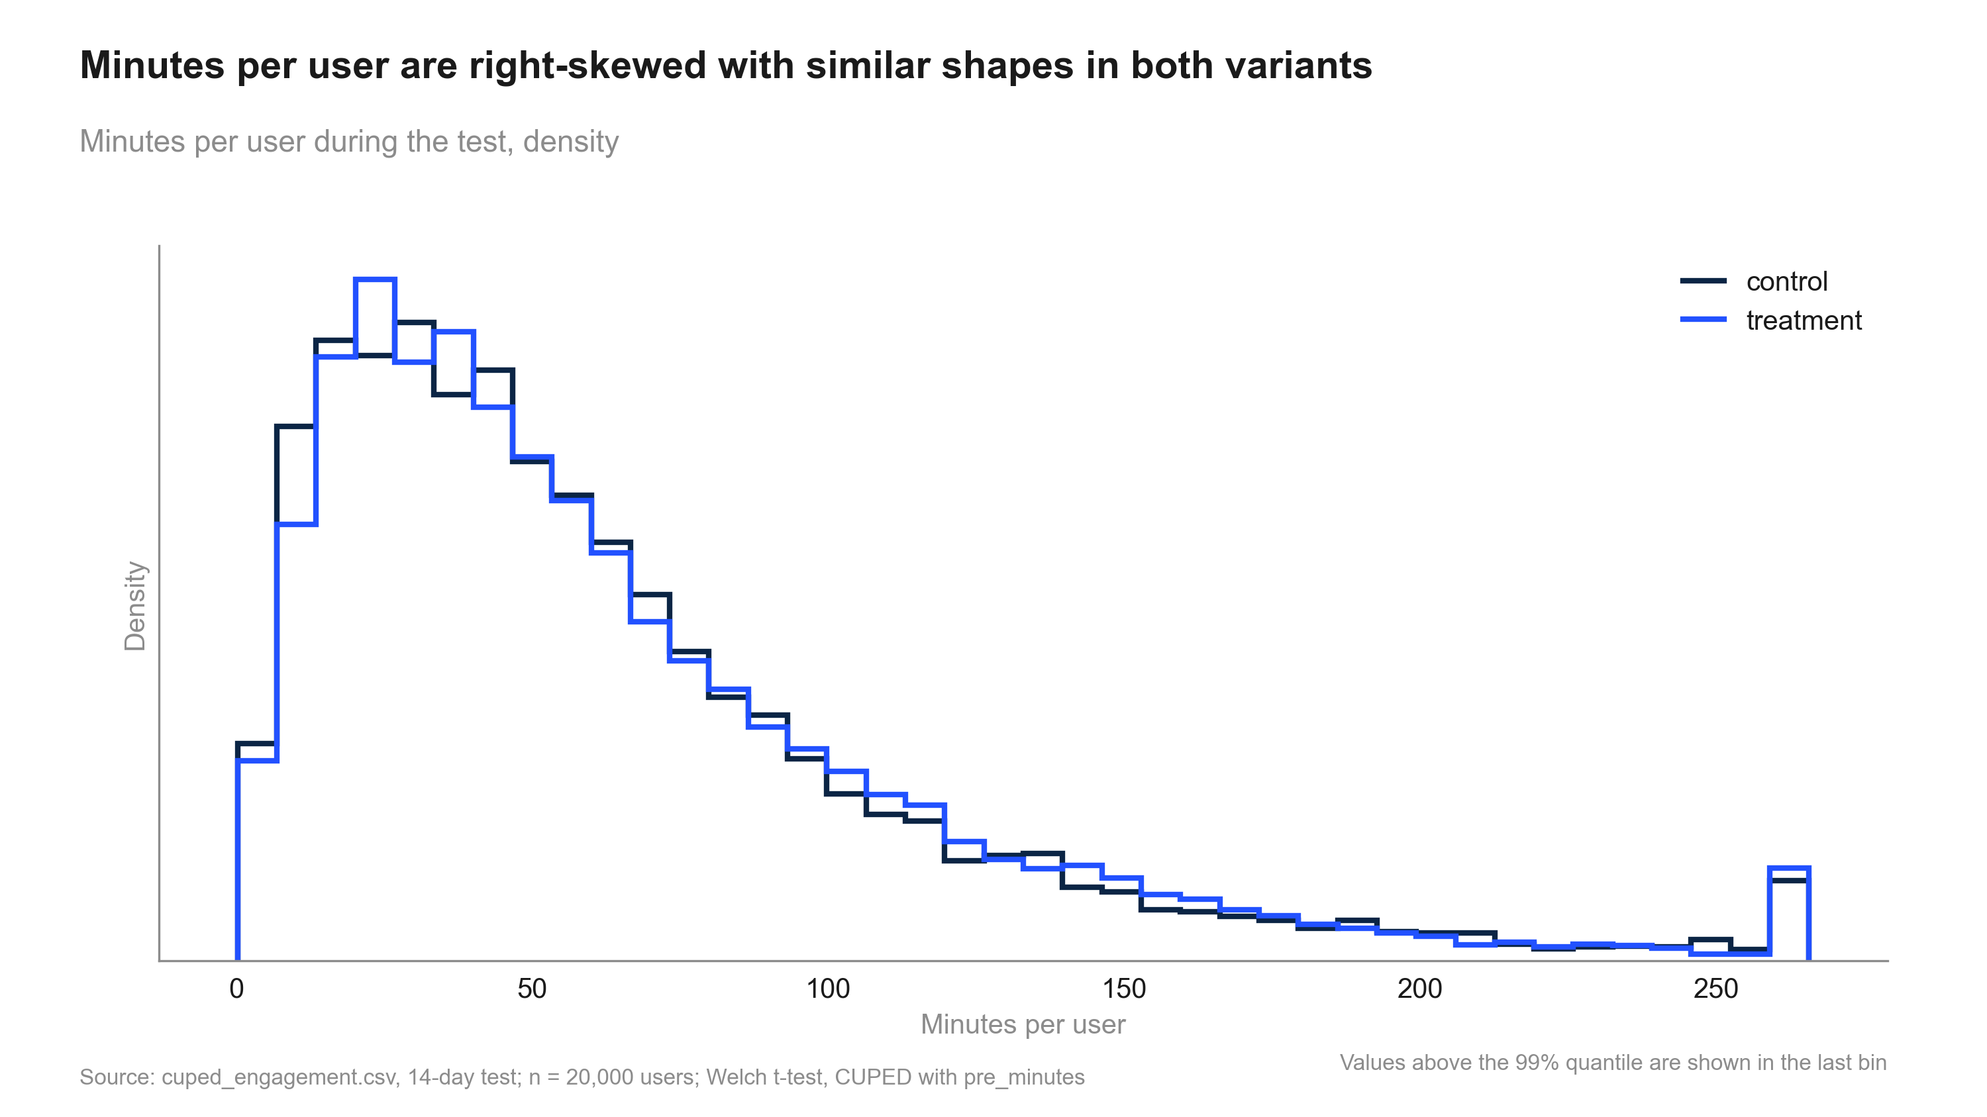
Figure 4: Minutes per user are right-skewed with similar shapes in both variants. Distribution of minutes

Code index
- 10_validate_profile.py: Validate cuped_engagement.csv incl. pre-period availability, correlation and balance; write data_profile.md.
- 20_analysis_cuped_test.py: CUPED-adjusted Welch test of minutes per user using pre_minutes. Step: cuped_test.
- 20_analysis_naive_test.py: Unadjusted comparison of minutes per user: Welch t-test plus a bootstrap check. Step: naive_test.
- 20_analysis_regression_check.py: Sensitivity: Lin (2013) regression adjustment with pre_minutes, HC2 robust SEs. Step: regression_check.
- 20_analysis_summary.py: Decision and summary on the CUPED estimate, with the unadjusted result and post-hoc caveat. Step: summary.
- 30_charts_cuped.py: Charts: naive vs CUPED lift, CI width reduction, minutes by variant, distribution (numbers from results.json).
- 40_deck_build.py: Build deck.pptx.
- 50_report_build.py: Build summary.docx.

