Onboarding checklist test
Results withheld: treatment has 7.1% fewer units than the intended split (p < 0.001, sample ratio mismatch)
Source: srm_broken.csv, 2026-09-01 to 2026-09-14; run 2026-10-01_onboarding-checklist

Executive summary
Recommendation: BLOCKED: DATA ISSUE
Results withheld: treatment has 7.1% fewer units than the intended split (p < 0.001, sample ratio mismatch)
The data failed a blocking validation check, so treatment effects cannot be trusted.

In plain terms: The groups being compared are not the ones the experiment created, so any difference between them could come from the data problem rather than the change.
- Observed share control: 53.6% (expected 50.0%)
- Observed share treatment: 46.4% (expected 50.0%)
- SRM test: chi-square p < 0.001 (threshold 0.001)
- Concentrated in: exposure_date 2026-09-05 to 2026-09-14 (10 of 14 levels); platform=Android
Caveats: iOS + Web alone show no mismatch (p = 0.323), but an iOS + Web-only readout would answer a different question (it excludes a whole platform); treat it as a sensitivity check only. Activation results were not computed: with units missing non-randomly, any difference could be caused by the loss.
Next step: Engineering: fix the Android exposure event lost since the 2026-09-05 release (about 3,085 treatment users missing)

Business question and hypothesis

Business question
Does the new onboarding checklist increase 7-day activation?

Decision to be made
Ship / don't ship the checklist.

Hypothesis
Showing a checklist during onboarding raises the share of new users who activate within 7 days.

Context as described
Test of a new onboarding checklist. File srm_broken.csv, one row per user: user_id, variant (control / treatment), exposure_date (2026-09-01 to 2026-09-14), platform, converted (1 if the user activated within 7 days). Intended split was 50/50 by user. Primary metric: activation (converted). Can you give me the readout?

Experiment design
Table 1: Experiment setup
Item | Detail
Variants (units) | control: 20,838, treatment: 18,073
Test period | 2026-09-01 to 2026-09-14 (14 days)
Primary metric | converted (binary, goal: increase)
Statistical settings | alpha 0.05, two-sided, power 0.8
Multiple-testing correction | secondary: holm; segments: benjamini-hochberg
Analysis type | srm investigation

Data and validation
Overall validation verdict: BLOCK. Checks follow; outliers are reported, never removed automatically.
Table 2: Validation checks
Check | Verdict | Detail
schema | PASS | 5 columns, 38,911 rows
dtypes | PASS | All metric columns numeric
missing values | PASS | No missing values
duplicates | PASS | 38,911 units, one row each
contamination | PASS | No unit appears in more than one variant
variants | PASS | Counts {'control': 20838, 'treatment': 18073}
SRM | BLOCK | Sample ratio mismatch: p = 1.22e-44 < 0.001; observed shares {'control': 0.5355, 'treatment': 0.4645}. Concent
dates | PASS | 2026-09-01 to 2026-09-14 (14 days)
outliers | PASS | No continuous metrics
impossible values | PASS | Metric values within valid ranges
pre-period data | PASS | None described (CUPED not possible)
covariate balance | WARN | Segment mix differs between variants: platform (p = 5.6e-119) (can indicate an assignment or logging problem,

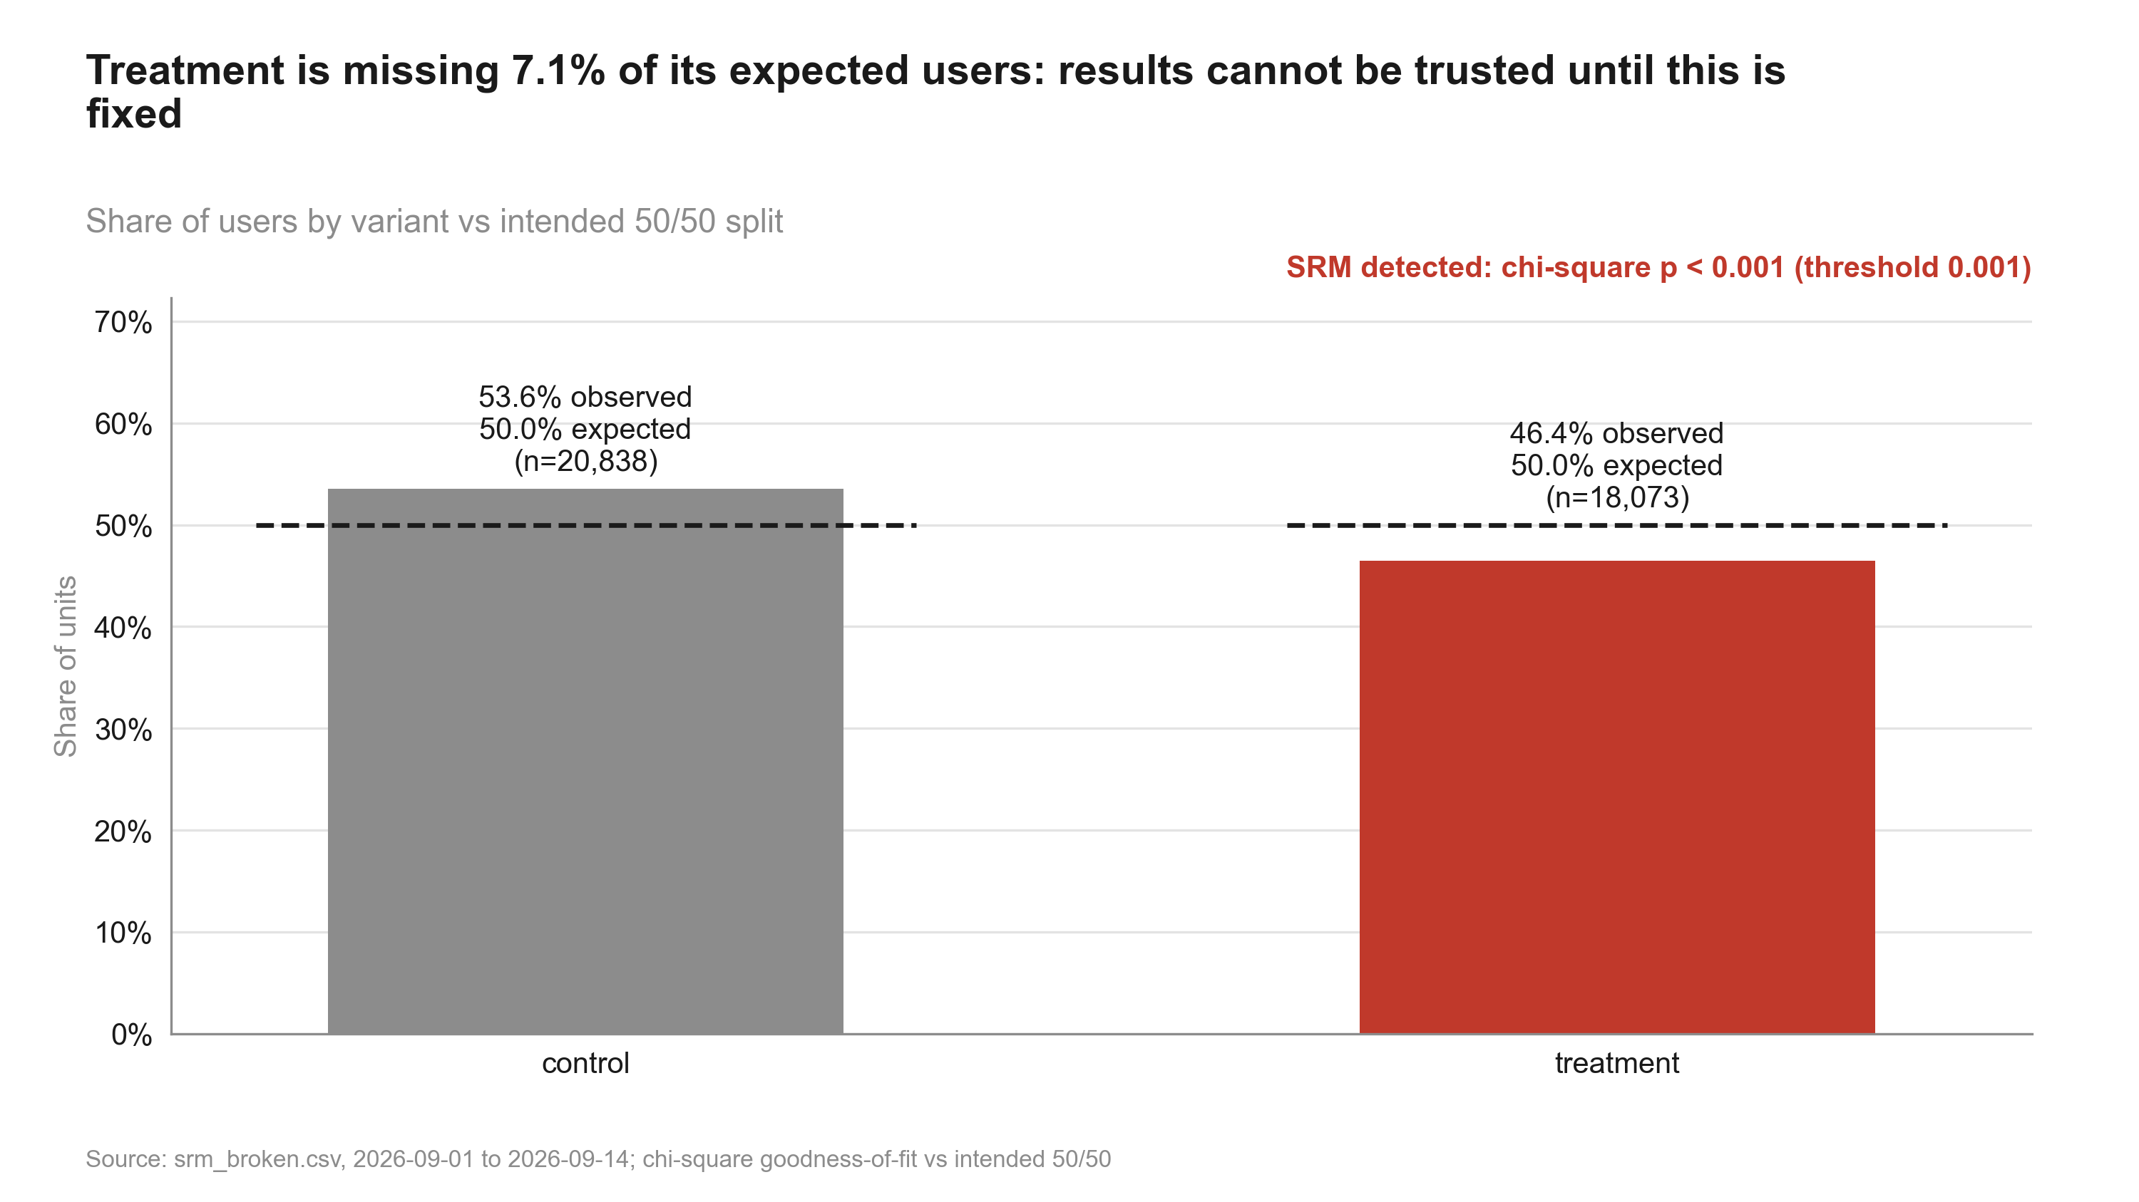
Figure 1: Treatment is missing 7.1% of its expected users: results cannot be trusted until this is fixed. Share of users by variant
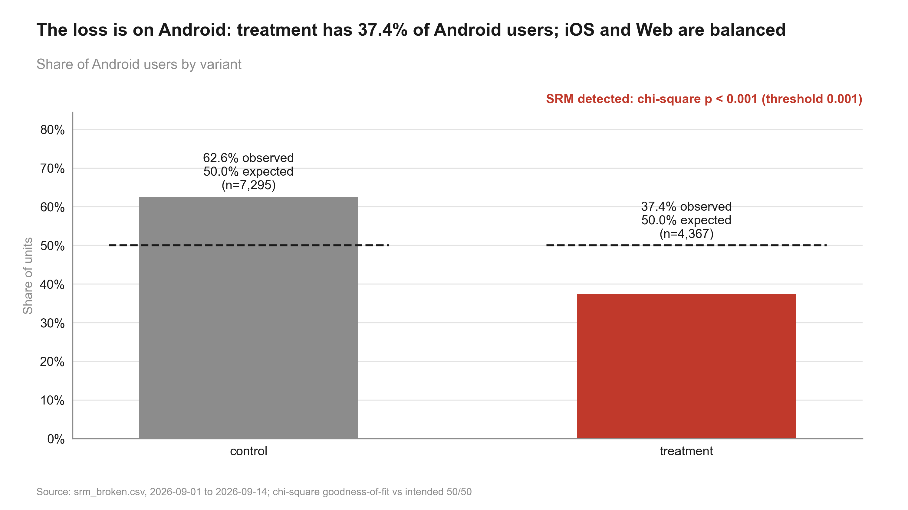
Figure 2: The loss is on Android: treatment has 37.4% of Android users; iOS and Web are balanced. Android users by variant

Recommendation and next steps
Blocked: data issue. The data failed a blocking validation check, so treatment effects cannot be trusted.
- Engineering: fix the Android exposure event lost since the 2026-09-05 release (about 3,085 treatment users missing)
- Re-extract exposures from server-side assignment logs and rerun this workflow on the corrected data
- If the logs cannot be repaired, rerun the test for two full weeks after the fix
- Add an automated daily SRM alert (by platform) to the experiment dashboard

Appendix

Settings
Table 3: Statistical settings used
Setting | Value
alpha | 0.05
sidedness | two-sided
power | 0.8
confidence_level | 0.95
correction_primary | none
correction_secondary | holm
correction_segments | benjamini-hochberg
srm_test | chi-square
srm_threshold | 0.001
min_days | 7
prefer_full_weeks | True
bayes_prior | weakly_informative
bayes_decision_threshold | 0.95
bootstrap_n_resamples | 10000
bootstrap_seed | 42
noninferiority_margin_relative | 0.01

Reviewer findings
Review: 2026-10-01_onboarding-checklist (round 1). Earlier rounds are in review.md.
- Verdict: PASS
- | # | Severity | Finding | Evidence | Suggested fix |
- |---|---|---|---|---|
- | 1 | note | Handling is correct: SRM blocked the analysis and no activation estimate was produced or reported. | results.json has no primary_test step; summary verdict "blocked" | none |
- | 2 | note | The loss is specific to Android from 2026-09-05; iOS + Web are balanced. An iOS + Web-only readout would change the population, and the caveat says so. | srm_localise: Android p < 0.001, iOS + Web p = 0.323 | none |
- | 3 | note | The covariate-balance warning (platform mix differs by variant) is a symptom of the same loss, not a separate issue. | data_profile.md covariate balance WARN | none |
- SRM - ok (detected, blocked, user decision recorded in intake.md).
- 2-6. Tests / units / corrections / significance wording - not applicable (no effect estimated).
- Peeking - not applicable.
- Novelty - not applicable.
- Simpson's paradox - n/a; platform mix imbalance explained by the SRM.
- Guardrails - none planned.
- Conclusion follows - ok ("Blocked: data issue" with fix-and-rerun next steps).
- Traceability - ok (counts recomputed from data/ match results.json; all scripts present).
- Failed assumptions - the design assumption of a 50/50 split fails; that is the finding.

Code index
- 10_validate_profile.py: Validate srm_broken.csv: full profile with SRM localised by date and platform; write data_profile.md.
- 20_analysis_srm_localise.py: SRM localisation: split counts by platform and by period (before / from 2026-09-05). Step: srm_localise.
- 20_analysis_summary.py: Blocked readout summary: verdict 'Blocked: data issue' built from the validation and SRM localisation results. Step: summary.
- 30_charts_srm.py: Charts for the blocked readout: overall SRM and Android-only SRM (numbers from results.json).
- 40_deck_build.py: Build deck.pptx for the blocked readout.
- 50_report_build.py: Build summary.docx for the blocked readout.

