1. Implemented pilot project along with user feedback
2. Impact of proposed solution
3. Implementation and outreach plan
4. Financial implication for the village

* Impact of Proposed Solution

1. Less land is required

In traditional farming, no matter how compact your farm setup is, every plant takes up a certain amount of fixed space that does not change throughout the lifetime of the plant.

In hydroponics, pots that hold the plants can be placed together very close to each other and the system can be structured to place the pots in mid-air, taking up less space. In fact, commercial hydroponics takes up 1/5th of the space required by traditional farming for the same harvest.

1. Eliminates all soil related issues

Agriculture is probably the most significant activity that accelerates soil erosion because of the amount of land that is farmed and how much farming practices disturb the ground. Hydroponic farming practices can be used in areas with infertile soil and harsh climatic conditions like deserts.

1. Eliminates the use of pesticides

Traditional Farming uses pesticides to kill pests/insects and herbicides to kill weeds. These pesticides not only harm the plants, but also the soil and nearby animals and beings are also affected to some extent.

Hydroponics does not use any form of pesticides as the entire setup is under closed greenhouses that resist the growth of insects in the setup.

1. Less water is used

Unlike traditional farming where water is absorbed by the soil and excess sinks past the roots, much of the water in hydroponics is retained for days and even weeks. As a result, hydroponics systems save water by almost 90% making it an effective solution for drought prone areas.

* Financial implication for the village

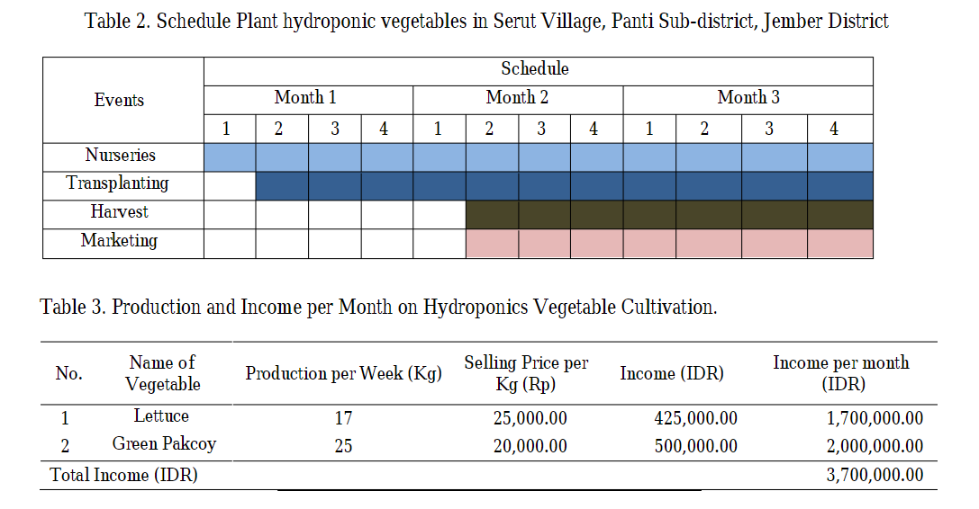

1. High-density maximum crop yield:

Hydroponics planting increases the maximum population of plants per unit area, increasing the yield and thereby making it more profitable for farmers.

1. Tackling climate change

Climate change has lead to inadequate rainfall and droughts in some regions and excessive rainfall in others. Usually, both these conditions have an adverse impact on the yield. Hydroponic farms are not affected by these harsh climatic conditions and will produce substantial yield regardless. Also, hydroponics is better for the environment because it reduces waste and pollution from soil runoff.

1. Helping farmers

The yield produced by hydroponic farms per unit area is much higher and very profitable for the farmers. With the ongoing problem of farmers’ suicides in India, hydroponic farming can help the farmers make more with less efforts and less land being used.

* Implementation and Outreach plan

Our proposed cost-effective system, Hydroponics, is a method of growing plants in a water based, nutrient rich solution. Our system does not use soil, instead the root is supported using an inert medium cocopeat.

The basic premise behind our system is to allow the plants’ roots to come in direct contact with the nutrient solution, while also having access to oxygen, which is essential for proper growth. Air stones provide the required oxygen in the solution.

All of this is possible through careful control of nutrient solution and pH levels. The concentration of nutrients is controlled by our very own custom designed and manufactured inexpensive EC (Electrical Conductivity) sensor which senses and adjusts the concentration of nutrients in the solution. The user is then notified about the system changes on the app on his phone.

Similarly, the pH is sensed by the pH sensor and controlled by our automated system which again notifies the user on his mobile app about the current state of the system.

Alternatively, the user can change the pH levels and nutrient concentration from his phone manually.

* Outreach Plan

Objectives:

* to produce high quality and nutritional vegetables for consumption in both local and international markets
* to create more opportunities and more profit for farmers

Strategy:

* Team Hydra’s strategy is to profitably and efficiently utilize present and future agricultural technology in the production of vegetables.
* Have an industry ready hydroponic farm for production of hydroponic chilli.