Human Activity Recognisation

**Introduction:**

The WISDM Smartphone and Smartwatch Activity and Biometrics Dataset includes data collected from 51 subjects, each of whom were asked to perform 18 tasks for 3 minutes each. Here we have to recognize the human activity by machine learning techniques. The dataset given consist of human activities measures by two different sensors accelerometer and gyroscope. The dataset has attributes x, y, z where x represents the sensor reading (accelerometer or gyroscope) for the x dimension, y represents the sensor reading (accelerometer or gyroscope) for the y dimension,z represents the sensor reading (accelerometer or gyroscope) for the z dimension. We used here Decision Tree with python to classify the human activities.

**Tool Used:**

* Python
* Jupyter Notebook
* Sklearn
* Decision Tree

**Implementation and result:**

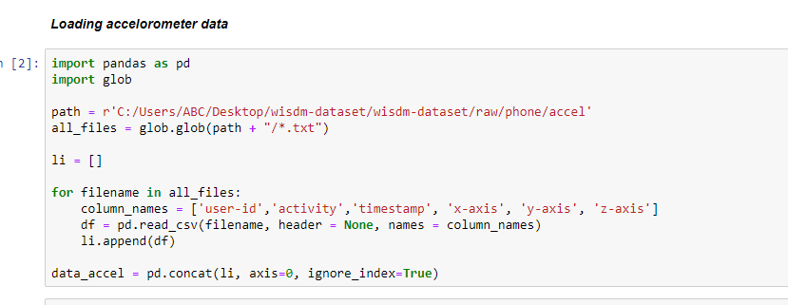

First, we import both accelerometer and gyroscope data

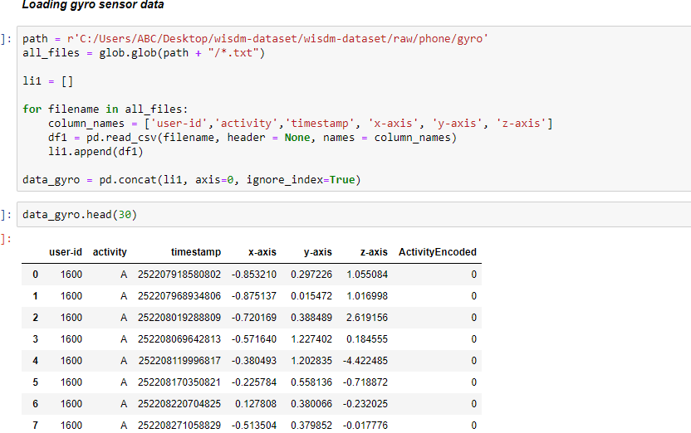

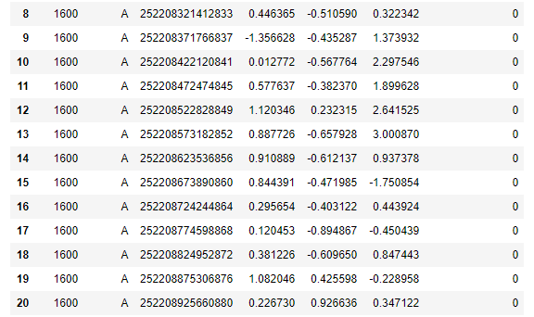

**Data Cleaning:**

Data cleaning for the both sensor data

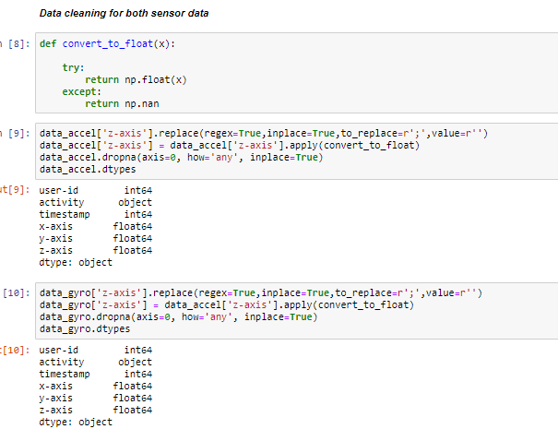

Here we can see that the user id is int64, activity is object, timestamp is in int64 and x-axis-axis and the z-axis are in the float data types.

**Data Visualization**

Now, we need to perform the data visualization on it .

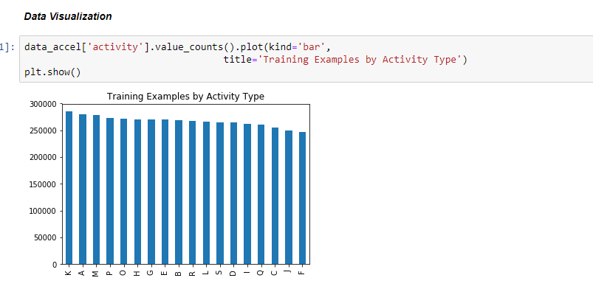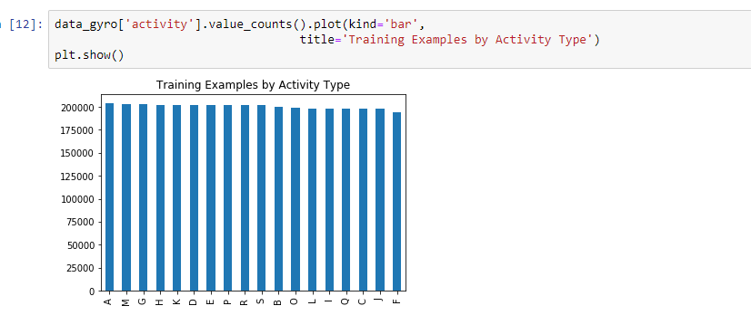

**Feature Engineering:**

Now we will do feature engineerig for model processings.

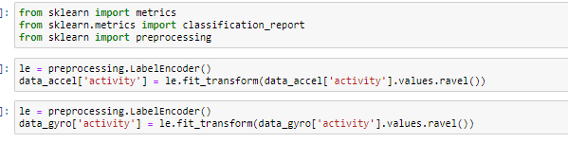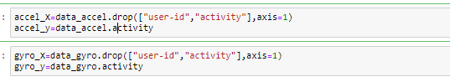

Now we split accel sensor data in train and test.

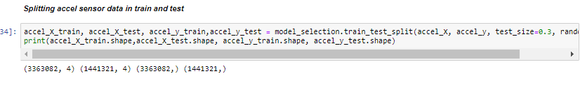

We will apply Decision tree Classifier on training data and check and accuracy on testing data.

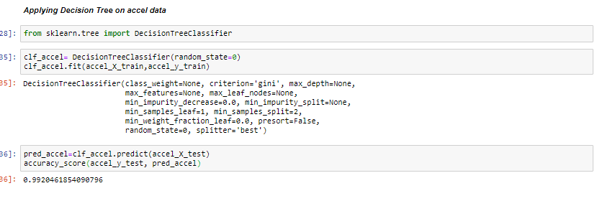

We got an accuracy around 99%. Here

Confusion Matrix for above classifier.

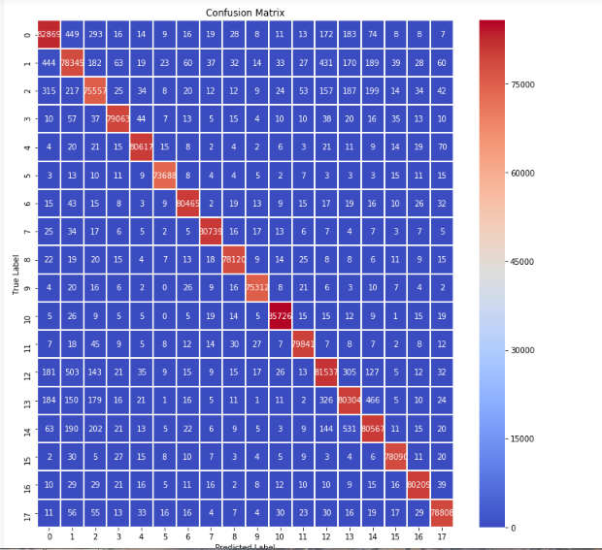

Now we split gyro sensor data in train and test.

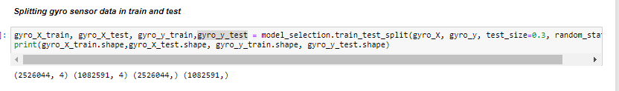

We will apply Decision tree Classifier on training data and check and accuracy on testing data.

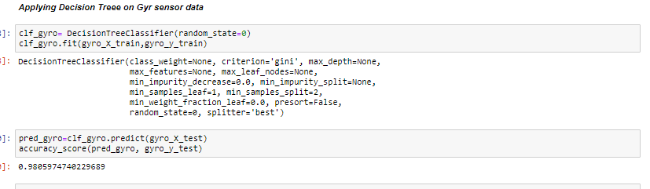

Here we got around 98% accuracy.

Confusion matrix for above classifier.

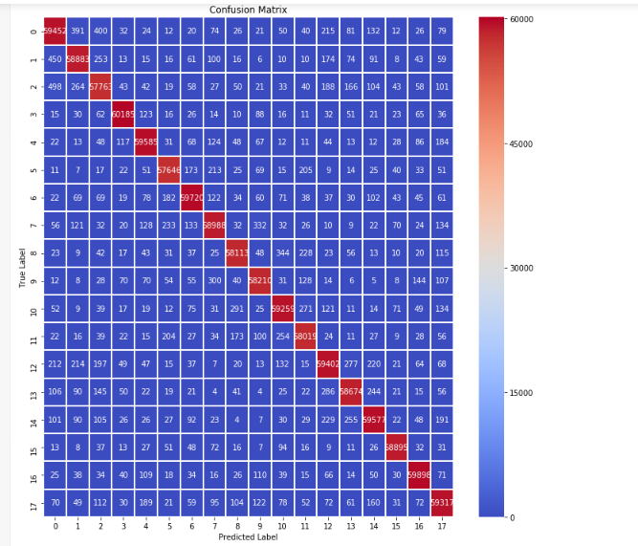

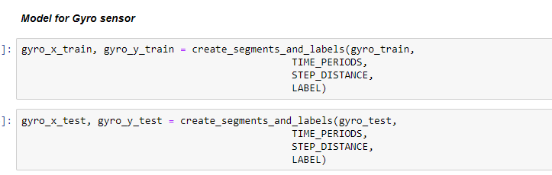

**References:**

* Alsheikh, M.A., Selim, A., Niyato, D., Doyle, L., Lin, S., Tan, H.P.: Deep activity recognition models with triaxial accelerometers. CoRR abs/1511.04664 (2015)
* Burns, A., Greene, B.R., McGrath, M.J., O’Shea, T.J., Kuris, B., Ayer, S.M., Stroiescu, F., Cionca, V.: ShimmerTM a wireless sensor platform for noninvasive biomedical research. IEEE Sensors Journal 10(9), 1527 – 1534 (2010).
* Zeng, M., Nguyen, L.T., Yu, B., Mengshoel, O.J., Zhu, J., Wu, P., Zhang, J.:Convolutional neural networks for human activity recognition using mobile sensors.In: 6th International Conference on Mobile Computing, Applications and Services.pp. 197–205 (Nov 2014).
* Wang, J., Chen, Y., Hao, S., Peng, X., Hu, L.: Deep learning for sensor-based activity recognition: A survey. CoRR abs/1707.03502 (2017).
* Kingma, D.P., Ba, J.: Adam: A method for stochastic optimization. CoRR abs/1412.6980 (2014).
* Robertas Lamaseries, Mindaugas Vasiljevic, Justas SalkeviIius, Marcin Wofniak, Human Activity Recognition in AAL Environments Using Random Projections, Computational and Mathematical Methods in Medicine, Volume 2016, Article ID 4073584, 17 pages
* Lichman, M. (2013). UCI Machine Learning Repository Irvine, CA: University of California, School of Information and Computer Science.
* Jose Daniel Pereira Ribeiro Filho, Francisco Jose da Silva eSilva, Luciano Reis Coutinho, Berto de Tácio Pereira Gomes, Markus Endler, A Movement Activity Recognition Pervasive System for Patient Monitoring in Ambient Assisted Living, SAC 2016, April 04 - 08, 2016, Pisa, Italy
* Cook, D., Feuz, K.D., Krishnan, N.C.: Transfer learning for activity recogni-tion: a survey. Knowledge and Information Systems 36(3), 537–556 (Sep 2013).
* Godfrey, A., Conway, R., Meagher, D., Laighin, G.: Direct measurement of humanmovement by accelerometry 30, 1364–86 (01 2009)