🧱 1. FULL DATASET (Create in Excel / CSV)
👉 Table 1: Patients
Patient_ID (PK)
Age
Gender
City

👉 Table 2: Doctors
Doctor_ID (PK)
Doctor_Name
Specialization

👉 Table 3: Admissions
Admission_ID (PK)
Patient_ID (FK)
Doctor_ID (FK)
Admission_Date
Discharge_Date
Department
Disease
Severity (Low/Medium/High)
Admission_Type (Emergency/Routine)
Outcome (Recovered/Not Recovered)

👉 Table 4: Treatments
Treatment_ID (PK)
Admission_ID (FK)
Treatment_Type
Cost
Treatment_Effectiveness (Success/Failure)

👉 Table 5: Date Table (create in Power BI)
Date
Year
Month
Month Name
Quarter

Table 6: TreatmentCost Table (create in Power BI)
Admission_ID
CostOFTreatment
RevenueGenerated

🧠 2. SQL — WHAT I AM PERFORMING

🔹 A. Data Quality Checks
- Find NULL discharge dates
- Count missing values per column
- Check duplicate Patient_ID or Admission_ID
--Find Duplicate Admission ID
select count(distinct Admission_ID) from [dbo].[Admission] -- No Duplicate Admission I
--Find Duplicate Patient ID
select
count(distinct Patient_ID)
from dbo.Admission -- Out of 200 121 patient are new and 79 are old patient or came for multiple treatment
--created a flag for analysing
with CTE_flagged as
(
SELECT *,
COUNT(*) OVER (PARTITION BY Patient_ID) AS patient_count,
CASE
WHEN COUNT(*) OVER (PARTITION BY Patient_ID) = 1 THEN 1
ELSE 2
END AS patient_flag
FROM dbo.Admission
)
select * from CTE_flagged
where patient_flag > 1
--Find Duplicate Doctor ID
select count(distinct Doctor_ID) from [dbo].[Admission] -- Total 20 unique Doctor ID

--Find count of Null admission date
SELECT
COUNT(*) AS total_rows,
COUNT(Admission_Date) AS non_null_age,
COUNT(*) - COUNT(Admission_Date) AS null_age_count -- Total 0 null admission date
FROM [dbo].[Admission];

--Find count Null discharge date
SELECT
COUNT(*) AS total_rows,
COUNT(Discharge_Date) AS non_null_age,
COUNT(*) - COUNT(Discharge_Date) AS null_age_count -- Total 39 null discharge date
FROM [dbo].[Admission];

--Find distinct department
SELECT
COUNT(*) AS total_rows,
COUNT(Department) AS non_null_age,
COUNT(*) - COUNT(Department) AS null_age_count -- Total 42 null Department data and distinct 4 department
FROM [dbo].[Admission];

--Total no of disease for which patient are admitted
select distinct (Disease) from [dbo].[Admission] --Total 4 distinct disease in this dataset

- Identify invalid data:
  - Discharge < Admission
--Check if admission date is after discharge date then data will be invalid
select * from [dbo].[Admission]
where Admission_Date > Discharge_Date --total 19 record are having discharge date is before admission date which mean these are invalida record

--Drop these invalid data
DELETE FROM [dbo].[Admission] where Admission_Date > Discharge_Date

👉 Output: Clean dataset summary

🔹 B. Feature Engineering (SQL level)
Create:
- Length_of_Stay
- Month, Year from Admission_Date


🔹 C. Core Business Queries
- Total Patients: 116
select
count(distinct Patient_ID)
from dbo.Admission
- Total Admissions : 181
select
count(distinct Admission_ID)
from dbo.Admission
- Patients per Department :
Patient_Count | Department
37 | NULL
31 | Cardiology
27 | General
43 | ICU
43 | Neuro
select
count(Patient_ID) as Patient_Count,
Department
from dbo.Admission
group by Department

- Patients per Disease
Patient_count | Disease
38 | NULL
35 | Fracture
41 | Heart
29 | Infection
38 | Stroke

select
COUNT(Patient_ID),
Disease
from dbo.Admission
group by Disease

🔹 D. Intermediate Analysis
- Avg Length of Stay is 5 days
--Avg length of stay
select
AVG(LengthOfStay) as AverageLengthOfstay
from dbo.Admission
- Recovery/ Not Recovered Rate per Disease
--Recovery/ Not Recovered rate per disease
SELECT
Disease,
ROUND(
COUNT(CASE WHEN Outcome = 'Recovered' THEN 1 END) * 100.0
/ COUNT(CASE WHEN Outcome IS NOT NULL THEN 1 END),
2) AS RecoveryRate_Percentage,
ROUND(
COUNT(CASE WHEN Outcome = 'Not Recovered' THEN 1 END) * 100.0
/ COUNT(CASE WHEN Outcome IS NOT NULL THEN 1 END),
2) AS NotRecoverdRate_Percentage
FROM dbo.Admission
GROUP BY Disease;
Disease | RecoveryRate_Percentage | NotRecoverdRate_Percentage
NULL | 38.460000000000 | 61.540000000000
Fracture | 38.100000000000 | 61.900000000000
Heart | 39.290000000000 | 60.710000000000
Infection | 36.840000000000 | 63.160000000000
Stroke | 51.720000000000 | 48.280000000000

- Emergency vs Routine comparison
--No of patient for Enegery vs Routing
select
count(Patient_ID),
Department,
Disease,
Severity,
Admission_Type
Outcome
from dbo.Admission
group by Admission_Type
, Department
, Disease
, Severity
, Outcome
We have 95 cases for emergency and 86 Routine
PatientCount | Admission_Type
95 | Emergency
86 | Routine
Out of 95 we have Emergency we have 17 whose department is unknown and 20 cardiology 12 general 24 ICU and 22 neuro cases
Out of 86 we have Emergency we have 20 whose department is unknown and 11 cardiology 15 general 19 ICU and 21 neuro cases
PatientCount | Department | Admission_Type
17 | NULL | Emergency
20 | NULL | Routine
20 | Cardiology | Emergency
11 | Cardiology | Routine
12 | General | Emergency
15 | General | Routine
24 | ICU | Emergency
19 | ICU | Routine
22 | Neuro | Emergency
21 | Neuro | Routine

🔹 E. Advanced SQL
1. Window Functions
- Rank top costly treatments
select
ad.Disease,
MAX(tc.CostOfTreatment) as TotalCost,
RANK() over (
order by MAX(tc.CostOfTreatment) ASC
) as RankByCost
from dbo.Admission ad
inner join dbo.TreatmentCost tc
on ad.Admission_ID = tc.admission_ID
group by ad.Disease

Disease | TotalCost | RankByCost
NULL | 48809 | 1
Infection | 49094 | 2
Heart | 49243 | 3
Stroke | 49470 | 4
Fracture | 49689 | 5

- Rank departments by revenue
Department | total_revenue | dept_rank
ICU | 2637828 | 1
Neuro | 2501028 | 2
NULL | 2200700 | 3
Cardiology | 1788012 | 4
General | 1586463 | 5
select
ad.Department,
SUM(tc.RevenueGenerated) AS total_revenue,
RANK() OVER (ORDER BY SUM(tc.RevenueGenerated) DESC) AS dept_rank
from dbo.Admission ad
inner join dbo.TreatmentCost tc
on ad.Admission_ID = tc.admission_ID
group by ad.Department

3. Cohort / Repeat Analysis
- Patients with multiple admissions
SELECT ad.Patient_ID, COUNT(ad.Patient_ID) AS TotalStays, pt.Age, pt.Gender, pt.City
FROM dbo.Admission as ad
inner join dbo.Patient pt
on ad.Patient_ID = pt.Patient_ID
GROUP BY ad.Patient_ID, pt.Age, pt.Gender, pt.City
Having count(ad.Patient_ID) > 1
Patient_ID | TotalStays | Age | Gender | City
4 | 2 | 34 | NULL | NULL
7 | 2 | NULL | Male | Delhi
9 | 2 | NULL | NULL | Ghaziabad
11 | 2 | NULL | Female | NULL
13 | 2 | NULL | Female | NULL
23 | 2 | 47 | NULL | Mumbai
29 | 2 | NULL | Female | Delhi
32 | 2 | 79 | NULL | Noida
33 | 2 | 73 | NULL | NULL
34 | 3 | NULL | NULL | Mumbai
35 | 3 | NULL | NULL | NULL
38 | 2 | 56 | Male | Ghaziabad
41 | 3 | 41 | Male | Ghaziabad
46 | 2 | NULL | NULL | NULL
48 | 2 | NULL | Male | Delhi
58 | 2 | 37 | NULL | Noida
69 | 2 | 27 | NULL | Mumbai
77 | 3 | NULL | NULL | NULL
79 | 2 | NULL | Male | Noida
82 | 2 | NULL | NULL | Mumbai
87 | 2 | NULL | NULL | Mumbai
88 | 3 | 68 | Female | Mumbai
90 | 2 | NULL | Male | Pune
105 | 3 | NULL | Female | Mumbai
110 | 2 | 38 | NULL | NULL
117 | 3 | 20 | NULL | Ghaziabad
121 | 3 | 63 | Male | NULL
122 | 2 | NULL | NULL | Delhi
125 | 3 | NULL | Male | NULL
127 | 2 | 32 | Female | Delhi
129 | 2 | NULL | Female | NULL
145 | 2 | NULL | Male | Mumbai
147 | 2 | NULL | NULL | NULL
151 | 3 | NULL | Female | Ghaziabad
154 | 2 | 27 | Male | Pune
156 | 4 | NULL | NULL | Delhi
159 | 2 | 42 | NULL | Pune
166 | 3 | 20 | Male | Pune
170 | 2 | NULL | NULL | Noida
171 | 2 | 72 | NULL | NULL
173 | 4 | 39 | NULL | NULL
177 | 2 | 48 | NULL | Noida
180 | 2 | 31 | Female | Ghaziabad
182 | 3 | NULL | Female | NULL
183 | 2 | 25 | NULL | Delhi
186 | 2 | NULL | NULL | NULL
193 | 2 | 49 | Female | NULL
194 | 3 | NULL | NULL | NULL

4. Severity Analysis
- Avg stay by severity
select
AVG(LengthOfStay) as AvgLengthOfStay,
Severity
from dbo.Admission
group by Severity
AvgLengthOfStay | Severity
5 | NULL
5 | High
5 | Low
4 | Medium
- Cost by severity

🧹 3. POWER QUERY

🔹 Cleaning Tasks
- Remove duplicates Yes
- Handle NULLs:
  - Discharge_Date → keep (active patients) : Cretated new column with if discharge date is null then Admitted else released
- Fix data types (date, numeric) yes
- Standardize text (Department, Disease) yes

🔹 Transformations
- Create Length_of_Stay column already did in sql
- Extract: yes already did in sql
  - Year
  - Month
- Create conditional column: created in Power query
  - Long Stay (>7 days = Yes/No) yes

🔹 Data Validation
- Remove invalid rows (Discharge < Admission) already did in sql
- Ensure relationships are consistent

🧱 4. DATA MODELING
👉 STAR SCHEMA
Fact Table:
- Admissions (main)
- Treatments (linked)

Dimension Tables:
- Patients
- Doctors
- Date

👉 Relationships:
- Patients → Admissions (1:M)
- Doctors → Admissions (1:M)
- Admissions → Treatments (1:M)
- Date → Admissions (1:M)

🧠 5. DAX

🔹 Basic Measures
- Total Patients :
Total Patient = SUM(Admission[Patient_ID])
- Total Revenue
Total Revenu = SUM(TreatmentCost[RevenueGenerated])

- Total Admissions
Total Admission = COUNT(Admission[Admission_ID])

🔹 Core Measures
- Avg Length of Stay
Average Length of Stay = AVERAGE(Admission[LengthOfStay])

- Recovery Rate
Recovery Rate =
DIVIDE(
CALCULATE(COUNTROWS(Admission), Admission[Outcome] = "Recovered"),
COUNTROWS(Admission)
)

- Cost per Patient
Cost Per Patient = DIVIDE(
[Total Cost],
COUNT(Admission[Patient_ID]),
"NA"
)

🔹 Advanced Measures
1. Rolling Metrics
- 30-day rolling admissions

4. Conditional Measures
- High Cost Flag
- Long Stay Flag

5. Ratio Analysis
- Revenue % by Department
Revenue % =
DIVIDE(
[Total Revenu],
CALCULATE([Total Revenu], ALL(Admission))
)

📊 6. DASHBOARD LAYOUT

👉 PAGE 1: Overview
KPIs:
- Total Patients
- Total Revenue
- Avg Stay
- Recovery Rate
Charts:
- Monthly admissions trend
- Revenue trend
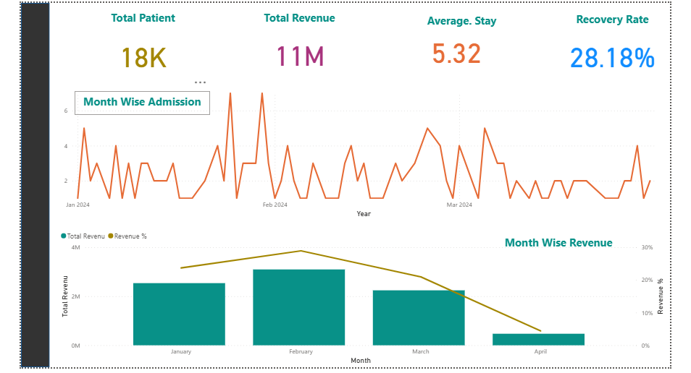

👉 PAGE 2: Department Analysis
- Patients by department
- Cost by department
- Avg stay by department
👉 Insight:
Which department is inefficient?
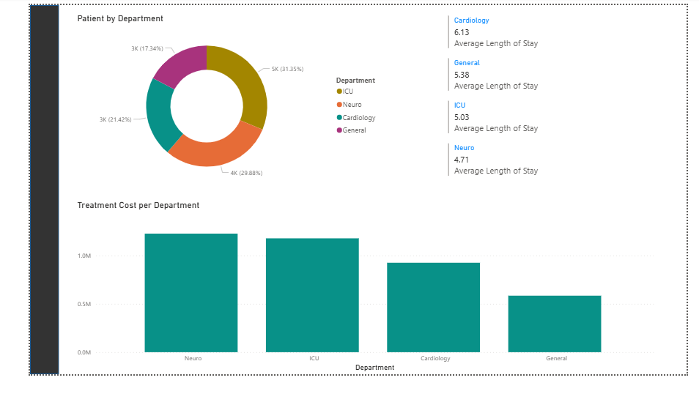

👉 PAGE 3: Disease & Treatment
- Top diseases
- Treatment cost distribution
- Recovery rate
